**CT331 Assignment 2**

Diarmuid Beirne | 15331436

**Question 1**

Screenshot

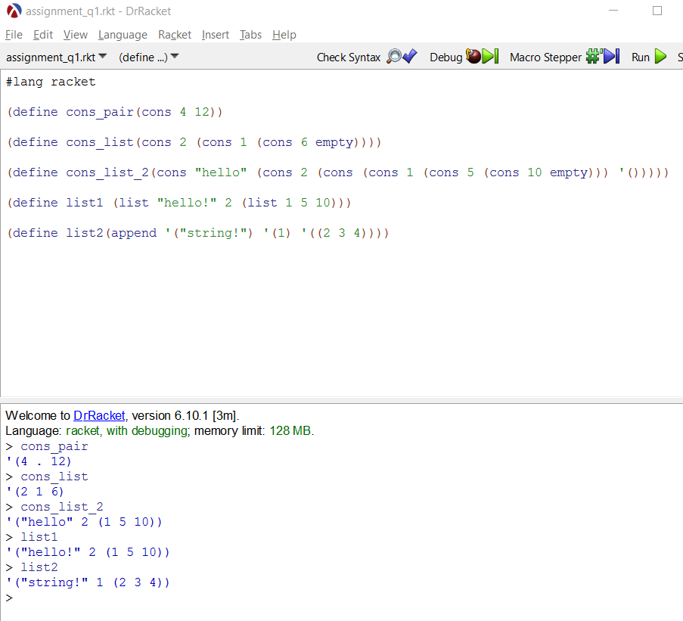

Comments

cons takes two s-expressions and combines then into a pair (which is also a s-expression).

cons_list and cons_list_2 above are nested cons.

cons can only take two values

list takes in a series of s-expressions and combines them into a list, shown in the output as a single unit.

list can take any number of values

append takes arguments that are lists and chains them together returning a larger of list of the elements.

append can take any number of values

**Question 2**

Screenshot

*Part A + B*

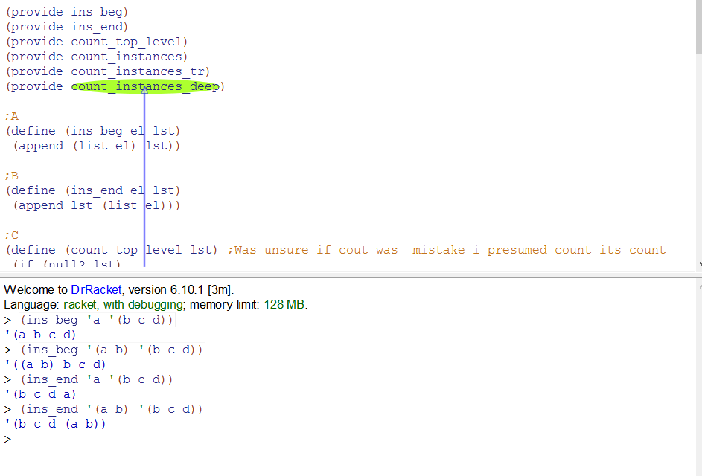

*Part C,D,E*

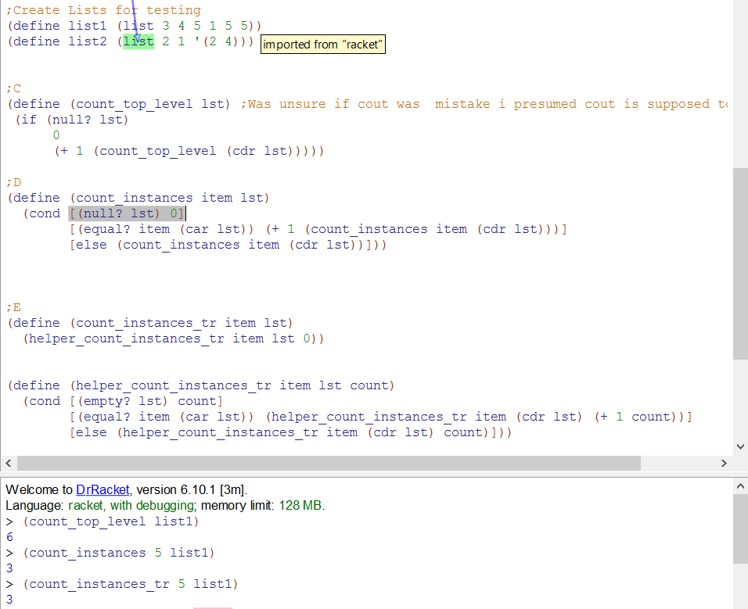

*Part F*

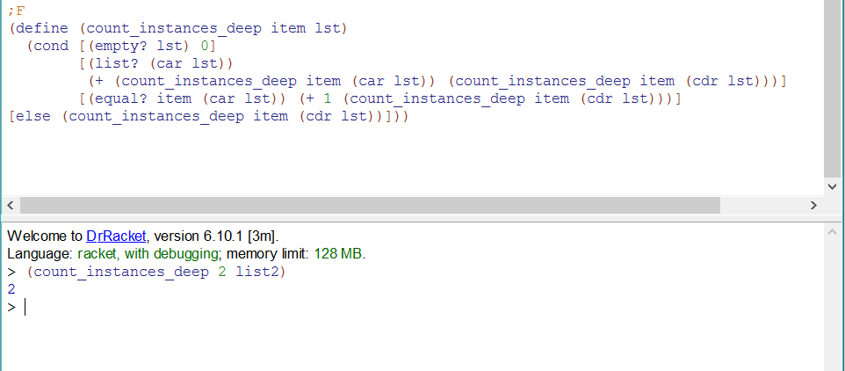

**Question 3**

*Part A,B*

