**Charity Density and Social Need: A Longitudinal Perspective**

**Tables and Figures**

**Table 1.** Key variables

|  |  |  |
| --- | --- | --- |
| Concept | Variable | Operationalisation |
| Charity density | charpop | Count of the number of registered charities in a local authority per 5000 residents |
|  | lcharpop, ncharpop, ocharpop | Count of the number of registered local, national and overseas charities in a local authority per 5000 residents |
|  | charpop_icnpo1-charpop_icnpo19 | Count of the number of particular icnpo registered charities in a local authority per 5000 residents |
|  |  |  |
| Social need | town | Continuous measure of the relative level of material deprivation in a local authority |
|  | town2 | Squared continuous measure of the relative level of material deprivation in a local authority |
| Urban/rural classification | pph_cat | Ordinal measure of the number of persons per hectare (pph) in a local authority:  1 = Most urban (> 33 pph)  2 = Very urban (26-33 pph)  3 = Urban (13-26 pph)  4 = Rural (1-13 pph)  5 = Most rural (< 1 pph) |
| Prior density | lag_charpop | Previous count of the number of charities in a local authority per 5000 residents |

**Table 2.** Summary statistics

|  |  |  |  |  |  |  |  |  |  |  |
| --- | --- | --- | --- | --- | --- | --- | --- | --- | --- | --- |
| Statistic | Population | Townsend Score | Charities | Charity Density | Local Charities | Local Charity Density | National Charities | National Charity Density | Overseas Charities | Overseas Charity Density |
| p5 | 55979 | -4.58 | 87 | 3.58 | 72 | 2.86 | 4 | 0.20 | 0 | 0 |
| p25 | 87015 | -2.65 | 179 | 7.22 | 152 | 6.05 | 13 | 0.55 | 1 | 0.05 |
| p50 | 116149 | -0.55 | 282 | 11.20 | 241 | 9.35 | 24 | 1.05 | 4 | 0.17 |
| p75 | 183450 | 1.46 | 436 | 17.28 | 367 | 14.78 | 53 | 1.83 | 12 | 0.47 |
| p95 | 315868 | 5.09 | 772 | 27.45 | 614 | 24.11 | 157 | 4.50 | 51 | 1.49 |
| Mean | 150935 | -0.34 | 343 | 12.89 | 285 | 10.97 | 45 | 1.54 | 13 | 0.38 |
| SD | 106820 | 3.01 | 252 | 7.43 | 203 | 6.67 | 62 | 1.75 | 29 | 0.61 |
| No. of Observations | 1635 | 1635 | 1635 | 1635 | 1635 | 1635 | 1635 | 1635 | 1635 | 1635 |
| No. of Local Authorities | 328 | 328 | 328 | 328 | 328 | 328 | 328 | 328 | 328 | 328 |

Note: Figures have been rounded to the nearest whole number, with the exception of Townsend Score and charity density measures (two decimal places).

**Table 3.** Zero-Truncated Poisson Regression: Charity Density (overall)

|  |  |  |  |  |  |  |
| --- | --- | --- | --- | --- | --- | --- |
|  |  | % change in expected level of charity density | | | | |
| Factors |  | 1971 | 1981 | 1991 | 2001 | 2011 |
| Townsend Score |  | -12.2*** | -2.9*** | -1.9** | -.8 | .3 |
| Townsend Score squared |  | 1.2* | .5** | .5*** | .4*** | .4*** |
| Urban/rural classification |  |  |  |  |  |  |
|  | Most urban | -37.8*** | .9 | 1.4 | -13.1*** | 1.5 |
|  | Very Urban | -39.6*** | -8.1 | 4.8 | -3.1 | 1.5 |
|  | Urban | -42.3*** | -14.2** | -12.1*** | -16.4*** | -5.9** |
|  | Rural | REF | REF | REF | REF | REF |
|  | Most rural | 102.8 | -4.3 | -8.5** | -2.2 | -10.1*** |
| Previous charity density |  | - | 8.4*** | 6.7*** | 4.9*** | 5.0*** |
|  |  |  |  |  |  |  |
| N (local authorities) |  | 327 | 326 | 327 | 327 | 327 |
| McFadden’s adjusted R2 |  | .11 | .39 | .41 | .40 | .36 |
| Cragg-Uhler/Nagelkerke R2 |  | .49 | .95 | .96 | .96 | .93 |
| Log-likelihood |  | -848.97*** | -728.30*** | -766.60*** | -785.74*** | -763.28*** |

Note: Coefficients rounded to one decimal place, all other figures rounded to two. Zero-truncated negative binomial model employed for 1971 due to presence of overdispersion. Coefficients are expressed as the percentage change in the expected number of charities per 5000 residents for a one-unit change in the independent variables. The Rural category is the reference category for Urban/rural classification. Constant (intercept) is omitted. Coefficients are estimated using robust standard errors. For every year, the material deprivation variables are jointly statistically significant, as is the urban/rural classification variable overall. *p < .05. **p < .01. ***p < .001.

**Table A1.** Correlation matrix of charity density and Townsend Score, by census year

|  |  |  |  |  |  |  |
| --- | --- | --- | --- | --- | --- | --- |
|  | Townsend Score | | | | | |
| Charity density | 1971 | 1981 | 1991 | 2001 | 2011 | Overall |
| Local | -.48*** | -.57*** | -.61*** | -.63*** | -.70*** | -.63*** |
| National | -.25*** | -.25*** | -.19** | -.22*** | -.16** | -.28*** |
| Overseas | -.15** | -.19*** | -.21*** | -.21*** | -.05 | -.50*** |
| Overall | -.45*** | -.53*** | -.54*** | -.57*** | -.59*** | -.59*** |
| *n* | 327 | 327 | 327 | 327 | 327 | 1635 |

Note: Correlations are Spearman rank-order coefficients. Figures have been rounded to two decimal places. *p < .05. **p < .01. ***p < .001.

**Figure 1.** Distribution of charities per 5,000 residents, by census year

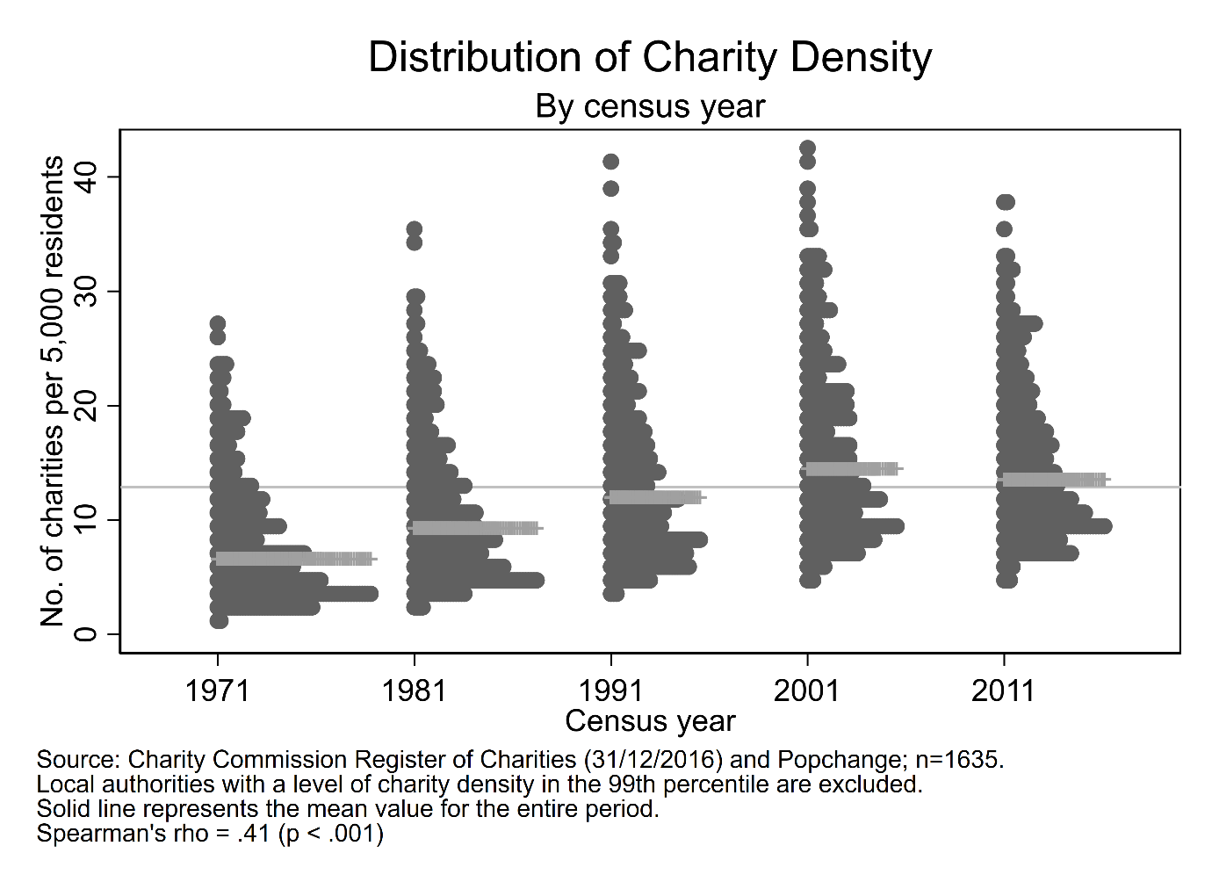

**Figure 2.** Distribution of charity density, by Townsend Score and census year

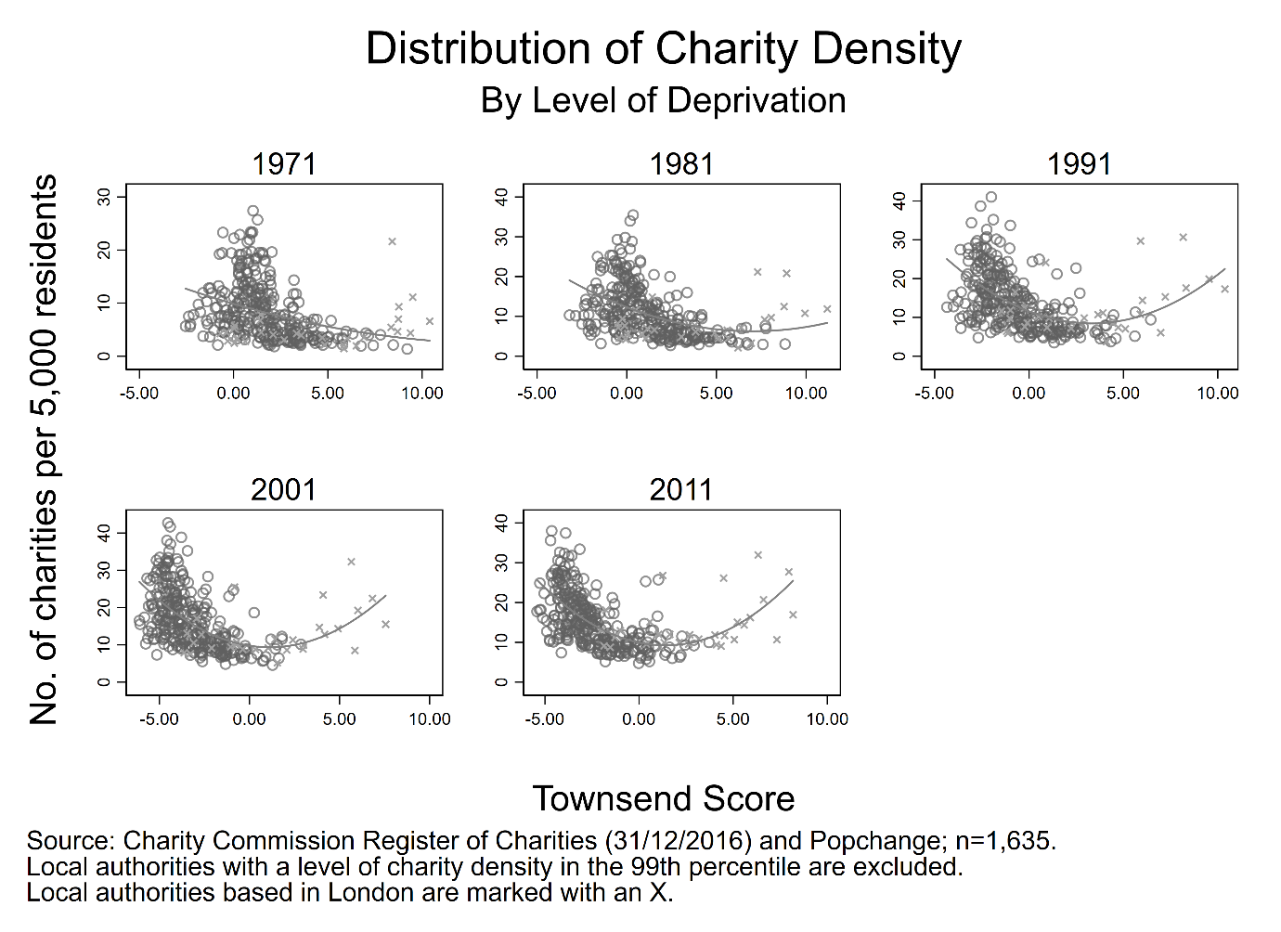

**Figure 3.** Distribution of predicted number of charities per 5000 residents, by Townsend Score and census year

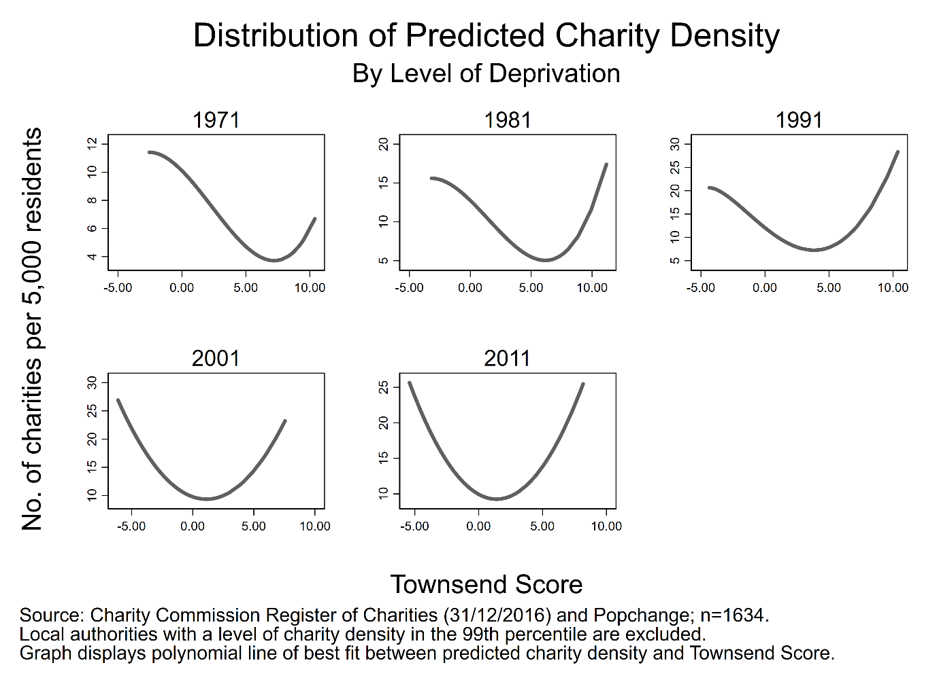

**Figure 4.** Distribution of predicted number of National charities per 5000 residents, by Townsend Score and census year

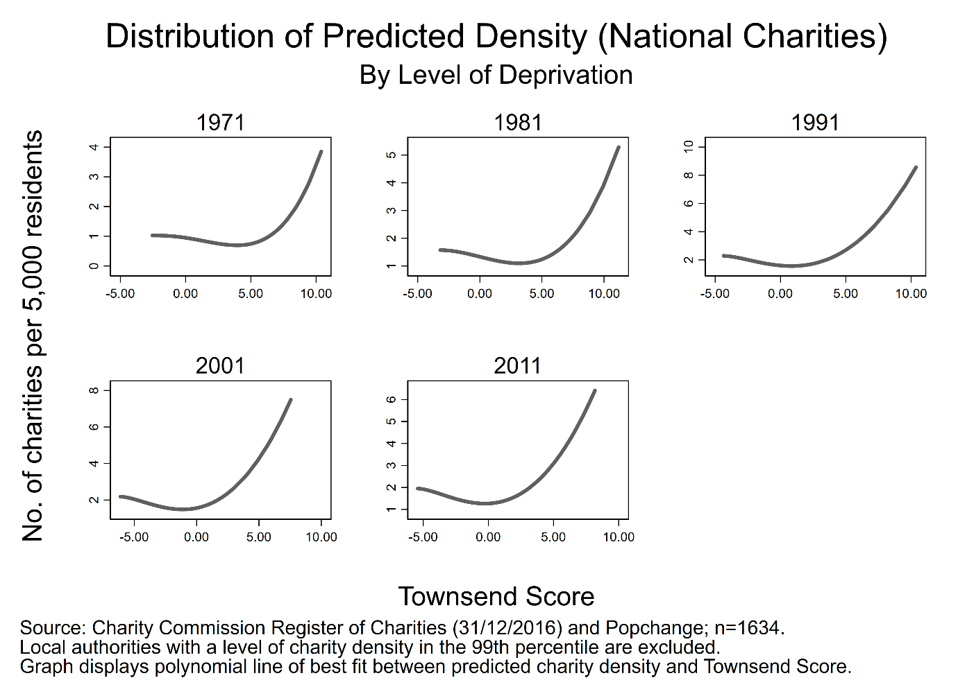

**Figure 5.** Distribution of predicted number of Overseas charities per 5000 residents, by Townsend Score and census year

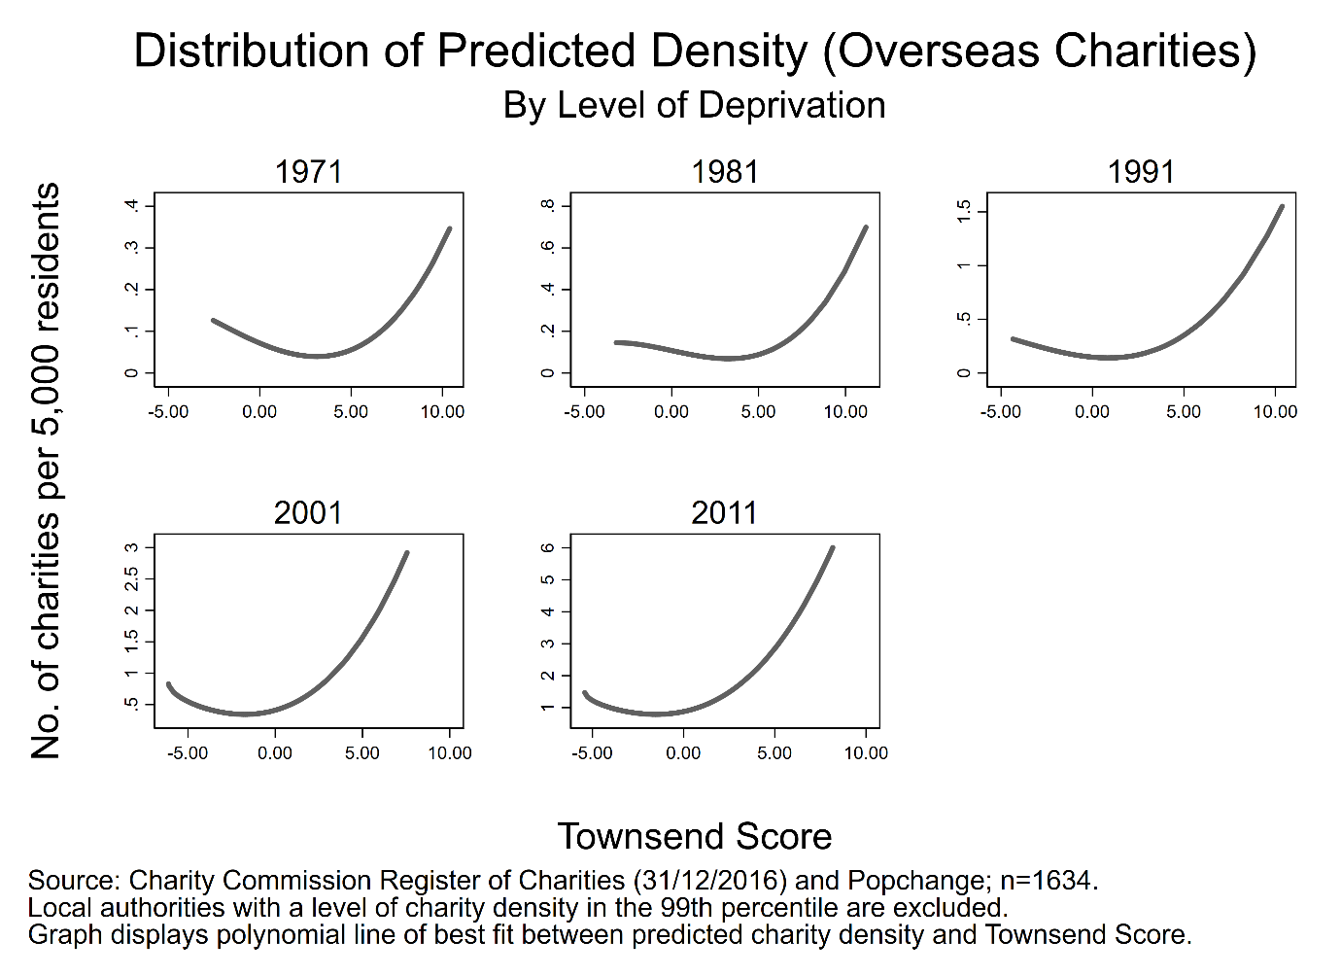

**Figure 6.** Distribution of predicted number of Local charities per 5000 residents, by Townsend Score and census year

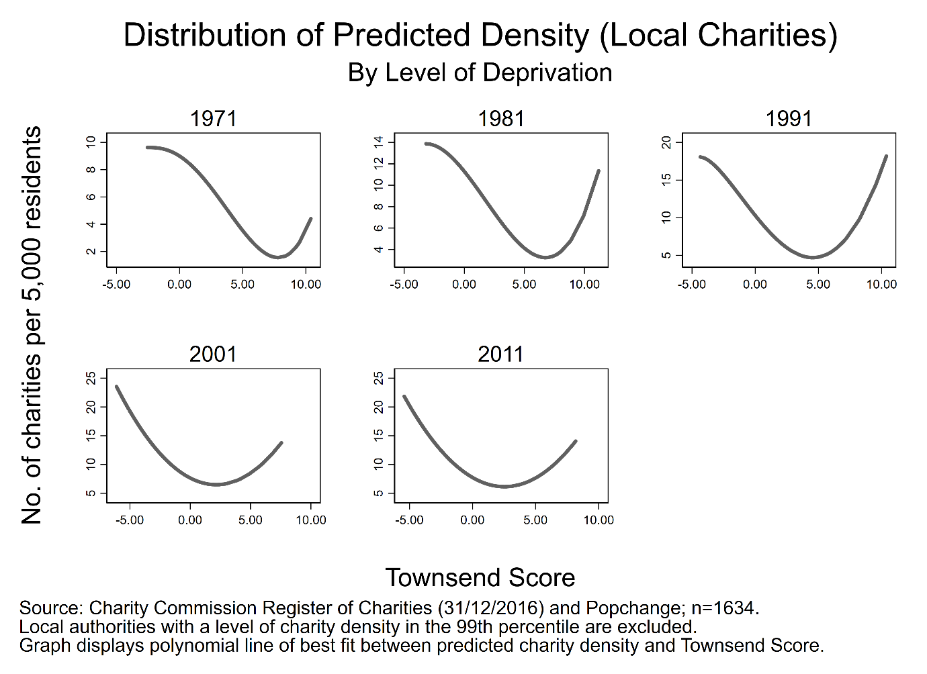

**Figure 7.** Distribution of predicted number of Religion charities per 5000 residents, by Townsend Score and census year

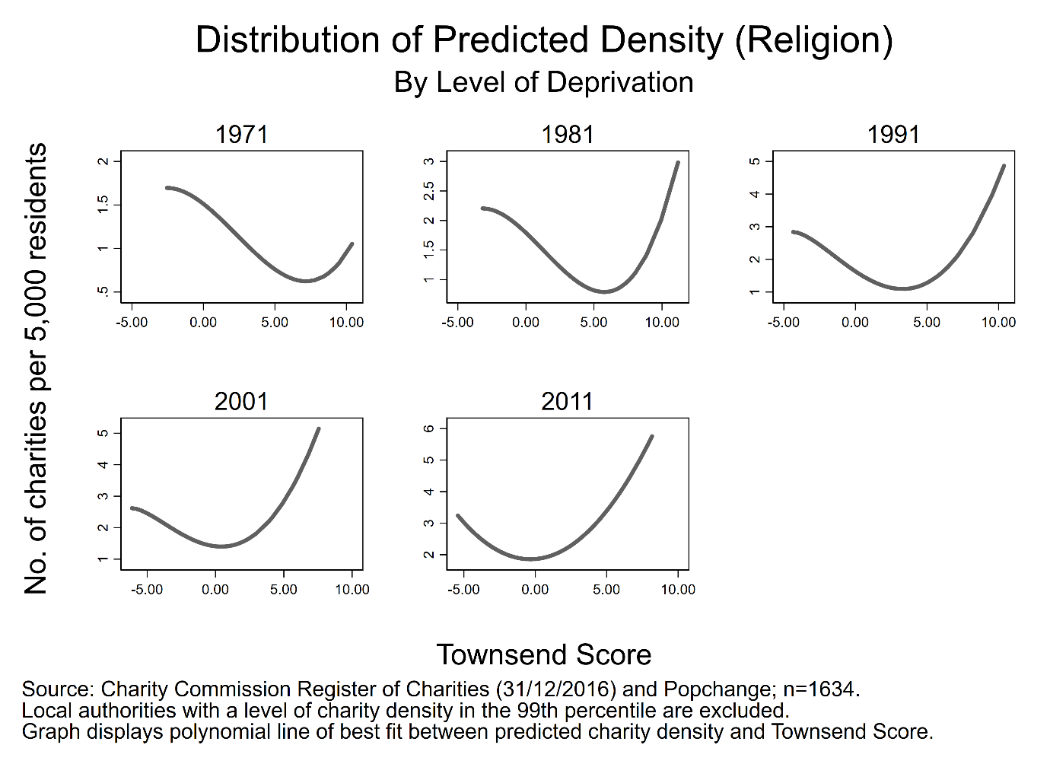

**Figure 8.** Distribution of predicted number of Social Services charities per 5000 residents, by Townsend Score and census year

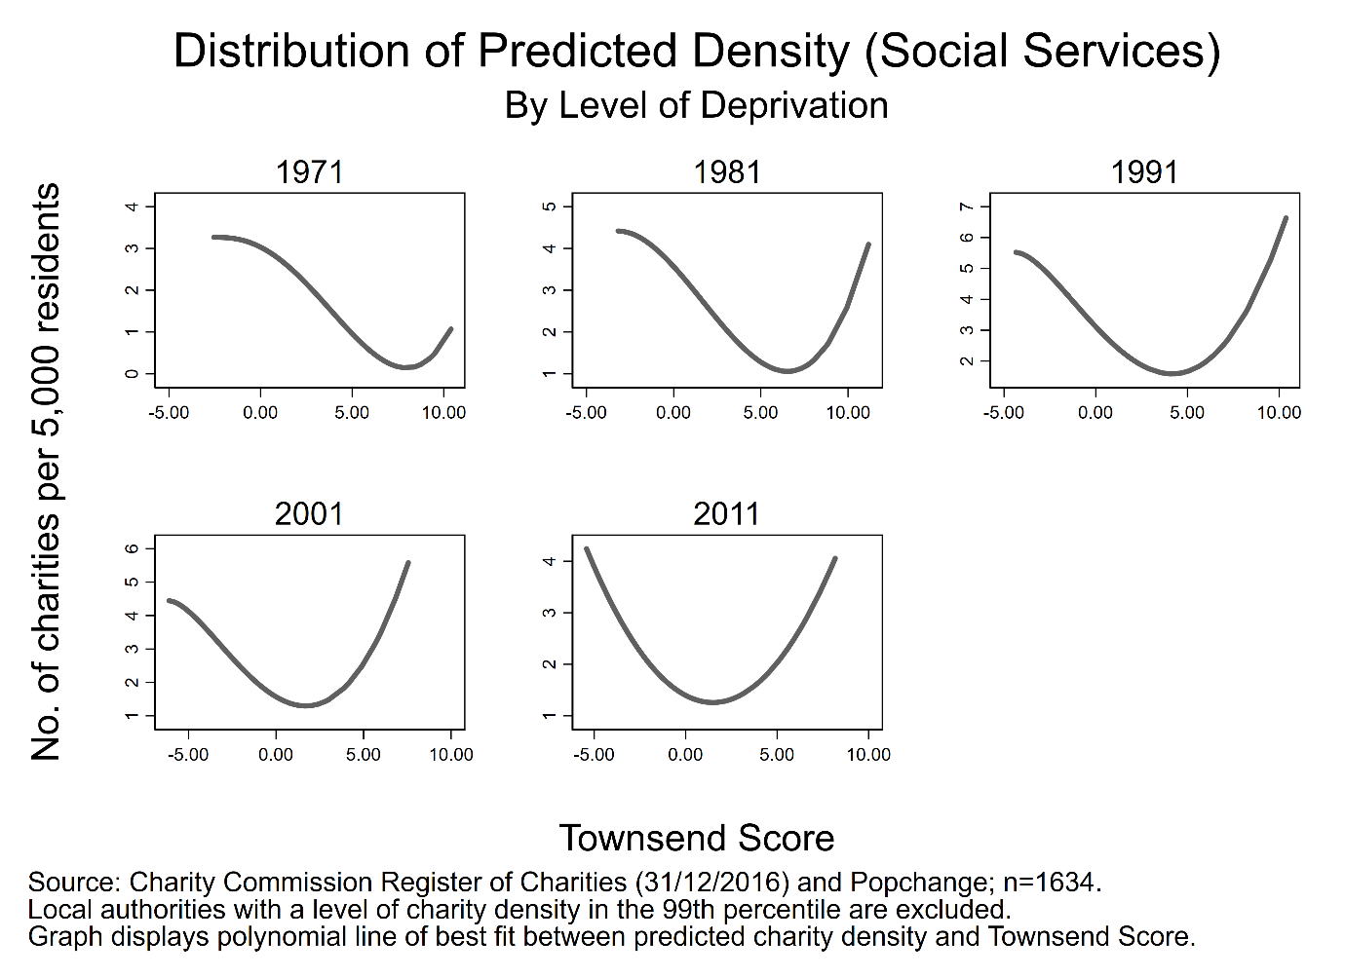

**Figure 9.** Distribution of predicted number of Culture and Recreation charities per 5000 residents, by Townsend Score and census year

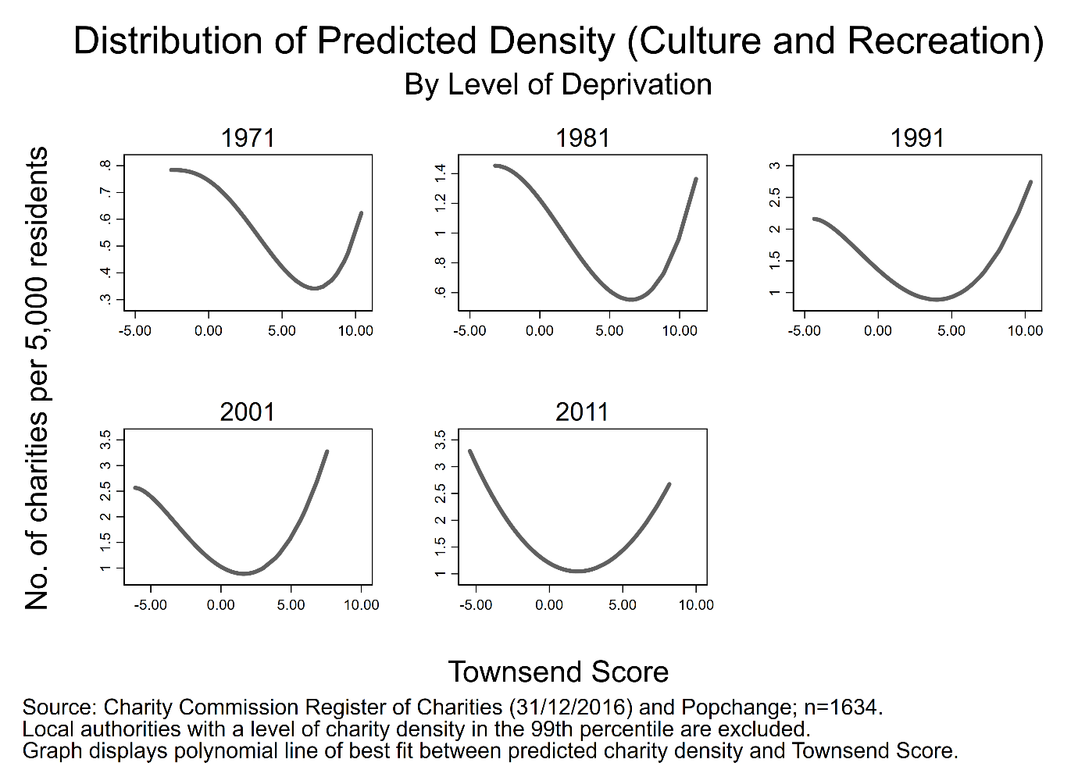

**Figure 10.** Distribution of predicted number of Development charities per 5000 residents, by Townsend Score and census year

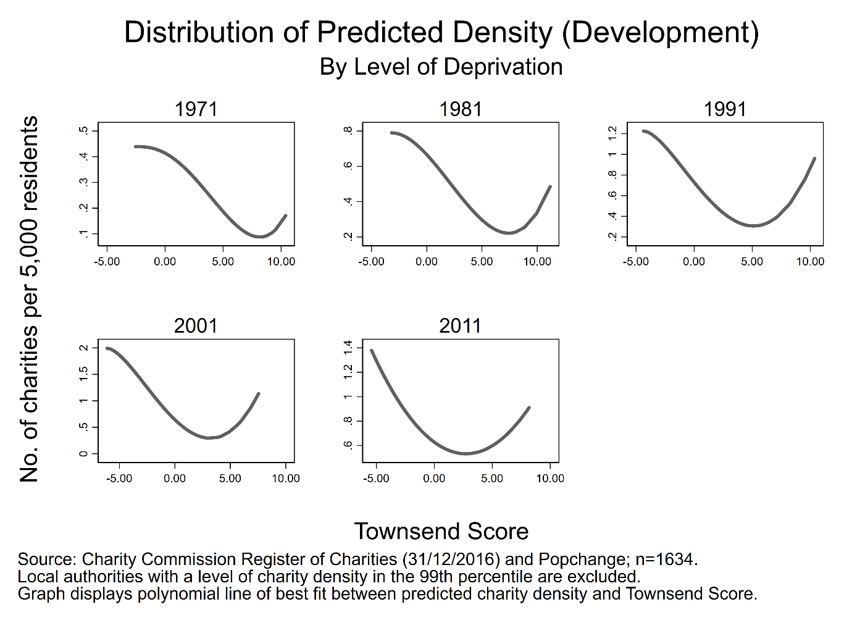

**Figure 11.** Distribution of predicted number of Education charities per 5000 residents, by Townsend Score and census year

