**The impact of COVID-19 on the foundation and dissolution of charitable organisations**

Diarmuid McDonnell1 and Alasdair Rutherford2

1. Research Fellow. Third Sector Research Centre, University of Birmingham, UK (d.mcdonnell.1@bham.ac.uk).

2. Professor of Social Statistics. Faculty of Social Sciences, Colin Bell Building, University of Stirling, UK.

**Abstract**

COVID-19 represents an existential threat to many charitable organisations, while simultaneously spurring new, large-scale forms of voluntary activity (Macmillan, 2020). Using comprehensive publicly available data from UK regulators, we examine the impact of COVID-19 on the foundation and dissolution of charitable organisations. We employ an “excess events” analytical approach, comparing the numbers of foundations and dissolutions in 2020 to what we would expect based on the trends from previous years. We examine variation in these trends by key organisational and geographic factors e.g., have some regions of the UK suffered a steeper decline in new charities being founded? We also describe the impact of COVID-19 on other charity jurisdictions, as well as attempt to decompose the empirical patterns into two distinct but related factors: the level of applications for foundation and dissolution by charities; and the capacity of the charity regulators to process these applications.

Funded by UK Research and Innovation Grant: ES/V004859/1

COVID-19 represents an existential threat to many charitable organisations, while simultaneously spurring new, large-scale forms of voluntary activity (Macmillan, 2020).

**Theory**

[Why might understanding the impact on registrations and de-registrations be valuable/important?]

**Impact of COVID-19 on charitable activity**

[Summarise empirical evidence and maybe bring in some prognostications also.]

**Data**

Data for this study come from the publicly available charity registers of seven regulatory agencies: England and Wales (Charity Commission for England and Wales), Scotland (Scottish Charity Regulator), Northern Ireland (Charity Commission for Northern Ireland), Australia (Australian Charities and Not-for-profits Commission), New Zealand (Charities Services), Canada (Canada Revenue Agency), and United States of America (Internal Revenue Services). The charity registers were collected on [DATE] using a Python web scraping script that has been running on the 28th of each month since August 2020 [DATE].

The charity registers are censuses of non-profit organisations that a) possess charity status and b) are registered with the relevant regulator. For some jurisdictions the register contains all organisations granted charity status (e.g., Scotland, New Zealand), while in others there are charitable organisations that operate outwith the oversight of the charity regulator (e.g., England and Wales, Northern Ireland). In most (all?) jurisdictions the regulator has a legal mandate to create, maintain and publish a charity register, thus we can be confident that these records are of sufficient quality for use in scholarly research (McDonnell and Rutherford, 2022).

**Method**

The main phenomenon of interest is the impact the COVID-19 pandemic had on the registration of new charities and the de-registration of existing organisations. The pandemic is a once-in-a-century event and thus posited to alter the expected or ‘normal’ levels of registrations and de-registrations. To measure this impact, we draw upon the analytical approach for calculating the level of “excess deaths” resulting from COVID-19 (see ONS, YEAR; Healy, 2020). Applied to this study, the impact of the COVID-19 pandemic can be measured as the number of excess registrations and de-registrations observed in each of our seven jurisdictions.[1] We do this using the following steps:

1. Measure observed numbers of registrations and de-registrations in 2020, annually and monthly.
2. Calculate average (mean) numbers of registrations and de-registrations for the period (2015-2019), annually and monthly.
3. Calculate different between observed and average (expected) numbers of registrations and de-registrations for 2020, annually and monthly.

A limitation of this approach is that it does not take account of temporal trends in registrations and de-registrations. For example, the number of registrations in [JURISDICTION] appear to be increasing over time (figure #). To account for any temporal trends present in the data, we estimate expected numbers of registrations and de-registrations using a simple linear model of the form:

yt = a + yt-1 + t + e

* where yt = event at time *t*
* yt-1 = number of events in the previous period
* t = period
* e = error term

Thus e 2020 represents the difference between observed and expected events for a given year.

*Worked example*

For example, let’s say there were 50 new charities registered in Scotland in January 2020 - is that number large or small, expected or unexpected based on previous figures for January?

|  |  |
| --- | --- |
| Month | Number of new charities |
| January 2015 | 60 |
| January 2016 | 55 |
| January 2017 | 82 |
| January 2018 | 65 |
| January 2019 | 75 |

The average number of new charities in January between 2015-2019 is: (60 + 55 + 82 + 65 + 75) / 5 = 67. So there are 17 fewer new charities in January 2020 compared to the average for 2015-2019. Of course, the figures for January vary each year, and thus we need to know if the figure for January 2020 falls outside the range of expected registrations for that month. Therefore we calculate the standard deviation of the average, which is 10, and use this to construct the range: 57 to 77 (i.e., 67 +- 10). So there are fewer new charities in January 2020 than we would expect.

**Results**

**Figure #:** Number of registrations for seven charity jurisdictions, 2015-2020

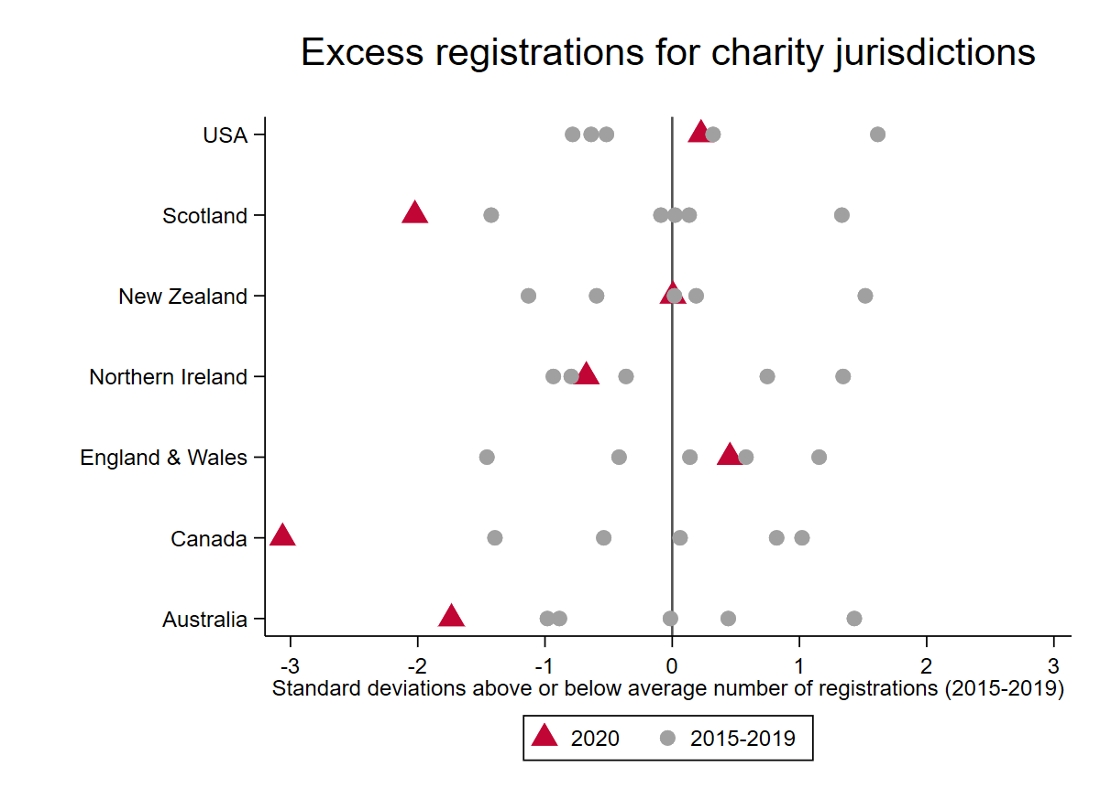

**Figure #:** Number of de-registrations for seven charity jurisdictions, 2015-2020

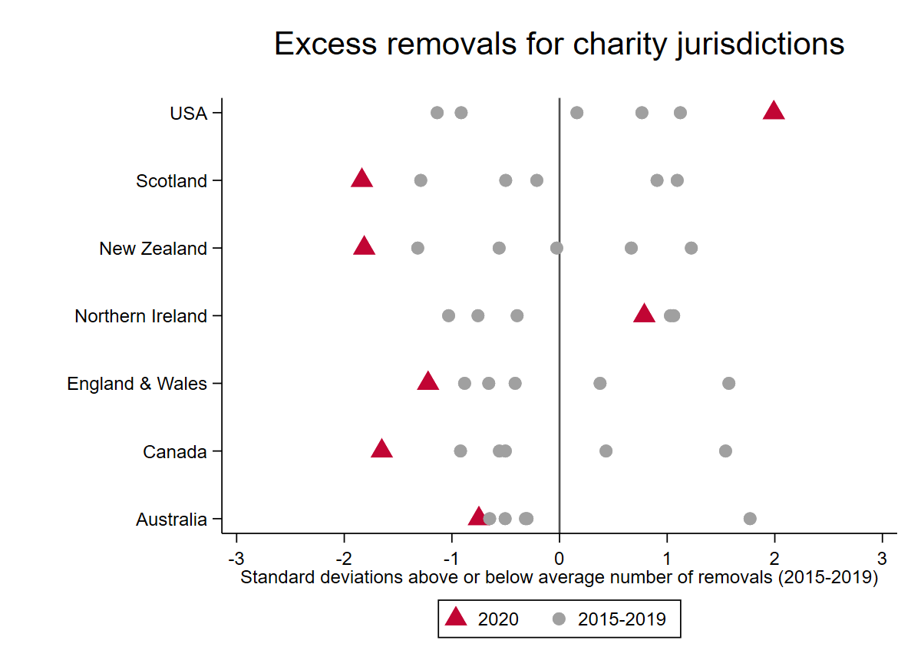

**References**

Macmillan, R. (2020). Somewhere over the rainbow – third sector research in and beyond coronavirus. *Voluntary Sector Review*, https://doi.org/10.1332/204080520X15898833964384.

McDonnell, D., & Rutherford, A. C. (2022). Researching risk in the voluntary sector: The challenges and opportunities of regulatory data. In J. Dean, E. Hogg (Eds.). *Researching Voluntary Action: Innovations and Challenges*. Bristol: Policy Press.

1. Note that excess events also captures a reduced level of registrations and de-registrations.