**Mission Accomplished? A Cross-national Examination of Charity Dissolution**

Diarmuid McDonnell1, Alasdair Rutherford2 and Carolyn Cordery3

1. Research Fellow. Third Sector Research Center, School of Social Policy, University of Birmingham, UK (d.mcdonnell.1@bham.ac.uk).

2. Professor of Social Statistics. Faculty of Social Sciences, Colin Bell Building, University of Stirling, UK.

3. Professor of Accounting. Department of Accounting, Aston Business School, UK.

**Abstract**

Encouraged by ‘open data’ movements, regulators have made it increasingly straightforward for stakeholders to access large-scale data about charities and their regulation. This research leverages some of these data resources to examine a topic of considerable public and regulatory importance: charity dissolution due to mission accomplishment. The charity sector's claim to exist for the public good is no longer assumed and must be evidenced, however little is known about the extent to which charities accomplish their missions. In this paper we describe continuing work to collect, clean, harmonise and analyse international data on charity dissolution. In doing so we identify real opportunities for interdisciplinary collaboration, combining accounting, social policy, law and data science in order to address important questions in novel ways.

Keywords: charity success, big data, open data, nonprofit regulation

Word Count: 3702

**1.** **Introduction**

Nonprofit and specifically charity regulation is in flux. Stagnant or declining regulator budgets are the new normal and charities themselves are subject to increasing levels of public scrutiny. To meet these and other challenges, many regulators are shifting to an approach informed by risk assessment and analysis (McDonnell & Rutherford, 2019). This requires regulators to leverage their considerable data resources to better target their interventionist and advisory activities, and deliver their mandate. Until recently, relatively little nonprofit regulatory data was shared beyond lists of registered charities. Encouraged by increasing ‘open data’ movements, regulators have made it increasingly easier for stakeholders to access a range of both quantitative and qualitative data about charities and their regulation on a large scale. New nonprofit regulators are being formed, or reformed, and decisions are being taken about what data to collect, and how to use it (Cordery & Deguchi, forthcoming). This paper describes ongoing work to leverage some of these data resources to examine a topic of considerable public and regulatory importance: charity dissolution due to mission accomplishment. There are many reasons charities shut down (e.g. insufficient funds, non-compliance with legal requirements), but this project will focus on organisations that dissolve after accomplishing their mission. The charity sector's claim to exist for the public good is no longer assumed and must be evidenced (Brody, 2002). However, little is known about the extent to which charities accomplish their missions. Given the increasing scrutiny on charitable organisations in many jurisdictions and the importance of public confidence to their sustainability (Breen, 2009; Keating & Frumkin, 2003), research on this topic has the potential to make a significant contribution to the evidence base on charity success and failure, benefiting a variety of stakeholders including those with responsibility for monitoring the sector (Saxton et al., 2012).

In this paper we report our initial work to collect, clean and analyse large-scale regulatory data to study charity dissolution. We provide a repository of well-documented syntax files that researchers can use to reproduce the work undertaken in this project, and to generate their own datasets for analysis. The paper proceeds as follows. The next section reviews scholarship on charity success and failure, revealing the empirical gap in our understanding of mission accomplishment. Next we describe the methodology underpinning the research, in particular focusing on the key issues of defining and measuring the dependent variable, and the data collection process. We present some preliminary findings, and reflect on the advantages and disadvantages of employing large-scale regulatory data to study this outcome. We conclude by outlining our plans for developing this research.

**2. Literature**

Defining charity success and/or failure has proved problematic (Lecy et al., 2011). There are various conceptualisations of failure including resource reduction, market exit, and mortality (Helmig et al., 2014; (Mellahi & Wilkinson, 2004). However, many of these constructs contain inconsistencies and contradictions. For example, organisational dissolution may indicate success rather than failure in cases where the charity accomplished its mission (Helmig et al., 2014; see also Hager, Galaskiewicz, Bielefeld & Pins, 1996). On the other hand, charity success is easier to conceptualise but poorly understood for a number of reasons (Helmig et al., 2014). Extant studies have focused on a limited number of subsectors such as Social Service organisations (Helmig et al., 2014); used observations from small regional study sites (e.g. Wollebaek, 2010); and covered short time periods (e.g. Hager et al., 1996). The most difficult issue has been to unambiguously measure mission accomplishment - those charities that voluntarily cease to exist due to achieving their stated mission - and differentiate it from other forms of dissolution such as organisational wind-up, statutory revocation of charity status due to misconduct, and other forms of ‘mortality’ e.g. amalgamation.

By using detailed measures of charity dissolution recorded in large-scale regulatory datasets, this research project responds to the call for greater focus on mission accomplishment as an outcome in nonprofit scholarship (Helmig et al., 2014). Our work has the potential to provide much-needed granularity and clarity to the various ways charities cease their activities, in particular by identifying those organisations that dissolve as a result of accomplishing their mission. Identifying the patterns and explanatory factors associated with charity dissolution can underpin public understanding of the sector, inform the allocation of funds by donors and government, and guide the activities and interventions of regulators.

**3. Methodology**

The research objectives are: to explore the extent to which large-scale regulatory data can be used to differentiate between different types of charity dissolution; to examine cross-national trends and predictive factors around charity dissolution; and to provide evidence and guidance for charity regulators seeking to target their activities with respect to this outcome. The project is guided by two research questions:

1. What is the rate of charity dissolution, and does it vary across jurisdictions?
2. What factors predict mission accomplishment, and do they vary across other forms of charity dissolution?

We will answer these questions using regulatory data from three charity jurisdictions: England & Wales, Canada, and New Zealand. These were selected for a number of reasons. First, in each jurisdiction regulatory data are publicly available via an open data portal or database; second, they represent important and comprehensive charity sectors in North America, the United Kingdom and Australasia; and third, they cover different stages of development of regulatory regimes: England & Wales is ‘mature’ (established 1853), Canada is ‘middle aged’ (1967), and New Zealand is ‘adolescent’ (2007). Data for each jurisdiction also allow us to analyse dissolution over the period of the financial crisis, enabling comparative analyses of the impact of this phenomenon on the sustainability of each charity sector.

**3.1. Dependent Variable**

Many nonprofit regulators have a mandate to construct and maintain an accurate, complete and public register of organisations that currently possess charity status. In addition these regulators will retain, though sometimes not share, the list of organisations no longer registered as charities. There is considerable variation across jurisdictions in how charity deregistration is recorded: some regulators do not disaggregate between the different forms (Scotland, Republic of Ireland, Northern Ireland), while others differentiate at least to some degree (England & Wales, Canada, New Zealand, Australia). Table A1 in the appendices outlines the categorical measures of deregistration employed by the three jurisdictions included in this study. Using these fields in the data, we attempt to define our dependent variable by process of elimination; this is suboptimal but necessary as regulators do not record mission accomplishment as a distinct category in the data. Therefore, the dependent variable should capture charities that voluntarily ceased to exist (i.e. dissolved), excluding instances of mergers, amalgamations, and wind ups – see Table 1 below for how we operationalised the dependent variable.

**Table 1.** Dependent Variable – Voluntary Dissolution

|  |  |  |
| --- | --- | --- |
| Concept | Variable | Operationalisation |
| Charity status | `depvar` | Multinomial measure of the current status of a charity.  0 = Registered  1 = Failed  2 = Voluntary Dissolution  3 = Other Deregistration |
|  |  |  |

To understand how these categories map to the regulators’ measures of deregistration we look at the case of Canadian data:

* 0 = organisations still possessing charity status;
* 1 = organisations deregistered by the regulator due to misconduct or noncompliance (e.g. failure to file annual returns and accounts);
* 2 = organisations voluntarily dissolved (e.g. mergers and amalgamation, mission accomplishment, insufficient resources);
* 3 = organisations deregistered for miscellaneous reasons (e.g. losing corporate status).

Table 2 below summarises how the regulatory measures of deregistration outlined in Table A1 map to the dependent variable:

**Table 2.** Mapping Regulatory Measures of Deregistration to the Dependent Variable

|  |  |  |  |
| --- | --- | --- | --- |
| Dependent Variable | Canada | England & Wales | New Zealand |
| 0 = Registered | N/A | N/A | N/A |
| 1 = Failed | Revoked – Audited  Annulled  Revoked – Failure To File | N/A[1] | Failed To File  Non-compliance |
| 2 = Voluntary Dissolution | Revoked – Voluntary | Voluntary – Dissolution | Voluntary |
| 3 = Other Deregistration | Revoked – Other | Other  Voluntary – Other | Request |

The dependent variable as it stands only takes us so far in differentiating different types of dissolution. For example in the Canadian data the Voluntary Dissolution category currently groups winding up, mergers and amalgamations and mission accomplishment together. Therefore we need to utilise other fields in the data to better identify distinct outcomes; we will discuss this in more depth in the presentation.

**3.2. Data Collection**

The data were collected from each regulator’s data portal or website:

* Charity Commission for England & Wales - <http://data.charitycommission.gov.uk/>
* Canada Revenue Agency - <https://www.canada.ca/en/revenue-agency/services/charities-giving/charities-listings.html>
* New Zealand Charities Services - <https://www.charities.govt.nz/charities-in-new-zealand/the-charities-register/open-data/>

The data were collected using Python scripts (an open-source programming language), some of which were already in existence. The downloaded data were imported into Stata where they were cleaned for analysis. This entire process was recorded and stored on the project’s Github repository: <https://github.com/DiarmuidM/paper-istr-2018>

*3.2.1. England & Wales*

Beginning in September 2017, the Charity Commission for England & Wales releases monthly extracts of the data it holds about charities. The extract consists of three ZIP files: Charity register extract; Supplementary Information Return (SIR) data; and Table build scripts, which consists of code for constructing the fifteen datasets contained in the Charity register extract ZIP file.[2] The datasets are provided in the .bcp file format, which is an SQL backup format. In order to convert these datasets to a more amenable format for research – comma separated values (CSV) files – we employed the use of Python scripts produced and publicly shared by the National Council for Voluntary Organisations (NCVO): see <https://github.com/ncvo/charity-commission-extract>. The execution of these scripts results in fifteen CSV datasets – see Table A2 in the appendices to understand what each dataset contains.[3]

*3.2.2. Canada*

The Canada Revenue Agency (CRA) makes charity data available via its website – see Table A4 in the appendices to understand what each dataset contains. Individuals can use the advanced search function to produce a list of charities containing the following fields: name, registration number, status (e.g. registered), effective date of status, sanction, city, geographical area, postal code, designation (e.g. private foundation), charity type (e.g. education), and category, which disaggregates the five types of charities. Upon performing a search users can download a plaintext file containing the search results. This information can then be used to search for the annual return history of a charity. As the regulator does not provide access to its data via an Application Programming Interface (API, like in New Zealand) or via files hosted on a data portal (like in England & Wales), we needed to employ web-scraping techniques in order to glean some of the financial information hosted on CRA’s website; we discuss this work in more detail in the presentation.

*3.2.3. New Zealand*

Charities Services Open Data web service provides a wealth of information about registered charities, their officers and financial profile.[4] The service is intended for use by software developers looking to create applications based on regulatory data; however, we have found the basic and advanced search functions the regulator provides through its website unreliable (e.g. search requests often time-out) and time consuming. The open data service is housed in a Microsoft stack that is accessed via the OData Protocol, and users can write code in multiple languages to interact with the Protocol (e.g. Python, PHP, Java). Charities Services OData end point can be reached at <http://www.odata.charities.govt.nz> and there is no authentication required to access it as all access is read only. The Data Dictionary lists 13 datasets that can be accessed via the Open Data web service – see Table A3 in the appendices to understand the contents of each dataset.[5] The datasets can be retrieved in any of three formats: ATOM, JSON and CSV.

**4. Results**

We now present some preliminary results from our download of the data. The rate of voluntary dissolution varies across the jurisdictions (Table 2), though this is probably due to our inability to clearly identify charities that “Failed” in the England & Wales data. Figures 1-3 show the distribution of deregistration reasons from 2007 for each jurisdiction. There was a sharp increase in the absolute number of voluntary and other dissolutions in England & Wales in 2009: the former from 4,149 in 2008 to 8,197 in 2009, the latter from 1,430 in 2008 to 4,223 a year later.

**Table 1.** Current status of charities, by jurisdiction

|  |  |  |  |  |  |  |  |  |
| --- | --- | --- | --- | --- | --- | --- | --- | --- |
|  | England & Wales | |  | New Zealand | |  | Canada | |
| Status | n | % |  | n | % |  | n | % |
| Registered | 168,210 | 53 |  | 27,280 | 77 |  | 86,246 | 68 |
| Failed | N/A | N/A |  | 5,563 | 16 |  | 21,478 | 17 |
| Voluntary Dissolution | 104,035 | 33 |  | 2,606 | 7 |  | 18,519 | 15 |
| Other Deregistration | 44,079 | 14 |  | 266 | 1 |  | 95 | 0 |
| **Total** | **239,203** | **100** |  | **35,715** | **100** |  | **126,338** | **100** |

*Note:* Percentages rounded to whole number. n = the number of charities for which we have no missing data for all of the independent variables in the statistical models.  
*Source:* Charity Commission Register of Charities (22/05/2018), Charities Services (19/04/2018), Canada Revenue Agency (22/05/2018).

**Figure 1.** Canada – Deregistration reasons, by year of deregistration

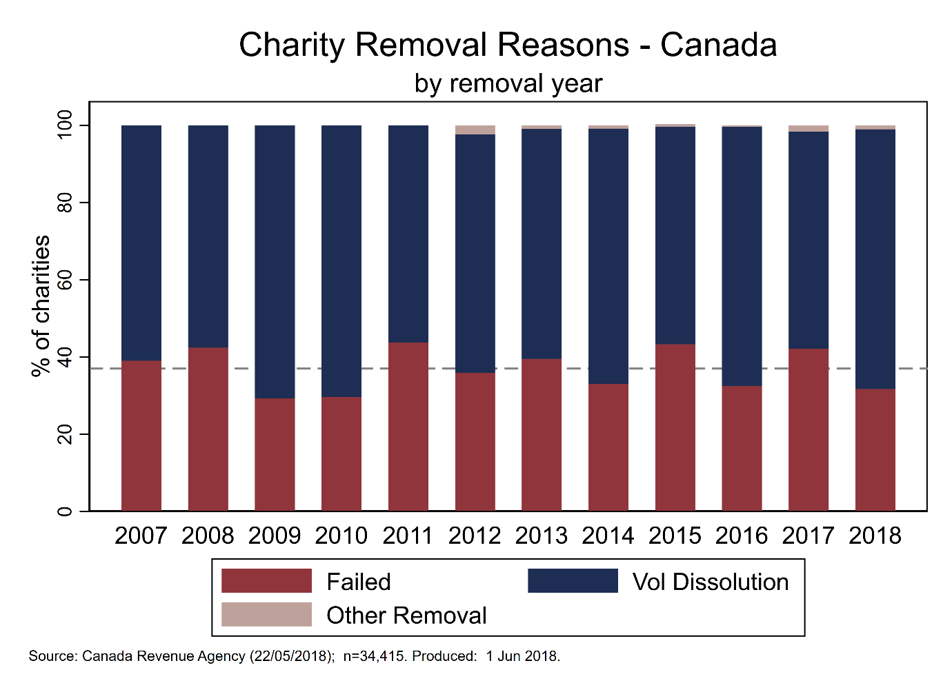

**Figure 2.** England & Wales – Deregistration reasons, by year of deregistration

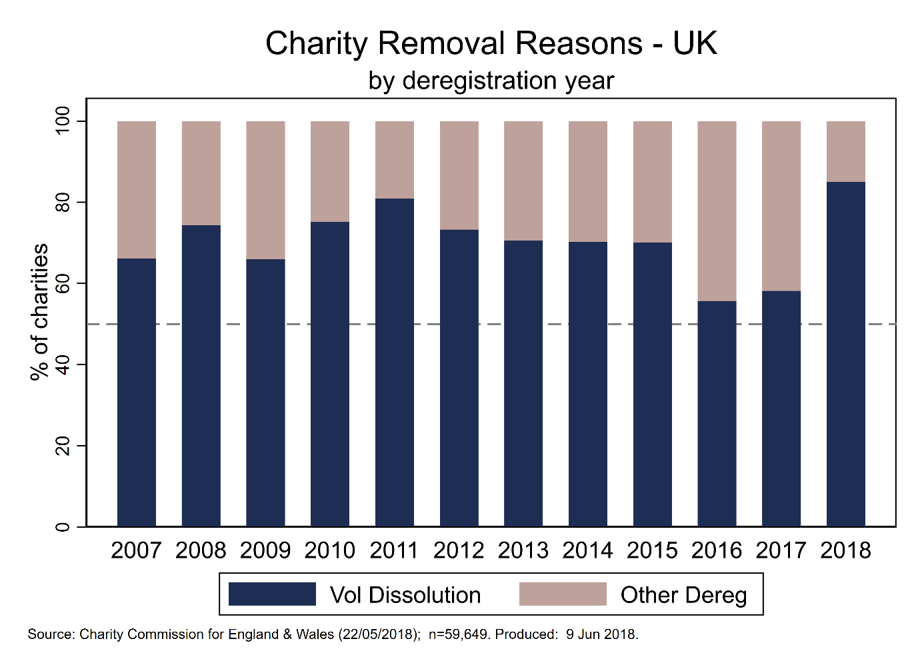

**Figure 3.** New Zealand – Deregistration reasons, by year of deregistration



**5. Conclusion**

This paper summarises emerging work on leveraging large-scale regulatory data to answer important research questions in the field of nonprofit studies. The universe of open data is expanding rapidly, offering scholars the opportunity to study key issues in a comprehensive, granular and cross-national manner. However, these datasets have been underemployed in scholarship and research, one of the main reasons for which is the need for intermediate programming and data analysis skills in order to work productively with the data. The impetus behind this research project, outwith the substantive validity of the topic and research questions, is to address some of these barriers by providing reproducible, well-documented syntax files that enable other researchers to generate their own datasets for analysis.

**Appendices**

**Table A1.** Regulatory Measures of Charity Deregistration

|  |  |  |
| --- | --- | --- |
| Country | Deregistration Type | Description |
| Canada | Annulled | Regulator ends a charity’s registration without revoking it i.e. as if it was never a charity to begin with. It is applied exclusively to charities whose registration was granted in error, and to charities that no longer qualify for registration because of a change in the law. |
| Revoked – Audited | Revoked by regulator for failure to comply with charity law/regulation:  - not devoting your resources to your charitable purposes and activities.  - not keeping adequate books and records.  - not having direction and control over your resources. |
| Revoked – Failure To File | If you do not file a complete return within six months of the end of your fiscal period, we will start the revocation process. |
| Revoked – Other | A variety of other reasons, one example of which is if you have lost your corporate status, your registration may be revoked. |
| Revoked – Voluntary | Can measure:  - you ended your operations because you merged or consolidated with another organization.  - you achieved your goal (for example, you were established to build a playground and you did).  - you no longer have the required financial or physical resources to run your charity. |
| New Zealand | Failed To File | Charities Services removed the charity because they did not file their annual returns despite follow up by Charities Services. [Section 42] |
| Non-compliance | Charities Services has the authority to deregister a charity that:  - no longer meets the requirements for registration;  - has acted in a way that is considered to be "serious wrongdoing";  - has "significantly and persistently" failed to comply with the Act. |
| Request | A charity may also request to be deregistered for the following reason: when Charities Services began compliance action the charity asked to be removed rather than make a submission. [Section 31] |
| Voluntary | A charity may ask to be deregistered at any time and for any reason. For example, a charity may request deregistration if it is winding-up and will cease to exist. [Section 32 (1)(f)] |
| England & Wales | Other | 17 other categories of ‘removed reason’ in the data: amalgamated, excepted, funds transferred, funds spent etc. |
| Failure To File | Not a distinct reason in the data, is captured by the ‘Ceased to exist’ and ‘Does not operate’ reasons. We may be able to make the assumption that charities with missing data for ‘latest_income’ were removed for failure to file. |
| Voluntary – Dissolution | Two reasons, and differences between incorporated and unincorporated:  - Incorporated: ‘Ceased to exist’ means it has dissolved (i.e. struck off Companies House Register), and ‘Does not operate’ means it has not dissolved but is effectively defunct because it has no assets.  - Unincorporated: An unincorporated charity will ‘cease to exist’ once it has no assets whether or not it has actually been legally dissolved. |
| Voluntary – Other | This variable captures voluntary removal from the Register, rather than dissolution, windup, merger etc:  - an exempt charity (which we will remove once identified, without the need for a removal request from the trustees);  - a charity which is for the time being permanently or temporarily excepted by order or regulation of the Commission or the Secretary of State; and complies with any conditions of the exception, and whose gross income does not exceed £100,000;  - a charity whose income does not exceed £5,000 (looks to be the main reason). |

**Table A2.** Charity Commission Data Extracts

|  |  |  |
| --- | --- | --- |
| File | Type | Description |
| extract_charity | Dataset | Gives the main details about each charity (one record per charity). Contains the contact information and address of each charity. |
| extract_registration | Dataset | Details of the date that charities were registered and removed, along with a code representing the reason for removal. Codes can be looked up from *extract_remove_ref* file. Note that some charities have more than one entry in this table, if (for example) they were removed in error and then reregistered. |
| extract_name | Dataset | Contains a record of any name the charity has informed the Charity Commission that it works under. This includes: former names that are no longer used, alternative names, acronyms and abbreviations, and names of subsidiary or merged organisations. |
| extract_class | Dataset | Contains a record of each classification category associated with a charity. Categories cover three broad areas: theme (eg health or education); activity (eg providing services, providing health); and beneficiaries (eg older people, animals). Each charity can have multiple categories across these three areas, and there is no "primary" value available. |
| extract_trustee | Dataset | Contains the name of the trustees associated with each charity. |
| extract_objects | Dataset | Contains the charitable objects of a charity. The objects are split into text strings, and there are multiple rows for each charity depending on how long their objects are. The objects then have to be concatenated to produce the full objects. |
| extract_charity_aoo | Dataset | Contains structured geographical data relating to the areas in which the charity operates. Most of the codes relate to common geographical aras, such as Local Authorities, or countries, but there are some additional codes such as "Throughout England and Wales" or "Throughout Greater London". |
| extract_ar_submit | Dataset | Contains details of when the charity's annual returns were submitted. |
| extract_main_charity | Dataset | Contains one record for every main registered charity (but doesn't include removed or subsidiary charities). This contains additional details such as their website, email address and company number. |
| extract_acct_submit | Dataset | Contains a record of when the charity's accounts were submitted. |
| extract_financial | Dataset | Contains a row for each year for each charity, showing what its income and expenditure was. Tends to only include the last five years or so. |
| extract_partb | Dataset | Contains a row for each year for each charity, with more detailed financial information. Charities only have to fill in this information if their income is greater than £500,000 in that year. |
| extract_class_ref | Reference list | Lookup reference for the Charity Commission classification scheme, used in the *extract_class* file. |
| extract_remove_ref | Reference list | Lookup reference for codes used to indicate the reasons why a charity has been removed from the register of charities, used in the *extract_registration* file. |
| extract_aoo_ref | Reference list | Lookup reference for codes used in the *extract_charity_aoo* file. |

Source: <https://github.com/ncvo/charity-commission-extract/blob/master/beginners-guide.md>

**Table A3.** Charities Services Open Data

|  |  |  |
| --- | --- | --- |
| File | Type | Description |
| Activities | Reference list | Lookup reference for codes used to identify the activities a charity undertakes. |
| AnnualReturns | Dataset | Contains one record for every annual return filed by a charity. |
| AreaOfOperations | Reference list | Lookup reference for codes used to identify the geographical areas a charity operates in. |
| Beneficiaries | Reference list | Lookup reference for codes used to identify a charity’s beneficiaries. |
| Groups | Dataset | Contains one record for every charity allowed to file group annual returns. |
| GrpOrgAllReturns | Dataset | Contains one record for every annual return filed by a charity. |
| GrpOrgLatestReturns | Dataset | Contains one record for the most recent annual return filed by a charity. |
| Officers | Dataset | Contains one record for every person that has been a trustee of a charity. |
| Organisations | Dataset | Contains one record for every charity, registered and deregistered. |
| Sectors | Reference list | Lookup reference for codes used to identify the sector in which a charity operates. |
| SourceOfFunds | Reference list | Lookup reference for codes used to identify a charity’s source(s) of funds. |
| vOfficerOrganisations | Dataset | Contains one record for every person that has been a trustee of a charity, linked to that charity’s organisational information. |
| vOrganisations | Dataset | Contains one record for every charity, linked to the information contained in the Activities, Beneficiaries and Sectors reference lists. |

Note: Charities Services does not provide a description of what each file contains, therefore the content of the *Description* field is our own judgement. As a result we are still unsure of how to accurately define the contents of some of the files; we plan on contacting the regulator to get further information.  
Source: <https://www.charities.govt.nz/assets/Resouces/data-dictionary.csv>

**Table A4.** Canada Revenue Agency Open Data

|  |  |  |
| --- | --- | --- |
| File | Type | Description |
| Charities Listing | Dataset | Contains one record for every charity, registered and deregistered. |
| Quick View | Dataset | Contains one record for every annual return submitted by a charity – summary. |
| Full View | Dataset | Contains one record for every annual return submitted by a charity – full details. |

Source: <https://www.charities.govt.nz/assets/Resouces/data-dictionary.csv>

1. Failure to file and other reasons leading to statutory deregistration by the regulator are not present in the data.
2. The SIR data is due to be discontinued by the Charity Commission and is not needed for analyses of the England & Wales charity sector.
3. The complete data dictionary is documented on the Charity Commission’s data portal: <http://data.charitycommission.gov.uk/data-definition.aspx>.
4. Note that not all charities have to register with the regulator, similar to the case in England & Wales.
5. Note that there is insufficient detail on the regulator’s website or in the data dictionary to fully understand what each of these 13 datasets contain; we plan on contacting Charities Services in order to better understand the data they make available.