**Mission Accomplished? A Cross-national Examination of Charity Dissolution**

Diarmuid McDonnell1, Alasdair Rutherford2 and Carolyn Cordery3

*Prepared for the Association for Research on Nonprofit Organizations and Voluntary Action 2019 Annual Conference*

1. Research Fellow. Third Sector Research Center, School of Social Policy, University of Birmingham, UK (d.mcdonnell.1@bham.ac.uk).

2. Professor of Social Statistics. Faculty of Social Sciences, Colin Bell Building, University of Stirling, UK.

3. Professor of Accounting. Department of Accounting, Aston Business School, UK.

**Abstract**

Encouraged by ‘open data’ movements, regulators have made it increasingly straightforward for stakeholders to access large-scale data about charities and their regulation. This research leverages some of these data resources to examine a topic of considerable public and regulatory importance: charity dissolution, including mission accomplishment. The charity sector's claim to exist for the public good is no longer assumed and must be evidenced, however little is known about the extent to which charities accomplish their missions. In this paper we describe continuing work to collect, clean, harmonise and analyse international data on charity dissolution. In doing so we identify real opportunities for interdisciplinary collaboration, combining accounting, social policy, law and data science in order to address important questions in novel ways.

Keywords: charity success, big data, open data, nonprofit dissolution

**Introduction**

Nonprofit and specifically charity regulation is in flux. Stagnant or declining regulator budgets are the new normal and charities themselves are subject to increasing levels of public scrutiny. To meet these and other challenges, many regulators are shifting to an approach informed by risk assessment and analysis (McDonnell & Rutherford, 2018). This requires regulators to leverage their considerable data resources to better target their interventionist and advisory activities, and deliver their mandate. Until recently, relatively little nonprofit regulatory data was shared beyond lists of registered charities. Encouraged by increasing ‘open data’ movements, regulators have made it increasingly easier for stakeholders to access a range of both quantitative and qualitative data about charities and their regulation on a large scale. New nonprofit regulators are being formed, or reformed, and decisions are being taken about what data to collect, and how to use it (Cordery & Deguchi, 2018). This paper describes ongoing work to leverage some of these data resources to examine a topic of considerable public and regulatory importance: charity dissolution due to mission accomplishment. There are many reasons charities cease operating (e.g. insufficient funds, non-compliance with legal requirements, mission completion), and this study provides a much-needed granular account of this outcome. Given the increasing scrutiny on charitable organisations in many jurisdictions and the importance of public confidence to their sustainability (Breen, 2009; Keating & Frumkin, 2003), research on this topic has the potential to make a significant contribution to the evidence base on charity success and failure, benefiting a variety of stakeholders including those with responsibility for monitoring the sector (Saxton, Kuo & Ho, 2012).

In this paper we report our initial work to collect, clean and analyse large-scale regulatory data to advance the study of charity dissolution. We aim to achieve this in two ways: operationalising dissolution in a granular manner and thus identifying charities that achieved their mission; and applying key theoretical frameworks to under-researched contexts (e.g. Oceania). We provide a repository of well-documented syntax files that researchers can use to reproduce the work undertaken in this project, and to generate their own datasets for analysis. The paper proceeds as follows. The next section describes the study site: the New Zealand charity sector. Then we review scholarship on charity success and failure, revealing the empirical gap in our understanding of dissolution, especially mission accomplishment. Next we describe the methodology underpinning the research, in particular focusing on the key issues of defining and measuring the dependent variable, and the data collection process. We present some preliminary findings, and reflect on the advantages and disadvantages of employing large-scale regulatory data to study this outcome. We conclude by outlining our plans for developing this research.

**New Zealand Charity Regulation and Reporting**

The charity regulator in New Zealand began in mid-2007, having been established under the Charities Act 2005. While it began as an Autonomous Crown Entity, since 2012, it has been situated within a large government department (Cordery & Deguchi, 2018). Charities have always been required to report annually to retain their registration and this includes details of the sector, main beneficiaries, updated list of officers/trustees and financial reporting. No specific financial accounting standards had been developed and therefore charity reporting was previously highly diverse. From 2009-2011, accounting requirements for the public and private sectors were overhauled owing to a need for a more strategic approach to reporting and the new arrangements included a full set of standards for the charity sector (with increasing levels of measurement and disclosure based on four different tiers related to annual expenditure); these new charity accounting standards were mandatory for all charities from 2016. Charities with expenditure over NZD1 million must have these statements audited (Crawford, Morgan, Cordery, Breen, Sheikh, Suyanto & Yekini, 2014). For charities with expenditure of less than NZD2 million, in addition to financial data, they must also provide performance information about the difference they make by operating, i.e. how they have achieved (or otherwise) their mission. Such reporting will also be required of larger charities from 2021 (McConville & Cordery, 2018).

**Understanding Charity Dissolution**

**Conceptual challenges**

Defining charity success and failure has proved problematic for researchers (Lecy, Schmitz & Swedlund, 2011). There are various conceptualisations of the latter including resource reduction, market exit, and mortality (Helmig, Ingerfurth & Pinz, 2014; Mellahi & Wilkinson, 2004). However, many of these constructs contain inconsistencies and contradictions. For example, organisational dissolution may indicate success rather than failure in cases where the charity accomplished its mission (Helmig et al., 2014; see also Hager, Galaskiewicz, Bielefeld & Pins, 1996). On the other hand, charity success is easier to conceptualise but poorly understood for a number of reasons (Helmig et al., 2014). Extant studies have focused on a limited number of subsectors such as Social Service organisations (Helmig et al., 2014); used observations from small regional study sites (e.g. Wollebaek, 2010); and covered short time periods (e.g. Hager et al., 1996). The most difficult issue has been to unambiguously measure mission accomplishment - those charities that voluntarily cease to exist due to achieving their stated mission - and differentiate it from other forms of dissolution such as organisational wind-up, statutory revocation of charity status due to misconduct, and other forms of ‘mortality’ e.g. amalgamation.

**Theoretical perspectives**

There are two core theories that are commonly applied to the study of the causes of charity dissolution (Fernandez, 2008): resource dependence and population ecology.[1]

*Resource dependence*

Resource dependencetheory contends that organisations and their environments are interdependent, in particular regarding resource acquisition (Pfeffer & Salancik, 2003). This interdependence has positive consequences in the form of offering organisations opportunities to acquire resources from a broad range of other entities in the environment; the negative implications centre on the potential for an organisation to become liable to the suppliers of its resources. In relation to the topic at hand, an organisation’s survival prospects hinge on being able to acquire and maintain resources (Pfeffer & Salancik, 2003). The distribution of dependence (or power) across an organisation’s relationships is a salient factor in its chances of survival: “organizations with a concentrated external dependence may face more discontinuities in the inflow of resources and may attain worse bargaining positions.” (Fernandez, 2008, p. 117) Therefore, resource dependence theory predicts that organisations that secure their resources from a diverse range of entities have lower prospects of dissolution. The logic of revenue diversification is simple and compelling: it hedges against uncertainty and instability in the organisation’s operating environment (Hung & Hager, 2019). However, a nuanced perspective is needed, as new and enhanced risks accompany the greater rewards associated with diversification (Froelich, 1990; Frumkin & Keating, 2011). Recent meta-analyses suggest that revenue diversification has, at best, a small, positive association with nonprofit financial health (Hung & Hager, 2019; Lu, Lin & Wang, 2019). We test whether this is the case by stating the following:

Hypothesis 1: Charities that rely on more diversified revenue portfolios are less likely to dissolve.

It is also important to consider the nature and source, not just the diversity, of an organisation’s resource base. A new source of revenue can be bring additional complexity, cost, dependence and risk, and lead to mission drift (Frumkin & Keating, 2011; Hung & Hager, 2019). Nonprofits are often differentiated in the literature using Hansmann’s (1980) classification: an organisation is classed as donative if it derives a majority of its income from donations or grants, and commercial if the majority comes from charging fees. This bifurcation, though limited, has been employed productively in various empirical studies (Lu, Shon & Zhang, 2019; Teasdale, Kerlin, Young, & Soh, 2013). The extant literature has failed to reach a consensus on the sign of the association between this factor and dissolution (Lu, Lin & Wang, 2019), therefore we specify the following hypothesis:

Hypothesis 2: Charities reliant on donations have different likelihoods of dissolution than commercial charities.

Our final resource dependence factor concerns the main source of a charity’s funds, specifically from government.

Hypothesis 3: Charities whose main source of revenue is from government have different likelihoods of dissolution.

*Population ecology*

Population ecology theory contends that an organisation’s demographic (e.g. age and size) and ecological (e.g. field of activity, area/market density) characteristics influence its survival prospects (Baum & Singh, 1994; Bielefeld, 1994; Hannan & Freeman, 1977). In essence, in a dynamic environment characterized by inter-organizational competition, less-fit organizations are selected out by environmental pressures, with only the fittest organizations surviving (Hannan & Freeman, 1989). There are a number of hypotheses within the broader framework of population ecology theory that have been empirically tested in relation to nonprofit dissolution. The liability of newness posits that younger organisations have higher likelihoods of dissolution, possibly due to a lack of social connections, absence of defined roles within the organisation, costs associated with establishing operating procedures, and reliance on entities that poorly known/unknown to the organisation (Stinchcombe, 1965). In a similar vein, the liability of smallness hypothesis claims that smaller organisations (often defined in terms of total income, expenditure, assets or staff) are at greater risk of dissolution (Freeman & Hannan, 1983). The empirical literature largely corroborates these hypotheses (e.g. Bielefeld 1994; Lu et al., 2019a; Twombly, 2003). This leads us to our next set of hypotheses:

Hypothesis 4: Younger charities are more likely to dissolve than older organisations

Hypothesis 5: Smaller charities have a higher likelihood of dissolution.

Another factor confirmed as salient for understanding dissolution is organisational niche, usually measured as the density of organisations in a field of activity (e.g. housing, social services) or geographic location (e.g. city, local authority, region), thus:[2]

Hypothesis 6: The likelihood of dissolution has a non-linear association with the level of organisational density in a charity’s geographic location.

There are two additional organisational characteristics that we consider congruent with population ecology theory:

Hypothesis 7: The likelihood of dissolution varies across fields of activity (e.g. education, health) and beneficiary groups served (e.g. children and young people).

**Methodology**

The research objectives are: to explore the extent to which large-scale regulatory data can be used to differentiate between different types of charity dissolution, paying particular attention to whether mission completion can be identified; to examine cross-national trends and predictive factors around charity dissolution; and to provide evidence and guidance for charity regulators seeking to target their activities with respect to this outcome.

While the wider project incorporates data from multiple jurisdictions, in this paper we focus on New Zealand. This jurisdiction is of interest for a number of reasons: the extant literature is US-centric and New Zealand represents an interesting new field of study for this topic (the regulator was established in 2007); the data are publicly available; and a synoptic review of the data suggested that dissolution can be measured in a granular manner.

**Data**

Using data science approaches, we construct a cross-sectional data set of registered charities by downloading and linking multiple data files from the New Zealand regulator’s online database (see the technical notes in Appendix A for details of this process). First, our primary data source is the register of charities, a census of all organisations (c. 37,000) that have at some point been registered with the New Zealand regulator as of 20th of August, 2019). This file contains core information such as charity name and registration number, registration status, organisational type, street address etc. Second, we link to information on a charity’s main sector, source of funds and activities, as well as areas of operation and number of trustees (which all exist as separate data files). Third, we construct a panel data set of annual returns filed by a subset of these charities (c. 32,000 submitting c. 190,000 returns over the period 2007-2019) and operationalise a number of summary measures in order to test our hypotheses (e.g. average annual gross income, average degree of revenue diversification); we then link this information to the cross-sectional register of charities via a charity’ unique registration number.

**Sample Building**

Our initial data, drawn from the register of charities, comprised of 37,903 observations for the same number of organisations. For data cleaning, we first excluded charities for which we could not identify dissolution type. Second, we drop observations for charities that never filed an annual return with the regulator; while this results in a moderate drop in sample size (c. 5,000 organisations), it is necessary as many of the independent variables are derived from annual returns data. Finally, we drop observations for which there is missing or clearly erroneous data for the independent variables (e.g. negative annual gross income). The final sample is composed of 29,458observations for the same number of charities.

**Variables**

*Dependent variable*

We define dissolution as the state of being deregistered with the New Zealand charity regulator: this includes organisations that continue to exist but voluntarily revoked their charity status, charities that have had their status removed for non-compliance with regulatory requirements, organisations that have merged or amalgamated with other charities etc. Within this conceptualisation we define mission completion as a charity that was voluntarily dissolved i.e. an organisation that no longer possesses charity status and no longer operates in any other organisational form. This is a limited but necessary operationalisation due to the available data. Therefore, we specify two dependent variables for New Zealand. The first is a binary measure of whether a charity is no longer registered with the regulator; this is defined as a charity whose status is recorded as ‘Deregistered’ on the public register of charities. The second is a multinomial measure of dissolution, where we disaggregate deregistered charities by type of dissolution. We identify dissolution by using regular expressions to extract the section of the Charities Act 2005 an organisation was deregistered under from the relevant field in the data file. For example, “This entity was removed from the Charities Register under section 32(1)(b) of the Charities Act because it failed to file Annual Returns as required by section 41 of the Charities Act.” is coded as “Failed to file”. Table 1 describes our two dependent variables.

**Table 1.** Dependent Variables - Operationalisation

|  |  |  |
| --- | --- | --- |
| Concept | Variable | Operationalisation |
| Dissolution | `deregistered` | Binary measure of the current status of a charity:  0 = Registered  1 = Deregistered |
|  |  |  |
| Dissolution type | `orgdiss` | Multinomial measure of a charity’s dissolution type:  0 = Registered  1 = Failed to file  2 = Voluntary removal  3 = Wound up |

Note: there are other types of dissolution (e.g. mergers) that occur very infrequently (c. 200 observations) and thus are recoded as missing data for the purposes of statistical modelling.

*Independent variables*

The first set of independent variables are drawn from population ecology theory and measure an organisation’s capacity and niche operating environment. *Size* is a log transformation of a charity’s mean annual gross income. *Age* is binary measure of the number of years a charity has been registered with the regulator (we are unable to tell when an organisation was founded): 1 = charities registered post-2010, 0 = charities registered pre-2010. *Type* is a categorical measure of a charity’s legal form: “standard”, “society or institution”, and “trustees of a trust” are the three valid values for this variable.[3] *Education* is a dummy variable capturing an organisation’s field of activity: 1 = charities operating in the education sector, 0 = charities operating in one of eighteen other sectors. *CYP* is a binary indicator of whether a charity’s primary beneficiary group is children and young people.

The second set of variables correspond to our resource dependence hypotheses. *Donations* is a binary indicator of whether a majority share of a charity’s annual gross income is derived from donations (on average). *Government* is also a binary measure, identifying charities whose main source of funding is the state.

Finally, we include a set of control variables that measure the mean number of employees a charity has, the mean number of volunteers engaging with the organisation per week, the total number of trustees (i.e. the sum of those currently and formerly serving), and the geographic scope of operations (i.e. local, national, international).

**Empirical Model**

We are interested not only in whether a charity experiences dissolution, but which type of dissolution occurred. As our first dependent variable - whether a charity has dissolved or not - has two mutually exclusive and exhaustive outcomes, we specify a logistic regression model with robust standard errors. Our second dependent variable – dissolution type – has multiple exclusive and exhaustive outcomes and thus we specify a multinomial logistic regression with robust standard errors. We model both dependent variables as the probability of a charity experiencing a given outcome as a function of organisational size, age, and type, field of activity, main beneficiary group served, geographic scale of operations, whether it derives a majority of its income from private donations, whether government is its main source of revenue, average number of employees and volunteers, and total number of trustees.

**Results**

**Descriptive Statistics**

Sample statistics are presented in table 2.

**Table 2.** Summary statistics for sample included in statistical models

|  |  |  |  |  |  |  |  |  |  |  |  |  |
| --- | --- | --- | --- | --- | --- | --- | --- | --- | --- | --- | --- | --- |
|  |  | Registered | |  | Failed to file | |  | Voluntary removal | |  | Wound up | |
| Variable |  | M | SD |  | M | SD |  | M | SD |  | M | SD |
| Size |  | 10.68 | 2.49 |  | 8.94 | 3.57 |  | 8.20 | 4.27 |  | 9.24 | 3.12 |
| Age (%) |  |  |  |  |  |  |  |  |  |  |  |  |
|  | Registered early | 52 | - |  | 12 | - |  | 0 | - |  | 20 | - |
|  | Registered recently | 48 | - |  | 88 | - |  | 100 | - |  | 80 | - |
| Type (%) |  |  |  |  |  |  |  |  |  |  |  |  |
|  | Standard charity | 97 | - |  | 18 | - |  | 2 | - |  | 31 | - |
|  | Society or institution | 1 | - |  | 32 | - |  | 47 | - |  | 24 | - |
|  | Trustees of a trust | 1 | - |  | 50 | - |  | 51 | - |  | 45 | - |
| Education (%) |  | 21 | - |  | 22 | - |  | 21 | - |  | 22 | - |
| CYP (%) |  | 22 | - |  | 27 | - |  | 20 | - |  | 22 | - |
| Donations (%) |  | 39 | - |  | 22 | - |  | 20 | - |  | 21 | - |
| Government (%) |  | 31 | - |  | 43 | - |  | 32 | - |  | 30 | - |
| Employees |  | 3.44 | 63.60 |  | 0.88 | 6.34 |  | 3.83 | 99.69 |  | 0.85 | 4.04 |
| Volunteers |  | 10.10 | 87.70 |  | 7.13 | 44.12 |  | 6.53 | 16.07 |  | 4.71 | 18.85 |
| Trustees |  | 12.02 | 10.11 |  | 6.69 | 4.96 |  | 6.13 | 5.11 |  | 6.91 | 5.91 |
| Area of Operation (%) |  |  |  |  |  |  |  |  |  |  |  |  |
|  | Local | 73 | - |  | 75 | - |  | 68 | - |  | 68 | - |
|  | National | 22 | - |  | 20 | - |  | 23 | - |  | 26 | - |
|  | International | 5 | - |  | 5 | - |  | 9 | - |  | 6 | - |

Note: percentages rounded to the nearest whole number, means and standard deviations rounded to two decimal places. Column percentages and figures are displayed and may not sum to 100 due to rounding.

Figure 1 below displays the trends in the cumulative number of dissolutions by type. The failure to file outcome shows a step trend, understandable given a charity must fail to submit two consecutive annual returns before being removed from the register. The lack of occurrences for each outcome prior to 2010 are likely a function of data capture limitations on the part of the regulator as opposed to evidence of absence.

**Figure 1.** Cumulative Number of Dissolutions, By Year and Type

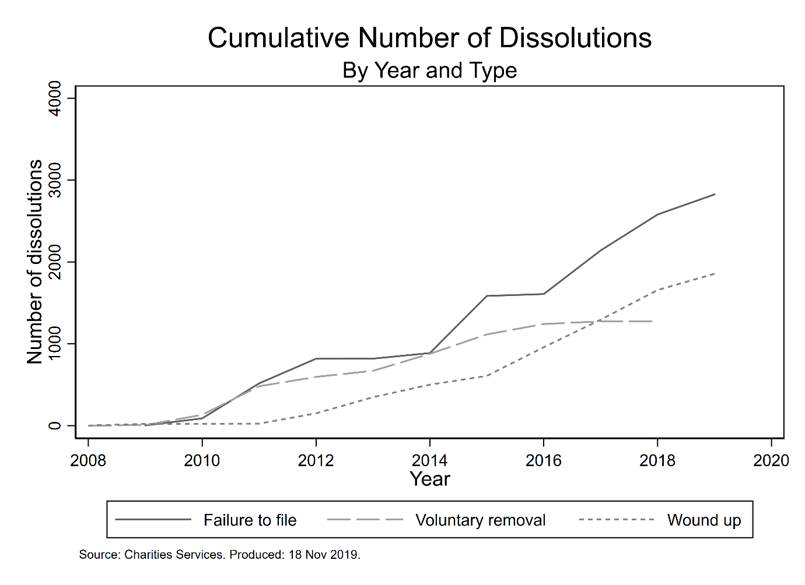

**Statistical Modelling**

We now present the results of two statistical models, one for each dependent variable. The presence of multicollinearity among the independent variables in the models was examined by calculating the variance inflation factors (VIF): mean VIF is 1.14 and no variable has a VIF greater than 1.23, below the threshold at which Allison (1999) suggests multicollinearity is problematic. We report log odds, robust standard errors, confidence intervals and a range of model fit statistics (see Connolly, Gayle & Lambert, 2016).

Table 3 reports the results of the logistic regression on whether a charity is dissolved or not. We focus first on our population ecology variables. An increase in organisation size is associated with a decrease in the odds of dissolution, while an increase in age is correlated with an increase in the odds. Compared to standard charities, both other organisational types have higher odds of experiencing dissolution. Both resource dependence measures are statistically significant: having government as a main source of revenue is associated with higher odds of experiencing dissolution, while deriving a majority of income from donations is correlated with lower odds. Finally, the control variables are not associated with the outcome, with the exception of total number of trustees, where there is some evidence that larger boards decreases the odds of becoming dissolved.

**Table 3.** Results of Logistic Regression on Outcome of Dissolution

|  |  |  |  |  |  |
| --- | --- | --- | --- | --- | --- |
|  |  |  |  | 95% CI | |
|  |  | Log odds | SE | Lower | Upper |
| *Population Ecology* |  |  |  |  |  |
| Size |  | -0.17*** | 0.01 | -0.19 | -0.15 |
| Age |  | 0.06*** | 0.01 | 0.05 | 0.08 |
| Type |  |  |  |  |  |
|  | Standard charity | Ref. | – | – | – |
|  | Society or institution | 5.02*** | 0.08 | 4.87 | 5.17 |
|  | Trustees of a trust | 5.26*** | 0.08 | 5.10 | 5.42 |
| Education |  | -0.19** | 0.07 | -0.33 | -0.06 |
| CYP |  | 0.07 | 0.06 | -0.06 | 0.19 |
| *Resource Dependence* |  |  |  |  |  |
| Donations |  | -0.23*** | 0.06 | -0.34 | -0.12 |
| Government |  | 0.37*** | 0.05 | 0.27 | 0.47 |
| *Controls* |  |  |  |  |  |
| Employees |  | 0.00* | 0.00 | 0.00 | 0.00 |
| Volunteers |  | 0.00 | 0.00 | 0.00 | 0.00 |
| Trustees |  | -0.05*** | 0.00 | -0.06 | -0.05 |
| Area of Operation |  |  |  |  |  |
|  | Local | Ref. | – | – | – |
|  | National | 0.07 | 0.06 | -0.04 | 0.18 |
|  | International | -0.01 | 0.10 | -0.21 | 0.20 |
| *n* |  | 29,458 | |  |  |
| McFadden’s adjusted R2 |  | 0.56 | |  |  |
| McKelvey and Zavoina’s R2 |  | 0.60 | |  |  |
| Cragg and Uhler’s R2 |  | 0.67 | |  |  |
| BIC full model |  | 14,536.67 | |  |  |

Note: Figures rounded to two decimal places. Constant is omitted. CYP: Children and Young People. SE: robust standard errors; CI: confidence interval; Ref.: reference category; BIC: Bayesian Information Criterion. The organisation type variable is statistically significant overall. *p < .05. **p < .01. ***p < .001.

We now consider our multinomial model of dissolution, where we are interested in whether the effects identified above vary significantly by type of dissolution. Figure 2 and Table 4 present the results of the multinomial regression. There is clear variation in the magnitude, and often sign, of the predictors across categories of dissolution. For example, the coefficient for operating internationally is positive for the outcome of voluntary removal, negative for the outcome of failure to file, and statistically significantly indistinguishable from zero for the outcome of winding up. Contrast this with the coefficient for this variable in the logistic regression model, which estimates a negligible effect for the outcome of deregistration.

**Figure 2.** Regression Coefficients of Independent Variables, By Dissolution Type

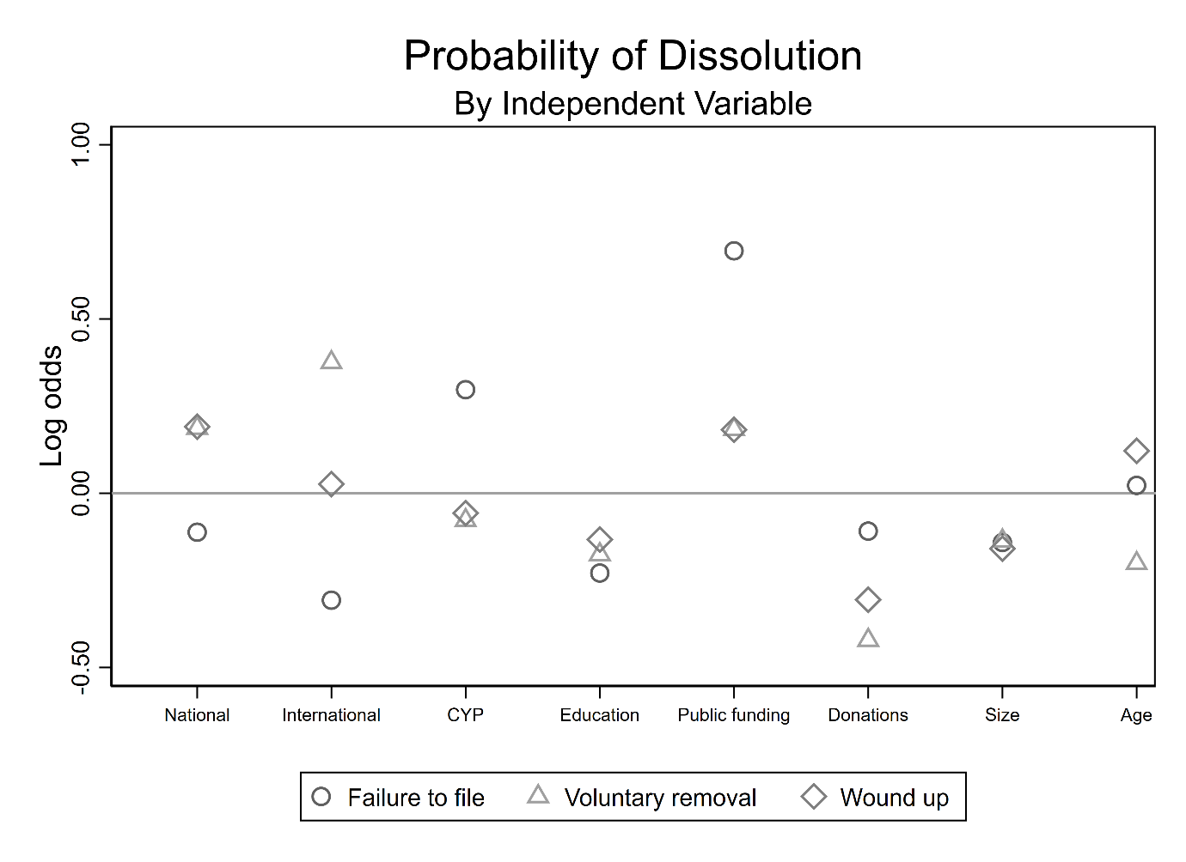

**Table 4.** Results of Multinomial Regression on Outcome of Dissolution Type

|  |  |  |  |  |  |  |  |  |  |
| --- | --- | --- | --- | --- | --- | --- | --- | --- | --- |
|  |  | Failed to file | |  | Voluntary removal | |  | Wound up | |
|  |  | Log odds | SE |  | Log odds | SE |  | Log odds | SE |
| *Population Ecology* |  |  |  |  |  |  |  |  |  |
| Size |  | -0.14*** | 0.01 |  | -0.14*** | 0.02 |  | -0.16*** | 0.01 |
| Age |  | 0.02* | 0.01 |  | -0.20*** | 0.02 |  | 0.12*** | 0.01 |
| Type |  |  |  |  |  |  |  |  |  |
|  | Standard charity | Ref. | – |  | Ref. | – |  | Ref. | – |
|  | Society or institution | 4.56*** | 0.08 |  | 7.31*** | 0.24 |  | 4.18*** | 0.09 |
|  | Trustees of a trust | 4.77*** | 0.08 |  | 7.43*** | 0.24 |  | 4.75*** | 0.09 |
| Education |  | -0.23** | 0.08 |  | -0.18 | 0.10 |  | 0.13 | 0.08 |
| CYP |  | 0.30*** | 0.07 |  | -0.08 | 0.10 |  | 0.06 | 0.08 |
| *Resource Dependence* |  |  |  |  |  |  |  |  |  |
| Donations |  | -0.11 | 0.07 |  | -0.42*** | 0.10 |  | 0.31*** | 0.07 |
| Government |  | 0.70*** | 0.06 |  | 0.18* | 0.08 |  | 0.18** | 0.06 |
| *Controls* |  |  |  |  |  |  |  |  |  |
| Employees |  | -0.01 | 0.01 |  | 0.00*** | 0.00 |  | 0.00 | 0.00 |
| Volunteers |  | 0.00 | 0.00 |  | 0.00 | 0.00 |  | 0.00 | 0.00 |
| Trustees |  | -0.07*** | 0.00 |  | -0.07*** | 0.01 |  | 0.08*** | 0.01 |
| Area of Operation |  |  |  |  |  |  |  |  |  |
|  | Local | Ref. | – |  | Ref. | – |  | Ref. | – |
|  | National | -0.11 | 0.07 |  | 0.19* | 0.09 |  | 0.19** | 0.07 |
|  | International | -0.31* | 0.13 |  | 0.38* | 0.15 |  | 0.03 | 0.14 |
| *n* |  | 29,458 | | | | | | | |
| McFadden’s adjusted R2 |  | 0.42 | | | | | | | |
| Cox-Snell R2 |  | 0.46 | | | | | | | |
| Cragg and Uhler’s R2 |  | 0.60 | | | | | | | |
| BIC full model |  | 26320.26 | | | | | | | |

Note: Figures rounded to two decimal places. Constant is omitted. SE: robust standard errors; CI: confidence interval; Ref.: reference category; BIC: Information Criterion. The organisation type and area of operation variables are statistically significant overall. *p < .05. **p < .01. ***p < .001.

**Conclusion**

This paper summarises emerging work on leveraging large-scale regulatory data to answer important research questions in the field of nonprofit studies. The universe of open data is expanding rapidly, offering scholars the opportunity to study key issues in a comprehensive, granular and cross-national manner. However, these datasets have been underemployed in scholarship and research, one of the main reasons for which is the need for intermediate programming and data analysis skills in order to work productively with the data. The impetus behind this research project, outwith the substantive validity of the topic and research questions, is to address some of these barriers by providing reproducible, well-documented and publicly available syntax files that enable other researchers to generate their own datasets for analysis.

By using detailed measures of charity dissolution recorded in large-scale regulatory datasets, this research project responds to the call for greater focus on mission accomplishment as an outcome in nonprofit scholarship (Helmig et al., 2014). Our work has the potential to provide much-needed granularity and clarity to the various ways charities cease their activities, in particular by identifying those organisations that dissolve as a result of accomplishing their mission. Identifying the patterns and explanatory factors associated with charity dissolution can underpin public understanding of the sector, inform the allocation of funds by donors and government, and guide the activities and interventions of regulators.

**References**

Baum, J. A. C., & Singh, J. V. (1994). Organizational niches and the dynamics of organizational mortality. *American Journal of Sociology, 100*, 346-380.

Bielefeld, W. (1994). What affects nonprofit survival? *Nonprofit Management and Leadership, 5*, 19-36.

Breen, O. (2009). Cross Border Issues in the Regulation of Charities: Experiences from the UK and Ireland. *International Journal of Not-for-Profit Law, 11*, 5-41.

Cordery, C., & Deguchi, M. (2018). Charity registration and reporting: a cross-jurisdictional and theoretical analysis of regulatory impact. *Public Management Review, 20*, 1332-1352.

Crawford, L., Morgan, G. G., Cordery, C., Breen, O., Sheikh, F., Suyanto, S., & Yekini, L. (2014). *International financial reporting for the not-for-profit sector*. London: CCAB.

Fernandez, J. J. (2008). Causes of dissolution among Spanish nonprofit associations. *Nonprofit and Voluntary Sector Quarterly, 37*, 113–137.

Freeman, J., & Hannan, M. T. (1983). Niche width and the dynamics of organizational populations. *American Journal of Sociology, 88*, 1116-1145.

Froelich, K. A. (1999). Diversification of revenue strategies: Evolving resource dependence in nonprofit organizations. *Nonprofit and Voluntary Sector Quarterly, 28*, 246-268.

Frumkin, P., & Keating, E. K. (2011). Diversification reconsidered: The risks and rewards of revenue concentration. *Journal of Social Entrepreneurship, 2*, 151-164.

Hager, M. A., Galaskiewicz, J., Bielefeld, W., & Pins, J. J. (1996). Tales from the grave: Organizations’ accounts of their own demise. *American Behavioral Scientist, 39*, 975-994.

Hannan, M. T., & Freeman, J. (1977). The population ecology of organizations. *American Journal of Sociology, 82*, 929-964.

Hannan, M. T., & Freeman, J. (1989). *Organizational ecology*. Cambridge: Harvard University Press.

Helmig, B., Ingerfurth, S., & Pinz, A. (2014). Success and Failure of Nonprofit Organizations: Theoretical Foundations, Empirical Evidence, and Future Research. *Voluntas: International Journal of Voluntary and Nonprofit Organizations, 25*, 1509-1538.

Hung, C. K., & Hager, M. A. (2019). The Impact of Revenue Diversification on Nonprofit Financial Health: A Meta-analysis. *Nonprofit and Voluntary Sector Quarterly*, https://doi.org/10.1177/0899764018807080.

Keating, E. K., & Frumkin, P. (2003). Reengineering Nonprofit Financial Accountability: Toward a More Reliable Foundation for Regulation. *Public Administration Review, 63*, 3-15.

Lecy, J. D., Schmitz, H. P., & Swedlund, H. (2011). Non-governmental and not-for-profit organizational effectiveness: A modern synthesis. *Voluntas: International Journal of Voluntary and Nonprofit Organizations, 23*, 434-457.

Lu, J., Lin, W., & Wang, Q. (2019). Does a more diversified revenue structure lead to greater financial capacity and less vulnerability in nonprofit organizations? A bibliometric and meta-analysis. *Voluntas: International Journal of Voluntary and Nonprofit Organizations, 30*, 593-609.

Lu, J., Shon, J., & Zhang, P. (2019). Understanding the Dissolution of Nonprofit Organizations: A Financial Management Perspective. *Nonprofit and Voluntary Sector Quarterly,* https://doi.org/10.1177/0899764019872006.

McConville, D., & Cordery, C. (2018). Charity performance reporting, regulatory approaches and standard-setting. *Journal of Accounting and Public Policy, 37*, 300-314.

McDonnell, D., & Rutherford, A. C. (2018). Promoting Charity Accountability: Understanding Disclosure of Serious Incidents. <https://doi.org/10.1016/j.accfor.2018.05.003>.

Mellahi, K., & Wilkinson, A. (2004). Organizational failure: A critique of recent research and a proposed integrative framework. *International Journal of Management Reviews, 5/6*, 21-41.

Pfeffer, J., & Salancik, G. R. (2003). *The external control of organizations: A resource dependence perspective* (2nd ed.). New York: Harper & Row.

Saxton, G. D., Kuo, J., & Ho, Y. (2012). The Determinants of Voluntary Financial Disclosure by Nonprofit Organizations. *Nonprofit and Voluntary Sector Quarterly, 41*, 1051-1071.

Stinchcombe, A. L. (1965). Social structure and organizations. In J. G. March (Ed.), *Handbook of Organizations* (pp. 142-193). Chicago: Rand McNally.

Teasdale, S., Kerlin, J., Young, D. & Soh, J. (2013). Oil and water rarely mix: exploring the relative stability of nonprofit revenue mixes over time. *Journal of Social Entrepreneurship, 4*, 69–87.

Wollebaek, D. (2009). Survival in local voluntary associations. *Nonprofit Management and Leadership, 19*, 267-284.

**Appendices**

**Appendix A**

Charities Services maintains an Application Programming Interface (API) that allows programmatic access to the register of charities and a host of other data sets. An API is a form of online database that users can download data from using http requests (similar to requesting a webpage using a url). The service is intended for use by software developers looking to create applications based on the Regulator’s data; however, we have found the basic and advanced online search functions available through its website unreliable (e.g. search requests often time-out) and time consuming. The open data service is housed in a Microsoft stack that is accessed via the OData Protocol, and users can write code in multiple languages to interact with the Protocol (e.g. Python, PHP, Java). Charities Services OData end point can be reached at <http://www.odata.charities.govt.nz> and there is no authentication required in order to interact with this end point as it is read only (i.e. users cannot alter the data available via the end point). The Data Dictionary lists 13 datasets that can be accessed via the Open Data web service – see the table below for a description of the contents of each dataset. The datasets can be retrieved in any of three formats: ATOM, JSON and CSV.

**Table A#.** Charities Services Open Data

|  |  |  |
| --- | --- | --- |
| File | Type | Description |
| Activities | Reference list | Lookup file of codes used to identify the activities a charity undertakes. |
| AnnualReturns | Dataset | Contains one record for every annual return filed by a charity. |
| AreaOfOperations | Reference list | Lookup reference for codes used to identify the geographical areas a charity operates in. |
| Beneficiaries | Reference list | Lookup file of codes used to identify a charity’s beneficiaries. |
| Groups | Dataset | Contains one record for every charity allowed to file group annual returns. |
| GrpOrgAllReturns | Dataset | Contains one record for every annual return filed by a charity. |
| GrpOrgLatestReturns | Dataset | Contains one record for the most recent annual return filed by a charity. |
| Officers | Dataset | Contains one record for every person that has been a trustee of a charity. |
| Organisations | Dataset | Contains one record for every charity, registered and deregistered. |
| Sectors | Reference list | Lookup file of codes used to identify the sector in which a charity operates. |
| SourceOfFunds | Reference list | Lookup file of codes used to identify a charity’s source(s) of funds. |
| vOfficerOrganisations | Dataset | Contains one record for every person that has been a trustee of a charity, linked to that charity’s organisational information. |
| vOrganisations | Dataset | Contains one record for every charity, linked to the information contained in the Activities, Beneficiaries and Sectors reference lists. |

Note: Charities Services does not provide a description of what each file contains, therefore the content of the *Description* field is our own judgement. As a result we are still unsure how to accurately define the contents of some of the files; we plan on contacting the regulator to get further information.  
Source: <https://www.charities.govt.nz/assets/Resouces/data-dictionary.csv>//

1. [Note about New Institutionalism and how we are unable to apply it to this study.]
2. [Add references]
3. Charities are not required to take any form of incorporation; those that do may be established as a Charitable Trust (registered under the Charitable Trusts Act 1956 either as an unincorporated charitable trust or incorporated as a Charitable Trust Board, accounting for c. 60% of incorporated bodies), Incorporated Society (registered under the Incorporated Societies’ Act 1908 – about 31%), a Limited Liability Company (registered under the Companies Act 2013 or its precursors about 1%), or by a specific Act of Parliament. The incorporated bodies enjoy limited liability, with incorporated societies being required to have minimum membership before incorporation, while trustees of unincorporated trusts are personally liable for any debts or contracts that such bodies could enter into (Crawford et al., 2014).