**Charity De-registration: Cross-national comparisons**

**Table 1.** Current status of charities, by jurisdiction

|  |  |  |  |  |  |  |  |  |
| --- | --- | --- | --- | --- | --- | --- | --- | --- |
|  | England & Wales | |  | New Zealand | |  | Canada | |
| Status | n | % |  | n | % |  | n | % |
| Active | 153,661 | 64 |  | 27,280 | 77 |  |  |  |
| Failed | 59,534 | 25 |  | 5,563 | 16 |  |  |  |
| Voluntary Removal | 5,161 | 2 |  | 2,606 | 7 |  |  |  |
| Other Removal | 20,847 | 9 |  | 266 | 1 |  |  |  |
| **Total** | **239,203** | **100** |  | **35,715** | **100** |  |  |  |

*Note:* Percentages rounded to whole number. n = the number of charities for which we have no missing data for all of the independent variables in the statistical models.  
*Source:* Charity Commission Register of Charities (31/12/2016); [NZ REGULATOR (DOWNLOAD DATE)]; [CANADA REGULATOR (DOWNLOAD DATE)].

Of charities that have been removed from the Register of Charities, the most common reason is that they no longer operate or have failed to comply with regulatory requirements (i.e. failed to submit annual returns). [COMPARE NZ AND UK]

**Figure 1.** UK Reason for removal, by removal year

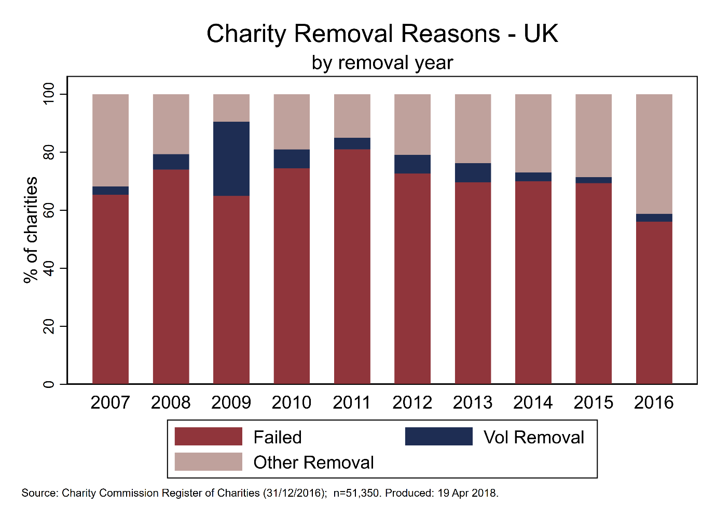



**Predicting removal**

**UK**

--------------------------------------------------------------------------------------------

| Robust

removed | Coef. Std. Err. z P>|z| [95% Conf. Interval]

---------------------------+----------------------------------------------------------------

Active | (base outcome)

---------------------------+----------------------------------------------------------------

Failed |

icnpo |

Cultureandrecreation | -.8715481 .0204254 -42.67 0.000 -.9115811 -.8315151

Development | -.3034321 .0232997 -13.02 0.000 -.3490987 -.2577656

Education | -.3492802 .0263158 -13.27 0.000 -.4008583 -.2977021

Employmentandtraining | .1237952 .0524381 2.36 0.018 .0210185 .226572

Environment | -.7335325 .0367646 -19.95 0.000 -.8055898 -.6614752

Grant-makingfoundations | -.7964166 .025828 -30.84 0.000 -.8470384 -.7457947

Health | -.0338305 .0283185 -1.19 0.232 -.0893336 .0216727

Housing | -.3849551 .0397951 -9.67 0.000 -.4629521 -.3069581

International | -.1656111 .0375593 -4.41 0.000 -.2392259 -.0919963

Lawandadvocacy | .3425138 .0371707 9.21 0.000 .2696605 .415367

Other | -.3983004 .0872419 -4.57 0.000 -.5692913 -.2273095

ParentTeacherAssociations | -.7907326 .0233729 -33.83 0.000 -.8365425 -.7449226

Playgroupsandnurseries | .5840529 .0255322 22.88 0.000 .5340108 .634095

Religion | -.7403921 .0185026 -40.02 0.000 -.7766564 -.7041277

Research | -.2206377 .0395597 -5.58 0.000 -.2981733 -.1431021

Scoutgroupsandyouthclubs | -.4471205 .0304677 -14.68 0.000 -.5068361 -.3874048

Umbrellabodies | .2843927 .0668033 4.26 0.000 .1534607 .4153247

VillageHalls | -2.953807 .0752006 -39.28 0.000 -3.101197 -2.806417

|

1.company | -.6186157 .0196158 -31.54 0.000 -.6570621 -.5801694

|

areaop |

National | .2652316 .0157229 16.87 0.000 .2344153 .2960479

International | -.7122153 .0267376 -26.64 0.000 -.7646199 -.6598106

|

charitysize |

No income | 1.381683 .0161432 85.59 0.000 1.350043 1.413323

10k - 25k | -1.195408 .0182693 -65.43 0.000 -1.231215 -1.159601

25k - 100k | -1.275684 .0184083 -69.30 0.000 -1.311764 -1.239605

100k - 500k | -1.313848 .0221455 -59.33 0.000 -1.357252 -1.270444

500k - 1m | -1.409687 .0509153 -27.69 0.000 -1.509479 -1.309895

1m - 10m | -1.770407 .0534511 -33.12 0.000 -1.87517 -1.665645

10m - 100m | -3.081879 .2257803 -13.65 0.000 -3.524401 -2.639358

Over 100m | -3.530203 1.017225 -3.47 0.001 -5.523928 -1.536478

|

charityage | -.0055941 .0001806 -30.98 0.000 -.005948 -.0052402

_cons | .0362703 .0147372 2.46 0.014 .007386 .0651547

---------------------------+----------------------------------------------------------------

Vol_Removal |

icnpo |

Cultureandrecreation | -.9497974 .0869299 -10.93 0.000 -1.120177 -.779418

Development | 2.647384 .0471169 56.19 0.000 2.555036 2.739731

Education | -.7160554 .1169045 -6.13 0.000 -.9451841 -.4869267

Employmentandtraining | -.3550058 .2664912 -1.33 0.183 -.877319 .1673074

Environment | -.9784749 .1861187 -5.26 0.000 -1.343261 -.6136889

Grant-makingfoundations | -.7581126 .1025167 -7.40 0.000 -.9590417 -.5571835

Health | -.856865 .1689853 -5.07 0.000 -1.18807 -.5256598

Housing | -.8992481 .2293373 -3.92 0.000 -1.348741 -.4497553

International | -.5763464 .2217565 -2.60 0.009 -1.010981 -.1417116

Lawandadvocacy | -.1062495 .1933628 -0.55 0.583 -.4852336 .2727346

Other | -.4652062 .5112605 -0.91 0.363 -1.467258 .5368459

ParentTeacherAssociations | -1.893112 .1375783 -13.76 0.000 -2.162761 -1.623464

Playgroupsandnurseries | -.1482606 .1592115 -0.93 0.352 -.4603095 .1637883

Religion | -.5559847 .072297 -7.69 0.000 -.6976843 -.4142852

Research | -.8132916 .2195662 -3.70 0.000 -1.243633 -.3829498

Scoutgroupsandyouthclubs | -1.038266 .1559704 -6.66 0.000 -1.343962 -.7325697

Umbrellabodies | -.1042614 .3613018 -0.29 0.773 -.8124 .6038771

VillageHalls | -2.471316 .2620508 -9.43 0.000 -2.984926 -1.957706

|

1.company | -2.329761 .1622056 -14.36 0.000 -2.647678 -2.011844

|

areaop |

National | .1011156 .0534365 1.89 0.058 -.0036181 .2058492

Nationalandoverseas | -1.601064 .1673079 -9.57 0.000 -1.928981 -1.273146

|

charitysize |

No income | -.2893899 .0633986 -4.56 0.000 -.4136488 -.165131

10k - 25k | -4.015455 .1849217 -21.71 0.000 -4.377895 -3.653015

25k - 100k | -3.945384 .1797193 -21.95 0.000 -4.297627 -3.59314

100k - 500k | -3.824679 .2378728 -16.08 0.000 -4.290901 -3.358456

500k - 1m | -3.120826 .5021163 -6.22 0.000 -4.104956 -2.136696

1m - 10m | -3.70929 .7104687 -5.22 0.000 -5.101783 -2.316797

10m - 100m | -15.96332 .1056545 -151.09 0.000 -16.1704 -15.75624

Over 100m | -16.12798 .2291299 -70.39 0.000 -16.57706 -15.67889

|

charityage | -.0019522 .0005157 -3.79 0.000 -.002963 -.0009414

_cons | -2.745357 .0475584 -57.73 0.000 -2.83857 -2.652144

---------------------------+----------------------------------------------------------------

Other_Removal |

icnpo |

Cultureandrecreation | -.9978676 .0305965 -32.61 0.000 -1.057836 -.9378995

Development | -.7290425 .0383897 -18.99 0.000 -.8042848 -.6538001

Education | -.3109453 .0341346 -9.11 0.000 -.3778479 -.2440427

Employmentandtraining | -.2023027 .0746812 -2.71 0.007 -.3486752 -.0559301

Environment | -.7346449 .0518817 -14.16 0.000 -.8363313 -.6329586

Grant-makingfoundations | -.8712627 .0372699 -23.38 0.000 -.9443103 -.7982151

Health | .1508202 .0343374 4.39 0.000 .0835201 .2181203

Housing | .0254906 .0431548 0.59 0.555 -.0590912 .1100724

International | -.3520966 .0608693 -5.78 0.000 -.4713982 -.232795

Lawandadvocacy | .8757244 .0374516 23.38 0.000 .8023207 .9491281

Other | -.3306027 .1052342 -3.14 0.002 -.5368579 -.1243474

ParentTeacherAssociations | -2.107609 .0612097 -34.43 0.000 -2.227578 -1.98764

Playgroupsandnurseries | -.4118025 .0412476 -9.98 0.000 -.4926463 -.3309587

Religion | -.8754897 .0260202 -33.65 0.000 -.9264883 -.8244911

Research | -.2234422 .0518367 -4.31 0.000 -.3250402 -.1218442

Scoutgroupsandyouthclubs | -1.279822 .0575827 -22.23 0.000 -1.392683 -1.166962

Umbrellabodies | .7237392 .0652693 11.09 0.000 .5958138 .8516646

VillageHalls | -2.066435 .078989 -26.16 0.000 -2.221251 -1.911619

|

1.company | -1.782856 .0327836 -54.38 0.000 -1.847111 -1.718602

|

areaop |

National | .1512772 .0218079 6.94 0.000 .1085345 .1940199

Nationalandoverseas | -1.158269 .0456908 -25.35 0.000 -1.247822 -1.068717

|

charitysize |

No income | 1.168005 .0247043 47.28 0.000 1.119586 1.216425

10k - 25k | -.7495525 .030467 -24.60 0.000 -.8092668 -.6898383

25k - 100k | -.0459279 .0233069 -1.97 0.049 -.0916086 -.0002471

100k - 500k | .4793012 .0239885 19.98 0.000 .4322847 .5263178

500k - 1m | .642973 .0474892 13.54 0.000 .5498959 .7360502

1m - 10m | .4715894 .0484318 9.74 0.000 .3766648 .566514

10m - 100m | .6474959 .0984516 6.58 0.000 .4545344 .8404575

Over 100m | -.1844207 .5225459 -0.35 0.724 -1.208592 .8397504

|

charityage | -.000434 .0001559 -2.78 0.005 -.0007395 -.0001285

_cons | -1.337991 .0192048 -69.67 0.000 -1.375632 -1.300351

--------------------------------------------------------------------------------------------

**Predicting Removal New Zealand**

Multinomial logistic regression Number of obs = 29,208

LR chi2(90) = 2962.85

Prob > chi2 = 0.0000

Log likelihood = -17924.013 Pseudo R2 = 0.0763

--------------------------------------------------------------------------------------------------

removed | Coef. Std. Err. z P>|z| [95% Conf. Interval]

---------------------------------+----------------------------------------------------------------

Active | (base outcome)

---------------------------------+----------------------------------------------------------------

Failed |

mainsector |

Arts / culture / heritage | -.1487722 .1588317 -0.94 0.349 -.4600767 .1625322

Care / protection of animals | -.1525326 .2579096 -0.59 0.554 -.6580261 .352961

Community development | -.0967952 .1613397 -0.60 0.549 -.4130151 .2194247

Economic development | .3380149 .2763306 1.22 0.221 -.2035831 .8796129

Education / training / research | -.0838771 .1524416 -0.55 0.582 -.3826571 .2149028

Emergency / disaster relief | -.4107634 .1898987 -2.16 0.031 -.782958 -.0385688

Employment | .6956677 .3988912 1.74 0.081 -.0861446 1.47748

Environment / conservation | -.2307292 .1833361 -1.26 0.208 -.5900614 .1286029

Fund-raising | -.0111296 .1741219 -0.06 0.949 -.3524022 .330143

Health | .1577682 .1623285 0.97 0.331 -.1603898 .4759261

International activities | .4868806 .3629763 1.34 0.180 -.2245398 1.198301

Marae on reservation land | .1752505 .2310684 0.76 0.448 -.2776352 .6281362

Other | -.0577296 .1625827 -0.36 0.723 -.3763858 .2609266

People with disabilities | -.2397608 .1818147 -1.32 0.187 -.5961111 .1165895

Promotion of volunteering | -.0886633 .3761305 -0.24 0.814 -.8258656 .648539

Religious activities | -.1920225 .1552825 -1.24 0.216 -.4963706 .1123256

Social services | .051944 .1604484 0.32 0.746 -.2625291 .3664172

Sport / recreation | -.0832157 .1641981 -0.51 0.612 -.405038 .2386066

|

company | -.2783861 .0622822 -4.47 0.000 -.4004569 -.1563153

|

charitysize |

Under 10k | -1.048891 .0665126 -15.77 0.000 -1.179254 -.9185289

10k - 25k | -1.496996 .075591 -19.80 0.000 -1.645152 -1.34884

25k - 100k | -1.777349 .0716617 -24.80 0.000 -1.917803 -1.636894

100k - 500k | -1.941469 .0763516 -25.43 0.000 -2.091116 -1.791823

500k - 1m | -2.639569 .1414446 -18.66 0.000 -2.916795 -2.362343

1m - 10m | -2.207563 .1125667 -19.61 0.000 -2.42819 -1.986937

10m - 100m | -3.160877 .3896447 -8.11 0.000 -3.924566 -2.397187

Over 100m | -15.94181 974.0135 -0.02 0.987 -1924.973 1893.09

|

charityage | .2139743 .0125048 17.11 0.000 .1894653 .2384833

|

areaop |

2 | -.0086296 .0465049 -0.19 0.853 -.0997774 .0825183

3 | -.0415085 .0880142 -0.47 0.637 -.2140132 .1309962

|

_cons | -2.167762 .1875142 -11.56 0.000 -2.535284 -1.800241

---------------------------------+----------------------------------------------------------------

Vol_Removal |

mainsector |

Arts / culture / heritage | -.5918856 .1863159 -3.18 0.001 -.9570582 -.2267131

Care / protection of animals | -.4381142 .3213936 -1.36 0.173 -1.068034 .1918057

Community development | -.7208585 .1939076 -3.72 0.000 -1.10091 -.3408066

Economic development | .3642443 .3032879 1.20 0.230 -.2301891 .9586778

Education / training / research | -.424334 .1758405 -2.41 0.016 -.768975 -.079693

Emergency / disaster relief | -.9764785 .2414767 -4.04 0.000 -1.449764 -.5031929

Employment | 1.046975 .4061375 2.58 0.010 .2509603 1.84299

Environment / conservation | -.5704085 .2165742 -2.63 0.008 -.9948862 -.1459307

Fund-raising | -.0799644 .2001965 -0.40 0.690 -.4723422 .3124135

Health | -.15016 .188678 -0.80 0.426 -.5199621 .2196422

International activities | -.0560883 .4301949 -0.13 0.896 -.8992548 .7870782

Marae on reservation land | -1.736167 .5354766 -3.24 0.001 -2.785682 -.6866523

Other | -.3061969 .1883972 -1.63 0.104 -.6754486 .0630549

People with disabilities | -.4280616 .2116334 -2.02 0.043 -.8428553 -.0132678

Promotion of volunteering | -.2489115 .4428177 -0.56 0.574 -1.116818 .6189952

Religious activities | -.621497 .1814787 -3.42 0.001 -.9771888 -.2658052

Social services | .4290574 .1789286 2.40 0.016 .0783638 .7797511

Sport / recreation | -.7894353 .2037686 -3.87 0.000 -1.188814 -.3900561

|

company | -.0873973 .0747056 -1.17 0.242 -.2338177 .059023

|

charitysize |

Under 10k | -1.210746 .0719902 -16.82 0.000 -1.351844 -1.069647

10k - 25k | -2.092192 .092414 -22.64 0.000 -2.273321 -1.911064

25k - 100k | -2.402804 .0864138 -27.81 0.000 -2.572172 -2.233436

100k - 500k | -2.666725 .0954741 -27.93 0.000 -2.853851 -2.4796

500k - 1m | -2.876892 .163647 -17.58 0.000 -3.197635 -2.55615

1m - 10m | -2.58424 .1337702 -19.32 0.000 -2.846424 -2.322055

10m - 100m | -3.009971 .3678637 -8.18 0.000 -3.73097 -2.288971

Over 100m | -2.085108 1.047017 -1.99 0.046 -4.137224 -.0329921

|

charityage | .2269187 .0160013 14.18 0.000 .1955567 .2582807

|

areaop |

2 | .1541223 .0565958 2.72 0.006 .0431966 .265048

3 | .4783332 .0928995 5.15 0.000 .2962535 .6604129

|

_cons | -2.241414 .2215216 -10.12 0.000 -2.675589 -1.80724

---------------------------------+----------------------------------------------------------------

Other_Removal |

mainsector |

Arts / culture / heritage | -1.758548 .4571466 -3.85 0.000 -2.654539 -.8625567

Care / protection of animals | -1.498057 1.050374 -1.43 0.154 -3.556751 .5606375

Community development | -1.116249 .4107712 -2.72 0.007 -1.921346 -.3111526

Economic development | .2507895 .5962837 0.42 0.674 -.9179051 1.419484

Education / training / research | -1.021697 .3450146 -2.96 0.003 -1.697913 -.3454808

Emergency / disaster relief | -1.073686 .5493803 -1.95 0.051 -2.150452 .0030796

Employment | -15.17644 1987.908 -0.01 0.994 -3911.405 3881.052

Environment / conservation | -2.162479 .7737076 -2.79 0.005 -3.678918 -.6460398

Fund-raising | -1.522439 .5922224 -2.57 0.010 -2.683173 -.361704

Health | -.2812019 .3577122 -0.79 0.432 -.9823048 .4199011

International activities | -14.8988 1447.878 -0.01 0.992 -2852.688 2822.89

Marae on reservation land | -14.88839 787.1275 -0.02 0.985 -1557.63 1527.853

Other | -.5682387 .3776524 -1.50 0.132 -1.308424 .1719464

People with disabilities | -.2011238 .3941524 -0.51 0.610 -.9736484 .5714007

Promotion of volunteering | -.3764427 1.056538 -0.36 0.722 -2.44722 1.694334

Religious activities | -.9179587 .3531182 -2.60 0.009 -1.610058 -.2258597

Social services | -.675463 .3730671 -1.81 0.070 -1.406661 .055735

Sport / recreation | -1.802566 .5136021 -3.51 0.000 -2.809208 -.7959243

|

company | .1747381 .1818964 0.96 0.337 -.1817723 .5312485

|

charitysize |

Under 10k | -1.202688 .2698881 -4.46 0.000 -1.731659 -.6737166

10k - 25k | -1.049951 .2832557 -3.71 0.000 -1.605122 -.4947804

25k - 100k | -1.569245 .2812507 -5.58 0.000 -2.120486 -1.018004

100k - 500k | -.9612624 .259584 -3.70 0.000 -1.470038 -.4524872

500k - 1m | -.9859201 .3370032 -2.93 0.003 -1.646434 -.325406

1m - 10m | -.7778641 .2993825 -2.60 0.009 -1.364643 -.1910853

10m - 100m | -1.10622 .6266709 -1.77 0.078 -2.334472 .1220327

Over 100m | -15.44865 3535.432 -0.00 0.997 -6944.769 6913.872

|

charityage | .1308515 .0441338 2.96 0.003 .0443508 .2173522

|

areaop |

2 | -.0752168 .1646422 -0.46 0.648 -.3979096 .2474759

3 | .0717777 .2943203 0.24 0.807 -.5050795 .6486348

|

_cons | -3.785422 .5187992 -7.30 0.000 -4.802249 -2.768594

--------------------------------------------------------------------------------------------------