**Mission Accomplished? A Cross-national Examination of Charity Dissolution**

Diarmuid McDonnell, Alasdair Rutherford and Carolyn Cordery

**Abstract**

Encouraged by ‘open data’ movements, regulators have made it increasingly straightforward for stakeholders to access large-scale data about charities and their regulation. This research leverages some of these data resources to examine a topic of considerable public and regulatory importance: charity dissolution due to mission accomplishment. The charity sector's claim to exist for the public good is no longer assumed and must be evidenced, however little is known about the extent to which charities accomplish their missions. In this paper we describe continuing work to collect, clean, harmonise and analyse international data on charity dissolution. We evaluate whether there is added value from adopting a cross-national approach and the extent to which other jurisdictions could be included in the analysis. In doing so we identify real opportunities for interdisciplinary collaboration, combining accounting, social policy, law and data science in order to address important questions in novel ways.**1.** **Introduction**

Nonprofit and specifically charity regulation is in flux. Stagnant or declining regulator budgets are the new normal and charities themselves are subject to increasing levels of public scrutiny. To meet these and other challenges, many regulators are shifting to an approach informed by risk assessment and analysis (McDonnell & Rutherford, 2019). This requires regulators to leverage their considerable data resources to better target their interventionist and advisory activities, and deliver their mandate. Until recently, relatively little nonprofit regulatory data was shared beyond lists of registered charities. Encouraged by increasing ‘open data’ movements, regulators have made it increasingly easier for stakeholders to access a range of both quantitative and qualitative data about charities and their regulation on a large scale. New nonprofit regulators are being formed, or reformed, and decisions are being taken about what data to collect, and how to use it (Cordery & Deguchi, forthcoming). This paper describes ongoing work to leverage some of these data resources to examine a topic of considerable public and regulatory importance: charity dissolution due to mission accomplishment. There are many reasons charities shut down (e.g. insufficient funds, non-compliance with legal requirements), but this project will focus on organisations that dissolve after accomplishing their mission. The charity sector's claim to exist for the public good is no longer assumed and must be evidenced (Brody, 2002). However, little is known about the extent to which charities accomplish their missions. Given the increasing scrutiny on charitable organisations in many jurisdictions and the importance of public confidence to their sustainability (Breen, 2009; Keating & Frumkin, 2003), research on this topic has the potential to make a significant contribution to the evidence base on charity success and failure, benefiting a variety of stakeholders including those with responsibility for monitoring the sector (Saxton et al., 2012).

The paper proceeds as follows. The next section reviews scholarship on charity success and failure, revealing the empirical gap in our understanding of mission accomplishment. Next we describe the methodology underpinning the research, in particular focusing on the key issues of defining and measuring the dependent variable, and the data collection process. We present some preliminary findings, and reflect on the advantages and disadvantages of employing large-scale regulatory data to study this outcome. We conclude by outlining our plans for developing this research.

**2. Literature**

Defining charity success and/or failure has proved problematic (Lecy et al., 2011). There are various conceptualisations of failure including resource reduction, market exit, and mortality (Helmig et al., 2014; (Mellahi & Wilkinson, 2004). However, many of these constructs contain inconsistencies and contradictions. For example, organisational dissolution may indicate success rather than failure in cases where the charity accomplished its mission (Helmig et al., 2014; see also Hager, Galaskiewicz, Bielefeld & Pins, 1996). On the other hand, charity success is easier to conceptualise but poorly understood for a number of reasons (Helmig et al., 2014). Extant studies have focused on a limited number of subsectors such as Social Service organisations (Helmig et al., 2014); used observations from small regional study sites (e.g. Wollebaek, 2010); and covered short time periods (e.g. Hager et al., 1996). The most difficult issue has been to unambiguously measure mission accomplishment - those charities that voluntarily cease to exist due to achieving their stated mission - and differentiate it from other forms of dissolution such as organisational wind-up, statutory revocation of charity status due to misconduct, and other forms of ‘mortality’ e.g. amalgamation.

By using detailed measures of charity dissolution recorded in large-scale regulatory datasets, this research project responds to the call for greater focus on mission accomplishment as an outcome in nonprofit scholarship (Helmig et al., 2014). Our work has the potential to provide much-needed granularity and clarity to the various ways charities cease their activities, in particular by identifying those organisations that dissolve as a result of accomplishing their mission. Identifying the patterns and explanatory factors associated with charity dissolution can underpin public understanding of the sector, inform the allocation of funds by donors and government, and guide the activities and interventions of regulators.

**3. Methodology**

The research objectives are: to explore the extent to which large-scale regulatory data can be used to differentiate between different types of charity dissolution; to examine cross-national trends and predictive factors around charity dissolution; and to provide evidence and guidance for charity regulators seeking to target their activities with respect to this outcome. The project is guided by two research questions:

1. What is the rate of charity dissolution, and does it vary across jurisdictions?
2. What factors predict mission accomplishment, and do they vary across other forms of charity dissolution?

These were selected for a number of reasons. First, in each jurisdiction regulatory data are publicly available via an open data portal or database; second, they represent important and comprehensive charity sectors in North America, the United Kingdom and Australasia; and third, they cover different stages of development of regulatory regimes: England & Wales is ‘mature’ (established 1853), Canada is ‘middle aged’ (1967), and New Zealand is ‘adolescent’ (2007). Data for each jurisdiction also allow us to analyse dissolution over the period of the financial crisis, enabling comparative analyses of the impact of this phenomenon on the sustainability of each charity sector.

**3.1. Dependent Variable**

Many nonprofit regulators have a mandate to construct and maintain an accurate, complete and public register of organisations that currently have charity status. In addition these regulators will also retain, though sometimes not share, the list of organisations no longer registered as charities. There is considerable variation across jurisdictions in how charity deregistration is recorded: some regulators do not disaggregate between the different forms (Scotland, Republic of Ireland, Northern Ireland), while others differentiate at least to some degree (England & Wales, Canada, New Zealand, Australia). Table A1 in the appendices outlines the categorical measures of deregistration employed by the three jurisdictions included in this study. Using these fields in the data, we attempt to define our dependent variable by process of elimination; this is suboptimal but necessary as regulators do not record mission accomplishment as a distinct category in the data. Therefore, the dependent variable should capture charities that voluntarily ceased to exist (i.e. dissolved), excluding instances of mergers, amalgamations, and wind ups – see Table 1 below. [DESCRIBE EACH OF THE CATEGORIES AND GIVE EXAMPLES.]

However, this approach only takes us so far in differentiating between different types of dissolution; for example the voluntary dissolution category currently groups winding up and mission accomplishment together. Therefore we needed to utilise other fields in the data to better identify the outcome of interest; this is discussed further in section 3.2.

**Table 1.** Dependent Variable – Voluntary Dissolution

|  |  |  |
| --- | --- | --- |
| Concept | Variable(s) | Operationalisation |
| Charity status | `depvar` | Multinomial measure of the current status of a charity.  0 = Registered  1 = Failed  2 = Voluntary Dissolution  3 = Other deregistration |
|  |  |  |

**3.2. Data Collection**

The data were collected either from each regulator’s data portal or website:

* Charity Commission for England & Wales - http://data.charitycommission.gov.uk/
* Canada Revenue Agency - https://www.canada.ca/en/revenue-agency/services/charities-giving/charities-listings.html
* New Zealand Charities Services - https://www.charities.govt.nz/charities-in-new-zealand/the-charities-register/open-data/

The data will be collected using Python scripts (an open-source programming language), some of which already exist (see https://github.com/ncvo/charity-commission-extract). The downloaded data will be stored on the University of Birmingham’s encrypted network and access will be granted only to members of the project team. The data will be imported into Stata and a harmonised dataset containing key variables and observations from all three jurisdictions will be produced. We will construct our dissolution variable using the information captured in each regulator's categorical measure of charity de-registration and where appropriate, seek to differentiate further by analysing the free-text field containing a description of why and under which section of the Charity Act the organisation was de-registered. Mission accomplishment is not recorded as a distinct outcome by regulators, therefore our work to differentiate types of dissolution will allow us to construct a novel and robust measure of this phenomenon.

We will then conduct statistical analysis of charity dissolution using two main techniques: survival analysis, where we will use Kaplan-Meier and survival curves to explore how long each type of charity dissolution takes to occur; and multinomial regression, where we will examine which factors – drawn from established theoretical frameworks such as resource dependence, population ecology and new institutionalism theory – best predict dissolution.

**Results**

In Canada there are three forms of charity de-registration:

* removal by the regulator (e.g. failure to file annual returns and accounts);
* voluntary dissolution (e.g. mergers and amalgamation, mission accomplishment, insufficient resources);
* and miscellaneous reasons (e.g. losing corporate status).

See Appendix A for a full list of de-registration reasons in our three jurisdictions.

**Table 1.** Current status of charities, by jurisdiction

|  |  |  |  |  |  |  |  |  |
| --- | --- | --- | --- | --- | --- | --- | --- | --- |
|  | England & Wales | |  | New Zealand | |  | Canada | |
| Status | n | % |  | n | % |  | n | % |
| Active | 168,210 | 53 |  | 27,280 | 77 |  | 86,246 | 68 |
| Failed | N/A | N/A |  | 5,563 | 16 |  | 21,478 | 17 |
| Voluntary Dissolution | 85,598 | 2 |  | 2,606 | 7 |  | 18,519 | 15 |
| Other Deregistration | 62,516 | 9 |  | 266 | 1 |  | 95 | 0 |
| **Total** | **239,203** | **100** |  | **35,715** | **100** |  | **126,338** | **100** |

*Note:* Percentages rounded to whole number. n = the number of charities for which we have no missing data for all of the independent variables in the statistical models.  
*Source:* Charity Commission Register of Charities (31/12/2016); [NZ REGULATOR (DOWNLOAD DATE)]; [CANADA REGULATOR (DOWNLOAD DATE)].

**Figure 1.** Canada – De-registration reasons, 2007-

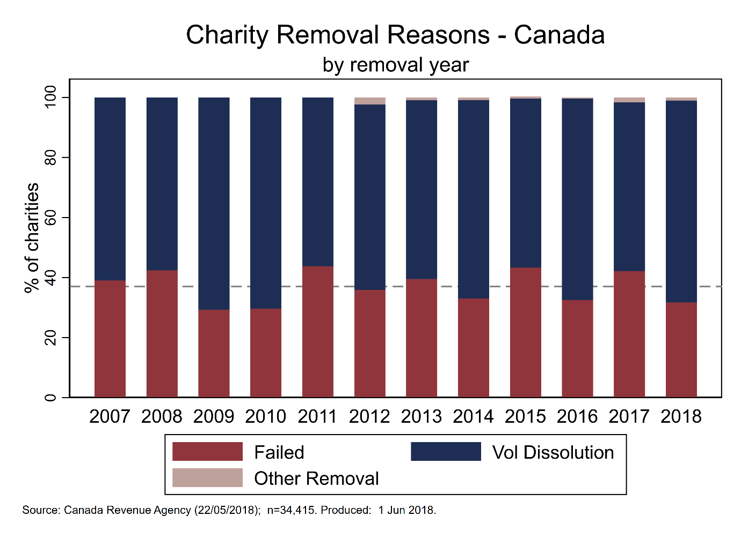

**Figure 2.** England & Wales - De-registration reasons, 2007-

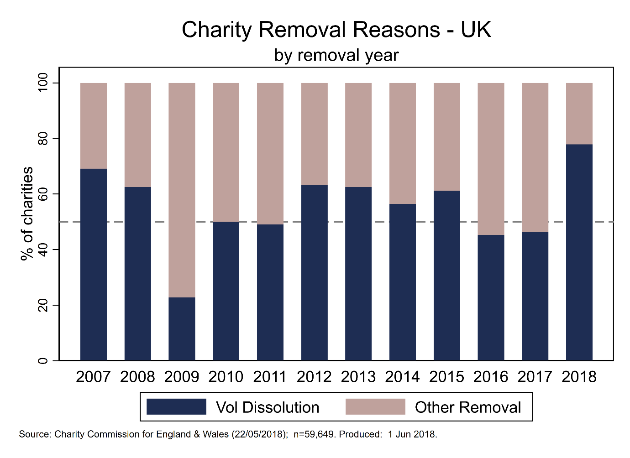

**Figure 3.** New Zealand - De-registration reasons, 2007-



**Notes**

Voluntary dissolution is not comparable (yet) between the three jurisdictions: in Canada mergers and amalgamations cannot be differentiated from other forms, something we can do with England & Wales and New Zealand.

**Appendices**

**Table A1.** Defining Charity Deregistration

|  |  |  |
| --- | --- | --- |
| **Country** | **Deregistration Type** | **Description** |
| Canada | Annulled | Regulator ends a charity’s registration without revoking it i.e. as if it was never a charity to begin with. It is applied exclusively to charities whose registration was granted in error, and to charities that no longer qualify for registration because of a change in the law. |
| Revoked – Audited | Revoked by regulator for failure to comply with charity law/regulation:  - not devoting your resources to your charitable purposes and activities.  - not keeping adequate books and records.  - not having direction and control over your resources. |
| Revoked – Failure To File | If you do not file a complete return within six months of the end of your fiscal period, we will start the revocation process. |
| Revoked – Other | A variety of other reasons, one example of which is if you have lost your corporate status, your registration may be revoked. |
| Revoked – Voluntary | Can measure:  - you ended your operations because you merged or consolidated with another organization.  - you achieved your goal (for example, you were established to build a playground and you did).  - you no longer have the required financial or physical resources to run your charity. |
| New Zealand | Failed To File | Charities Services removed the charity because they did not file their annual returns despite follow up by Charities Services. [Section 42] |
| Non-compliance | Charities Services has the authority to deregister a charity that:  - no longer meets the requirements for registration;  - has acted in a way that is considered to be "serious wrongdoing";  - has "significantly and persistently" failed to comply with the Act. |
| Request | A charity may also request to be deregistered for the following reason: when Charities Services began compliance action the charity asked to be removed rather than make a submission. [Section 31] |
| Voluntary | A charity may ask to be deregistered at any time and for any reason. For example, a charity may request deregistration if it is winding-up and will cease to exist. [Section 32 (1)(f)] |
| England & Wales | Other | 17 other categories of ‘removed reason’ in the data: amalgamated, excepted, funds transferred, funds spent etc. |
|  | Failure To File | Not a distinct reason in the data, is captured by the ‘Ceased to exist’ and ‘Does not operate’ reasons. We may be able to make the assumption that charities with missing data for ‘latest_income’ were removed for failure to file. |
|  | Voluntary - Dissolution | Two reasons, and differences between incorporated and unincorporated:  - Incorporated: ‘Ceased to exist’ means it has dissolved (i.e. struck off Companies House Register), and ‘Does not operate’ means it has not dissolved but is effectively defunct because it has no assets.  - Unincorporated: An unincorporated charity will ‘cease to exist’ once it has no assets whether or not it has actually been legally dissolved. |
|  | Voluntary - Other | This variable captures voluntary removal from the Register, rather than dissolution, windup, merger etc:  - an exempt charity (which we will remove once identified, without the need for a removal request from the trustees);  - a charity which is for the time being permanently or temporarily excepted by order or regulation of the Commission or the Secretary of State; and complies with any conditions of the exception, and whose gross income does not exceed £100,000;  - a charity whose income does not exceed £5,000 (LOOKS TO BE THE MAIN REASON). |