Business Template

Subject areas
Logo / Image

Contents
Business Description 3
1.1 Definitions & Acronyms 3
1.2 Logical Scheme 3

Business Description

1.1 Definitions & Acronyms
- Fuel Station – a physical location where fuel is sold to customers.
- Fuel Type – categories of fuel such as AI-92, AI-95, Diesel, etc.
- Customer – a person purchasing fuel from a station.
- Employee – staff member working at a fuel station.
- Transaction – a record of fuel purchase by a customer.
- Fuel Delivery – supply of fuel received from a supplier.
- Station-Fuel Relationship – availability of fuel types at a station.
- PK (Primary Key) – unique identifier for a record.
- FK (Foreign Key) – reference to another table.?

1.2 Logical Scheme
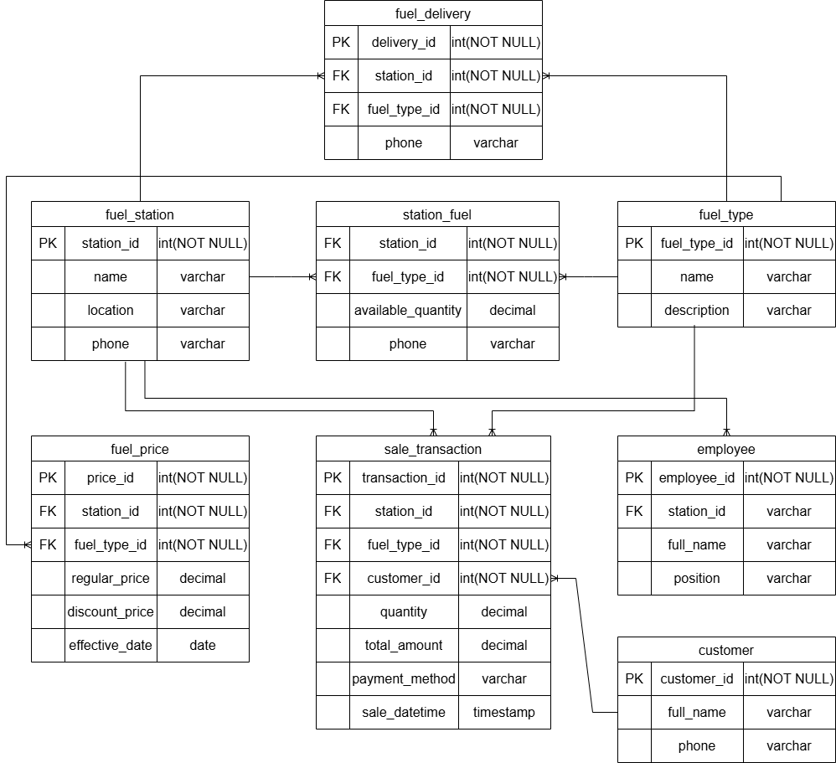

It is In the 3rd normal form, so no redundancy and anomalies. What was challenging is to realize the need to separate fuel pricing into a dedicated table instead of storing it within the station or fuel type table
Update anomaly fixed by separation of prices and transaction data.
Insert anomaly fixed by foreign key constraints
Delete anomaly fixed by maintaining historical transaction data

