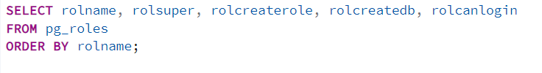
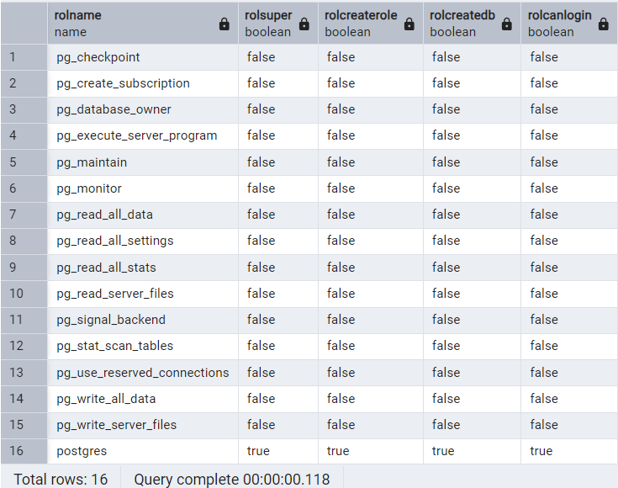
Here only postgres user can do everything, everyone else doesnt have any other roles

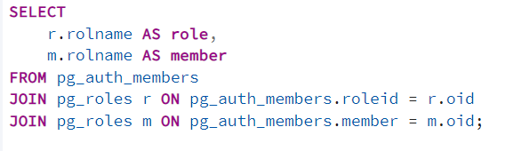
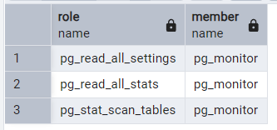

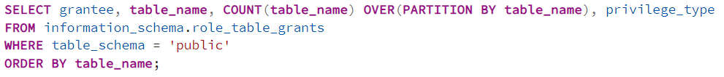
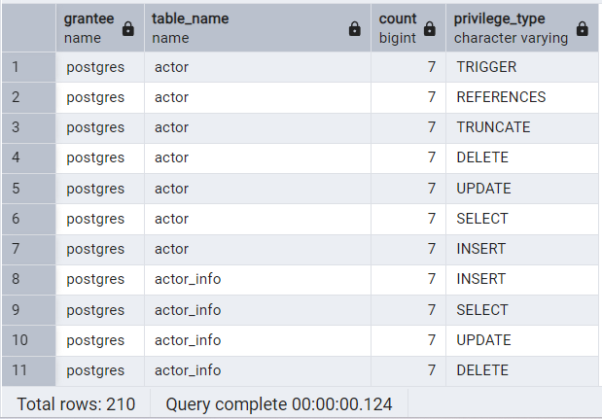
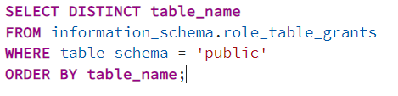
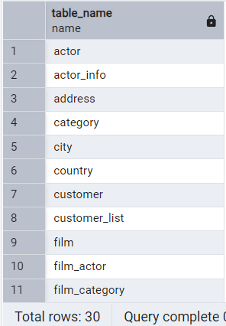

There 30 distinct elements in table_name, each has 7 privileges:
SELECT, INSERT, UPDATE, DELETE, TRUNCATE, REFERENCES, TRIGGER
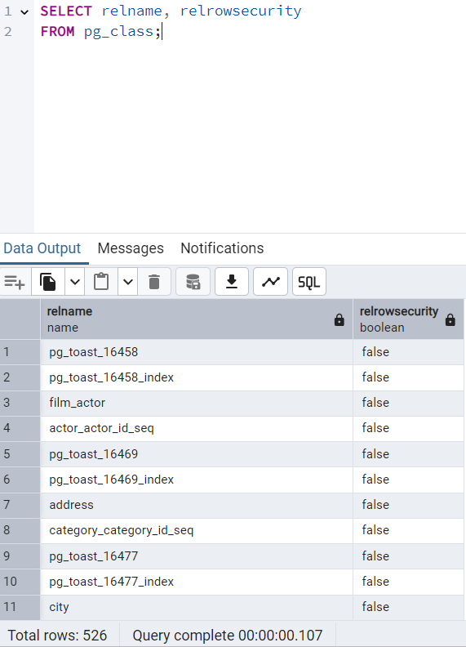
There are many tables but none have row level security

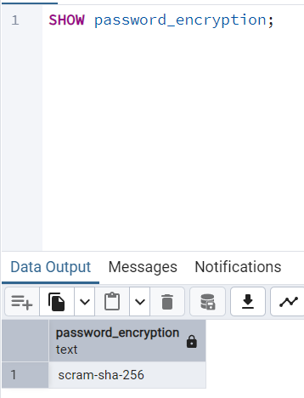
Password encryption is sha-256 as expected
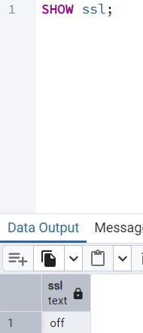
Ssl is off
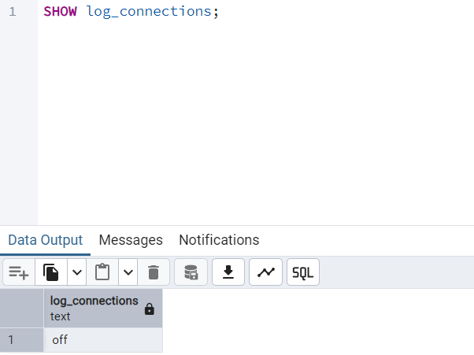
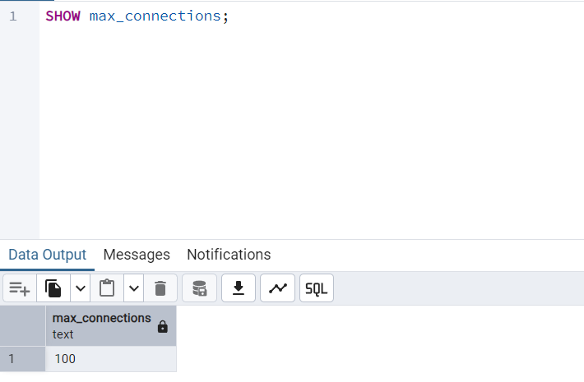

A potential security vulnerability would be absence of row-level security. Would suggest to enable RLS.

