1) How can one restrict access to certain columns of a database table?
In Postgresql we can give access to specific columns inside a table. That way we can limit columns user could use from the table

Practical example:
Clerk at rental desk can see only names of the customers but nothing else for security reasons
GRANT SELECT (first_name, last_name) ON TABLE customer TO rental_clerk;

Real scenario:
HR seeing all info, but team lead seeing only main info like name, title, department

2) What is the difference between user identification and user authentication?
Identification is when you just state who you are without having to prove it. While authentication is proving your identity
Practical example:
When you connect to a dvd_rental database you are trying to connect by telling which user you are(this is identification) and then using password to prove it(this is authentication).
Real scenario:
Entering into a corporate laptop with your email(identification) and then giving one time password from a phone(authentication)

3) What are the recommended authentication protocols for PostgreSQL?
The standart is SCRAM-SHA-256. It is more secure than older md5
Practical example:
In dvd rental we can see the existing encryption
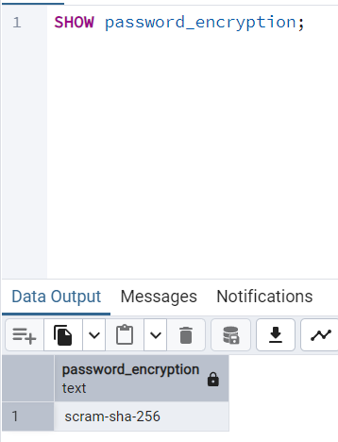
Real scenario:
Financial system for storing credit card transactions metadata would use scram-sha-256. So that if certain traffic data is intercepted, they could not get any sort of credentials

4) What is proxy authentication in PostgreSQL and what is it for? Why does it make the previously discussed role-based access control easier to implement?
Proxy authentication gives ability for trusted application to connect to db as one user and “masquerade” or “impersonate” a different smaller role for other session. It’s not efficient to have thousands of active database connections. So then what we can do is connect application with one pool and for each query use SET ROLE to adopt the specific permissions of logged in customer.

