Business Template

Subject areas
Logo / Image

Contents
Business Description 3
1.1 the Benefits of implementing a database. Project Vision 3
2 Model description 3
2.1 Definitions & Acronyms 3
2.2 Logical Scheme 3
2.3 Objects 3

Business Description
  - the Benefits of implementing a database. Project Vision
To answer these questions, you can rely on the following questions:
- How will the database solve the problems listed in the description?
- How will it ensure data integrity, consistency, and traceability?
- How does your model store the history of changes?
- How does your structure allow the system to scale without major redesign?
- Which constraints and checks have you added to keep data correct as volume grows?

The subway operates multiple lines connecting stations. Trains travel along these lines according to planned schedules with defined departure and arrival times. Passengers purchase tickets to travel in this system. Infrastructure components - trains, stations require maintenance. The system should manage schedule, train assignments, tickets and maintenance.
What lets database to ensure integrity, consistency, traceability is the use of Primary keys, Foreign keys and constraints. Example of this is ticket table that can by design reference only valid booking or schedule referencing existing train and line.
Structure is able to maintain scaling without redesign. New stations, trains or ticket types can be added in the existing system without changing a structure at all.
Constraints and checks I have added to keep data correct as volume grows:
Primary keys(PK)
Foreign keys(FK)
Not null constraints
Unique constraints
Check constraints
- Model description
  - Definitions & Acronyms
Passenger – person using the system to but tickets for travel
Booking – table connecting tickets with train and schedule
Ticket – table that stores tickets of passengers
Fare_category – stores information about ticket type like single ride or daily pass, price, when valid
Line – lines of a train
Station – location where trains stop
Line_station – table that connects line and station
Station_maintenance – maintenance of a station
Schedule – valid schedules of trains
Train – our vehicle for transportion in this system
Train_maintenance - maintenance of a trains
Train_assignment – assigns trains to lines

  - Logical Scheme
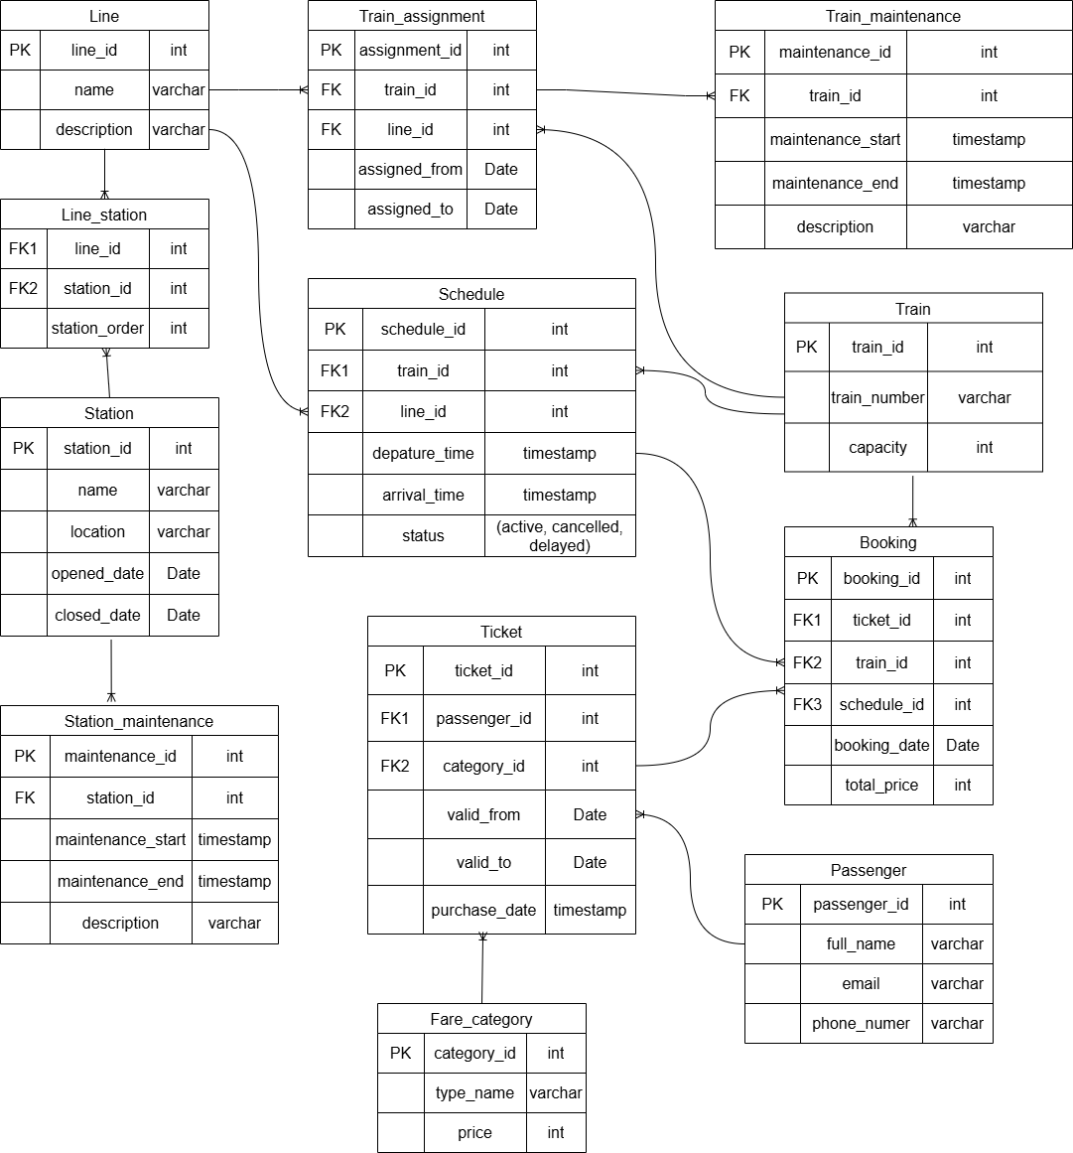

Hardest part was figuring out out how to connect ticket not only to passengers, but also to trains, as information about it is crucial. The solution I came up with is to to create new table Booking, which connects schedules, trains and tickets in one table.
Design prevents several anomalies. For example I avoided storing any train information inside Ticket table. By storing any train information exclusively inside the Train table we prevent update anomaly: if train information changes we to update only Train table. Also, by storing lines and trains in different tables, I avoided insetion anomaly: station can be inserted without line assigned to it. Similarly, I avoided deletion anomaly by separating schedules and trains because now deleting a schedule doesn’t remove train information.
My system is scalable because it tables are holding independent information about entities and are connected by relationships.
  - Objects
Table Description:
- What real-world concept or event does this table represent?
- Why must this information be stored separately instead of inside another table?
- What is the normalization level of the table (1NF, 2NF, 3NF)? Explain your reasoning.
- Are there partial or transitive dependencies? How did you eliminate them? Which attributes depend only on the key, and which depend on other fields?
- Why did you choose this primary key (PK) for the table? Could a composite key work instead? Which foreign keys (FK) did you add and why?

Passenger
It represents a person using a metro system. Its 3NF because each attribute depends only on the primary key. No transitive dependencies. Name, email and phone dont uniquely identify in a table, thus passenger_id to work as a Primary key was created.

Passenger | Field name | Field Description | Data Type
Passenger | passenger_id | Unique identificicaton of passenger in a table(PK) | Int
 | full_name | Name of passenger | Text
 | email | Email of passenger | Text
 | phone_number | Phone number of passenger | Text

passenger_id | full_name | email | phone_number
1 | Dias Kabdeshov | dias@gmail.com | 87001112233
2 | Diana Kabdusheva | diana@gmail.com | 87004445566

Booking
This table exists so that system is able to track which which passenger bought which ticket to which train. It connects Ticket, Schedule, Train tables. Its strored separately because passenger can have multiple purchases over a prolonged period. This way I can store multiple information about purchases of the passenger without duplicates. All attributes depend directly on the primary key. Its in 3NF, no transitive dependencies.
Booking | Field name | Field Description | Data Type
Booking | booking_id | Unique identificicaton of booking(PK) | Int
 | ticket_id | References purchased ticket (FK) | Int
 | train_id | References train for the trip (FK) | Int
 | passenger_id | Passenger who made the booking (FK) | Int
 | booking_date | Date when booking was made | Date
 | total_price | Total price of the booking | Int

booking_id | ticket_id | train_id | passenger_id | booking_date | total_price
1 | 101 | 5 | 1 | 2026-03-10 | 3
2 | 102 | 7 | 2 | 2026-03-11 | 7

Ticket
So that passenger can buy tickets.
Ticket | Field name | Field Description | Data Type
Ticket | ticket_id | Unique identificicaton of ticket(PK) | Int
 | passenger_id | Unique identificicaton of a person which bought the ticket(FK) | Int
 | category_id | Unique identificicaton of ticket category(FK) | Int
 | valid_from | From when ticket is valid | Date
 | valid_to | To when ticket is valid | Date
 | purchase_date | Date of a purchase | Date

Fare_category
Table for category of tickets

Fare_category | Field name | Field Description | Data Type
Fare_category | category_id | Unique identificicaton of ticket category(PK) | Int
 | type_name | Type of a ticket | Text
 | price | Price of ticket of this type | Int

