**LAPORAN TUGAS SISTEM INFORMASI PENGELOLAAN PERSEDIAAN OBAT IF-UN FARMA**

**Perancangan Prototype**

**PERANCANGAN SISTEM**

Dosen Pengajar :

Sali Alas Majapahit, S.ST, M.Kom

DISUSUN OLEH :

Kelompok

223040024 - Diaz Alfiari Rachmad

223040023 - Hikmal Ryvaldi Pelu

223040040 - Rama Dhaniaji Refin

223040043 - Muhammad Rafly Alfarizi

**TEKNIK INFORMATIKA**

**UNIVERSITAS PASUNDAN**

**BANDUNG**

**2024**

1. **Tabel Dialog**

* **Dialog**

|  |  |  |  |
| --- | --- | --- | --- |
| **User Role**  **Function** | **Manajer Apotek** | **Apoteker** | **Asisten Apoteker** |
| Pengecekan Kualitas | x | x | x |
| Perekaman Penerimaan Obat | x | x |  |
| Penerimaan Permintaan Obat |  | x | x |
| Pengecekan Stok Obat |  | x | x |
| Penghapusan Stok Obat | x |  |  |
| Penerimaan Permintaan Obat |  | x | x |
| Pengecekan Ketersediaan Obat | x | x | x |
| Penghapusan Obat Keluar | x |  |  |

* **Dialog Kritis**

|  |  |  |  |
| --- | --- | --- | --- |
| **User Role**  **Function** | **Manajer Apotek** | **Apoteker** | **Asisten Apoteker** |
| Pengecekan Kualitas | (x) | (x) | (x) |
| Perekaman Penerimaan Obat | x | x |  |
| Penerimaan Permintaan Obat |  | (x) | (x) |
| Pengecekan Stok Obat |  | (x) | (x) |
| Penghapusan Stok Obat | x |  |  |
| Penerimaan Permintaan Obat |  | x | x |
| Pengecekan Ketersediaan Obat | (x) | (x) | (x) |
| Penghapusan Obat Keluar | x |  |  |

* 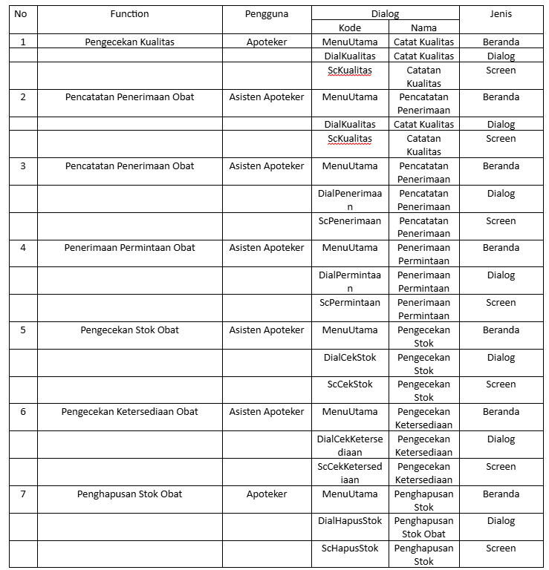Antarmuka

1. Membuat rencana prototype :

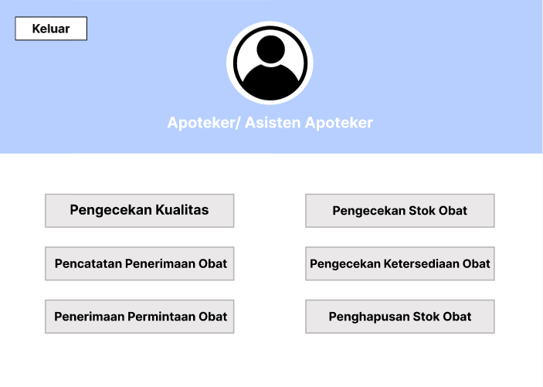

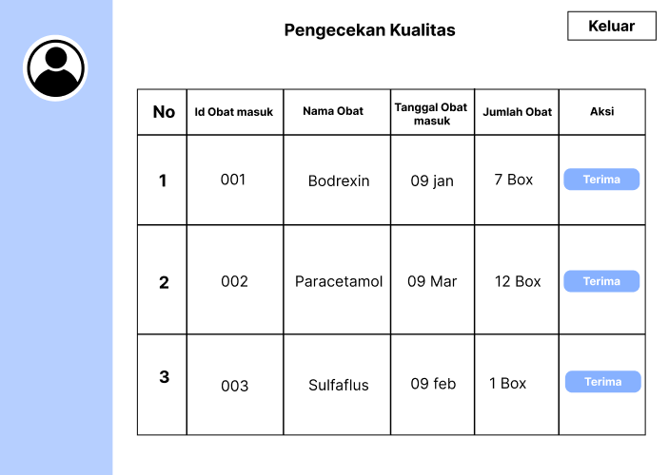

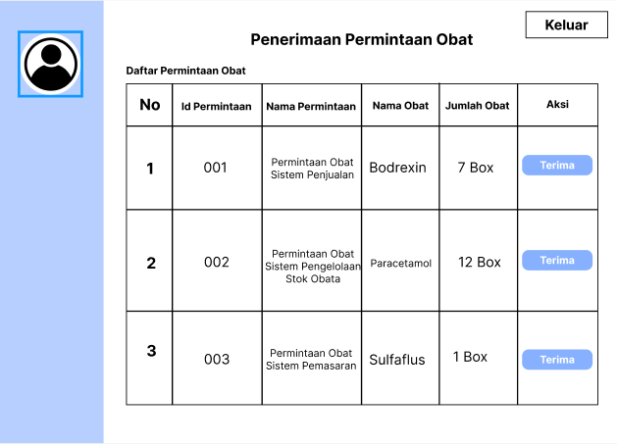

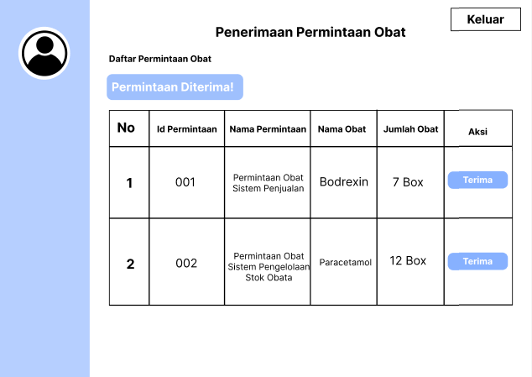

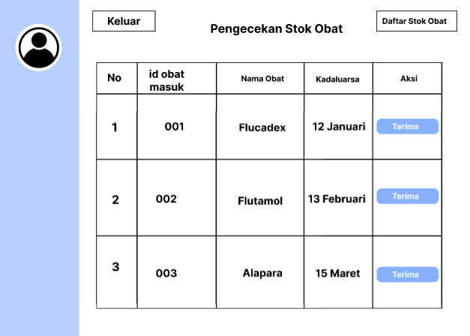

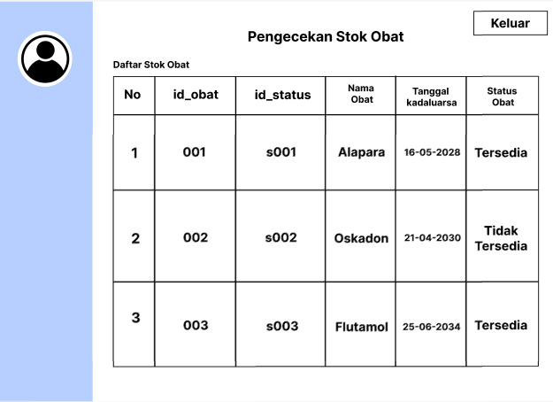

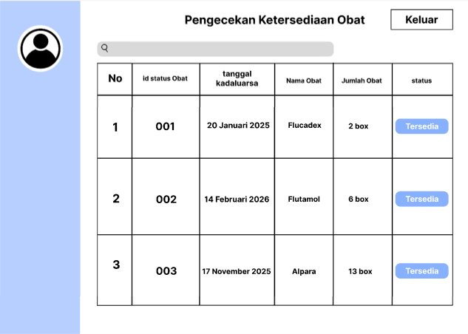

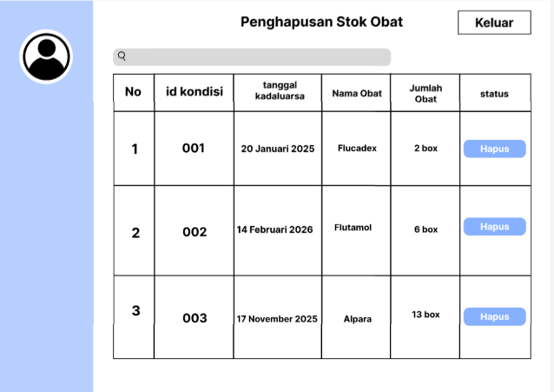

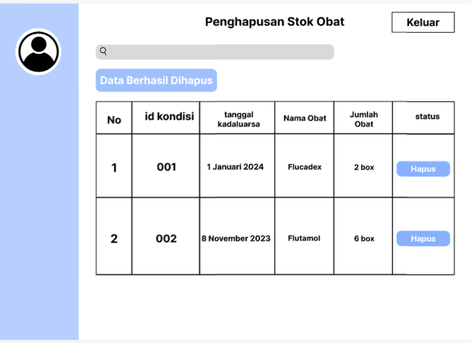

|  |  |
| --- | --- |
| Tools : | Figma |

Tim yang mengerjakan :

|  |  |
| --- | --- |
| Nama | Pengerjaan tugas |
| Hikmal Ryvaldi Pelu | * Membuat Antarmuka * Pathway |
| Rama Dhaniaji Refin | * Prototype * Pathway |
| Diaz Alfiari Rachmad | * Dialog * Protoype |

* Pathway

1. Pengecekan Kualitas

|  |  |  |  |  |
| --- | --- | --- | --- | --- |
| **Prototype Pathway** | | | | |
| **Function Name:** Pengecekan Kualitas | | **User Role:** Apoteker | | |
|  | | | | |
|  | Menu Id : MenuUtama Beranda – Catat Kualitas  Component No. 01 | | |  |
|  |  | |  |  |
|  | Dialog Id : DialKualitas Catat Kualitas  Component No. 02 | | |  |
|  |  | |  |  |
|  | Screen  Kode : ScKualitas  Name : Catatan Kualitas Function : Pengecekan Kualitas Component No. 03 | | |  |
|  | | | | |

1. Pencatatan Penerimaan Obat

|  |  |  |  |  |
| --- | --- | --- | --- | --- |
| **Prototype Pathway** | | | | |
| **Function Name:** Pencatatan Penerimaan Obat | | **User Role:** Asisten Apoteker | | |
|  | | | | |
|  | Menu Id : MenuUtama  Beranda – Pencatatan Penerimaan Component No. 01 | | |  |
|  |  | |  |  |
|  | Dialog Id : DialPenerimaan Pencatatan Penerimaan  Component No. 02 | | |  |
|  |  | |  |  |
|  | Screen  Kode : ScPenerimaan  Name : Pencatatan Penerimaan Function : Pencatatan Penerimaan Obat Component No. 03 | | |  |
|  | | | | |

1. Penerimaan Permintaan Obat

|  |  |  |  |  |  |  |
| --- | --- | --- | --- | --- | --- | --- |
| **Prototype Pathway** | | | | | | |
| **Function Name:** Penerimaan Permintaan Obat | | | **User Role:** Asisten Apoteker | | | |
|  | | | | | | |
|  | Menu Id : MenuUtama  Beranda – Penerimaan Permintaan Component No. 01 | | | |  | |
|  |  | | |  |  | |
|  | Dialog Id : DialPermintaan Penerimaan Permintaan  Component No. 02 | | | |  | |
|  |  | | |  | |  |
|  | | Screen  Kode : ScPermintaan  Name : Penerimaan Permintaan Function : Penerimaan Permintaan Obat  Component No. 03 | | | |  |
|  | | | | | | |

1. Pengecekan Stok Obat

|  |  |  |  |  |
| --- | --- | --- | --- | --- |
| **Prototype Pathway** | | | | |
| **Function Name:** Pengecekan Stok Obat | | **User Role:** Asisten Apoteker | | |
|  | | | | |
|  | Menu Id : MenuUtama  Beranda – Pengecekan Stok Component No. 01 | | |  |
|  |  | |  |  |
|  | Dialog Id : DialCekStok Pengecekan Stok  Component No. 02 | | |  |
|  |  | |  |  |
|  | Screen  Kode : ScCekStok  Name : Pengecekan Stok Function : Pengecekan Stok Obat Component No. 03 | | |  |
|  | | | | |

1. Pengecekan Ketersediaan Obat

|  |  |  |  |  |
| --- | --- | --- | --- | --- |
| **Prototype Pathway** | | | | |
| **Function Name:** Pengecekan Ketersediaan Obat | | **User Role:** Asisten Apoteker | | |
|  | | | | |
|  | Menu Id : MenuUtama  Beranda – Pengecekan Ketersediaan Component No. 01 | | |  |
|  |  | |  |  |
|  | Dialog Id : DialCekKetersediaan Pengecekkan Ketersediaan  Component No. 02 | | |  |
|  |  | |  |  |
|  | Screen  Kode : ScCekKetersediaan  Name : Pengecekan Ketersediaan Function : Pengecekan Ketersediaan Obat Component No. 03 | | |  |
|  | | | | |

1. Penghapusan Stok Obat

|  |  |  |  |  |
| --- | --- | --- | --- | --- |
| **Prototype Pathway** | | | | |
| **Function Name:** Penghapusan Stok Obat | | **User Role:** Apoteker | | |
|  | | | | |
|  | Menu Id : MenuUtama  Beranda – Penghapusan Stok Component No. 01 | | |  |
|  |  | |  |  |
|  | Dialog Id : DialHapusStok Penghapusan Stok Obat  Component No. 02 | | |  |
|  |  | |  |  |
|  | Screen  Kode : ScHapusStok  Name : Penghapusan Stok Function : Penghapusan Stok Obat Component No. 03 | | |  |
|  | | | | |