**PRAKTIKUM PEMROGRAMAN II**

**Tugas 03**

**(Tugas Studi Kasus)**

Dosen Pengajar :  
WANDA GUSDYA PURNAMA, ST., MT.



DISUSUN OLEH :

**Diaz Alfiari Rachmad**

**223040024**

***TEKNIK INFORMATIKA***

***UNIVERSITAS***

***PASUNDAN BANDUNG***

***2024***

**Struktur Program :**

* LibraryApp.java - Kelas utama untuk menjalankan aplikasi
* MainFrame.java - Frame utama dengan menu navigasi
* BookForm.java - Form pengelolaan data buku
* MemberForm.java - Form pengelolaan data anggota
* LoanForm.java - Form pengelolaan peminjaman buku

Link Repository : https://github.com/Diazalfiari/pp2_223040024_A/tree/main/Tugas/Sesi6

**Class : MainFrame**

package Tugas.Sesi6;

/**

 *

 * @author diaza

 */

import javax.swing.*;

import java.awt.*;

import java.awt.event.*;

public class MainFrame extends *JFrame* {

    public MainFrame() {

        setTitle("Sistem Manajemen Perpustakaan");

        setSize(800, 600);

        setDefaultCloseOperation(JFrame.EXIT_ON_CLOSE);

        setLocationRelativeTo(null);

        // Membuat menu bar

*JMenuBar* menuBar = new JMenuBar();

*JMenu* menuFile = new JMenu("File");

*JMenu* menuForms = new JMenu("Forms");

*JMenuItem* menuItemExit = new JMenuItem("Exit");

*JMenuItem* menuItemBook = new JMenuItem("Manajemen Buku");

*JMenuItem* menuItemMember = new JMenuItem("Manajemen Anggota");

*JMenuItem* menuItemLoan = new JMenuItem("Peminjaman");

        menuFile.add(menuItemExit);

        menuForms.add(menuItemBook);

        menuForms.add(menuItemMember);

        menuForms.add(menuItemLoan);

        menuBar.add(menuFile);

        menuBar.add(menuForms);

        setJMenuBar(menuBar);

        // Event handlers

        menuItemExit.addActionListener(e *->* System.exit(0));

        menuItemBook.addActionListener(e *->* new BookForm().setVisible(true));

        menuItemMember.addActionListener(e *->* new MemberForm().setVisible(true));

        menuItemLoan.addActionListener(e *->* new LoanForm().setVisible(true));

        // Label selamat datang

*JLabel* welcomeLabel = new JLabel("Selamat Datang di Sistem Manajemen Perpustakaan", SwingConstants.CENTER);

        welcomeLabel.setFont(new Font("Arial", Font.BOLD, 24));

        add(welcomeLabel);

    }

    public static *void* main(*String*[] *args*) {

        SwingUtilities.invokeLater(() *->* {

            new MainFrame().setVisible(true);

        });

    }

}

**Komponen MainFrame :**

1. Menggunakan JMenuBar untuk membuat menu navigasi utama
2. Menu terdiri dari dua kategori: File dan Forms
3. Setiap menu item memiliki event handler untuk membuka form terkait
4. Menggunakan setLocationRelativeTo(null) untuk menampilkan frame di tengah layar

**Class : BookForm**

package Tugas.Sesi6;

/**

 *

 * @author diaza

 */

import javax.swing.*;

import javax.swing.table.DefaultTableModel;

import java.awt.*;

public class BookForm extends *JFrame* {

    private *JTextField* txtIsbn = new JTextField();

    private *JTextField* txtTitle = new JTextField();

    private *JTextArea* txtDescription = new JTextArea();

    private *JComboBox*<*String*> comboCategory;

    private *JRadioButton* radioNew, radioUsed;

    private *JCheckBox* checkAvailable;

    private *JSpinner* spinnerStock;

    private *JSlider* sliderPrice;

    private *JTable* tblBooks;

    private *DefaultTableModel* tableModel;

    public BookForm() {

        setTitle("Manajemen Buku");

        setSize(600, 800);

        setLocationRelativeTo(null);

        setDefaultCloseOperation(JFrame.DISPOSE_ON_CLOSE);

        // Setup components

*JPanel* mainPanel = new JPanel(new BorderLayout(10, 10));

*JPanel* inputPanel = new JPanel(new GridBagLayout());

*GridBagConstraints* gbc = new GridBagConstraints();

        gbc.fill = GridBagConstraints.HORIZONTAL;

        gbc.insets = new Insets(5, 5, 5, 5);

        // ISBN & Title

        gbc.gridx = 0; gbc.gridy = 0;

        inputPanel.add(new JLabel("ISBN:"), gbc);

        gbc.gridx = 1;

        inputPanel.add(txtIsbn, gbc);

        gbc.gridx = 0; gbc.gridy = 1;

        inputPanel.add(new JLabel("Judul:"), gbc);

        gbc.gridx = 1;

        inputPanel.add(txtTitle, gbc);

        // Description

        gbc.gridx = 0; gbc.gridy = 2;

        inputPanel.add(new JLabel("Deskripsi:"), gbc);

        gbc.gridx = 1;

        txtDescription.setRows(3);

        inputPanel.add(new JScrollPane(txtDescription), gbc);

        // Category ComboBox

*String*[] categories = {"Novel", "Pendidikan", "Komik", "Majalah"};

        comboCategory = new *JComboBox*<>(categories);

        gbc.gridx = 0; gbc.gridy = 3;

        inputPanel.add(new JLabel("Kategori:"), gbc);

        gbc.gridx = 1;

        inputPanel.add(comboCategory, gbc);

        // Condition Radio Buttons

*ButtonGroup* groupCondition = new ButtonGroup();

        radioNew = new JRadioButton("Baru");

        radioUsed = new JRadioButton("Bekas");

        groupCondition.add(radioNew);

        groupCondition.add(radioUsed);

*JPanel* radioPanel = new JPanel(new FlowLayout(FlowLayout.LEFT));

        radioPanel.add(radioNew);

        radioPanel.add(radioUsed);

        gbc.gridx = 0; gbc.gridy = 4;

        inputPanel.add(new JLabel("Kondisi:"), gbc);

        gbc.gridx = 1;

        inputPanel.add(radioPanel, gbc);

        // Available Checkbox

        checkAvailable = new JCheckBox("Tersedia");

        gbc.gridx = 0; gbc.gridy = 5;

        inputPanel.add(new JLabel("Status:"), gbc);

        gbc.gridx = 1;

        inputPanel.add(checkAvailable, gbc);

        // Stock Spinner

        spinnerStock = new JSpinner(new SpinnerNumberModel(0, 0, 100, 1));

        gbc.gridx = 0; gbc.gridy = 6;

        inputPanel.add(new JLabel("Stok:"), gbc);

        gbc.gridx = 1;

        inputPanel.add(spinnerStock, gbc);

        // Price Slider

        sliderPrice = new JSlider(0, 500000, 50000);

        sliderPrice.setMajorTickSpacing(100000);

        sliderPrice.setPaintTicks(true);

        sliderPrice.setPaintLabels(true);

        gbc.gridx = 0; gbc.gridy = 7;

        inputPanel.add(new JLabel("Harga:"), gbc);

        gbc.gridx = 1;

        inputPanel.add(sliderPrice, gbc);

        // Submit Button

*JButton* btnSubmit = new JButton("Simpan");

        gbc.gridx = 1; gbc.gridy = 8;

        inputPanel.add(btnSubmit, gbc);

        // Table

*String*[] columns = {"ISBN", "Judul", "Kategori", "Kondisi", "Status", "Stok", "Harga"};

        tableModel = new DefaultTableModel(columns, 0);

        tblBooks = new JTable(tableModel);

        mainPanel.add(inputPanel, BorderLayout.NORTH);

        mainPanel.add(new JScrollPane(tblBooks), BorderLayout.CENTER);

        add(mainPanel);

        // Event handler untuk button submit

        btnSubmit.addActionListener(e *->* {

*String* isbn = txtIsbn.getText();

*String* title = txtTitle.getText();

*String* category = (String) comboCategory.getSelectedItem();

*String* condition = radioNew.isSelected() ? "Baru" : "Bekas";

*String* status = checkAvailable.isSelected() ? "Tersedia" : "Tidak Tersedia";

*int* stock = (*int*) spinnerStock.getValue();

*int* price = sliderPrice.getValue();

*Object*[] row = {isbn, title, category, condition, status, stock, price};

            tableModel.addRow(row);

            // Clear inputs

            txtIsbn.setText("");

            txtTitle.setText("");

            txtDescription.setText("");

            comboCategory.setSelectedIndex(0);

            radioNew.setSelected(true);

            checkAvailable.setSelected(false);

            spinnerStock.setValue(0);

            sliderPrice.setValue(50000);

        });

    }

}

**Komponen BookForm :**

1. JTextField

* txtIsbn: Input untuk ISBN buku
* txtTitle: Input untuk judul buku

1. JTextArea

* txtDescription: Input untuk deskripsi buku dengan multiple lines

1. JComboBox

* comboCategory: Pilihan kategori buku (Novel, Pendidikan, Komik, Majalah)

1. JRadioButton

* radioNew dan radioUsed: Pilihan kondisi buku (Baru/Bekas

1. JCheckBox

* checkAvailable: Status ketersediaan buku

1. JSpinner

* spinnerStock: Input jumlah stok buku (0-100)

1. JSlider

* sliderPrice: Input harga buku dengan visual slider

1. JTable

* tblBooks: Menampilkan data buku yang telah diinput

**Class : MemberForm**

package Tugas.Sesi6;

/**

 *

 * @author diaza

 */

import javax.swing.*;

import javax.swing.table.DefaultTableModel;

import java.awt.*;

public class MemberForm extends *JFrame* {

    private *JTextField* txtId = new JTextField();

    private *JTextField* txtName = new JTextField();

    private *JTextArea* txtAddress = new JTextArea();

    private *JRadioButton* radioMale, radioFemale;

    private *JCheckBox* checkActive;

    private *JComboBox*<*String*> comboMembership;

    private *JList*<*String*> listHobbies;

    private *JTable* tblMembers;

    private *DefaultTableModel* tableModel;

    public MemberForm() {

        setTitle("Manajemen Anggota");

        setSize(600, 800);

        setLocationRelativeTo(null);

        setDefaultCloseOperation(JFrame.DISPOSE_ON_CLOSE);

*JPanel* mainPanel = new JPanel(new BorderLayout(10, 10));

*JPanel* inputPanel = new JPanel(new GridBagLayout());

*GridBagConstraints* gbc = new GridBagConstraints();

        gbc.fill = GridBagConstraints.HORIZONTAL;

        gbc.insets = new Insets(5, 5, 5, 5);

        // ID & Name

        gbc.gridx = 0; gbc.gridy = 0;

        inputPanel.add(new JLabel("ID:"), gbc);

        gbc.gridx = 1;

        inputPanel.add(txtId, gbc);

        gbc.gridx = 0; gbc.gridy = 1;

        inputPanel.add(new JLabel("Nama:"), gbc);

        gbc.gridx = 1;

        inputPanel.add(txtName, gbc);

        // Address

        gbc.gridx = 0; gbc.gridy = 2;

        inputPanel.add(new JLabel("Alamat:"), gbc);

        gbc.gridx = 1;

        txtAddress.setRows(3);

        inputPanel.add(new JScrollPane(txtAddress), gbc);

        // Gender Radio Buttons

*ButtonGroup* groupGender = new ButtonGroup();

        radioMale = new JRadioButton("Laki-laki");

        radioFemale = new JRadioButton("Perempuan");

        groupGender.add(radioMale);

        groupGender.add(radioFemale);

*JPanel* radioPanel = new JPanel(new FlowLayout(FlowLayout.LEFT));

        radioPanel.add(radioMale);

        radioPanel.add(radioFemale);

        gbc.gridx = 0; gbc.gridy = 3;

        inputPanel.add(new JLabel("Jenis Kelamin:"), gbc);

        gbc.gridx = 1;

        inputPanel.add(radioPanel, gbc);

        // Active Status Checkbox

        checkActive = new JCheckBox("Aktif");

        gbc.gridx = 0; gbc.gridy = 4;

        inputPanel.add(new JLabel("Status:"), gbc);

        gbc.gridx = 1;

        inputPanel.add(checkActive, gbc);

        // Membership ComboBox

*String*[] memberships = {"Regular", "Silver", "Gold", "Platinum"};

        comboMembership = new *JComboBox*<>(memberships);

        gbc.gridx = 0; gbc.gridy = 5;

        inputPanel.add(new JLabel("Membership:"), gbc);

        gbc.gridx = 1;

        inputPanel.add(comboMembership, gbc);

        // Hobbies List

*String*[] hobbies = {"Membaca", "Menulis", "Menggambar", "Fotografi", "Musik"};

        listHobbies = new *JList*<>(hobbies);

        listHobbies.setSelectionMode(ListSelectionModel.MULTIPLE_INTERVAL_SELECTION);

        gbc.gridx = 0; gbc.gridy = 6;

        inputPanel.add(new JLabel("Hobi:"), gbc);

        gbc.gridx = 1;

        inputPanel.add(new JScrollPane(listHobbies), gbc);

        // Submit Button

*JButton* btnSubmit = new JButton("Simpan");

        gbc.gridx = 1; gbc.gridy = 7;

        inputPanel.add(btnSubmit, gbc);

        // Table

*String*[] columns = {"ID", "Nama", "Jenis Kelamin", "Status", "Membership", "Hobi"};

        tableModel = new DefaultTableModel(columns, 0);

        tblMembers = new JTable(tableModel);

        mainPanel.add(inputPanel, BorderLayout.NORTH);

        mainPanel.add(new JScrollPane(tblMembers), BorderLayout.CENTER);

        add(mainPanel);

        // Event handler untuk button submit

        btnSubmit.addActionListener(e *->* {

*String* id = txtId.getText();

*String* name = txtName.getText();

*String* gender = radioMale.isSelected() ? "Laki-laki" : "Perempuan";

*String* status = checkActive.isSelected() ? "Aktif" : "Tidak Aktif";

*String* membership = (String) comboMembership.getSelectedItem();

*Object*[] row = {id, name, gender, status, membership, hobbies};

            tableModel.addRow(row);

            // Clear inputs

            txtId.setText("");

            txtName.setText("");

            txtAddress.setText("");

            radioMale.setSelected(true);

            checkActive.setSelected(false);

            comboMembership.setSelectedIndex(0);

            listHobbies.clearSelection();

        });

    }

}

**Komponen MemberForm :**

1. JTextField

* txtId: Input untuk ID anggota
* txtName: Input untuk nama anggota

1. JTextArea

* txtAddress: Input untuk alamat anggota

1. JRadioButton

* radioMale dan radioFemale: Pilihan jenis kelamin

1. JCheckBox

* checkActive: Status keaktifan anggota

1. JComboBox

* comboMembership: Pilihan tipe keanggotaan

1. JList

* listHobbies: Pilihan multiple hobi anggota

1. JTable

* tblMembers: Menampilkan data anggota

**Class : LoanForm**

package Tugas.Sesi6;

/**

 *

 * @author diaza

 */

import javax.swing.*;

import javax.swing.table.DefaultTableModel;

import java.awt.*;

import java.time.LocalDate;

public class LoanForm extends *JFrame* {

    private *JTextField* txtLoanId = new JTextField();

    private *JTextField* txtMemberId = new JTextField();

    private *JComboBox*<*String*> comboBooks;

    private *JSpinner* spinnerDuration;

    private *JCheckBox* checkReturn;

    private *JTable* tblLoans;

    private *DefaultTableModel* tableModel;

    public LoanForm() {

        setTitle("Peminjaman Buku");

        setSize(600, 800);

        setLocationRelativeTo(null);

        setDefaultCloseOperation(JFrame.DISPOSE_ON_CLOSE);

*JPanel* mainPanel = new JPanel(new BorderLayout(10, 10));

*JPanel* inputPanel = new JPanel(new GridBagLayout());

*GridBagConstraints* gbc = new GridBagConstraints();

        gbc.fill = GridBagConstraints.HORIZONTAL;

        gbc.insets = new Insets(5, 5, 5, 5);

        // Loan ID & Member ID

        gbc.gridx = 0; gbc.gridy = 0;

        inputPanel.add(new JLabel("ID Peminjaman:"), gbc);

        gbc.gridx = 1;

        inputPanel.add(txtLoanId, gbc);

       gbc.gridx = 0; gbc.gridy = 1;

        inputPanel.add(new JLabel("ID Anggota:"), gbc);

        gbc.gridx = 1;

        inputPanel.add(txtMemberId, gbc);

        // Book ComboBox

*String*[] books = {"Java Programming", "Database Design", "Web Development", "Mobile App Development"};

        comboBooks = new *JComboBox*<>(books);

        gbc.gridx = 0; gbc.gridy = 2;

        inputPanel.add(new JLabel("Buku:"), gbc);

        gbc.gridx = 1;

        inputPanel.add(comboBooks, gbc);

        // Duration Spinner

        spinnerDuration = new JSpinner(new SpinnerNumberModel(7, 1, 30, 1));

        gbc.gridx = 0; gbc.gridy = 3;

        inputPanel.add(new JLabel("Durasi (hari):"), gbc);

        gbc.gridx = 1;

        inputPanel.add(spinnerDuration, gbc);

        // Return Checkbox

        checkReturn = new JCheckBox("Sudah Dikembalikan");

        gbc.gridx = 0; gbc.gridy = 4;

        inputPanel.add(new JLabel("Status:"), gbc);

        gbc.gridx = 1;

        inputPanel.add(checkReturn, gbc);

        // Submit Button

*JButton* btnSubmit = new JButton("Simpan");

        gbc.gridx = 1; gbc.gridy = 5;

        inputPanel.add(btnSubmit, gbc);

        // Table

*String*[] columns = {"ID Peminjaman", "ID Anggota", "Buku", "Tanggal Pinjam", "Durasi", "Status"};

        tableModel = new DefaultTableModel(columns, 0);

        tblLoans = new JTable(tableModel);

        mainPanel.add(inputPanel, BorderLayout.NORTH);

        mainPanel.add(new JScrollPane(tblLoans), BorderLayout.CENTER);

        add(mainPanel);

        // Event handler untuk button submit

        btnSubmit.addActionListener(e *->* {

*String* loanId = txtLoanId.getText();

*String* memberId = txtMemberId.getText();

*String* book = (String) comboBooks.getSelectedItem();

*LocalDate* loanDate = LocalDate.now();

*int* duration = (*int*) spinnerDuration.getValue();

*String* status = checkReturn.isSelected() ? "Dikembalikan" : "Dipinjam";

*Object*[] row = {loanId, memberId, book, loanDate.toString(), duration, status};

            tableModel.addRow(row);

            // Clear inputs

            txtLoanId.setText("");

            txtMemberId.setText("");

            comboBooks.setSelectedIndex(0);

            spinnerDuration.setValue(7);

            checkReturn.setSelected(false);

        });

    }

}

**Komponen LoanForm :**

1. JTextField

* txtLoanId: Input untuk ID peminjaman
* txtMemberId: Input untuk ID anggota peminjam

1. JComboBox

* comboBooks: Pilihan buku yang akan dipinjam

1. JSpinner

* spinnerDuration: Input durasi peminjaman (1-30 hari)

1. JCheckBox

* checkReturn: Status pengembalian buku

1. JTable

* tblLoans: Menampilkan data peminjaman

**Class : LibraryApp**

package Tugas.Sesi6;

import javax.swing.SwingUtilities;

import javax.swing.UIManager;

/**

 *

 * @author diaza

 */

public class LibraryApp {

    public static *void* main(*String*[] *args*) {

        // Set Look and Feel to System default

        try {

            UIManager.setLookAndFeel(UIManager.getSystemLookAndFeelClassName());

        } catch (*Exception* *e*) {

            e.printStackTrace();

        }

        // Run the application

        SwingUtilities.invokeLater(() *->* {

            new MainFrame().setVisible(true);

        });

    }

}

**Implementasi Event Handling**

Setiap form memiliki event handling untuk tombol Submit yang akan:

1. Mengambil nilai dari semua komponen input
2. Membuat array Object yang berisi data input
3. Menambahkan data ke JTable menggunakan DefaultTableModel
4. Membersihkan semua komponen input untuk entri data berikutnya

**Layout Management**

Program menggunakan kombinasi beberapa layout manager:

1. BorderLayout untuk layout utama setiap form

* Input panel di NORTH
* Table di CENTER

1. GridBagLayout untuk panel input

* Memberikan fleksibilitas dalam pengaturan posisi komponen
* Menggunakan insets untuk spacing antar kompone

1. FlowLayout untuk panel radio button dan checkbox

**Hasil Running :**

1. 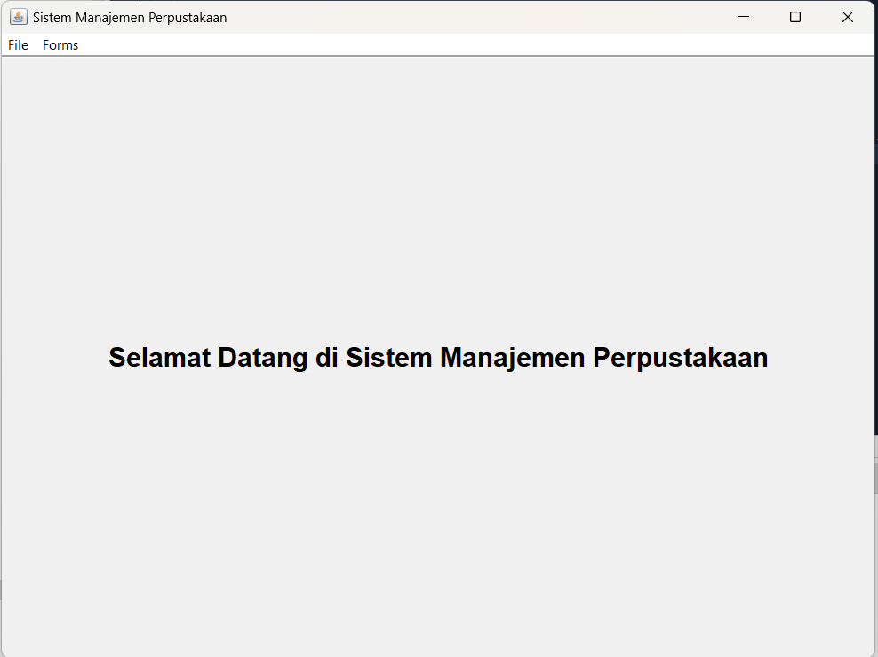
2. 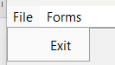
3. 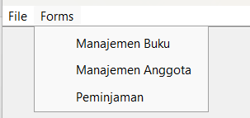
4. 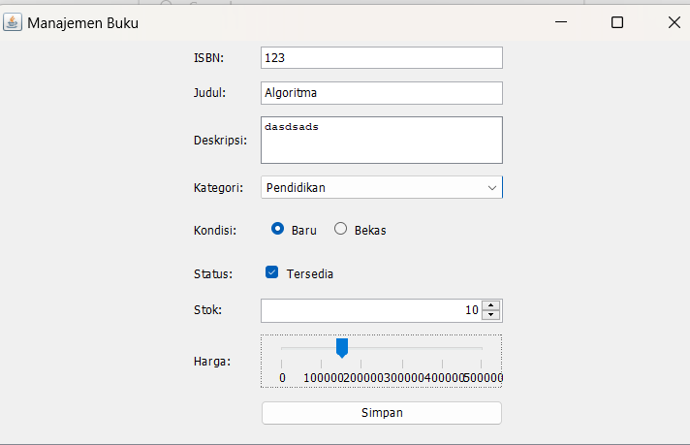



1. 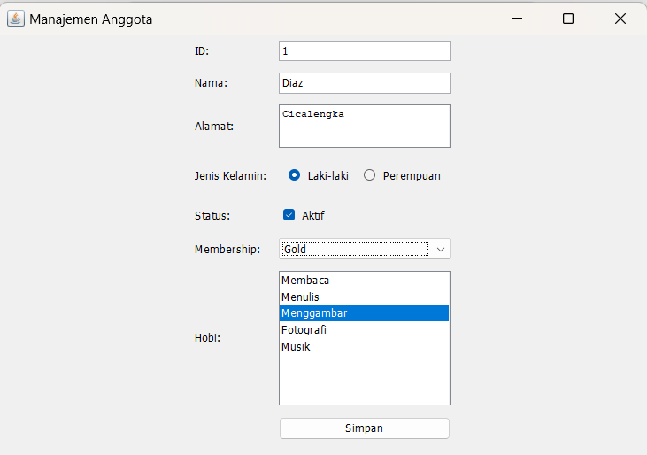

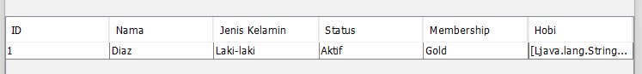

1. 