|  |  |
| --- | --- |
| **Project Case** |  |
| COMP6144  Web Programming |
| **Computer Science** | **O202-COMP6144-SV04-00** |
| ***Valid on*** *Odd Semester Year 2019/2020* | **Revision 00** |

1. Seluruh kelompok tidak diperkenankan untuk:

*The whole group is not allowed to:*

* + - Melihat sebagian atau seluruh proyek kelompok lain,

*Seeing a part or the whole project from other groups*

* + - Menyadur sebagian maupun seluruh proyek dari buku,

*Adapted a part or the whole project from the book*

* + - Mendownload sebagian maupun seluruh proyek dari internet,

*Downloading a part or the whole project from the internet,*

* + - Mengerjakan soal yang tidak sesuai dengan tema yang ada di soal proyek,

*Working with another theme which is not in accordance with the existing theme in the matter of the project,*

* + - Melakukan tindakan kecurangan lainnya,

*Committing other dishonest actions,*

* + - Secara sengaja maupun tidak sengaja melakukan segala tindakan kelalaian yang menyebabkan hasil karyanya berhasil dicontek oleh orang lain / kelompok lain.

*Accidentally or intentionally conduct any failure action that cause the results of the project was copied by someone else / other groups.*

1. Jika kelompok terbukti melakukan tindakan seperti yang dijelaskan butir 1 di atas, maka **nilai kelompok** yang melakukan kecurangan (menyontek maupun dicontek) akan di – **NOL** – kan.

*If the group is proved to the actions described in point 1 above, the score of the group which committed dishonest acts (cheating or being cheated) will be “Zero”*

1. Perhatikan jadwal pengumpulan proyek, segala jenis pengumpulan proyek di luar jadwal tidak dilayani.

*Pay attention to the submission schedule for the project, all kinds of submission outside the project schedule will not be accepted*

1. Jangan lupa untuk melihat kriteria penilaian proyek yang ditempel di papan pengumuman, atau tanya asisten anda.

*Don’t forget to look at the project assessment criteria that posted on the announcement board, or ask your teaching assistant.*

1. Persentase penilaiaan untuk matakuliah ini adalah sebagai berikut:

*Marking percentage for this subject is described as follows:*

|  |  |  |
| --- | --- | --- |
| **Tugas Mandiri**  *Assignment* | **Proyek**  *Project* | **UAP**  *Final Exam* |
| - | 100% | - |

1. Software yang digunakan pada matakuliah ini adalah sebagai berikut:

*Software will be used in this subject are described as follows:*

|  |
| --- |
| **Software**  *Software* |
| PHP Composer  PHP Storm 2019.1  Laravel Framework 5.8  XAMPP 3.23 (Apache, PHP >= 7, MySQL)  Firefox / Chrome |

## Ekstensi file yang harus disertakan dalam pengumpulan tugas mandiri dan proyek untuk matakuliah ini adalah sebagai berikut:

*File extensions should be included in assignment and project collection for this subject are described as follows:*

|  |  |
| --- | --- |
| **Tugas Mandiri**  *Assignment* | **Proyek**  *Project* |
| - | Folder Project (PHP, SQL, Image Files (JPG / PNG), ENV, HTML, CSS, SCSS, JS, JSON, HTACCESS, ARTISAN) |

## Soal

*Case*

General Provisions:

* Use **MySQL** asdatabase and **Laravel Migration** features
* **All file upload** feature such as image and document must be **stored to server storage**
* Use PHP Framework **Laravel 5.8** to build the project
* Use Laravel **MVC** concept (**Model**, **View**, **Controller**) to build the project
* Use **Eloquent Query / Query Builder** to work with database
* You are free to design your own database table **based on given requirements**
* Print screen given below is only an example. You are free to create your own user interfaces
* It is **prohibited** to install any kind of Laravel packages. You must use fresh installation of **Laravel 5.8**
* Only **validation** in the **backend** (using Laravel) will be graded

**BMDb**

**BMDb** is famous online database of information related to movie company in Indonesia. To have a better engagement with their customers, **BMDb** company wants to create a website for their **online database of movie** website. In that website, user could find any information movie.

As a web developer, you are asked to create a website using **Laravel 5.8** for this question thread. There are threetypes of user’s role in this website: **Admin**, **Member**, and **Guest** (**non-logged-in user**). For each role, the website must contain at least these pages:

* + - Admin
* Home
* Profile
* Inbox
* Master User
* Master Movie
* Master Genre
  + - Member
* Home
* Comment
* Profile
* Inbox
* List Saved Movie
  + - Guest
* Login
* Register
* Home

Each page shows **greeting to user** and **current date time**. The descriptions for each page are:

1. Login

This page is accessible only to **guest**. This page allows user to log in to the website. Display an **error message** on the login page if user enters wrong combination of **Email** and **Password**.

If user has entered correct **Email** and **Password**, redirect user to the **Home Page** based on the user’s role. If user checks the “**Remember Me**” checkbox, the website will save the **Email** and **Password** using cookies.

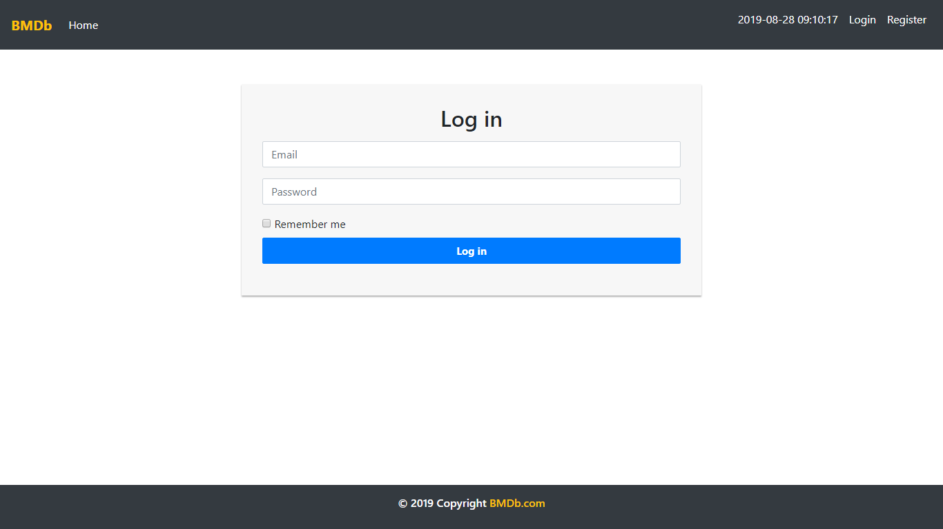

Figure . Login Page

1. Register

This page is accessible only to **guest**. This page allows guests to **register** themselves as a **Bjora** member. Display an **error message** if user input incorrect personal data.

The following table shows the existing fields on this page and the validation for each field:

|  |  |
| --- | --- |
| **Field** | **Information** |
| **Fullname** | Must be **filled** with **at most 100 characters** |
| **Email** | Must be **filled** with **email** and **unique** |
| **Password** | Must be **filled** with **at least 6 characters** and **alphanumeric format** |
| **Confirm Password** | Must be **filled** and **same with password** |
| **Gender** | Must be **selected** |
| **Address** | Must be **filled** |
| **Birthday** | Must be **filled** with **date format** |
| **Profile Picture** | Must be **selected** and must **match** one of the **allowed MIME types** (**jpeg**, **png**, **jpg**) |

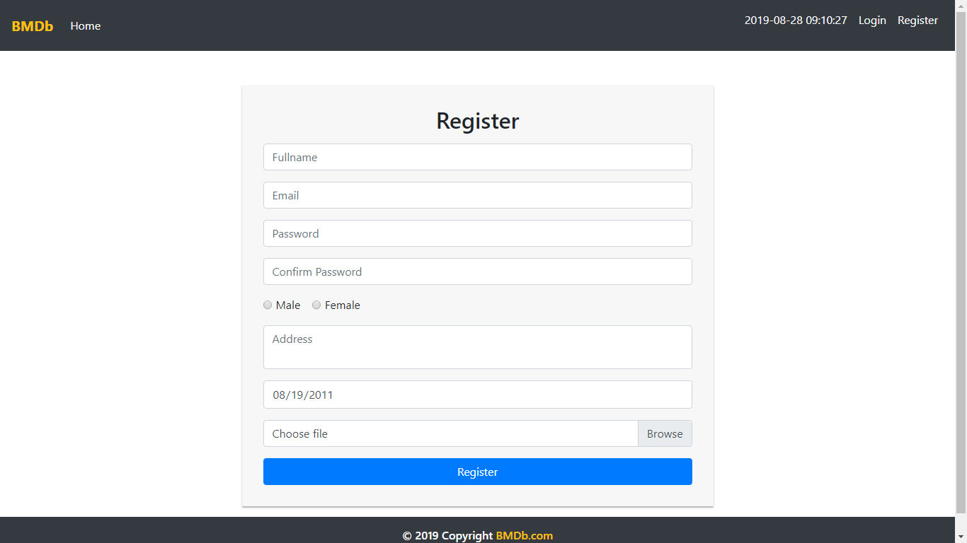

Figure 2. Register Page

1. Home

This page is accessible to **all users**. This page allows user to see all **BMDb** movie post by the admin. This page allows user to **search movie by title** or **genre**. BMDb is displayed using **pagination** with **10** **questions for each page**.

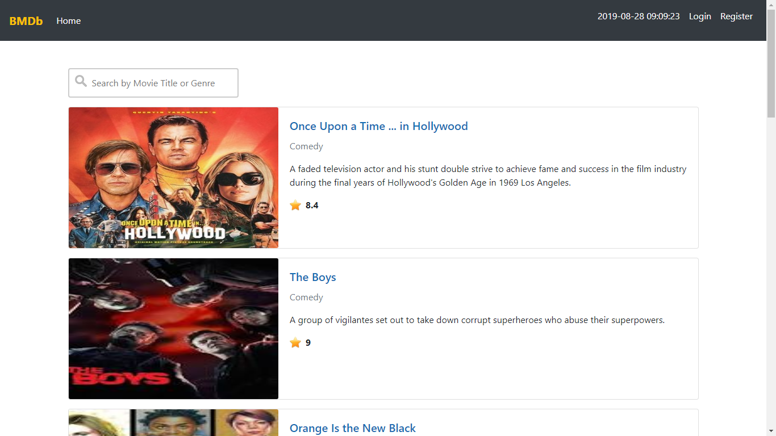

Figure 3. Home Page (for Guest)

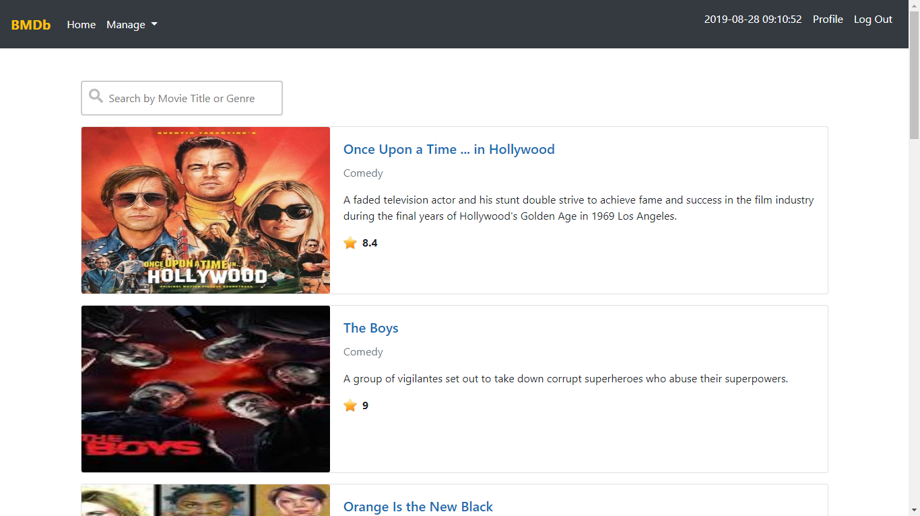

Figure 4. Home Page (for Admin)

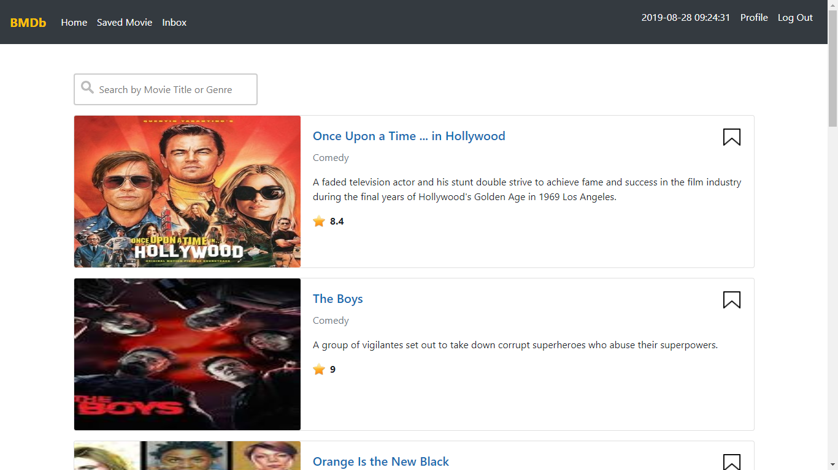

Figure 5. Home Page (for Member)

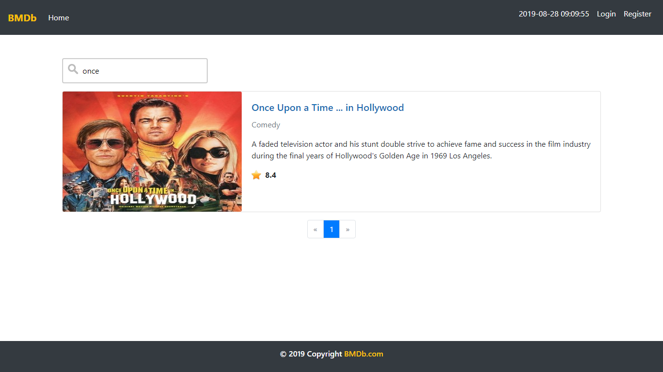

Figure 6. Searching Question with 'Once' Keyword

1. Movie Detail Page

This page is accessible to **all users**. This page can be accessed if user clicks **Movie Title** in **Home page**. This page allows user to **view and comment** the selected movie. Display movie information such as **movie’s title**, **movie’s genre, movie’s description, movie’s rating,** **movie’s creation date**, **comment**, **comment’s owner** and **comment’s creation** **date**. Make sure all **comment’s owner name** can be clicked. Redirect user to **profile page** if user clicked the user’s name.

User could **post** a comment to the current movie by using the form below the question. Show the form only to **member** and **admin**. The requirements for each field are:

|  |  |
| --- | --- |
| **Field** | **Information** |
| **Comment** | Must be **filled** |

The user can also **delete** their **own comment**. Validate that the **delete** buttons only appeared to **the current logged in user**’**s comment**. If user clicked the **delete** button, then **delete** the selected answer.

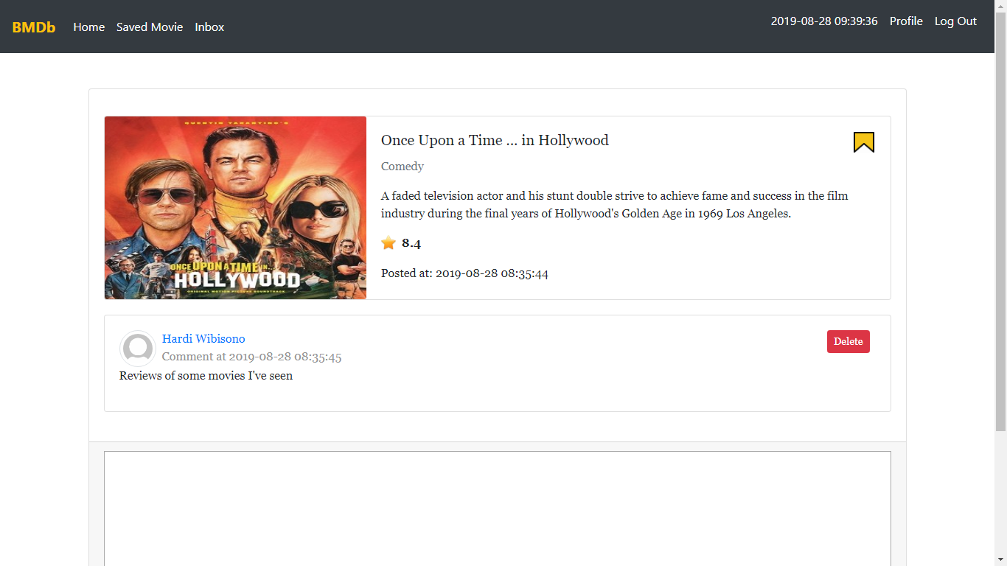

Figure 7. Movie Detail Page (Opening Current Logged In User)

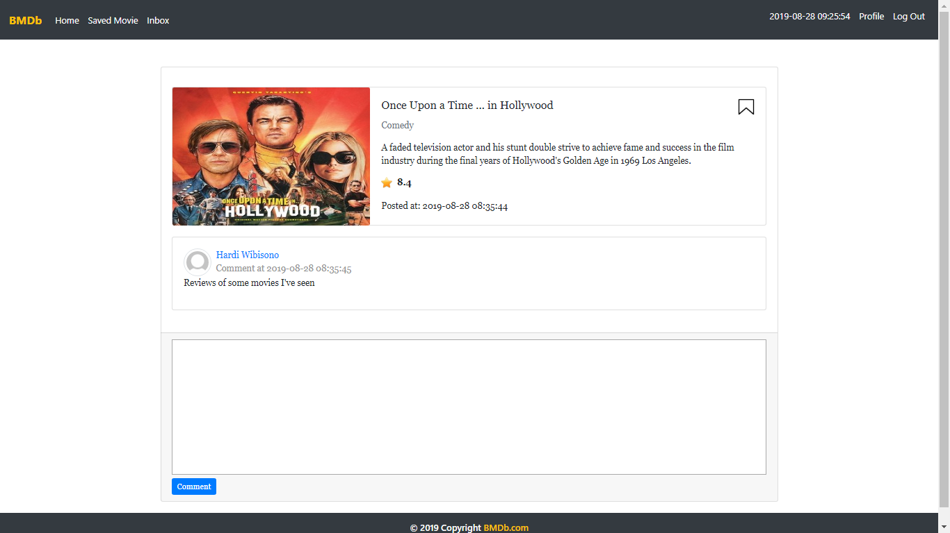

Figure 8. Movie Detail Page (Viewing Another User Comment)

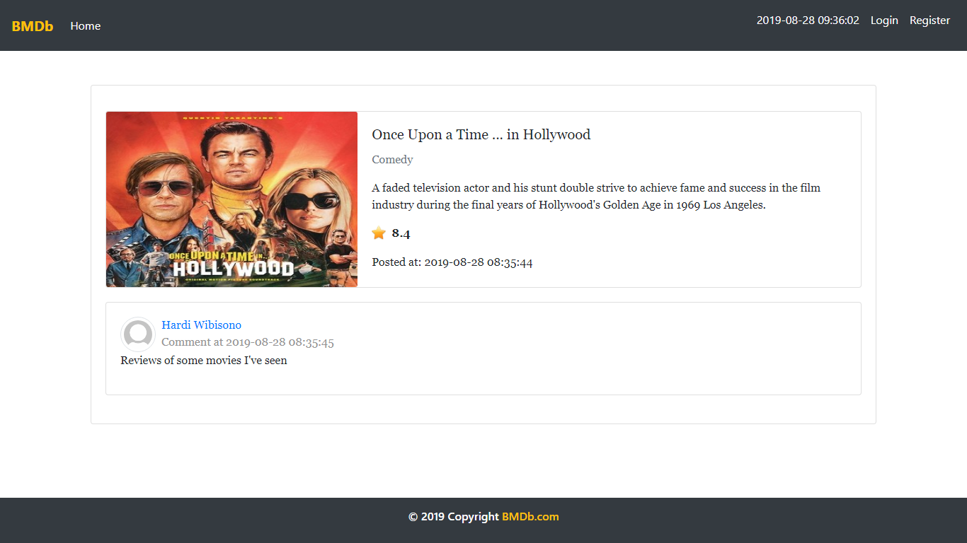

Figure 9. Movie Detail Page (for Guest)

1. Profile Page

This page is accessible to **member** and **admin**. This page allows user to **see their profile** or **another** **user**’**s** **profile**.

There are some requirements on this page:

* If the user is viewing their own profile, validate that only **Update** button is **visible**. If user clicks the **Update** button, then redirect user to **Update** **Profile** page
* If the user is viewing others user’s profile, validate that only **Send Message** form is visible. If user clicks the **Send Message** button, validate that the **message** field must be **filled** beforehand, and then send the **corresponding message** to the user

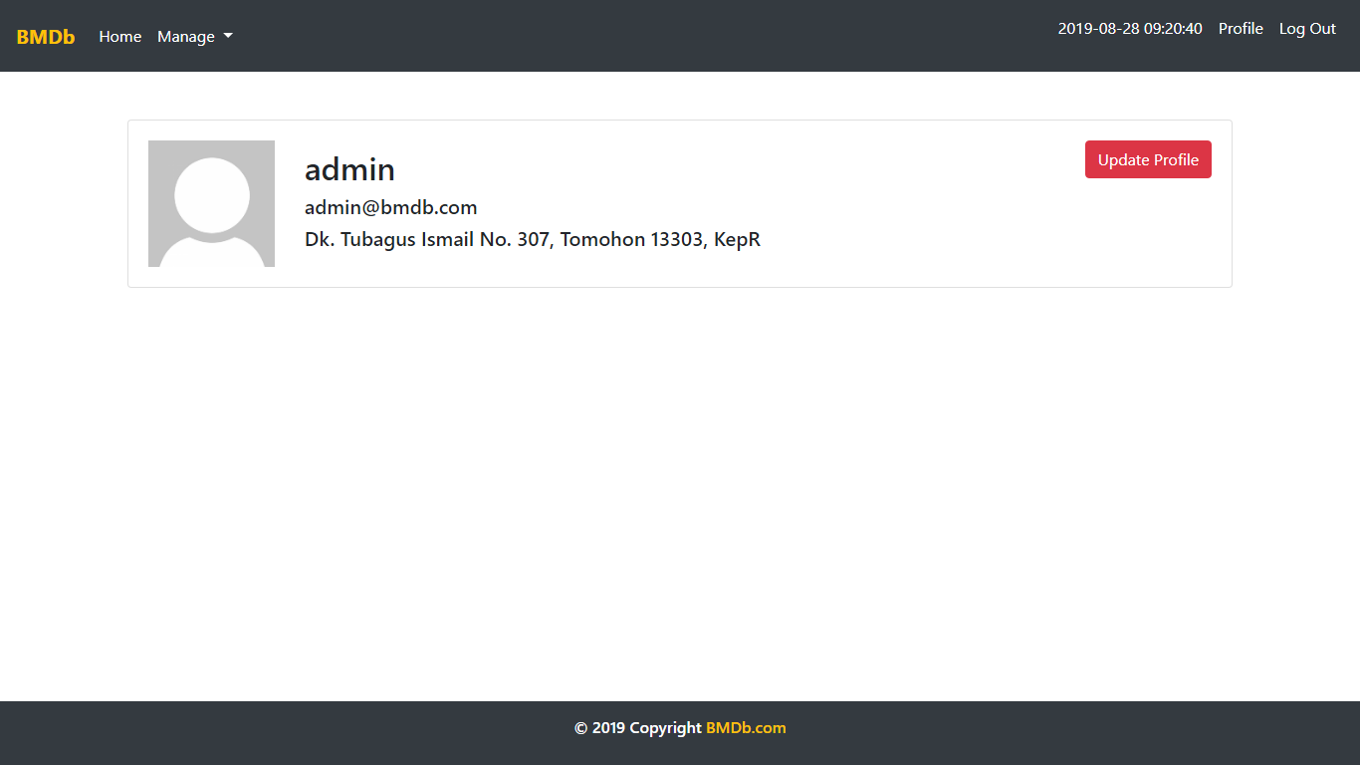

Figure 10. Profile Page (Opening Current Logged In User)

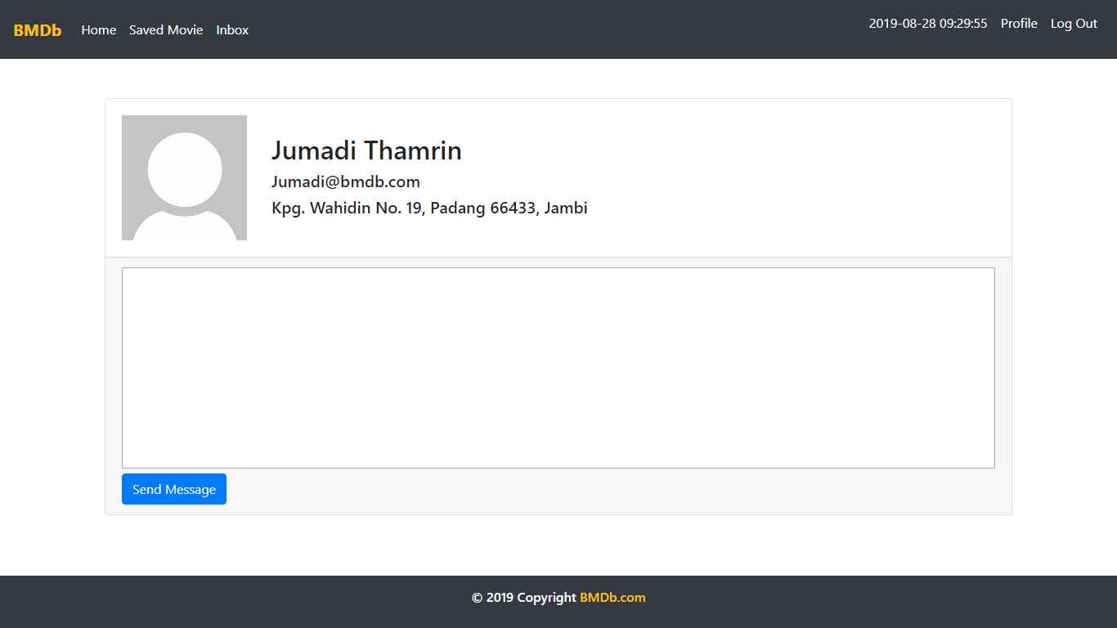

Figure 11. Profile Page (Viewing Another User Profile)

1. Edit Profile Page

This page allows user to **update** their profile data. Display **error message** if user input incorrect user data.

The following table shows existing fields in the **Edit Profile Page** and the validation for each field:

|  |  |
| --- | --- |
| **Field** | **Information** |
| **Fullname** | Must be **filled** with **at most 100 characters** |
| **Email** | Must be **filled** with **email** and **unique** |
| **Role** | Must be **selected** |
| **Password** | Must be **filled** with **at least 6 characters** and **alphanumeric format** |
| **Confirm Password** | Must be **filled** and **same with password** |
| **Gender** | Must be **selected** |
| **Address** | Must be **filled** |
| **Birthday** | Must be **filled** with **date format** |
| **Profile Picture** | Must be **selected** and must **match** one of the **allowed MIME types** (**jpeg**, **png**, **jpg**) |

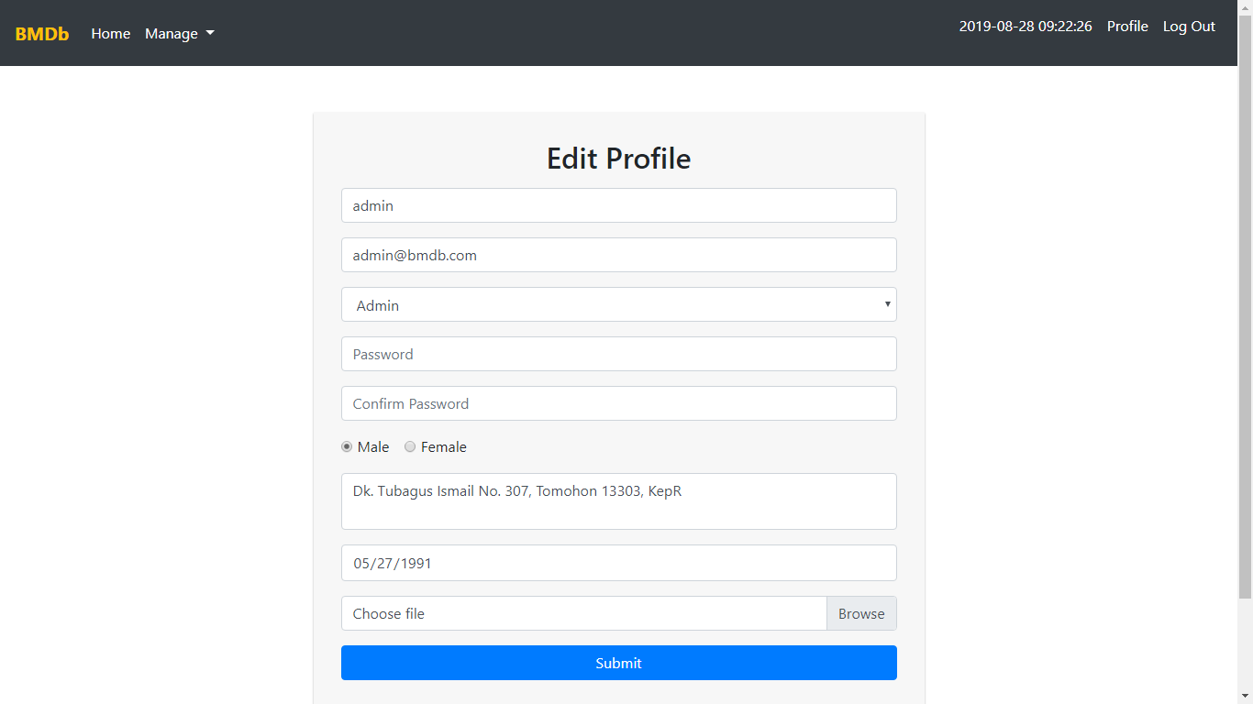

***Figure 12. Edit Profile Page***

1. Inbox Page

This page is accessible to **member**. This page allows user to **view** and **delete** messages they received. Display message information such as **message’s content**, **message’s sender**, and **message’s creation date**. In this page, all messages displayed using **pagination** with **10 messages each page**. If user click **Remove button**, then **delete** the selected message.

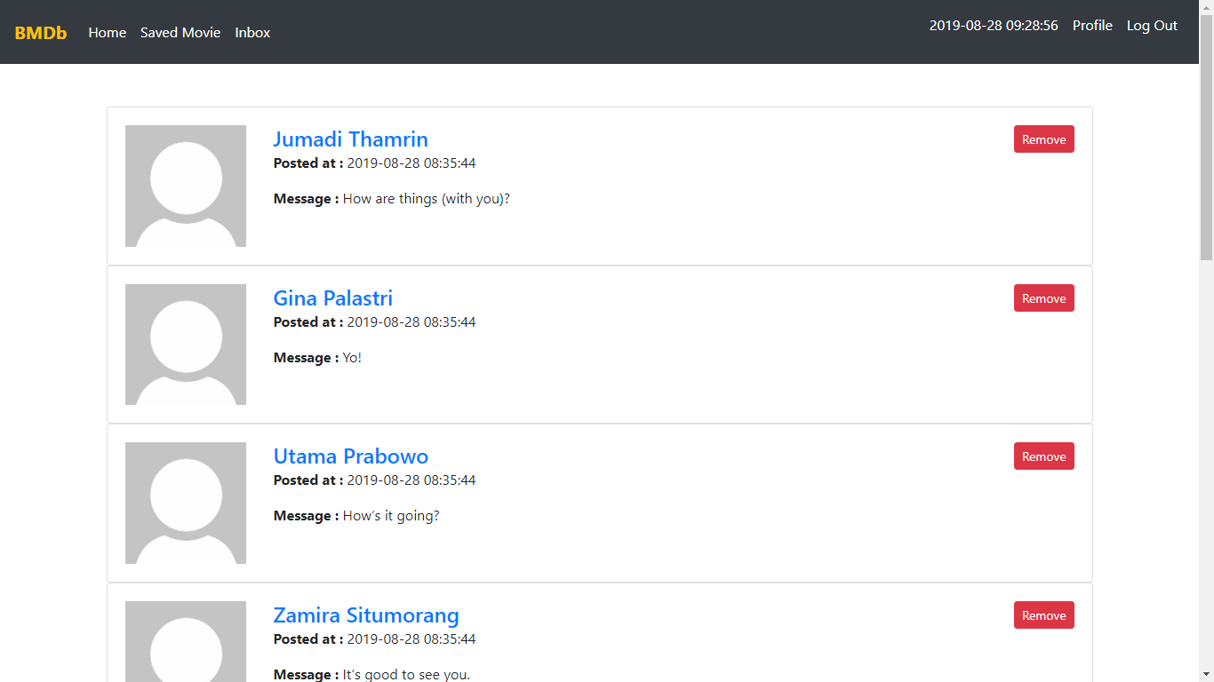

Figure 13. Inbox Page

1. Saved Page

This page is accessible to **member**. This page is accessible by clicking **Saved Movie** in navigation bar. This page **shows** all **movie** that user has saved by using **pagination** with **10** **questions per page** and allows user to **remove** it from saved movie by clicking the **unsaved icon**.Display movie information such as **movie’s content** and **movie’s status**.

Each movie in the lists have **unsaved icon**:

* If user click **unsaved icon**, change the **selected** **status** to ‘**unsaved**’. Validate ‘**unsaved icon**’only **enabled** for movie that the **status** still ‘**saved icon**’

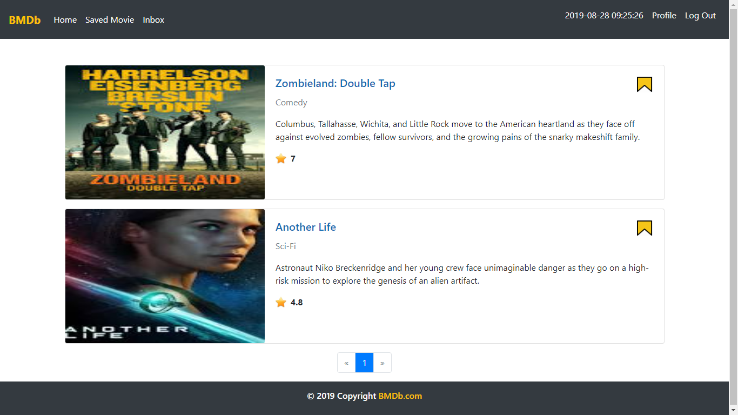

Figure 14. Saved Page

1. Master User Page

This page is accessible only to **admin**. This page shows all users using **pagination** with **10** **users each page**.

In this page, there are ‘**Add User**’, ‘**Edit**’, and ‘**Delete**’ button:

* If user click **Add User** button, redirect user to **Add User Page**
* If user click **Edit** button, redirect user to **Update User Page**
* If user click **Delete** button, **delete** selecteduser

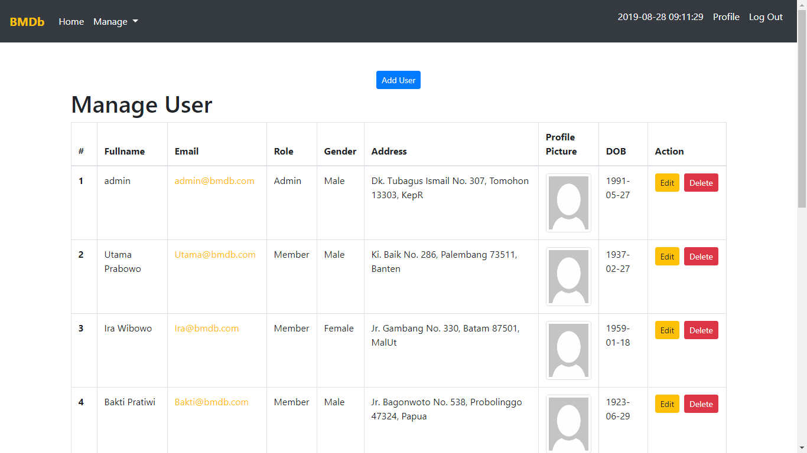

Figure 15. Master User Page

1. Add User Page

This page allows **Admin** to **add new user**. Display **error message** if user input incorrect user data.

The following table shows existing fields in the **Add User Page** and the validation for each field:

|  |  |
| --- | --- |
| **Field** | **Information** |
| **Fullname** | Must be **filled** with **at most 100 characters** |
| **Email** | Must be **filled** with **email** and **unique** |
| **Role** | Must be **selected** |
| **Password** | Must be **filled** with **at least 6 characters** and **alphanumeric format** |
| **Confirm Password** | Must be **filled** and **same with password** |
| **Gender** | Must be **selected** |
| **Address** | Must be **filled** |
| **Birthday** | Must be **filled** with **date format** |
| **Profile Picture** | Must be **selected** and must **match** one of the **allowed MIME types** (**jpeg**, **png**, **jpg**) |

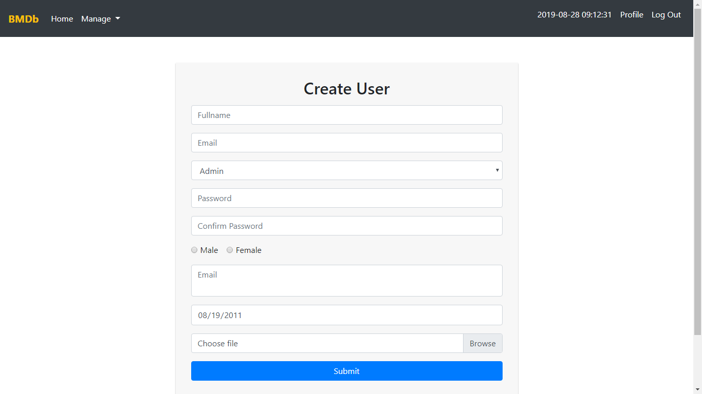

Figure 16. Add User Page

1. Edit User Page

This page allows **Admin** to **update** user data. Display an **error message** if user input incorrect data.

The following table shows existing fields in the **Edit Profile Page** and the validation for each field:

|  |  |
| --- | --- |
| **Field** | **Information** |
| **Name** | Must be **filled** with **at most 100 characters** |
| **Role** | Must be **selected** |
| **Email** | Must be **filled** with **email** and **unique** |
| **Password** | Must be **filled** with **at least 6 characters** and **alphanumeric format** |
| **Confirm Password** | Must be **filled** and **same with password** |
| **Gender** | Must be **selected** |
| **Address** | Must be **filled** |
| **Profile Picture** | Must be **selected** and must **match** one of the **allowed MIME types** (**jpeg**, **png**, **jpg**) |
| **Birthday** | Must be **filled** with **date format** |

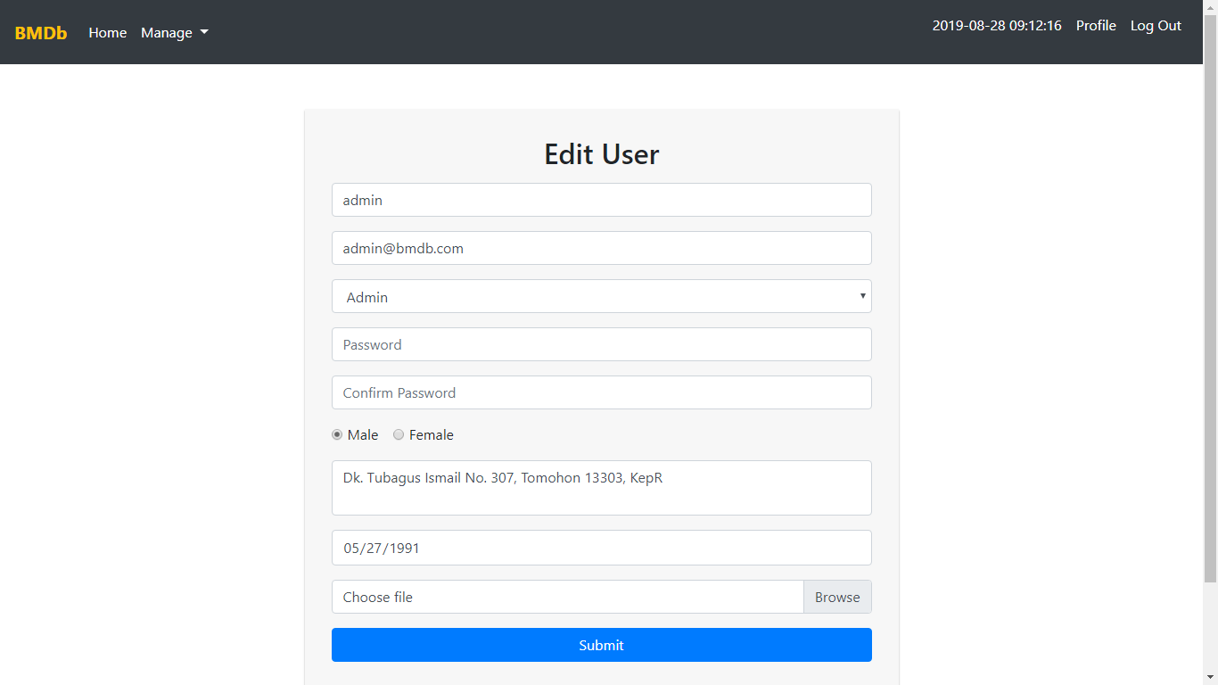

Figure 17. Update User Page

1. Master Movie Page

This page is accessible only to **admin**. This page shows all movies using **pagination** with **10** movies each page.

In this page, there are ‘**Delete**’ button:

* If user click ‘**Delete**’ **button**, **delete** the movie

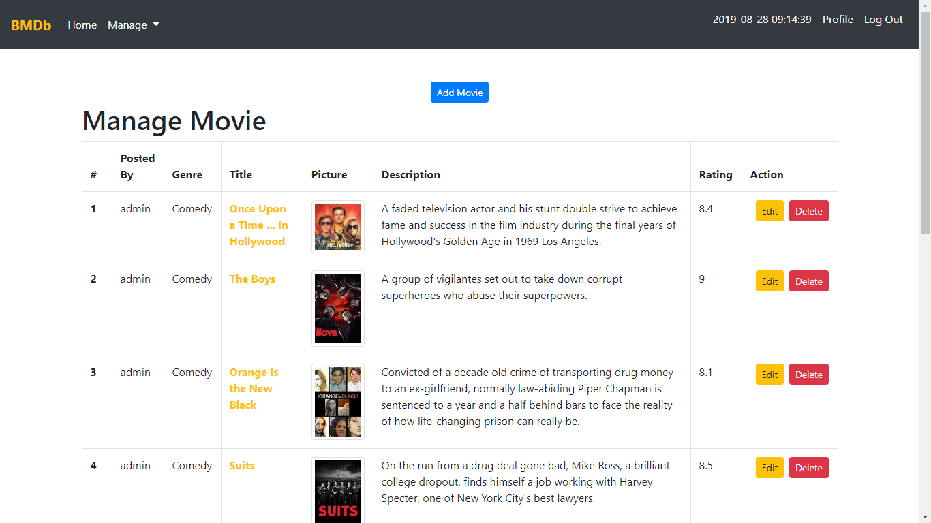

Figure 18. Master Movie Page

1. Add Movie Page

This page is accessible for **admin**. This page allows user to **insert** new movie. Display **error message** if user input incorrect movie data.

The following table shows existing fields in the **Add Movie Page** and the validation for each field:

|  |  |
| --- | --- |
| **Field** | **Information** |
| **Title** | Must be **filled** |
| **Genre** | Must be **selected** |
| **Description** | Must be **filled** |
| **Rating** | Must be **numeric** with between **0** and **10** |
| **Picture** | Must be **selected** and must **match** one of the **allowed MIME types** (**jpeg**, **png**, **jpg**) |

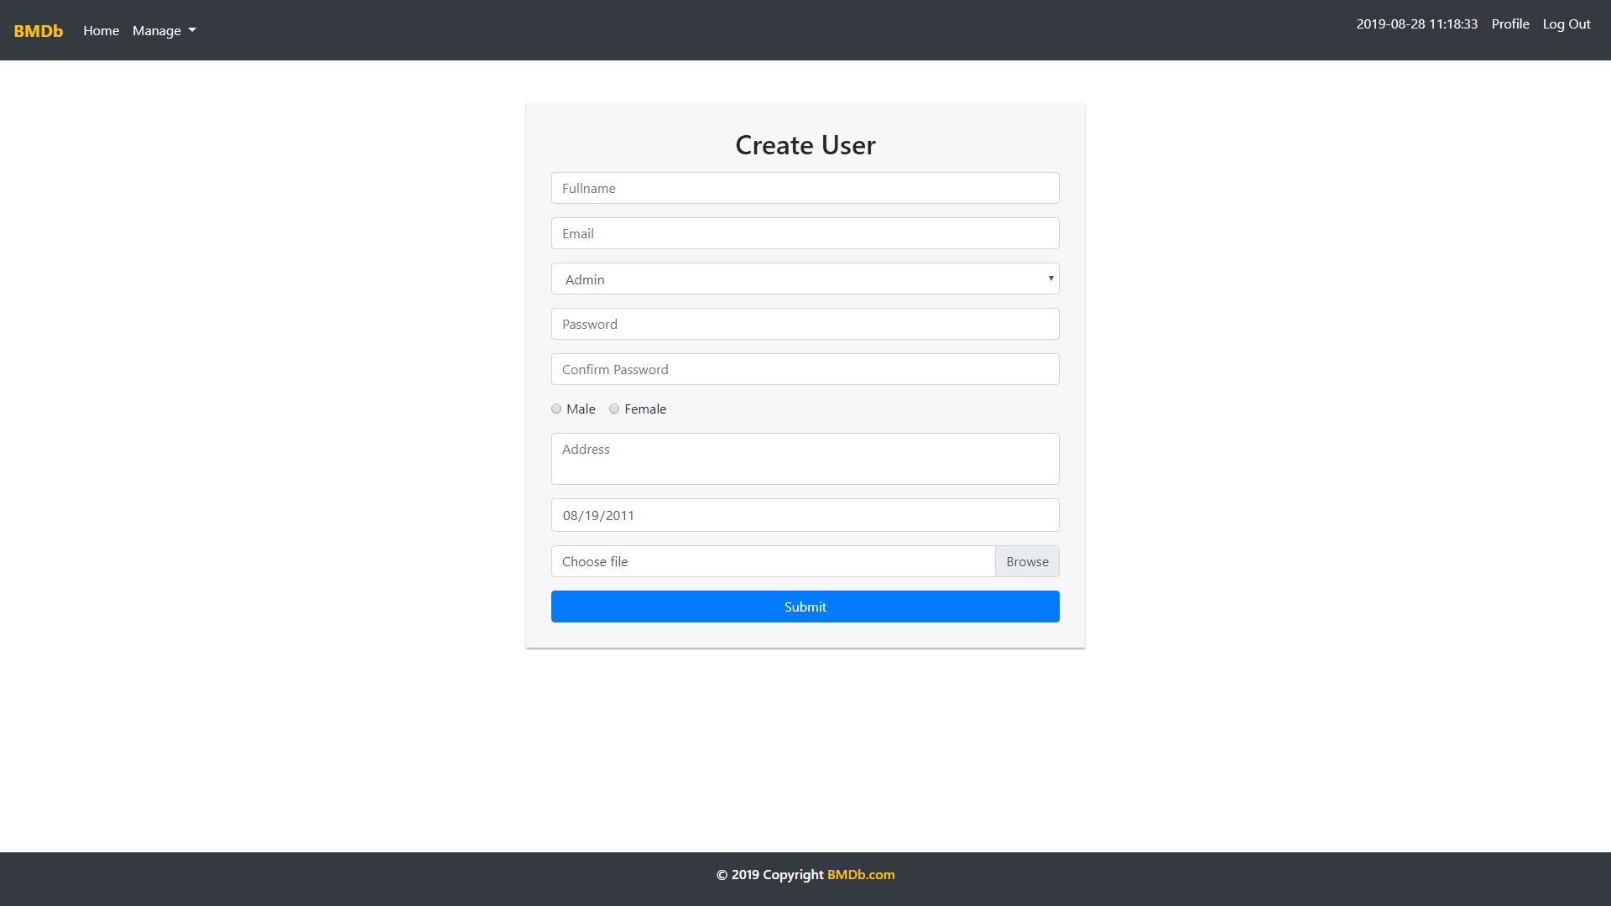

Figure 19. Add Movie Page

1. Update Movie Page

This page is accessible to **admin**. This page allows user to **update** specific movie. Display **error message** if user input incorrect movie data. The following table shows existing fields in the **Update Movie Page** and the validation for each field:

|  |  |
| --- | --- |
| **Field** | **Information** |
| **Title** | Must be **filled** |
| **Genre** | Must be **selected** |
| **Description** | Must be **filled** |
| **Rating** | Must be **numeric** with between **0** and **10** |
| **Picture** | Must be **selected** and must **match** one of the **allowed MIME types** (**jpeg**, **png**, **jpg**) |

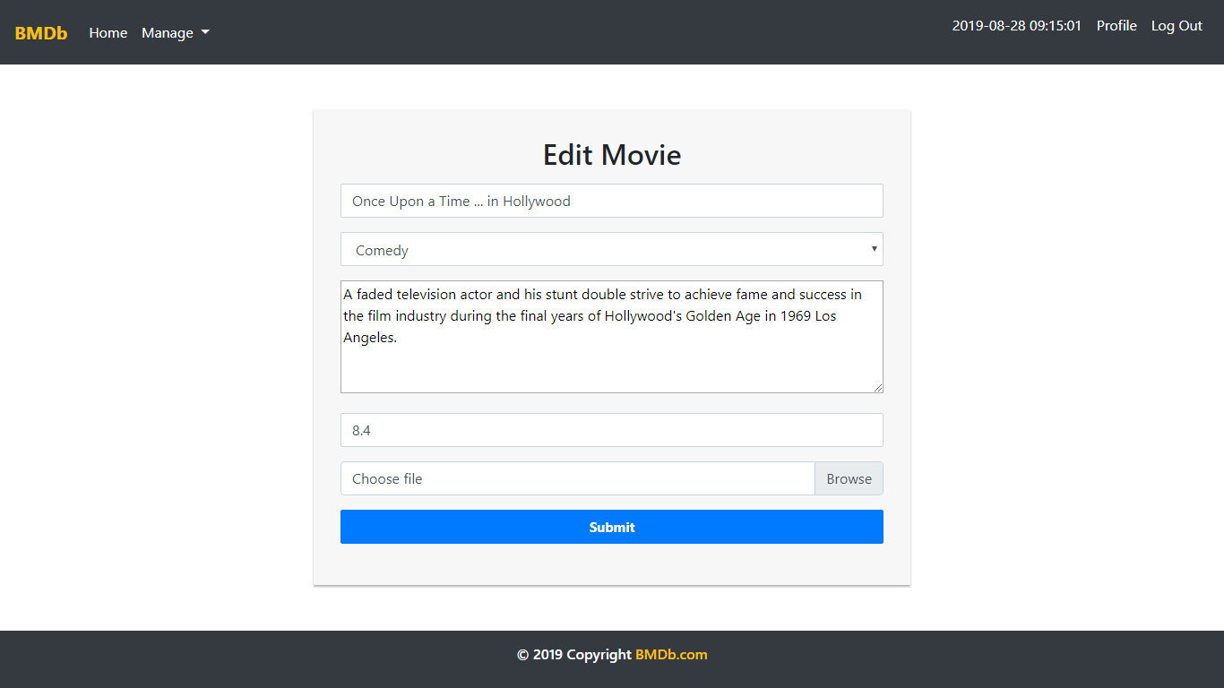

Figure 20. Update Movie Page

1. Master Genre Page

This page is accessible only to **admin**. This page allows **Admin** to manage all genres. In this page, there are ‘**Add**’, ‘**Edit**’, and ‘**Delete**’ button:

* If user click **Add button**, validate **name field** must be **filled** before user can **add** the genre. Display error message if user input incorrect topic data
* If user click **Edit** **button**, redirect user to **Edit Genre Page**
* If user click **Delete** **button**, **delete** the selected topic

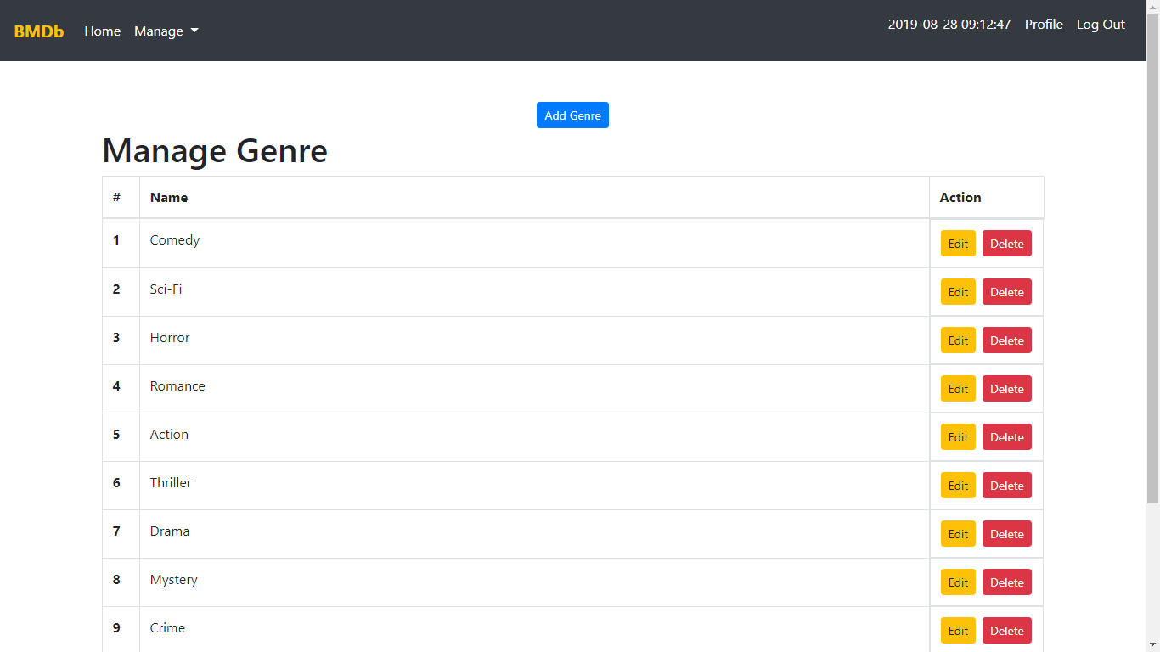

Figure 21. Master Genre Page

1. Add Genre Page

This page is accessible for **admin**. This page allows user to **insert** new genre. Display **error message** if user input incorrect genre data.

The following table shows existing fields in the **Add Genre Page** and the validation for each field:

|  |  |
| --- | --- |
| **Field** | **Information** |
| **Name** | Must be **filled** |

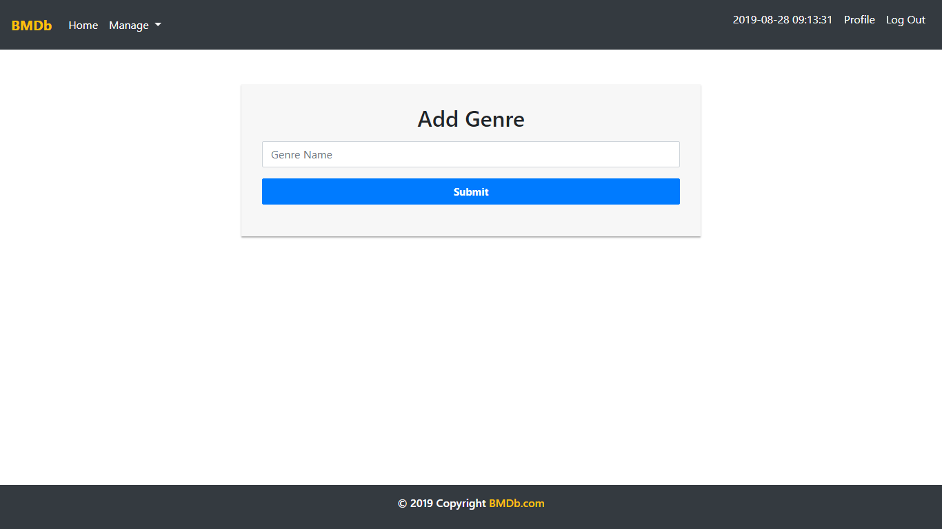

**Figure 22. Edit Genre Page**

1. Update Genre Page

This page allows user to **update genre’s** **name**. The **name field** must be **filled** before user click **Update button**. If the user clicks **Update button**, then **update** **selected genre**.

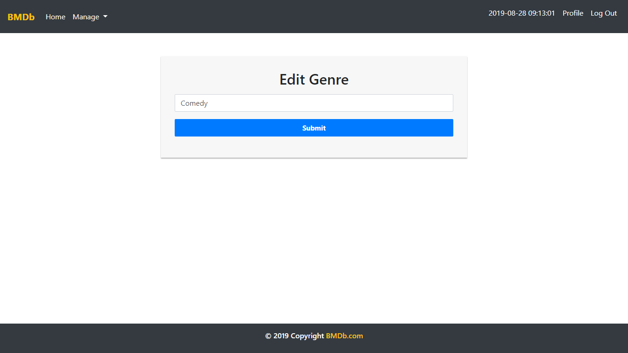

**Figure 23. Edit Genre Page**

Here are the rules that you must follow to create your project:

1. Use appropriate software for this subject based on **Sistem Praktikum** that can be downloaded from Binusmaya.
2. Collect appropriate files for this subject based on **Sistem Praktikum** that can be downloaded from Binusmaya.
3. Include the other files that can support your project, such as:
   * All files in your project
   * Other files (image, audio, video, etc.) used in your project
   * *.DOC file (documentation of your project) that contains all pages in your project, reference links of additional files (image, audio, video, etc.) used in your project, the description about how to use your application, etc.
4. If there are some hidden creativities, please note them in the existing documentation because they can greatly affect your project score

**Reference**:

* <https://cresscap.com/dummy-profile-pic/>
* <https://www.google.com/url?sa=i&source=images&cd=&ved=2ahUKEwis1pKXuKXkAhVJVH0KHUX_CSAQjRx6BAgBEAQ&url=https%3A%2F%2Fwww.iconfinder.com%2Ficons%2F3951293%2Fbookmark_icon_instagram_save_saved_sets_icon&psig=AOvVaw3YuBkrdx7E0Li93I-jqVoU&ust=1567077348318080>