**Analyzing HTTP Traffic with Wireshark**

**1.Introduction**

This project shows how to use Wireshark to capture and analyze HTTP traffic. HTTP traffic analysis is crucial for understanding web communication, identifying potential security issues, and investigating anomalies in network traffic.

**2.Tools**

1. **Wireshark**.
2. **Web Browser**.

**3.Exercises**

**Exercise 1: Capture HTTP Traffic**

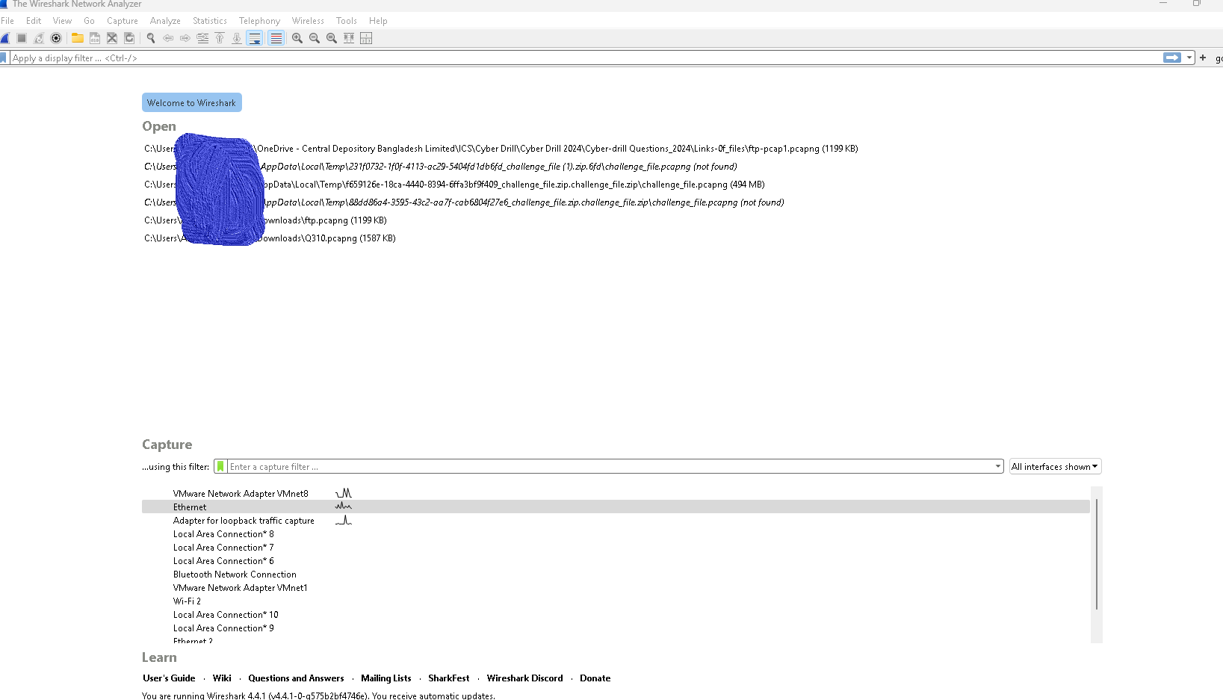

**Expected Output**

* A capture file containing network traffic, including HTTP requests and responses.

**Exercise 2: Filter HTTP Traffic**

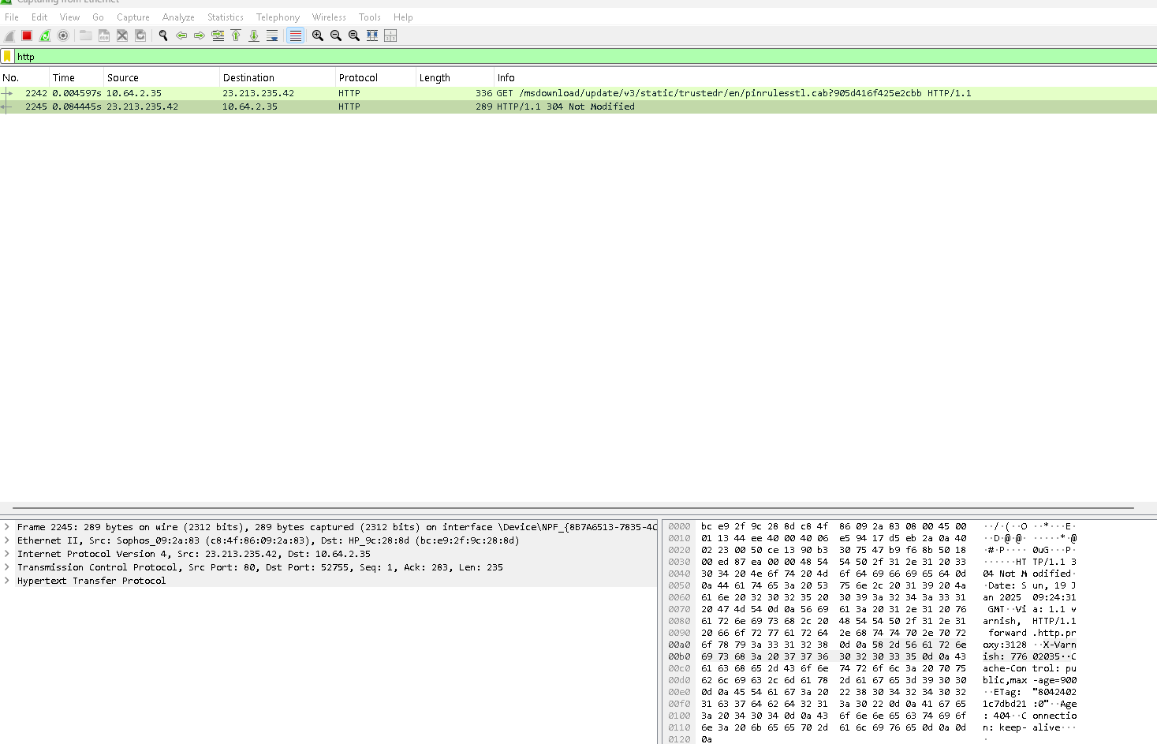

**Expected Output**

* Displayed HTTP traffic filtered from the overall capture.

**Exercise 3: Analyze HTTP Requests**

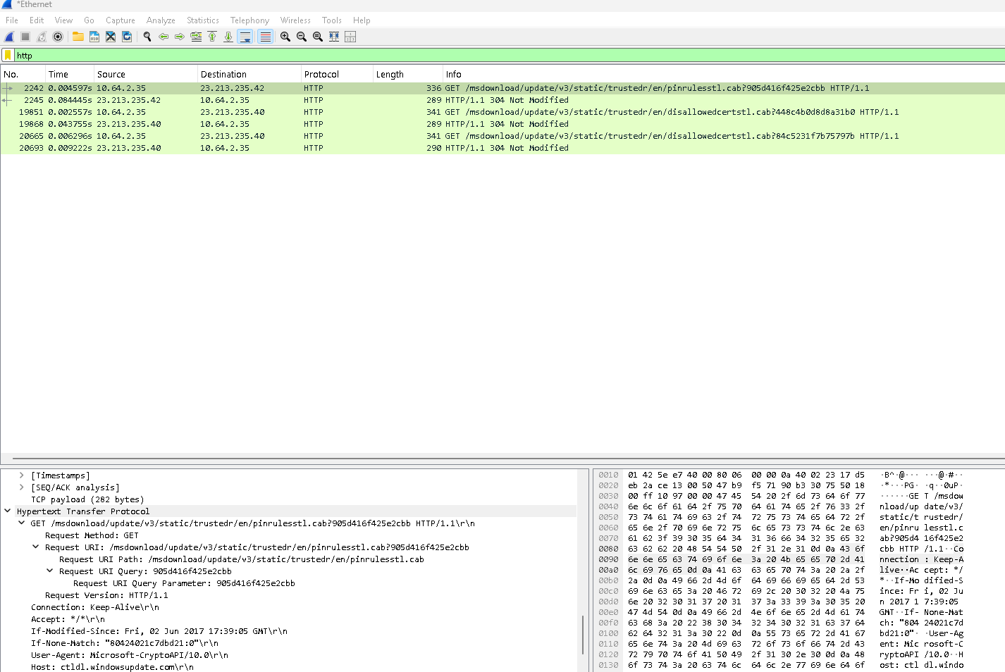

**Expected Output**

* Detailed information about an HTTP GET request displayed.

**Exercise 4: Analyze HTTP Responses**

#### **Expected Output**

* Detailed information about an HTTP response displayed.

### **Exercise 5: Extract and Examine Payload Data**

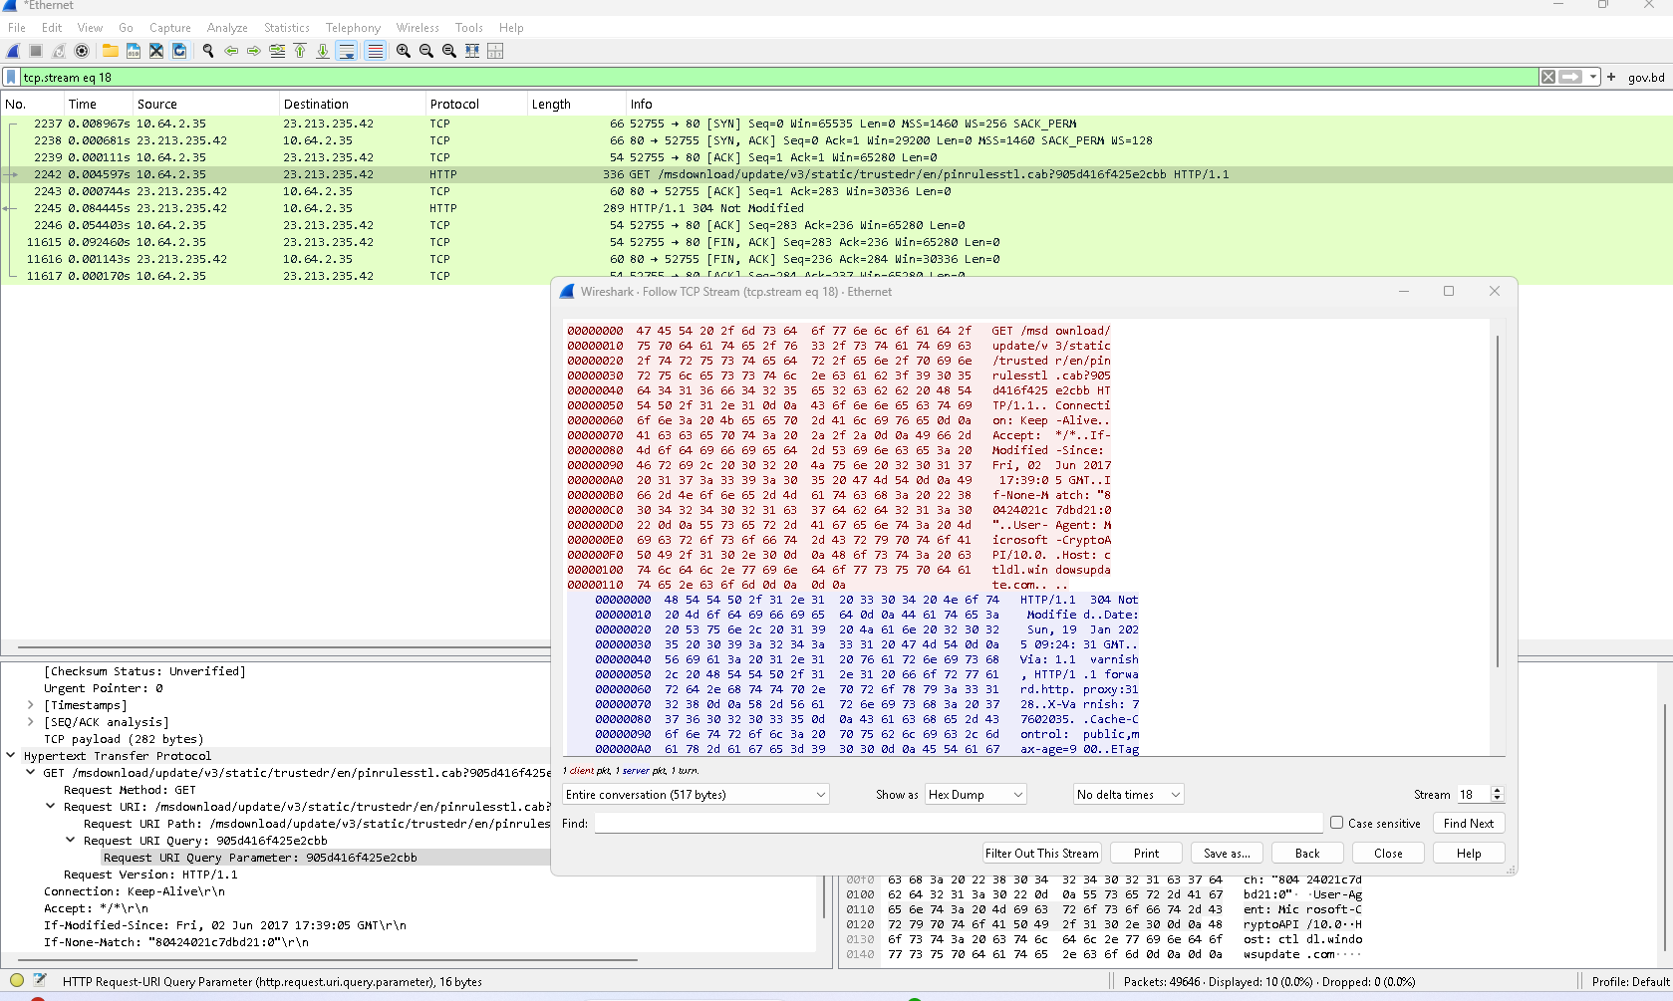

#### **Expected Output**

* Payload data from the HTTP response extracted and examined.