**TADA**

**Group 4**

ITU

Chia Chia Tu 95375

Chen Zhang

Moonisha Kapur

On Lan Law 94685

Tom Ahsan

**Table of Contents**

|  |  |  |  |  |  |
| --- | --- | --- | --- | --- | --- |
|  | **1.0** | **Executive Summary . . . . . . . . . . . . . . . . . . . . . . . . . . . . . . . . . . . . . . . . . . . . . . . . . . . . . . . . . . . . . . . . . . . . . . . . . . . . . . . . . . . . . . . . . . . . . . . . . . . . . . . . . . . . . . . . . . . . . . . . . . . . . . . . . . . . . . . . . . . . . . . .** | | | **3** |
|  | | | 1.1 | Overview . . . . . . . . . . . . . . . . . . . . . . . . . . . . . . . . . . . . . . . . . . . . . . . . . . . . . . . . . . . . . . . . . . . . . . . . . . . . . . . . . . . . . . . . . . . . . . . . . . . . . . . . . . . . . . . . . . . . . . . . . . . . . . . . . . . . . . . . . . . . . . . . | 3 |
|  | | | 1.2 | Objectives . . . . . . . . . . . . . . . . . . . . . . . . . . . . . . . . . . . . . . . . . . . . . . . . . . . . . . . . . . . . . . . . . . . . . . . . . . . . . . . . . . . . . . . . . . . . . . . . . . . . . . . . . . . . . . . . . . . . . . . . . . . . . . . . . . . . . . . . . . . . . . . . | 3 |
|  | | | 1.3 | Mission . . . . . . . . . . . . . . . . . . . . . . . . . . . . . . . . . . . . . . . . . . . . . . . . . . . . . . . . . . . . . . . . . . . . . . . . . . . . . . . . . . . . . . . . . . . . . . . . . . . . . . . . . . . . . . . . . . . . . . . . . . . . . . . . . . . . . . . . . . . . . . . . | 3 |
|  | | | 1.4 | Management Team . . . . . . . . . . . . . . . . . . . . . . . . . . . . . . . . . . . . . . . . . . . . . . . . . . . . . . . . . . . . . . . . . . . . . . . . . . . . . . . . . . . . . . . . . . . . . . . . . . . . . . . . . . . . . . . . . . . . . . . . . . . . . . . . . . . . . . . . . . . . . . . . | 3 |
|  | | | 1.5 | Industry Needs . . . . . . . . . . . . . . . . . . . . . . . . . . . . . . . . . . . . . . . . . . . . . . . . . . . . . . . . . . . . . . . . . . . . . . . . . . . . . . . . . . . . . . . . . . . . . . . . . . . . . . . . . . . . . . . . . . . . . . . . . . . . . . . . . . . . . . . . . . . . . . . . | 4 |
|  | | | 1.6 | Market . . . . . . . . . . . . . . . . . . . . . . . . . . . . . . . . . . . . . . . . . . . . . . . . . . . . . . . . . . . . . . . . . . . . . . . . . . . . . . . . . . . . . . . . . . . . . . . . . . . . . . . . . . . . . . . . . . . . . . . . . . . . . . . . . . . . . . . . . . . . . . . . | 5 |
|  | | | 1.7 | Products . . . . . . . . . . . . . . . . . . . . . . . . . . . . . . . . . . . . . . . . . . . . . . . . . . . . . . . . . . . . . . . . . . . . . . . . . . . . . . . . . . . . . . . . . . . . . . . . . . . . . . . . . . . . . . . . . . . . . . . . . . . . . . . . . . . . . . . . . . . . . . . . | 9 |
|  | | |  |  |  |
|  | | | 1.8 | Development Status . . . . . . . . . . . . . . . . . . . . . . . . . . . . . . . . . . . . . . . . . . . . . . . . . . . . . . . . . . . . . . . . . . . . . . . . . . . . . . . . . . . . . . . . . . . . . . . . . . . . . . . . . . . . . . . . . . . . . . . . . . . . . . . . . . . . . . . . . . . . . . . . | 11 |
|  | | | 1.9 | Keys to Success . . . . . . . . . . . . . . . . . . . . . . . . . . . . . . . . . . . . . . . . . . . . . . . . . . . . . . . . . . . . . . . . . . . . . . . . . . . . . . . . . . . . . . . . . . . . . . . . . . . . . . . . . . . . . . . . . . . . . . . . . . . . . . . . . . . . . . . . . . . . . . . . | 11 |
|  | | | 1.10 | Technological Advantages . . . . . . . . . . . . . . . . . . . . . . . . . . . . . . . . . . . . . . . . . . . . . . . . . . . . . . . . . . . . . . . . . . . . . . . . . . . . . . . . . . . . . . . . . . . . . . . . . . . . . . . . . . . . . . . . . . . . . . . . . . . . . . . . . . . . . . . . . . . . . . . . | 11 |
|  | | | 1.11 | Competitive Advantages . . . . . . . . . . . . . . . . . . . . . . . . . . . . . . . . . . . . . . . . . . . . . . . . . . . . . . . . . . . . . . . . . . . . . . . . . . . . . . . . . . . . . . . . . . . . . . . . . . . . . . . . . . . . . . . . . . . . . . . . . . . . . . . . . . . . . . . . . . . . . . . . | 12 |
|  | | | 1.12 | Strategy . . . . . . . . . . . . . . . . . . . . . . . . . . . . . . . . . . . . . . . . . . . . . . . . . . . . . . . . . . . . . . . . . . . . . . . . . . . . . . . . . . . . . . . . . . . . . . . . . . . . . . . . . . . . . . . . . . . . . . . . . . . . . . . . . . . . . . . . . . . . . . . . | 13 |
|  | | | 1.13 | Financial Goals . . . . . . . . . . . . . . . . . . . . . . . . . . . . . . . . . . . . . . . . . . . . . . . . . . . . . . . . . . . . . . . . . . . . . . . . . . . . . . . . . . . . . . . . . . . . . . . . . . . . . . . . . . . . . . . . . . . . . . . . . . . . . . . . . . . . . . . . . . . . . . . . | 13 |

1.0 Executive Summary

**1.1 Overview**

Matching the right design candidate to a job position has been challenging for both the job seekers as well as the recruiters. When it comes to recruitment, there are a lot of things a recruiter / hiring manager needs to know in order to decide if a candidate is qualified for a job. On the job seekers side, it’s also been difficult for many to showcase their past experience and portfolio in a way that can best represent themselves as designers that are qualified for the job. On the recruiter side, it’s often time consuming for them to go through a list of resumes before finding the right one.

Our solution to these problems is to build a platform that enables designers to best showcase their past work and experience in a way that can help them stand out and get matched with the right job position. We will use machine learning to match recruiters to the top qualified candidates using 3 data points: **project type** (example: Visual Design, Illustration, Design System, Wireframing, Prototyping, User Research, Animation), **tools** (example: Figma, Adobe Suite, Unity, Invision, Sketch) and a **feedback system** that recruiters will provide every time they get match with candidates. The more data and feedback we gather, the smarter the platform will be.

This product will allow:

* **Designers** to upload their portfolio work and tag each work to a specific category that is easily searchable by recruiters
* **Recruiters** to come to the platform and immediately get the best recommendation for top qualified candidates so they don’t have to go through hundreds of resumes

**1.2 Objectives**

Tada’s objective is to help designers showcase their best selves so that they can be matched and found by the right people. There’s a gap in the industry for job seeking designers to be able to showcase their work in order to get recruited and there’s also a gap in the recruiting industry that recruit designers where it’s very time consuming to filter out the right design candidate for the job that recruiters are trying to fill in. Our goal is to build a tool that benefits both sides of the coin so that the right candidate can be found by the right recruiter.

**1.3 Mission**

We aim to provide design professionals with a platform that allows them to showcase their careers and allows recruiters to easily find and connect with them.

**1.4 Management Team**

Chen Zhang

Chia Chia Tu

Moonisha Kapur

On Lan Law

Tom Ahsan

**1.5 Industry Needs**

The size of the global design industry to be $162 billion and believe it will grow more than 20% this year. The number of designers is probably going to grow even faster according to updated employment projections from US Bureau of Labor Statistics for the next 10 years.

*For the designers*

Designers usually have a more complicated / complex way to show their skill sets and their past experience. A designer’s qualification cannot be as simple as being written as a one-pager resume where people usually put in their past work experience and their roles.

For designers, recruiters and hiring managers need to see beyond their role and the work that they do at their previous company. A designer can only stand out by truly showcasing the breadth of their creative work which is usually in the form of multimedia. Different designers will need a different type of media to best showcase their work. For example, a UX Designer will need to be able to embed an interactive prototype such as Figma or Invision. An Interior Designer will need to be able to embed an Autocad sketch to show the work that they do.

Also, the tools being used by designers vary for different types of design and the tools are constantly evolving. There’s always new tools that need to be learned in order to keep up with the industry standard so it’s another thing that needs to be showcased on a designer’s profile.

Another concern that we’re filling in for the gaps is that many designers, especially those who just graduated often find it challenging to best showcase their portfolio. Unlike a resume where there’s an industry standard for ‘the perfect resume’, there’s no such thing for a portfolio. Designers often will need to find portfolios from those who’ve gotten a job at big tech companies in order to get inspiration. Our platform can be the tool that guides them to build out their portfolio in a way that will attract the right companies / hiring managers / recruiters.

*For the recruiters / hiring managers*

### 

Hiring fast: Hiring teams want to hire as fast as possible, because vacant positions cost money and delay operations. Making a hire can take several months putting pressure on recruiters and frustrating hiring teams. A long [time to hire](https://resources.workable.com/tutorial/faq-time-to-fill-hire) may be a byproduct of a shortage of qualified candidates. The hiring process may be too long or hiring teams might struggle to reach a consensus, resulting in the best candidates finding jobs elsewhere.

Our AI tools and recruiter save many times with sourcing and elevating the best fit candidate’ profile. Move the right people forward faster. Easily collaborate with hiring teams to evaluate applicants, gather fair and consistent feedback, check for unconscious bias, and decide who’s the best fit, all in one system.

Using data-driven recruitment: Companies can use [recruitment data and metrics](https://resources.workable.com/tutorial/faq-recruitment-metrics) to constantly improve their recruiting process and make more informed decisions. But collecting and processing data can be a hassle. Spreadsheets are one way to track hiring data but they [require manual work](https://blog.workable.com/spreadsheets-and-emails-are-not-hiring-tools/), are prone to human error—and [they’re not compliant](https://www.workable.com/gdpr-compliance). This makes it hard to track data and trends accurately. Hiring teams need ways to compile and organize data in an efficient and streamlined way.

With our product, you can store data and export helpful reports using systems like an [ATS](https://www.workable.com/recruiting-analytics-reporting), Google Analytics or recruitment marketing software. You don’t need to track every recruiting metric there is. Have a conversation with senior management to settle on a few metrics that make sense to you and your company.

**1.6 Market Research**

The market size of the designers is increasing as these days both small and large companies require designers for the growth of their companies because UI/UX designers use their skills and technical knowledge to improve the way that existing products work and look and produce them at a lower cost. They may also be involved in designing entire products.

There are currently an estimated 266,300 graphic designers in the United States. The graphic designer job market is expected to grow by 4.2% between 2016 and 2026. Whereas, an estimated 39,700 product designers in the United States. Their job market is expected to grow by 4.3% between 2016 and 2026.

Over the next 10 years, it is expected the USA will need 7,300 designers. That number is based on 1,700 additional product designers and the retirement of 5,600 existing product designers.

The number of people employed as Designers has been growing at a rate of 0.00687%, from 786,017 people in 2016 to 786,071 people in 2017.

This graphic shows the share of Designers employed by various industries. [Specialized design services](https://datausa.io/profile/naics/5414) employ the largest share of Designers at 20.1%, followed by [Architectural, engineering & related services](https://datausa.io/profile/naics/5413) with 7.99% and [Retail florists](https://datausa.io/profile/naics/4531) with 4.87%.

Data from the Census Bureau [ACS PUMS 1-Year Estimate](https://census.gov/programs-surveys/acs/technical-documentation/pums.html).

53.4% of Designers are Female, making them the more common gender in the occupation. This chart shows the gender breakdown of Designers.

Data from the Census Bureau [ACS PUMS 1-Year Estimate](https://census.gov/programs-surveys/acs/technical-documentation/pums.html).

Reference Link: https://datausa.io/profile/soc/designers

Types of designers:

* Web Designer
* Graphic Designer
* Animation Designer
* Interior Designer
* Motion Graphics Designer
* Industrial Product Designer
* Fashion Designer
* UI/UX Designer
* Architectural Designer
* Research on how big the design industry is
* Research on how many type of designers are there currently in the industry (Visual, Web, UX/UI, Fashion, Game, Interior, Exterior, etc etc)

Job Search Apps Pros and Cons

CareerBuilder

Pros:

Advanced keyword and Boolean search options

Sourcing and identifying candidates by geographical location

Contacting potential candidates directly through the CareerBuilder platform

Creating original and generic email and job posting templates

Cons:

Functionality can be more user-friendly for beginners.

More options to integrate with other platforms and Applicant Tracking Systems

Make it easier to create candidate lists, and send mass emails--while this feature is available, CareerBuilder.com does not make it easy for users to perform these tasks.

Add an option for the user to be notified when candidates in saved folders have removed their resume or are no longer available.

Glassdoor

Pros:

Millions of Job Listings: – Due to the fact that Glassdoor finds all open jobs at all companies, this job search site probably has one of the most number of open job listings, with over 10 million available. The sheer amount of open jobs ensures that users can easily find what they are looking for.

View Real Employee Salaries: - Another great thing that Glassdoor does to help job seekers find the right career or employer for them is by allowing employees to anonymously share their salaries for all to see. As a user this helps you see the bigger picture, as well as decide which job offer or employer is the best fit for you.

View Company Reviews from Real Employees: – In addition to the ability to see how much real employees make in the companies that employ them, this job search site also lets you view company reviews made, yet again, by real employees. This allows potential employees to have a glimpse into how working in a particular company is really like, giving them a more realistic view of an employer.

Glassdoor Blogs: – This company offers more than just solid job search and company reviews features; they also offer some pretty solid career resources in the form of their Glassdoor Blogs. While their blog is not as robust as other job search sites' career resources, you can find some really helpful articles here that cover everything from job seeking advice, product or features announcements, and the latest company headlines.

Mobile App: – For those who are constantly on the move, or are simply occupied with other obligations outside of home, you can now have the full power of Glassdoor's platform in your mobile devices.

Cons:

Lacks Advanced Search Options: – While this job search site has a lot of features that no other similar website has, they do seem to lack one feature that is fairly common among services such as this: advanced search options. That said, there are a few filtering options that should help narrow search results down such as Freshness, Company Ratings, and Job Types.

Indeed:

Pros:

Reach the most job seekers today.With over 200 million monthly job seekers from over 60 countries, Indeed offers employers the most comprehensive and diverse talent pool of job seekers.

Post jobs for FREE

Find your perfect candidate FAST. Indeed offer great sponsored options for employers looking to go farther and wider in their search for the perfect candidate.

Showcase your employer brand. With employer branding becoming more and more important to your business’ talent attraction efforts, Indeed offers businesses the ability create a company page for free where you can: Showcase your jobs; Upload company photos; Respond to employer reviews; Add your company information.

Cons:

Indeed is sort of a no-frills job site. The navigation and layout isn't as aesthetically pleasing as other sites, and it offers very little in terms of additional resources. It's just a search engine for job listings, which makes it somewhat redundant if you're already using other sites.

LinkedIn

Pros:

LinkedIn allows users to share their experience, skills, and qualifications with future employers, while also allowing people to build and interact with their network and grow their brand as a professional.

It is more than just a job-seeking tool, people use it daily to network with peers from the industry, hire and find talents, learn and grow new skills, etc.

Cons:

LinkedIn Profile is built to fit the majority of professions in the world but for designers specifically, it’s rather challenging to show the whole breadth of their portfolio on a LinkedIn Profile.

LinkedIn heavily focuses on people who’ve had job experience but for people who have just graduated with no job experience, it’s hard for them to stand out among other candidates when applying for a job.

Dribbble

Pros:

Dribble allows designers to showcase their work. Designers can build their portfolio on the dribble, instead of building a website on any other platform.

Designers use the dribble to make networks with other designers and get inspiration from their work.

Designers use this platform to get a job in their own design field as dribble offers jobs only for designers.

Ability to search by skill, location, experience level, and more.

Cons:

Companies or searchers need to use premium packages to search by skill, location, experience level, and more.

There is no way for designers to upload their resumes on Dribble instead job board takes you to indeed or companies website to fill the job form.

The only premium package will allow minimum messaging chat with the hiring manager or recruiter.

Stronger demand for computers, software, and related equipment to outfit home workstations is expected to drive an increase in computer and peripheral equipment manufacturing employment, which is projected to reach a level of 194,100 by 2029 in both alternate scenarios, up from 163,000 in 2019, rising 19.1 percent over the decade.

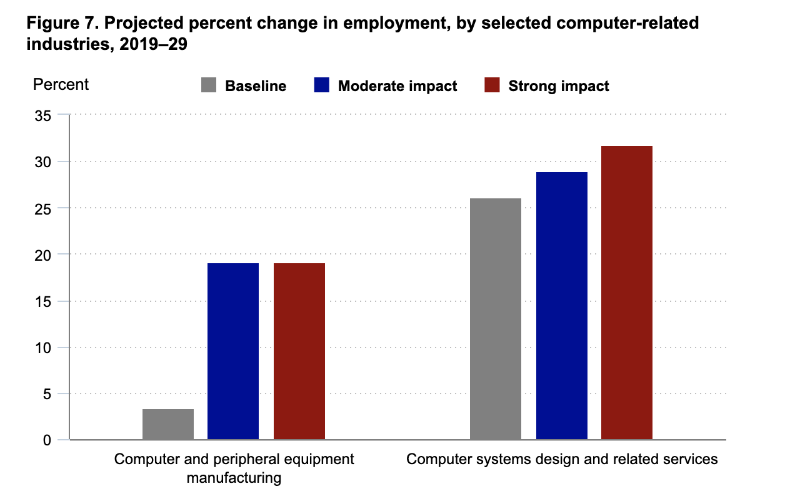

Recent global survey of design teams found that half expected to grow in 2021 and one third expected to grow by more than 25%.

* Research on job seeking tool that designers use to get a job

LinkedIn

Indeed

Zip recruiters

Glassdoor

Career Builder

Monster

Job leads

* Research on job seeking tool that designers use to showcase their portfolio and skills

Dribbble

Behance

Krop

Dunked

Carbonmade

Coroflot

* Research on current tools that recruiters use to find talent (LinkedIn Recruiter)

Twitter

Github

LinkedIn

Dribbble

Slack

Zillion resumes

Greenhouse

**1.7 Products**

There will be two main features of the product. One is **profile builder** that allows designers to upload their resume and portfolio, the other one is a **recruiters search** where they can input a search query and get matched with top 3 qualified candidates.

**Profile Builder**

Our platform will take into consideration the many different types of designers that exist in the industry in order to build the best profile for each different type of designer. When a user first joins the platform, they’ll be prompted to upload their resume and have our platform parse out information OR they can manually input their resume information onto the platform.

Once the resume is uploaded and parsed, our platform will ask them to upload a portfolio work for each of their past experience and they can then embed their portfolio in a format that is best suited for the project (example: UX designer can embed Figma, Presentation Designer can embed a Powerpoint, Interior Designer can embed Autocad rendering, etc). They can also tag each portfolio work with a project type (example: Design System, Interactive Prototype, Wireframe, Presentation Design, Animation) and tools used for each project.

**Recruiters Search**

First, based on the candidate profile our products recommend mechanics that can easily help recruiters to find the best-fit candidate. All the recommendation source is from the candidate's resume. For example, the recruiter wants to find a 3 years mobile UX designer who has some experience with e-commerce. Our recommendation system will rank the top 3 relevant candidates for the recruiter to review.

Second, current recruiting products like Linkedin or Monster are more like a resume library, more like a one-way interaction. But with our product, the recruiter also needs to score the candidate's skill set. This scoring part also influences the recommended ranking result. So more active users have a high chance to be seen by recruiters.

Lastly, our product can provide a summary report for users, this report can be skill set analysis, industry analysis, and the market trends.

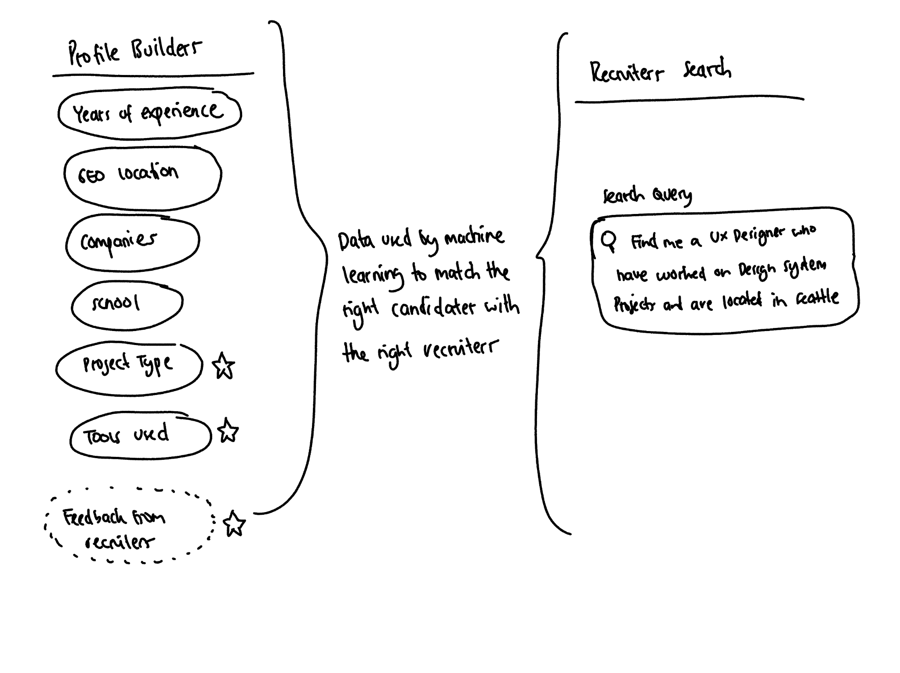

**1.8 Development Status**

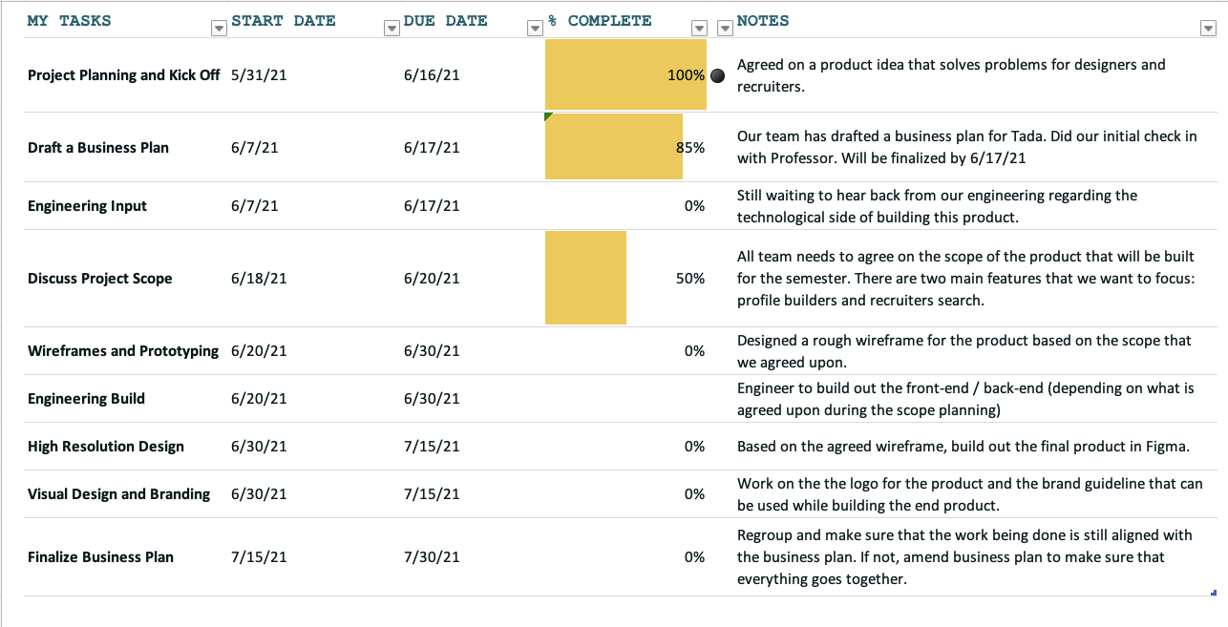

**1.9 Keys to Success**

The keys to our success can be itemized as follows:

1. Secure enough designers user to achieve our business plan
2. Partner with 1-2 high designer demand opening companies in the US.
3. Meet products development milestone dates
4. Obtain prospective customers commitments during the next 6 months
5. Continue the path of patenting intellectual properties
6. Hire Excellent Machine Learning Scientists

**1.10 Technological Advantages**

Targeted Candidates Are Reached

This is one of the more impactful use-cases for AI in recruitment. Beyond automating monotonous tasks, AI can help locate passive job-seekers and search based on alignment with organizational values, going beyond what human recruiters could accomplish. All of this is achieved without spending time or money organizing face-to-face meetings.

AI Levels the Playing Field

There are several ways smart recruiting technology makes things more equitable for candidates. First, and this is most important - it can remove bias from job posts, interview questionnaires, and screening methodologies. Further, resumes are no longer the only touchpoint for candidates interacting with the recruiter.

We have implemented a system that models the candidate's CVs in HR-XML, and ranks the candidates based on AHP (Analytic Hierarchy Process).

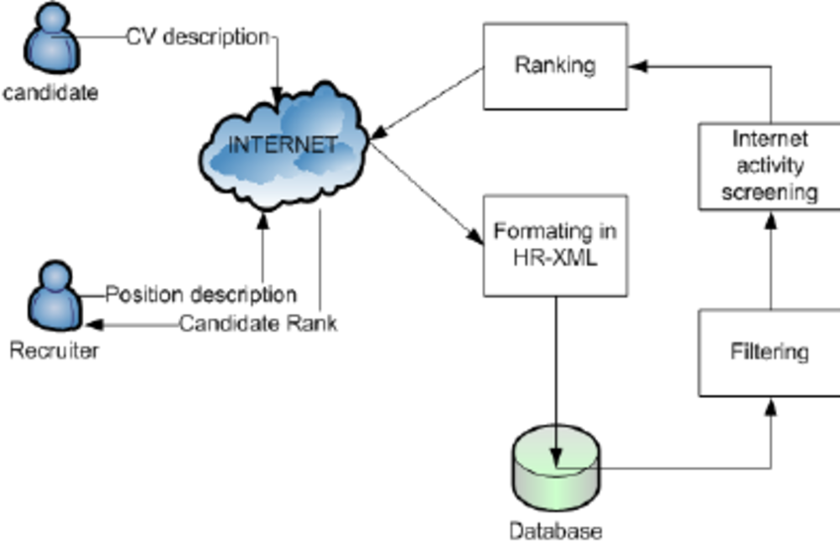

**1.11 Competitive Advantages**

Technology has changed the entire recruitment and job search process. For recruiters and hiring managers it’s easier than ever to find candidates to suit niche skills and job seekers can reach out directly to employers, create online profiles to attract recruiters and apply for jobs with a click of the button.

Ten years ago, it would have been so difficult to find employee reviews and salary data for a company. But now, with a little online research on Glassdoor and kununu, job seekers can now do salary negotiations, prepare for job-specific interviews and even determine whether a company is a good fit before the first interview.

Using tools like LinkedIn allows job seekers to see who they know at each company — so they know if they have someone who can help get their resume seen by the right people. LinkedIn has played a major role in how we search for jobs and how recruiters find candidates. With a strong profile, you can attract hiring managers and recruiters, bringing jobs straight to your inbox.

Technology made it possible to seek out the best talent, not just locally but worldwide. Chances are, you don't even have to worry about relocating the prospective employee because you've got Skype, Slack, Trello, Basecam and old-school email.

However, With the help of machine learning our company Tada has decided to build a platform that enables designers to best showcase their past work and experience in a way that can help them stand out and get matched with the right job position.

**1.12 Strategy**

Our business strategy is to first focus on building the Profile Builders and have the ability to upload a PDF resume and parse out all the information into the profile. We can also work on integrating with online portfolio websites such as Behance and Dribbble so that users don’t have to reupload their portfolio work.

Business Model

We will use a subscription based model where designers can only upload a maximum of 3 projects before they are required to pay a monthly subscription.

On the recruiters side, they can also get matched for free for the first 3 times before they are required to pay a monthly subscription. In the near future, we will also work on selling our Recruiters Search as an enterprise tool that allows companies to buy as many seats as they need in order to fulfill their recruiting needs.

On our initial launch, we will only focus on the U.S market and slowly expand globally to countries that have an emerging market in hiring for designers such as China, Korea, Japan, and London.

**1.13 Financial Goals**

1. Complete Profile Builder by end of 2021
2. Complete Recruiter Search by end of Q1 2022
3. Acquire 5000 profiles by end of 2022
4. Revenue of $250,000 in first year of operation (2022) - assuming we have 5000 users and each user bringing in about $50 of revenue
5. Sell Recruiter Search as an enterprise tool to big corporations in the US who are constantly hiring designers
6. Achieve 60% of gross margin by 2023
7. Provide 5x returns to shareholders in 3 years

