Looping:
- Write a Java program that uses a "for" loop to print the numbers from 1 to 10.
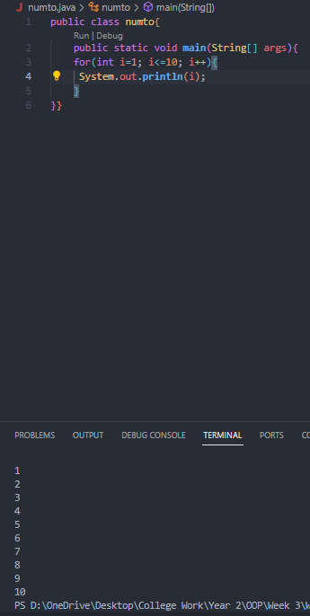
- Implement a Java program that utilizes a "while" loop to find the factorial of a given number.
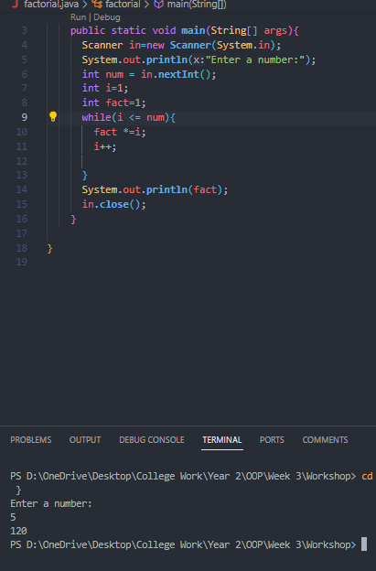
- Create a Java program using a "do-while" loop to repeatedly ask the user for input until they enter a specific value (e.g., 0).
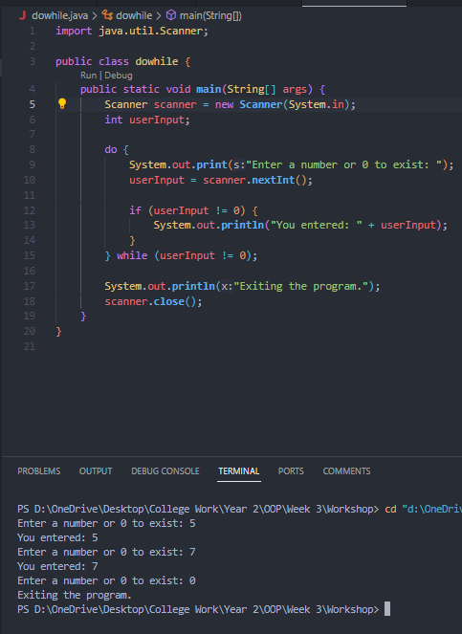
- Write a Java program that demonstrates the use of nested loops to print a pattern, such as a pyramid of stars.
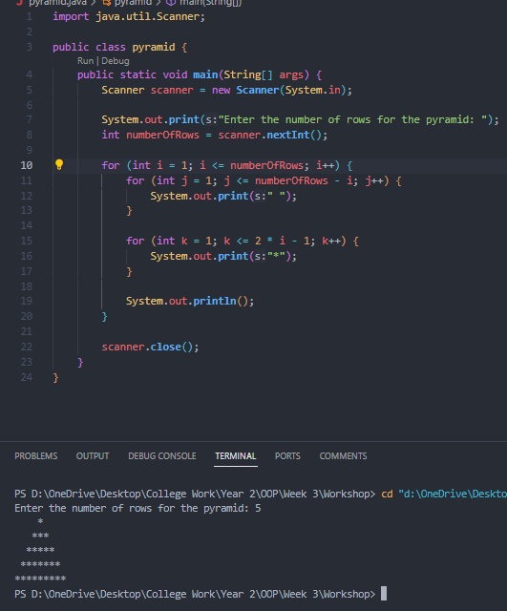
Arrays:
- Develop a Java program that declares and initializes an array of integers. Print the elements of the array in reverse order.
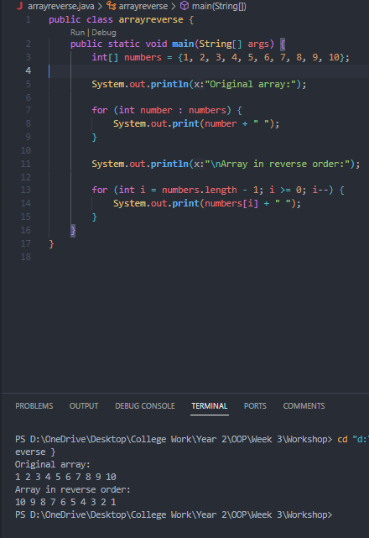
- Implement a Java program that finds the sum and average of elements in an array of floating-point numbers.
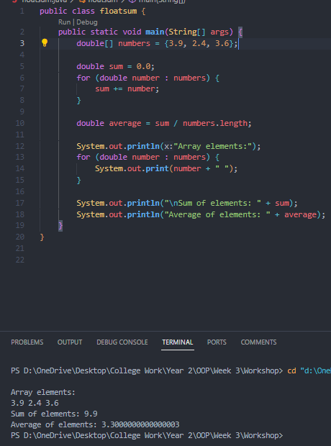
- Write a Java program that checks if a given element is present in an array of strings. If present, print its index; otherwise, print a message indicating its absence.
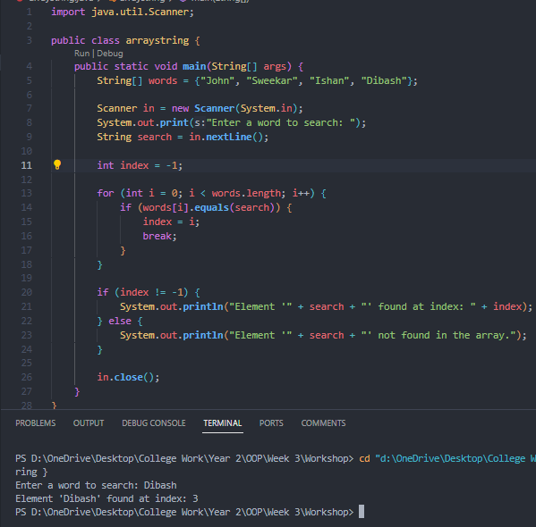
- Create a Java program that sorts an array of integers in ascending order using the bubble sort algorithm.
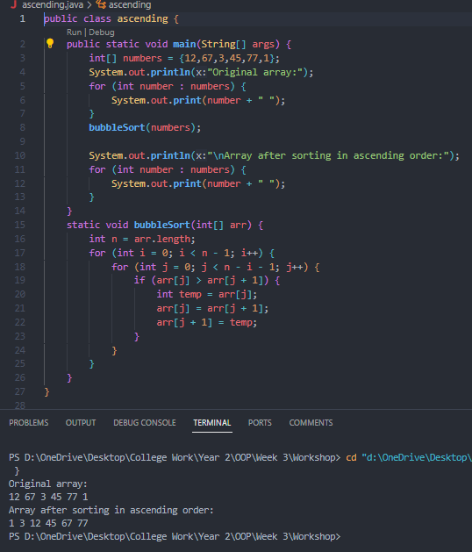
Enhanced For Loop:
- Develop a Java program that uses the enhanced for loop to iterate through an array of characters and count the number of vowels.
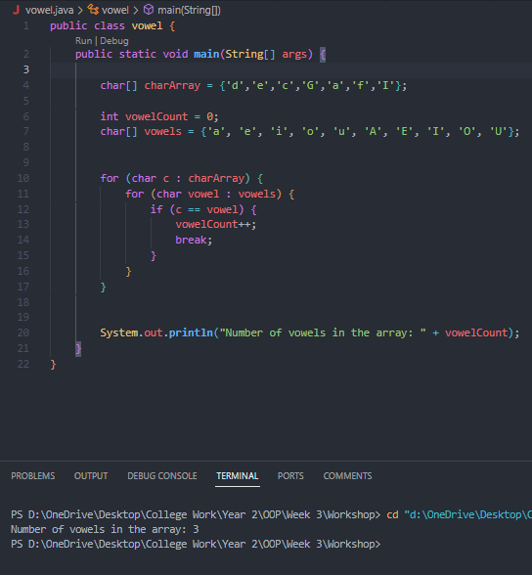
- Write a Java program that uses the enhanced for loop to find the maximum value in an array of doubles.

- Implement a Java program that initializes a 2D array and uses an enhanced for loop to calculate the sum of all elements.
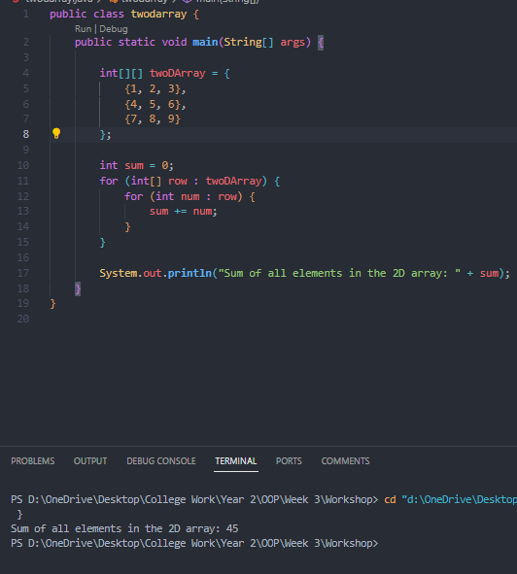
- Create a Java program that utilizes the enhanced for loop to concatenate all strings in an array and print the result.
