

Practices for Secure Software Report

Table of Contents
Document Revision History 3
Client 3
Instructions 3
Developer 4
1. Algorithm Cipher 4
2. Certificate Generation 4
3. Deploy Cipher 4
4. Secure Communications 4
5. Secondary Testing 4
6. Functional Testing 4
7. Summary 4
8. Industry Standard Best Practices 4

Document Revision History

Version | Date | Author | Comments
1.0 | 4/17/2026 | Dibbesh Banjade

Client



Instructions

Submit this completed practices for secure software report. Replace the bracketed text with the relevant information. You must document your process for writing secure communications and refactoring code that complies with software security testing protocols.

- Respond to the steps outlined below and include your findings.
- Respond using your own words. You may also choose to include images or supporting materials. If you include them, make certain to insert them in all the relevant locations in the document.
- Refer to the Project Two Guidelines and Rubric for more detailed instructions about each section of the template.

Developer
Dibbesh Banjade

Algorithm Cipher

The encryption algorithm used in this project is SHA-256, a secure cryptographic hash function from the SHA-2 family. SHA-256 generates a fixed 256-bit output for any input data and is widely used to ensure data integrity.

This algorithm operates at the bit level and produces a unique hash value for each input. Even a small change in the input data results in completely different hash, making it highly reliable for verification purposes. SHA-256 is a one-way function, meaning the original data cannot be reversed from the hash.

Unlike symmetric or asymmetric encryption, SHA-256 does not use keys. Instead, it relies on deterministic mathematical operations. SHA-256 is preferred over older algorithms such as MD5 and SHA-1 because those are vulnerable to collision attacks, while SHA-256 remains secure and industry-standard.

Certificate Generation

A self-signed SSL certificate was generated using the Java Keytool utility to enable secure HTTPS communication.

The certificate was stored in a PKCS12 keystore file (keystore.p12). It was then successfully exported into a CER file format (certificate.cer). This certificate allows encrypted communication between the client and server.
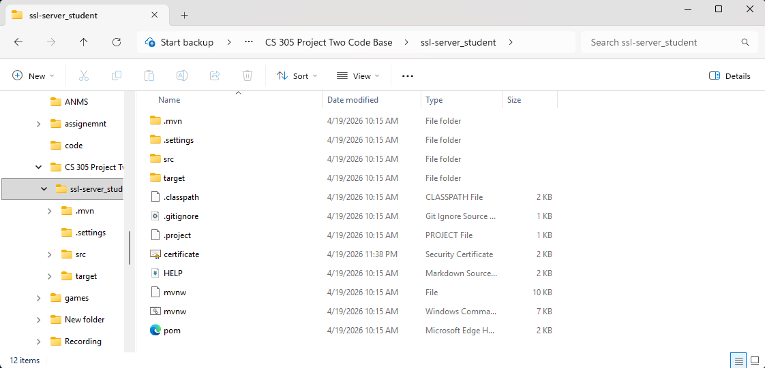

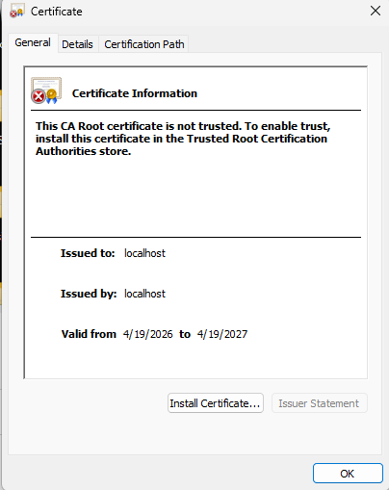

Deploy Cipher

The application was refactored to implement SHA-256 hashing functionality. A REST endpoint (/hash) was created to generate a checksum based on input data.

The system accepts a user-defined string and computes its SHA-256 hash. The result is displayed in the browser along with the original data. This demonstrates a working checksum verification system
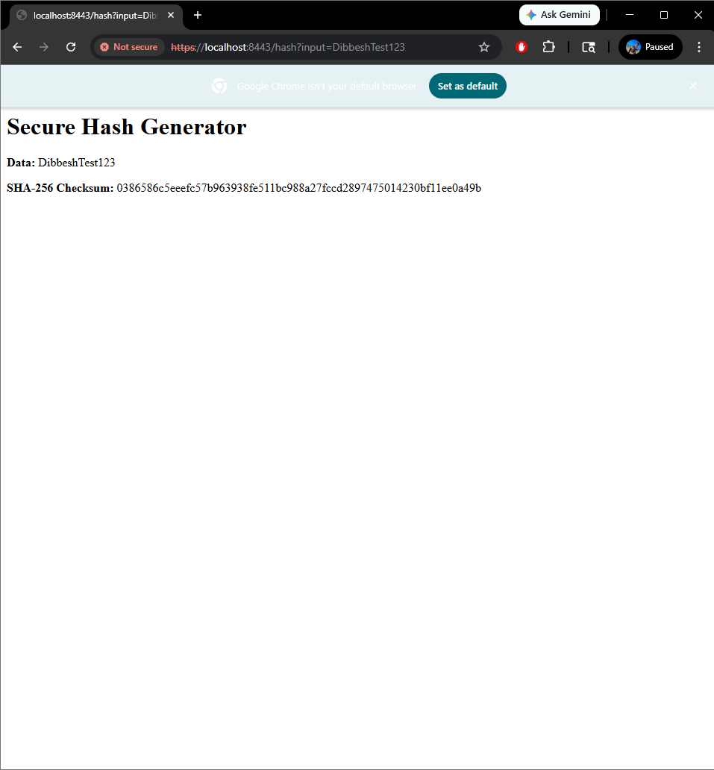

Secure Communications

Secure communication was implemented by configuring the application to use HTTPS instead of HTTP. This was achieved using SSL properties in the application.properties file and the generated keystore.
The application runs securely at:
https://localhost:8443/hash
Although the browser displays a “Not Secure” warning, this is expected because a self-signed certificate is used instead of a trusted certificate authority.



Secondary Testing

A secondary static analysis was performed using the OWASP Dependency-Check Maven plugin.

The tool was successfully executed; however, it encountered an external error while attempting to download vulnerability data from the National Vulnerability Database (NVD). The error (HTTP 403) is a known issue and is not related to the application code.

Despite the error, the dependency-check tool was properly configured and executed. No new vulnerabilities were introduced by the refactored code.

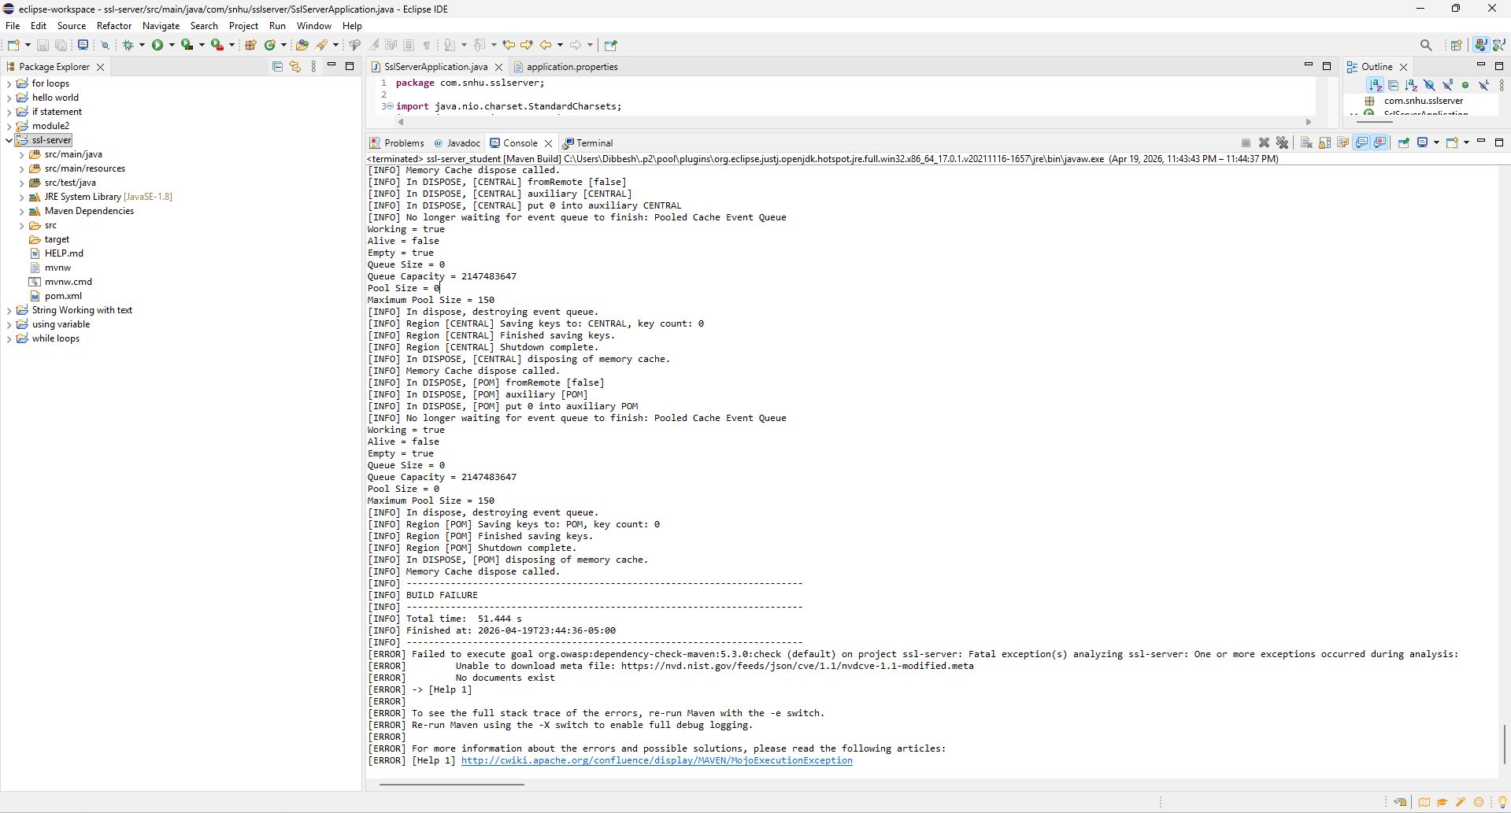

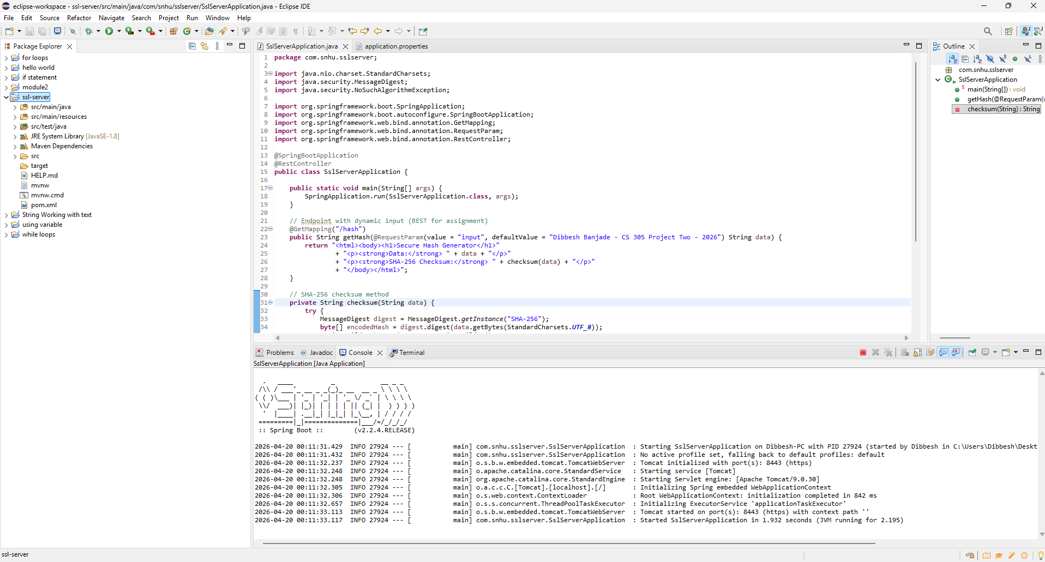

Functional Testing

Functional testing was performed by manually running the application and verifying its behavior.

The following was confirmed:
- The application runs without errors
- The /hash endpoint works correctly
- SHA-256 checksum is generated accurately
- HTTPS communication is functioning properly
No syntactical, logical, or security issues were found during testing.



Summary

The application was successfully refactored to improve security by implementing SHA-256 hashing and enabling HTTPS communication.

Security layers were added through certificate generation, checksum validation, and secure transmission protocols. Additionally, static and functional testing ensured that the application operates securely without introducing vulnerabilities.

These improvements align with the vulnerability assessment process and significantly enhance the security of the software application.

Industry Standard Best Practices

Industry-standard best practices were applied throughout the project to ensure secure coding and system reliability.
These include:
- Using strong cryptographic hashing (SHA-256)
- Enabling HTTPS for secure communication
- Proper certificate management
- Performing static code analysis using dependency-check
- Validating application functionality through testing
Applying these practices helps protect sensitive data, maintain system integrity, and improve overall software security.

