

A PROJECT REPORT
ON
ECOSENSE
An Environmental Health Companion for Android
Live air quality, personal advice and symptom insights
Submitted By
Dibbo Adhikary
2307080
In
Computer Science and Engineering
Second Year ; Second Term
Khulna University of Engineering & Technology
Course No: CSE2200
Course Title: Advanced Programming Laboratory
Submitted to
Ehsanul Karim  Lecturer  Department of Computer Science and  Engineering  Khulna University of Engineering &  Technology, Khulna | Safin Ahmmed  Assistant Professor  Department of Computer Science and  Engineering  Khulna University of Engineering &  Technology, Khulna

1. Introduction and Objectives

Objectives
- Build a native Java Android application (minSdk 24) that shows live air-quality and weather readings and keeps a persistent offline history.
- Monitor conditions in a foreground service and warn the user when limits are exceeded or conditions change suddenly.
- Recommend when to go outside and what is safe to do, adjusted to the selected health profile.
- Let the user log symptoms and discover personal triggers from their own data.
- Offer a guided symptom chat that explains what may be happening, why, and what to do, stored in Firebase Realtime Database.
- Respond sensibly to system broadcasts such as low battery, airplane mode and loss of connectivity.
- Retrieve data from a JSON REST API (Open-Meteo) with Retrofit and keep it in Room.
- Synchronise readings to Cloud Firestore for signed-in users with Firebase Authentication, while staying usable as a guest.

Scope and Target Users
In scope: email/password authentication, live data from Open-Meteo, local persistence, background monitoring, notifications, forecasting, a symptom diary and chat, CSV export and cloud synchronisation. Out of scope: medical diagnosis, hardware sensors, iOS or web clients and external AI services; the advice engine is rule-based and runs on the device.
Intended users are people with asthma, allergies or heart and lung conditions, parents and carers of children and older adults, runners and cyclists, and anyone who wants to understand how their environment affects their health.

2. System Overview and Technology
EcoSense has eight screens connected by a floating bottom navigation bar, with the Dashboard as the home screen. Data is collected on demand (refresh) or automatically by the monitoring service, stored locally and then analysed by several independent modules. The table below summarises what the finished application provides.
Area | Features
Live conditions | Temperature, humidity, PM2.5, PM10 and US AQI with an animated AQI gauge; location chip with reverse-geocoded place name; default location (Khulna) when location is unavailable.
Background monitoring | Foreground service with a live notification and a configurable check interval (default 15 minutes, minimum 5).
Alerts | High-priority notifications when a limit is exceeded; sudden-spike detection for PM2.5, PM10 and temperature.
Device awareness | Reacts to low battery, airplane mode and connectivity changes with banners, toasts and adjusted polling.
Today’s Plan | Best and worst time outside in the next 24 hours, a colour-coded 24-hour strip and advice for seven activities.
Health profile | Normal, Sensitive, Elderly, Child or Athlete changes every recommendation and the recommended alert limits.
Symptom Link | Ten-second symptom diary with air snapshot, early signals after 3 days and tested patterns after 7 days, and a “Your triggers today” warning.
Symptom Chat | Guided questions and a four-section advice reply with red-flag detection; stored in Realtime Database for signed-in users.
History | List, card and grid views with search, Safe / Unsafe filters, a details dialog, CSV export and Sync to cloud.
Trend prediction | Linear regression chart with a six-step forecast, confidence band and safe-limit line.
Accounts and cloud | Firebase email/password sign-in, sign-up, password reset and guest mode; Firestore upload and restore of readings.
Appearance | Light and dark themes, entrance animations, custom-drawn gauge and chart.

3. Architecture and Navigation
The app has five layers: presentation (activities), long-running background components (service and receivers), logic (framework-free algorithms), local storage (Room, content provider, preferences, cache) and network and cloud (Open-Meteo through Retrofit, and three Firebase services).
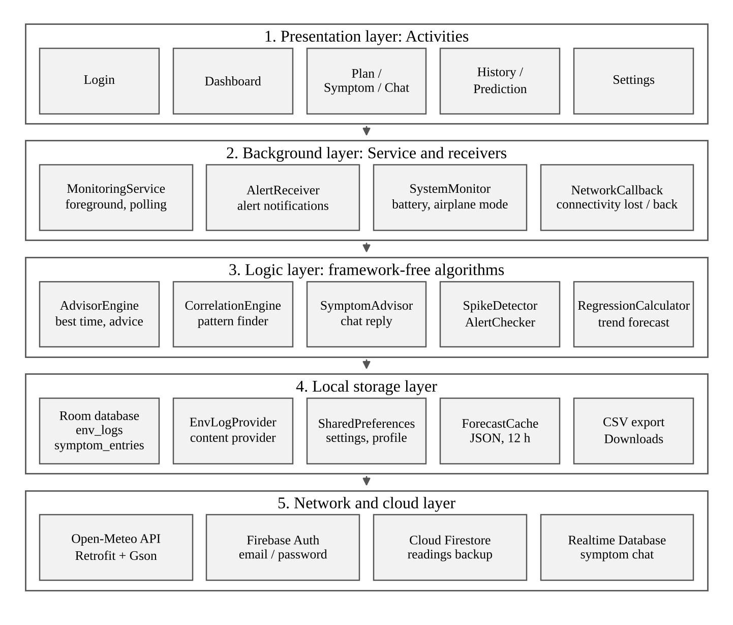
Fig 1: Layered architecture of EcoSense

Design Decisions
- Offline first: every reading is written to Room before it is shown, and the last forecast is cached for up to 12 hours.
- Background work stays off the main thread: networking and database operations run on a shared executor; the monitoring service uses its own single-thread executor.
- Algorithms are independent of the UI: the advisor, pattern finder, spike detector and regression live in a utils package with no Android UI dependency.
- Broadcasts connect the layers: when the service stores a reading, a broadcast refreshes the visible Dashboard; system broadcasts such as airplane mode reach the service the same way.
- Rule-based advice: recommendations and chat replies are generated on the device by transparent rules; no external AI service is used.

Packages
Package (com.ecosense.app) | Responsibility | Key classes
data.local | Room database, DAOs, content provider, forecast cache | AppDatabase, EnvLog, SymptomEntry, EnvLogDao, SymptomDao, EnvLogProvider, ForecastCache
data.remote | Retrofit API, repositories, Firebase helpers | WeatherApi, ApiClient, EnvRepository, ForecastRepository, FirebaseHelper, ChatRepository
service | Background monitoring and alert delivery | MonitoringService, AlertReceiver
ui.* | Eight activities and their adapters and custom views | LoginActivity, DashboardActivity, PlanActivity, SymptomActivity, ChatActivity, HistoryActivity, PredictionActivity, SettingsActivity
utils | Algorithms and helpers | AdvisorEngine, CorrelationEngine, SymptomAdvisor, SpikeDetector, RegressionCalculator, SystemMonitor, AlertChecker, CsvExporter, NavHelper, Prefs

Screens and Navigation
Navigation is multi-activity. The Login screen is shown first; after a successful sign-in, or when the user continues as a guest, the Dashboard opens. A floating bottom bar (NavHelper) switches between the six main screens; Home is the root and uses CLEAR_TOP | SINGLE_TOP so the back stack stays shallow.
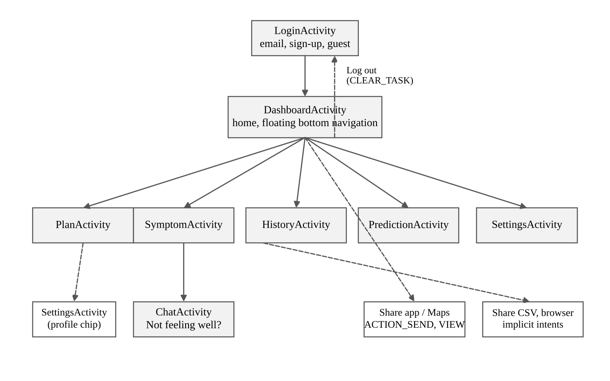
Fig 2: Screen navigation flow
From | To | Intent type | Trigger
Login | Dashboard | Explicit | Successful sign-in or guest mode
Any main screen | Home, Plan, Symptom, History, Predict, Settings | Explicit | Bottom navigation bar
Symptom | Chat | Explicit | “Not feeling well?” card
Settings | Login | Explicit (CLEAR_TASK) | Log out
Dashboard | Any sharing app | Implicit (ACTION_SEND) | Share report
Dashboard | Maps | Implicit (ACTION_VIEW) | Tap the location chip
History, Symptom | Email, Drive, etc. | Implicit (ACTION_SEND, text/csv) | Share exported CSV
Settings | Browser | Implicit (ACTION_VIEW) | Data source link

Fig 3 shows the project structure in Android Studio. The generated classes AppDatabase_Impl, EnvLogDao_Impl and SymptomDao_Impl are created by the Room annotation processor.
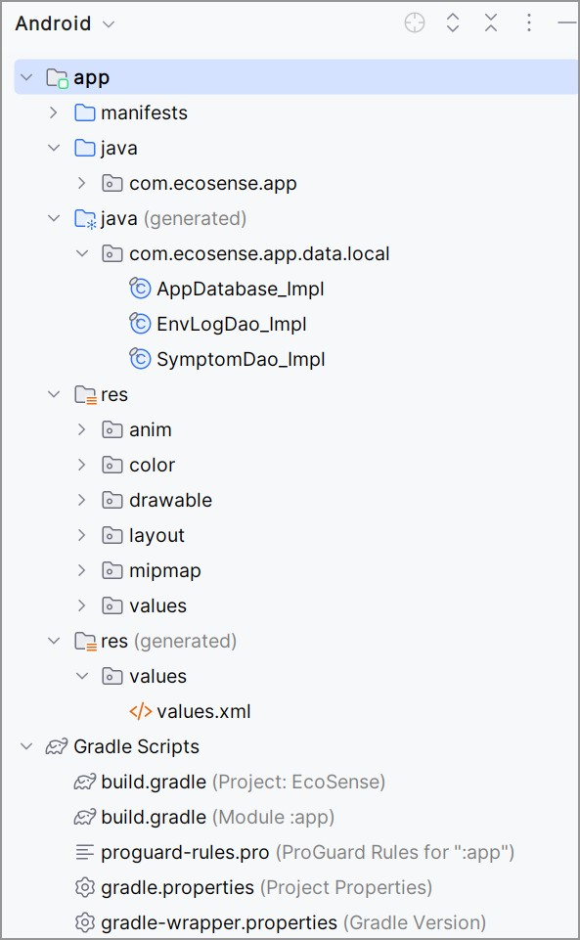
Fig 3: Android Studio project structure

4. Overview and Feature Walkthrough
This section walks through the main screens of EcoSense with screenshots taken on a physical Android phone.

4.1 Sign-in, Guest Mode and Permissions
The Login screen offers Firebase email/password sign-in, account creation and password reset by email. Input is validated before any request is made (a valid email address and a password of at least six characters), and a show / hide eye on the password field helps the user check what they typed. Users who do not want an account choose Continue offline (guest), which gives access to every local feature.
On first use the app explains why it needs location (to fetch local data) and notifications (to warn about unsafe conditions) and then shows the Android permission prompt. Every permission is optional: if location is denied, the default location (Khulna, Bangladesh) is used and the user is told.
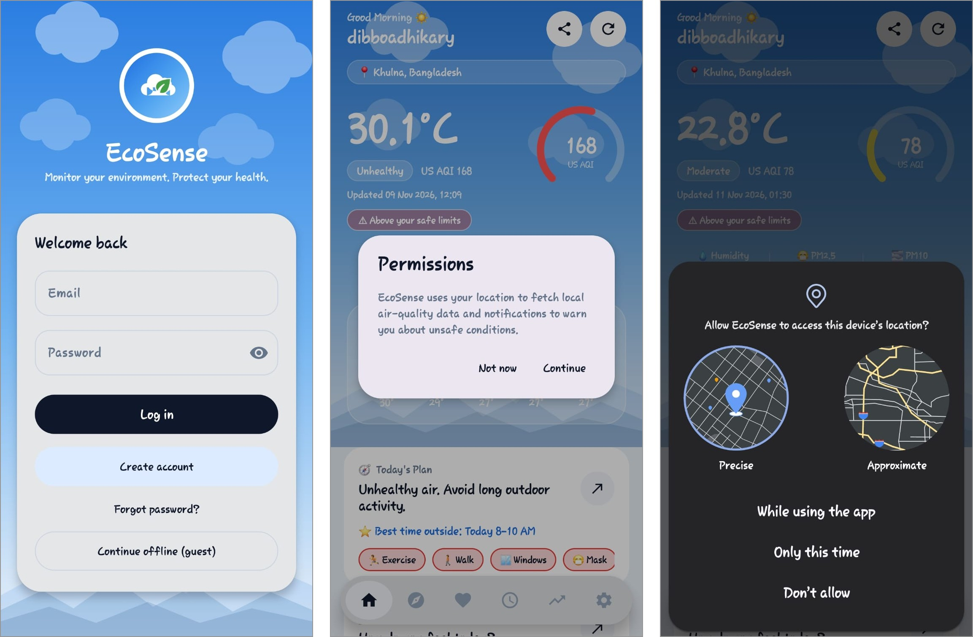
Fig 4: Login screen (left), in-app permission explanation (centre) and Android location prompt (right)

4.2 Dashboard
The Dashboard shows the latest reading at a glance: a time-based greeting, a location chip, the large temperature, an AQI category chip and an animated AQI gauge ring coloured by category, and the humidity, PM2.5 and PM10 values (a value turns amber when it exceeds the user’s limit). A banner such as “Above your safe limits” appears when a limit is exceeded, and a glass card lists the five most recent readings. Scrolling down reveals the Today’s Plan card, the Symptom Link card with one-tap quick-log chips, the Background monitoring switch and a daily Eco Tip.

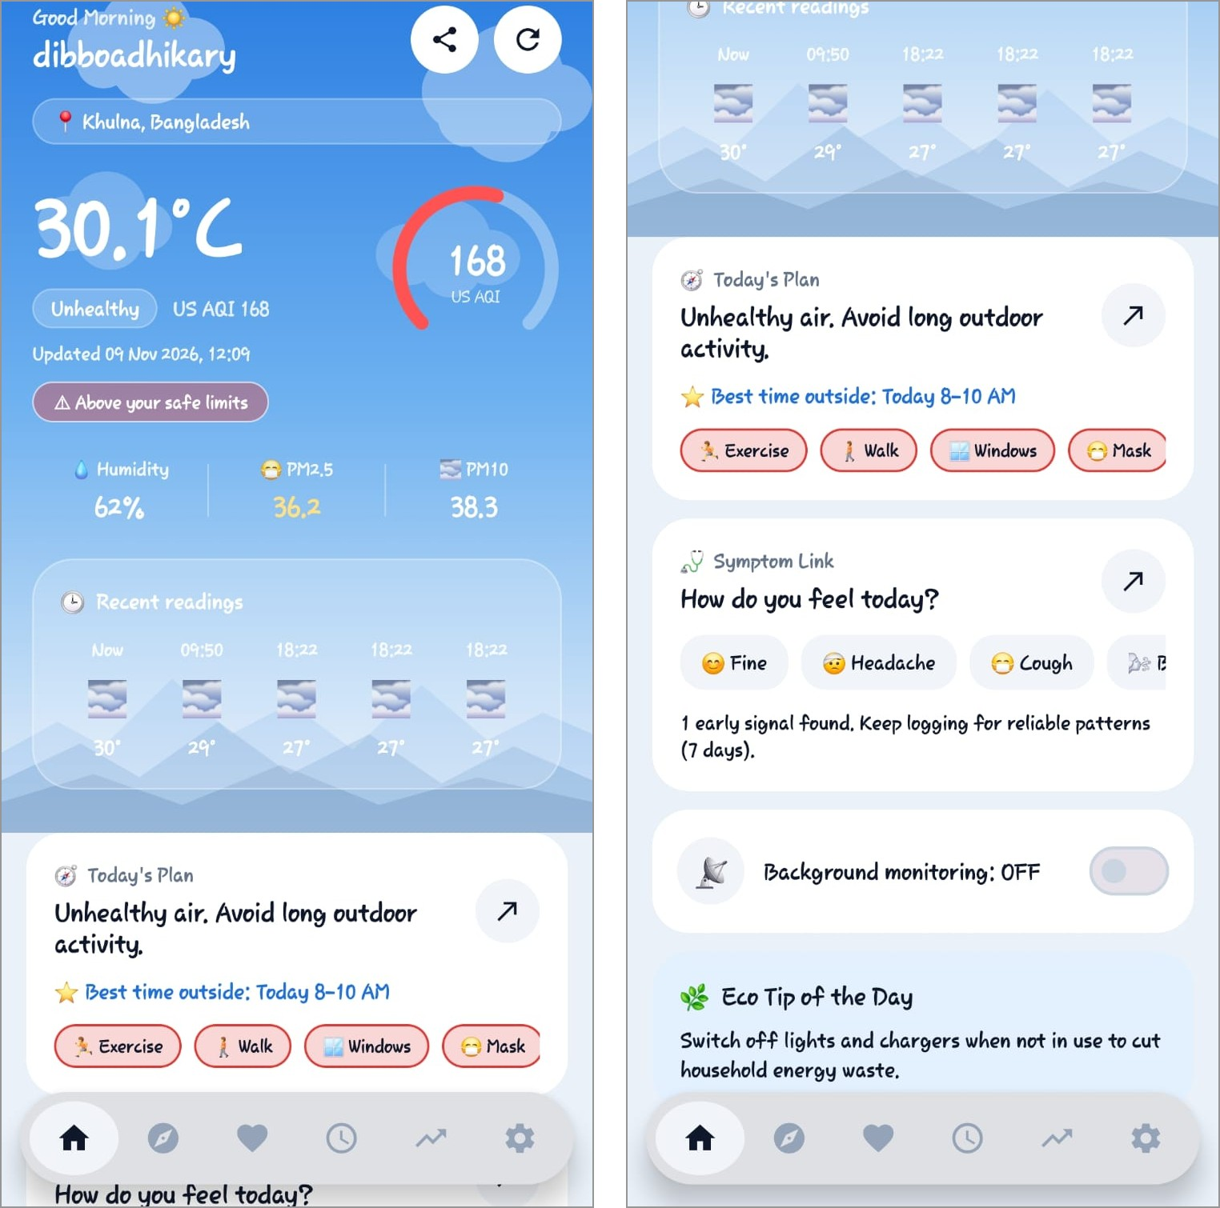
Fig 5: Dashboard: live conditions (left) and the plan, symptom, monitoring and tip cards (right)

4.3 Today’s Plan
Today’s Plan converts the hourly forecast into decisions. Forecast hours are scored from the AQI multiplied by a factor for the selected health profile, plus a heat penalty. The screen reports the best 2-hour daytime window (05:00 to 20:00) in the next 24 hours, the window to avoid when it is clearly worse, a colour-coded 24-hour strip, and advice with a short reason for seven activities: outdoor exercise, walking or cycling, opening windows, wearing a mask, drying clothes outside, children and older adults outdoors, and heat and hydration. Each activity is marked Good, Careful, Briefly, Limit, Not today or Not needed. The last forecast is cached for 12 hours, so the plan also works offline.
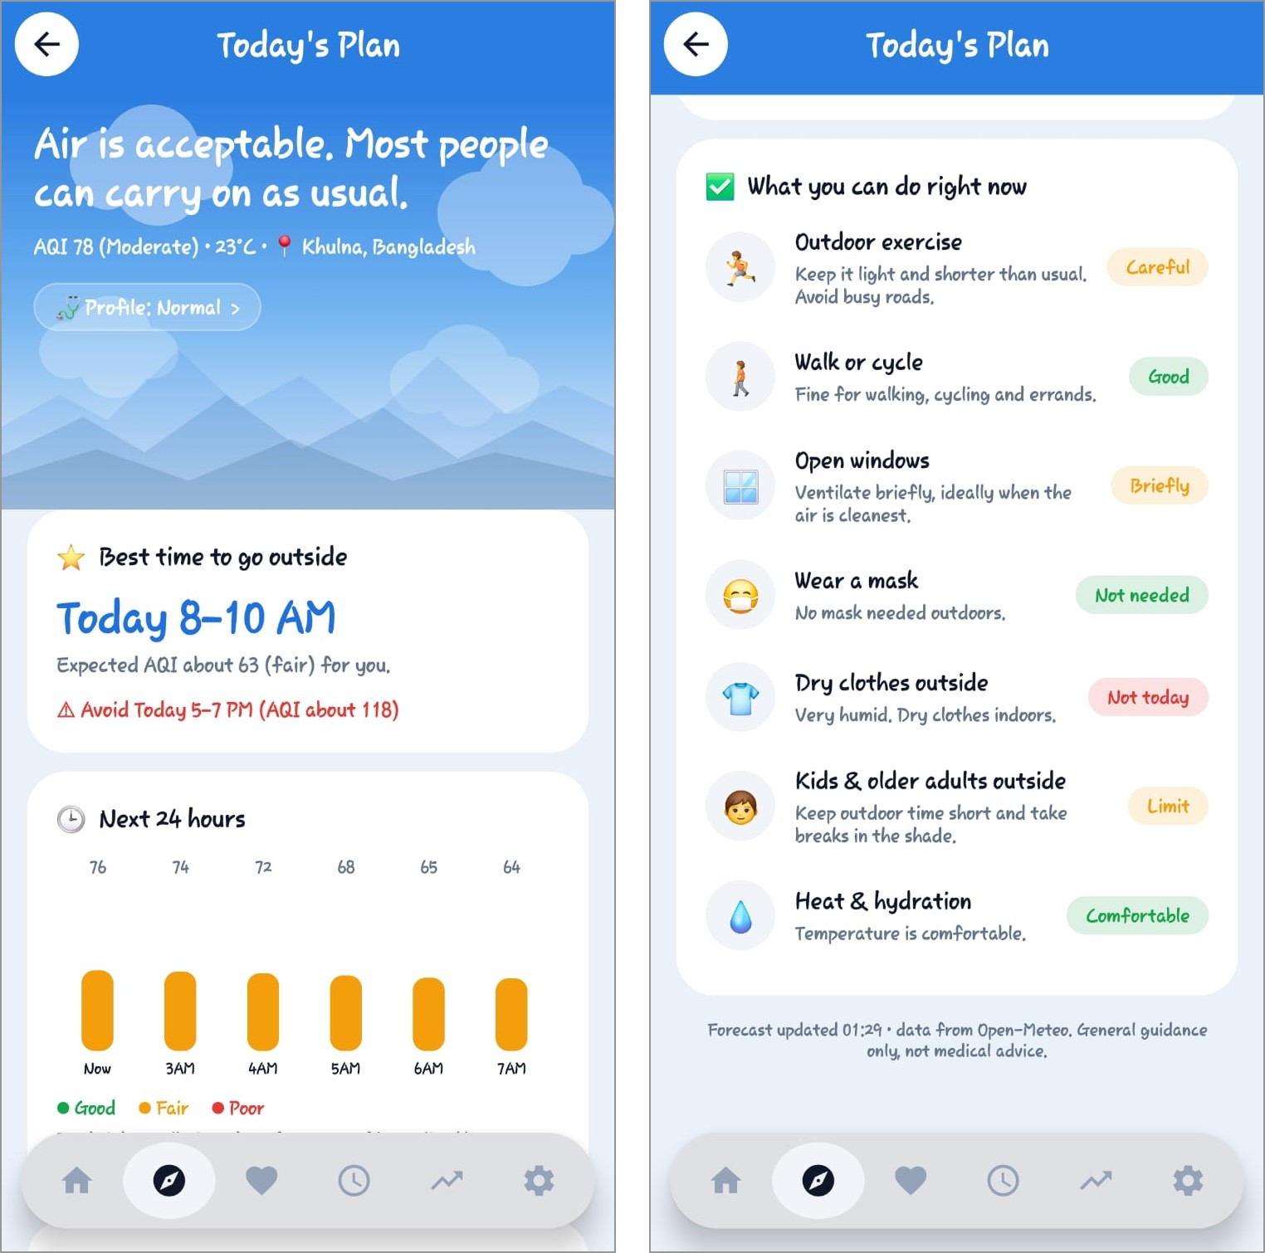
Fig 6: Today’s Plan: best time and hourly strip (left) and the activity advice list (right)

4.4 Symptom Link
Symptom Link is a ten-second diary. The user chooses a symptom (headache, cough, irritation, breathing trouble, fatigue, poor sleep, sneezing or allergy, or feeling fine) and a strength; each entry stores a snapshot of the air at that moment. The pattern finder compares days with symptoms against days without them: after 3 logged days it shows early signals labelled low confidence, and after 7 days it runs a statistical analysis and reports only patterns that pass.
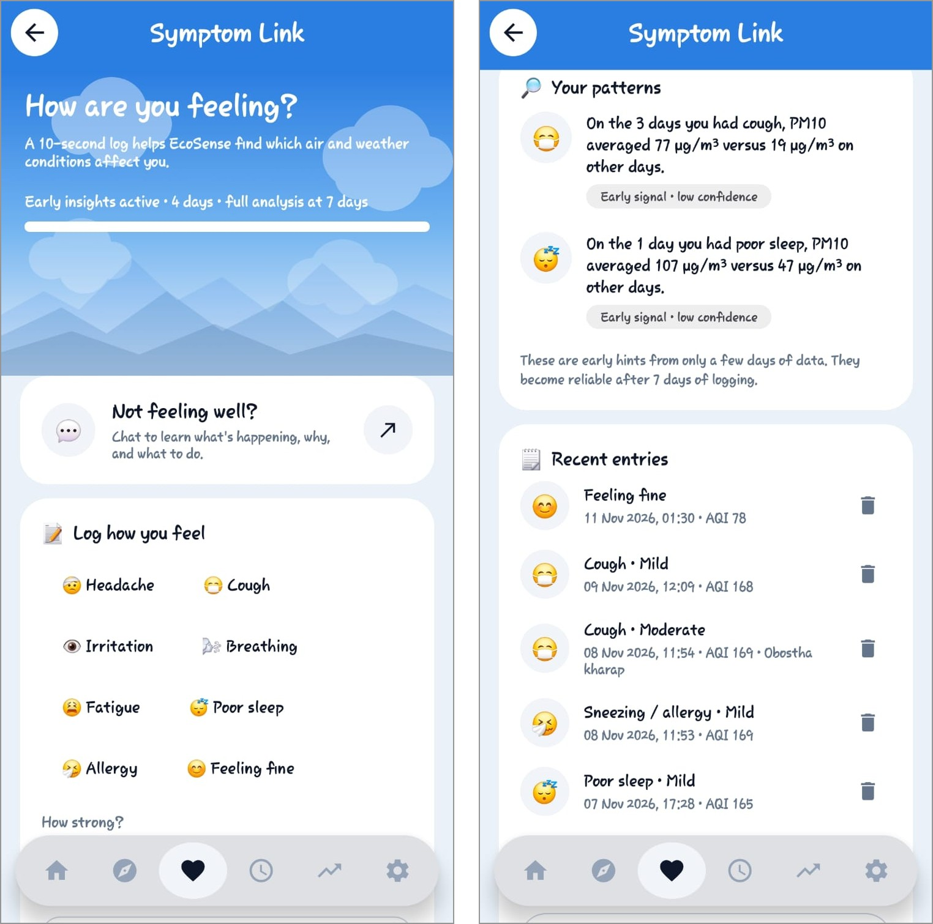
Fig 7: Symptom Link: logging screen with progress bar (left) and patterns with recent entries (right)

4.5 Symptom Chat
From Symptom Link the user opens a minimal chat. A panel at the bottom guides the user through four questions: which symptoms (multi-select), how strong, how long, and an optional note. EcoSense then answers with four sections: what may be happening, why this may be happening (current PM2.5, temperature and humidity against the user’s limits, plus patterns from the diary), what you can do, and see a doctor if (stricter for higher-risk profiles). Serious phrases such as chest pain, fainting or severe breathing trouble produce an urgent-care message instead. The conversation is saved in Firebase Realtime Database under the user’s id (Section 7.3) and also works offline; guests use a local in-memory chat. The reply is generated by rules on the device. | 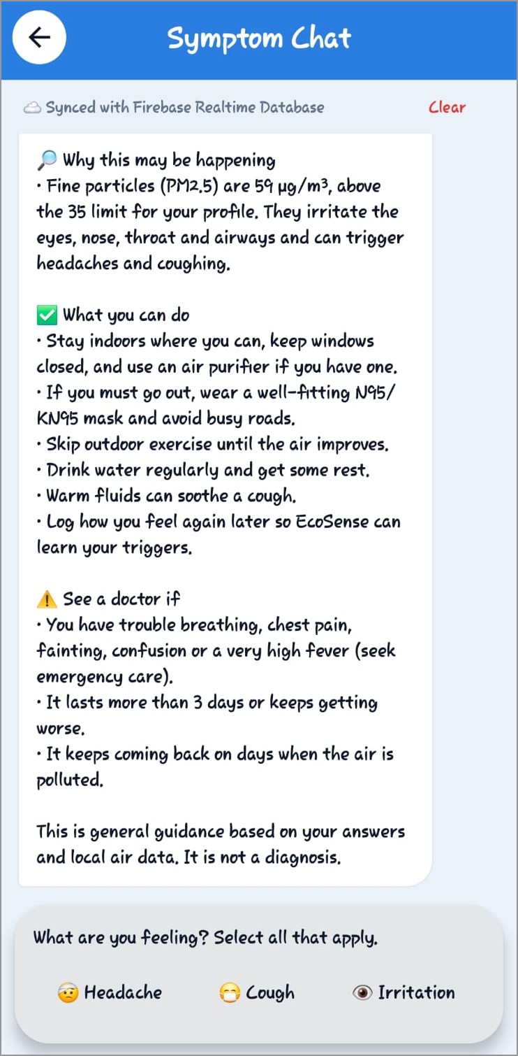  Fig 8: Symptom Chat: “Synced with Firebase Realtime Database” status, advice reply and question panel

4.6 History and Export
History displays every stored reading in three ways: a classic ListView with a custom ArrayAdapter, a card list and a two-column grid (both RecyclerView with a ListAdapter and DiffUtil). The user can search by date or value and filter by All, Safe or Unsafe, and tapping a reading opens its details and warnings. Export CSV saves the data to the device’s Downloads folder and offers to share it, and Sync to cloud uploads unsynced readings to Firestore.

4.7 Trend Prediction
The Prediction screen fits a linear regression (written from scratch) to the latest readings of the selected metric and extends it six steps ahead. The chart shows the history curve, the dashed forecast with a widening confidence band and the user’s safe limit.
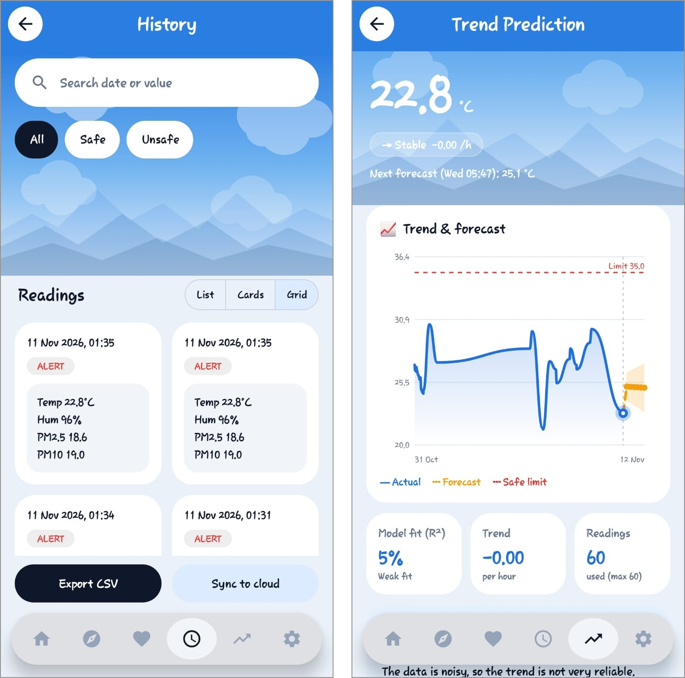
Fig 9: History in grid mode (left) and Trend Prediction (right)

4.8 Settings and Themes
Settings lets the user choose a health profile, apply the recommended alert limits for that profile in one tap, set custom limits for temperature, humidity, PM2.5 and PM10, choose the background check interval and toggle push notifications and dark mode. It also offers granting permissions, restoring history from the cloud, clearing local history, opening the data-source website (Open-Meteo) and logging out. All screens support light and dark themes; the choice is stored and applied when the application starts.
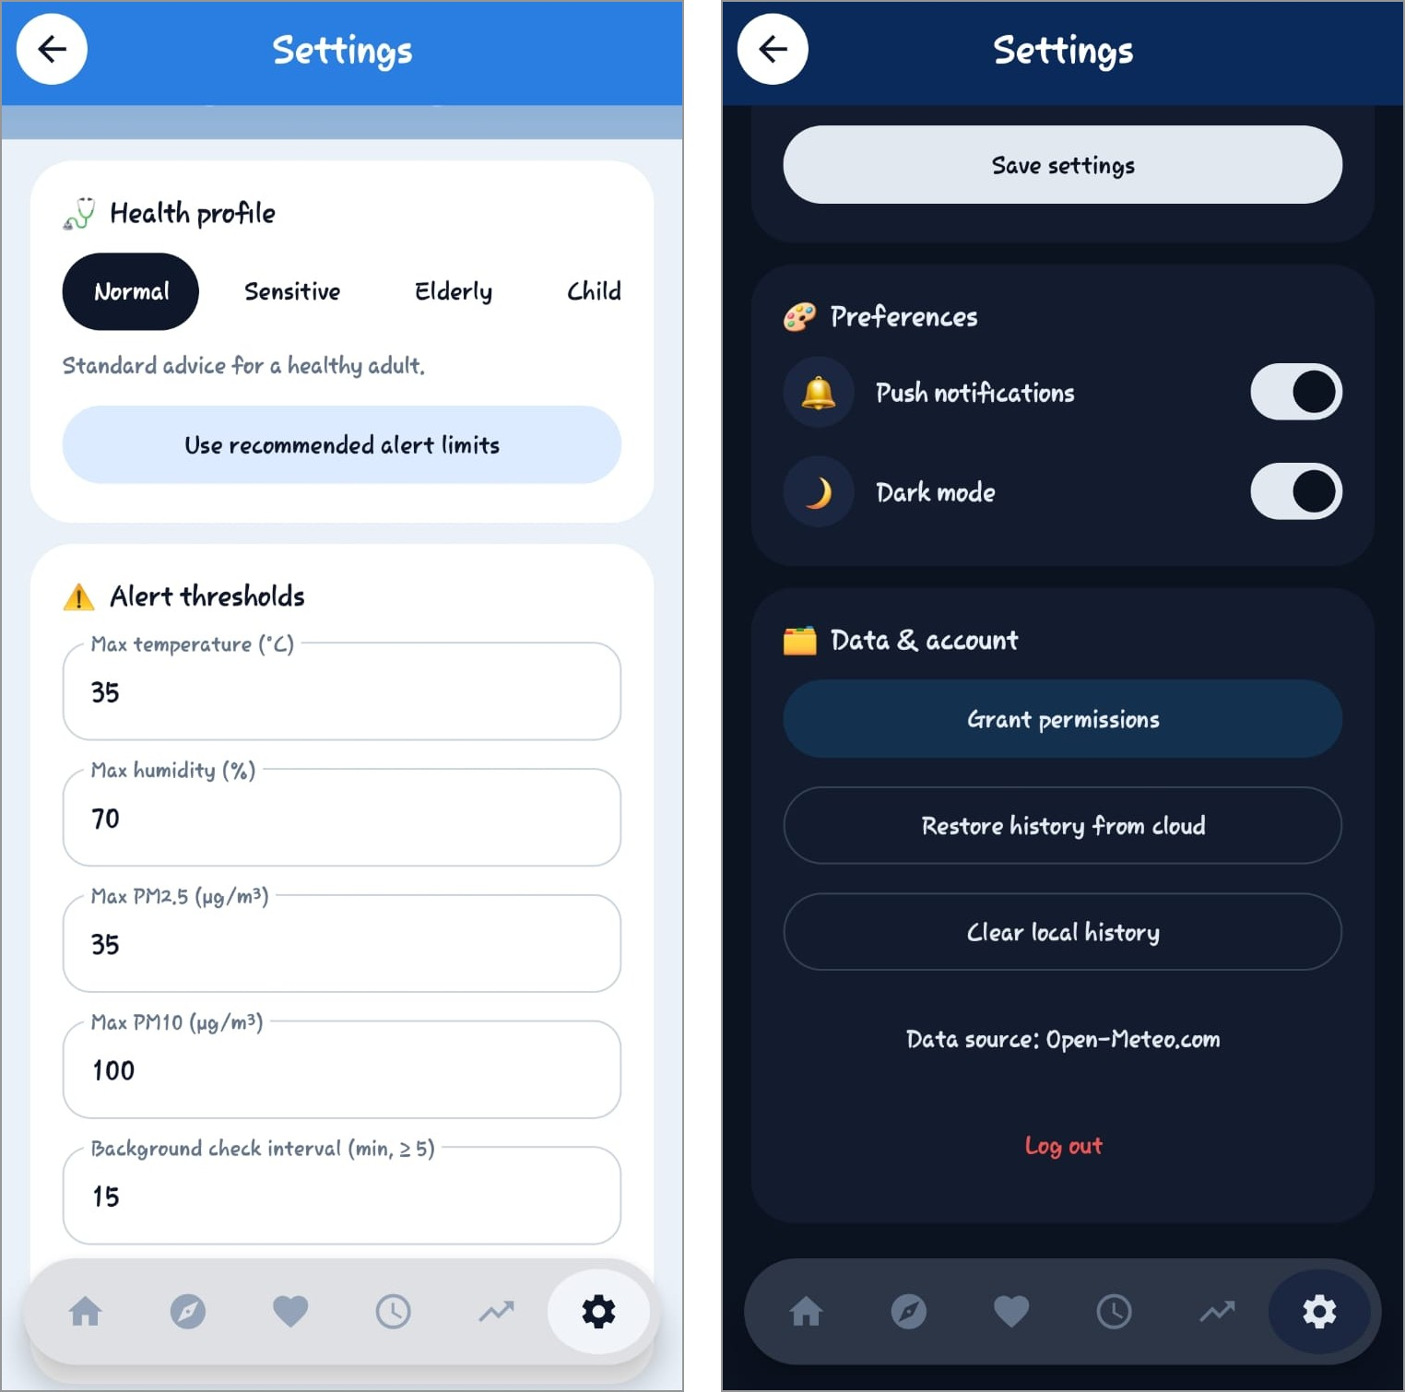
Fig 10: Settings in the light theme (left) and the dark theme (right)

5. Background Services and System Events

MonitoringService
When Background monitoring is switched on, MonitoringService runs as a foreground service of type dataSync. It fetches new data at the interval set in Settings (default 15 minutes, minimum 5), stores it, checks the limits and updates its ongoing notification after every check.

Alerts and Spike Detection
AlertChecker compares each reading with the user’s limits, and SpikeDetector compares the newest reading with the average of readings taken 20 to 120 minutes earlier. AlertReceiver, declared in the manifest, turns the broadcasts into high-priority notifications on a separate channel, with separate ids for threshold alerts and spike alerts. Spike notifications are limited to one every three hours.
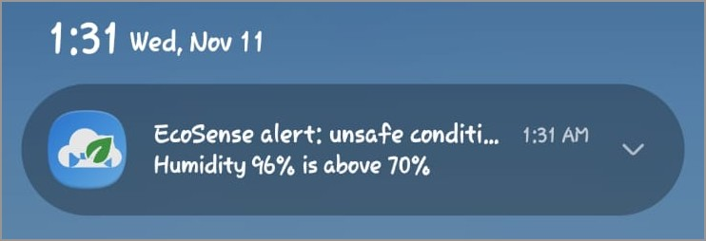
Fig 11: Threshold alert notification: “Humidity 96% is above 70%”

SystemMonitor and Broadcast Events
SystemMonitor listens to system events and the application changes its behaviour accordingly; the service and the Dashboard share the same state.
System event | How it is detected | Application response
Battery low | ACTION_BATTERY_LOW broadcast | Polling slows to three times the interval (never faster than every 30 minutes); the banner and notification say “power saving”.
Battery OK | ACTION_BATTERY_OKAY broadcast | The normal interval resumes.
Airplane mode | ACTION_AIRPLANE_MODE_CHANGED broadcast | Polling pauses; the Dashboard banner shows saved data and Refresh explains why it cannot fetch.
Connectivity lost / restored | ConnectivityManager.NetworkCallback | Pauses while offline. On reconnection it refreshes immediately and uploads unsynced readings to Firestore.

Network changes use a NetworkCallback rather than the legacy CONNECTIVITY_ACTION broadcast, which is no longer delivered to applications on modern Android versions. Fig 12 shows the airplane-mode banner with its toast and the offline banner with the “You are offline” toast.
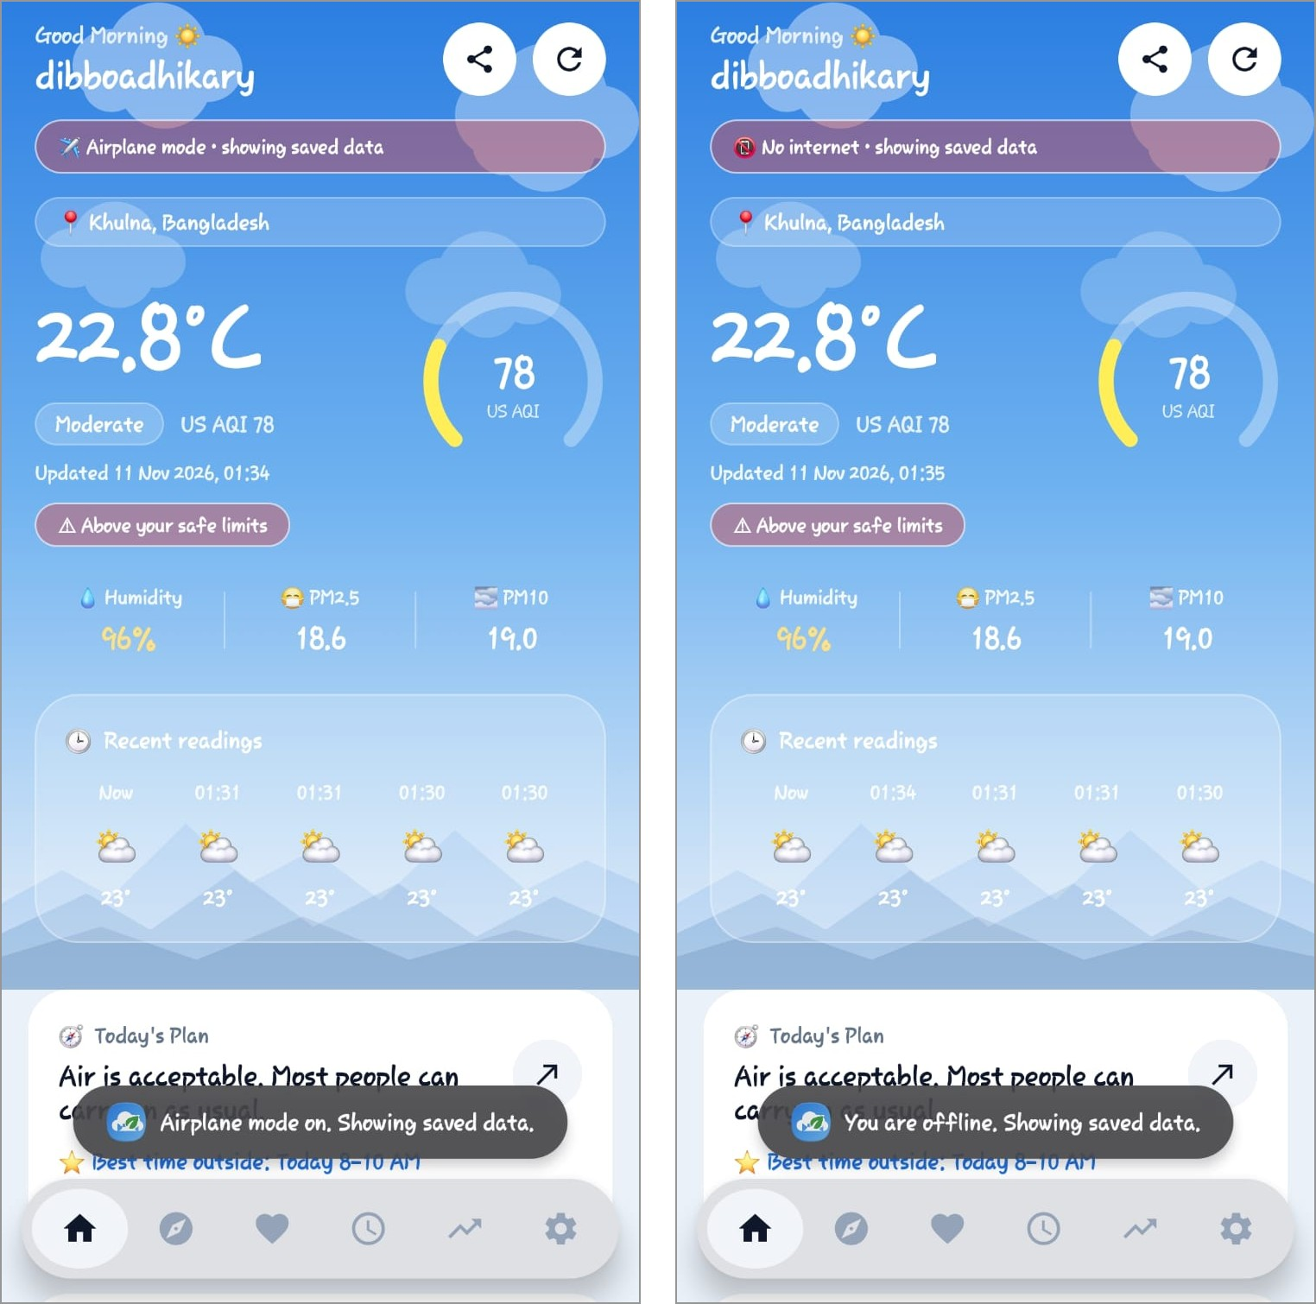
Fig 12: Airplane mode: “showing saved data” banner and toast (left); offline banner and toast (right)

Permissions
Permission | Purpose | Handling
INTERNET, ACCESS_NETWORK_STATE | Fetch data and detect connectivity | Normal permissions
ACCESS_FINE / COARSE_LOCATION | Local weather and air quality | Runtime request with rationale; default location if denied
POST_NOTIFICATIONS (Android 13+) | Alerts and the monitoring notification | Runtime request; notifications skipped silently if denied
FOREGROUND_SERVICE, FOREGROUND_SERVICE_DATA_SYNC | Background monitoring | Declared in the manifest
WRITE_EXTERNAL_STORAGE (maxSdk 28) | CSV export on Android 9 and below | Requested only when needed; newer versions use MediaStore
com.ecosense.app.permission.READ_LOGS | Guards the content provider | Custom permission

6. Core Algorithms
The algorithm classes are written without Android UI dependencies, which keeps them easy to test on a standard Java runtime.

Linear Regression
RegressionCalculator implements ordinary least squares. For readings (x, y), where x is the number of hours since the first reading:
slope = sum((x - mean_x) * (y - mean_y)) / sum((x - mean_x)^2)
intercept = mean_y - slope * mean_x
R^2 = sum((x - mean_x) * (y - mean_y))^2 / (Sxx * Syy)
std error = sqrt( sum(residual^2) / (n - 2) )

The prediction uses the last 60 readings, extends six steps ahead at the average reading interval and draws a confidence band whose width grows with the standard error.

Personal Pattern Finder
- Group diary entries and readings by calendar day; a day counts only if the user logged something and at least two readings exist.
- For each symptom and factor (PM2.5, PM10, temperature, humidity, AQI), split the days at the median exposure into a high and a low group.
- Compute the risk ratio between the groups, the Pearson correlation with severity and a one-sided Fisher exact test.
- Keep only the best factor for each symptom to limit false positives from multiple testing.
- With 3 to 6 days of data, report descriptive early signals instead of tested patterns.

Advisor and Best-time Search
The AQI is multiplied by a profile factor (Normal 1.0, Sensitive 1.4, Elderly 1.2, Child 1.25, Athlete 1.1). Rules map the adjusted value, the temperature and the humidity to a status (good, careful or avoid) for each activity. Each forecast hour receives a score (adjusted AQI plus 4 points per degree above 30°C) and the lowest-scoring consecutive two-hour window between 05:00 and 20:00 is the best time.

Spike Detection and Symptom Advisor
A spike is reported when PM2.5 rises by at least 15 µg/m³ and 1.8 times compared with the earlier average (thresholds are tighter for higher-risk profiles), when PM10 rises similarly, or when the temperature changes by 6°C or more. SymptomAdvisor combines the chosen symptoms, strength, duration, note, current air and weather and the user’s own patterns into the four-section reply; a fixed list of red-flag phrases, and severe breathing trouble, switch it to an urgent-care message.

7. API and Database

7.1 External API: Open-Meteo
EcoSense uses the free Open-Meteo web services, which return JSON over HTTPS and need no API key. The Forecast API supplies temperature and humidity and the Air-Quality API supplies PM2.5, PM10 and the US AQI. Requests are made with Retrofit (base URL https://api.open-meteo.com/, with absolute URLs for the air-quality host), converted by Gson and executed on a background thread through OkHttp with 15-second timeouts.
Purpose | Endpoint | Key parameters
Current weather | api.open-meteo.com/v1/forecast | latitude, longitude, current=temperature_2m,relative_humidity_2m
Current air quality | air-quality-api.open-meteo.com/v1/air-quality | latitude, longitude, current=pm10,pm2_5,us_aqi
Hourly weather forecast | api.open-meteo.com/v1/forecast | hourly=temperature_2m,relative_humidity_2m, forecast_days=2, timezone=auto
Hourly air-quality forecast | air-quality-api.open-meteo.com/v1/air-quality | hourly=pm10,pm2_5,us_aqi, forecast_days=2, timezone=auto

API responses
The screenshots below show the JSON returned for the user’s location (about 22.81°N, 89.53°E, Khulna). The first request returns the current temperature (22.8°C) and relative humidity (98%) inside the current object; the second returns pm10 (19.6), pm2_5 (18.4) and us_aqi (76).
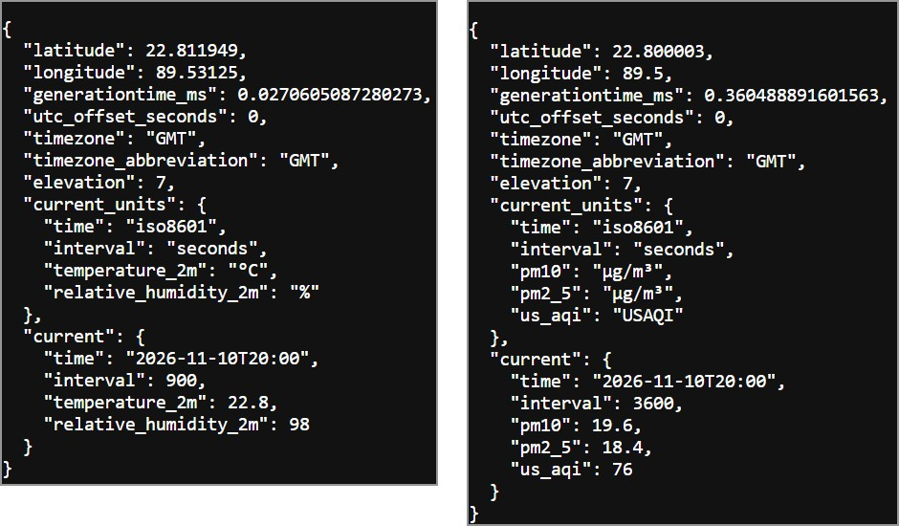
Fig 13: API response: current weather (left) and current air quality (right)
The hourly request returns arrays of time, temperature_2m and relative_humidity_2m for two days together with utc_offset_seconds (21600 for Asia/Dhaka), which the app uses to convert local forecast times to epoch time.
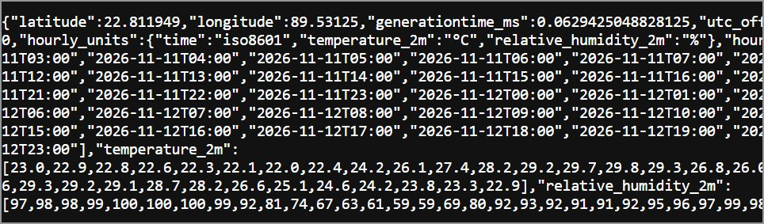
Fig 14: API response: hourly weather forecast (partial view)

JSON parsing
JSON field | Java class and field | Used for
current.temperature_2m | WeatherResponse.Current.temperature | Temperature of a reading
current.relative_humidity_2m | WeatherResponse.Current.humidity | Humidity of a reading
current.pm2_5 / pm10 / us_aqi | AirQualityResponse.Current.pm25 / pm10 / usAqi | Particulates and AQI
hourly.time[], temperature_2m[], relative_humidity_2m[] | HourlyWeatherResponse.Hourly | Forecast hours
hourly.pm10[], pm2_5[], us_aqi[] | HourlyAirResponse.Hourly | Forecast hours
utc_offset_seconds | HourlyWeatherResponse.utcOffsetSeconds | Converting local forecast times to epoch time

Error handling: the response code and body are checked and failures surface as readable messages. The Dashboard shows a toast, the Plan falls back to the cached forecast, and missing values default to zero where that is safe.

7.2 Local Database (Room)
All readings and diary entries are stored on the device in a Room database (ecosense.db, schema version 2). The version 1 to 2 migration added the symptom table without removing existing readings.

Table env_logs (entity EnvLog)
Column | Type | Description
id | INTEGER, primary key, auto-increment | Row identifier
timestamp | INTEGER | Time of the reading (epoch milliseconds)
temperature | REAL | Degrees Celsius
humidity | REAL | Percent
pm25, pm10 | REAL | Particulate matter in µg/m³
aqi | INTEGER | US Air Quality Index
synced | INTEGER (boolean) | Whether the reading was uploaded to Firestore
source | TEXT | Data provider (Open-Meteo)

Table symptom_entries (entity SymptomEntry)
Column | Type | Description
id | INTEGER, primary key, auto-increment | Row identifier
timestamp | INTEGER | Time of the entry
type | INTEGER | Symptom (0 headache … 6 allergy, 7 feeling fine)
severity | INTEGER | 1 mild, 2 moderate, 3 severe, 0 for feeling fine
note | TEXT | Optional note
aqi, pm25, temperature, humidity | INTEGER / REAL | Snapshot of the air when the entry was logged

Content provider and other storage
Item | Details
Content provider | Authority com.ecosense.app.provider, URI content://com.ecosense.app.provider/logs, read-only, protected by the custom permission com.ecosense.app.permission.READ_LOGS. The CSV exporter reads the data through it.
SharedPreferences | Alert limits, interval, health profile, dark mode, notification and monitoring switches, guest flag, last location and spike cooldown.
Forecast cache | The last hourly forecast stored as JSON (valid for 12 hours) so the plan works offline.
Exported files | CSV reports are written to the device’s Downloads folder (MediaStore on Android 10 and above).

7.3 Firebase
EcoSense uses three Firebase services: Authentication, Cloud Firestore and Realtime Database. The Android app is registered in the Firebase project Ecosense with the package name com.ecosense.app and is configured through google-services.json. Firebase Cloud Storage is not used (Section 7.3.5).

7.3.1 Firebase Authentication
Email/password authentication is enabled. The Login screen supports sign-in, account creation and password reset by email. A signed-in user can synchronise data; guests keep all data on the device. Fig 15 lists the registered accounts, which were created from the app.
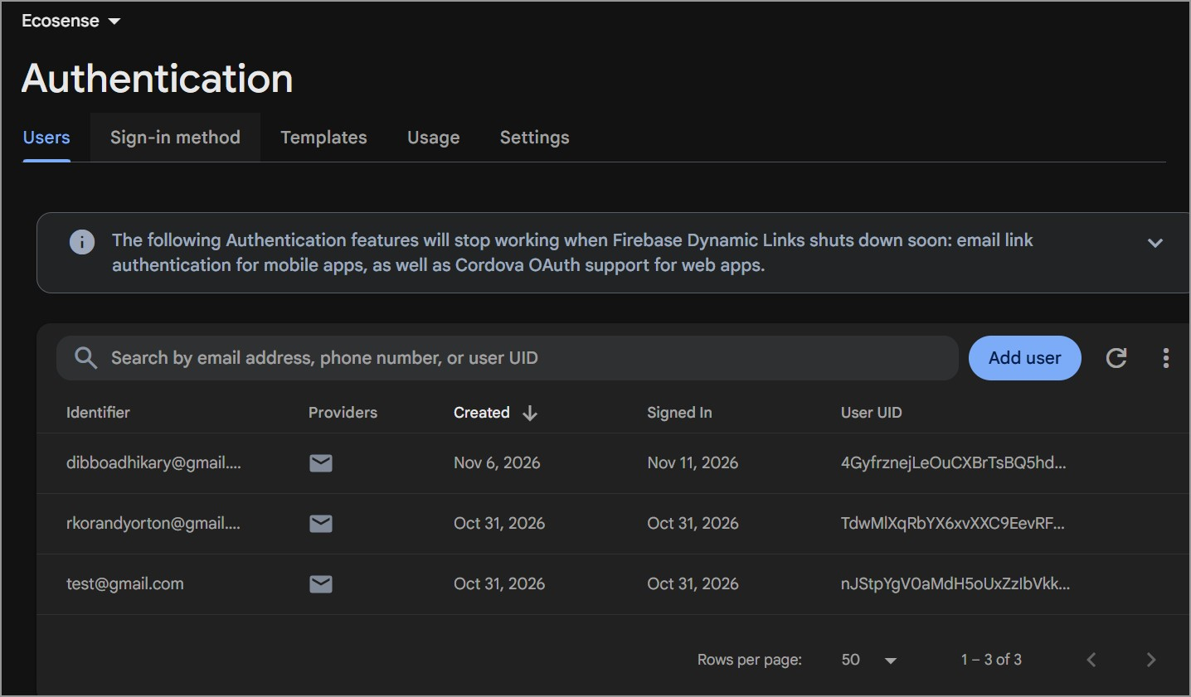
Fig 15: Firebase Authentication: registered email and password users

7.3.2 Cloud Firestore
Readings are synchronised to Cloud Firestore for signed-in users. Each reading becomes one document, so uploads are idempotent. Unsynced readings are written in batches of up to 400 and then marked as synced locally; this runs from History (Sync to cloud), automatically from the service and when the connection returns. Settings > Restore history from cloud downloads readings that are missing locally.
Item | Details
Path | users/{uid}/logs/{timestamp}
Fields | timestamp, temperature, humidity, pm25, pm10, aqi (numbers) and source (string)
Access | Only the signed-in owner of the uid (see Appendix A)

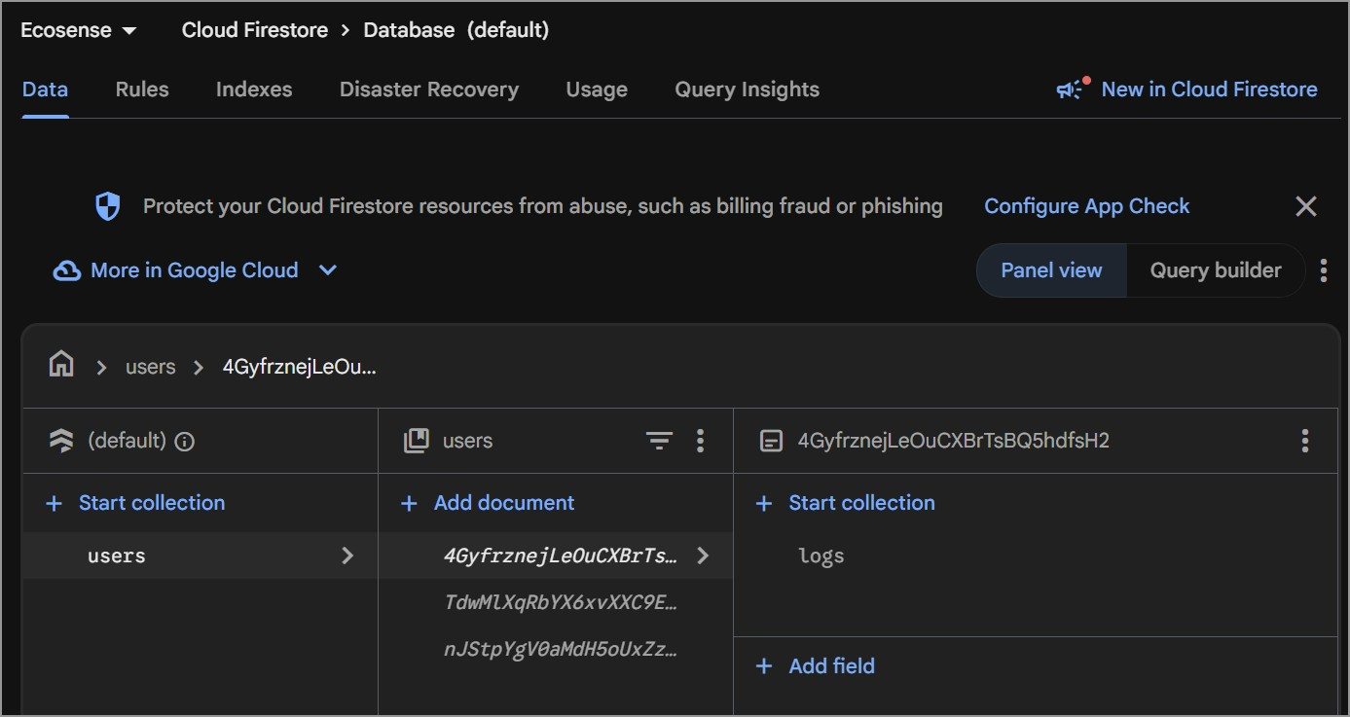
Fig 16: Cloud Firestore: the users collection with a user document and its logs sub-collection

7.3.3 Firebase Realtime Database
The symptom chat stores its messages in Realtime Database. The conversation is delivered by a ChildEventListener, local writes appear immediately even offline and offline persistence is enabled. Guests have no cloud access; their messages are kept in memory for the session, and if the database is not configured the chat runs in local mode and says so on screen.
Item | Details
Path | users/{uid}/chat/{pushId}
Fields | role (“user” or “bot”), text (string), ts (timestamp, number)
Region | asia-southeast1 (Singapore)

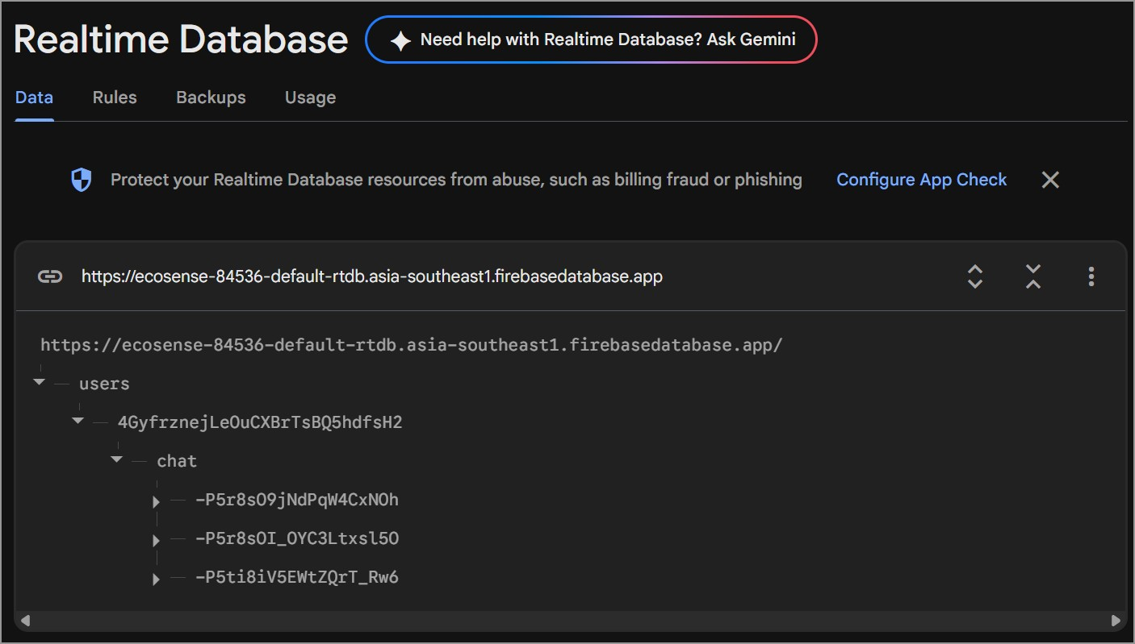
Fig 17: Realtime Database: users > uid > chat with the stored chat messages

7.3.4 Firebase usage
The usage dashboard confirms that the app really reads and writes both databases: Firestore shows reads and writes from the history synchronisation, and Realtime Database shows downloads and a small stored size (a few kilobytes) for the chat messages.
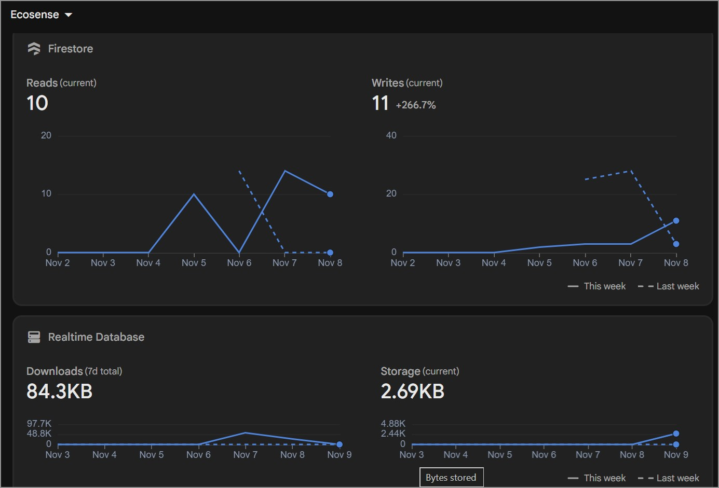
Fig 18: Firebase usage: Firestore reads and writes, and Realtime Database downloads and storage

7.3.5 Cloud Storage and media
Firebase Cloud Storage is not used. EcoSense does not capture, upload or store pictures, audio or video. The only files it creates are CSV reports saved to the device’s Downloads folder at the user’s request.

7.4 Summary of Data Stores
Data | Local | Cloud
Environmental readings | Room (env_logs) | Firestore (signed-in users)
Symptom diary | Room (symptom_entries) | Not uploaded (CSV export only)
Chat messages | In memory for guests | Realtime Database (signed-in users)
Preferences | SharedPreferences | Not uploaded
Forecast | JSON cache | Not uploaded
Accounts | None | Firebase Authentication

8. Limitations, Challenges and Conclusion

Limitations
- The advice is general guidance and the chat is rule-based; it does not diagnose and understands free text only for red-flag phrases.
- Pattern analysis shows correlation, not causation.
- The location is the last known fix rather than an active GPS request.
- Interface text is in English and mostly defined in the layouts rather than string resources.
- The project uses findViewById rather than View Binding and parses JSON only (no XML).
- It does not read device contacts or media through system content providers.
- Only readings are backed up to the cloud; the symptom diary is exported as CSV instead.

Challenges and Solutions
Challenge | Solution
Android restricts background work and implicit broadcasts | A foreground service for monitoring; dynamic receivers and a NetworkCallback instead of manifest receivers for system events.
Notification permission on Android 13+ | Runtime request with an explanation; notifications are skipped without crashing when denied.
Scoped storage for exports | MediaStore on Android 10+; storage permission requested only on Android 9 and below.
Network not always available | Offline-first design with Room, a forecast cache, and automatic refresh and sync when the connection returns.
Finding patterns in very little personal data | Early signals are labelled low confidence; tested patterns need 7 days and use a Fisher exact test and the best factor per symptom.
Changing the database without losing data | A real Room migration from version 1 to 2.
Using the app without an account or cloud setup | Guest mode and a local chat fallback when Firebase is unavailable.
Making numbers meaningful to non-experts | A rule-based advisor with reasons, plus a health profile that adjusts every recommendation.

Conclusion
EcoSense shows how public environmental data can be turned into personal, actionable guidance on a mobile device. It combines a well-structured Android application (multi-activity navigation, lists, a foreground service, receivers, a content provider, notifications and runtime permissions) with a JSON web API, an offline-first Room database and three Firebase services. Its original contributions are the profile-aware planner that finds the best time to go outside, the system-aware monitoring that adapts to battery and connectivity, and the Symptom Link module that connects a person’s symptoms to the air around them.
The project met its objectives: it works offline and as a guest, synchronises with the cloud for signed-in users and presents clear, cautious advice. The limitations above give a clear direction for further development.

References
- Open-Meteo. Free Weather API and Air Quality API documentation. https://open-meteo.com/en/docs
- Google. Android Developers: Services, BroadcastReceiver, ContentProvider, Notifications, Permissions. https://developer.android.com
- Google. Room persistence library. https://developer.android.com/training/data-storage/room
- Google. Firebase documentation: Authentication, Cloud Firestore and Realtime Database. https://firebase.google.com/docs
- Square. Retrofit and OkHttp. https://square.github.io/retrofit/
- Google. Material Design 3. https://m3.material.io
- US EPA. Air Quality Index (AQI) basics. https://www.airnow.gov/aqi/aqi-basics/

