Operating Systems, Security and Network
Lab Report 4: A Practical Approach to Understanding System Internals (Data Types and OS Memory Management)
Student Name: Kshitish | Module: ST5003CMD | Softwarica College

Part I: Theoretical Overview & Process Memory Architecture
A data type is an explicit contract established between the programmer, the compiler, and the operating system kernel. It defines the exact number of bytes allocated in memory, dictates binary bit interpretation (integer, character, floating-point), and restricts valid CPU operations on those memory registers.
In a modern 64-bit Linux operating system, each process executes within its own isolated virtual address space divided into distinct segments:
• Stack Segment: Allocated automatically for function call frames, local variables, and return addresses. Grows downward from high virtual memory addresses (e.g. 0x7ffd...).
• Heap Segment: Managed dynamically at runtime via malloc() and free(). Grows upward from lower memory towards the stack.
• BSS Segment: Holds uninitialized global and static variables, zero-initialized by the OS loader.
• Data Segment: Holds initialized global and static variables loaded directly from the executable binary.
• Text Segment: Contains read-only compiled machine code instructions executed by the CPU.

Part II: Practical Laboratory Exercises & Verification
Exercise 1: Data Type Size Exploration (lab1_datatypes.c)
Command: gcc -Wall lab1_datatypes.c -o lab1_datatypes && ./lab1_datatypes
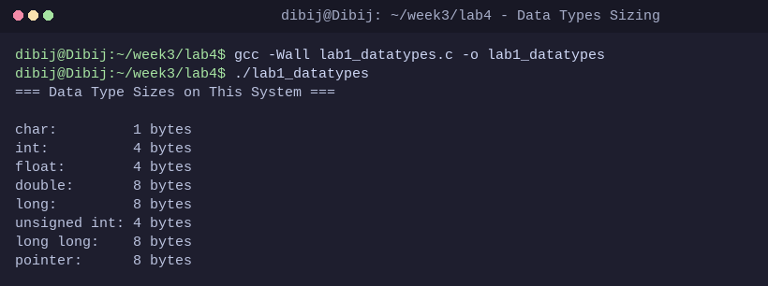
Description: We ran this command to compile and evaluate the byte sizes of primitive C types and memory pointers on our 64-bit Linux architecture using sizeof().
Architectural Observation & Analysis: On our 64-bit Linux operating system (LP64 data model), sizeof(long) is 8 bytes, and sizeof(int*) is 8 bytes. In contrast, on 32-bit architectures (ILP32 model), sizeof(long) and pointers are 4 bytes because native register width and address bus size are restricted to 32 bits.

Exercise 2: Memory Segment Address Mapping (lab2_segments.c)
Command: gcc -Wall lab2_segments.c -o lab2_segments && ./lab2_segments
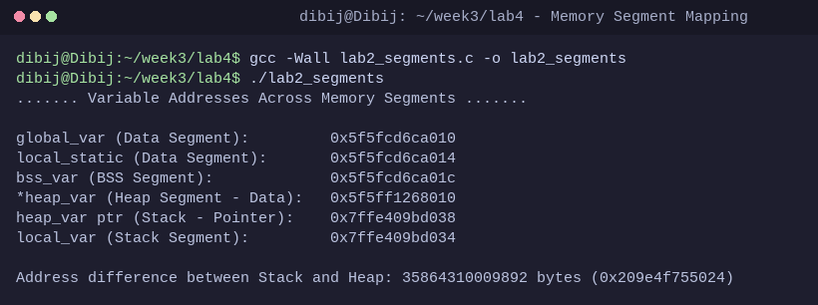
Description: We ran this command to inspect virtual addresses of variables declared in the Data, BSS, Heap, and Stack segments and calculate the address gap between Stack and Heap.
Memory Segment Identification & Observations:
• Highest Address Segment: Stack segment (local_var at 0x7ffe409bd034 and heap_var ptr at 0x7ffe409bd038).
• Lowest Address Segment: Data segment (global_var at 0x5f5fcd6ca010, local_static at 0x5f5fcd6ca014) followed immediately by the BSS segment (bss_var at 0x5f5fcd6ca01c).
• Mid-Range Segment: Heap segment (*heap_var allocated at 0x5f5ff1268010).
• Observation: The Stack and Heap segments are separated by a massive virtual address difference of over 35 Terabytes (35,864,310,009,892 bytes / 0x209e4f755024). This vast unallocated space allows the Stack to grow downward and the Heap to grow upward without collision.

Exercise 3: Pointer and Dynamic Heap Allocation (heap_pointer_demo.c)
Command: gcc -Wall heap_pointer_demo.c -o heap_pointer_demo && ./heap_pointer_demo
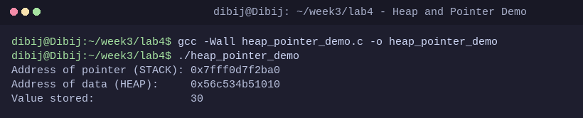
Description: We ran this command to demonstrate pointer mechanics: the pointer variable itself resides on the Stack while holding the address of dynamically allocated memory on the Heap.

Part III: Knowledge Check Assessment Solutions
Question 1: What is a data type in the context of programming and operating systems?
Answer: In programming and OS internals, a data type acts as a formal contract. It instructs the compiler and OS kernel how many bytes of physical/virtual memory to allocate, how to encode and decode the underlying binary bit patterns (e.g. two's complement for signed integers, IEEE 754 for floats), and which ALU operations are legally permitted on the data.

Question 2: Name the five main memory segments in a process memory layout.
Answer: The five primary segments in standard process memory architecture are:
1. Text Segment (Executable machine instructions)
2. Initialized Data Segment (Global and static variables initialized with non-zero values)
3. BSS Segment (Block Started by Symbol: uninitialized global and static variables)
4. Heap Segment (Dynamically allocated memory via malloc/calloc growing upward)
5. Stack Segment (Stack frames for local variables, parameters, and function calls growing downward).

Question 3: What is the difference between the Data segment and the BSS segment?
Answer: The Data segment stores global and static variables that have been explicitly initialized with non-zero values by the programmer, which increases the physical file size of the compiled binary. The BSS segment stores uninitialized or zero-initialized global and static variables; it takes up virtually zero space in the binary on disk because the OS kernel automatically zeroes this memory during process loading.

Question 4: Why does the OS place the stack at high virtual addresses and the text segment at low addresses?
Answer: The Text segment contains immutable, fixed-size machine code, making it optimal to anchor at low addresses above the reserved null-pointer safety zone. Conversely, placing the Stack at high virtual addresses growing downward and the Heap at lower addresses growing upward maximizes the flexible virtual address space between them, preventing premature collisions as memory needs expand.

Question 5: What happens to stack memory when a function returns? Who reclaims it?
Answer: When a function returns, its stack frame is instantly reclaimed by adjusting the CPU stack pointer register (RSP / ESP) back to the caller's frame. The OS is not invoked for this reclamation; rather, the compiled machine instructions generated by the compiler execute the function epilogue (e.g. leave and ret) to automatically recycle the memory.

Question 6: How does the OS know which memory belongs to which process?
Answer: The OS kernel relies on Virtual Memory Management and hardware-enforced Page Tables managed by the Memory Management Unit (MMU). Each process is allocated its own distinct page directory and page tables referenced by the CPU's CR3 control register. During a context switch, the OS loads the active process's page table pointer, ensuring virtual addresses map exclusively to isolated physical memory frames.

Part IV: Conclusion
This lab demystified the underlying mechanics of C data types and process memory layout under Linux. Through direct address printing using %p, we confirmed that the Stack resides at the highest virtual addresses, the Heap expands from lower memory, and the Data/BSS segments are organized sequentially near the base of the address space. Understanding these boundaries provides a crucial foundation for low-level systems programming, memory safety, and operating system design.

