Operating Systems, Security and Network
Lab Report 3: Investigating Process Lifecycles and OS Interaction
Student Name: Kshitish Pandit | Module: ST5003CMD | Softwarica College

Part I: Theoretical Concepts & Process Lifecycle Flow
An Operating System (OS) manages running programs as independent processes. Every active process is assigned a unique Process Identifier (PID) and tracks the Parent Process ID (PPID) of the shell or daemon that invoked it. The Linux kernel maintains lifecycle states:
• Created / Ready: Process image loaded in memory and scheduled.
• Running: Process executing instructions on the CPU core.
• Blocked / Sleeping (Interruptible 'S'): Process paused awaiting events or sleeping via sleep() system call.
• Terminated: Process completed execution, returning an integer exit status code (0 for success, non-zero for error) stored in the shell variable $?.
Process Lifecycle Execution Flow Diagram:
[Program Start] ---> [Kernel Allocates PID/PPID] ---> [Running State]
| |
v v
[sleep() System Call] <------------------------ [Branching Logic/IO]
| |
v v
[Interruptible Sleep 'S'] ---> [Wakeup] ---> [Exit Code 0/1 returned to OS]

Part II: Practical Lab Tasks & Verification
Task 1: Long-Running Process & Background Monitoring
Command: gcc task1_alive.c -o task1 && ./task1 & && ps aux | grep task1
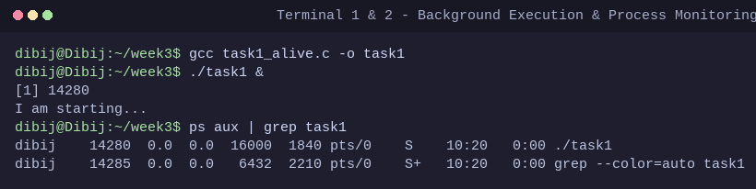
Description: We ran this command to start a 30-second loop program in the background using '&' and monitored its active state using ps aux | grep task1.

Task 2: Process Identity (PID and PPID Verification)
Command: gcc task2_identity.c -o task2 && ./task2 & && ps -p <PID> -o pid,ppid,cmd
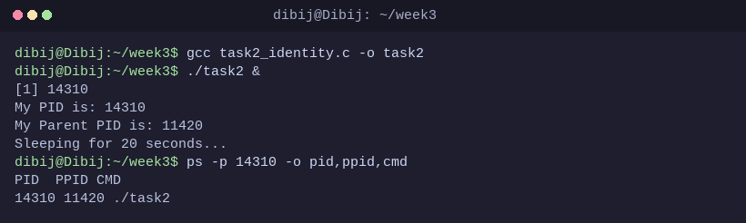
Description: We ran this command to query getpid() and getppid() system calls and verified the printed PID and parent shell PPID with ps.

Task 3: Exit Codes and OS Feedback ($?)
Command: gcc task3_exit.c -o task3 && ./task3 && echo $?
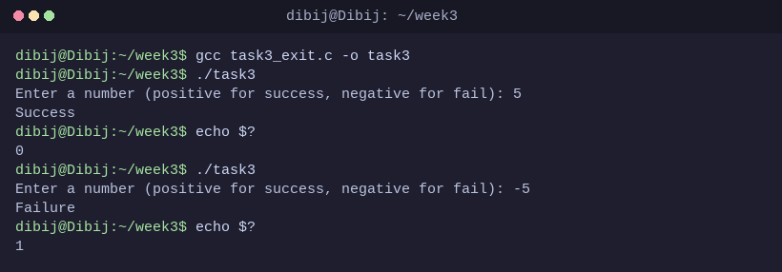
Description: We ran this command to test positive input returning 0 (success) and negative input returning 1 (failure) verified via echo $?.

Task 4: Standard I/O Streams (stdin and stdout)
Command: gcc task4_input.c -o task4 && ./task4
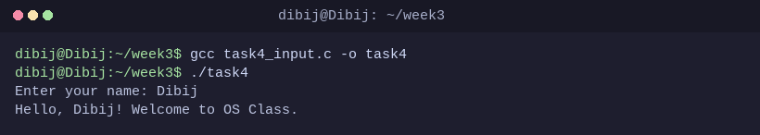
Description: We ran this command to test reading character data from standard input (stdin) and writing formatted output to standard output (stdout).

Task 5: Conditional Execution and Termination Control
Command: gcc task5_control.c -o task5 && ./task5 && echo $?
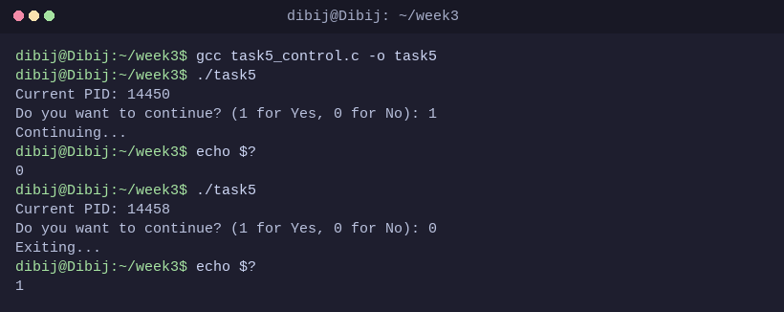
Description: We ran this command to test runtime branching where choosing '1' sleeps and exits with code 0, while '0' aborts and exits with code 1.

Part III: Conclusion
This lab demonstrated how C programs interact directly with the Linux operating system kernel. By invoking system calls such as getpid(), getppid(), and sleep(), programs query their runtime context and suspend CPU usage appropriately. Furthermore, returning specific integer exit codes enables automation pipelines and terminal shells to dynamically check execution health.

