Dockerized MERN Application – Project Documentation (Updated)
1. Project Overview
This project is a Dockerized MERN (MongoDB, Express, React, Node.js) application. The purpose is to containerize all services (frontend, backend, and database) to ensure consistent development and deployment using Docker and Docker Compose.

2. Technologies Used
- Node.js (v20)
- React (Vite / Development Server)
- MongoDB
- Docker
- Docker Compose

3. Architecture Overview
The application consists of three services:
- Backend → Node.js API (port 3000)
- Frontend → React app (port 5173)
- Database → MongoDB (port 27017)
All services communicate through a custom Docker bridge network:
👉 Network Name: workout-app-network

4. Backend Docker Configuration
FROM node:20
WORKDIR /app
COPY package*.json ./
RUN npm install
COPY . .
EXPOSE 3000
CMD ["npm", "run", "start:dev"]
Explanation:
- Uses Node.js 20
- Installs dependencies
- Runs backend in development mode
- Exposes API on port 3000

5. Frontend Docker Configuration
FROM node:20-alpine
WORKDIR /app
COPY package*.json ./
RUN npm install
COPY . .
EXPOSE 5173
CMD ["npm", "run", "dev", "--", "--host"]
Explanation:
- Lightweight Alpine Node image
- Runs React/Vite development server
- Exposes frontend on port 5173

6. Docker Compose Configuration
services:
backend:
build: ./backend
ports:
- "3000:3000"
env_file:
- ./backend/.env
depends_on:
- mongodb
networks:
- workout-app-network
frontend:
build: ./frontend
ports:
- "5173:5173"
networks:
- workout-app-network
mongodb:
image: mongo
ports:
- "27017:27017"
volumes:
- mongo_data:/data/db
networks:
- workout-app-network
volumes:
mongo_data:
networks:
workout-app-network:
driver: bridge

7. Networking
All containers communicate using a shared bridge network:
- Network Name: workout-app-network
- Driver: bridge
- Purpose: Enables inter-service communication using container names
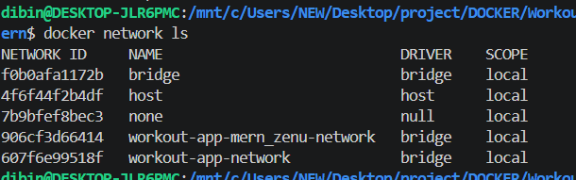

8. Persistent Storage
MongoDB uses Docker volume:
- Volume: mongo_data
- Purpose: Keeps database data persistent across restarts

9. Deployment Commands
Start project:
docker compose up --build
Stop project:
docker compose down
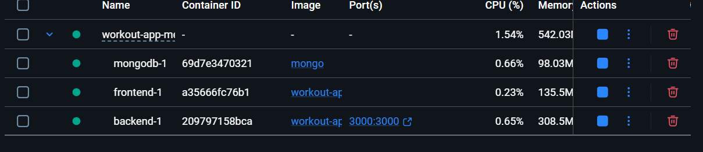
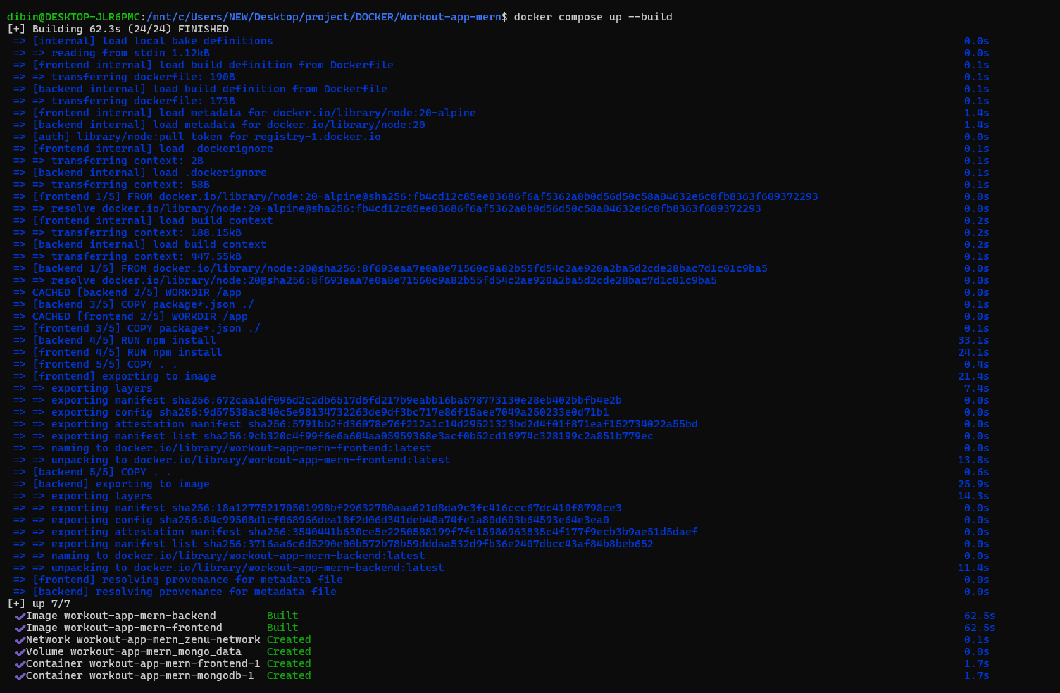

10. Conclusion
This project demonstrates a complete Dockerized MERN stack setup with isolated services, persistent storage, and a shared network (workout-app-network) ensuring portability and scalability.

