CI/CD Pipeline Troubleshooting Documentation
Jenkins Build Pipeline Failure

1. Incident Summary
The Jenkins CI/CD pipeline failed during the Build stage while executing the Maven build command. Multiple issues were identified during troubleshooting, including missing build dependencies, missing project configuration files, and malformed Maven configuration.

2. Environment Details
Component | Details
Platform | Docker
CI/CD Tool | Jenkins
Build Tool | Maven
Host Environment | WSL2 Ubuntu
Container Name | jenkins-lab
Pipeline Name | docker-troubleshoot-pipeline

3. Initial Scenario
The Jenkins pipeline was configured with the following build stage:
pipeline {
agent any
stages {
stage('Build') {
steps {
sh 'mvn clean package'
}
}
}
}
During execution, the pipeline failed in the Build stage.

4. Issues Identified
Issue 1 — Maven Not Installed
Error
mvn: command not found
Root Cause
The Jenkins Docker container did not contain Maven installation.
Troubleshooting Steps
Verified Maven availability inside Jenkins container:
docker exec -it jenkins-lab bash
mvn -v
The command returned:
mvn: command not found
Resolution
Installed Maven inside Jenkins container:
apt update
apt install maven -y
Verified installation:
mvn -v

Issue 2 — Missing pom.xml File
Error
The goal you specified requires a project to execute but there is no POM in this directory
Root Cause
The Jenkins workspace did not contain the Maven project configuration file (pom.xml).
Workspace Path
/var/jenkins_home/workspace/docker-troubleshoot-pipeline
Troubleshooting Steps
Verified Jenkins workspace path from console logs:
Running on Jenkins in /var/jenkins_home/workspace/docker-troubleshoot-pipeline
Confirmed pom.xml was missing from workspace.
Resolution
Created pom.xml in the Jenkins workspace:
jenkins_home/workspace/docker-troubleshoot-pipeline/pom.xml

Issue 3 — Invalid pom.xml Syntax
Error
expected end tag </project>
Root Cause
The Maven configuration file (pom.xml) was malformed and missing the closing XML tag.
Troubleshooting Steps
Reviewed Jenkins console output and identified XML parsing error.
Resolution
Corrected the pom.xml structure:
<project xmlns="http://maven.apache.org/POM/4.0.0"
xmlns:xsi="http://www.w3.org/2001/XMLSchema-instance"
xsi:schemaLocation="http://maven.apache.org/xsd/maven-4.0.0.xsd">
<modelVersion>4.0.0</modelVersion>
<groupId>com.demo</groupId>
<artifactId>java-app</artifactId>
<version>1.0</version>
</project>

5. Docker Volume Mapping Understanding
The Jenkins home directory was mapped between host and container using Docker volumes.
Docker Compose Configuration
volumes:
- ./jenkins_home:/var/jenkins_home
Mapping Details
Host System | Container
./jenkins_home | /var/jenkins_home
This allowed Jenkins workspace files to be accessible both from:
- WSL/Windows filesystem
- Jenkins Docker container
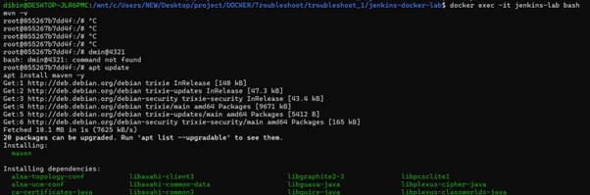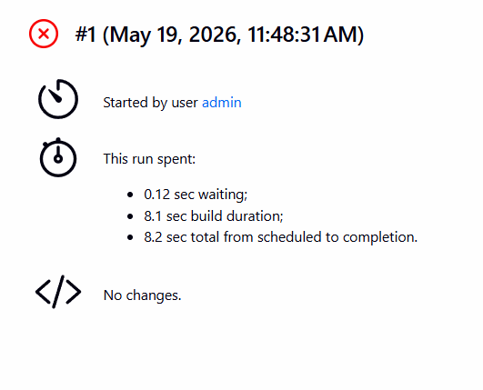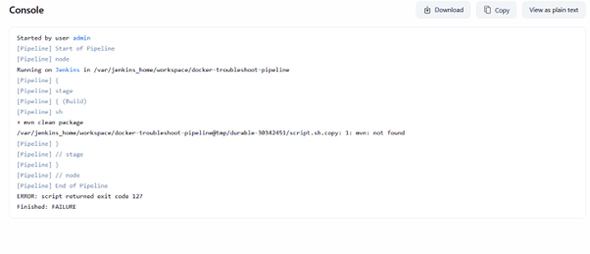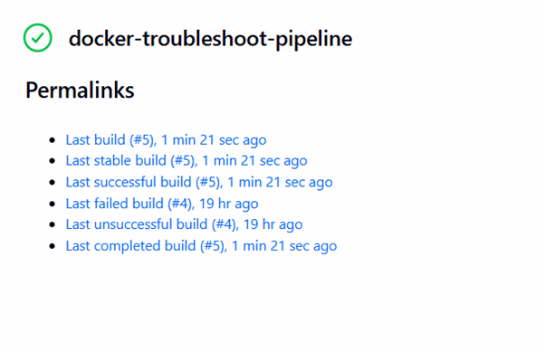
6. Final Outcome
After:
- installing Maven,
- placing pom.xml correctly,
- and fixing XML syntax,
the Jenkins pipeline executed successfully.

7. Preventive Measures
Preventive Action | Description
Use Prebuilt CI Images | Create Jenkins images with Maven preinstalled
Use Git Integration | Pull project files automatically from Git repositories
Validate Build Files | Verify pom.xml syntax before execution
Use Containerized Agents | Maintain consistent build environments
Monitor Workspace Configuration | Ensure correct workspace structure

8. Key Learnings
- Jenkins pipelines execute inside container workspaces.
- Docker containers maintain isolated filesystems.
- Missing dependencies can cause build failures.
- Maven requires a valid pom.xml in the execution directory.
- Docker volume mapping allows host-container file sharing.
- CI/CD troubleshooting often involves multiple sequential issues.

9. Important Commands Used
Start Jenkins
docker compose up -d
Access Jenkins Container
docker exec -it jenkins-lab bash
Verify Maven
mvn -v
Check Running Containers
docker ps
View Jenkins Logs
docker logs jenkins-lab

10. Conclusion
The CI/CD pipeline failure was successfully analyzed and resolved through systematic troubleshooting. The exercise demonstrated practical DevOps troubleshooting concepts involving Docker containers, Jenkins pipelines, Maven dependencies, workspace management, and configuration validation.

