Assistive Smart Home Automation System
Comprehensive Engineering Report & Technical Documentation
1. Executive Summary & Project Overview
This comprehensive technical project details the design, hardware integration, and firmware software architecture of an integrated Assistive Smart Home Automation System. Modern home automation systems often rely heavily on complex smartphone interfaces or active voice assistants that present steep learning curves or physical barriers for elderly users and individuals with severe motor function impairments. The target system consolidates three dedicated assistive sub-modules into a cohesive, low-latency, conflict-free ecosystem designed specifically to foster independent living.
By uniting infrared remote communication, contactless ultrasonic detection, dual-servo actuation, dimmable PWM lighting, and variable motor fan control onto a unified microcontroller platform, this system provides accessible, tactile, and non-intrusive environmental control without physical exertion.
2. System Firmware & Architecture
The complete consolidated C++ firmware for the ATmega328P microcontroller resolves hardware timer conflicts between IR receiver decoding, servo motor timing, and PWM output drivers through structured pin reassignment and timer management:
// MANDATORY: Must define timer before including IRremote header
#define IR_USE_TIMER2
#include <IRremote.hpp>
#include <Servo.h>
// PIN DEFINITIONS
const int IR_RECEIVE_PIN = 2;
const int SERVO1_PIN = 7;
const int SERVO2_PIN = 8;
const int W_PIN = 11;
const int W2_PIN = 5;
const int EN1_PIN = A2;
const int IN1_PIN = A3;
const int IN2_PIN = A4;
const int TRIG_PIN = A0;
const int ECHO_PIN = A1;
const int BUZZER_PIN = 12;
Servo servo1;
Servo servo2;
int brightness = 0;
bool isMotorOn = false;
unsigned long lastSonarScanTime = 0;
const unsigned long SONAR_INTERVAL = 60;
const int DISTANCE_THRESHOLD = 8;
const unsigned long RING_DURATION = 2000;
unsigned long alarmStartTime = 0;
bool isAlarmActive = false;
bool hasTriggered = false;
const unsigned long BTN_W1_ON = 0xBA45FF00;
const unsigned long BTN_W1_OFF = 0xB946FF00;
const unsigned long BTN_W2_UP = 0xB847FF00;
const unsigned long BTN_W2_DN = 0xBB44FF00;
const unsigned long BTN_MOT_UP = 0xBF40FF00;
const unsigned long BTN_MOT_DN = 0xBC43FF00;
const unsigned long BTN_7 = 0xF807FF00;
const unsigned long BTN_8 = 0xEA15FF00;
const unsigned long BTN_9 = 0xF609FF00;
const unsigned long BTN_0 = 0xE619FF00;
void setMotorState(bool turnOn) {
if (turnOn) {
digitalWrite(IN1_PIN, HIGH);
digitalWrite(IN2_PIN, LOW);
digitalWrite(EN1_PIN, HIGH);
isMotorOn = true;
} else {
digitalWrite(IN1_PIN, LOW);
digitalWrite(IN2_PIN, LOW);
digitalWrite(EN1_PIN, LOW);
isMotorOn = false;
}
}
void processUltrasonic() {
if (millis() - lastSonarScanTime >= SONAR_INTERVAL) {
lastSonarScanTime = millis();
digitalWrite(TRIG_PIN, LOW);
delayMicroseconds(2);
digitalWrite(TRIG_PIN, HIGH);
delayMicroseconds(10);
digitalWrite(TRIG_PIN, LOW);
long duration = pulseIn(ECHO_PIN, HIGH, 10000);
int distance = duration * 0.034 / 2;
if (distance > 0 && distance <= DISTANCE_THRESHOLD) {
if (!hasTriggered) {
isAlarmActive = true;
hasTriggered = true;
alarmStartTime = millis();
digitalWrite(BUZZER_PIN, HIGH);
}
} else {
hasTriggered = false;
}
}
if (isAlarmActive && (millis() - alarmStartTime >= RING_DURATION)) {
digitalWrite(BUZZER_PIN, LOW);
isAlarmActive = false;
}
}
void setup() {
Serial.begin(9600);
pinMode(W_PIN, OUTPUT);
pinMode(W2_PIN, OUTPUT);
pinMode(EN1_PIN, OUTPUT);
pinMode(IN1_PIN, OUTPUT);
pinMode(IN2_PIN, OUTPUT);
pinMode(TRIG_PIN, OUTPUT);
pinMode(ECHO_PIN, INPUT);
pinMode(BUZZER_PIN, OUTPUT);
digitalWrite(W_PIN, LOW);
analogWrite(W2_PIN, 0);
setMotorState(false);
servo1.attach(SERVO1_PIN);
servo2.attach(SERVO2_PIN);
servo1.write(0);
servo2.write(0);
IrReceiver.begin(IR_RECEIVE_PIN, ENABLE_LED_FEEDBACK);
Serial.println("System Hardware Fully Initialized.");
}
void loop() {
if (IrReceiver.decode()) {
unsigned long code = IrReceiver.decodedIRData.decodedRawData;
if (code != 0) {
if (code == BTN_W1_ON) digitalWrite(W_PIN, HIGH);
else if (code == BTN_W1_OFF) digitalWrite(W_PIN, LOW);
else if (code == BTN_W2_UP) { brightness = min(brightness + 31, 255); analogWrite(W2_PIN, brightness); }
else if (code == BTN_W2_DN) { brightness = max(brightness - 31, 0); analogWrite(W2_PIN, brightness); }
else if (code == BTN_MOT_UP) setMotorState(true);
else if (code == BTN_MOT_DN) setMotorState(false);
else if (code == BTN_7) servo1.write(100);
else if (code == BTN_8) servo1.write(0);
else if (code == BTN_9) servo2.write(100);
else if (code == BTN_0) servo2.write(0);
}
IrReceiver.resume();
}
processUltrasonic();
}
3. Complete Bill of Materials (BOM)
Component Name | Qty | Hardware Specifications | System Functional Role
Arduino Uno / Nano | 1 | ATmega328P, 16MHz clock, 32KB Flash | Main central processing unit for sensors and actuators
TSOP1838 IR Receiver | 1 | 38 kHz carrier frequency, 3-pin package | Captures infrared pulses from NEC format remote controllers
NEC IR Remote | 1 | 38 kHz modulation, 21-button keypad | Handheld wireless interface for tactile user input
Standard Servo (SG90/MG995) | 2 | 5V Operating voltage, 0°-180° range | Automated physical actuation (door latches, window blinds)
HC-SR04 Ultrasonic Sensor | 1 | 4-pin (VCC, Trig, Echo, GND), 2cm-400cm | Non-contact proximity and obstacle detection
Piezo Electric Buzzer | 1 | 5V Active Buzzer module | Audio chime and alarm feedback generator
L293D / L298N Motor Driver | 1 | Dual H-Bridge IC / Module, 5V-36V | Drives high-current DC cooling fan motor
5V DC Motor / Fan | 1 | 5V-12V brush DC motor | Simulated HVAC or personal cooling ventilation unit
5mm Standard LEDs | 2 | White/Yellow, 20mA nominal current | Room overhead lighting & dimmable bedside lamp
Current Limiting Resistors | 2 | 220 Ω, 1/4W resistor | Protects LEDs from over-current destruction
External Power Supply | 1 | 5V / 2A Regulated DC Adapter | Provides isolated power for servos and DC motor loads
4. Circuit Interconnection Schematic
The system visual circuit schematic illustrates all signal lines, power distribution rails, and peripheral pin connections. To eliminate electrical noise and voltage drops caused by high-current inductive loads (motors and servos), the logic rail is decoupled from the motor supply.
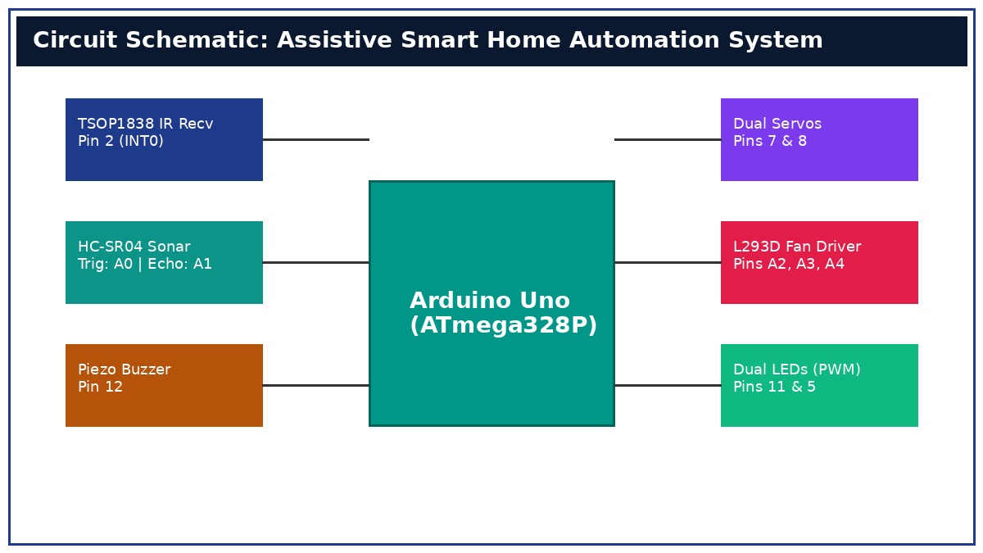
Figure 1: High-level System Wiring Schematic & Interconnection Diagram.
Hardware Pin Assignment Summary
Module / Component | Arduino Pin | Pin Function / Signal Type | Hardware Notes
TSOP1838 IR Receiver | Pin 2 (INT0) | Digital Input (38 kHz Decoder) | Timer 2 active decoding
Servo Motor 1 | Pin 7 | Digital Output (Servo PWM) | Standard Servo Control (0°-100°)
Servo Motor 2 | Pin 8 | Digital Output (Servo PWM) | Standard Servo Control (0°-100°)
Standard LED (W_PIN) | Pin 11 | Digital Output (HIGH/LOW) | Overhead lighting switch
Dimmable LED (W2_PIN) | Pin 5 | Hardware PWM (Timer 0) | 0-255 Smooth brightness dimming
L293D Motor Driver | Pins A2, A3, A4 | Digital GPIO Outputs | A2: EN1, A3: IN1, A4: IN2
HC-SR04 Ultrasonic | Pins A0, A1 | Digital IO (Trigger / Echo) | A0: Trig Output, A1: Echo Input
Piezo Alert Buzzer | Pin 12 | Digital Output | 2-second non-blocking audio alarm
5. Software Libraries & Technical Functions
- IRremote.hpp (v3.0+): Handles real-time decoding of 38 kHz modulated infrared signals. Configured with #define IR_USE_TIMER2 to assign hardware interrupts to Timer 2.
- Servo.h: Generates 50 Hz PWM pulse-width signals (1ms to 2ms pulse width) to dictate exact rotational angles for standard RC servo motors.
6. Real-Life Applications & Assistive Impact
- Hands-Free Door & Latch Control: Standard door knobs and mechanical latches require fine motor control and grip strength. The dual-servo mechanism automates door opening or cabinet unlocking via remote control buttons (7/8 & 9/0), restoring privacy and autonomy.
- Autonomous Contactless Entryway Alerting: Wheelchair users often struggle to reach mounted doorbells or physical entry pull cords. The HC-SR04 ultrasonic proximity array detects an approaching individual within 8 cm and automatically sounds a 2-second alert, functioning as a contactless chime.
- Bedside Environmental Control: Bedridden individuals or elderly patients can control overhead lighting (W_PIN), adjust nightlight brightness smoothly via PWM (W2_PIN), and toggle ventilation fans without getting out of bed or calling for assistance.

