Arduino Microcontroller Circuit Analysis
Detailed Working Mechanism & Operational Architecture for Smart Home & Garage Automation

1. Circuit Overview & Working Mechanism
This circuit centers around an Arduino Uno acting as the main microcontroller, which processes inputs from sensors and receivers to control various outputs including lighting, motor drivers, buzzers, and precision servo motors. The entire system creates a unified framework for smart home automation and intelligent garage control.
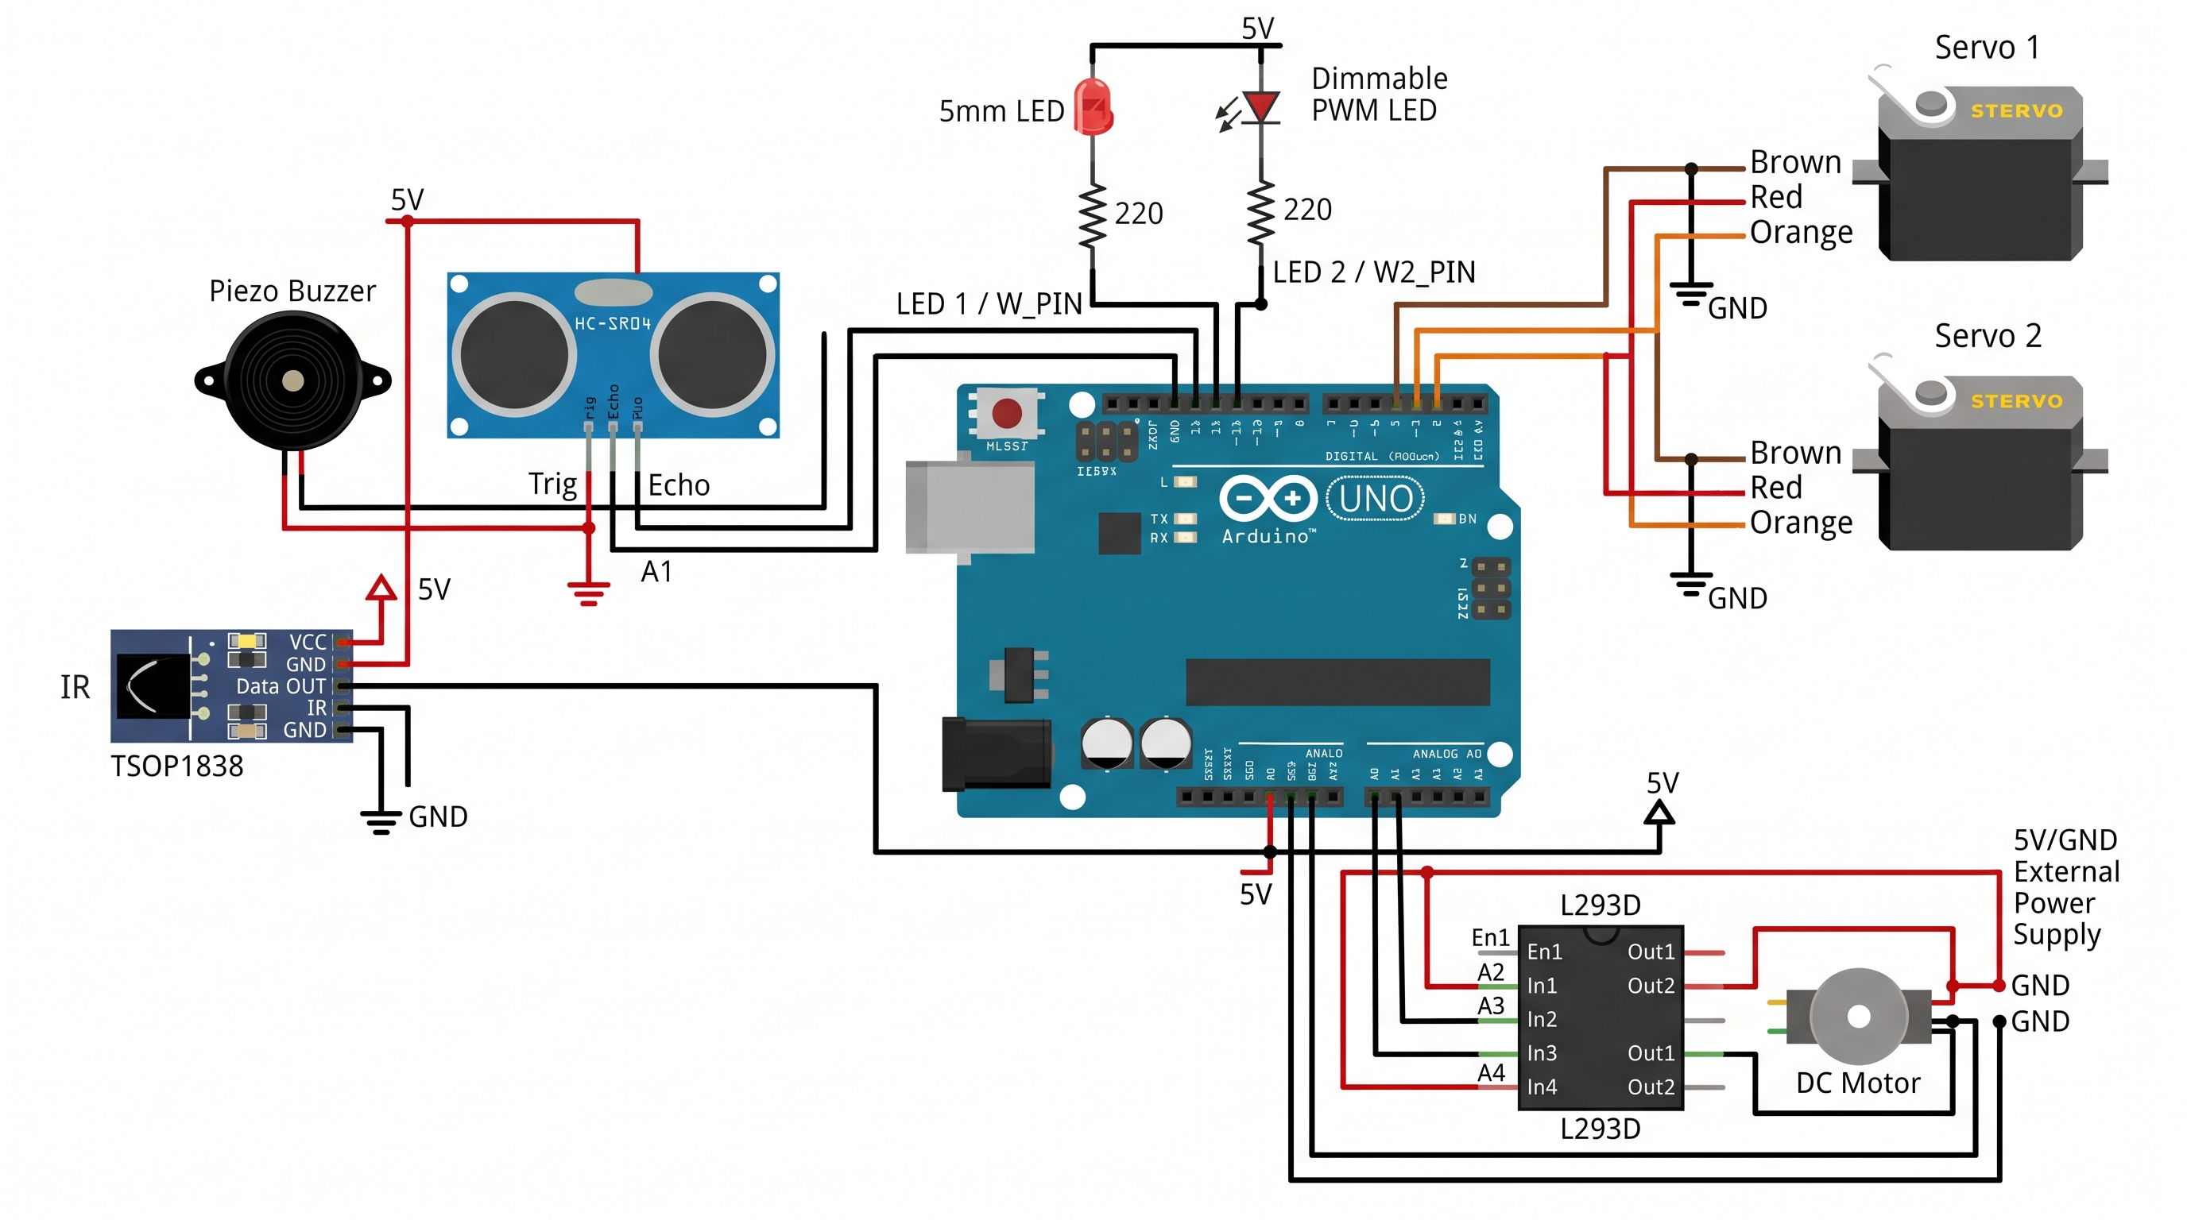
Figure 1: Complete Circuit Diagram for Smart Home & Smart Garage Automation
2. Key Components & Detailed Pin Connections
Control Unit
• Arduino Uno Microcontroller: Acts as the brain of the circuit. It reads incoming analog and digital signals from input components, processes logical conditions, and executes precise output signals to control attached hardware.
Input Devices
• TSOP1838 IR Receiver: Connected to VCC (5V), GND (Ground), and Data OUT to Digital Pin 2. Decodes infrared signals sent from an IR remote control to transmit user command pulses to the microcontroller.
• HC-SR04 Ultrasonic Sensor: Connected to VCC (5V), GND (Ground), Trig pin to Digital Pin 12, and Echo pin to Analog Pin A1. Measures object distance by emitting an ultrasonic sound wave from the Trig pin and calculating the exact time taken for the echo to reflect back to the Echo pin.
Output Devices
• Standard 5mm LED: Connected to Digital Pin 13 through a 220Ω current-limiting resistor to prevent overcurrent damage. Controlled via simple digital states (HIGH/LOW).
• Dimmable PWM LED: Connected to PWM-capable Digital Pin 11 through a 220Ω resistor. Uses Pulse Width Modulation (PWM) to dynamically adjust brightness levels by varying the signal duty cycle.
• Piezo Buzzer: Connected between Digital Pin 10 and Ground. Produces acoustic audio alerts using square wave frequencies or standard digital ON/OFF pulse signals.
• Servo Motors (Servo 1 & Servo 2): Power lines connected to 5V and GND; control signal lines connected to PWM Digital Pins 9 and 6. Servos use PWM control signals to precisely hold or adjust angular positions (0° to 180°).
• DC Motor via L293D Driver: The L293D H-bridge IC enables bidirectional movement and variable speed control. Enable pin En1 connects to PWM Digital Pin 3 for speed control. Directional input pins In1 and In2 connect to Analog Pins A2 and A3. Motor outputs Out1 and Out2 connect directly to the DC motor terminals. The motor driver is powered via an external 5V power supply to handle higher current loads without overloading the Arduino board.
3. Application in Smart Home Automation
In a smart home ecosystem, the circuit operates through wireless commands received via the TSOP1838 IR Receiver, delegating tasks across lighting, ventilation, and access control:
• Standard & Dimmable LED Lighting: Standard LED (Pin 13) acts as a primary room light that toggles fully ON or OFF upon remote command. The Dimmable PWM LED (Pin 11) functions as ambient or night lighting, allowing users to increase or decrease brightness in stepped increments through PWM signal adjustments.
• DC Motor Fan Control: Serves as a ceiling or ventilation fan. Fan speed is dynamically controlled via PWM signals on pin En1 (Pin 3). Furthermore, the airflow direction can be reversed (e.g., toggling seasonal circulation) by swapping the logical HIGH/LOW states on input pins In1 and In2 (Pins A2/A3).
• Servo Motors for Smart Doors & Windows: Servo 1 and Servo 2 are mounted to door hinges or window slider mechanisms. Upon receiving valid remote control signals, the Arduino rotates the servos to 0° (Closed) or 90°/180° (Fully Open).
4. Application in Smart Garage Control
The combination of distance sensing, acoustic alerts, and servo motor actuation provides an intelligent, automated parking and security system for garages:
• Proximity & Collision Alert System: The HC-SR04 ultrasonic sensor constantly monitors the distance between a reversing or parking vehicle and the garage wall. If the vehicle approaches closer than a predefined safety threshold (e.g., less than 15 cm), the Arduino triggers the Piezo Buzzer to sound an immediate acoustic alert, warning the driver to stop.
• Automated Garage Gate Operation: When the ultrasonic sensor detects an approaching vehicle entering an outer distance threshold (e.g., between 50 cm and 100 cm), the Arduino automatically signals Servo 1 to rotate and lift/swing open the garage door. Once the vehicle is parked safely and clear of the entry threshold, the gate closes automatically after a programmed time delay.

