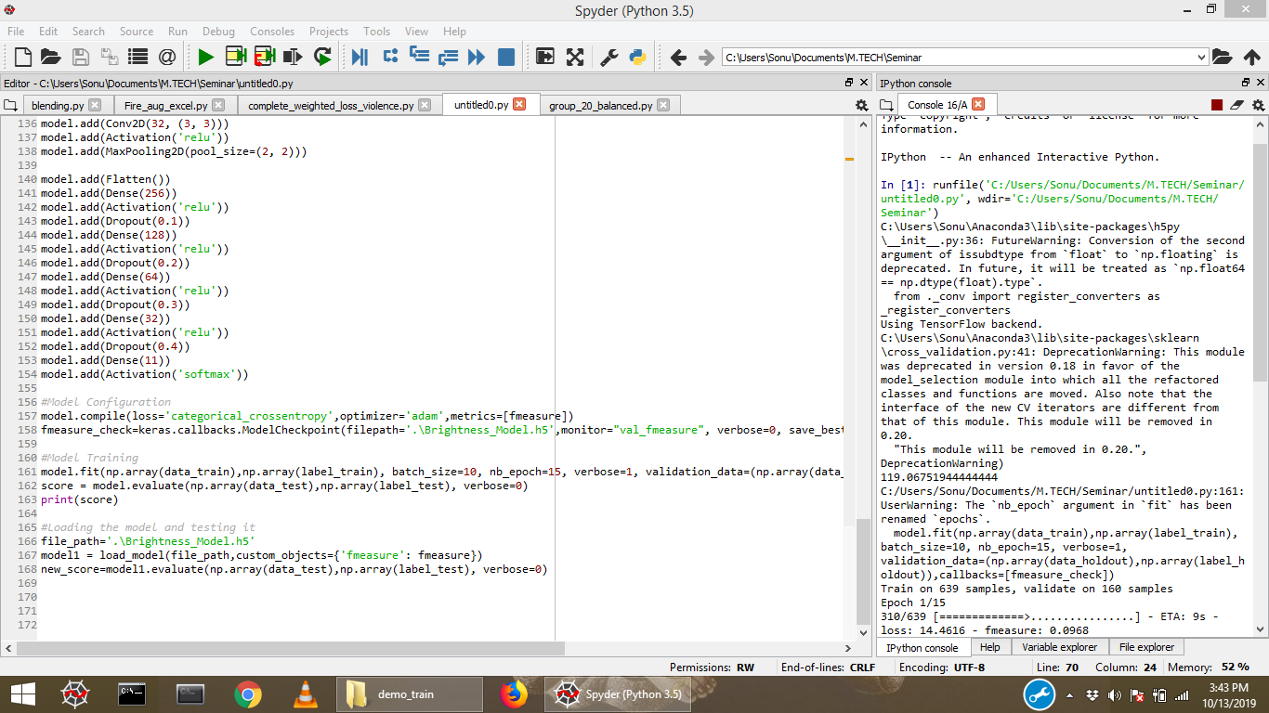

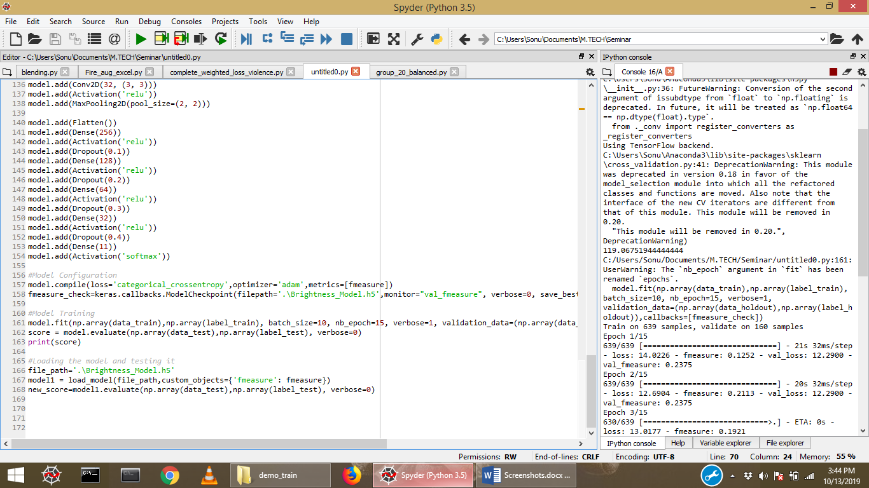

Doing a demo run on the model with 15 epochs training on 620 images of 150*150 and validating on around 160 Images, the ETA for each epoch is around 21 seconds without GPU and the memory utilization is 55%.

Test results were around 23% with F-Measure as metric.

Please validate it with the screenshots.

**Increasing the model’s convolutional base by multiple of 2 i.e. increasing the convolutional filter size by 2 for each layer.**

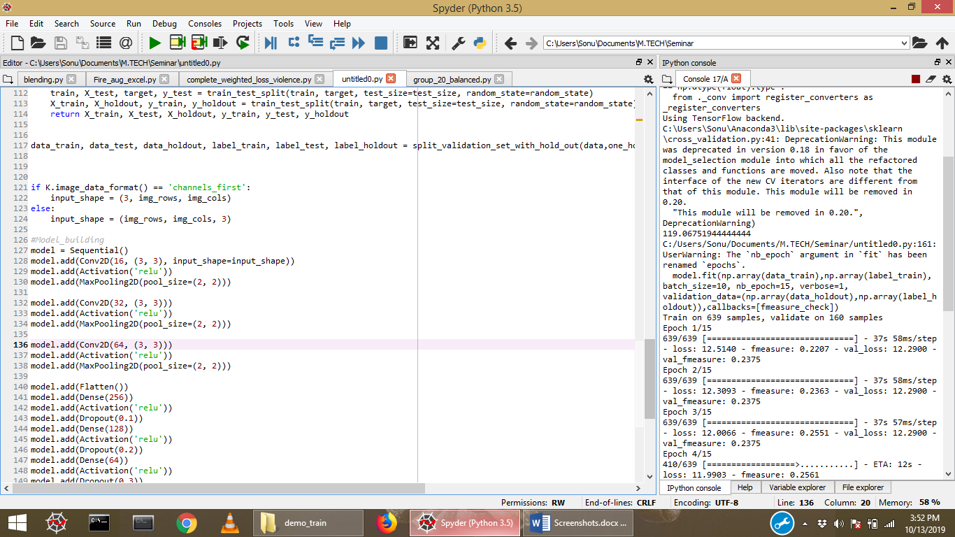

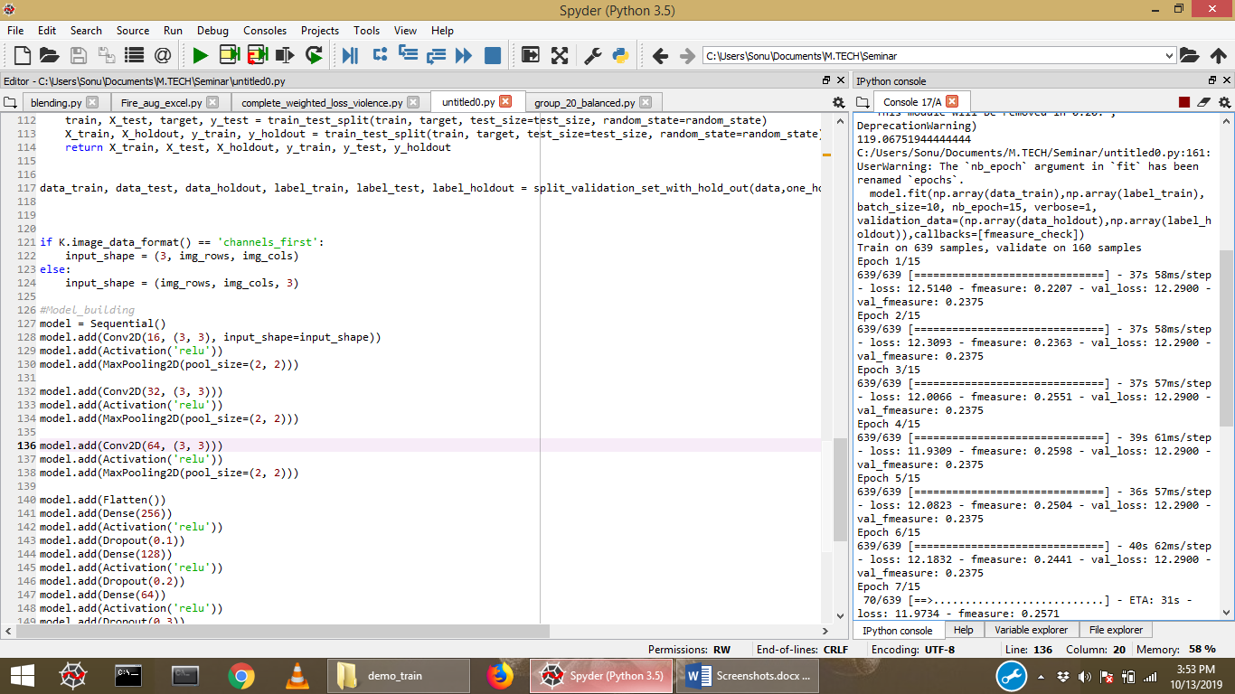

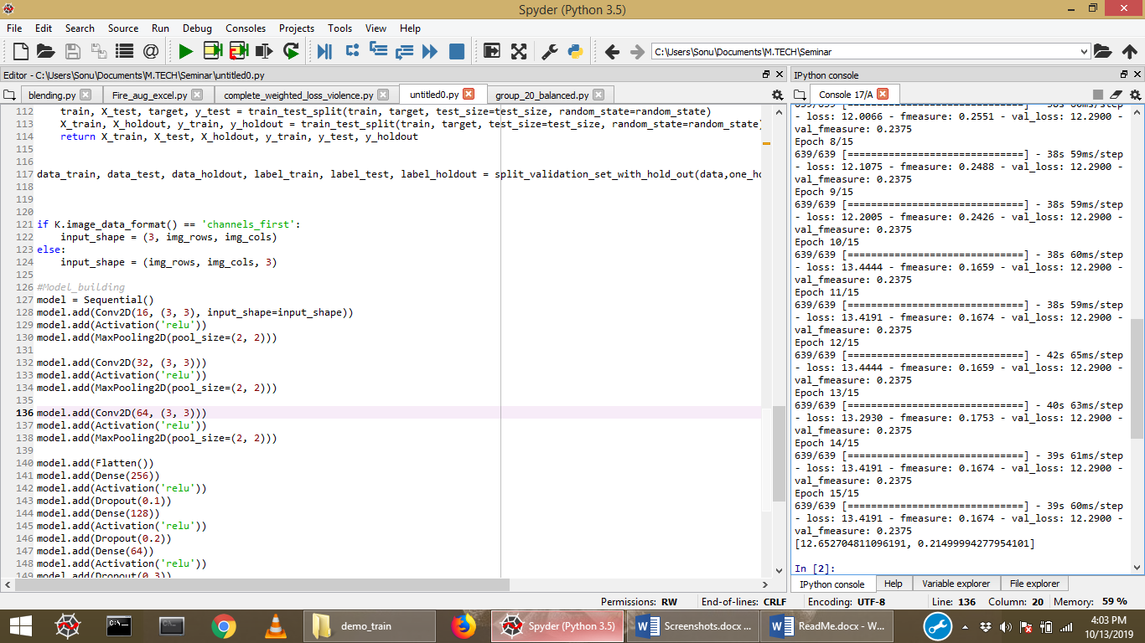

Doing a demo run on the model with 15 epochs training on 620 images of 150*150 and validating on around 160 Images, the ETA for each epoch is around 37 seconds without GPU and the memory utilization is 59%.

Test results were around 23% with F-Measure as metric.

Did not see any Improvement were seen with this higher configuration.

**Using Prior configuration but with higher image resolution (300*300).**

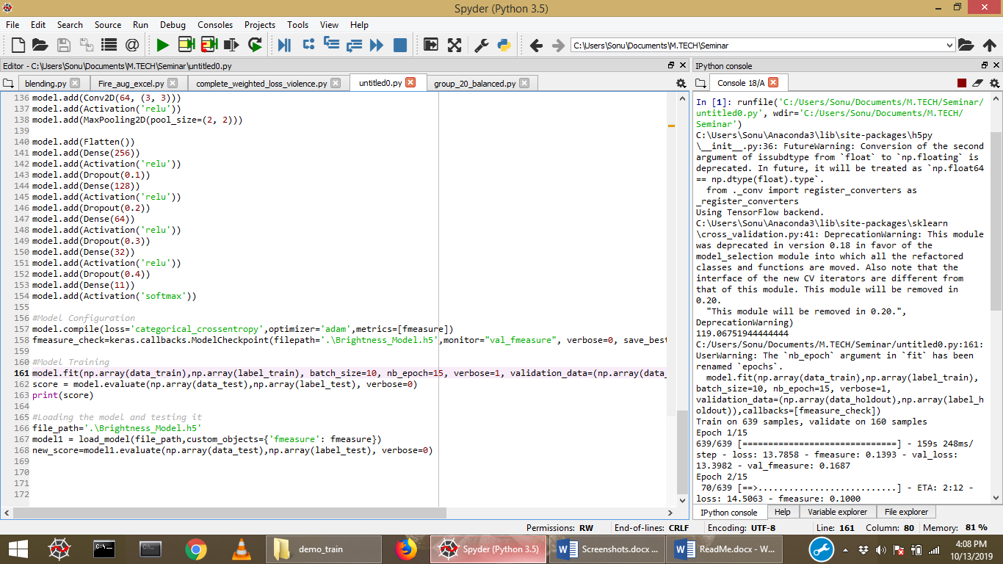

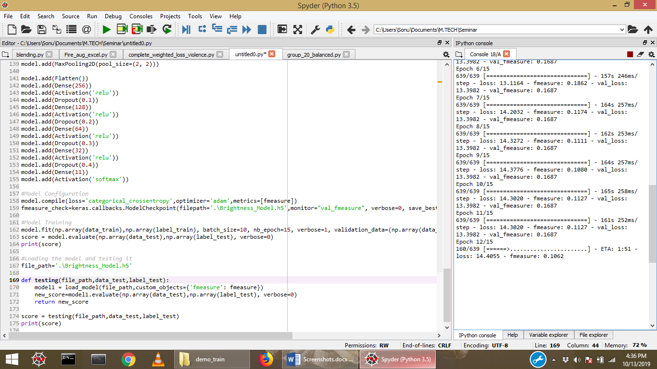

Doing a demo run on the model with 15 epochs training on 620 images of 300*300 and validating on around 160 Images, the ETA for each epoch is around 159 seconds without GPU and the memory utilization is 72%.

No Improvement were seen with this higher configuration.

Learning stagnated at 16.87 fmeasure.

**Doing final training with the reduced configuration till now and reduced image resolution to (150*150).**

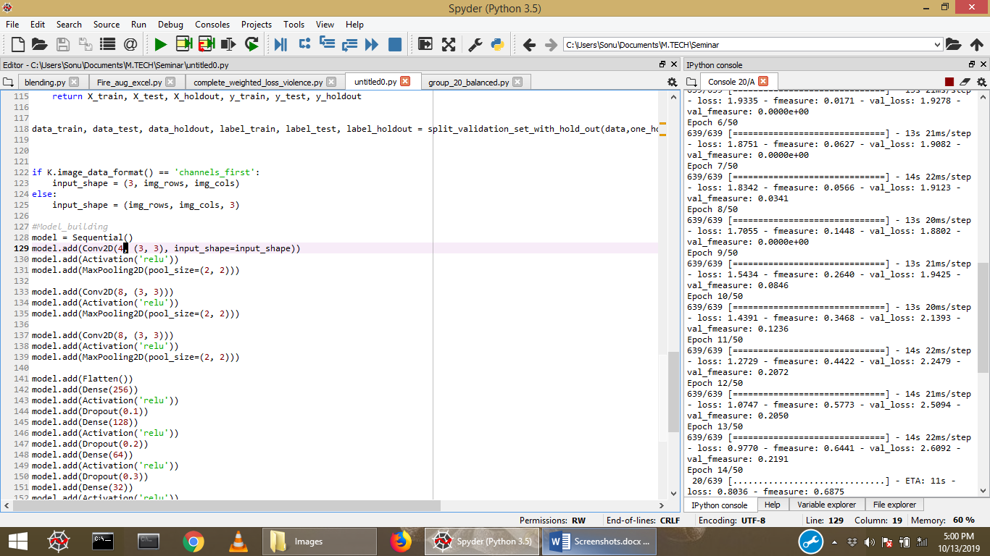

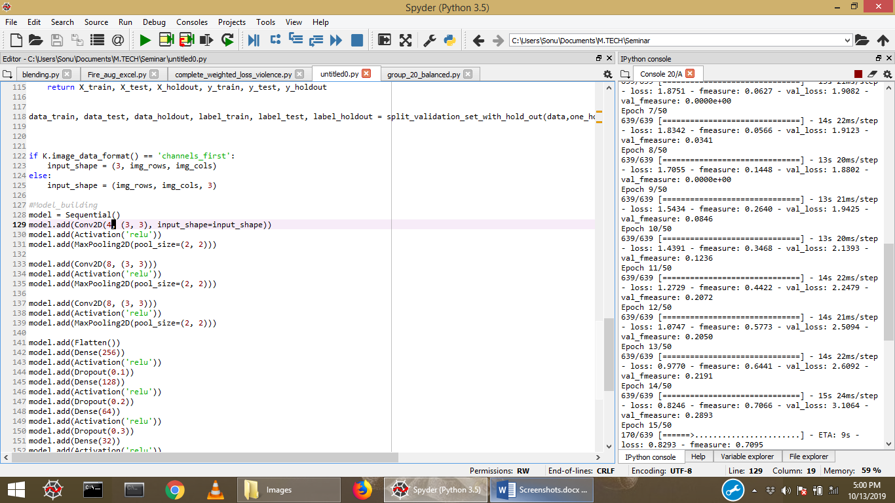

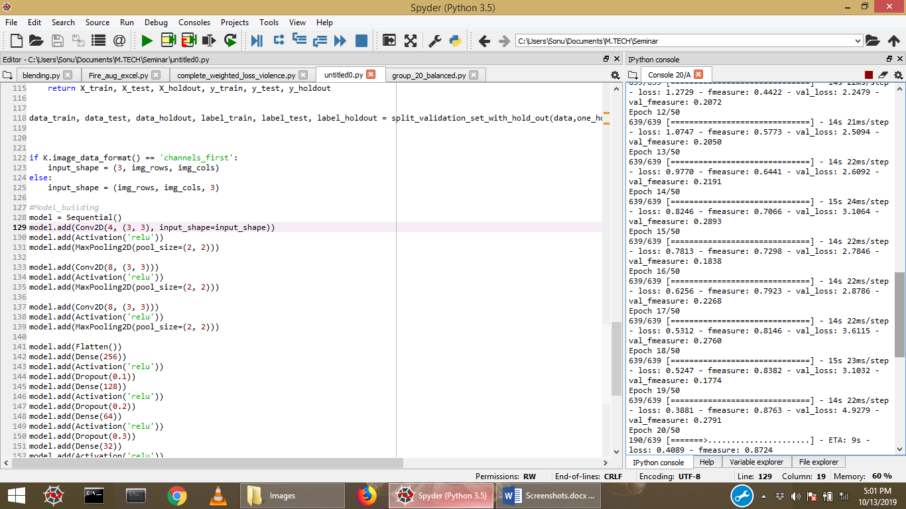

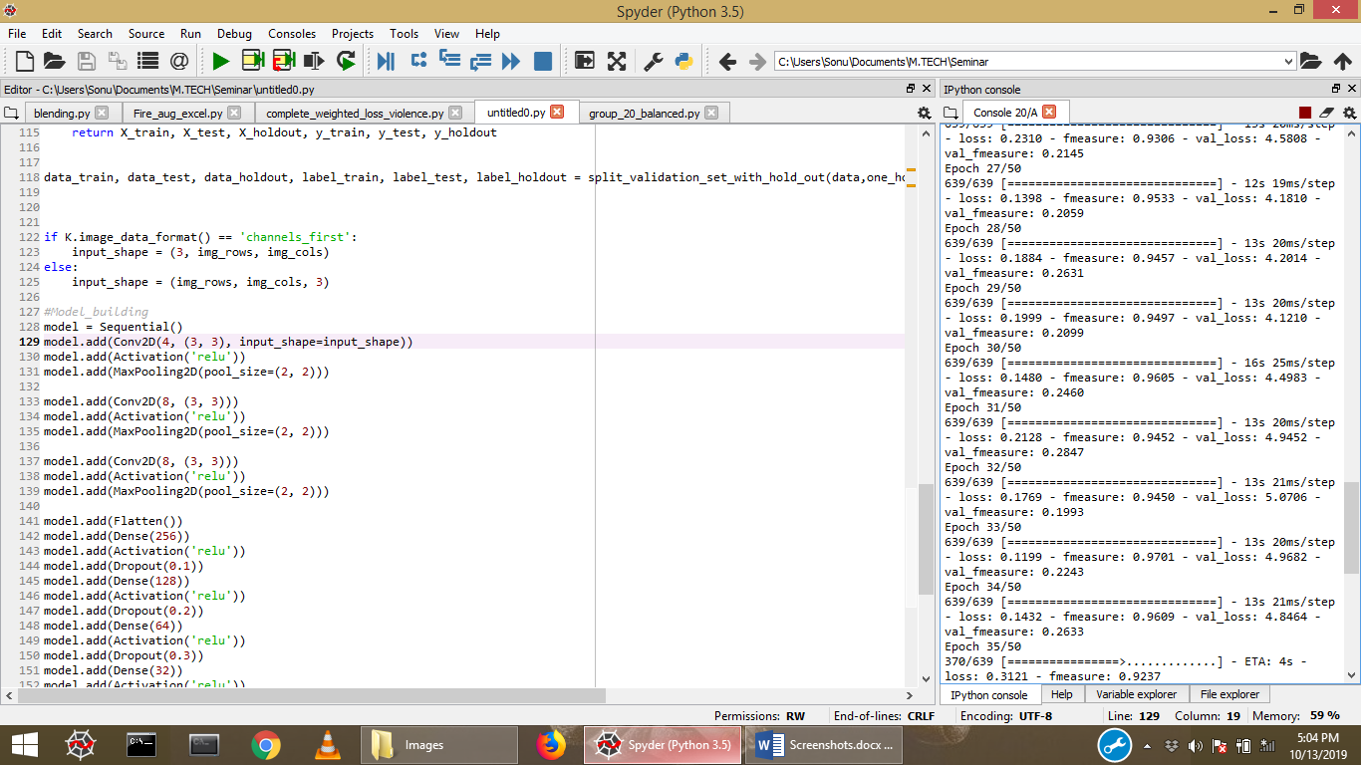

Doing a final run on the model with 50 epochs training on 620 images of 150*150 and validating on around 160 Images, the ETA for each epoch is around 15 seconds without GPU and the memory utilization is 59%.

Considerable Improvement were seen with this lower configuration which proves that higher configuration models were getting overfitted training on this small volume of data.

Although this model also started getting overfitted after 31 epochs with the training f measure increasing to around 100% while validation f measure remaining stagnant at around 28%. With more Dropout rate the model would have yielded better results.

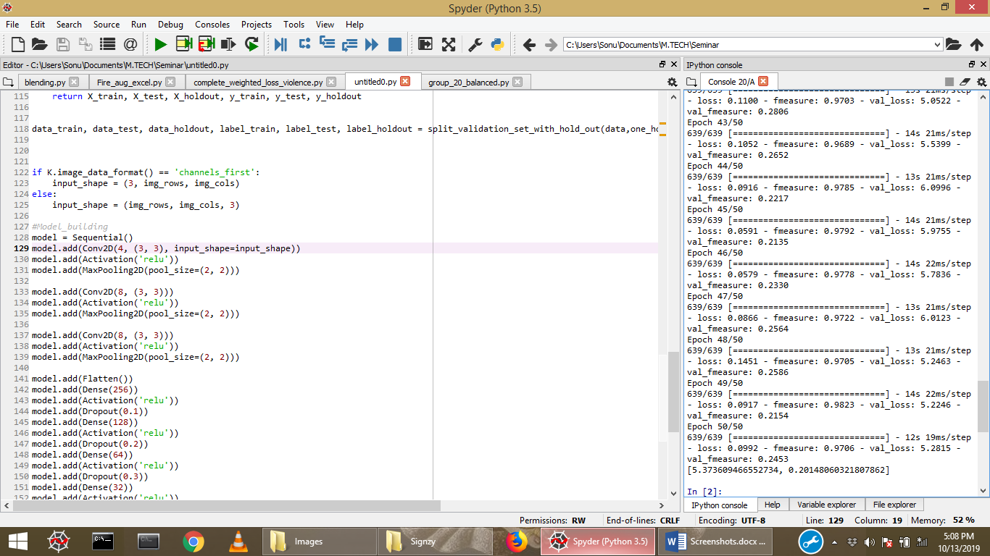

The final F-Measure on test set was around 20%.