

TECHNOLOGY TRANSFER AND COMMERCIALISATION OF THE BIOSCIENCES
BIOL5200
GUID: 2811937

“GROWW”
It is an inexpensive and smooth process for the regrowth of hair.

Business Proposition
GROWW aims to become a biotechnology company that treats baldness through gene therapy and extends the growth phase.

Unique selling point
The incidence of alopecia commonly known as baldness has increased by 49.14% worldwide, as reported by Wang et al. (2022). According to the findings of Pfizer (2024), baldness affects approximately 160 million people worldwide. Adil et al. (2017) stated that the only FDA-approved medications for the treatment of alopecia are finasteride and minoxidil and that the only FDA-cleared device for the same is low-level laser light therapy (LLLLT). However, the efficacy of these treatments is unknown. Complicating matters further, Strazzulla et al. (2018) noted that while there are several treatments for alopecia areata, neither can induce and maintain remission currently. However, GROWW envisions disrupting the stereotypical way of treating baldness with a hair transplant, which is expensive, painful, and has a high post-transplantation cost, in favour of a painless, smooth, and permanent treatment of alopecia with a high efficacy rate at a relatively low cost.

Summary of End-users and Value proposition
Alopecia, affecting all age groups and both sexes, sees approximately 80% of patients experience the first onset by the age of 40 and 40% by the age of 20 (Mostaghimi et al. 2023). The market value of baldness treatment has risen significantly over time, as illustrated in Figure 1 (Elflein, 2015).
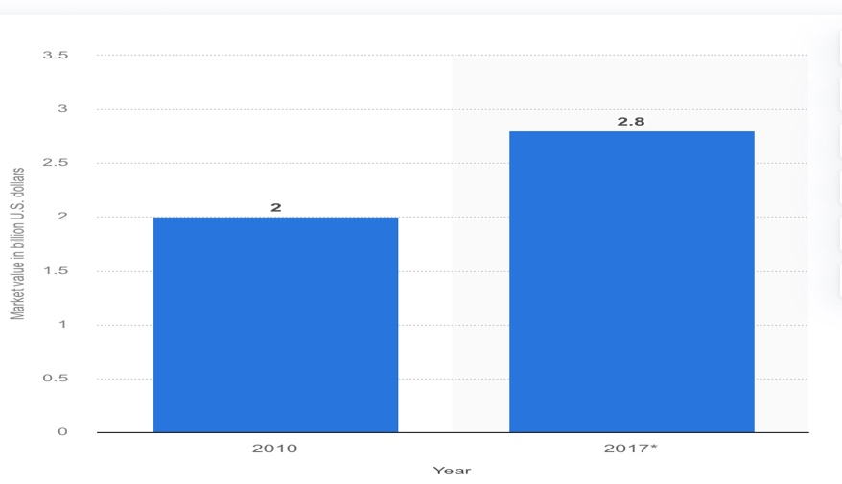
Fig 1: The growth in the hair loss treatment market worldwide (Elflein, 2015)
Though the treatment's end users will come from a variety of age groups, those in their early forties are the main target group. A further opportunity for easy commercialisation involves the identification of hospitals as secondary clients. According to Hunt et al. (2005), individuals with alopecia are more likely to experience psychiatric disorders and are at a higher risk of developing anxiety disorders, paranoid disorders, social phobias, and serious depressive episodes. GROWW seeks to provide alopecia patients with a smooth, highly effective alopecia treatment that will boost their self-esteem and help them feel psychologically safe.

1-year Milestones
To date, only a few in vivo studies have been conducted by a few researchers. For its inaugural year, GROWW intends to continue the in vivo study until the process is finalised and to monitor the repercussions, thereby increasing the treatment's efficacy rate. It intends to begin the initial clinical trial on humans at the end of the first year, collaborating with government organisations to provide an accurate picture of the efficacy rate and consumer satisfaction.

Underpinning research supporting the seamless treatment of alopecia
Alopecia is defined as the patterned loss of hair on the scalp of genetically predisposed individuals, which begins with thinning hair (Kaufman, 2002). Alopecia areata, trichotillomania, androgenic alopecia, richotillomania, telogen effluvium traction alopecia and anagen effluvium are common types (Rambwawasvika et al. 2021).The most typical sign of alopecia is clearly defined areas of non-scarring, inflammatory hair loss, which can eventually spread to the entire scalp or body. Trichoscopy can be used to detect exclamation point hairs, dystrophic hairs, and yellow dots, which are characteristics of alopecia. Ten to twenty per cent of patients have abnormal nails, such as striations, brittleness, or regular pitting (Strazzulla, 2018).
Existing follicles go through phases of growth (anagen), regression (catagen), rest (telogen), and finally exogen (shedding) to produce new hairs. The anagen phase persists for around a six-year period, the catagen phase continues for a few weeks, and the telogen phase endures nearly nine months, as stated by Paus (1998), which is elucidated in Figure 2.
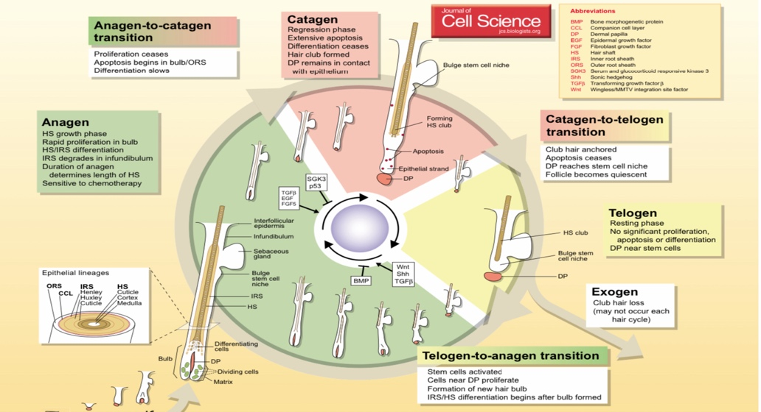
Fig 2: Life cycle of the hair follicle (Alonso et al. 2006)
As posited by Rishikaysh et al. (2014), the complex synchronisation of many signalling pathways - such as Wnt, Shh, Notch, and BMP among a few others within mesenchymal and epithelial cells is necessary for the morphogenesis of hair follicles, with the Wnt pathway serving as the master regulator.
The stimulation of the Sonic Hedgehog (SHH) or Wnt/β-catenin [5-7] signalling pathways encourages the growth of hair and the entrance of anagen. Wingless and integrated-1 (Wnt)-mediated hair regrowth stabilises hypo-phosphorylated β-catenin, facilitating its interaction with T-cell factor/lymphoid enhancer factor (TCF/LEF) in the nucleus, resulting in the transactivation of growth-promoting genes and hair regrowth. Conversely, the onset of the anagen phase is suppressed by the induction of both bone morphogenetic proteins (BMP) and transforming growth factor β (TGF-β) signalling.
As a natural Wnt inhibitor, Dickkopf-related protein 1 (DKK1) significantly inhibits the Wnt/β-catenin signalling pathway by interfering with the origination of the Wnt-induced frizzled-low-density lipoprotein receptor-related proteins (LRP) 5/6 complex. When comparing alopecia sufferers to healthy individuals, elevated tissue amounts of DKK1 have been found, as per Papukashvili et al. (2021). The signalling cascade and DKK1 control are explained in Figure 3.
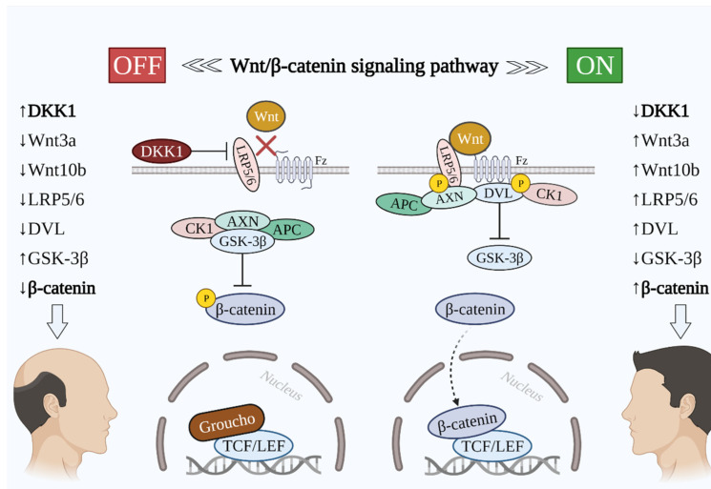
Fig 3: Signalling pathway during hair loss and hair growth phase (Papukashvili et al. 2021)
An extended duration of the anagen phase was noted in mice in an in vivo study in which 5 mg of antiDK-1 antibody was injected. Notably, it was discovered that in the late anagen phase of follicular keratinocytes, DKK-1 was highly expressed (Kwack et al. 2012). Another in vivo study examined the possibility of introducing the SHH gene into telogen hair follicles to promote early anagen initiation using intradermal injections of the SHH-adenoviral vector. SHH was found to be expressed in various cells and demonstrated the premature appearance of anagen with early melanogenesis, enlarged hair follicles along with rapid growth of hair in the experimental region (Ohyama et al. 2003).
Motivated by the outcomes of the in vivo research, GROWW intends to disrupt the alopecia treatment market by either silencing the DKK-1 gene or giving patients anti-DKK-1 antibodies to prevent it from blocking the Wnt/β-catenin signalling pathway, which stimulates the development of hair. Furthermore, GROWW intends to start the early anagen phase in the telogen hair follicle by introducing the SHH gene, providing a regrowth solution.

Reference list
- Adil, A. and Godwin, M., 2017. The effectiveness of treatments for androgenetic alopecia: a systematic review and meta-analysis. Journal of the American Academy of Dermatology, 77(1), pp.136-141.
- Alonso, L. and Fuchs, E., 2006. The hair cycle. Journal of cell science, 119(3), pp.391-393.
- Alopecia areataPfizer. Available at: https://www.pfizer.com/disease-and-conditions/alopecia-areata#:~:text=Alopecia%20areata%20affects%20about%20160%20million%20people%20worldwide.&text=Researchers%20have%20estimated%20that%20the,the%20autoimmune%20disease%20is%202%25.&text=To%20assess%20the%20burden%20of,adjusted%20life%20years%20(DALYs). (Accessed: 04 February 2024).
- Elflein, J. (2015) Value of the global hair loss treatment market 2010-2017, Statista. Available at: https://www.statista.com/statistics/489025/value-of-the-global-hair-loss-treatment-market/ (Accessed: 04 February 2024).
- Gilhar, A. and Kalish, R.S., 2006. Alopecia areata: a tissue-specific autoimmune disease of the hair follicle. Autoimmunity reviews, 5(1), pp.64-69.
- Hunt, N. and McHale, S., 2005. The psychological impact of alopecia. Bmj, 331(7522), pp.951-953.
- Kaufman, K.D., 2002. Androgens and alopecia. Molecular and cellular endocrinology, 198(1-2), pp.89-95.
- Kwack, M.H., Kim, M.K., Kim, J.C. and Sung, Y.K., 2012. Dickkopf 1 promotes the regression of hair follicles. Journal of Investigative Dermatology, 132(6), pp.1554-1560.
- Mostaghimi, A., Gao, W., Ray, M., Bartolome, L., Wang, T., Carley, C., Done, N. and Swallow, E. (2023). Trends in Prevalence and Incidence of Alopecia Areata, Alopecia Totalis, and Alopecia Universalis Among Adults and Children in a US Employer-Sponsored Insured Population. JAMA Dermatology. [online] doi: https://doi.org/10.1001/jamadermatol.2023.0002.
- Ohyama, M. and Vogel, J.C., 2003, October. Gene delivery to the hair follicle. In Journal of Investigative Dermatology Symposium Proceedings (Vol. 8, No. 2, pp. 204-206). Elsevier.
- Papukashvili, D., Rcheulishvili, N., Liu, C., Xie, F., Tyagi, D., He, Y. and Wang, P.G., 2021. Perspectives on miRNAs targeting DKK1 for developing hair regeneration therapy. Cells, 10(11), p.2957.
- Paus, R., 1998. Principles of hair cycle control. The Journal of dermatology, 25(12), pp.793-802.
- Rambwawasvika, H., Dzomba, P. and Gwatidzo, L., 2021. Alopecia types, current and future treatment. J Dermatol Cosmetol, 5(4), pp.93-99.
- Rishikaysh, P., Dev, K., Diaz, D., Qureshi, W.M.S., Filip, S. and Mokry, J., 2014. Signaling involved in hair follicle morphogenesis and development. International journal of molecular sciences, 15(1), pp.1647-1670.
- Strazzulla, L.C., Wang, E.H.C., Avila, L., Sicco, K.L., Brinster, N., Christiano, A.M. and Shapiro, J., 2018. Alopecia areata: an appraisal of new treatment approaches and overview of current therapies. Journal of the American Academy of Dermatology, 78(1), pp.15-24.
- Strazzulla, L.C., Wang, E.H.C., Avila, L., Sicco, K.L., Brinster, N., Christiano, A.M. and Shapiro, J., 2018. Alopecia areata: disease characteristics, clinical evaluation, and new perspectives on pathogenesis. Journal of the American Academy of Dermatology, 78(1), pp.1-12.
- Wang, H., Pan, L. and Wu, Y., 2022. Epidemiological Trends in Alopecia Areata at the Global, Regional, and National Levels. Frontiers in Immunology, 13. doi: https://doi.org/10.3389/fimmu.2022.874677.

