# **Berry Field – gym env**

## Requirements:

gym – version 0.0.1

## Installation:

Located in the folder **env**. To install navigate into the **env** folder and use the command:  
 *pip install -e berry-field*

## Documentation (in writing):

The agent can move in 8 directions and also choose to not move at every step.

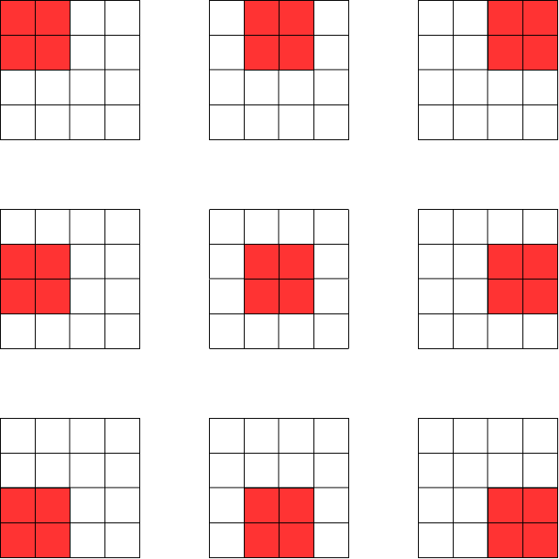

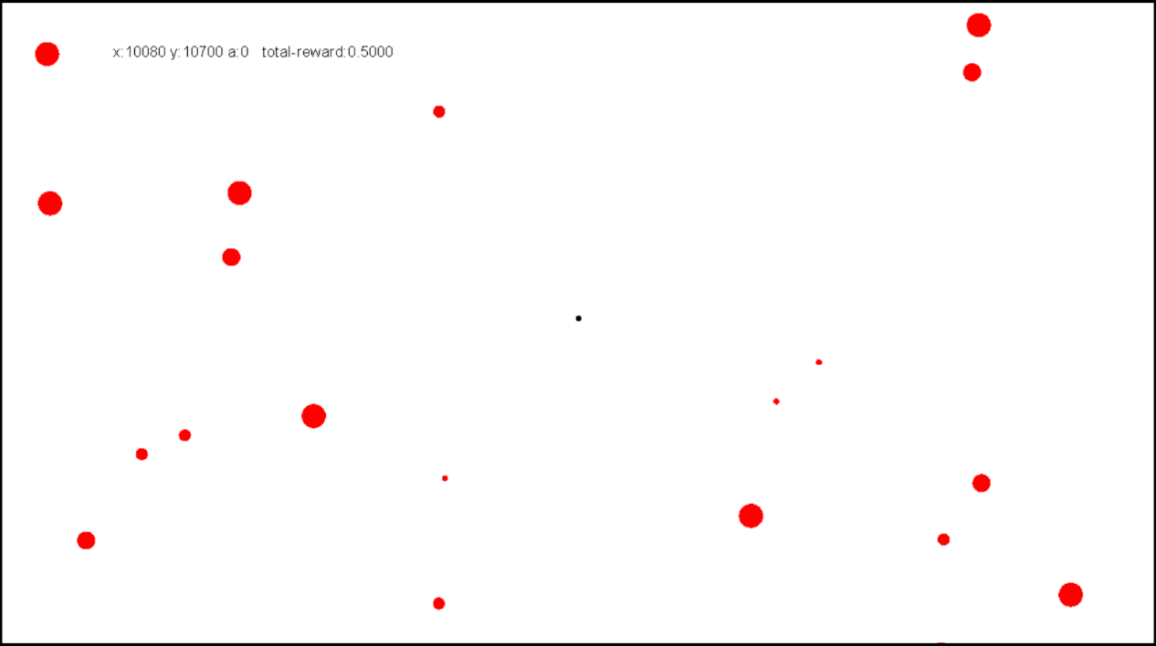Whenever the agent collides with a berry, it collects the berry and gets a reward. The agent gets a negative reward for every movement through the environment. The agent can view only a limited section of the environment. It cannot move outside the boundary of the environment.

The environment supports both square and circular agent, square and circular berries.