ENGG3960 Final Report 2023

Full Name: Cheung Dick Ho
Student ID: 20857899
Major Program: CPEG
Sub-team: Robocon
Role: FD RR SW Junior, FD Pit Crew, FD RR backup controller

Part 1 – Technical Report
In this part, please write at least one part of your robot that involved your contributions, pictures are recommended. Please specific what you have done, including testing procedure, results and improvements adopted.
Project Title
2023 FD RR Embedded System Programming –
RM wheelbase positioning, Real time trapezoidal pathing and Tof pathing

Objective and Methodology
2023 FD RR Embedded System Programming
I am in charge of writing the code for 2023 FD RR and I mainly focus on pathing.
Part of the embedded code below: (I am DicaprioCheung)
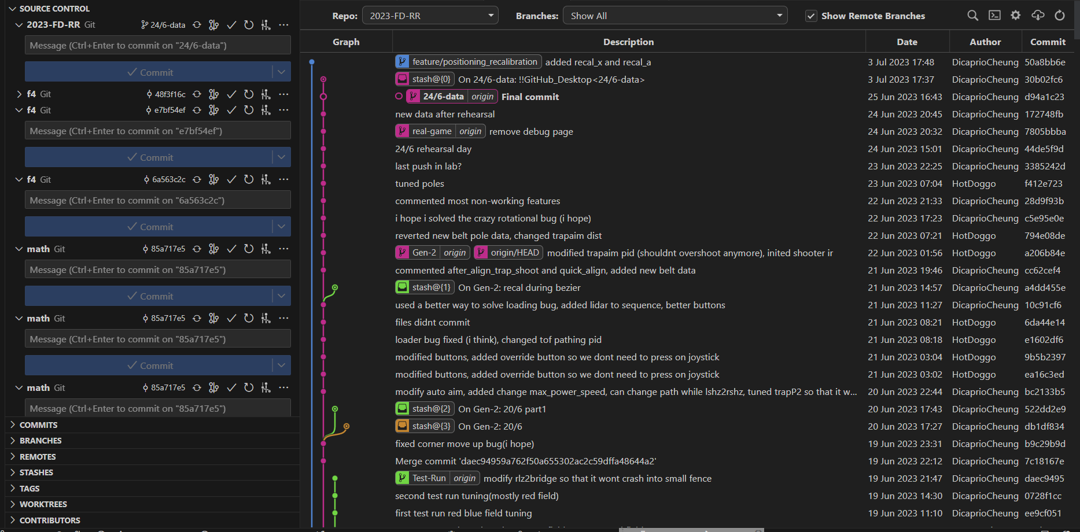
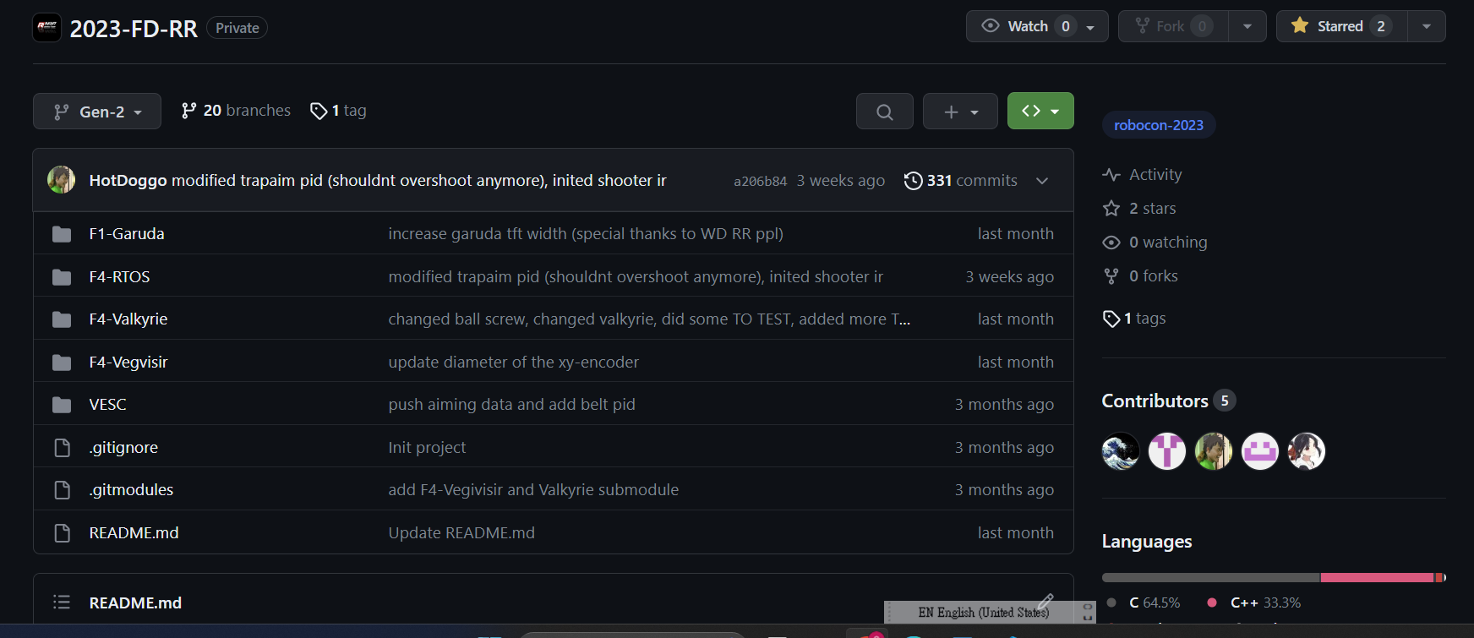

RM Wheelbase Positioning
Since RR is small and it is hard to install the traditional xy-encoder for positioning, I decided to implement a new positioning system that doesn’t need xy encoder. By using the readings from the RM motors of the 4 wheels and optionally the reading from imu of our traditional vegvisir board, I successfully calculate the position of the robot and use it on all different auto paths of BOTH TEAM’S RR this year.

Real Time Trapezoidal Pathing and Trap-aiming
I divided the game field into 12 areas and link them up using some turning points (blue circles in the figure). So, I just need to calculate my current area using my current position(calculated from the RM positioning system above) and calculate the target area using the target coordinates. Then, the robot can move to any target position from any position on the game field using the shortest straight-line path possible. It also uses trapezoidal path so that it could move using the highest speed. I call this real time trapezoidal pathing because the starting position and the straight line paths are calculated in real time.
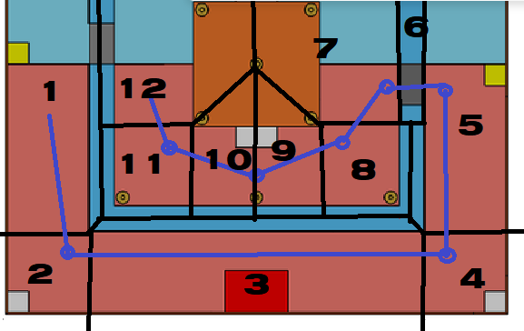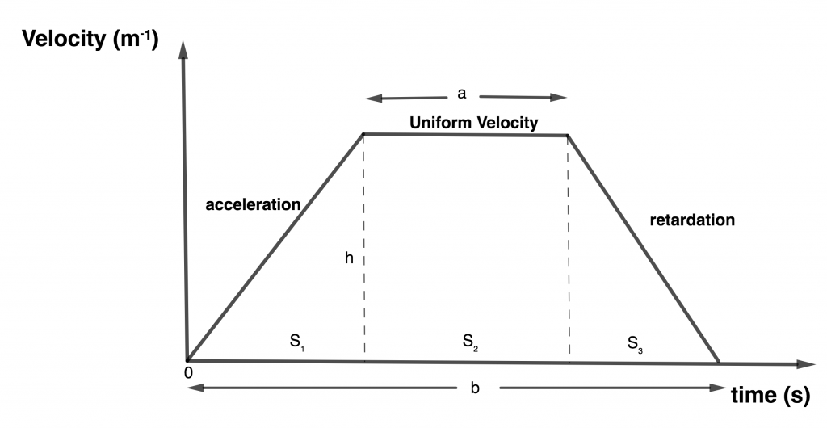
Using this real time trapezoidal system, I managed to make the robot to go to any poles on the game field from any points using the shortest straight-line distance possible. Since it can shoot when the distance between the robot and the pole is the same, it can shoot from any angle instead of a fix point.
Example of some possible shortest straight-line paths to shoot pole 1: (The robot stops at the b;ack circle so that t maintains the same distance from the pole)
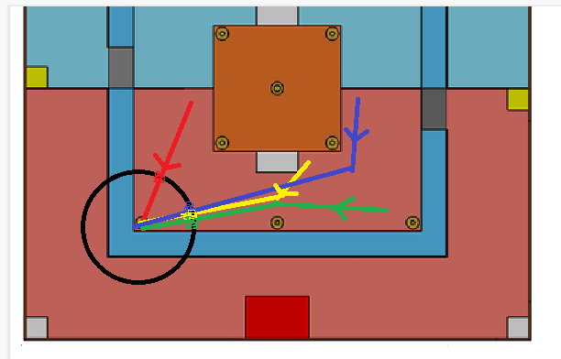

Tof Pathing
Since Real time trapezoidal pathing and trap aiming highly relies on RM positioning system, and RM positioning system highly relies on the friction between the wheels and the floor, it is not stable to use it for all scenario as it might shift position after slipping. So, by using the Tof sensors in the front and sides of our robot, I made a more stable pathing using external Tof distance readings.
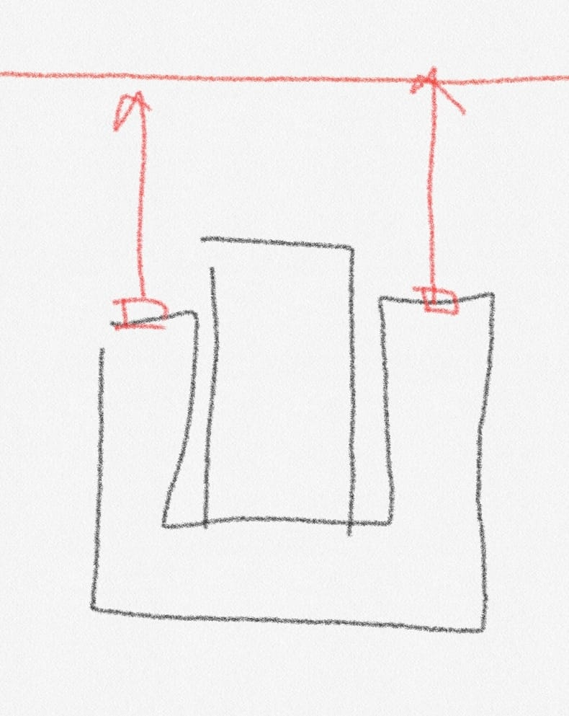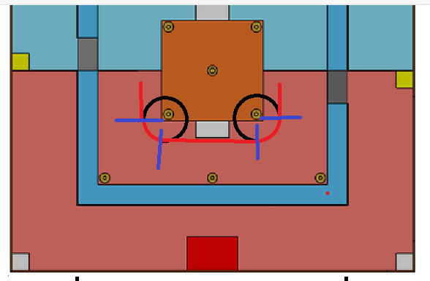
By using the difference between the left and right Tof sensor reading, we can calculate the actual angle error of our robot and use PID to correct it. And by using the average of the 2 sensors, I can calculate the vertical error of our robot and use PID to correct it. Our robot uses trapezoidal speed control to move to the right or left(horizontal). When the robot reach a corner, one of the Tof reading would have no reading as it couldn’t see the wall in front of it. Then the robot would calculate the position of the corner and rotate around the corner for 90 degrees. After 90 degrees rotation, it would use Tof sensors to sense the wall and continue to move horizontally again.

Test Result
RM Wheelbase Positioning
RM wheelbase positioning system works quite well. In fact, it is even better than active pneumatic separate xy encoder Mech made. RM wheelbase positioning system can give accurate position reading if it is moving at low speed and it didn’t hit any wall or fence or poles. If the robot accelerates quickly or hits a wall, the wheels of our robot would slip, and the position reading would shift. Although it shifted, since it shifts roughly the same every time, we (Both dragons’ RR SW team) continue to use it for auto paths.
Real Time Trapezoidal Pathing and Trap-aiming
Since our positioning system would shift at high acceleration, our real time trapezoidal pathing can only use a low acceleration for a more accurate shooting position. Although we couldn’t use a higher speed, it is still one of the most flexible auto aiming system in Robocon 2023. Most teams only have a few(2~6) fix points shoot zone but our robot can shoot from any points colored in red in the figure below.
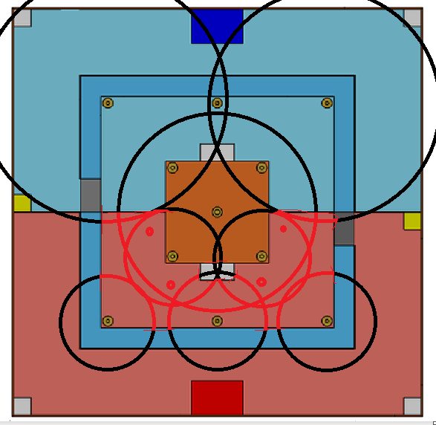
Tof Pathing
Tof pathing is stable but it is also slow. Since mecanum wheels move faster when moving vertically and slower when moving horizontally, Tof pathing is slow as it always moves horizontally. So, we only use it for short distance travel and we uses traditional Bezier pathing for left-right shoot zone switching path.

Summary, Improvement and Further Development
I tried a lot of different pathing because our shooting range is small. I have to use agility to compensate our weakness in shooting. In the end, other strong teams have a better shooter(linear shooter) and a better wheelbase(independent steering) than us so we couldn’t win against them. I am glad that I achieve roughly the same speed using mecanum wheels but I hope we can have a better robot next year.

RM Wheelbase Positioning
Rm wheelbase positioning can be merged into our wheelbase library so that we can use it in the future years. It can also be further developed to support other wheelbase such as omni wheels, independent steering or to support other motors besides RM motors.

Real Time Trapezoidal Pathing and Trap-aiming
Real time trapezoidal pathing and trap aiming are game-field dependent. But I believe this methodology can be applied to future game fields so I would write documentations for future members to understand.

Tof Pathing
Tof pathing is also a bit game-field dependent. However, I believe some parts of it (move along a wall/fence, rotate around a point) can be pass down to next year’s members.

Part 2 – Reflection Report
The following questions aim to assist you in recalling and reflecting on your experience in the Robotics Team.
- Are there any memorable incidents or stories? What did you learn from the experience? (at least 100 words)
One of the most memorable things is that when our team leader say something would happen, that thing won’t happen or happens oppositely. Like when he say something would work, it would not work. When he say some teams would win, that team would lose immediately. When he say something don’t have bugs, that code would have bugs eventually
- What were your personal and team goals? (Please refer to the goals you set in Jan 2018.) To what extent have you achieved them? (at least 100 words)
My personal goal is to test all my software ideas and implement the ones that can achieve the highest potential that the mechanical part of the robot allows. I have tested most of my ideas and implement most of them (as described in part 1). Wheelbase positioning was an idea I had in F6, successfully implemented in RDC and finally used in Robocon competition this year. Real time trapezoidal pathing is an idea after learning trapezoidal pathing and Bezier pathing. Tof pathing is an idea after trying real time trapezoidal pathing. I think I have achieved 90+% potential of our current robot and the remaining few percent are stability, slight speed increase of pathings.
My team goal is to win regional competition and compete in international competition. We lost in regional competition this year and I hope we can win next year.

- What factors do you think facilitated or affected the achievement of your goals? (at least 100 words)
Enough sleep and resting time is needed to think of new ideas and a lot of testing time is needed to test and implement these ideas. A balance between sleeping time and working time facilitate the achievement of my personal goals such that I can think of new ideas and implement all of them in such a small amount of time. I don’t have much regrets even though we lost as I already did what I could have done.
An imbalance between sleeping time and working time affects the achievement of our team goal. Mech is working 36 hour shift and sleep for only 4~5 hours. Although they have many working time to build the robots, they don’t have enough resting time to think of new, high quality robot design. That is why most of our generation robots failed and our gen2 robot is not much better than our gen1 robot.
- How will you apply what you have learned in the future? (at least 100 words)
I learned a lot about embedded programming and pathing. I would continue to develop libraries for our embedded programming and I might learn how to do real time Bezier pathing.
- Do you have any other comments or suggestions to the HKUST Robotics team or the sub-team?
We need more and better mech to build better robot next year. Mech decide how high our whole team can achieve so we need more people to decrease to workload of our mech
- What would you expect from our TA?
I hope TA can give more support when we are lagging schedule. I think TA can teach us things that our senior of senior couldn’t pass down.

Part 3 – Survey (Your Teamwork Experiences and Perceptions)
Please respond to the following questions according to what you believe. There is no right or wrong answer. We simply want to understand your view about teamwork.

1. Amy, Kevin and two other teammates were having a team discussion. Kevin proposed an idea. The other teammates supported it. Amy believed that Kevin’s idea could cause some problems but she was not sure. She decided to keep quiet in the discussion and collect some more information after the meeting by herself to verify the idea.

What do you think of Amy’s behavior in terms of teamwork?
A. Contributes to teamwork.
B. Does harm to teamwork.
C. No effect on teamwork.

Answer of Q1:
B

2. Four people were working on a robot design. Jack and James lived in the dormitory on campus while the others did not. The schedule was tight. Jack and James wanted to have meetings in late evening. The other two teammates disagreed. Jack and James decided to meet first and talk to the other two teammates later.

What do you think of Jack and James’s behavior in terms of teamwork?
A. Contributes to teamwork.
B. Does harm to teamwork.
C. No effect on teamwork.

Answer of Q2:
A
If you were Jack or James, what would you do?
I would organize a mixed meeting so that others who do not live in dormitory can join the meeting at home through Zoom or Discord to discuss together.

3. Mark, Paul and three others members were organizing a student society activity. Mark and Paul had strong disagreements on the event rundown. Paul used Whatsapp messages to contact the other three members individually to explain his idea.

What do you think of Paul’s behavior in terms of teamwork?
A. Contributes to teamwork.
B. Does harm to teamwork.
C. No effect on teamwork.

Answer of Q3:
B
If you were Paul, what would you do?
I would explain my idea in Whatsapp group chat so that everyone knows what I am thinking instead of explain it individually.

Your teamwork experiences

- What is your conception of teamwork? What are its major components?
I believe teamwork is that everyone works on what they are most familiar or what they are the best in and everyone helps each other’s out when other people need them.

- What do you enjoy the most in the Robotics Team over the past year?
I enjoy creating new features and successfully implement them.

- What could be done better in the Robotics Team over the past year?
Senior members can tell junior members more about what they have tested in fall so that we won’t miss any ideas. A better communications between different departments is needed so that other departments can urge other departments to do things quicker and other departments can find out problems earlier and solve them.

