**UML Class Diagram**

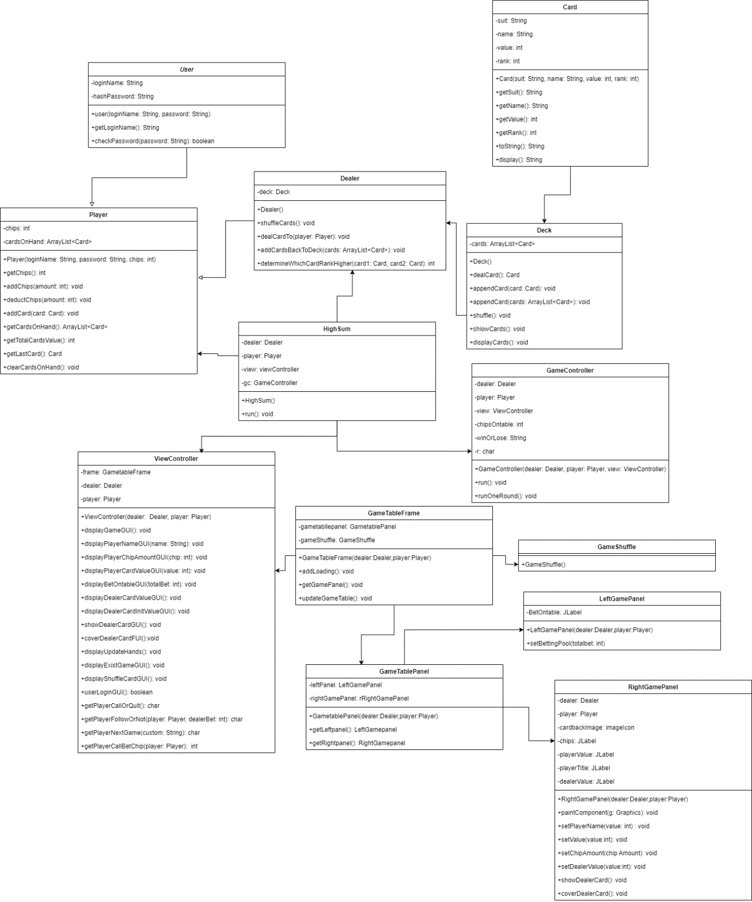

**Test-Run of Program**

**Player Login**

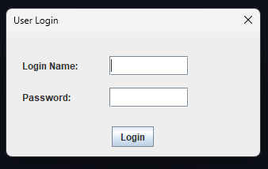

Program will ask name and password. To login as player, user need to enter “IcePeak” in Login Name and “password” in Password since those are hardcoded.

**Deck Shuffling Animation**

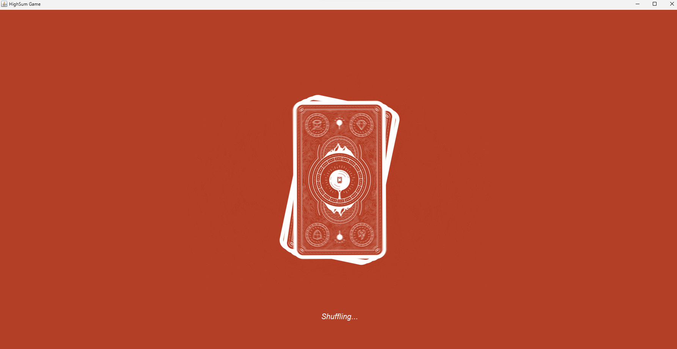

Deck shuffling animation will run before round start.

**Round Start**

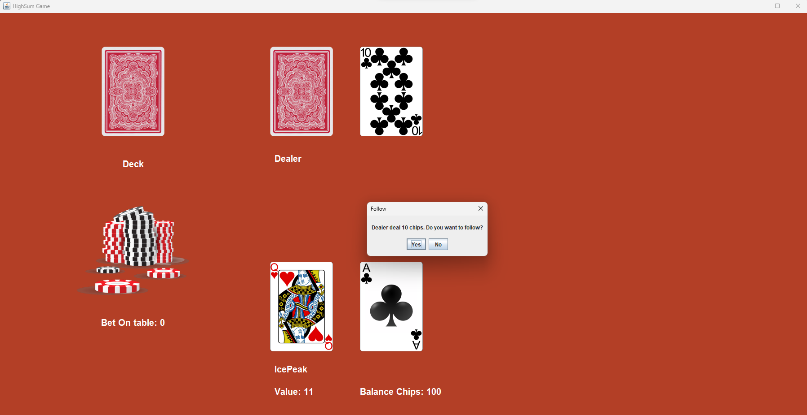

Round will start by who ever has the highest last card. In this case dealer has the high card so player can only follows.

**Round 2**

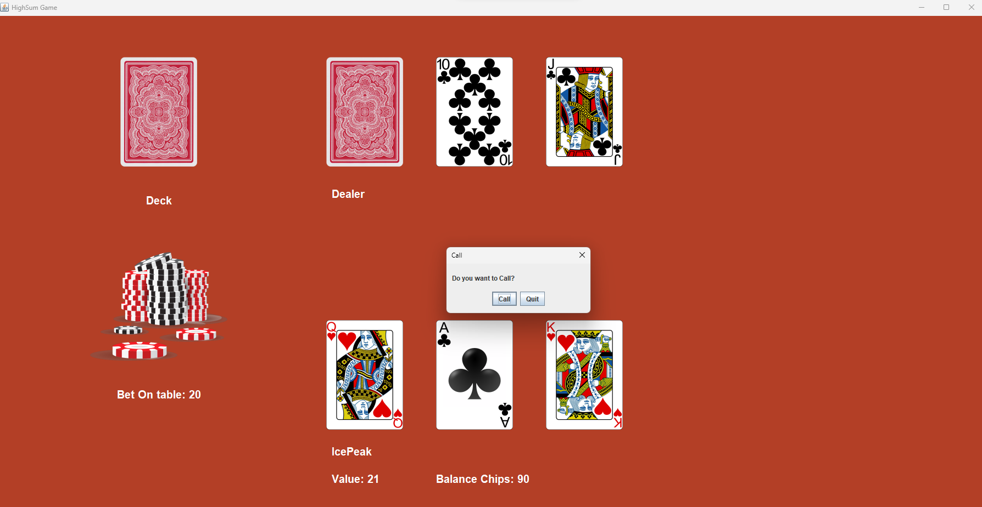

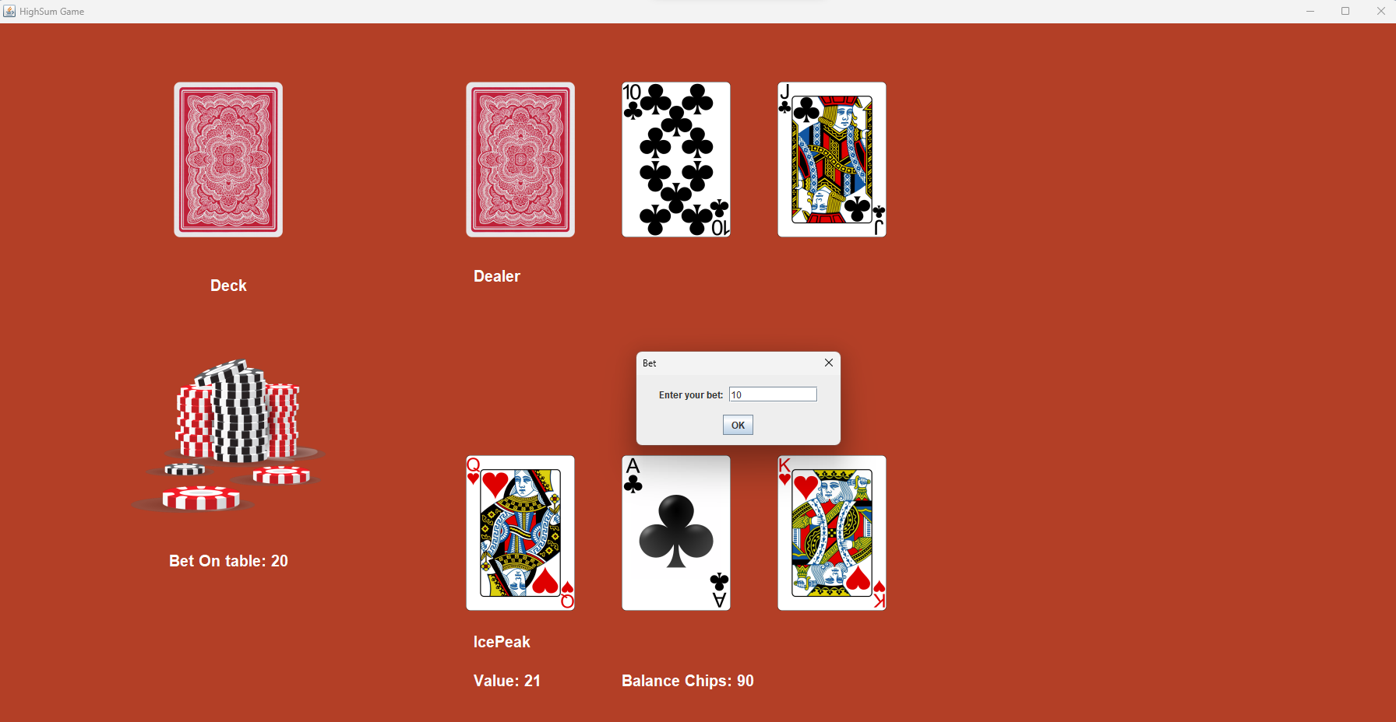Another round of card will be dealt by the dealer. In this case, player has the high card so he can either call or quit the round.

**Round 3**

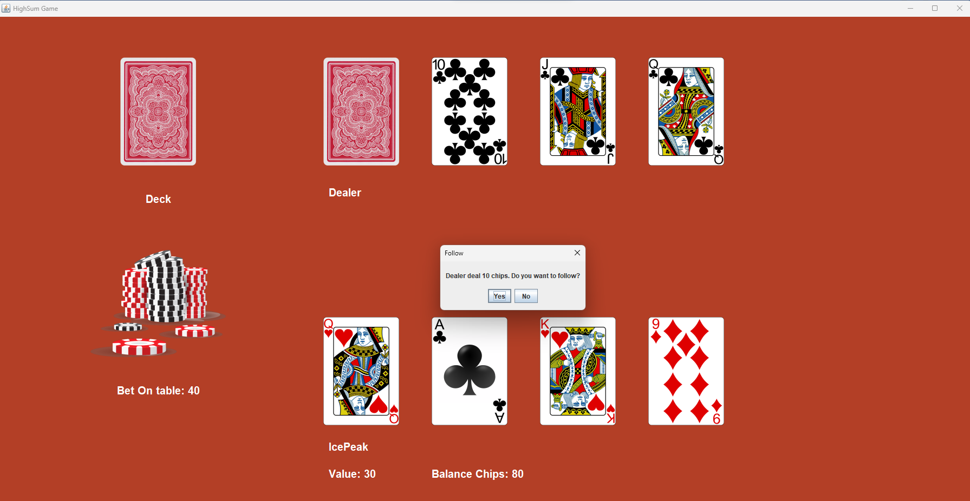

Same as round 1.

**Round 4**

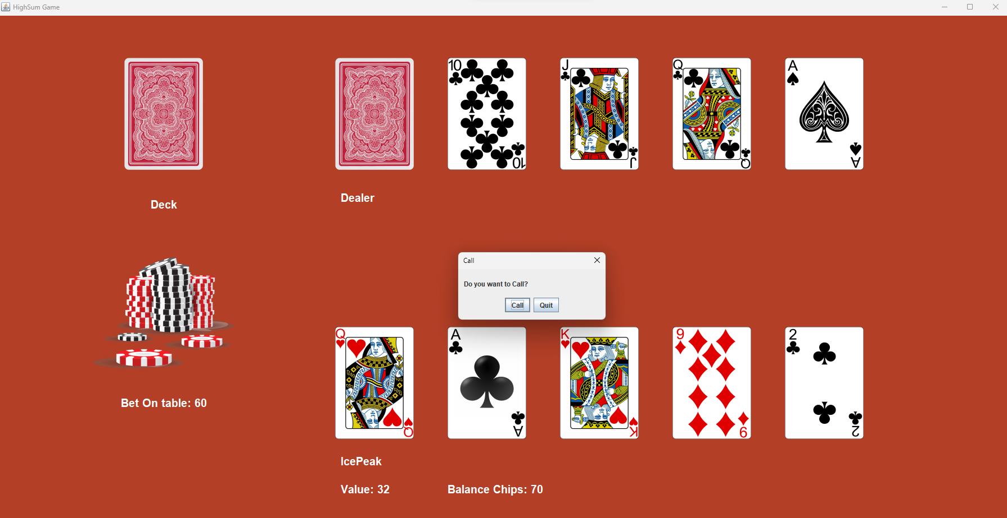

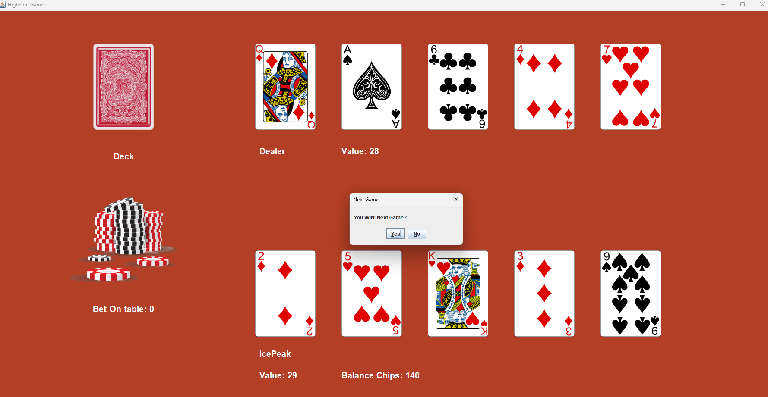

Final round. After betting this round, the hidden dealer’s card will be shown and who ever has the highest total value win.

**Player Start Condition**

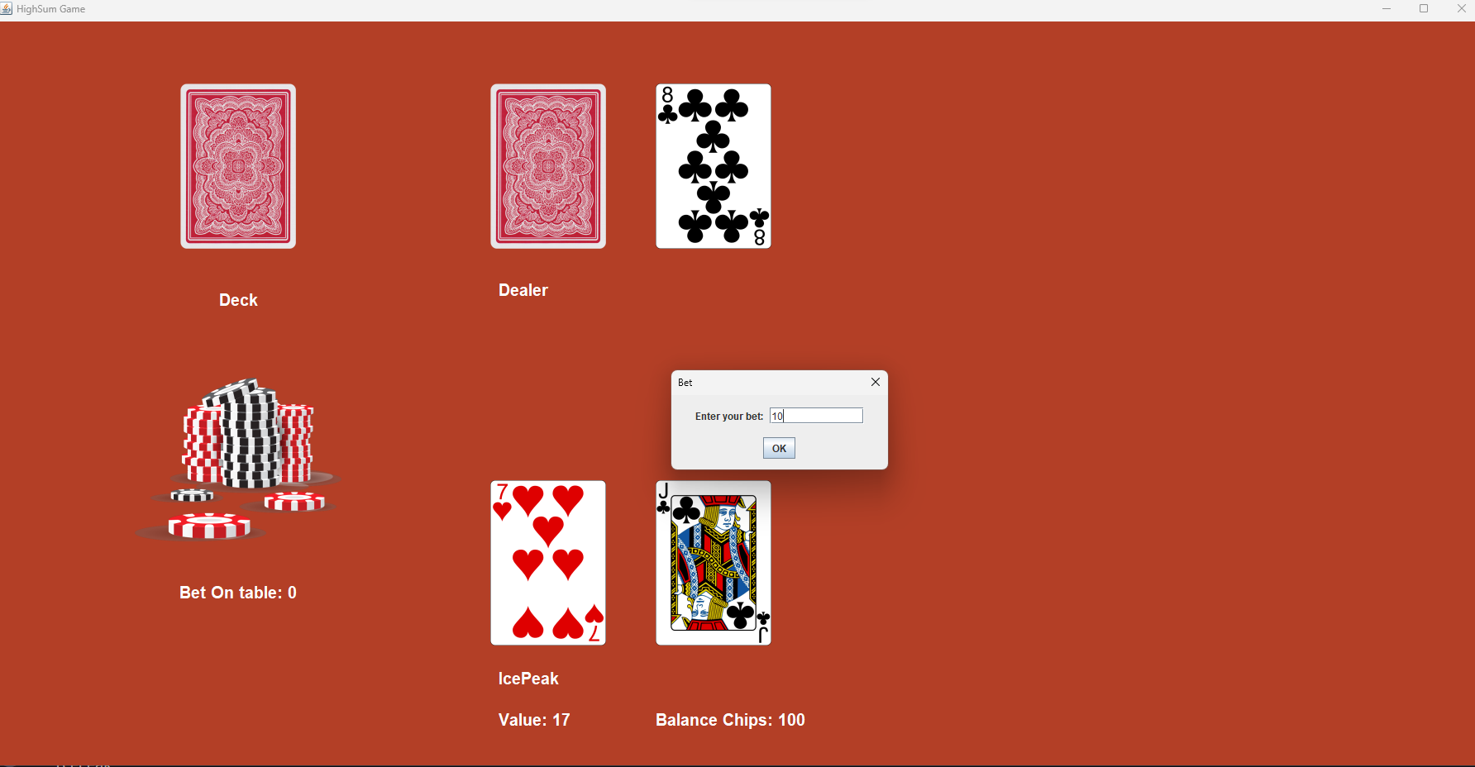

**Tie Condition**

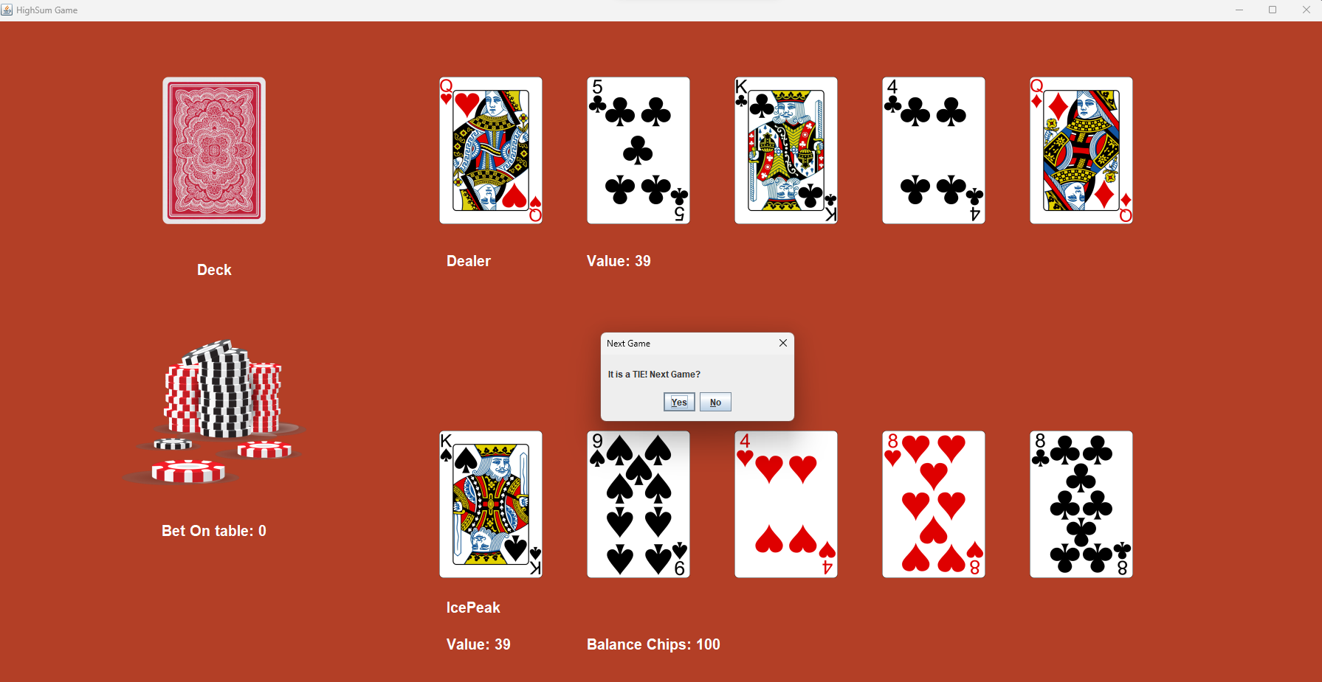

**Lose Condition**

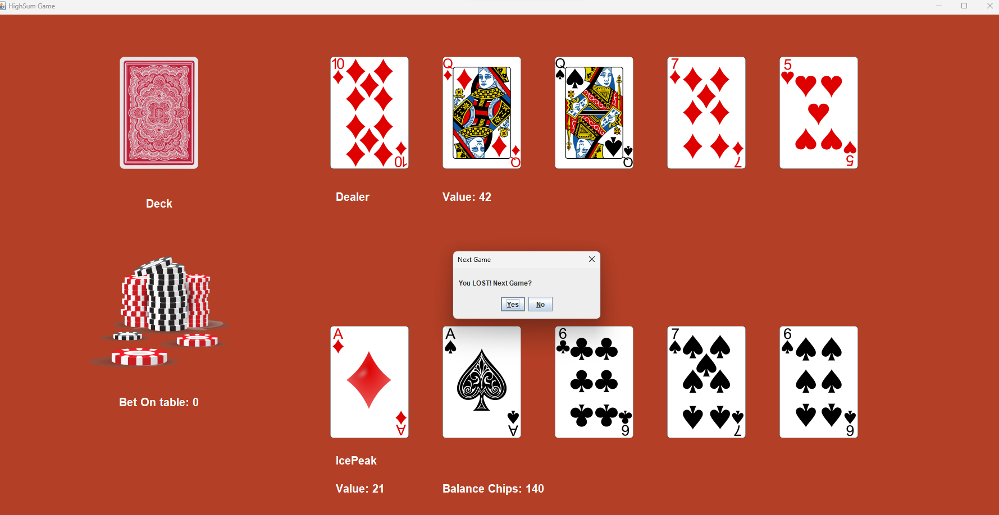

**Win Condition**

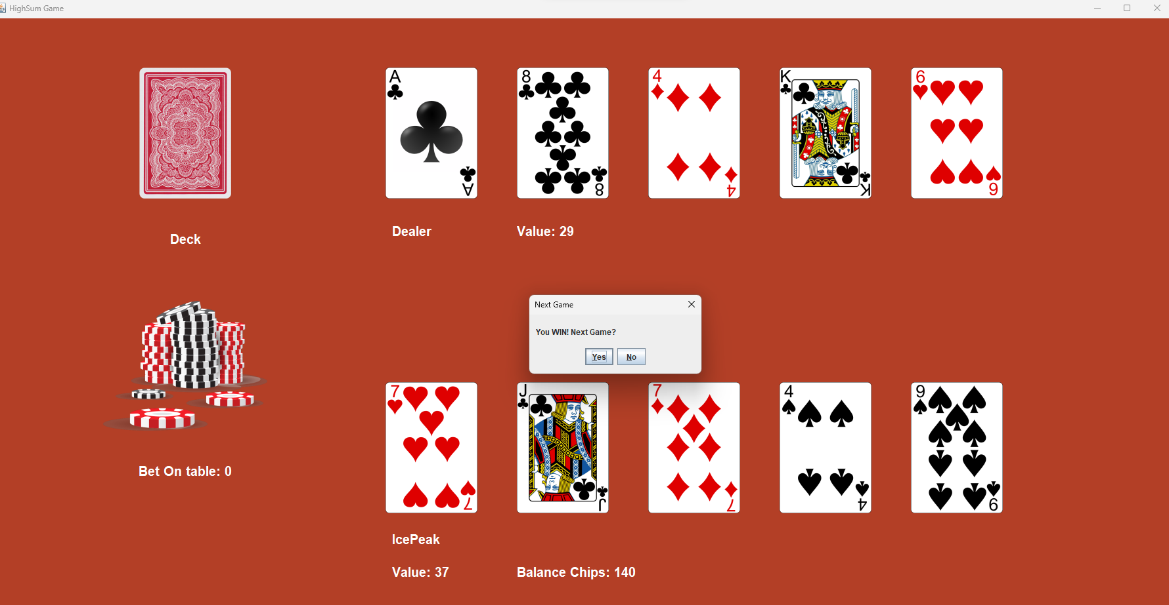

**Game Quit**

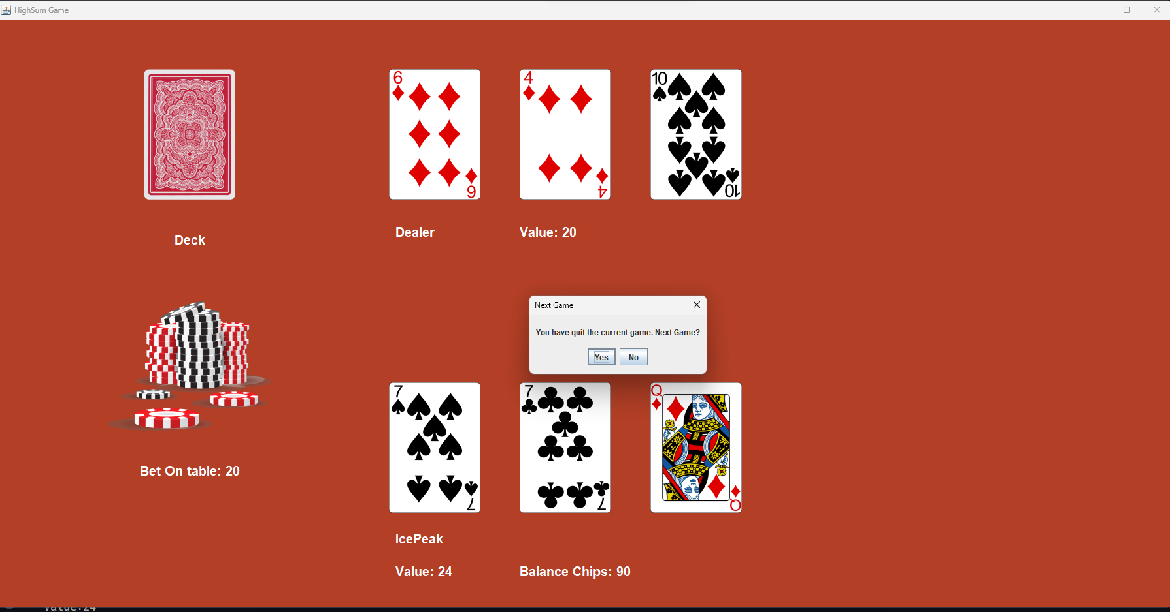

**Error handling**

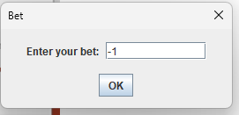

Entering negative Integer.

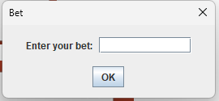

Entering space.

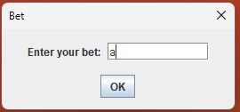

Entering character.

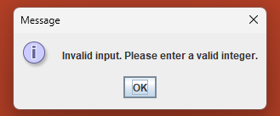

Player must not enter invalid character(String, space, negative integer).

**User Login Check**

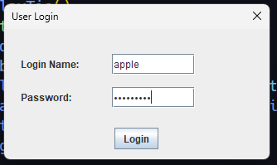

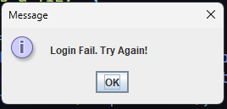

User must not enter wrong password and wrong name.

**Note to take**

Player is hard coded.

To play game, user must enter “IcePeak” in Login Name and “password” in Password.

Players’ balance will be now carried over to the next new games.