|  |  |
| --- | --- |
| [Machine Learning]  [2023-1] |  |
| Homework 3 |  |
| [Due Date] 2021.05.24  Student ID :  Name :  Professor : Juntae Kim | logo-placeholder |

1. Explain the differences between K-means and DBSCAN clustering algorithms, and discuss the advantages and disadvantages. (10 pts)

|  |
| --- |
| Your Answer |
|  |

1. Explain what are the ‘one-hot representation’ and ‘vector representation’ of a word. Select one of the existing word embedding algorithms and explain how it works to obtain an appropriate vector representation. (10 pts)

|  |
| --- |
| Your Answer |
|  |

1. Explain what ‘Vanishing Gradient Problem’ is. Compare the sigmoid function and ReLU function in the context of the vanishing gradient and computation efficiency. (10 pts)

|  |
| --- |
| Your Answer |
|  |

1. Explain the difference between Sigmoid and Softmax function. For following x, compute both Sigmoid(**x**) and Softmax(**x**) (10 pts)

**x** = [-0.5, 1.2, -0.1, 2.4]

|  |
| --- |
| Your Answer |
|  |

1. The “urbanGB-simple.csv” is the coordinates (longitude and latitude) of 1000 road accidents occurred in urban areas in Great Britain. Perform k-means and DBSCAN clustering on this dataset. For k-means, find proper *k* by using distortion and silhouette analysis. For DBSCAN, find proper *epsilon* and *minPts* so that you can get the similar result to the K-means. Plot the clusters and outliers. (20 pts)

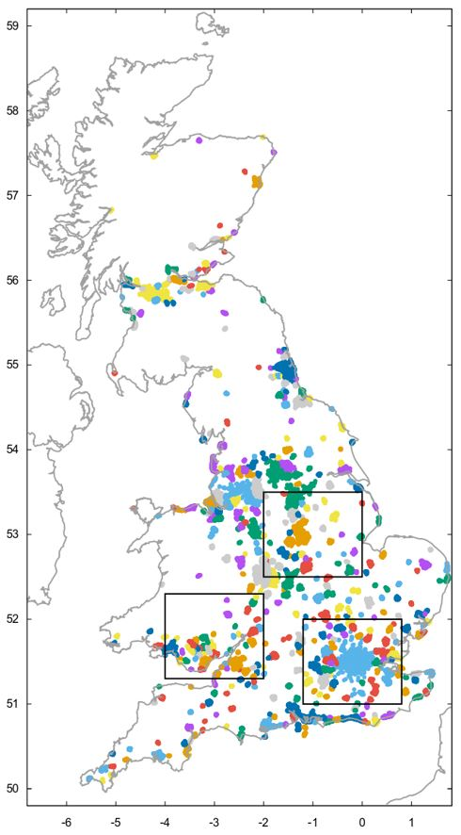

|  |
| --- |
| Code |
|  |
| Result(Captured images) |
|  |
| Description |
|  |

1. 20newsgroup dataset is a news dataset consisting of 20 categories. Apply Logistic Regression and Decision Tree Classifier on 20newsgroups dataset to build a document classification model. In this question, we only use samples from 4 categories. (30pts)

Follow this process:

1) Load the data. Use fetch_20newsgroups().

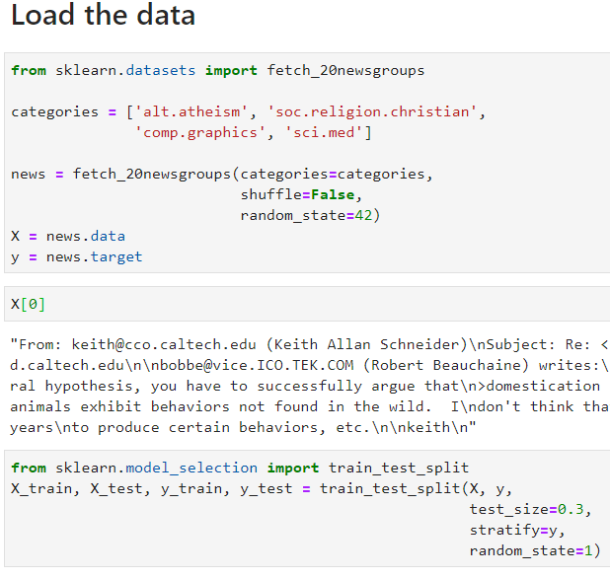

2) Make preprocessor function & porter stemmer tokenizer function.

3) Apply the TF-IDF(TFidfVectorizer) on the data.

- Use the preprocessor function & porter stemmer tokenizer

- Use stop-words

- Drop terms occurred in more than 10% of docs

- Drop terms occurred in less than 10 docs

4) Train models(Logistic Regression, Decision Tree) using TF-IDF vectors.

- Check the accuracies of the model

- Find out what are the most important words for this classification

5) Predict the categories of following 4 sentences

|  |
| --- |
| 'The outbreak was declared a global pandemic by the World Health Organization (WHO) on 11 March.',  'Today, computer graphics is a core technology in digitalphotography, film, video games, cell phone and computer displays,and many specialized applications.',  'Arguments for atheism range from philosophical to social and historical approaches.',  'The Bible is a compilation of many shorter books written at different times by a variety of authors, and later assembled into the biblical canon.' |

|  |
| --- |
| Code |
|  |
| Result(Captured images) |
|  |
| Description |
|  |

**Note**

1. Summit the file to e-class as pdf.

2. Specify your file name as “hw3_<StudentID>_<Name>.pdf”