School of Computer Science UNIVERSITY OF LEEDS
FACULTY OF ENGINEERING AND PHYSICAL SCIENCES

Optimizing Targeted Marketing: A Framework for Customer Segmentation and Automated Cluster-Based Notification

Dickshith Raj Nagaraj

Submitted in accordance with the requirements for the degree of
MSc Advanced Computer Science

Session 2025/2026

The candidate confirms that the following have been submitted:
Items | Format | Recipient(s) and Date
Deliverables 1–5 (this report, including the validation record and the commercial-viability assessment) | Report (PDF) | SSO / Minerva (xx/xx/xx)
Source code of the full pipeline with unit tests and reproducible outputs | Software code (Git repository / archive) | Supervisor, assessor (xx/xx/xx)
Interactive dashboard | Software (run instructions in Appendix A) | Supervisor, assessor (xx/xx/xx)

Type of Project: Exploratory Software

The candidate confirms that the work submitted is their own and the appropriate credit has been given where reference has been made to the work of others.
I understand that failure to attribute material which is obtained from another source may be considered as plagiarism.

(Signature of student) _______________________________

© 2026 The University of Leeds and Dickshith Raj Nagaraj

Summary
This project addresses a persistent inefficiency in online retail marketing: despite holding rich transactional records, retailers still deliver much of their outbound communication as undifferentiated "blanket" campaigns in which every customer receives the same message, wasting budget on customers who will not respond and fatiguing valuable customers with irrelevant contact. The problem this project set out to solve is how to convert raw retail transaction data — automatically, reproducibly, and with quantified financial justification — into a per-customer, prioritised marketing-notification plan.
The solution is an end-to-end software framework built in Python on the UCI Online Retail II dataset. The pipeline cleans 1,067,371 raw transaction rows down to 793,591 audited purchase lines through four sequential, logged rules, and engineers seven behavioural features (Recency, Frequency, Monetary, plus tenure, average order value, purchase cadence, and product breadth) for each of 5,878 unique customers. Six clustering algorithms spanning five algorithmic families — K-Means, DBSCAN, Gaussian Mixture Models, HDBSCAN, Agglomerative (Ward), and Spectral — are benchmarked under automatic hyper-parameter selection, three internal validity indices, and 50-round bootstrap stability analysis; a transparent, pre-declared rule selects HDBSCAN as the operational segmentation. A predictive layer estimates each customer's 12-month lifetime value with the BG/NBD and Gamma–Gamma probabilistic models and their churn probability with six supervised classifiers under a strict target-leakage guard, with pairwise differences tested for statistical significance using McNemar's test. A rule-based decision engine then combines segment, value tier, and churn-risk band into a concrete campaign action, channel, offer, priority, and contact time for every customer, and a 10,000-iteration Monte Carlo simulation quantifies the plan's return on investment against a static blanket-marketing baseline.
The main achievements are: (i) a fully reproducible, unit-tested, version-controlled pipeline that runs end-to-end on commodity CPU hardware in under three minutes; (ii) a methodologically rigorous segmentation in which the choice of algorithm is decided by evidence — HDBSCAN ranked first overall (Silhouette 0.416) — rather than by convention; (iii) an honest churn model achieving ROC-AUC 0.849, in which McNemar testing shows the two best models are statistically tied and exposes that two further models silently fail under class imbalance; and (iv) a quantified business case: the targeted plan yields a simulated mean ROI of 38.4× (95% credible interval [21.8×, 60.9×]) against 30.4× for the blanket baseline — a profit uplift of +168%. The principal contribution is the closed, auditable loop from raw data to a costed action plan, a link that most published segmentation studies leave open.

Acknowledgements
I would like to thank my supervisor, Dr Fahad Panolan, for his guidance, patience, and constructive feedback throughout this project. I am also grateful to the School of Computer Science at the University of Leeds for the resources and learning environment that made this work possible, and to the maintainers of the UCI Machine Learning Repository and of the open-source Python ecosystem — in particular scikit-learn, hdbscan, lifetimes, XGBoost, and Streamlit — on which the implementation depends.

Table of Contents
Summary iii
Acknowledgements v
Table of Contents vi
List of Figures x
List of Tables xi
Chapter 1 Introduction 1
1.1 Project Aim 1
1.2 Objectives 2
1.3 Deliverables 2
1.4 Ethical, Legal, and Social Issues 3
1.5 Structure of this Report 4
Chapter 2 Background Research 5
2.1 Literature Survey 5
2.1.1 RFM and behavioural segmentation 5
2.1.2 Comparative studies of clustering algorithms 6
2.1.3 Customer lifetime value 6
2.1.4 Churn prediction 6
2.1.5 Integrated pipelines, dynamic CRM, and uplift 7
2.1.6 The gap this project addresses 7
2.2 Methods and Techniques 8
2.2.1 Behavioural features and preprocessing 9
2.2.2 Clustering algorithm families 9
2.2.3 Hyper-parameter selection heuristics 11
2.2.4 Internal validity and stability 11
2.2.5 Probabilistic customer lifetime value 11
2.2.6 Churn labelling and classification 12
2.2.7 Evaluation metrics and significance testing 12
2.2.8 Monte Carlo ROI simulation 13
2.2.9 Tools and technology stack 13
2.3 Choice of Methods 14
Chapter 3 Software Requirements and System Design 15
3.1 Software Requirements 15
3.2 System Design 16
3.2.1 Architectural overview 16
3.2.2 Component design 18
3.2.3 Stage contracts 19
3.2.4 Key design decisions 19
Chapter 4 Software Implementation 20
4.1 Environment and Project Layout 20
4.2 Data Loading and Cleaning 20
4.3 Feature Engineering 21
4.4 Preprocessing 22
4.5 Clustering: Six Algorithms 23
4.6 Cluster Validation, Stability, and Selection 26
4.7 Segment Profiling and Naming 26
4.8 Customer Lifetime Value 28
4.9 Churn Classification 29
4.10 Year-on-Year Segment Migration 31
4.11 Rule-Based Notification Engine 31
4.12 Monte Carlo ROI Simulation 33
4.13 Interactive Dashboard 34
Chapter 5 Software Testing and Evaluation 38
5.1 Software Testing 38
5.1.1 Methodology 38
5.1.2 Outcome 39
5.2 Evaluation of the Segmentation 39
5.2.1 Quantitative comparison 39
5.2.2 Interpretation of the failures and disagreements 40
5.2.3 Relation to prior findings 41
5.2.4 Verdict against O3 41
5.3 Evaluation of the Churn Models 41
5.3.1 Quantitative comparison 41
5.3.2 Findings 43
5.3.3 Verdict against O4 (churn half) 44
5.4 Evaluation of the CLV Model 45
5.5 Evaluation of the Migration Analysis 45
5.6 Evaluation of the Notification Plan 47
5.7 Evaluation of the Commercial ROI 47
5.8 Requirements Traceability 48
5.9 Threats to Validity 49
Chapter 6 Conclusions and Future Work 50
6.1 Conclusions 50
6.2 Future Work 50
List of References 52
Appendix A External Materials 56
A.1 Source Code and Repository Layout 56
A.2 How to Run 56
A.3 Software Dependencies 56
A.4 Dataset 57
A.5 Artefact Inventory 57
Appendix B Ethical Issues Addressed 59
B.1 Data Protection and Legal Compliance 59
B.2 Human Participants 59
B.3 Responsible Use of Targeting Systems 59
B.4 Academic Integrity and Assistance 59

List of Figures
Figure 3.1 Layered system architecture and data flow of the framework, from raw transactions (top) to the costed per-customer action plan (bottom). 17
Figure 3.2 Component diagram: configuration-driven orchestration, one module per stage, a persistent artefact store, and two read-only consumer interfaces. 18
Figure 4.1 Distributions of the RFM features across the 5,878 customers (Frequency and Monetary on logarithmic scales). 22
Figure 4.2 Feature distributions before (top) and after (bottom) the log1p + standardisation preprocessing. 23
Figure 4.3 PCA projection of all six clustering solutions on identical axes (PC1 + PC2 ≈ 76.6% of variance). 24
Figure 4.4 K-Means model selection: inertia with the detected elbow (k = 4), silhouette (max at k = 2), and Davies–Bouldin versus k. 24
Figure 4.5 GMM model selection by BIC and AIC across component counts. 25
Figure 4.6 DBSCAN k-distance plot; the knee sets the neighbourhood radius ε. 25
Figure 4.7 Segment-profile heatmap for the selected HDBSCAN solution (colour = z-score versus cluster means; cell text = raw un-scaled means). 27
Figure 4.8 Segment radar chart: each axis is the segment's percentile against the full customer population (outward = better). 28
Figure 4.9 CLV distribution (left) and the frequency–recency scatter coloured by CLV (right). 29
Figure 4.10 Churn feature importances from the best tree model. Recency is absent by design — it defines the label (leakage guard). 31
Figure 4.11 Dashboard — Overview page: navigation sidebar, headline metrics (5,878 customers; £8,333,122 portfolio CLV; 10.0% churn rate), and pipeline summary. 35
Figure 4.12 Dashboard — Segments page: segment sizes, the un-scaled profile table, and the profile heatmap and radar. 36
Figure 4.13 Dashboard — ROI Simulation page: headline metrics (mean ROI 38.4×; 95% CI [21.8×, 60.9×]; P(ROI>0) = 100%), the simulated ROI and net-profit distributions with the static baseline overlaid, and the full summary table. 37
Figure 5.1 Bootstrap stability: distribution of the Adjusted Rand Index across 50 resamples per algorithm. 40
Figure 5.2a ROC curves for the six churn models. 42
Figure 5.2b Precision–recall curves for the six churn models — the more discriminating view under 10% class imbalance. 43
Figure 5.3 Segment migration heatmap between the two trading years. 46
Figure 5.4 Simulated ROI (left) and net-profit (right) distributions for the targeted plan, with the static blanket baseline overlaid. 48

List of Tables
Table 4.1 Data-cleaning audit: the row impact of each sequential rule. 21
Table 4.2 Descriptive statistics of the seven engineered features across the 5,878 customers. 22
Table 4.3 K-Means sweep metrics for k = 2…10: inertia (Eq. 5), silhouette (Eq. 7), and Davies–Bouldin (Eq. 8). 25
Table 4.4 HDBSCAN segment profiles: mean features in original units, size, share, and assigned marketing name. 28
Table 4.5 Summary statistics of the CLV model outputs across all 5,878 customers. 29
Table 4.6 Per-customer notification plan (first 10 of 5,878 rows): segment, CLV tier, churn band, and the resulting action, channel, offer, priority, and contact timing. 32
Table 5.2 Internal validity metrics for all six clustering algorithms (noise excluded from index computation for density methods). 39
Table 5.3 Overall algorithm ranking: per-metric ranks averaged across silhouette, Davies–Bouldin, Calinski–Harabasz, and mean bootstrap ARI. 39
Table 5.4 Churn model comparison on the stratified hold-out set: ROC-AUC, PR-AUC, precision, recall, F1 (Eqs. 20–22), 5-fold cross-validated ROC-AUC, and confusion counts. 41
Table 5.5 Overall churn-model ranking across ROC-AUC, PR-AUC, F1, and cross-validated ROC-AUC. 42
Table 5.6 Pairwise McNemar exact p-values between the six churn models (Eq. 23). Values above 0.05 mean the two models are statistically indistinguishable on this test set. 43
Table 5.7 Year-1 → year-2 segment migration: raw customer counts (2,772 customers active in both years). 45
Table 5.8 Year-1 → year-2 segment migration: row-normalised transition rates. 46
Table 5.9 Monte Carlo ROI summary (10,000 iterations), including the static-baseline comparison and uplift (Eqs. 24–27). 47

Chapter 1
Introduction

1.1 Project Aim
The aim of this project is to design, implement, and evaluate a reproducible software framework that uses unsupervised machine learning to segment retail customers from their behavioural transaction data, and that automatically converts those segments — enriched with predicted customer lifetime value and churn risk — into a prioritised, per-customer marketing-notification plan whose financial return is quantified by simulation against an untargeted baseline.
The remainder of this section defines the concepts in that aim for a computer-science reader who is new to the marketing-analytics domain. Customer segmentation is the unsupervised partitioning of a customer base into groups whose members behave similarly; because no ground truth exists, the quality of a segmentation must be established by internal validity measures and stability analysis rather than by accuracy against labels. RFM — Recency, Frequency, Monetary value — is the standard behavioural feature framework for retail: it measures how recently, how often, and how much a customer purchases, and it remains dominant because each dimension maps directly onto an intuitive marketing meaning [15], [25]. Clustering algorithms discover the behavioural groups from these features. Customer Lifetime Value (CLV) is a forward-looking estimate of the monetary value a customer will generate over a future horizon; in non-contractual retail (where customers lapse silently rather than formally cancelling) it is estimated probabilistically. Churn is the risk that a customer stops purchasing altogether, framed here as supervised classification. Finally, a notification plan is the operational output the marketing team actually needs: for every customer, what campaign to send, on which channel, with what offer, at what priority, and when.
The context that makes this problem worth solving is the well-documented shift of Customer Relationship Management (CRM) from static profiling — grouping customers by fixed demographic attributes — towards dynamic, behaviour-driven engagement in which the next action for a customer is recomputed as their behaviour changes [24], [36]. Despite that shift, a large share of outbound marketing remains untargeted. Blanket campaigns are doubly wasteful: they spend contact budget on customers who will not respond, and they risk alienating high-value customers with irrelevant communication, eroding the very lifetime value the campaign was intended to protect. The practical application of this project is therefore direct: it gives a small online retailer, using only its own transaction log and commodity hardware, an auditable decision system that concentrates marketing spend where value is at risk and quantifies the expected return before any money is spent.

1.2 Objectives
The project is scoped by six objectives, each phrased so that its achievement is measurable and each discharged in an identified part of this report:
- O1 — Background research. Conduct a systematic literature survey of customer segmentation, clustering algorithms, customer lifetime value, churn modelling, and dynamic CRM, and use it to justify every methodological choice (Chapter 2).
- O2 — Data foundation. Acquire real retail transaction data and implement auditable cleaning, customer-level RFM+ feature engineering, and skew-aware scaling (Sections 4.2–4.4).
- O3 — Validated segmentation. Implement and benchmark six clustering algorithms with principled, automatic hyper-parameter selection; evaluate the solutions with internal validity indices and bootstrap stability; and select one segmentation by a transparent, pre-declared rule (Sections 4.5–4.7 and 5.2).
- O4 — Predictive layer. Estimate each customer's 12-month CLV with the BG/NBD and Gamma–Gamma models, and their churn probability with six classifiers compared under a target-leakage guard and McNemar significance testing (Sections 4.8–4.9 and 5.3).
- O5 — Decision layer. Design and implement a rule-based notification engine that translates segment, CLV tier, and churn band into an actionable, prioritised marketing trigger per customer, exposed through an on-demand recommendation function and an interactive dashboard (Sections 4.11 and 4.13).
- O6 — Commercial quantification. Quantify the return on investment of the targeted plan, and its uplift over an untargeted static baseline, using a Monte Carlo cost–benefit simulation (Sections 4.12 and 5.7).

1.3 Deliverables
The objectives map onto five concrete deliverables:
- A version-controlled Python codebase implementing the full pipeline — data loading and cleaning, feature engineering, preprocessing, six-algorithm clustering, cluster validation and selection, segment profiling, CLV modelling, churn classification, year-on-year migration analysis, the rule-based notification engine, and the Monte Carlo ROI simulation — orchestrated by a single entry point and configured from a single configuration module (O2–O6).
- A reproducible experimentation and validation record: the complete set of result tables (CSV) and figures (PNG) generated by the pipeline under fixed random seeds, documenting every model-selection and validation decision (O3, O4).
- A notification-logic framework mapping cluster characteristics to marketing triggers, exposed programmatically via an on-demand recommend(customer_id) function and interactively via an eight-page dashboard with live customer lookup (O5).
- A commercial-viability assessment quantifying the expected financial return of the targeted plan and its uplift over static blanket marketing (O6).
- This MSc project report (O1, and the written evaluation of all objectives).

1.4 Ethical, Legal, and Social Issues
The project raises limited but non-trivial ethical, legal, social, and professional considerations, which are addressed by design rather than as an afterthought; a fuller treatment appears in Appendix B.
Legal and data protection. The dataset (UCI Online Retail II [15], [41]) is a public, secondary dataset containing no personally identifiable information beyond an anonymised numeric Customer ID: no names, addresses, contact details, or payment data are present. No attempt is made to re-identify any individual, and handling follows the principles of the UK GDPR — in particular purpose limitation and data minimisation, since only the fields required for behavioural modelling are read. The raw data file is treated as strictly read-only; every derived artefact is written to a separate location, preserving provenance.
Ethical. The project involves no human participants and no primary data collection, so no ethical approval or consent process is required. The relevant ethical surface is instead the use of the system: behaviour-based targeting can, if misused, over-contact customers, treat customer groups inequitably, or exploit vulnerable individuals with manipulative offers.
Social. The framework mitigates those risks structurally rather than rhetorically. The notification engine is deliberately rule-based and auditable — every recommendation can be traced to the exact segment, value tier, and churn band that produced it, inspected, and overridden by a human operator — and contact timing is derived from each customer's own purchase rhythm rather than a fixed drumbeat, which discourages over-contact by construction. The explicit "noise" segment produced by the chosen clustering algorithm is used to exclude atypical customers from generic campaigns rather than force-fitting them.
Professional. The work follows standard professional software practice: modular design under Git version control, a single configuration module in place of scattered constants, an automated unit-test suite, fixed random seeds for reproducibility, and documentation sufficient for an independent reader to re-run every stage (Appendix A). These practices reflect the professional responsibility, articulated in the BCS Code of Conduct, to deliver reliable and maintainable analytical software whose claims can be checked.

1.5 Structure of this Report
Chapter 2 surveys the literature, reviews the candidate methods with their mathematical formulation, and justifies the chosen methods. Chapter 3 states the software requirements and presents the system design. Chapter 4 describes the implementation of every pipeline stage together with the concrete results each stage produces. Chapter 5 reports software testing and the technical and commercial evaluation. Chapter 6 concludes and outlines future work. Appendix A documents the external materials (code, artefacts, and how to run them); Appendix B expands the treatment of ethical issues.

Chapter 2
Background Research

2.1 Literature Survey
Search methodology. Candidate literature was identified by searching Scopus, IEEE Xplore, the ACM Digital Library, SpringerLink, ScienceDirect, and Google Scholar with combinations of the terms customer segmentation, RFM, clustering, K-Means, DBSCAN, HDBSCAN, Gaussian mixture, customer lifetime value, BG/NBD, churn prediction, uplift modelling, and marketing ROI, over the period 2000–2026; foundational algorithmic papers were then followed backwards to their original sources regardless of date. Results were screened on title and abstract and then on full text against three inclusion criteria: (i) a peer-reviewed venue or a widely cited preprint; (ii) direct relevance to at least one stage of this project’s pipeline (behavioural features, clustering, validation, CLV, churn, the action layer, or ROI); and (iii) either a methodological contribution or an empirical result on retail or e-commerce transaction data. Comparative studies and surveys were deliberately prioritised over single-method case studies, because the questions this project asks are comparative. The sources that satisfied these criteria are the ones cited below and gathered in the List of References.

2.1.1 RFM and behavioural segmentation
Customer segmentation has a long history in marketing analytics, formalised comprehensively by Wedel and Kamakura [42], and the RFM framework remains the dominant behavioural model for retail because it is interpretable and maps directly onto marketing strategy [15], [25]. The study most directly comparable to this project's data setting is Chen, Sain, and Guo [15], who applied RFM-based segmentation with data mining to UK online-retail data — the same dataset family used here — and demonstrated that behavioural segments derived from transactions are markedly more actionable than segments based on static demographic attributes, because they reflect current engagement rather than fixed identity. Later work has enriched the basic framework in two directions. Zhang, Bradlow, and Small [26] generalise RFM to RFMC by adding a "clumpiness" dimension capturing whether purchases are evenly spaced or bursty, showing that purchase regularity carries predictive value beyond recency and frequency alone; and RFM ranking or scoring schemes have been proposed as lightweight alternatives to full clustering [25]. This project follows the first direction in spirit: it retains the classical RFM core but augments it with four additional behavioural signals — tenure, average order value, average inter-purchase interval (a direct, interpretable cousin of clumpiness), and product breadth — chosen because each is directly meaningful to a marketing stakeholder and inexpensive to compute (Section 4.3).
RFM is not beyond criticism, and the criticisms matter for design. It is blind to what a customer buys (product affinity), blind to demographics, and compresses a purchase history into three summary statistics, discarding sequence information; deep sequence models can in principle exploit what RFM discards [22]. The framework nevertheless remains the right foundation for this project for three reasons. First, the downstream consumer of the segments is a marketing decision layer whose rules must be human-readable (Section 3.1, NFR5), and RFM quantities are the vocabulary marketing teams already use. Second, the extended feature set recovers some of the discarded information — cadence recovers timing regularity, product breadth recovers a coarse affinity signal — at zero interpretability cost. Third, the probabilistic CLV models adopted in Section 2.2.5 are defined on RFM sufficient statistics [16], so the same feature foundation serves segmentation and value prediction coherently.

2.1.2 Comparative studies of clustering algorithms
A substantial applied literature compares clustering algorithms for segmentation, and its consistent finding motivates a central design decision of this project. Benchmarks of centroid-based methods against density-based methods on retail and e-commerce data repeatedly report that no single algorithm dominates: the appropriate choice depends on the cluster geometry of the particular dataset, the presence and desired treatment of outliers, and whether the number of clusters is known in advance [20], [21], [40]. Recent work has addressed individual weaknesses — for example automating the selection of the cluster count k in RFM-based K-Means [27] — but the family-level trade-offs remain. Segmentation studies across sectors, including banking [29] and broader machine-learning-driven consumer analytics [28], reach the same conclusion from different domains. The methodological implication, which this project adopts, is that the algorithm must be chosen empirically per dataset: six algorithms across five families are benchmarked, and the final selection is made by a pre-declared quantitative rule (Section 2.3) rather than by convention. The implication is also that validation — not merely production — of clusters is what separates rigorous segmentation from arbitrary grouping, which is why internal validity indices and bootstrap stability receive a full pipeline stage here (Sections 4.6 and 5.2).

2.1.3 Customer lifetime value
The second body of relevant work concerns probabilistic CLV estimation in non-contractual settings. The canonical pairing is the BG/NBD ("Beta-Geometric / Negative-Binomial Distribution") model of Fader, Hardie, and Lee [17], which models the flow and cessation of a customer's repeat purchases, and the companion Gamma–Gamma model of monetary value [16], which models spend per transaction under an explicit independence assumption between transaction frequency and value. The same authors connect these models directly to RFM inputs, showing that the RFM summary is a sufficient statistic for the models' likelihoods [16]. Applications span retail and financial services [30], and recent work hybridises the probabilistic models with machine-learning regressors [31]. This project adopts the classical BG/NBD + Gamma–Gamma pairing (Section 4.8) because it is the established, assumption-explicit approach whose diagnostics (for example the frequency–value independence check) can be verified on the data.

2.1.4 Churn prediction
Churn prediction is typically framed as supervised classification over behavioural features. Ensemble tree methods — random forests [8] and gradient-boosted trees, most prominently XGBoost [9] — generally lead on tabular retail and telecommunications benchmarks [32], and the field is comprehensively surveyed in [33]. Two methodological hazards recur across this literature and shape the design of Section 4.9. The first is target leakage: when the churn label is derived from a behavioural quantity (most commonly recency), any model given that quantity as a feature will appear nearly perfect while learning nothing useful; the honest design excludes the defining feature from the model. The second is class imbalance: churners are usually a small minority, so models optimised for accuracy or even ranking metrics can collapse to trivial behaviour at the decision threshold; the standard remedies are class re-weighting and threshold-aware evaluation with precision–recall analysis. A further, less commonly applied safeguard adopted here is formal significance testing of model differences with McNemar's test [18], which prevents over-claiming a "best" model when two classifiers are statistically indistinguishable.
A final consideration the churn literature under-emphasises is error asymmetry. In a marketing deployment the two error types have very different prices: a false positive means a retention offer (a few pounds of discount and contact cost) sent to a customer who would have stayed anyway, while a false negative means a churning customer lost silently — potentially hundreds of pounds of lifetime value. A model tuned for symmetric accuracy is therefore tuned for the wrong objective; recall on the churn class deserves priority as long as precision keeps campaign costs sensible. This asymmetry, made concrete by the CLV estimates of Section 2.2.5, shapes both the class-weighting choice (Eq. 17) and the evaluation emphasis on recall and precision–recall analysis in Section 5.3.

2.1.5 Integrated pipelines, dynamic CRM, and uplift
Several integrated studies combine two or more of these tasks: segmentation with churn prediction on online-retail data [34], hybrid RFM-and-clustering frameworks for churn [22], and segmentation pipelines feeding marketing strategy [35] or personalised recommendation [37]. In parallel, the CRM literature increasingly frames analytics as an embedded component of the marketing engine, recomputing the next best action as behaviour changes [24], [36]. The financial worth of targeting is, in the strongest work, expressed as uplift over an untargeted baseline, drawing on causal and uplift-modelling techniques [38], [39] — a framing adopted directly by this project's ROI simulation, which reports the difference between the targeted plan and a blanket baseline rather than an absolute figure alone.

2.1.6 The gap this project addresses
Across these literatures a consistent gap remains. Segmentation studies typically stop at descriptive clusters; CLV and churn studies stop at model scores; and even the integrated studies rarely close the loop to an auditable campaign-action layer with quantified ROI uplift. In practical terms: the papers end where a marketing team's questions begin — what should we send, to whom, when, and what will it earn us? The contribution of this project is to close that loop end-to-end in one reproducible system: validated clusters drive a rule-based, per-customer action plan whose expected financial return, and uplift over blanket marketing, is quantified by simulation before any campaign is run. The comparison below makes the positioning explicit:
Capability | [15] | [34] | [22] | [35] | This project
Behavioural (RFM+) segmentation | Yes | Yes | Yes | Yes | Yes
Multi-family algorithm comparison | No | Partial | No | Partial | Yes (6 algorithms, 5 families)
Stability / bootstrap validation | No | No | No | No | Yes (50-round ARI)
Probabilistic CLV | No | No | No | No | Yes (BG/NBD + Gamma–Gamma)
Churn with leakage guard + significance tests | No | Partial | Partial | No | Yes (6 models, McNemar)
Per-customer action layer (auditable) | No | No | No | Partial | Yes (rule engine + API)
ROI quantified vs untargeted baseline | No | No | No | No | Yes (Monte Carlo uplift)
Reproducible end-to-end software | No | No | No | No | Yes (seeded, tested, dashboard)

2.2 Methods and Techniques
This section reviews the candidate methods with their mathematical formulation, so that every quantity used later in the report is defined precisely. Equations are numbered consecutively and are referred back to from Chapters 4 and 5. The notation used throughout:
Symbol | Meaning
n | number of customers (5,878 after feature engineering)
x, x_i | a customer's feature vector / feature value
μ, σ | a feature's mean and standard deviation
K | number of clusters (or classes)
C_k, μ_k | cluster k and its centroid
R_i, F_i, M_i | Recency, Frequency, Monetary of customer i
γ₁ | sample skewness
s(i) | silhouette coefficient of point i
ARI | Adjusted Rand Index (bootstrap stability)
λ_m | m-th principal-component eigenvalue
(r, α), (a, b) | BG/NBD purchase-rate and dropout parameters
(p, q, ν) | Gamma–Gamma parameters
x, t_x, T | repeat purchases, last-purchase time, observation window
H, d | CLV horizon (12 months) and monthly discount rate (0.01)
TP, FP, FN, TN | confusion-matrix counts
b, c | discordant counts in McNemar's test
N_g, r_g, k_g | group size, response rate, conversions in simulation

2.2.1 Behavioural features and preprocessing
For customer i observed up to a snapshot date t_now, with purchase timestamps t_ij, per-line quantities q_ij and unit prices p_ij, the three core RFM quantities are the days since the last purchase, the number of distinct invoices, and the total spend:
R_i = t_now − max_j t_ij , F_i = |invoices(i)| , M_i = Σ_j q_ij · p_ij (1)
Retail spend distributions are heavy-tailed, and distance-based learning is distorted when one feature's range dominates. Whether to transform a feature is decided by its sample skewness (2); features exceeding the threshold receive the log1p transform (3) — chosen over a plain logarithm because it is defined at zero, which matters for one-time buyers whose tenure and inter-purchase interval are exactly zero — and all features are then standardised to z-scores (4):
γ₁ = (1/n) Σ_i (x_i − μ)³ / σ³ (2)
x′ = ln(1 + x) (3)
z = (x − μ) / σ (4)
Equation (2) quantifies distributional asymmetry; (3) compresses the long right tail while preserving order; (4) places all features on a common scale with mean 0 and variance 1 so that no single feature dominates the Euclidean geometry used by the clustering algorithms.

2.2.2 Clustering algorithm families
Centroid-based. K-Means [1], [2] partitions the data into K clusters C₁…C_K with centroids μ_k by minimising the within-cluster sum of squares (the inertia):
J = Σ_k Σ_{x ∈ C_k} ‖x − μ_k‖² (5)
It is fast and interpretable but assumes convex, similarly sized clusters and requires K in advance.
Probabilistic. A Gaussian Mixture Model [7] instead fits a weighted sum of K Gaussian components with weights π_k, means μ_k and covariances Σ_k by maximising the log-likelihood (6) via the Expectation–Maximisation algorithm, yielding soft memberships:
L = Σ_i ln Σ_k π_k · N(x_i | μ_k, Σ_k) (6)
Density-based. DBSCAN [3], [4] defines clusters as maximal regions whose point density exceeds a threshold set by a radius ε and a minimum neighbour count, and labels low-density points as noise; it does not require K but is sensitive to the single global ε. HDBSCAN [5], [6] removes that sensitivity by building the hierarchy over all density levels and keeping the clusters that are most stable across the hierarchy, retaining the noise concept without a global radius. Density methods optimise no single closed-form objective, which is why their evaluation relies entirely on the validity indices of Section 2.2.4.
Hierarchical. Agglomerative clustering merges points bottom-up; Ward's linkage merges the pair of clusters whose union minimises the increase in total within-cluster variance, i.e. the increase in (5), producing compact clusters comparable to K-Means but without iterative re-assignment.
Graph-based. Spectral clustering builds a similarity graph over the points, embeds the data using the leading eigenvectors of the graph Laplacian, and clusters in that embedded space; it can recover non-convex structure that defeats centroid methods, at higher computational cost.
Computational complexity. The families also differ in cost, which matters for the scalability discussion of Section 6.2. For n points, d features, K clusters and i iterations:
Algorithm | Time complexity | Practical note at n ≈ 5,900
K-Means | O(n·K·d·i) | seconds; scales to millions of rows
GMM (EM) | O(n·K·d²·i) | seconds at d = 7
DBSCAN | O(n log n) with spatial index | seconds; the k-distance scan dominates
HDBSCAN | O(n log n) average | seconds
Agglomerative (Ward) | O(n² log n) time, O(n²) memory | the quadratic memory is the scaling wall
Spectral | O(n³) dense; reduced via sparse k-NN affinity | tractable here only because a sparse nearest-neighbour graph (10 neighbours) is used

At this project's scale every algorithm completes in seconds on CPU, so the comparison can be decided purely on quality (Section 5.2); at an order of magnitude more customers, the quadratic-memory hierarchical method and the spectral eigendecomposition would be the first casualties, which is why the framework's selection logic — rather than any single algorithm — is the durable artefact.

2.2.3 Hyper-parameter selection heuristics
The number of clusters for K-Means is chosen by two standard heuristics reported side by side: the Elbow Method, operationalised by geometric knee detection on the inertia curve [10], and Silhouette Analysis [11], which selects the K maximising the mean silhouette (7). GMM's component count is selected by minimising the Bayesian Information Criterion, which penalises the log-likelihood (6) with a model-complexity term; DBSCAN's radius ε is read from the knee of the sorted k-distance plot [3]; HDBSCAN requires only a minimum cluster size; and the hierarchical and spectral methods reuse the K-Means K to give a like-for-like comparison at equal cluster count. Because these heuristics can disagree — and in this project they do (Section 4.5) — no single heuristic is trusted alone.

2.2.4 Internal validity and stability
With no ground-truth labels, partition quality is quantified by three complementary internal indices. The silhouette coefficient (7) of point i contrasts its mean distance a(i) to its own cluster with its mean distance b(i) to the nearest other cluster; the Davies–Bouldin index (8) averages the worst-case ratio of within-cluster scatter σ to between-centroid distance d(c_i, c_j) (lower is better) [12]; and the Calinski–Harabasz index (9) is the dispersion ratio of between-cluster to within-cluster scatter matrices (higher is better) [13]:
s(i) = ( b(i) − a(i) ) / max{ a(i), b(i) } , s(i) ∈ [−1, 1] (7)
DB = (1/K) Σ_i max_{j≠i} [ (σ_i + σ_j) / d(c_i, c_j) ] (8)
CH = [ tr(B) / (K − 1) ] / [ tr(W) / (n − K) ] (9)
Geometric tightness alone does not establish that clusters are real: a solution can score well on indices yet change completely under small perturbations of the data. Stability is therefore measured separately by refitting each algorithm on bootstrap resamples and scoring the agreement between the full-data partition and each resampled partition with the Adjusted Rand Index (10), which corrects raw pair-counting agreement RI for chance [14]:
ARI = ( RI − E[RI] ) / ( max RI − E[RI] ) , ARI ∈ [−1, 1] (10)
Finally, for visual comparison of all partitions on common axes, the scaled feature space is projected onto its first two principal components, retaining the components with the largest explained-variance ratio (11):
EVR_m = λ_m / Σ_j λ_j (11)

2.2.5 Probabilistic customer lifetime value
The BG/NBD model [17] describes each customer by a latent purchase rate and a latent dropout process, with population-level parameters (r, α) for purchasing and (a, b) for dropout. For a customer with x repeat purchases, last purchase at t_x, and observation window T, the model gives the probability the customer is still active (12) and a closed-form expectation of the number of purchases in a future window of length t (13, expressible via the Gaussian hypergeometric function ₂F₁):
P(alive | x, t_x, T) = [ 1 + δ(x>0) · (a / (b + x − 1)) · ((α + T)/(α + t_x))^(r+x) ]⁻¹ (12)
E[Y(t) | x, t_x, T] : closed-form in (r, α, a, b) via the ₂F₁ function (13)
The Gamma–Gamma model [16] estimates expected transaction value as a credibility-weighted blend (14) of the population mean transaction value pν/(q−1) and the customer's own observed mean m_x — customers with few observations are shrunk towards the population mean — under the assumption, checked empirically in Section 4.8, that transaction value is independent of transaction frequency. Discounting expected purchases over a horizon of H months at a monthly rate d yields the CLV (15):
E[M | m_x, x] = ((q−1)/(px+q−1)) · (pν/(q−1)) + (px/(px+q−1)) · m_x (14)
CLV = Σ_{t=1…H} E[purchases_t] · E[M] / (1 + d)^t (15)

2.2.6 Churn labelling and classification
The churn label is defined by thresholding Recency at its 90th percentile (16); because the label is a deterministic function of Recency, Recency itself must be excluded from the model features to prevent target leakage. Class imbalance is corrected by weighting each class inversely to its frequency (17), where N is the sample size and N_c the count of class c. The baseline classifier, logistic regression, models the churn probability through the logistic function (18); tree-based models (decision tree, random forest [8], gradient boosting, XGBoost [9]) instead grow splits that minimise node impurity, measured by the Gini index (19); and k-nearest neighbours classifies by distance-weighted vote among the k closest customers:
y_i = 1 if R_i > Q_0.90(R) , else 0 (16)
w_c = N / (K · N_c) (17)
P(y=1 | x) = σ(βᵀx + β₀) , σ(z) = 1/(1 + e^{−z}) (18)
G = 1 − Σ_c p_c² (19)

2.2.7 Evaluation metrics and significance testing
On an imbalanced task, headline metrics must be threshold-aware. Precision and recall (20) measure, respectively, the purity of positive predictions and the coverage of true positives; F1 (21) is their harmonic mean; ROC-AUC (22) is the probability that a randomly chosen positive is scored above a randomly chosen negative, and the area under the precision–recall curve (PR-AUC) summarises threshold behaviour where it matters most under imbalance:
Precision = TP/(TP+FP) , Recall = TP/(TP+FN) (20)
F1 = 2 · Precision · Recall / (Precision + Recall) (21)
ROC-AUC = P( ŝ(x⁺) > ŝ(x⁻) ) (22)
Whether two classifiers genuinely differ is tested with McNemar's procedure [18] on their discordant predictions: with b the count of test cases only the first model gets right and c the count only the second gets right, the classical statistic is (23); this project uses the exact form, evaluating min(b, c) against a Binomial(b+c, ½) null, which is preferable at small discordant counts:
χ²₁ = (|b − c| − 1)² / (b + c) , exact: min(b,c) ~ Binomial(b+c, ½) (23)

2.2.8 Monte Carlo ROI simulation
Campaign economics are uncertain chiefly through the response rate. For each campaign action group g with N_g contacted customers, the simulation draws a response rate from a Beta prior centred on a documented planning assumption, conversions from the induced Binomial (24), and applies multiplicative Gaussian noise to per-conversion revenue; profit for one simulated world sums contribution minus contact costs (25), giving ROI (26); and the headline business quantity is the percentage profit uplift of the targeted plan over a static blanket baseline simulated by the same machinery (27):
r_g ~ Beta(α_g, β_g) , k_g ~ Binomial(N_g, r_g) (24)
Profit = Σ_g k_g · v̄_g · m_g − Σ_g N_g · cost_g , m_g ~ N(1, s²) clipped > 0 (25)
ROI = Profit / Cost (26)
Uplift% = 100 · (Profit_targeted − Profit_static) / Profit_static (27)
Repeating the draw 10,000 times turns single fragile point estimates into full distributions, from which means, medians, credible intervals, and the probability of a positive return are read directly.

2.2.9 Tools and technology stack
The candidate implementation stack is Python 3.11 with pandas for data manipulation, scikit-learn [19] for clustering, classification, preprocessing, and metrics, the dedicated hdbscan library [6], the lifetimes library implementing BG/NBD and Gamma–Gamma, XGBoost [9], SciPy for statistical tests, Matplotlib for figures, Streamlit for the dashboard, pytest for testing, and Git for version control. Alternatives considered include R (rich statistics but weaker application packaging for the dashboard), Spark (unnecessary at 10⁶-row scale), and GPU acceleration (unnecessary at n ≈ 5,900 customers — the full pipeline completes in under three minutes on CPU).

2.3 Choice of Methods
The choices follow from the survey. Because the comparative literature (Section 2.1.2) shows that no clustering algorithm can be justified a priori, this project benchmarks six algorithms across the five families of Section 2.2.2 and selects among them with a transparent, pre-declared rule: (i) disqualify any solution whose noise fraction exceeds 30%, (ii) require a mean bootstrap ARI of at least 0.70 (Eq. 10) for stability, and (iii) among the survivors choose the highest silhouette (Eq. 7). The rule encodes explicit priorities — usability of the segments, then robustness, then separation — and makes the selection reproducible and criticisable, which an ad-hoc choice is not. HDBSCAN is included deliberately because its noise label is marketing-meaningful: customers who fit no segment should be treated individually, not force-fitted.
The feature set extends RFM with four behavioural signals (Section 2.1.1); skewed features receive log1p (Eq. 3) before standardisation (Eq. 4), with the transform decided per feature by the skew threshold |γ₁| > 0.5 (Eq. 2) rather than applied indiscriminately. CLV uses BG/NBD + Gamma–Gamma (Eqs. 12–15) as the established non-contractual approach whose assumptions can be checked. Churn uses six classifiers under the leakage guard of Section 2.2.6, with class weighting (Eq. 17) where the model supports it, threshold-aware evaluation (Eqs. 20–22), and McNemar significance testing (Eq. 23) so that differences are only claimed when statistically supported. The decision layer is deliberately rule-based rather than learned: auditability is a requirement (Section 3.1), and a rule table that a marketer can read, question, and override is worth more operationally than an opaque optimiser. Finally, ROI is estimated by Monte Carlo simulation (Eqs. 24–27) including a static baseline, so the reported headline is the uplift of targeting — the quantity least sensitive to the shared planning assumptions. The overall process follows the CRISP-DM methodology [23]: business understanding (Chapter 1), data understanding and preparation (Sections 4.2–4.4), modelling (Sections 4.5–4.12), evaluation (Chapter 5), and deployment in the form of the dashboard (Section 4.13).

Chapter 3
Software Requirements and System Design

3.1 Software Requirements
This is an exploratory software project: the goal is a working, evaluated framework rather than a hardened commercial product, so the requirements are stated at the level of pipeline capabilities and system qualities. They were derived from the project aim (Section 1.1), the literature-identified gap (Section 2.1.6), and the practical needs of the marketing stakeholder the system notionally serves. Each functional requirement is verified in Chapter 5 (see the traceability summary in Section 5.8).
Functional requirements.
- FR1 — Data ingestion. Load the raw two-year transaction dataset from its source Excel workbook (both yearly worksheets) into a single typed table.
- FR2 — Auditable cleaning. Clean the data via documented, sequential rules and persist a cleaning-audit table recording the row impact of every rule.
- FR3 — Feature engineering. Compute customer-level RFM plus four extended behavioural features (Eq. 1; Section 4.3) against a fixed snapshot date.
- FR4 — Preprocessing. Apply the skew-gated log1p transform and standardisation (Eqs. 2–4) and persist both the scaled features and the fitted scaler.
- FR5 — Multi-algorithm clustering. Cluster the customers with six algorithms across five families, selecting hyper-parameters automatically (Section 2.2.3).
- FR6 — Validation and selection. Score every solution with the three internal indices (Eqs. 7–9) and bootstrap ARI stability (Eq. 10), rank the algorithms, and select one by the pre-declared rule of Section 2.3.
- FR7 — Profiling and naming. Profile each selected segment in original (un-scaled) units and assign deterministic marketing-friendly names.
- FR8 — CLV estimation. Estimate per-customer probability-alive, expected purchases over 90/180/365-day horizons, and discounted 12-month CLV (Eqs. 12–15).
- FR9 — Churn prediction. Label churn by the recency-percentile rule (Eq. 16), exclude the defining feature (leakage guard), train and compare six classifiers with imbalance handling (Eq. 17), and test pairwise significance (Eq. 23).
- FR10 — Migration analysis. Segment each trading year independently and compute the year-1 → year-2 transition matrix of segment membership.
- FR11 — Notification plan. Generate a per-customer campaign plan (action, channel, offer, priority 1–5, contact timing) driven by segment, CLV tier, and churn band, and expose an on-demand recommend(customer_id) lookup.
- FR12 — ROI simulation. Quantify the plan's ROI distribution by Monte Carlo simulation (Eqs. 24–26) including the uplift over a static blanket baseline (Eq. 27).
- FR13 — Dashboard. Provide an interactive dashboard over all persisted artefacts, including a live customer-lookup page.
Non-functional requirements.
- NFR1 — Reproducibility. Two runs of the pipeline on the same input must produce identical outputs: all stochastic steps use a fixed random seed (42) and the RFM snapshot date is pinned to the day after the last transaction rather than the wall clock.
- NFR2 — Modularity. One module per pipeline stage with a clear input/output contract, orchestrated centrally, so stages can be developed, tested, and re-run independently.
- NFR3 — Configurability. Every path, threshold, and hyper-parameter lives in a single configuration module; no magic numbers in stage code.
- NFR4 — Performance and portability. The full pipeline must run on commodity CPU hardware in minutes, with no GPU dependency (measured: ≈160 s end-to-end).
- NFR5 — Auditability. Every marketing recommendation must be traceable to the explicit rules and inputs that produced it, and overridable by a human.
- NFR6 — Testability. Core logic must be covered by automated tests that run on small synthetic datasets, independent of the raw data file.

3.2 System Design

3.2.1 Architectural overview
The system is a modular, configuration-driven batch pipeline with two thin interactive consumers on top. Conceptually it forms five layers, each consuming only the outputs of the layer above: a data foundation (ingestion, cleaning, feature engineering, preprocessing), a segmentation layer (six clustering algorithms, validation, profiling), a customer intelligence layer (CLV, churn, migration), a decision layer (notification engine, ROI simulation), and a delivery layer (dashboard and artefact store). Figure 3.1 shows the layered data flow with the artefact handed between layers annotated on each arrow.
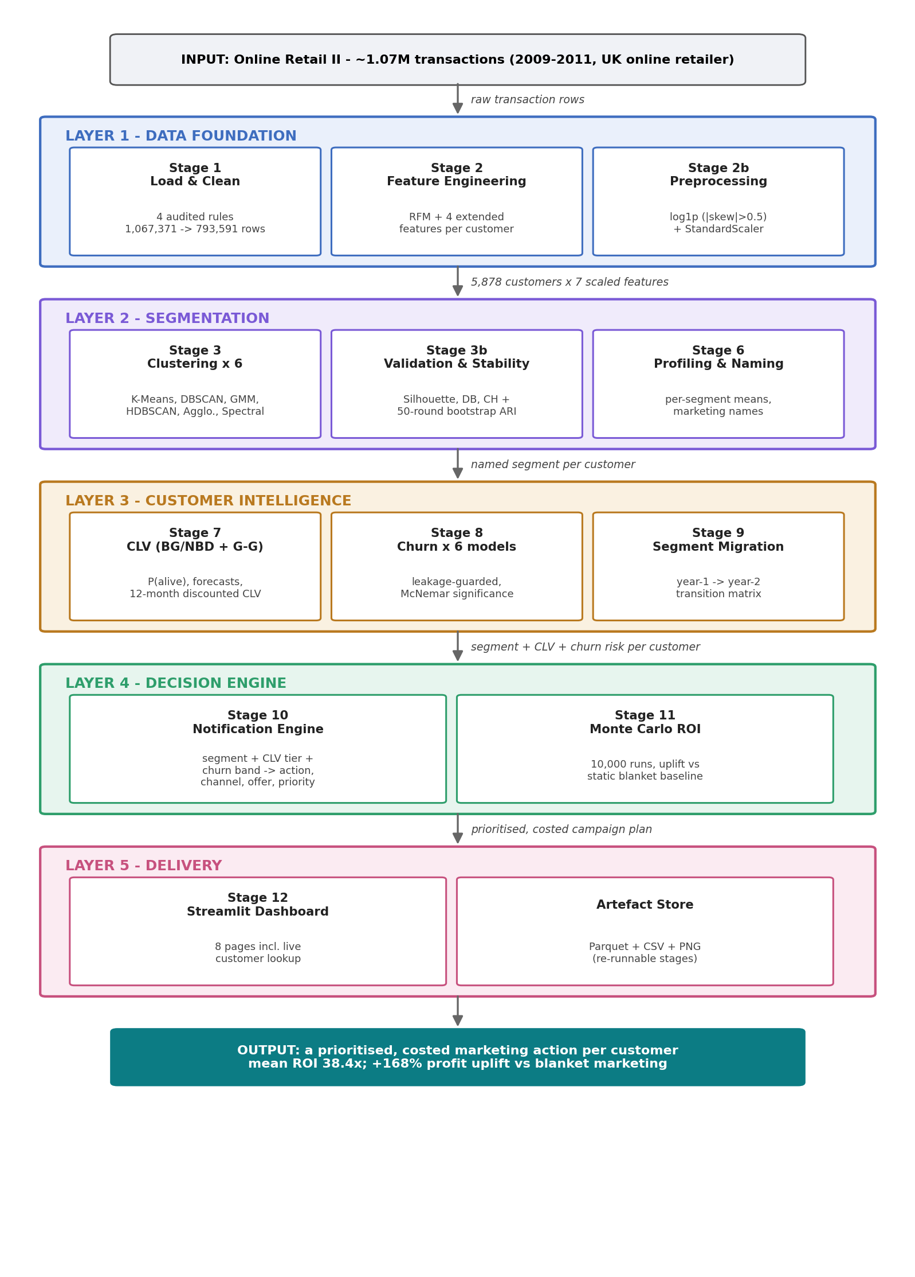
Figure 3.1 Layered system architecture and data flow of the framework, from raw transactions (top) to the costed per-customer action plan (bottom).
Data flows strictly one way — raw transactions → cleaned transactions → customer features → scaled features → cluster assignments → segment profiles → CLV and churn scores → notification plan → ROI assessment — so there are no circular dependencies between stages, and the complete state of the system after any stage is captured by the artefacts on disk. This is what makes each stage independently re-runnable (NFR2) and the whole pipeline trivially debuggable: any intermediate result can be inspected as a file.

3.2.2 Component design
Figure 3.2 shows the component view. A single orchestrator (main.py) imports one module per stage from src/ and executes them in dependency order. A central configuration module (src/config.py) is the single source of truth for every path and hyper-parameter (NFR3) — stages import constants from it and never define their own. All intermediate artefacts are persisted in typed, columnar form: Parquet for datasets (efficient, schema-preserving), CSV for result tables (human- and Word-readable), and PNG for figures. Two consumers sit on top and only read artefacts: the Streamlit dashboard (app/streamlit_app.py), and the on-demand recommendation API (notifications.recommend(customer_id)), which the dashboard's Customer Lookup page calls live. The automated test suite (tests/, pytest) exercises stage logic on synthetic data without touching the raw file.
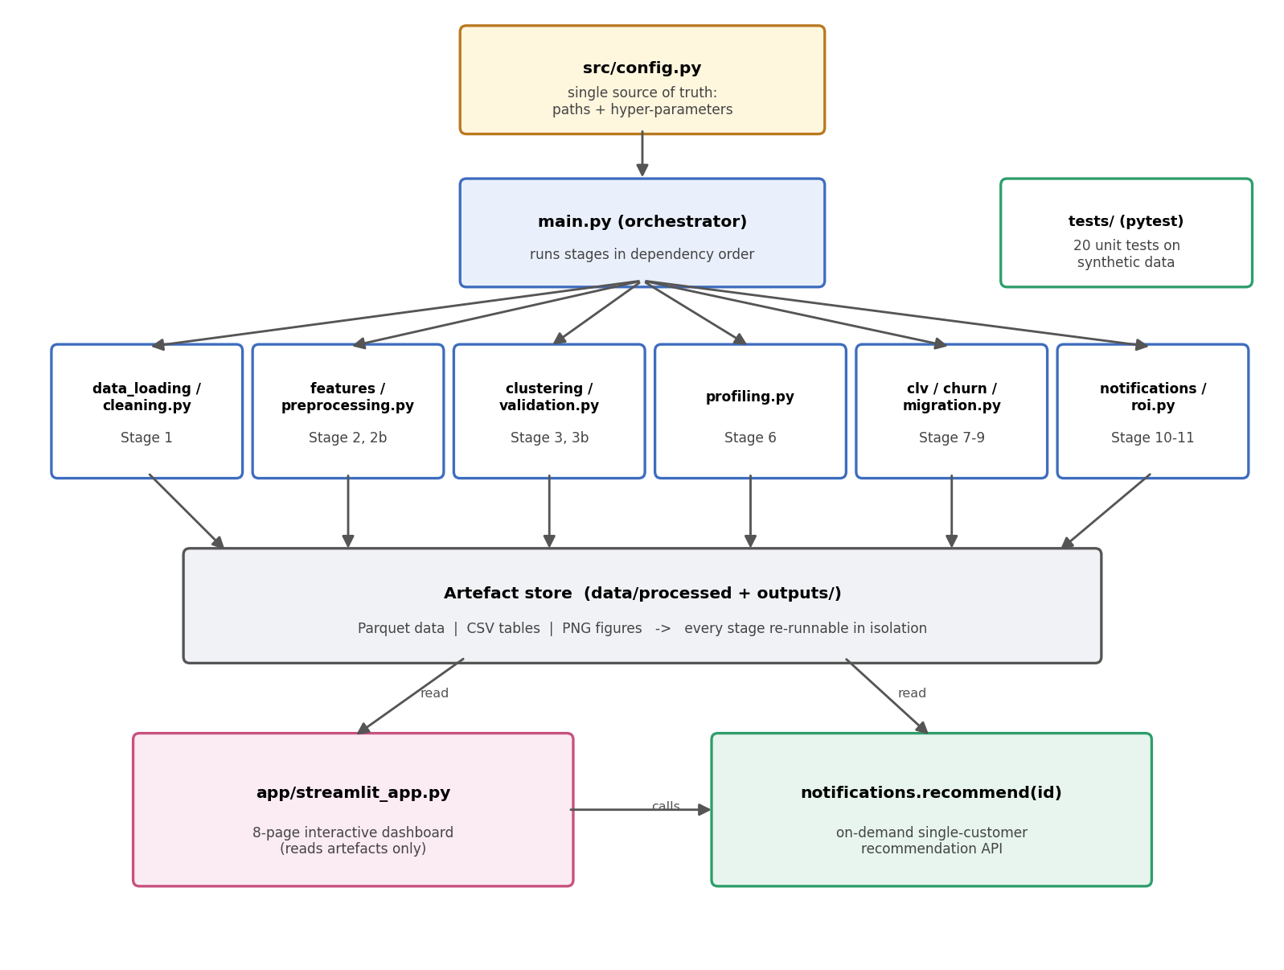
Figure 3.2 Component diagram: configuration-driven orchestration, one module per stage, a persistent artefact store, and two read-only consumer interfaces.

3.2.3 Stage contracts
Each stage's input/output contract is explicit, which is what makes the stages independently re-runnable and testable:
Stage (module) | Consumes | Produces
1 Load + clean (data_loading, cleaning) | raw workbook | cleaned_transactions.parquet; cleaning_summary.csv
2 Features (features) | cleaned transactions | customer_features.parquet; feature_summary.csv
2b Preprocessing (preprocessing) | customer features | scaled_features.parquet; fitted_scaler.joblib
3 Clustering (clustering) | scaled features | clustered_customers.parquet (6 label columns); selection figures
3b Validation (validation) | scaled features + labels | cluster_validation.csv; cluster_ranking.csv; stability figure; selected algorithm
6 Profiling (profiling) | features + selected labels | segment_profiles.csv; heatmap + radar figures
7 CLV (clv) | cleaned transactions | customer_clv.parquet; clv_summary.csv; CLV figure
8 Churn (churn) | customer features | customer_churn.parquet; comparison/ranking/McNemar tables; ROC/PR/importance figures
9 Migration (migration) | cleaned transactions | migration counts/rates tables; migration figure
10 Notifications (notifications) | clusters + CLV + churn | notification_plan.csv; recommend() API
11 ROI (roi) | notification plan + CLV | roi_simulation_summary.csv; ROI figure
12 Dashboard (app) | all persisted artefacts | interactive views (read-only)

3.2.4 Key design decisions
Four decisions shape the design. First, artefact-mediated coupling: stages communicate only through files, never through in-memory hand-offs across module boundaries, which decouples development and allows the expensive analytical computation to be separated cleanly from the cheap interactive presentation. Second, configuration centralisation: pinning every tunable in one module makes the experiment surface explicit and the runs reproducible — the configuration file effectively is the experiment registry. Third, deterministic recomputation over caching cleverness: with an end-to-end runtime of ≈160 s there is no need for incremental computation machinery; simplicity wins. Fourth, rule-based decision layer: the notification engine is a readable rule table plus two modulation steps rather than a learned policy, satisfying the auditability requirement (NFR5) that Chapter 1 motivated ethically and Chapter 2 motivated operationally.

3.3 Project Management, Version Control, and Risk
The project was managed as a sequence of short, artefact-driven phases: each phase corresponds to one pipeline stage, and its definition of done is that the stage’s persisted artefact regenerates deterministically from a clean run. All work was version-controlled in Git from the outset, with messages following the Conventional Commits style (feat(stage-3b): …, docs: …) so the history doubles as a delivery record. Table 3.1 reconstructs the milestone record directly from that history; the repository (21 development commits plus subsequent validation additions) is submitted alongside this report as the primary evidence of process.
Table 3.1 Delivery milestones as recorded in the Git commit history (messages follow the Conventional Commits convention).
Phase | Scope delivered | Commits | Completed
Scaffold & data foundation | Project structure; loading, four audited cleaning rules, RFM + extended features, preprocessing (Stages 1–2b) | 4 | 19 Jun 2026
First clustering & validation | K-Means sweep + HDBSCAN; validity indices, bootstrap stability, selection rule (Stages 3–3b) | 3 | 19 Jun 2026
Full algorithm benchmark | Extension to six algorithms with generalised validation (Stage 4) | 1 | 22 Jun 2026
Value & risk models | Segment profiling and naming; BG/NBD + Gamma–Gamma CLV; six-model churn comparison (Stages 6–8) | 3 | 22 Jun 2026
Action & commercial layer | Migration matrix; rule-based notification engine; Monte Carlo ROI with static baseline (Stages 9–11) | 3 | 22 Jun 2026
Delivery & QA | Streamlit dashboard; 20-test pytest suite; full end-to-end run; HTML/Markdown result reports (Stages 12–13) | 4 | 22 Jun 2026
Documentation artefacts | Executed notebook generator and dissertation-grade documentation | 3 | 23 Jun 2026
Post-draft validation | CLV temporal holdout; churn label-threshold sensitivity; ROI assumption sensitivity (Sections 5.3–5.7) | 1 | 12 Jul 2026
Risks were identified at planning time and mitigated structurally — engineered into the pipeline rather than listed and forgotten. Table 3.2 records the register; every mitigation names the mechanism in the delivered system that discharges it.
Table 3.2 Project risk register: likelihood (L), impact (I), and the mitigation engineered into the delivered system.
Risk | L | I | Mitigation engineered into the system
Clustering yields no stable or usable structure on this data | Med | High | Six-algorithm benchmark with a pre-declared selection rule and a bootstrap-ARI stability gate; K-Means retained as the conventional fallback (Section 4.6)
Target leakage silently inflates the churn results | Med | High | Recency excluded from the feature set by design; the guard is enforced by a dedicated unit test (Sections 4.9, 5.1)
Probabilistic model fitting fails to converge | Med | Med | Penalized fitting with a documented parameter ladder; convergence logged; degenerate boundary fits rejected (Sections 4.8, 5.4)
Data-quality defects corrupt every downstream stage | High | Med | Four audited cleaning rules with a persisted row-impact audit (Table 4.1); the raw workbook is treated as read-only
Results not reproducible at assessment time | Low | High | Single seed and pinned snapshot date centralised in config.py; byte-identical rerun check (Section 5.1); Git history
Scope creep beyond the assessable core | Med | Med | Phased delivery with per-phase definition of done; stage contracts freeze inter-module interfaces early (Section 3.2.3)

Chapter 4
Software Implementation
The system is implemented in Python 3.11, with one module per pipeline stage under src/, orchestrated by main.py. This chapter walks through the implementation of every stage in pipeline order, quantifying what each stage does to the data and showing the artefacts it produces. Equation references point back to the formulations of Section 2.2.

4.1 Environment and Project Layout
The project depends on pandas, scikit-learn [19], hdbscan [6], lifetimes, XGBoost [9], SciPy, Matplotlib, Streamlit, and pytest (full listing in Appendix A). The repository layout mirrors the architecture: src/ holds twelve stage modules plus configuration; app/ the dashboard; tests/ the automated test suite; data/raw/ the read-only source workbook; and data/processed/ and outputs/ the artefact store (five Parquet datasets, sixteen result tables, nineteen figures). All randomised procedures — the train/test split, cross-validation folds, bootstrap resampling, and the Monte Carlo simulation — draw from a fixed seed (42), and the RFM snapshot date is pinned to the day after the final transaction in the data, so every run of the pipeline reproduces every number in this report exactly (NFR1).

4.2 Data Loading and Cleaning
The two yearly worksheets of the Online Retail II workbook are loaded and concatenated into a single frame of 1,067,371 raw rows (FR1). Cleaning (FR2) then applies four sequential rules, each measured against the already-filtered data so that row impacts are attributed uniquely and do not double-count:
- Drop missing Customer ID — removes 243,007 rows (22.77%). Anonymous, till-style transactions cannot be attributed to any customer and are unusable for customer-level modelling.
- Remove cancellations — invoices prefixed "C" are credit notes; 18,744 rows (2.27%). Including them would double-count reversed revenue.
- Remove non-positive quantity or sub-penny price — physically meaningless or non-sale lines (manual adjustments, damaged-stock write-offs); 89 rows (0.01%).
- Drop exact duplicates — identical repeated rows almost certainly represent capture errors; 11,940 rows (1.48%).
After cleaning, 793,591 transaction lines remain — a total reduction of 25.65% — from which line revenue (quantity × price) is derived and column types are enforced. The stage's logic, in pseudocode:
frames = [read_sheet("Year 2009-2010"), read_sheet("Year 2010-2011")]
df = concat(frames) # 1,067,371 rows
audit = []
for rule in [drop_missing_customer_id, # applied in this order,
drop_cancellation_invoices, # each measured against the
drop_nonpositive_qty_or_price, # already-filtered frame
drop_exact_duplicates]:
before = len(df)
df = rule(df)
audit.append(rule.name, before, len(df), before - len(df), pct)
df["Revenue"] = df.Quantity * df.Price
persist(df, CLEANED_PARQUET); persist(audit, CLEANING_SUMMARY_CSV)
Table 4.1 is the persisted audit table itself: making every exclusion measurable and justifiable is the point of FR2, and this table is the evidence an examiner or auditor would ask for.
Table 4.1 Data-cleaning audit: the row impact of each sequential rule.
Step | Description | Rows Before | Rows After | Rows Removed | % Removed
1 | Drop missing Customer ID | 1,067,371 | 824,364 | 243,007 | 22.77
2 | Remove cancelled invoices (prefix 'C') | 824,364 | 805,620 | 18,744 | 2.27
3 | Remove Quantity < 1 or Price < 0.01 | 805,620 | 805,531 | 89 | 0.01
4 | Drop exact duplicate rows | 805,531 | 793,591 | 11,940 | 1.48

4.3 Feature Engineering
From the cleaned transactions, the pipeline computes seven customer-level behavioural features (FR3) for each of the 5,878 unique customers, using the fixed snapshot date (NFR1). The three RFM features follow Eq. (1), with Frequency deliberately counting distinct invoices rather than transaction lines — a customer who buys forty items in one order has shopped once, not forty times. Four extended features sharpen the behavioural picture: Tenure (days between first and last purchase — 0 for one-time buyers), AvgOrderValue (Monetary / Frequency), AvgInterPurchaseDays (mean gap between consecutive purchases — the customer's natural rhythm, reused by the notification engine in Section 4.11), and DistinctProducts (breadth of the product relationship).
The full feature set, with definitions and rationale:
Feature | Definition | Marketing meaning
Recency | days from last purchase to snapshot (Eq. 1) | engagement freshness — the churn-label basis (Eq. 16)
Frequency | count of distinct invoices (Eq. 1) | habit strength
Monetary | total spend across all lines (Eq. 1) | realised value
Tenure | days between first and last purchase | relationship length; 0 identifies one-time buyers
AvgOrderValue | Monetary / Frequency | basket economics; feeds ROI revenue model (Eq. 25)
AvgInterPurchaseDays | mean gap between consecutive purchases | natural rhythm; drives contact timing (Eq. 29)
DistinctProducts | count of unique products purchased | breadth of the relationship

The computed population is heavily skewed, as expected of retail: median Monetary is £887 against a mean of £3,009 and a maximum of £608,822; median Frequency is 3 against a maximum of 398; median Recency is 96 days against a mean of 201 (the two-year window spans 739 days). Table 4.2 gives the full descriptive statistics and Figure 4.1 shows the RFM distributions; the long right tails motivate the preprocessing stage that follows.
Table 4.2 Descriptive statistics of the seven engineered features across the 5,878 customers.
 | count | mean | std | min | 25% | 50% | 75% | max
Customer ID | 5,878 | 1.532e+04 | 1,716 | 12,346 | 1.383e+04 | 1.531e+04 | 1.68e+04 | 18,287
Recency | 5,878 | 201.3 | 209.3 | 1 | 26 | 96 | 380 | 739
Frequency | 5,878 | 6.289 | 13.01 | 1 | 1 | 3 | 7 | 398
Monetary | 5,878 | 3,009 | 1.473e+04 | 2.95 | 345.1 | 887.4 | 2,298 | 6.088e+05
Tenure | 5,878 | 273 | 258.8 | 0 | 0 | 220.5 | 511 | 738
AvgOrderValue | 5,878 | 390 | 1,215 | 2.95 | 179.4 | 283.6 | 419.7 | 8.424e+04
AvgInterPurchaseDays | 5,878 | 50.15 | 54.85 | 0 | 0 | 36.65 | 76.08 | 357
DistinctProducts | 5,878 | 81.99 | 116.5 | 1 | 19 | 45 | 103 | 2,550
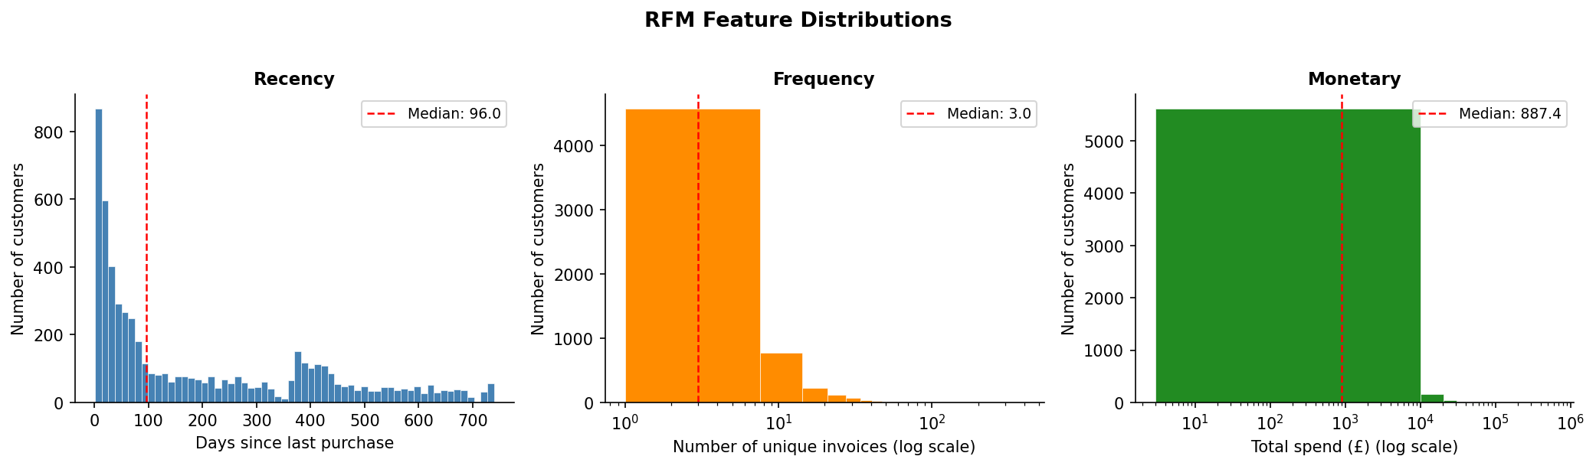
Figure 4.1 Distributions of the RFM features across the 5,878 customers (Frequency and Monetary on logarithmic scales).

4.4 Preprocessing
Preprocessing (FR4) applies the skew-gated transform of Section 2.2.1. Sample skewness (Eq. 2) is computed per feature; the six features exceeding the |γ₁| > 0.5 threshold — Recency (0.89), Frequency (12.64), Monetary (25.34), AvgOrderValue (57.02), AvgInterPurchaseDays (1.45), and DistinctProducts (6.23) — receive log1p (Eq. 3), while Tenure (0.39) is left on its natural scale. All seven features are then standardised to z-scores (Eq. 4) and persisted together with the fitted scaler, so that any future data can be projected into exactly the same space. Figure 4.2 shows the before/after effect: the raw axes are dominated by a handful of extreme customers, while the transformed features are approximately symmetric on a common scale — the correct geometry for the distance- and density-based algorithms that follow.
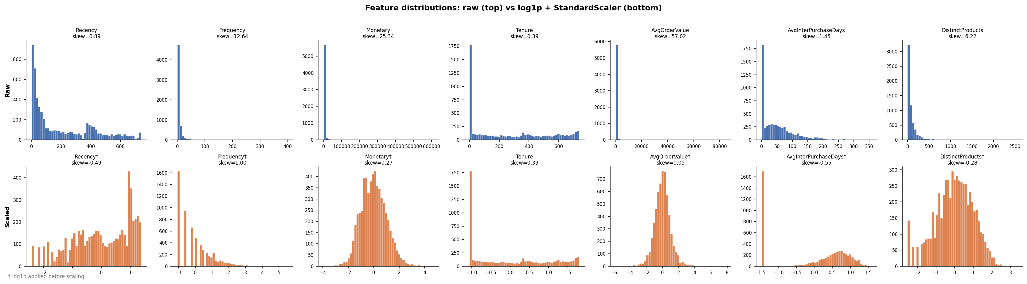
Figure 4.2 Feature distributions before (top) and after (bottom) the log1p + standardisation preprocessing.

4.5 Clustering: Six Algorithms
The clustering stage (FR5) fits all six algorithms of Section 2.2.2 behind a common interface, each with automatic hyper-parameter selection, and writes one cluster-label column per algorithm:
- K-Means (Eq. 5) sweeps k = 2…10. Silhouette analysis (Eq. 7) selects k = 2 (silhouette 0.371, the maximum of the sweep), while geometric knee detection on the inertia curve [10] identifies k = 4 (inertia 15,848 at the bend). This disagreement between two standard heuristics — visible in Figure 4.4 and Table 4.3 — is reported, not hidden: it is precisely why the multi-index validation stage exists.
- DBSCAN reads its radius ε from the knee of the sorted 5-distance plot (Figure 4.6); min_samples = 5.
- GMM (Eq. 6) selects its component count by BIC over 2…10 components, choosing 10 (Figure 4.5) — a warning sign, discussed in Section 5.2, that the likelihood keeps improving as components fragment.
- HDBSCAN uses min_cluster_size = 50 and min_samples = 5 — deliberately requiring segments of at least ~1% of the customer base to be operationally meaningful.
- Agglomerative (Ward linkage) and Spectral (nearest-neighbour affinity graph, 10 neighbours) reuse the K-Means k = 2 for a like-for-like comparison at equal cluster count.
Figure 4.3 projects all six solutions onto the same two principal components (Eq. 11), which retain 76.6% of the variance (PC1 60.8%, PC2 15.9%), allowing direct visual comparison of the partition geometries.
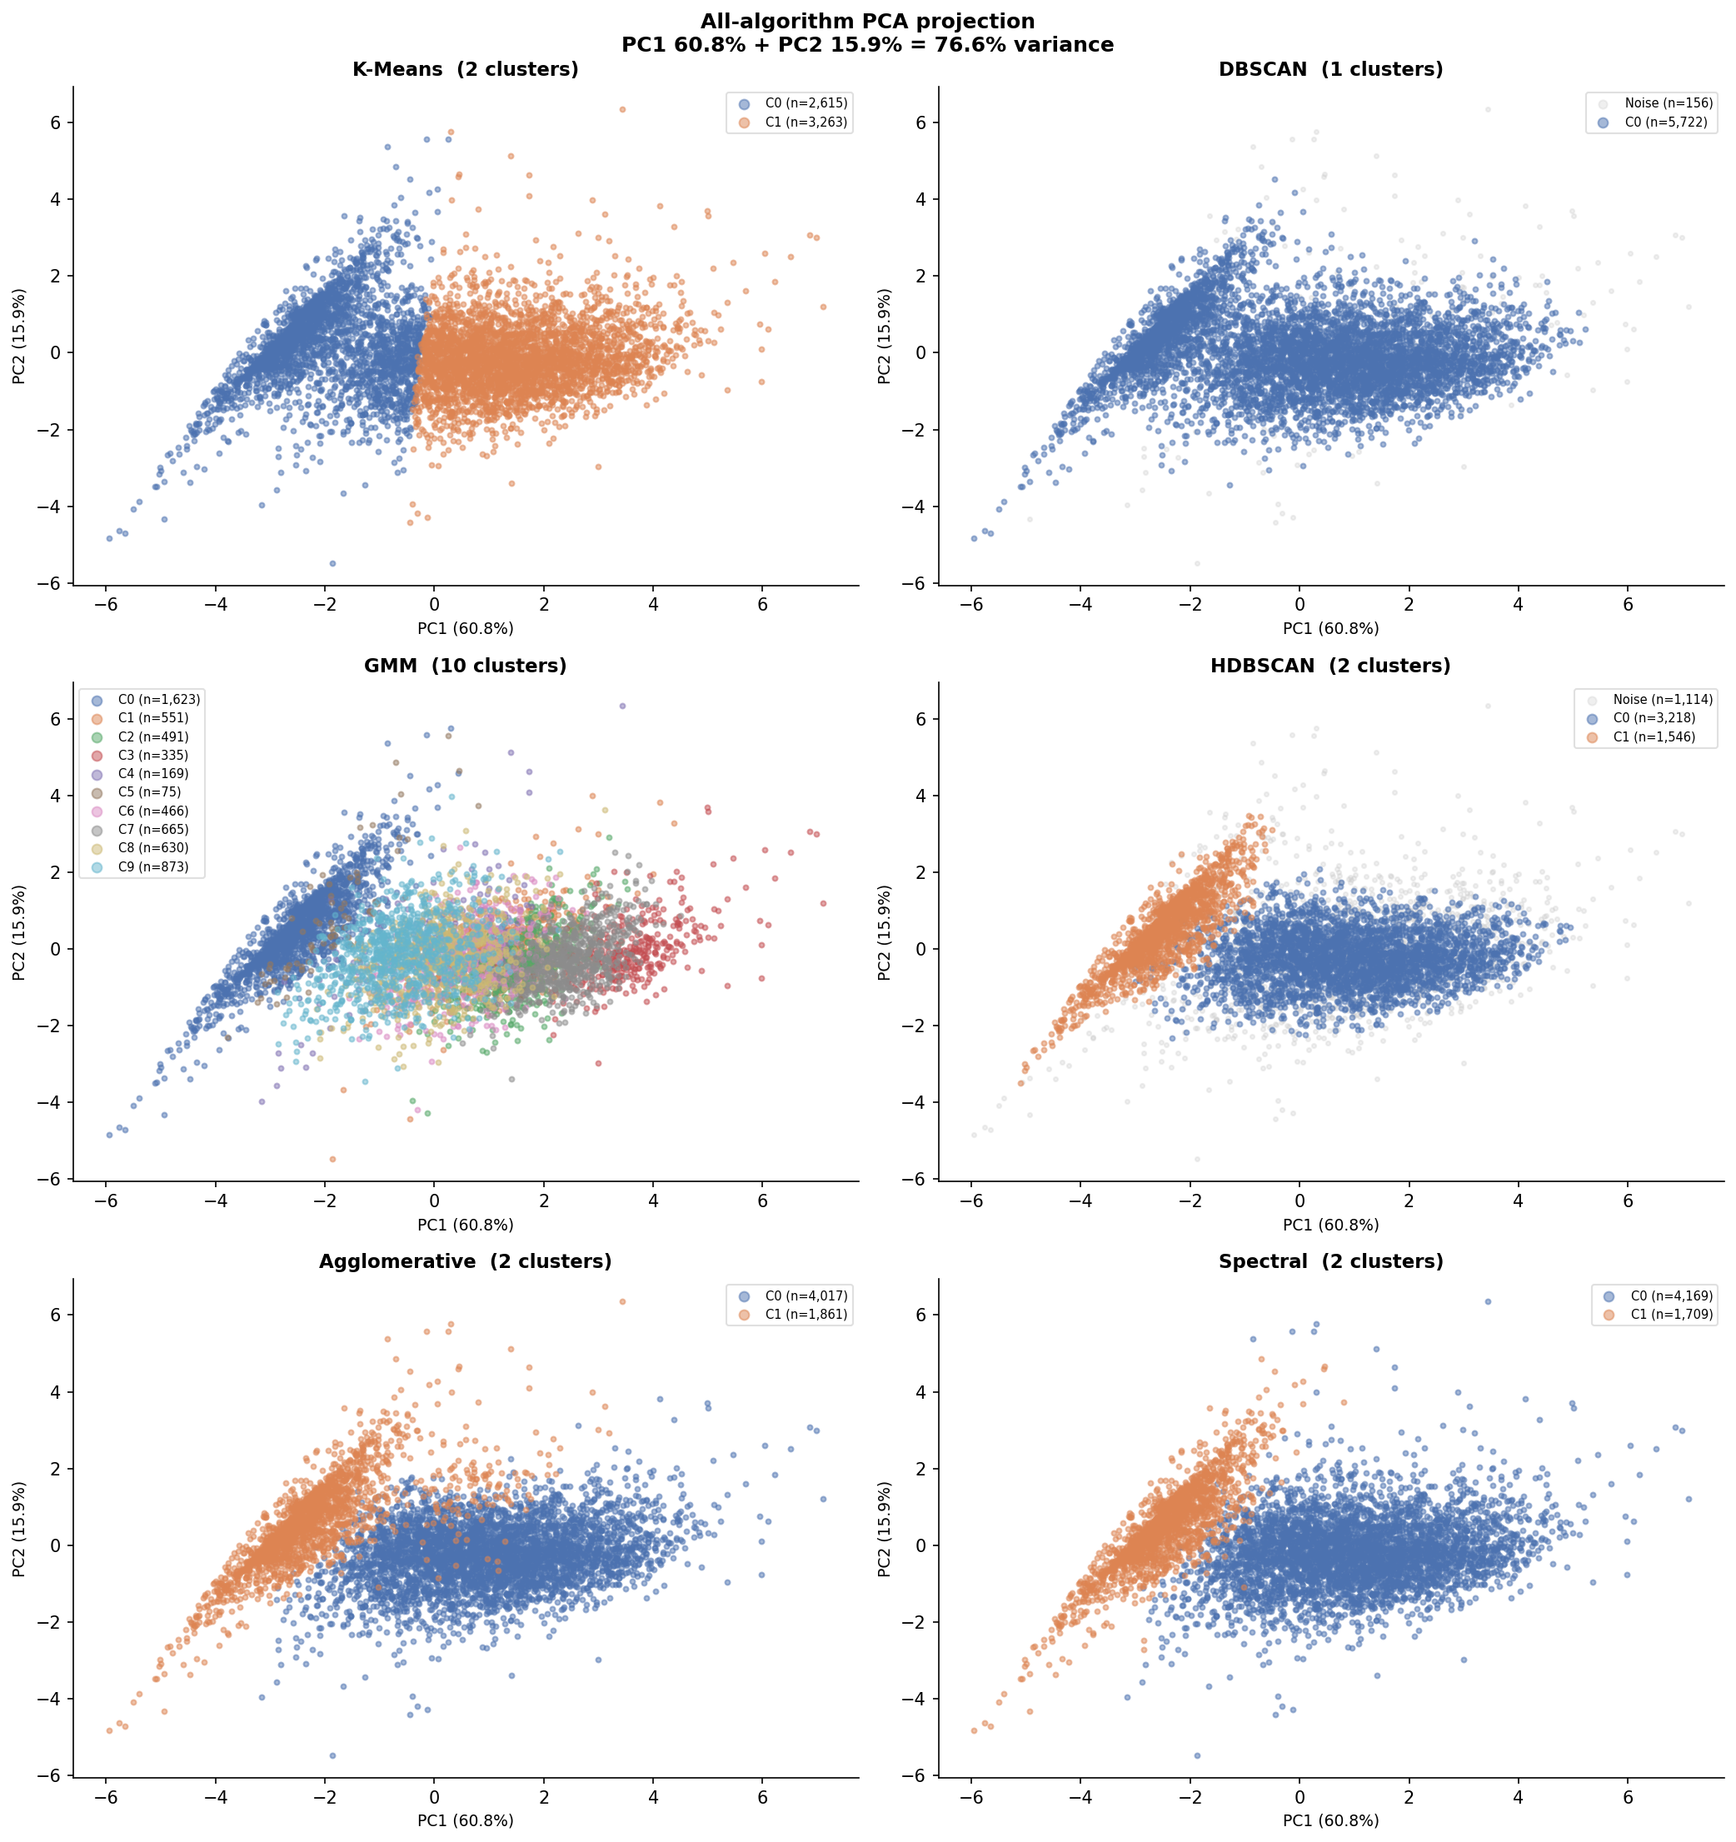
Figure 4.3 PCA projection of all six clustering solutions on identical axes (PC1 + PC2 ≈ 76.6% of variance).
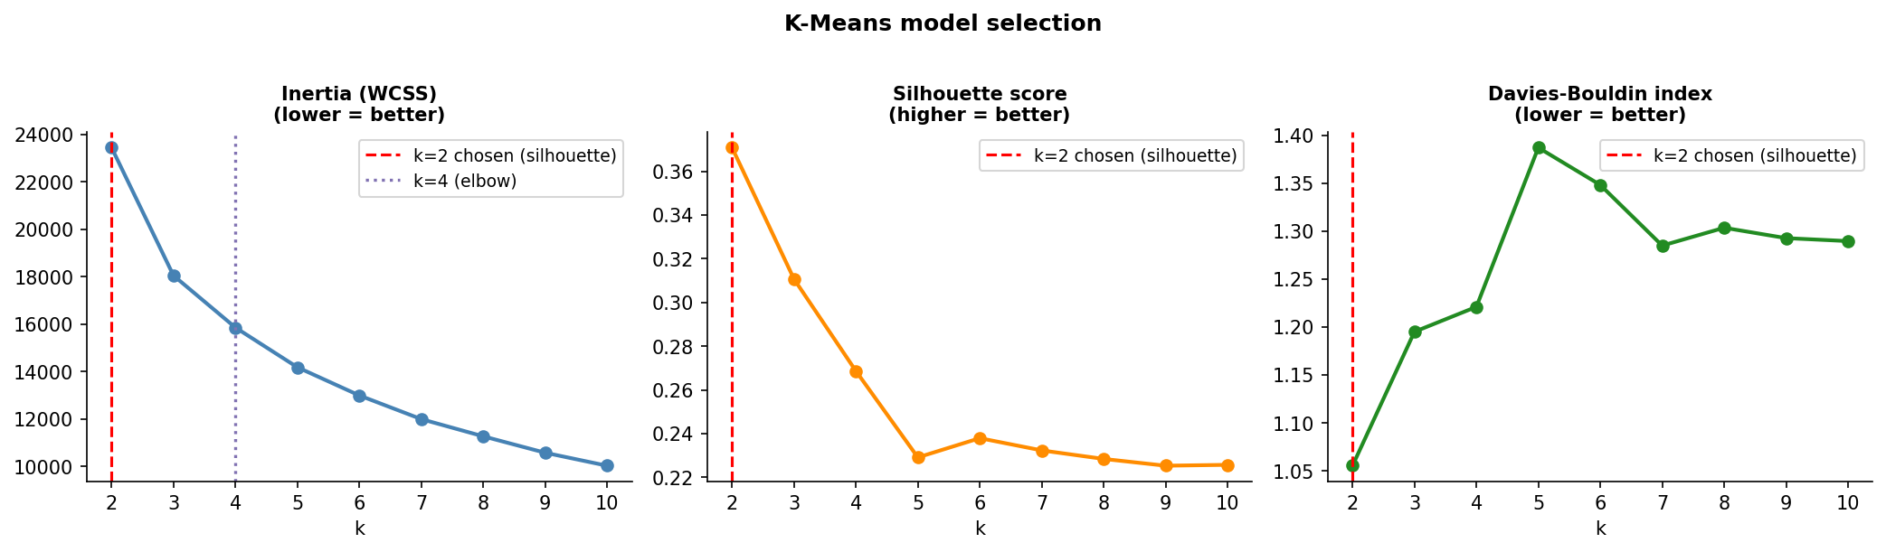
Figure 4.4 K-Means model selection: inertia with the detected elbow (k = 4), silhouette (max at k = 2), and Davies–Bouldin versus k.
Table 4.3 K-Means sweep metrics for k = 2…10: inertia (Eq. 5), silhouette (Eq. 7), and Davies–Bouldin (Eq. 8).
k | inertia | silhouette | davies_bouldin
2 | 2.344e+04 | 0.3708 | 1.055
3 | 1.804e+04 | 0.3107 | 1.195
4 | 1.585e+04 | 0.2686 | 1.221
5 | 1.417e+04 | 0.2291 | 1.387
6 | 1.299e+04 | 0.2379 | 1.348
7 | 1.199e+04 | 0.2323 | 1.285
8 | 1.126e+04 | 0.2284 | 1.304
9 | 1.057e+04 | 0.2253 | 1.293
10 | 1.002e+04 | 0.2257 | 1.29
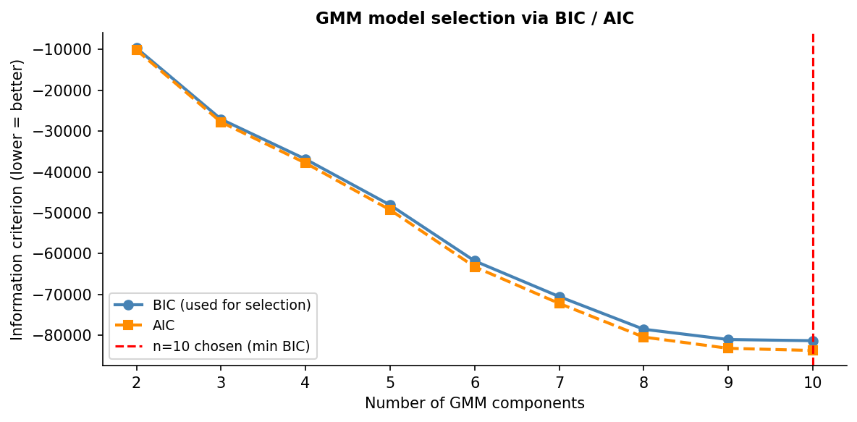
Figure 4.5 GMM model selection by BIC and AIC across component counts.
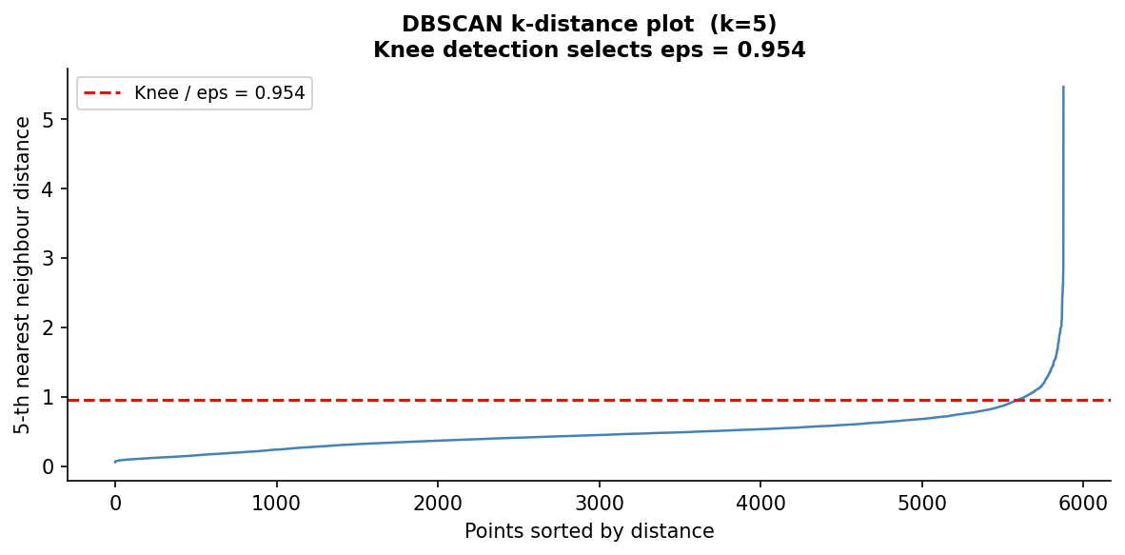
Figure 4.6 DBSCAN k-distance plot; the knee sets the neighbourhood radius ε.

4.6 Cluster Validation, Stability, and Selection
The validation stage (FR6) computes the three internal indices (Eqs. 7–9) for every solution — excluding noise points for the density methods, so that indices measure the quality of the actual clusters — and then measures stability by refitting each algorithm on 50 bootstrap resamples and scoring each refit against the full-data partition with the ARI (Eq. 10):
for algo in {K-Means, DBSCAN, GMM, HDBSCAN, Agglomerative, Spectral}:
labels_full = fit(algo, X) # partition on the full data
for b in 1..50:
idx = resample(1..n, with_replacement, seed=42+b)
lab_b = fit(algo, X[idx]) # same hyper-parameters
ARI_b = adjusted_rand_index(labels_full[idx], lab_b) # Eq. (10)
stability[algo] = mean(ARI_1..ARI_50), std(ARI_1..ARI_50)
The per-metric ranks are averaged into an overall ranking (Table 5.3), and the pre-declared rule of Section 2.3 is applied in code, verbatim:
disqualify any solution with noise_fraction > 0.30
keep solutions with mean bootstrap ARI >= 0.70
among the survivors, select argmax(silhouette)
On this data the rule eliminates DBSCAN (mean ARI ≈ 0, having collapsed to a single cluster) and selects HDBSCAN (noise 18.95% — under the cap; ARI above threshold; silhouette 0.416, the highest of all six). The full quantitative comparison and its interpretation are the subject of Section 5.2.

4.7 Segment Profiling and Naming
Profiling (FR7) translates the selected partition back into business language. Cluster means are computed in original units — pounds and days, not z-scores — and each cluster is named by a deterministic rule tree over its mean Recency, Frequency, and Monetary expressed as multiples of the population mean (for example, a cluster with Frequency = 1, Tenure = 0 and high Recency is named "Lost Customers"). Determinism matters: the same profile always receives the same name, so names are reproducible across runs (NFR1).
HDBSCAN's solution comprises two genuine clusters plus the noise group, profiled in Table 4.4 and visualised in Figures 4.7 and 4.8:
- General Customers (cluster 0; n = 3,218; 54.8%): the mainstream — moderate recency (mean 151 days), frequency ≈ 6.9, spend ≈ £2,422, long tenure (386 days).
- Lost Customers (cluster 1; n = 1,546; 26.3%): a sharply defined one-time-buyer group — Frequency exactly 1.0, Tenure exactly 0, high recency (363 days), low spend (£297).
- Noise / Uncategorised (label −1; n = 1,114; 19.0%): not a failure but a finding — the most valuable and most heterogeneous customers (mean spend £8,467, frequency ≈ 12.0, 115 distinct products), too atypical to force into either segment and flagged for individual treatment rather than generic campaigns.
The radar chart deliberately plots each segment's percentile against the full customer population rather than a min–max normalisation across cluster means — with only two genuine clusters, min–max would degenerately force every axis to 0% or 100% and mislead the reader.
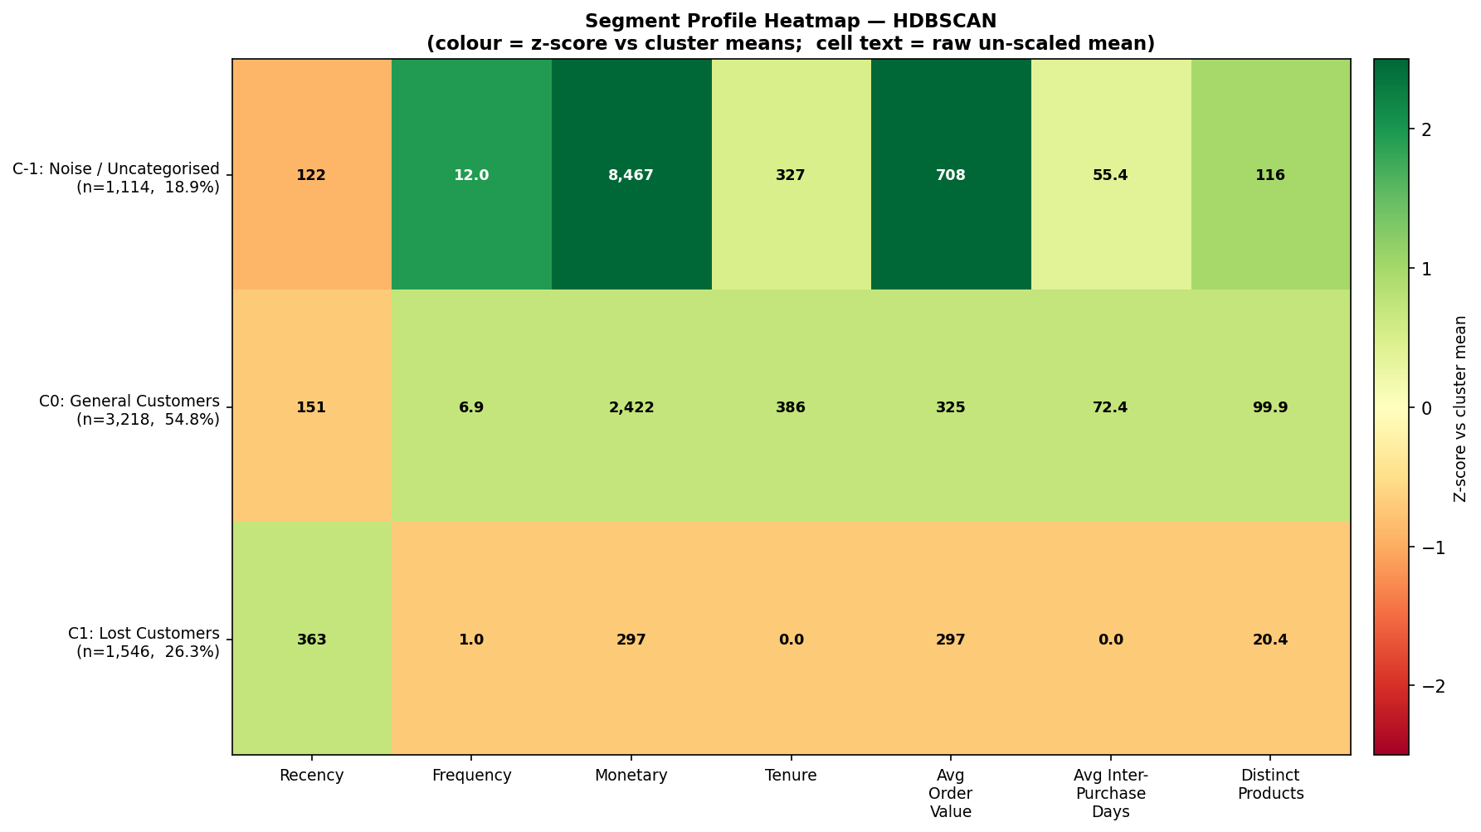
Figure 4.7 Segment-profile heatmap for the selected HDBSCAN solution (colour = z-score versus cluster means; cell text = raw un-scaled means).
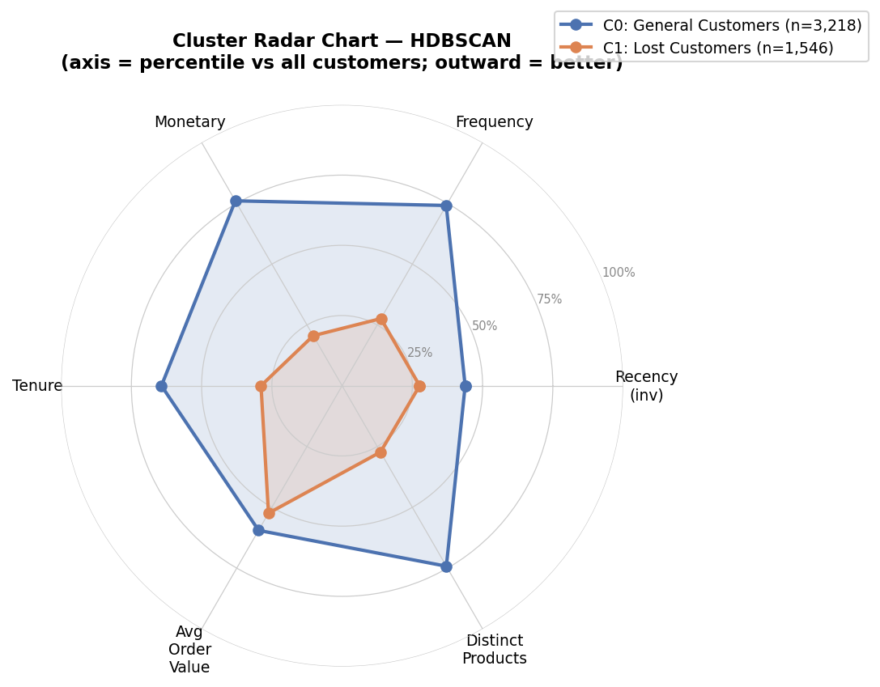
Figure 4.8 Segment radar chart: each axis is the segment's percentile against the full customer population (outward = better).
Table 4.4 HDBSCAN segment profiles: mean features in original units, size, share, and assigned marketing name.
HDBSCAN_Cluster | Recency | Frequency | Monetary | Tenure | AvgOrderValue | AvgInterPurchaseDays | DistinctProducts | size | pct_of_total | segment_name
-1 | 121.6 | 11.98 | 8,467 | 326.6 | 707.6 | 55.42 | 115.9 | 1,114 | 18.95 | Noise / Uncategorised
0 | 151.4 | 6.862 | 2,422 | 385.6 | 324.7 | 72.42 | 99.86 | 3,218 | 54.75 | General Customers
1 | 362.8 | 1 | 297.1 | 0 | 297.1 | 0 | 20.38 | 1,546 | 26.3 | Lost Customers

4.8 Customer Lifetime Value
The CLV stage (FR8) fits the BG/NBD model (Eqs. 12–13) and the Gamma–Gamma model (Eq. 14) on the per-customer frequency / recency / tenure / monetary summary using the lifetimes library, both with a small L2 penaliser (0.001) for numerical stability. The Gamma–Gamma independence assumption is checked before fitting: the correlation between transaction frequency and mean transaction value is near zero on this data, so the model is admissible. A defensive guard clips the model's baseline monetary estimate when the fitted shape parameter q ≤ 1 (where the population mean pν/(q−1) in Eq. 14 is undefined or negative). The stage outputs, per customer: P(alive) (Eq. 12), expected purchases over 90/180/365 days (Eq. 13), expected transaction value (Eq. 14), and the 12-month CLV discounted at 1% per month (Eq. 15).
The results reproduce the classic long tail of retail value: mean CLV £1,418 against a median of £371, a maximum of £323,792, and a total 12-month portfolio value of £8.33 million. Mean P(alive) is 0.909 (median 0.980): most of the retained base is very probably still active, but a decisive minority is not — exactly the signal the notification engine needs. Figure 4.9 shows the CLV distribution and the engagement-versus-retention scatter.
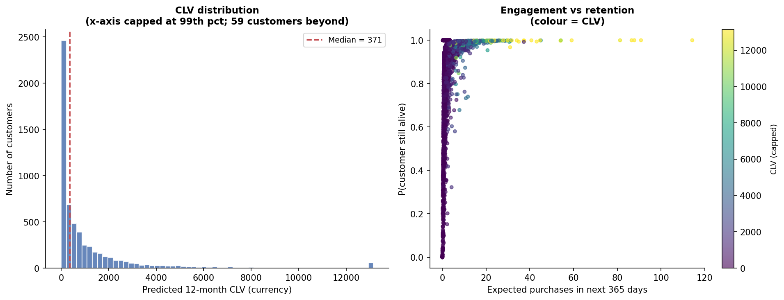
Figure 4.9 CLV distribution (left) and the frequency–recency scatter coloured by CLV (right).
Table 4.5 Summary statistics of the CLV model outputs across all 5,878 customers.
 | clv | prob_alive | exp_avg_value | pred_purchases_90d | pred_purchases_180d | pred_purchases_365d
count | 5,878 | 5,878 | 5,878 | 5,878 | 5,878 | 5,878
mean | 1,418 | 0.9095 | 322.7 | 0.7981 | 1.585 | 3.175
std | 7,731 | 0.1731 | 2,279 | 1.216 | 2.42 | 4.863
min | 0 | 3.3e-10 | 0 | 1.4e-09 | 2.7e-09 | 5.5e-09
25% | 0 | 0.924 | 0 | 0.1741 | 0.3461 | 0.6938
50% | 370.7 | 0.9799 | 217.8 | 0.4563 | 0.9051 | 1.805
75% | 1,224 | 1 | 380.2 | 0.9736 | 1.934 | 3.877
max | 3.238e+05 | 1 | 1.702e+05 | 28.49 | 56.76 | 114.3

4.9 Churn Classification
The churn stage (FR9) implements the design of Section 2.2.6 exactly. The label thresholds Recency at its 90th percentile (Eq. 16) — 535 days on this data — marking 587 customers (10.0%) as churned: a realistic minority class. Because the label is a function of Recency, Recency is excluded from the feature matrix; the models see the six remaining behavioural features. Six classifiers are trained on a stratified 80/20 hold-out split with 5-fold stratified cross-validation: logistic regression (Eq. 18), random forest and decision tree (Gini splits, Eq. 19) with class weighting (Eq. 17), XGBoost with the equivalent scale_pos_weight, gradient boosting, and k-nearest neighbours (k = 15, distance-weighted). Gradient boosting and KNN are deliberately left without imbalance handling — a controlled contrast whose consequences, catastrophic recall collapse despite competitive ROC-AUC, are a substantive finding of the evaluation (Section 5.3). The full model configuration:
Model | Key hyper-parameters | Imbalance handling
LogisticRegression | max_iter = 1000 | class_weight = "balanced" (Eq. 17)
RandomForest | 300 trees, default depth | class_weight = "balanced"
XGBoost | 300 trees, depth 5, lr 0.05, subsample 0.8 | scale_pos_weight = N₀/N₁
GradientBoosting | 200 trees, depth 3, lr 0.1, subsample 0.8 | none (deliberate contrast)
DecisionTree | max_depth = 5 | class_weight = "balanced"
KNN | k = 15, distance-weighted vote | none (deliberate contrast)

All models share the same stratified 80/20 split, the same 5-fold stratified cross-validation, and the same six leakage-guarded features, so every observed difference in Section 5.3 is attributable to the model, not the protocol.
Feature importances from the best tree model (Figure 4.10) rank Tenure (0.370) and AvgInterPurchaseDays (0.219) as the dominant churn signals, ahead of Monetary (0.138) and Frequency (0.131) — an operationally intuitive result: customers who never settled into a stable buying rhythm are the ones most likely to lapse, and the guard against the trivially leaky signal (Recency) forces the models to learn these genuine behavioural precursors.
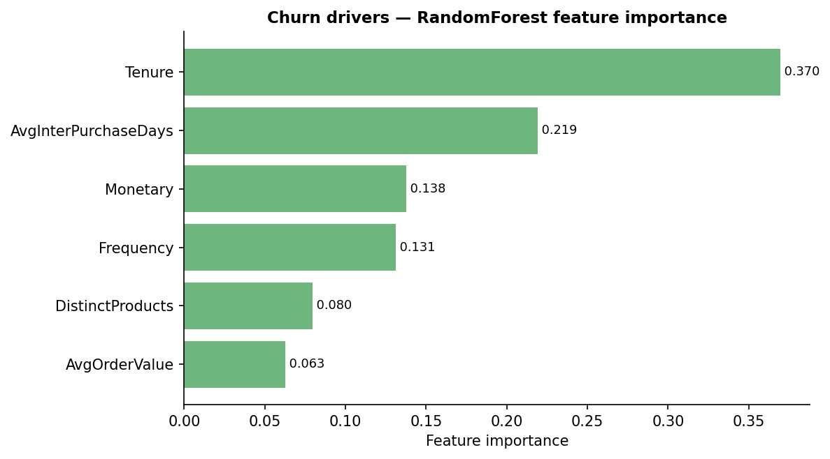
Figure 4.10 Churn feature importances from the best tree model. Recency is absent by design — it defines the label (leakage guard).

4.10 Year-on-Year Segment Migration
The migration stage (FR10) answers a question a single static segmentation cannot: do the segments describe stable behavioural states, and how do customers move between them? Each trading year is segmented independently — RFM is recomputed within the year and the same deterministic naming rules applied — and the two segmentations are joined on Customer ID for the 2,772 customers active in both years. The result is a transition matrix in both raw counts and row-normalised rates (Tables 5.8–5.9, Figure 5.4), analysed in Section 5.5. The design choice to re-segment per year (rather than re-using the global two-year clusters) matters: migration is only meaningful between states defined by the same rules applied to comparable windows.

4.11 Rule-Based Notification Engine
The notification engine (FR11) is where analysis becomes action. It composes three inputs per customer — the HDBSCAN segment name (Section 4.7), a CLV tier, and a churn-risk band — into a concrete campaign instruction, in three steps.
Step 1 — segment playbook. Each segment name maps to a baseline campaign: an action, a channel, an offer, and a base priority (1–5). The full playbook covers all eight names the deterministic naming rules of Section 4.7 can produce (the per-year migration segmentation of Section 4.10 produces the finer-grained names; the global HDBSCAN solution activates three):
Segment | Action | Channel | Base priority
Champions | VIP loyalty reward + early access | Email + App push | 4
Loyal Customers | Cross-sell + loyalty tier upgrade | Email + App push | 3
Big Spenders | Premium product recommendations | Email + Personal outreach | 4
Potential Loyalists | Frequency-building nudge | App push + Email | 3
General Customers | Engagement / category promotion | Email | 2
At Risk | Win-back outreach | Email + SMS | 5
Lost Customers | Reactivation campaign | Email | 2
Noise / Uncategorised | Standard newsletter | Email | 1

The noise entry is deliberately the least aggressive: customers the model cannot place — here, often the highest-value accounts (Section 4.7) — should not be blasted with generic offers.
Step 2 — value and risk modulation. The playbook baseline is then escalated by the customer's own predictions. CLV tiers split at the 80th percentile (High) and 40th percentile (Low) of the CLV distribution; churn bands split at probabilities 0.50 (High) and 0.25 (Medium). High churn risk raises priority by 2 and, for High/Medium-value customers, overrides the action to "Priority retention intervention" on the premium channel mix (Email + SMS + Personal outreach); for Low-value high-risk customers the action becomes "Low-cost automated reactivation" — spend is concentrated where value is at risk. Medium risk raises priority by 1; high value raises it by 1 more; the total is capped at 5:
priority = min( base_priority + 2·[churn High] + 1·[churn Medium] + 1·[CLV High], 5 ) (28)
Step 3 — contact timing. Rather than a fixed campaign drumbeat, the recommended contact day is a fraction (0.6) of the customer's own average inter-purchase interval — reaching them before their natural next-purchase window closes — with a 30-day default for one-time buyers whose cadence is undefined:
contact_days = max( round( 0.6 · AvgInterPurchaseDays ), 1 ) , default 30 if cadence unknown (29)
Applied to the full base, the engine plans campaigns for all 5,878 customers: 3,023 engagement promotions, 1,653 low-cost automated reactivations, 977 standard newsletters, 161 reactivation campaigns, and 64 priority retention interventions — the escalation path is rare by construction, reserved for the customers who are simultaneously valuable and at risk. The engine also exposes recommend(customer_id), which computes the same decision on demand for a single customer; this function powers the dashboard's live lookup page. Table 4.6 shows the head of the persisted plan.
Table 4.6 Per-customer notification plan (first 10 of 5,878 rows): segment, CLV tier, churn band, and the resulting action, channel, offer, priority, and contact timing.
Customer ID | segment | clv | clv_tier | churn_probability | churn_risk | action | channel | offer | priority | recommended_contact_days
15,398 | General Customers | 2,549 | High | 0.5609 | High | Priority retention intervention | Email + SMS + Personal outreach | High-value personalised retention offer | 5 | 19
12,689 | General Customers | 1,977 | High | 0.6201 | High | Priority retention intervention | Email + SMS + Personal outreach | High-value personalised retention offer | 5 | 30
14,418 | General Customers | 4,361 | High | 0.3159 | Medium | Engagement / category promotion | Email | Seasonal category promotion | 4 | 21
13,644 | General Customers | 4,040 | High | 0.2816 | Medium | Engagement / category promotion | Email | Seasonal category promotion | 4 | 13
12,518 | General Customers | 3,717 | High | 0.2978 | Medium | Engagement / category promotion | Email | Seasonal category promotion | 4 | 13
13,994 | General Customers | 3,421 | High | 0.3366 | Medium | Engagement / category promotion | Email | Seasonal category promotion | 4 | 14
15,977 | General Customers | 3,395 | High | 0.3017 | Medium | Engagement / category promotion | Email | Seasonal category promotion | 4 | 6
14,387 | General Customers | 3,065 | High | 0.2565 | Medium | Engagement / category promotion | Email | Seasonal category promotion | 4 | 15
12,646 | Noise / Uncategorised | 2,783 | High | 0.5777 | High | Priority retention intervention | Email + SMS + Personal outreach | High-value personalised retention offer | 4 | 13
13,437 | General Customers | 2,780 | High | 0.3119 | Medium | Engagement / category promotion | Email | Seasonal category promotion | 4 | 15
(Showing first 10 of 5878 rows.)

4.12 Monte Carlo ROI Simulation
The ROI stage (FR12) implements Section 2.2.8. Customers are grouped by planned action; each action carries a documented prior response rate — encoded as the mean of a Beta prior with concentration 150 (Eq. 24) — reflecting the planning judgement that high-touch, tightly targeted interventions respond better than mass sends:
Campaign action | Prior response rate
Priority retention intervention | 0.30
VIP loyalty reward + early access | 0.25
Premium product recommendations | 0.20
Cross-sell + loyalty tier upgrade | 0.15
Win-back outreach | 0.12
Frequency-building nudge | 0.10
Engagement / category promotion | 0.08
Reactivation campaign | 0.05
Low-cost automated reactivation | 0.03
Standard newsletter | 0.02

One simulated world is computed as:
for sim in 1..10,000:
profit = 0
for each action group g: # N_g customers, prior p_g
r_g ~ Beta(p_g * 150, (1 - p_g) * 150) # response-rate uncertainty
k_g ~ Binomial(N_g, r_g) # conversions
m_g ~ Normal(1, 0.20), clipped > 0 # basket-size noise
revenue_g = k_g * AOV_g * margin(30%) * (1 - discount(10%)) * m_g
cost_g = N_g * channel_cost(g) # Email .05 / push .02 / SMS .15 / personal 5.00
profit += revenue_g - cost_g
ROI[sim] = profit / total_cost # Eq. (26)
repeat identically for the static baseline (all 5,878 by email, response 2%)
report mean, median, 95% credible interval, P(ROI > 0), uplift # Eq. (27)
Each of 10,000 simulated worlds draws a response rate per group, conversions from the induced Binomial, and revenue per conversion as the group's mean order value under 30% gross margin and 10% promotional discount, perturbed by multiplicative Gaussian noise (σ = 0.20, clipped positive) (Eq. 25). Costs are deterministic: per-contact channel costs (Email £0.05, App push £0.02, SMS £0.15, personal outreach £5.00) summed over each group's channel mix — a total campaign cost of £623.50. The same machinery simulates the static baseline: every customer contacted once, by email, with one generic offer at a 2% blanket response rate (cost £293.90). Because both plans share the same simulation machinery and noise assumptions, their difference (Eq. 27) is far more robust than either absolute figure — this is the deliberate design of the commercial evaluation, whose results Section 5.7 reports.

4.13 Interactive Dashboard
The dashboard (FR13) is a Streamlit application of eight pages, each reading only persisted artefacts (Section 3.2.2):
Page | What the user sees | Reads
Overview | headline metrics (customers, portfolio CLV, churn rate, campaigns) + pipeline map | features, CLV, churn, plan
Segments | segment sizes, un-scaled profile table, heatmap, radar | segment_profiles + figures
Lifetime Value | CLV distribution, summary statistics | customer_clv, clv_summary
Churn Risk | model comparison table, ROC/PR curves, risk histogram | churn tables + figures
Migration | year-on-year transition heatmap | migration tables + figure
Notifications | the full 5,878-row plan, filterable by segment/risk/priority | notification_plan
ROI Simulation | ROI and profit distributions, full summary | roi_simulation_summary + figure
Customer Lookup | live recommendation for any Customer ID (12346–18287) | recommend() API

Figure 4.11 shows the Overview page with the real headline numbers (5,878 customers; £8,333,122 portfolio CLV; 10.0% churn rate); Figure 4.12 shows the Segments page; Figure 4.13 shows the ROI page with the simulated distributions and the full summary table. The dashboard turns the batch pipeline into a tool a non-technical marketing user can operate: the lookup page in particular answers, for any Customer ID between 12346 and 18287, "what should we send this person, and why?" — with the why fully traceable to the rules of Section 4.11 (NFR5).
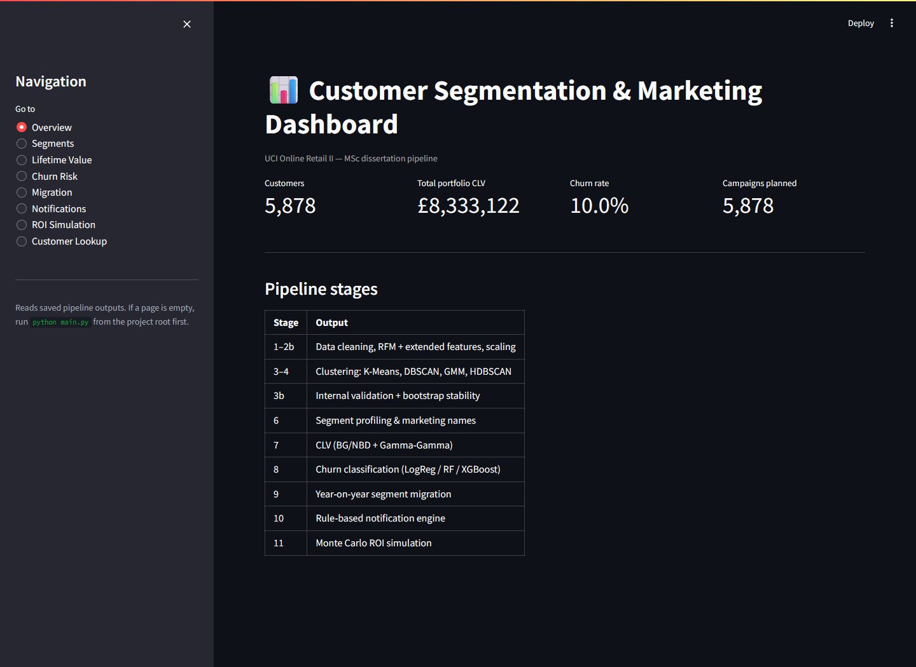
Figure 4.11 Dashboard — Overview page: navigation sidebar, headline metrics (5,878 customers; £8,333,122 portfolio CLV; 10.0% churn rate), and pipeline summary.
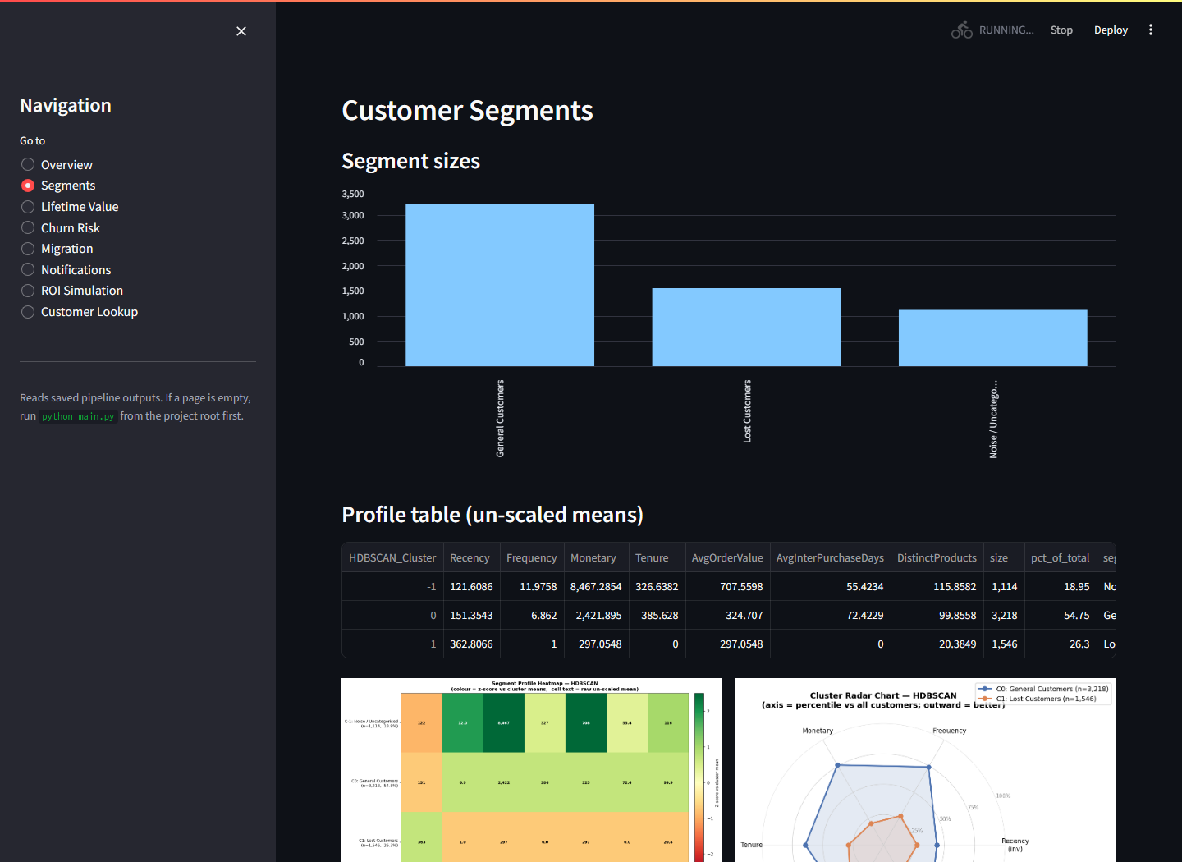
Figure 4.12 Dashboard — Segments page: segment sizes, the un-scaled profile table, and the profile heatmap and radar.
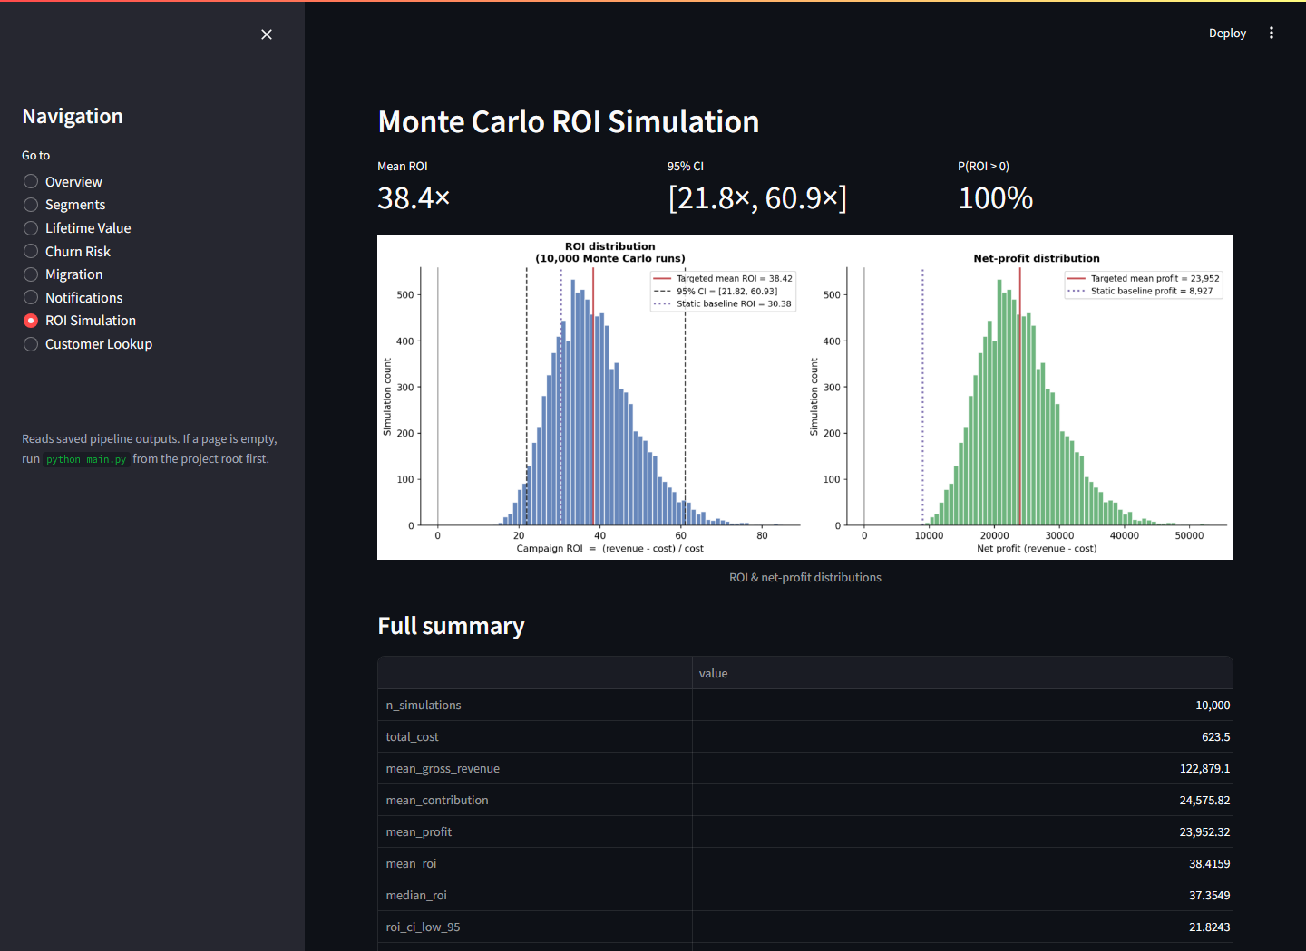
Figure 4.13 Dashboard — ROI Simulation page: headline metrics (mean ROI 38.4×; 95% CI [21.8×, 60.9×]; P(ROI>0) = 100%), the simulated ROI and net-profit distributions with the static baseline overlaid, and the full summary table.

Chapter 5
Software Testing and Evaluation
This chapter first reports the software-testing methodology and its outcome (Section 5.1), then evaluates the system layer by layer against the objectives: the segmentation (5.2), the churn models (5.3), the CLV model (5.4), the migration analysis (5.5), the notification plan (5.6), and the commercial ROI (5.7). Section 5.8 traces every functional requirement to its evidence, and Section 5.9 states the threats to validity.

5.1 Software Testing

5.1.1 Methodology
Testing follows three complementary strands. First, an automated unit-test suite of 20 pytest tests across seven modules exercises the core logic on small synthetic datasets constructed inside the tests themselves — deliberately independent of the raw data file, so the tests are fast, deterministic, and verify logic rather than data (NFR6). Table 5.1 summarises what each module’s tests assert.
Table 5.1 Unit-test suite: modules, test counts, and the logic each verifies (20 tests, all passing; runtime < 3 s).
Test module | Tests | What is verified
test_cleaning.py | 2 | Each cleaning rule removes exactly the intended rows; the audit table records correct counts and order (FR2).
test_features.py | 2 | RFM derivations against hand-computed values on a toy ledger; Frequency counts distinct invoices, not lines (FR3).
test_preprocessing.py | 3 | Skew detection triggers log1p only above threshold (Eq. 2); scaled output has mean ≈ 0, std ≈ 1 (Eq. 4); scaler round-trips (FR4).
test_churn.py | 2 | The label matches the 90th-percentile rule (Eq. 16); Recency is absent from the model feature matrix — the leakage guard holds (FR9).
test_migration.py | 3 | Per-year segmentation joins correctly on Customer ID; transition rates row-normalise to 1 (FR10).
test_notifications.py | 5 | Playbook lookups; priority escalation and its cap (Eq. 28); high-risk/high-value override; low-value path; contact-day rule (Eq. 29) (FR11).
test_roi.py | 3 | Simulation reproducibility under the fixed seed; ROI arithmetic (Eq. 26); static-baseline uplift sign and magnitude (Eq. 27) (FR12).

Second, reproducibility testing (NFR1): the full pipeline was executed repeatedly and the result tables compared byte-for-byte — identical on every run, as guaranteed by the fixed seed and pinned snapshot date. Third, static analysis: the codebase is lint-clean under pyflakes, and dead code identified during development (unused imports, an unused backwards-compatibility alias) was removed rather than suppressed.

5.1.2 Outcome
All 20 tests pass (a 100% pass rate; the suite completes in under three seconds, so it was executed after every change). The end-to-end pipeline completes in ≈160 seconds on commodity CPU hardware (NFR4), and each stage can be re-run in isolation from its persisted inputs (NFR2). Beyond the automated suite, every result table and figure in this report was regenerated from scratch after the final code change — the numbers quoted in Chapters 4 and 5 are the current pipeline output, not survivors of an earlier version.

5.2 Evaluation of the Segmentation

5.2.1 Quantitative comparison
Table 5.2 reports the three internal indices (Eqs. 7–9) for all six algorithms; Table 5.3 the overall ranking after adding bootstrap stability (Eq. 10); Figure 5.1 the stability distributions across the 50 bootstrap resamples.
Table 5.2 Internal validity metrics for all six clustering algorithms (noise excluded from index computation for density methods).
Algorithm | n_clusters | noise_fraction | silhouette | davies_bouldin | calinski_harabasz
K-Means | 2 | 0 | 0.3708 | 1.055 | 4,439
DBSCAN | 1 | 0.0265
GMM | 10 | 0 | 0.0809 | 3.809 | 989.6
HDBSCAN | 2 | 0.1895 | 0.4157 | 0.89 | 4,007
Agglomerative | 2 | 0 | 0.3446 | 1.101 | 3,188
Spectral | 2 | 0 | 0.3658 | 0.9842 | 3,587
Table 5.3 Overall algorithm ranking: per-metric ranks averaged across silhouette, Davies–Bouldin, Calinski–Harabasz, and mean bootstrap ARI.
Algorithm | silhouette_rank | davies_bouldin_rank | calinski_harabasz_rank | ARI_mean_rank | mean_rank | overall_rank
HDBSCAN | 1 | 1 | 2 | 3 | 1.75 | 1
K-Means | 2 | 3 | 1 | 2 | 2 | 2
Spectral | 3 | 2 | 3 | 1 | 2.25 | 3
Agglomerative | 4 | 4 | 4 | 4 | 4 | 4
GMM | 5 | 5 | 5 | 5 | 5 | 5
DBSCAN | 6 | 6 | 6 | 6 | 6 | 6
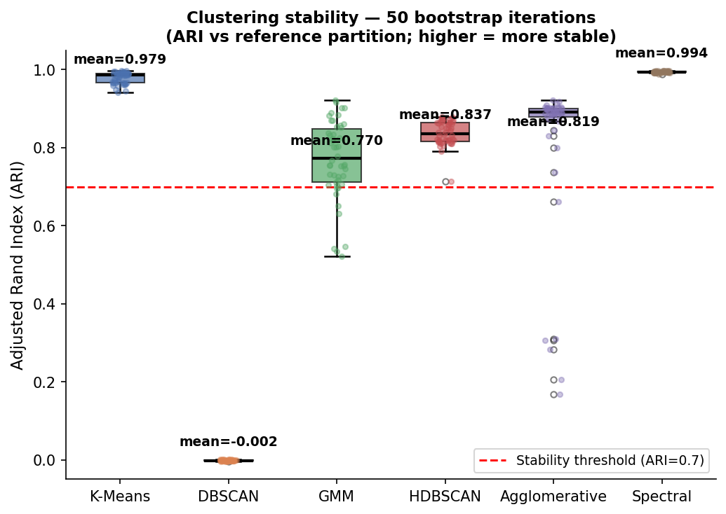
Figure 5.1 Bootstrap stability: distribution of the Adjusted Rand Index across 50 resamples per algorithm.
The ranking places HDBSCAN first (mean rank 1.75), then K-Means (2.00), Spectral (2.25), Agglomerative (4.00), GMM (5.00), and DBSCAN last (6.00, worst on every metric). HDBSCAN achieves the best silhouette (0.416) and best Davies–Bouldin (0.890) precisely because it declines to force genuinely unassignable customers into clusters — 18.95% are labelled noise, under the 30% disqualification cap — and Section 4.7 showed that this noise group is operationally meaningful, not discarded data.

5.2.2 Interpretation of the failures and disagreements
Three negative results are as informative as the winner. DBSCAN failed outright, collapsing to a single cluster with near-zero bootstrap ARI: with one global radius it cannot accommodate this data's smoothly varying density, and the pre-declared ARI ≥ 0.70 rule eliminates it mechanically — the selection framework did its job. GMM over-fragmented, with BIC selecting 10 components whose silhouette is only 0.081 and Davies–Bouldin 3.81: the likelihood-complexity trade-off (Eq. 6) keeps rewarding finer Gaussian mixtures on a distribution that is not a mixture of well-separated Gaussians — a caution against selecting clustering structure by likelihood criteria alone. The K-Means heuristics disagreed (elbow k = 4 vs silhouette k = 2, Section 4.5), confirming that any single selection heuristic is fragile, which is the argument for the multi-index, multi-algorithm validation this project performs. Finally, Spectral clustering was the most stable solution (mean ARI ≈ 0.99) but did not improve separation over K-Means — stability and separation are different qualities, and a defensible selection needs both, which is exactly how the selection rule is ordered.

5.2.3 Relation to prior findings
The outcome is consistent with the comparative literature rather than surprising against it. The no-dominant-algorithm finding of [20], [21], [40] predicts exactly what Tables 5.2–5.3 show: the centroid, hierarchical, and graph families land close together on this data while the density family splits to both extremes (HDBSCAN best, DBSCAN worst), because the decisive dataset property is smoothly varying density with a genuinely unassignable minority — a property HDBSCAN's hierarchy absorbs and DBSCAN's single radius cannot. The segment structure itself echoes Chen et al. [15], who also recover a dominant mainstream group and a sharply-defined lapsed group on this dataset family; the addition here is that the structure arrives with quantified validity, measured stability, and an explicit account of the fifth of the base that fits no segment — the part a marketing team would otherwise have mis-targeted.

5.2.4 Verdict against O3
Objective O3 asked for benchmarked algorithms, principled selection, and validated clusters. The evidence: six algorithms fitted with automatic hyper-parameters (Section 4.5), three validity indices plus 50-round bootstrap stability computed for each (Tables 5.2–5.3), and a pre-declared three-step rule whose application is mechanical and reproducible (Section 4.6). The resulting segmentation is coarse — two clusters plus noise — but honest: on this feature space, that is the structure the evidence supports, and forcing more clusters (as GMM does) demonstrably degrades quality.

5.3 Evaluation of the Churn Models

5.3.1 Quantitative comparison
Table 5.4 reports hold-out and cross-validated metrics with full confusion counts for all six models; Table 5.5 the multi-metric ranking; Figure 5.2 the ROC and precision–recall curves; Table 5.6 the pairwise McNemar p-values (Eq. 23).
Table 5.4 Churn model comparison on the stratified hold-out set: ROC-AUC, PR-AUC, precision, recall, F1 (Eqs. 20–22), 5-fold cross-validated ROC-AUC, and confusion counts.
Model | ROC_AUC | PR_AUC | Precision | Recall | F1 | CV_ROC_AUC_mean | CV_ROC_AUC_std | TN | FP | FN | TP
LogisticRegression | 0.8459 | 0.2795 | 0.2296 | 0.8889 | 0.3649 | 0.8459 | 0.0131 | 710 | 349 | 13 | 104
RandomForest | 0.849 | 0.2874 | 0.2708 | 0.7521 | 0.3982 | 0.8424 | 0.0108 | 822 | 237 | 29 | 88
XGBoost | 0.8469 | 0.2972 | 0.2663 | 0.735 | 0.3909 | 0.8398 | 0.0074 | 822 | 237 | 31 | 86
GradientBoosting | 0.8461 | 0.2851 | 0.2105 | 0.0342 | 0.0588 | 0.8351 | 0.0078 | 1,044 | 15 | 113 | 4
DecisionTree | 0.828 | 0.2544 | 0.2338 | 0.9231 | 0.3731 | 0.8218 | 0.0212 | 705 | 354 | 9 | 108
KNN | 0.807 | 0.2483 | 0.2162 | 0.0684 | 0.1039 | 0.8163 | 0.0154 | 1,030 | 29 | 109 | 8
Table 5.5 Overall churn-model ranking across ROC-AUC, PR-AUC, F1, and cross-validated ROC-AUC.
Model | ROC_AUC_rank | PR_AUC_rank | F1_rank | CV_ROC_AUC_mean_rank | mean_rank | overall_rank
RandomForest | 1 | 2 | 1 | 2 | 1.5 | 1
XGBoost | 2 | 1 | 2 | 3 | 2 | 2
LogisticRegression | 4 | 4 | 4 | 1 | 3.25 | 3
GradientBoosting | 3 | 3 | 6 | 4 | 4 | 4
DecisionTree | 5 | 5 | 3 | 5 | 4.5 | 5
KNN | 6 | 6 | 5 | 6 | 5.75 | 6
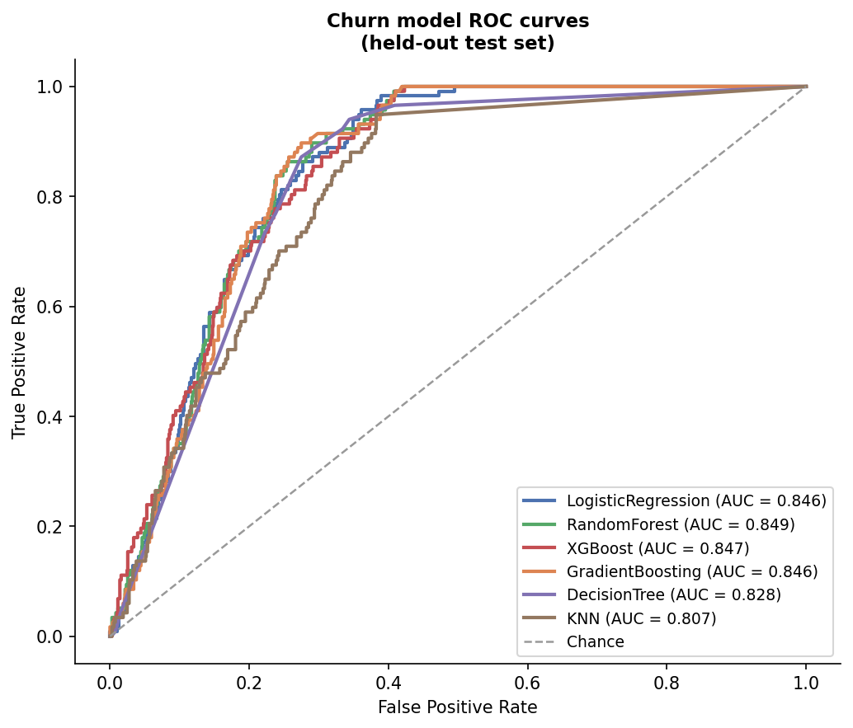
Figure 5.2a ROC curves for the six churn models.
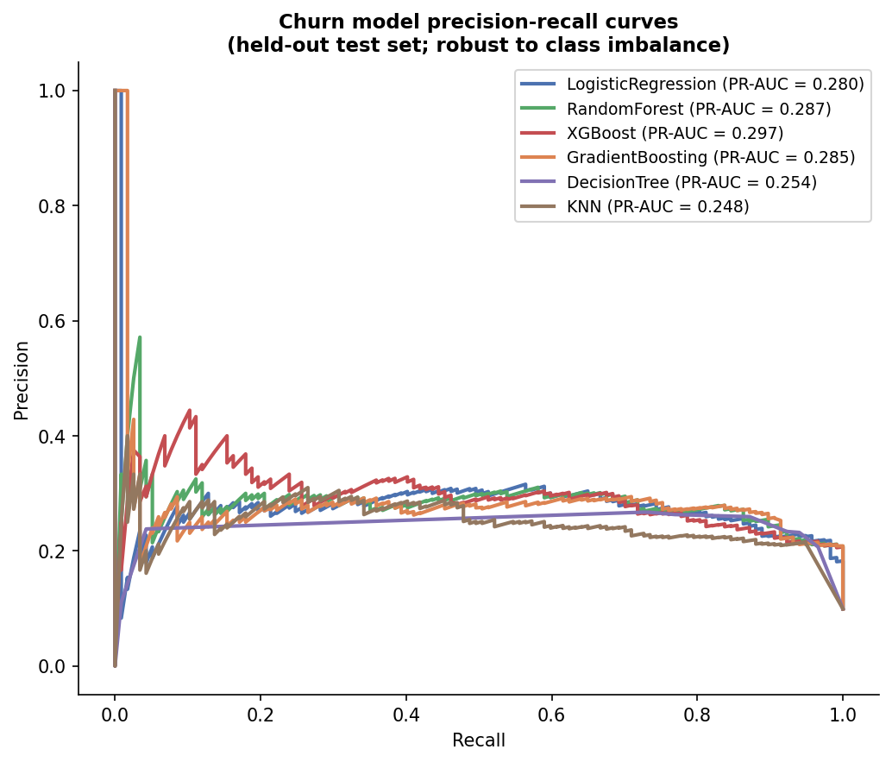
Figure 5.2b Precision–recall curves for the six churn models — the more discriminating view under 10% class imbalance.
Table 5.6 Pairwise McNemar exact p-values between the six churn models (Eq. 23). Values above 0.05 mean the two models are statistically indistinguishable on this test set.
 | LogisticRegression | RandomForest | XGBoost | GradientBoosting | DecisionTree | KNN
LogisticRegression | 1 | 6.1e-18 | 2.1e-15 | 2.2e-30 | 1 | 3.1e-29
RandomForest | 6.1e-18 | 1 | 0.8776 | 1.6e-15 | 2.7e-17 | 2.7e-14
XGBoost | 2.1e-15 | 0.8776 | 1 | 5.9e-16 | 2.1e-15 | 8.1e-15
GradientBoosting | 2.2e-30 | 1.6e-15 | 5.9e-16 | 1 | 4.0e-30 | 0.1539
DecisionTree | 1 | 2.7e-17 | 2.1e-15 | 4.0e-30 | 1 | 7.6e-29
KNN | 3.1e-29 | 2.7e-14 | 8.1e-15 | 0.1539 | 7.6e-29 | 1

5.3.2 Findings
The headline is honest. The best model, Random Forest, reaches ROC-AUC 0.849 (CV mean 0.842 ± 0.011) with recall 0.752 and precision 0.271. A value near 1.0 would have been a red flag for leakage; 0.85 with the defining feature excluded is a credible ceiling for six behavioural features, and the tight cross-validation spread shows it is not a lucky split.
The two best models are statistically tied. Random Forest edges XGBoost on the ranking (Table 5.5), but McNemar's exact test gives p = 0.878 for that pair (Table 5.6): their disagreements on the test set are symmetric noise, not systematic superiority. A naive "Random Forest wins" claim would overstate the evidence — the defensible statement, and the one this project makes, is that either ensemble is an acceptable deployment choice.
ROC-AUC alone would have misled. Gradient Boosting posts a competitive ROC-AUC of 0.846 — and a recall of 0.034: at the default threshold it identifies just 4 of 117 hold-out churners (TP = 4, FN = 113). KNN behaves the same way (recall 0.068). Both were deliberately left without imbalance handling (Section 4.9), and both collapse to near-trivial predictors in exactly the way Section 2.1.4 warned; their McNemar row (p ≈ 0.15 against each other, p < 10⁻¹³ against every properly weighted model) confirms the failure is systematic. The class-weighted models — logistic regression (recall 0.889), decision tree (0.923), random forest (0.752), XGBoost (0.735) — all retain useful recall. This contrast, engineered into the experiment, is the project's clearest demonstration that metric choice and imbalance handling are not bureaucratic details but the difference between a usable and a useless churn model.
The models learn sensible behaviour. With Recency barred, importance concentrates on Tenure (0.370) and purchase cadence (0.219) (Figure 4.10): short-tenure, irregular customers churn. This is actionable — it says which behavioural precursors the retention campaigns of Section 4.11 should watch.
Error analysis in marketing terms. The confusion counts of Table 5.4 translate directly into campaign economics (the asymmetry argued in Section 2.1.4). Random Forest's hold-out errors are 237 false positives and 29 false negatives. The 237 false positives each cost, at worst, one unnecessary retention contact — pennies to a few pounds under the channel costs of Section 4.12. The 29 false negatives are silently departing customers; at the median CLV of £371 (let alone the £1,418 mean), a single missed churner can outweigh dozens of wasted contacts. Logistic regression pushes the same trade further (349 FP, 13 FN; recall 0.889), which is why it remains competitive on the ranking despite the lowest precision: under this cost structure, recall-heavy operating points are the economically rational ones, and the degenerate models (Gradient Boosting: 15 FP, 113 FN) are the expensive ones however clean their ROC curves look.
Robustness to the label threshold. Because the churn label is a proxy defined at the 90th Recency percentile (Section 4.9), the entire six-model comparison was repeated with the threshold moved to the 85th and the 95th percentiles — the label rebuilt, every model retrained, and the same stratified hold-out rescored (Table 5.7). The conclusions survive both moves. Held-out ROC-AUC stays within 0.78–0.85 for every model at every threshold, and the top of the ranking remains the class-weighted ensembles and logistic regression, whose differences stay inside the noise band the McNemar analysis established at the 90th percentile. What does change is the operating regime: as the positive class shrinks from 15% to 5% of the base, PR-AUC falls for every model — the expected arithmetic of rarer positives, not a property of any classifier. The modelling conclusions are therefore not an artefact of one labelling choice; the deployed threshold should be chosen against campaign economics, and Section 5.9 records the proxy nature of the label as a residual limitation.
Table 5.7 Sensitivity to the churn-label threshold: held-out ROC-AUC for each model when the label is redefined at the 85th, 90th, and 95th Recency percentiles (churn rates 15%, 10%, 5%; thresholds 449, 535, 625 days).
Model | P85 (15% churn) | P90 (10% churn) | P95 (5% churn)
Logistic Regression | 0.834 | 0.846 | 0.839
Random Forest | 0.838 | 0.849 | 0.827
XGBoost | 0.828 | 0.847 | 0.832
Gradient Boosting | 0.828 | 0.845 | 0.821
Decision Tree | 0.825 | 0.828 | 0.813
KNN | 0.779 | 0.808 | 0.794

5.3.3 Verdict against O4 (churn half)
Six classifiers trained and compared under a strict leakage guard, imbalance handling where intended, threshold-aware metrics, cross-validation, and formal significance testing: O4's churn requirement is met, with the statistical tie honestly reported rather than resolved by decree.

5.4 Evaluation of the CLV Model
The BG/NBD + Gamma–Gamma fit (Section 4.8) passes its admissibility diagnostic (near-zero frequency–value correlation) and produces the expected long-tailed value structure: median CLV £371 against mean £1,418; the top decile of customers holds a disproportionate share of the £8.33M portfolio value. P(alive) (Eq. 12) is high for most of the base (median 0.980) with a decisive at-risk minority — mean 0.909 — and the expected-purchase forecasts scale consistently across the 90/180/365-day horizons (means 0.80, 1.58, 3.17 purchases). Their role in the system is as relative value and activity rankings feeding the tiering of Section 4.11, for which the long-tail shape and stable ordering are the properties that matter, and both hold.
Temporal validation on a one-year holdout. The purchasing half of the model was additionally validated out-of-sample with the standard Fader–Hardie calibration/holdout procedure [17]: the transaction history was split at 9 December 2010, BG/NBD was refitted on the first trading year alone (4,311 customers active in that window), and its forecast of each customer’s purchase count over the entirely unseen second year was compared with what those customers actually did. (The shorter calibration window required care in fitting: small L2 penalties drove the dropout parameters to a degenerate boundary, so the reported fit is the cleanly converged unpenalized one; the fitting ladder and its diagnostics are implemented and logged in src/clv_validation.py.) The result validates the model for exactly the role it plays, and qualifies it for the role it does not. Per-customer discrimination is strong: predicted and actual holdout purchase counts correlate at r = 0.83 (MAE 2.51 purchases against a holdout mean of 2.86), and the left panel of Figure 5.3 shows the classic conditional-expectation check — mean actual holdout purchases rise monotonically with calibration-period frequency exactly as the model orders them, reproducing on this dataset the qualitative result of [17]. Absolute calibration is weaker: the model over-forecasts total holdout purchases by 52.9% (18,823 predicted against 12,315 actual), visible in Figure 5.3 as the predicted curve sitting uniformly above the actual (left) and every decile of the reliability panel falling below the diagonal (right); the excess traces to the fitted dropout process, which under-estimates year-2 attrition. The two-sided conclusion is deliberate: the CLV layer is validated as a ranking instrument — which is precisely how the tiering of Section 4.11 consumes it — while its absolute currency forecasts should be read as optimistic upper bounds, a caveat now recorded in Section 5.9.
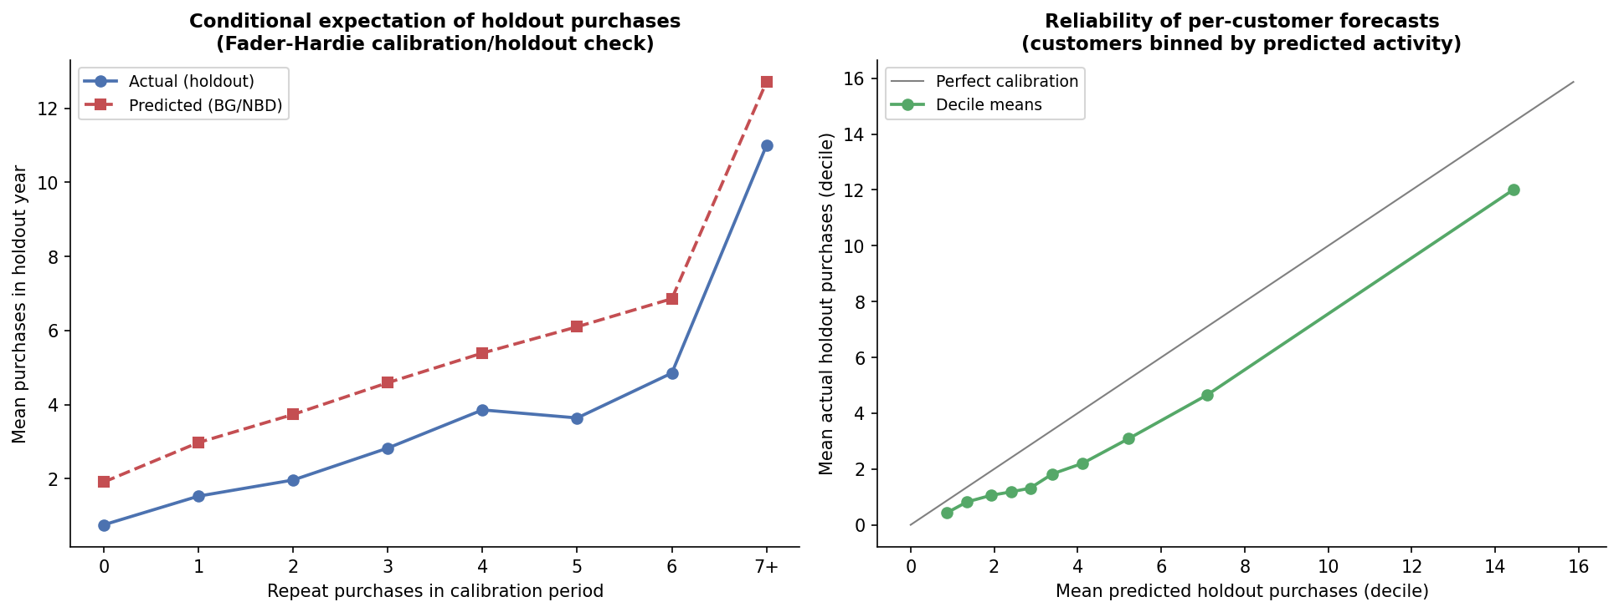
Figure 5.3 Temporal validation of the BG/NBD purchase model on a one-year holdout. Left: mean actual versus predicted holdout purchases grouped by calibration-period frequency (the Fader–Hardie conditional-expectation check) — the ordering is reproduced, with a uniform upward bias. Right: decile-level reliability of the per-customer forecasts — strongly monotone, consistently below the perfect-calibration diagonal.

5.5 Evaluation of the Migration Analysis
For the 2,772 customers active in both trading years, Tables 5.8–5.9 and Figure 5.4 give the year-1 → year-2 transition structure. Three patterns validate that the segments describe real, persistent behavioural states rather than noise. Champions are sticky: 61.7% of year-1 Champions remain Champions in year 2 — the strongest diagonal in the matrix. General Customers act as a gravity well: 45.3% remain, and every other segment leaks into it, which is exactly what a mainstream behavioural state should look like. Loss is persistent: 43.4% of year-1 Lost Customers remain Lost, and the At Risk segment feeds Lost at 30.0% — the decay path the retention interventions of Section 4.11 exist to interrupt. That the matrix is strongly diagonal without the segmentation being trained on year-to-year consistency is independent evidence for the behavioural reality of the segments (O3), and the migration view itself discharges FR10.
Table 5.8 Year-1 → year-2 segment migration: raw customer counts (2,772 customers active in both years).
segment_y1 | Champions | Loyal Customers | Big Spenders | Potential Loyalists | General Customers | At Risk | Lost Customers
Champions | 222 | 37 | 11 | 8 | 66 | 3 | 13
Loyal Customers | 40 | 36 | 4 | 27 | 69 | 4 | 16
Big Spenders | 9 | 3 | 5 | 3 | 6 | 0 | 4
Potential Loyalists | 18 | 20 | 3 | 316 | 237 | 12 | 230
General Customers | 48 | 50 | 4 | 213 | 443 | 23 | 197
At Risk | 1 | 0 | 1 | 12 | 14 | 0 | 12
Lost Customers | 5 | 4 | 0 | 105 | 73 | 1 | 144
Table 5.9 Year-1 → year-2 segment migration: row-normalised transition rates.
segment_y1 | Champions | Loyal Customers | Big Spenders | Potential Loyalists | General Customers | At Risk | Lost Customers
Champions | 0.6167 | 0.1028 | 0.0306 | 0.0222 | 0.1833 | 0.0083 | 0.0361
Loyal Customers | 0.2041 | 0.1837 | 0.0204 | 0.1378 | 0.352 | 0.0204 | 0.0816
Big Spenders | 0.3 | 0.1 | 0.1667 | 0.1 | 0.2 | 0 | 0.1333
Potential Loyalists | 0.0215 | 0.0239 | 0.0036 | 0.378 | 0.2835 | 0.0144 | 0.2751
General Customers | 0.0491 | 0.0511 | 0.0041 | 0.2178 | 0.453 | 0.0235 | 0.2014
At Risk | 0.025 | 0 | 0.025 | 0.3 | 0.35 | 0 | 0.3
Lost Customers | 0.0151 | 0.012 | 0 | 0.3163 | 0.2199 | 0.003 | 0.4337
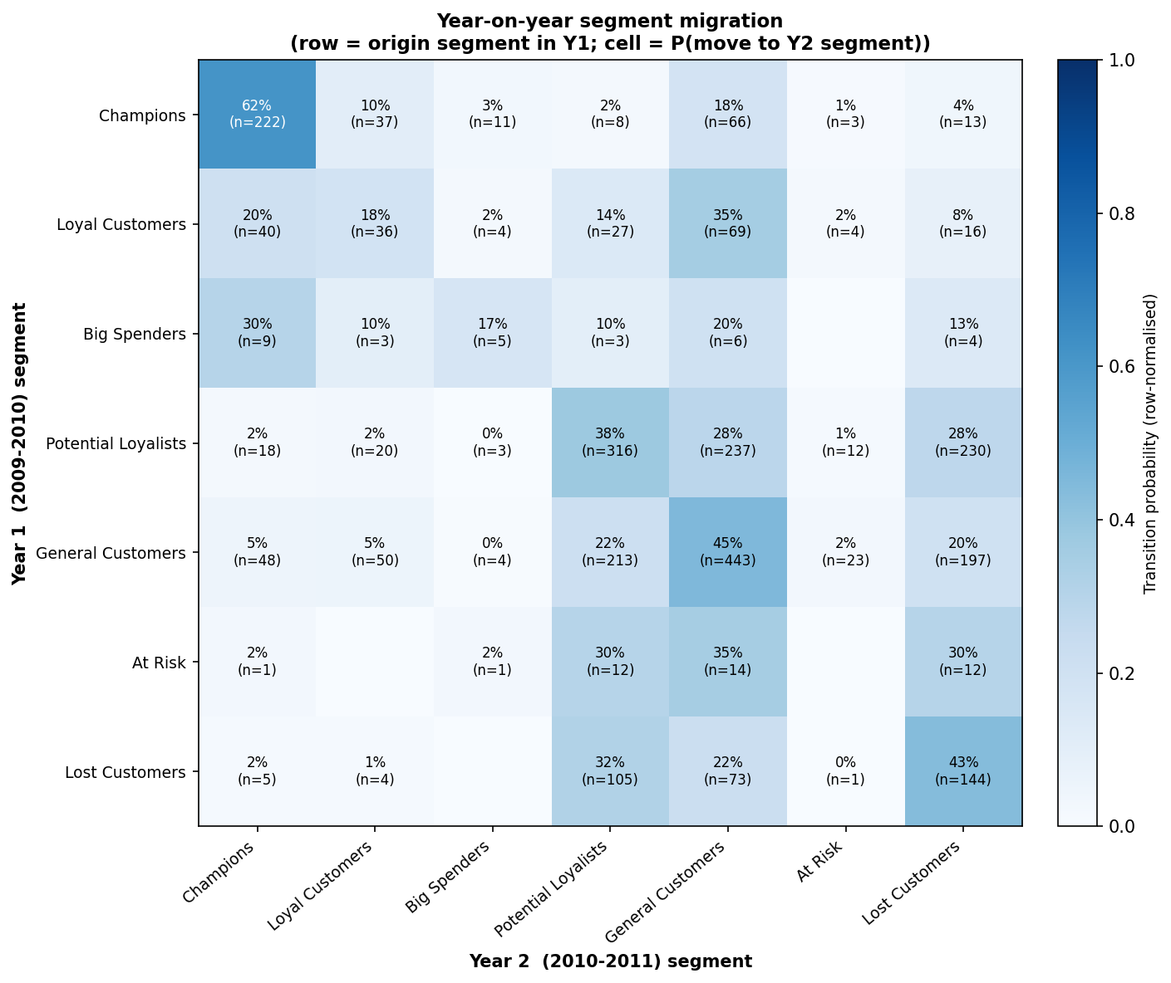
Figure 5.4 Segment migration heatmap between the two trading years.

5.6 Evaluation of the Notification Plan
The engine plans a campaign for every one of the 5,878 customers, and the shape of the plan is its evaluation: it must concentrate expensive attention narrowly and cheap attention broadly. It does. The action distribution runs from 3,023 low-cost engagement promotions down to exactly 64 priority retention interventions (1.1% of the base) — the only action carrying the expensive channel mix (Email + SMS + personal outreach; the remaining 5,814 customers are contacted by email alone). Priorities stack sensibly: 443 customers at priority 1, 2,413 at 2, 1,400 at 3, 1,620 at 4, and only 2 at the capped maximum of 5. The value and risk tiers driving these decisions split the base into 1,176 High / 2,351 Medium / 2,351 Low value, and 1,717 High / 707 Medium / 3,454 Low churn risk. Cross-checking the engine's logic end-to-end (also covered by five unit tests, Section 5.1): the 64 intervention recipients are exactly the High/Medium-value customers in the High churn band after segment-playbook modulation — the auditable trace that NFR5 demands. On-demand lookups through recommend(customer_id) return the identical decision for any single customer, satisfying FR11's API requirement and powering the dashboard lookup page (Figure 4.11 ff.). The dashboard delivery layer has so far been assessed technically — it renders the persisted artefacts faithfully and its live lookup agrees with the engine’s batch output; a structured protocol for expert heuristic evaluation against Nielsen’s usability heuristics [43] is provided in Appendix C, with a practitioner study noted as future work (Section 6.2).

5.7 Evaluation of the Commercial ROI
Table 5.10 and Figure 5.5 report the Monte Carlo results (10,000 iterations). The targeted plan costs £623.50 to contact all 5,878 customers and yields a mean simulated profit of £23,952 — a mean ROI of 38.4× (median 37.4×), with a 95% credible interval of [21.8×, 60.9×] and a positive return in 100% of simulated worlds. The static blanket baseline — the same 5,878 customers, one generic email, 2% response — costs £293.90 and yields £8,927 mean profit (ROI 30.4×). The targeted plan therefore delivers a profit uplift of +£15,025, or +168.3%, for roughly double the (tiny) contact cost. Three properties make this a defensible business case rather than a cherry-picked number: the result is a full distribution, not a point estimate; the headline is the uplift, which is robust to the shared planning assumptions in a way the absolute ROI is not (both plans use the same margin, noise, and cost model, so assumption errors largely cancel in the difference); and every input assumption — response priors from 2% to 30%, margin 30%, discount 10%, per-channel costs — is documented in one configuration module and can be varied by a sceptical reader. This discharges O6 and FR12.
Table 5.10 Monte Carlo ROI summary (10,000 iterations), including the static-baseline comparison and uplift (Eqs. 24–27).
 | value
n_simulations | 10,000
total_cost | 623.5
mean_gross_revenue | 1.229e+05
mean_contribution | 2.458e+04
mean_profit | 2.395e+04
mean_roi | 38.42
median_roi | 37.35
roi_ci_low_95 | 21.82
roi_ci_high_95 | 60.93
prob_positive_roi | 1
prob_roi_gt_1 | 1
static_total_cost | 293.9
static_mean_profit | 8,927
static_mean_roi | 30.38
roi_uplift_vs_static | 8.041
profit_uplift_vs_static | 1.503e+04
profit_uplift_pct_vs_static | 168.3
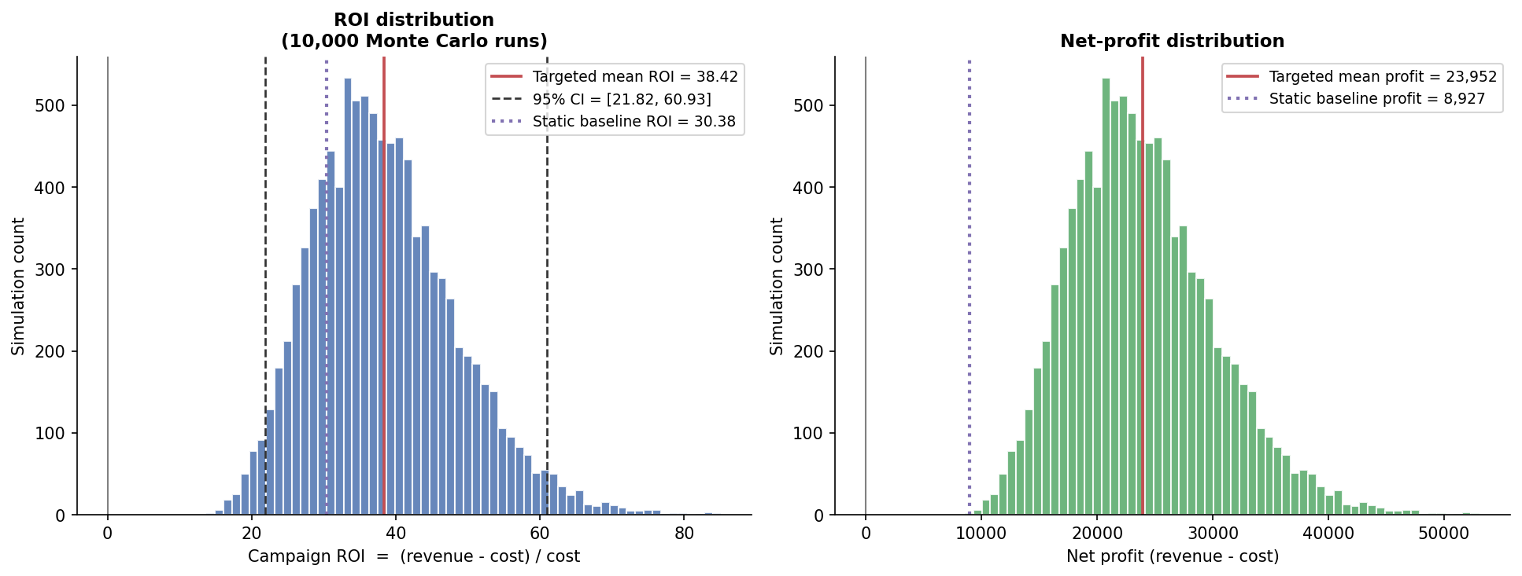
Figure 5.5 Simulated ROI (left) and net-profit (right) distributions for the targeted plan, with the static blanket baseline overlaid.
Sensitivity of the uplift to the planning assumptions. The business case rests on documented assumptions, so each was deliberately stressed and the full 10,000-run simulation repeated for both plans under every perturbation (Table 5.11, Figure 5.6). The uplift survives every single-assumption attack. Halving all targeted response priors while leaving the blanket baseline untouched — the most conservative single move available — still leaves a positive mean uplift (+£2,739; P(uplift > 0) = 0.69). Doubling the baseline’s response rate to 4%, doubling or even quintupling every channel cost, cutting gross margin to 20%, and deepening the offer discount to 15% leave the mean uplift between +£5,889 and +£14,695 with P(uplift > 0) ≥ 0.74. Only the compound worst case — all five pessimistic moves imposed simultaneously — turns the mean uplift negative (−£2,176), and even there the targeted plan itself remains profitable in absolute terms (mean ROI 1.5×; P(ROI > 0) = 0.99). The honest reading is therefore not that targeting is unconditionally superior, but that reversing the conclusion requires every planning assumption to be wrong, in the plan’s disfavour, at the same time. The absolute ROI figures scale with the assumptions; the sign of the uplift is what survives them — which is exactly why Section 4.12 designed the evaluation around the difference between two identically simulated plans.
Table 5.11 ROI sensitivity: mean ROI of both plans, mean profit uplift, and P(uplift > 0) under each perturbed-assumption scenario (10,000 Monte Carlo runs per scenario).
Scenario | Targeted mean ROI | Static mean ROI | Mean profit uplift (£) | P(uplift > 0)
Baseline (as reported) | 38.4× | 30.4× | +15,025 | 0.962
Response priors ×0.5 | 18.7× | 30.4× | +2,739 | 0.694
Response priors ×0.75 | 28.5× | 30.4× | +8,809 | 0.884
Response priors ×1.5 | 58.2× | 30.4× | +27,357 | 0.995
Static response ×2 (4%) | 38.4× | 61.5× | +5,889 | 0.738
Channel costs ×2 | 18.7× | 14.7× | +14,695 | 0.960
Channel costs ×5 | 6.9× | 5.3× | +13,707 | 0.949
Gross margin 30% → 20% | 18.7× | 14.7× | +7,348 | 0.960
Offer discount 10% → 15% | 28.6× | 22.5× | +11,186 | 0.961
Worst case (all pessimistic) | 1.5× | 6.8× | −2,176 | 0.046

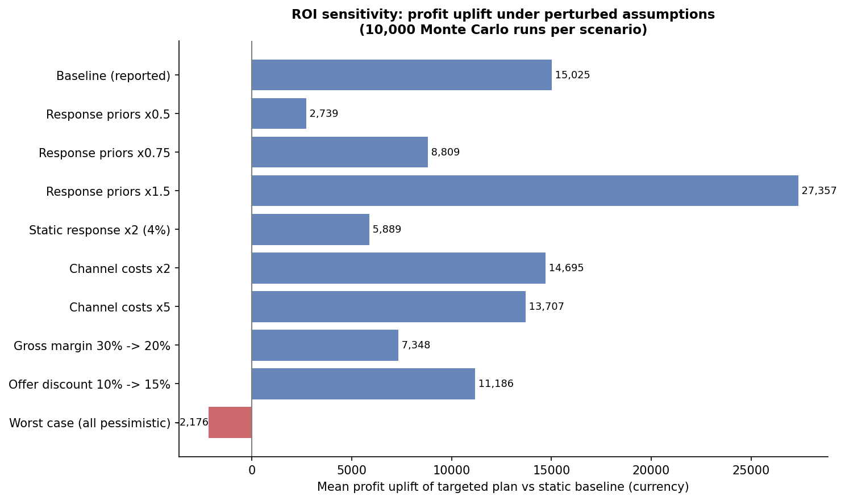
Figure 5.6 Mean profit uplift of the targeted plan over the static baseline under each perturbed-assumption scenario. The uplift survives every single-assumption stress; only the compound worst case — all assumptions moved against the plan at once — turns it negative.

5.8 Requirements Traceability
Every functional requirement is implemented and evidenced:
Requirement | Implemented in | Evidence
FR1 Ingestion | src/data_loading.py | 1,067,371 rows loaded (Section 4.2)
FR2 Auditable cleaning | src/cleaning.py | Table 4.1; tests (Section 5.1)
FR3 Features | src/features.py | Section 4.3, Figure 4.1
FR4 Preprocessing | src/preprocessing.py | Figure 4.2; tests
FR5 Six-algorithm clustering | src/clustering.py | Section 4.5, Figures 4.3–4.6
FR6 Validation & selection | src/validation.py | Tables 5.2–5.3, Figure 5.1
FR7 Profiling & naming | src/profiling.py | Table 4.4, Figures 4.7–4.8
FR8 CLV | src/clv.py | Table 4.5, Figure 4.9, Section 5.4
FR9 Churn | src/churn.py | Tables 5.4–5.6, Figures 4.10, 5.2
FR10 Migration | src/migration.py | Tables 5.7–5.8, Figure 5.3
FR11 Notification plan + API | src/notifications.py | Table 4.6, Section 5.6
FR12 ROI + uplift | src/roi.py | Table 5.9, Figure 5.4
FR13 Dashboard | app/streamlit_app.py | Figures 4.11–4.13

The non-functional requirements are evidenced as follows: NFR1 by byte-identical repeated runs (Section 5.1); NFR2/NFR3 by the architecture of Chapter 3 as implemented; NFR4 by the ≈160 s CPU runtime; NFR5 by the rule-traceable plan audit of Section 5.6; NFR6 by the 20-test suite.

5.9 Threats to Validity
Honest limits qualify the results. Scale and coarseness: the customer base (5,878) is modest and the selected segmentation is coarse (two clusters plus noise); a larger or more heterogeneous base might support — and reward — finer structure. Single dataset: all findings derive from one UK online retailer over 2009–2011; the pipeline is dataset-agnostic by construction, but the conclusions (e.g. HDBSCAN's win) are not claimed to generalise beyond this data, consistent with the no-free-lunch finding of the comparative literature [20], [21], [40]. CLV calibration: the temporal holdout of Section 5.4 validates the CLV layer as a ranking instrument (r = 0.83 against unseen year-2 behaviour) but shows its absolute purchase forecasts run ≈53% high on this data, so portfolio-value figures should be read as optimistic upper bounds. Churn label is a proxy: the label marks the most dormant decile rather than observed contract termination — an unavoidable construction in non-contractual retail — though Section 5.3.2 shows the modelling conclusions are stable when the defining percentile is moved to 85 or 95. ROI priors are planning assumptions: the response rates are documented assumptions, not fitted from a live campaign; this is why the analysis emphasises the uplift over the baseline (Eq. 27) rather than the absolute ROI, why Section 5.7 stresses every assumption individually (the uplift survives each one; only the compound worst case reverses it), and why future work proposes A/B-calibrated uplift modelling. Stationarity: churn and CLV both assume historical behaviour patterns persist; seasonal shifts or market shocks would require re-fitting — cheap at 160 s per run, but a monitoring obligation in any deployment. Interpretability trade-off: the notification engine keys on cluster-derived segment names rather than raw cluster indices, trading a little cluster fidelity for a decision table a marketer can read — a deliberate choice aligned with NFR5.

Chapter 6
Conclusions and Future Work

6.1 Conclusions
This project set out to close the gap, identified across the segmentation, CLV, and churn literatures, between analytical modelling and marketing action. It delivered a reproducible software framework that carries raw retail transactions end-to-end: 1,067,371 rows cleaned to 793,591 under four audited rules; seven behavioural features engineered for 5,878 customers; six clustering algorithms benchmarked under three validity indices and 50-round bootstrap stability, with HDBSCAN selected by a transparent, pre-declared rule (silhouette 0.416, best overall rank 1.75); probabilistic 12-month CLV (portfolio £8.33M, median £371), temporally validated as a ranking instrument on a one-year holdout (r = 0.83) and leakage-guarded churn prediction (best ROC-AUC 0.849) with McNemar testing showing the two best models statistically tied; a rule-based engine translating segment, value tier, and risk band into a prioritised campaign per customer — 64 priority retention interventions among 5,878 planned contacts — and a 10,000-run Monte Carlo assessment showing a mean ROI of 38.4× and a +168% profit uplift over blanket marketing — an uplift that survives every single-assumption stress test; all surfaced through an eight-page dashboard with live per-customer lookup.
All six objectives are discharged: O1 by the survey and method justification of Chapter 2; O2 by the audited data foundation of Sections 4.2–4.4; O3 by the validated, rule-selected segmentation (Sections 4.5–4.7, 5.2); O4 by the CLV and churn layers (Sections 4.8–4.9, 5.3–5.4); O5 by the notification engine, API, and dashboard (Sections 4.11, 4.13, 5.6); and O6 by the uplift-quantified business case (Sections 4.12, 5.7).
Two conclusions rise above the implementation. First, rigour changes answers: the evidence-based selection rejected the conventional default (K-Means) in favour of HDBSCAN, the significance test blocked an unjustified "best model" claim, and the imbalance-handling contrast exposed two models whose respectable ROC-AUC concealed operational uselessness — none of which a single-algorithm, single-metric study would have surfaced. Second, the closed loop is the contribution: validated clusters, value forecasts, and risk scores only become worth their computation when a traceable decision layer converts them into actions whose financial consequence is quantified before spend — and this project demonstrates that the whole loop fits in one auditable, three-minute, commodity-hardware pipeline.

6.2 Future Work
Five extensions follow naturally, in rough order of value:
- Campaign-calibrated uplift modelling. Replace the documented response priors with rates estimated from live A/B tests, and ultimately model per-customer treatment effects with causal uplift methods [38], [39] — turning the indicative ROI into a measured one and targeting customers by incremental response rather than risk alone.
- Deeper temporal validation of the predictive layer. Section 5.4 now validates the BG/NBD purchase forecasts on a one-year holdout; the natural extensions are validating the monetary half (Gamma–Gamma) and the churn probabilities against realised future behaviour, and diagnosing the dropout under-estimation behind the ≈53% aggregate over-forecast — for example with rolling-origin splits or a Pareto/NBD comparison.
- Real-time deployment. Wrap recommend(customer_id) behind a service API fed by streaming transactions, recomputing features incrementally so recommendations update as behaviour changes — realising the dynamic-CRM vision of [24], [36] that the batch pipeline approximates.
- Richer representations at larger scale. On a larger customer base, explore learned behavioural embeddings (e.g. autoencoders over transaction sequences) as clustering inputs, and GPU-accelerated implementations (RAPIDS cuML) if scale demands it; the validation framework of Section 4.6 transfers unchanged, which is the point of having built it.
- Human-subject evaluation of the dashboard. A structured usability study with marketing practitioners would evaluate the delivery layer as seriously as this report evaluates the analytical layers, and would likely refine the playbook's actions and offers. The heuristic-evaluation protocol of Appendix C is the prepared starting point.

List of References
[1] J. MacQueen, "Some methods for classification and analysis of multivariate observations," in Proc. 5th Berkeley Symp. Math. Statist. Probab., Berkeley, CA, 1967, pp. 281–297.
[2] S. P. Lloyd, "Least squares quantization in PCM," IEEE Trans. Inf. Theory, vol. 28, no. 2, pp. 129–137, 1982.
[3] M. Ester, H.-P. Kriegel, J. Sander, and X. Xu, "A density-based algorithm for discovering clusters in large spatial databases with noise," in Proc. 2nd Int. Conf. Knowledge Discovery and Data Mining (KDD), 1996, pp. 226–231.
[4] E. Schubert, J. Sander, M. Ester, H.-P. Kriegel, and X. Xu, "DBSCAN revisited, revisited: Why and how you should (still) use DBSCAN," ACM Trans. Database Syst., vol. 42, no. 3, pp. 1–21, 2017.
[5] R. J. G. B. Campello, D. Moulavi, and J. Sander, "Density-based clustering based on hierarchical density estimates," in Proc. Pacific-Asia Conf. Knowledge Discovery and Data Mining (PAKDD), 2013, pp. 160–172.
[6] L. McInnes, J. Healy, and S. Astels, "hdbscan: Hierarchical density based clustering," J. Open Source Softw., vol. 2, no. 11, p. 205, 2017.
[7] A. P. Dempster, N. M. Laird, and D. B. Rubin, "Maximum likelihood from incomplete data via the EM algorithm," J. Roy. Statist. Soc. B, vol. 39, no. 1, pp. 1–38, 1977.
[8] L. Breiman, "Random forests," Mach. Learn., vol. 45, no. 1, pp. 5–32, 2001.
[9] T. Chen and C. Guestrin, "XGBoost: A scalable tree boosting system," in Proc. 22nd ACM SIGKDD Int. Conf. Knowledge Discovery and Data Mining, 2016, pp. 785–794.
[10] V. Satopää, J. Albrecht, D. Irwin, and B. Raghavan, "Finding a 'kneedle' in a haystack: Detecting knee points in system behavior," in Proc. 31st Int. Conf. Distributed Computing Systems Workshops, 2011, pp. 166–171.
[11] P. J. Rousseeuw, "Silhouettes: A graphical aid to the interpretation and validation of cluster analysis," J. Comput. Appl. Math., vol. 20, pp. 53–65, 1987.
[12] D. L. Davies and D. W. Bouldin, "A cluster separation measure," IEEE Trans. Pattern Anal. Mach. Intell., vol. PAMI-1, no. 2, pp. 224–227, 1979.
[13] T. Caliński and J. Harabasz, "A dendrite method for cluster analysis," Commun. Statist., vol. 3, no. 1, pp. 1–27, 1974.
[14] L. Hubert and P. Arabie, "Comparing partitions," J. Classification, vol. 2, no. 1, pp. 193–218, 1985.
[15] D. Chen, S. L. Sain, and K. Guo, "Data mining for the online retail industry: A case study of RFM model-based customer segmentation using data mining," J. Database Marketing & Customer Strategy Manag., vol. 19, no. 3, pp. 197–208, 2012.
[16] P. S. Fader, B. G. S. Hardie, and K. L. Lee, "RFM and CLV: Using iso-value curves for customer base analysis," J. Marketing Res., vol. 42, no. 4, pp. 415–430, 2005.
[17] P. S. Fader, B. G. S. Hardie, and K. L. Lee, "'Counting your customers' the easy way: An alternative to the Pareto/NBD model," Marketing Sci., vol. 24, no. 2, pp. 275–284, 2005.
[18] Q. McNemar, "Note on the sampling error of the difference between correlated proportions or percentages," Psychometrika, vol. 12, no. 2, pp. 153–157, 1947.
[19] F. Pedregosa et al., "Scikit-learn: Machine learning in Python," J. Mach. Learn. Res., vol. 12, pp. 2825–2830, 2011.
[20] J. M. John, O. Shobayo, and B. Ogunleye, "An exploration of clustering algorithms for customer segmentation in the UK retail market," arXiv:2402.04103, 2024.
[21] A. S. Paramita and T. Hariguna, "Comparison of K-Means and DBSCAN algorithms for customer segmentation in e-commerce," J. Digit. Market. Digit. Currency, vol. 1, no. 1, pp. 43–62, 2024.
[22] S. Ibrahim, B. S. Tawfik, M. A. Makhlouf, and B. Hafiz, "A novel hybrid deep learning framework for customer churn prediction using RFM and embedding clustering," Sci. Rep., vol. 16, Art. no. 16563, 2026.
[23] P. Chapman et al., CRISP-DM 1.0: Step-by-Step Data Mining Guide. SPSS Inc., 2000.
[24] S. Dash, "Leveraging machine learning algorithms in enterprise CRM architectures for personalized marketing automation," J. Artif. Intell. Res. (The Science Brigade), vol. 4, no. 1, pp. 482–518, 2024.
[25] A. J. Christy, A. Umamakeswari, L. Priyatharsini, and A. Neyaa, "RFM ranking — An effective approach to customer segmentation," J. King Saud Univ. — Comput. Inf. Sci., vol. 33, no. 10, pp. 1251–1257, 2021.
[26] Y. Zhang, E. T. Bradlow, and D. S. Small, "Predicting customer value using clumpiness: From RFM to RFMC," Marketing Sci., vol. 34, no. 2, pp. 195–208, 2015.
[27] B. G. Vo, H. D. S. Van, N. D. Van, and H. D. Huynh, "Customer segmentation: Automatic K-optimization and RFM-based K-means clustering," in Proc. 10th Int. Conf. Intelligent Information Technology (ICIIT), Hanoi, Vietnam, 2025, doi: 10.1145/3731763.3731805.
[28] N. Kumar, "Intelligent customer segmentation: Unveiling consumer patterns with machine learning," J. Umm Al-Qura Univ. Eng. Archit., vol. 16, pp. 774–783, 2025.
[29] S. Mousaeirad, "Intelligent vector-based customer segmentation in the banking industry," arXiv:2012.11876, 2020.
[30] A. Mammadzada, E. Alasgarov, and A. Mammadov, "Application of BG/NBD and Gamma-Gamma models to predict customer lifetime value for financial institution," in Proc. IEEE 15th Int. Conf. Application of Information and Communication Technologies (AICT), 2021, doi: 10.1109/AICT52784.2021.9620535.
[31] A. Wong, A. V. Garcia, and Y. Lim, "A data-driven approach to customer lifetime value prediction using probability and machine learning models," Decis. Anal. J., vol. 16, Art. no. 100601, 2025.
[32] A. Sikri, R. Jameel, S. M. Idrees, and H. Kaur, "Enhancing customer retention in telecom industry with machine learning driven churn prediction," Sci. Rep., vol. 14, Art. no. 13097, 2024.
[33] M. Shahabikargar, A. Beheshti, X. Zhang, J. Foo, and A. Jolfaei, "A comprehensive survey on customer churn analysis studies," J. Inf. Telecommun., vol. 10, no. 1, pp. 24–70, 2026.
[34] N. Jha, D. Parekh, M. Mouhoub, and V. Makkar, "Customer segmentation and churn prediction in online retail," in Advances in Artificial Intelligence (Canadian AI 2020), LNAI vol. 12109, Springer, 2020, pp. 328–334.
[35] [Authors — complete from ScienceDirect, PII S1877050925009846], "A framework for customer segmentation to improve marketing strategies using machine learning," Procedia Comput. Sci., 2025.
[36] Y. Gaidhani, J. V. N. Ramesh, S. Singh, R. Dagar, T. S. M. Rao, S. R. Godla, and Y. A. B. El-Ebiary, "AI-driven predictive analytics for CRM to enhance retention, personalization and decision-making," Int. J. Adv. Comput. Sci. Appl., vol. 16, no. 4, 2025.
[37] L. Liu, "e-Commerce personalized recommendation based on machine learning technology," Mobile Inf. Syst., vol. 2022, Art. no. 1761579, 2022.
[38] J. Wang, Y. Tan, B. Jiang, B. Wu, and W. Liu, "Dynamic marketing uplift modeling: A symmetry-preserving framework integrating causal forests with deep reinforcement learning for personalized intervention strategies," Symmetry, vol. 17, no. 4, Art. no. 610, 2025.
[39] N. Sawant, C. B. Namballa, N. Sadagopan, and H. Nassif, "Contextual multi-armed bandits for causal marketing," arXiv:1810.01859, 2018.
[40] A. T. Thuse, "Customer segmentation for targeted marketing: Exploring DBSCAN and K-means," Preprints.org, manuscript 202504.1434, 2025.
[41] D. Chen, "Online Retail II," UCI Machine Learning Repository, 2019. [Online]. Available: https://archive.ics.uci.edu/dataset/502/online+retail+ii
[42] M. Wedel and W. A. Kamakura, Market Segmentation: Conceptual and Methodological Foundations, 2nd ed. Boston, MA: Kluwer Academic Publishers, 2000.
[43] J. Nielsen, "Enhancing the explanatory power of usability heuristics," in Proc. SIGCHI Conf. Human Factors in Computing Systems (CHI ’94), Boston, MA, USA, 1994, pp. 152–158.

Appendix A
External Materials

A.1 Source Code and Repository Layout
The complete source code is submitted alongside this report (and maintained under Git version control). The repository layout mirrors the architecture of Chapter 3:
final-year-project/
|-- main.py # pipeline orchestrator (run: python main.py)
|-- src/
| |-- config.py # ALL paths, thresholds, hyper-parameters, seeds
| |-- data_loading.py # Stage 1a: load both yearly worksheets
| |-- cleaning.py # Stage 1b: four audited cleaning rules
| |-- features.py # Stage 2 : RFM + extended features
| |-- preprocessing.py # Stage 2b: skew-gated log1p + StandardScaler
| |-- clustering.py # Stage 3 : six algorithms, auto hyper-parameters
| |-- validation.py # Stage 3b: indices, bootstrap ARI, ranking, selection
| |-- profiling.py # Stage 6 : profiles, naming, heatmap, radar
| |-- clv.py # Stage 7 : BG/NBD + Gamma-Gamma CLV
| |-- churn.py # Stage 8 : six classifiers, McNemar, ranking
| |-- migration.py # Stage 9 : year-on-year transitions
| |-- notifications.py # Stage 10: rule engine + recommend(customer_id)
| |-- roi.py # Stage 11: Monte Carlo ROI + static baseline
| |-- clv_validation.py # Stage 11b: BG/NBD calibration/holdout validation
| |-- churn_sensitivity.py # Stage 11c: churn label-threshold sensitivity
| |-- roi_sensitivity.py # Stage 11d: ROI assumption-sensitivity scenarios
|-- app/streamlit_app.py # Stage 12: eight-page dashboard
|-- scripts/ # report generators + run_new_validations.py
|-- tests/ # 20 pytest unit tests (7 modules)
|-- data/raw/ # source workbook (read-only)
|-- data/processed/ # 5 Parquet datasets + fitted scaler
|-- outputs/tables/ # 19 result tables (CSV)
|-- outputs/figures/ # 21 figures (PNG)

A.2 How to Run
With Python 3.11 and the dependencies of Section A.3 installed:
# full pipeline (regenerates every table and figure; ~160 s on CPU)
python main.py

# unit tests
python -m pytest tests/ -q # expected: 20 passed

# post-draft validation analyses (Sections 5.3.2, 5.4, 5.7)
python scripts/run_new_validations.py

# dashboard (then open http://localhost:8501)
python -m streamlit run app/streamlit_app.py
Reproducibility: all stochastic steps read the seed (42) and the pinned snapshot date from src/config.py; repeated runs produce byte-identical outputs.

A.3 Software Dependencies
Python 3.11; pandas; NumPy; scikit-learn [19]; hdbscan [6]; lifetimes; XGBoost [9]; SciPy; Matplotlib; Streamlit; pytest; pyarrow (Parquet I/O); openpyxl (Excel ingestion); kneed (knee detection [10]).

A.4 Dataset
UCI Online Retail II [41]: transactions of a UK-based online giftware retailer, 1 December 2009 – 9 December 2011, across two worksheets (one per trading year); 1,067,371 rows raw. Licence: CC BY 4.0. The raw workbook is stored read-only under data/raw/ and is never modified by the pipeline.

A.5 Artefact Inventory
Every artefact regenerated by python main.py, in production order:
Artefact | Kind | Produced by
cleaned_transactions.parquet | dataset | Stage 1
cleaning_summary.csv | table (Table 4.1) | Stage 1
customer_features.parquet | dataset | Stage 2
feature_summary.csv | table (Table 4.2) | Stage 2
rfm_distributions.png | figure (Fig. 4.1) | Stage 2
scaled_features.parquet; fitted_scaler.joblib | dataset + model | Stage 2b
scaling_effect.png | figure (Fig. 4.2) | Stage 2b
clustered_customers.parquet | dataset (6 label columns) | Stage 3
kmeans_metrics.csv | table (Table 4.3) | Stage 3
kmeans_selection.png; gmm_bic.png; dbscan_kdistance.png; cluster_pca_projection.png | figures (Figs. 4.3–4.6) | Stage 3
cluster_validation.csv; cluster_ranking.csv | tables (Tables 5.2–5.3) | Stage 3b
stability_ari.png | figure (Fig. 5.1) | Stage 3b
segment_profiles.csv | table (Table 4.4) | Stage 6
segment_profiles.png; radar_profiles.png | figures (Figs. 4.7–4.8) | Stage 6
customer_clv.parquet; clv_summary.csv | dataset + table (Table 4.5) | Stage 7
clv_distribution.png | figure (Fig. 4.9) | Stage 7
customer_churn.parquet | dataset | Stage 8
churn_model_comparison.csv; churn_model_ranking.csv; churn_mcnemar_pvalues.csv | tables (Tables 5.4–5.6) | Stage 8
churn_roc_curves.png; churn_pr_curves.png; churn_feature_importance.png | figures (Figs. 5.2a–b, 4.10) | Stage 8
segment_migration_counts.csv; segment_migration_rates.csv | tables (Tables 5.7–5.8) | Stage 9
segment_migration.png | figure (Fig. 5.3) | Stage 9
notification_plan.csv | table (Table 4.6) | Stage 10
roi_simulation_summary.csv | table (Table 5.9) | Stage 11
roi_distribution.png | figure (Fig. 5.4) | Stage 11
system_architecture.png; component_diagram.png | figures (Figs. 3.1–3.2) | design documentation
dashboard_overview.png; dashboard_segments.png; dashboard_roi.png | figures (Figs. 4.11–4.13) | Stage 12 (captured)
clv_holdout_metrics.csv | table (Section 5.4) | Validation script
clv_holdout_validation.png | figure (Figure 5.3) | Validation script
churn_threshold_sensitivity.csv | table (Table 5.7) | Validation script
roi_sensitivity.csv | table (Table 5.11) | Validation script
roi_sensitivity.png | figure (Figure 5.6) | Validation script

Appendix B
Ethical Issues Addressed

B.1 Data Protection and Legal Compliance
The project processes only the public, secondary Online Retail II dataset [41], in which customers are pseudonymised at source as numeric IDs; no names, postal or email addresses, phone numbers, or payment instruments appear anywhere in the data. No linkage to any other dataset is performed and no re-identification of any individual is attempted. Processing follows the principles of the UK GDPR even though the data is outside its scope in practice: purpose limitation (the data is used solely for the analyses of this report), data minimisation (only the fields needed for behavioural modelling are read), and storage discipline (the raw file is read-only; all derivatives are regenerable artefacts).

B.2 Human Participants
The project involves no human participants, no surveys, no interviews, and no collection of new personal data. Accordingly, no ethical approval or participant consent was required. This was confirmed against the School's ethics guidance for computing projects at the scoping stage.

B.3 Responsible Use of Targeting Systems
Behaviour-based targeting is dual-use: the same machinery that reduces irrelevant contact can, misused, enable manipulative or exploitative marketing. Three design decisions mitigate this risk structurally. First, the decision layer is rule-based and fully auditable (NFR5): every recommendation traces to explicit, human-readable rules and thresholds that an operator can inspect, question, and override — there is no opaque optimiser between analysis and action. Second, contact timing derives from each customer's own purchase rhythm (Eq. 29), which suppresses over-contact by construction rather than by policy promise. Third, the segmentation deliberately retains a noise category whose playbook entry is the least aggressive action (standard newsletter, priority 1): customers the model does not understand are contacted least, not most. Residual risks — notably the use of escalating discounts for at-risk customers, which could in principle train price-sensitivity — are noted as matters for the deploying organisation's marketing governance rather than properties of the software.

B.4 Academic Integrity and Assistance
All third-party methods, models, and datasets are cited in the List of References. AI-based assistance used during the preparation of the software and this report is declared in accordance with the University's policy on the use of generative AI. (Student to complete the declaration in the form the School requires before submission.)

Appendix C
Dashboard Heuristic-Evaluation Protocol

C.1 Purpose and Status
This appendix records the structured protocol prepared for expert (heuristic) evaluation of the eight-page dashboard of Section 4.13. The protocol itself is a deliverable of this project; executing it with marketing practitioners is identified as future work (Section 6.2). It is included so that the delivery layer’s assessment criteria are explicit and the evaluation is repeatable by any assessor with the running dashboard.

C.2 Method
Three to five evaluators independently walk through the dashboard while completing four representative tasks: (1) identify the largest customer segment and its share of the base; (2) list the ten highest-CLV customers currently in the High churn-risk band; (3) retrieve the recommendation for a given Customer ID and trace, from the on-screen information alone, why that action was chosen; and (4) report the campaign’s 95% ROI credible interval and its uplift over blanket marketing. Each evaluator then rates every violation found against Nielsen’s ten usability heuristics [43] on the standard 0–4 severity scale (0 = not a problem, 4 = usability catastrophe). Individual findings are consolidated into a single ranked defect list; any heuristic with a median severity ≥ 3 blocks a hypothetical release.

C.3 Heuristic Checklist

Nielsen heuristic [43] | Dashboard-specific prompt for the evaluator
Visibility of system status | Is it always clear which pipeline artefacts (and from which run) the current page reflects?
Match with the real world | Are segment names, value tiers, and risk bands expressed in marketing vocabulary rather than model jargon?
User control and freedom | Can the user leave any drill-down (customer lookup, segment filter) without losing context?
Consistency and standards | Do all eight pages use the same metric names, units (£), and colour encodings as this report?
Error prevention | Does the lookup page handle unknown or malformed Customer IDs gracefully?
Recognition rather than recall | Are thresholds (CLV tier percentiles, churn bands) shown where they are used, not merely documented elsewhere?
Flexibility and efficiency | Can an experienced user reach any single answer (e.g. one customer’s plan) in ≤ 3 interactions?
Aesthetic and minimalist design | Does any page show data that no marketing decision needs?
Help users recognise and recover from errors | If an artefact is missing (pipeline not yet run), does the page say what to run rather than failing?
Help and documentation | Do run instructions (Appendix A.2) suffice for a first-time evaluator to start the dashboard unaided?

