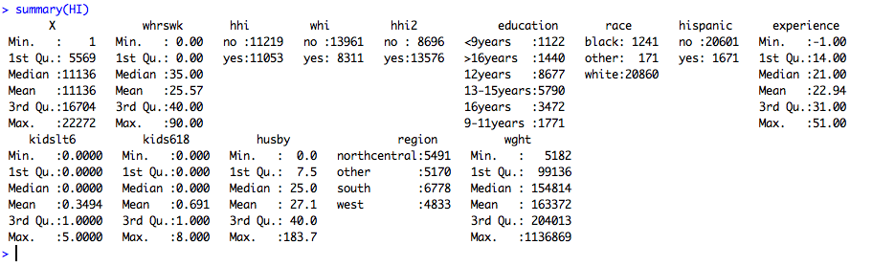

> pairs(head(HI,10))

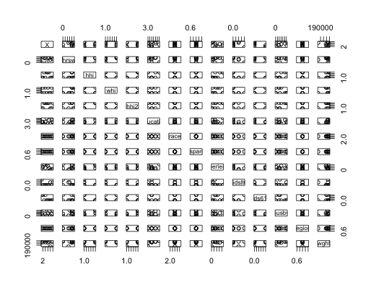

* boxplot(whrswk~hhi, data=HI, xlab="Wife covered by husbands insurance", ylab="No. hours wife works", col=c('red', 'blue'))

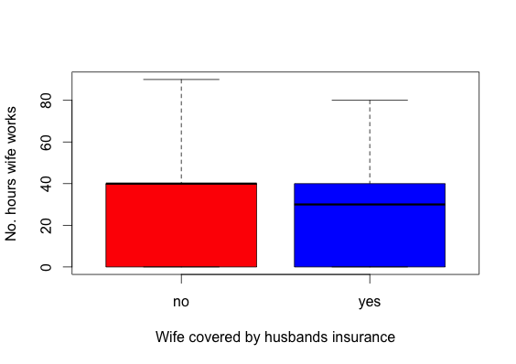

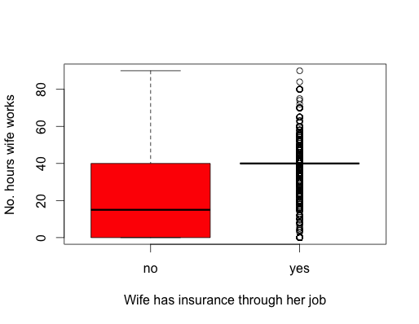

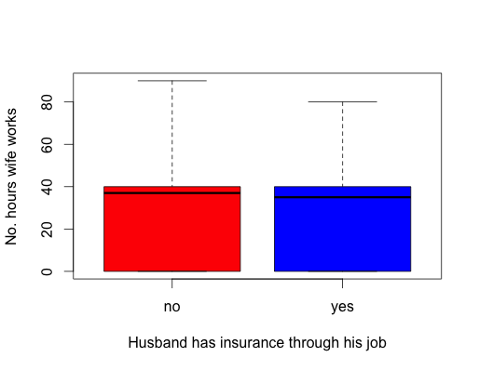

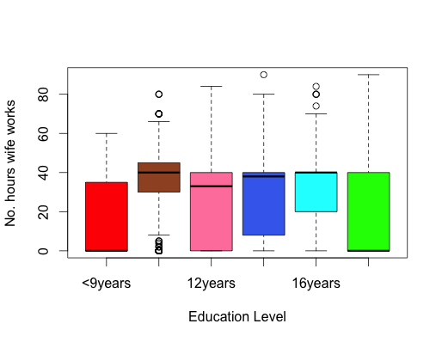

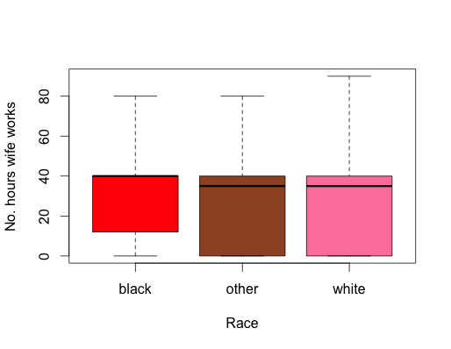

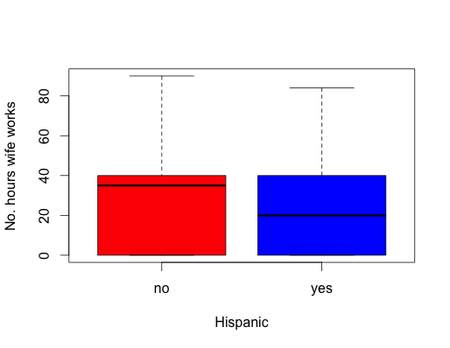

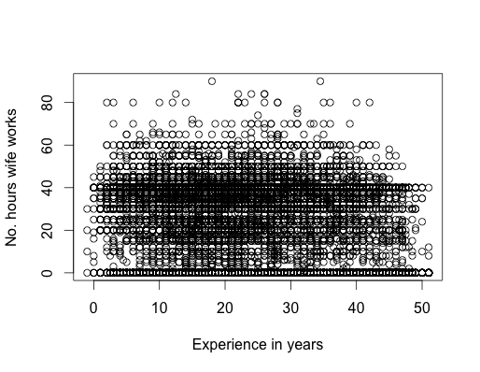

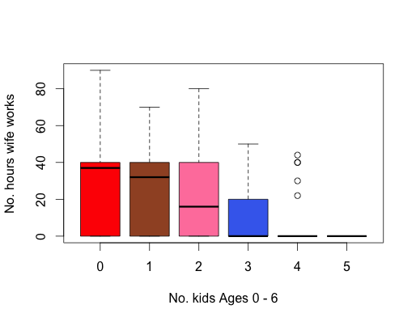

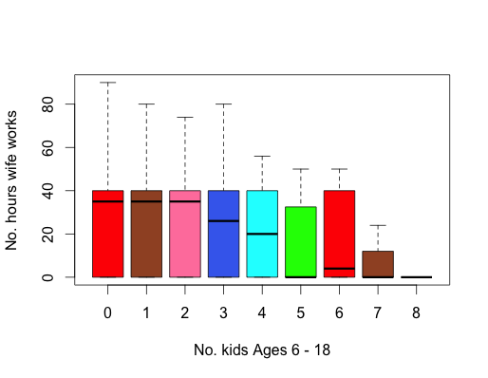

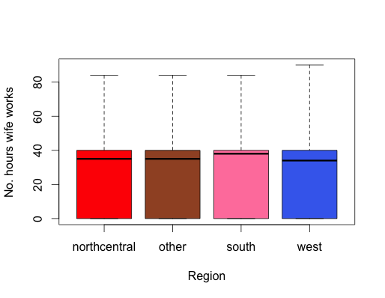

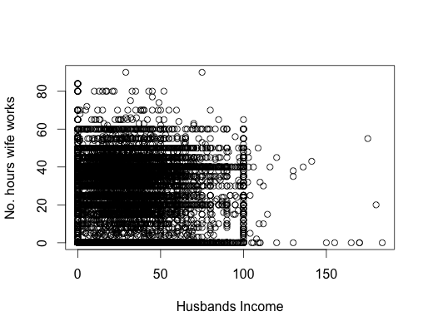

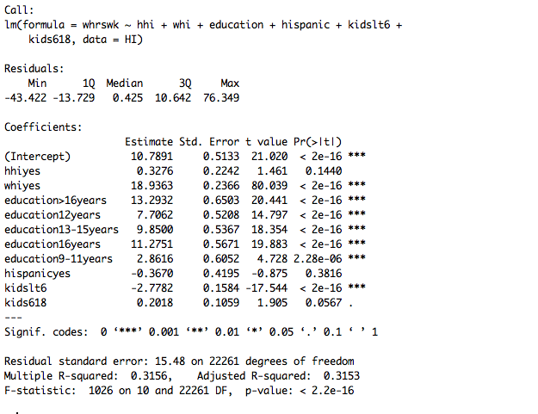

> lmall_hhi_yes <- lm(whrswk ~ whi + education + race + hispanic + experience + I(experience^2) + I(experience^3) + I(experience^4) + kidslt6 + kids618 + husby + I(husby^2) + I(husby^3) + I(husby^4) + region + wght, data = subset(HI, hhi == 'yes'))

> summary(lmall_hhi_yes)

Residual standard error: 15.25 on 11029 degrees of freedom

Multiple R-squared:  0.3252, Adjusted R-squared:  0.3238

F-statistic: 231.1 on 23 and 11029 DF,  p-value: < 2.2e-16

> lmall_hhi_no <- lm(whrswk ~ whi + education + race + hispanic + experience + I(experience^2) + I(experience^3) + I(experience^4) + kidslt6 + kids618 + husby + I(husby^2) + I(husby^3) + I(husby^4) + region, data = subset(HI, hhi == 'no'))

> summary(lmall_hhi_no)

Residual standard error: 13.96 on 11196 degrees of freedom

Multiple R-squared:  0.4334, Adjusted R-squared:  0.4322

F-statistic: 389.2 on 22 and 11196 DF,  p-value: < 2.2e-16