1. Flowchart

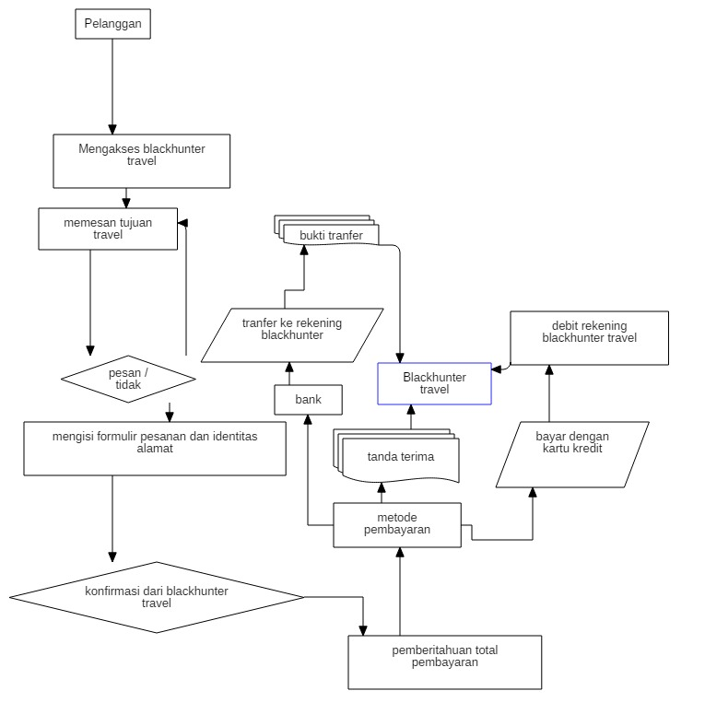

2. CFG (control flow graph)

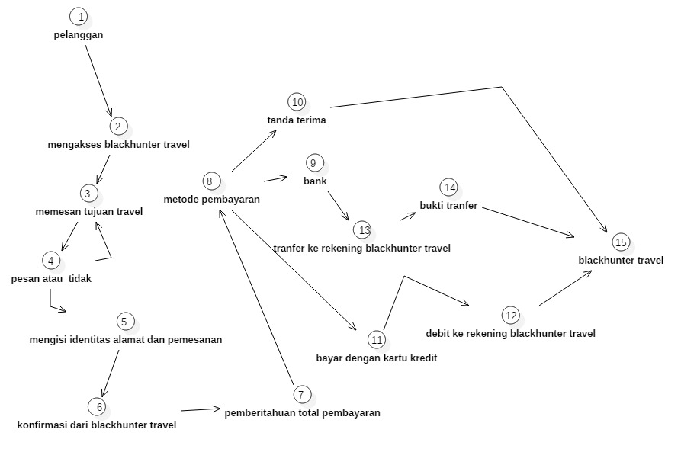

3. Cyclomatic Complexity

F = (E-N)+2

F = 17 – 15 + 2

F = 4

4. Basic Path

Path 1 : 1-2-3-4-5-6-7-8-10-15

Path 2 : 1-2-3-4-5-6-7-8-9-13-14-15

Path 3 : 1-2-3-4-5-6-7-8-11-12-15