INDUSTRIAL TRAINING REPORT

Done by

OLAGUNDOYE DICKSON
Faculty No. 1310302003

At

Motivian. 102, Bulgaria Blvd., 1680 Sofia, Bulgaria. Tel: +3 592 933 5501 Fax: +3 592 933 5502 Email: info@Motivian.com

Submitted to



Department of Applied Computer Science
EUROPEAN POLYTECHNICAL UNIVERSITY

Contents
Contents Pages
1. Company profile ……………………....................3-4
2. Product description ……..…………………………5-6
2.1. General information………………….……..5
2.2. Description …………………………………5
2.3. Syntax………………………………....…….5
2.4. Set of messages………………………..……6
2.5. Paying……………………………….………6
2.6. Service promotion………………….………..6
3. Project description ……………………….......….…7-13
4. Conclusion. …………………………………………13
5. References………………………………………..…14
6. Appendix 1-Database currencydat.sql……………….15
7. Appendix2- currencydata php source code…….….16-17

COMPANY PROFILE

http://www.motivian.com/aboutus
http://www.motivian.com/home http://www.motivian.com/services

MOTIVIAN IN SHORT WE MAKE IT EASY
The company was initially incorporated in 2005 under the name VCI as an Innovation Incubator. With a management buyout in 2012, Motivian absorbed all commercial-focused businesses and concentrated in providing Integrated Software Solutions in the SE European region, as well as in the Middle East. Since then, the company functions as a trusted software integrator serving customers in the financial services, telecom operator markets, retail and FMCG, and in the government sector.

Motivian employs more than 80 people, with high-level university degrees and significant professional experience in Greece and abroad. The company also participates in many EU Research & Development projects along with Academic and enterprise partners.

Motivian is a trustworthy technology services provider for prominent organizations. Based on our extensive business expertise, we develop innovative software solutions, which we combine with versatile services in order to drive long term growth & operational excellence of our customers.

Motivian has offices in Greece, Italy, Bulgaria and Cyprus.

ATHENS :5 Chimaras str.,15125 Marousi, AthensTel: +30 213 0186800Fax: +30 213 0186888Email: info@Motivian.com

MILANO :12, Via Appiani,20121 Milan, ItalyTel: +39 0287368375Fax: +390287368375Email: info@Motivian.com

SOFIA : 102, Bulgaria Blvd.,1680 Sofia, BulgariaTel: +3 592 933 5501Fax: +3 592 933 5502Email: info@Motivian.com

LARNACA :81-83 Griva Digeni Ave.,1066 Larnaca, CyprusTel: +357 22 503136Fax: +357 22 503001Email: info@Motivian.com

At http://www.motivian.com/aboutus we may read:

CONCEPT
They bring ideas to life with innovative designs. We love meshing fresh ideas and new technology. We are not just interested in the latest trends, but essentially in what has been designed well; contemporary, modern or vintage.

WEB DESIGN
We’re here to make sure your visitors not only stay longer, but also turn into customers. Our team of experts will guide you on creating visually compelling websites & portals that instantly reinforce credibility and drive conversions.

USER INTERFACE
We're a team of designers, builders & thinkers who craft digital experiences, allowing your brand to express its singularity and build emotive connections with users. We offer the finest designers to create a perfect solution for your business goals by designing digital products and services for the web, mobile and devices.

MOBILE DESIGN
We are here to help you keep your customers connected when they’re on the go. Whether this is making your existing website mobile compatible or creating a mobile application with a seamless user experience.

CAMPAIGNS
We design campaigns that are engaging, and through these campaigns we create genuine connections between people and brands. We enable your brand to become a lovable part of consumers’ daily conversations. We allow people to see and be a part of the things as they happen, and then share their good experience with others.

PRODUCT DESCRIPTION
General information

Product | SMS Currency price Checker & Converter
Version | 5.5
Date | 01.04.2016
Status | Confidential
Product manager | Olagundoye Dickson

Description

This service is intended to respond to clients request accurately without any delay.
This service consists of getting the latest currency price from the updated database and returning result to the clients without any delay.

Syntax

For either one or two input parameters, the input data must correspond to the data stored in the database to receive valid figures and if did not correspond, will receive invalid response.

Input Parameters | Answers
Valid response for one parameter:  EUR/USD | +OK EUR/USD is 1.13755 at 2016-04-25 10:31:26
Invalid response for one parameter :  EUR/UDS | +OK Invalid Currency Name.
Valid response for two parameters : EUR/USD:100 | +OK The converted amount for EUR/USD is 113.755 at 2016-04-25 10:31:26
Invalid response for two parameters:  EUR/USD: zay | +OK Invalid type of amount ( Amount=zay )

To check currency price, the client only needs to send the currency name (e.g EUR/USD) to short code 432 and get a return of the newest CurrencyName, Price, Date_Time. And as a converter, the client only needs to send the currency name and the amount to be converted (EUR/USD: 100) to a short code 432 and get the converted amount.

Set of messages

One Input Parameters | Answers
Valid parameters:  e.g : EUR/USD | +OK EUR/USD is 1.13755 at 2016-04-25 10:31:26
Invalid parameters :  e.g : EUR/UDS | +OK Invalid CurrencyName.

Two Input Parameters | Answers
Valid response for two parameters : EUR/USD:100 | +OK The converted amount for EUR/USD is 113.755 at 2016-04-25 10:31:26
Invalid response for two parameters:  EUR/USD: zay | +OK Invalid type of amount ( Amount=zay )

Paying by short number with value added SMS (VASMS) on short number 432 -0.30lv. with VAT

Service promotion
Using Internet advertising, media and newspapers.

PROJECT DESCRIPTION

Firstly, I launch XAMPP and I start Apache and MySQL.

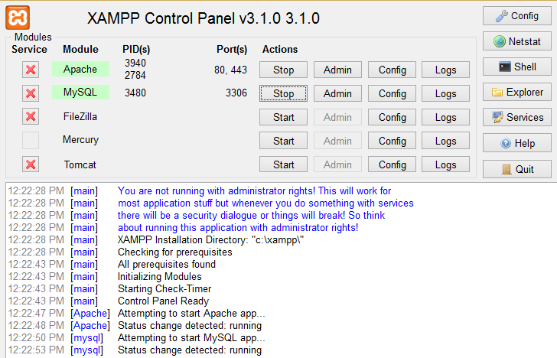

When I confirmed XAMPP running, I proceed to phpMyAdmin where I created database for my project. To create this database,

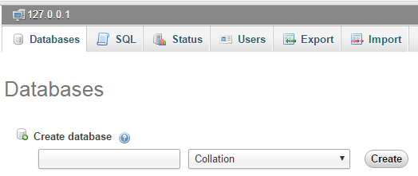

After creating the database, I need name and number of columns to create tables for my database.

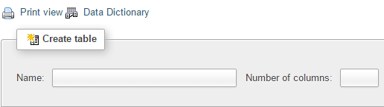

Moreover, from the columns, I fill in names which corresponds with my project and the type, collation, etc. After these, I attain

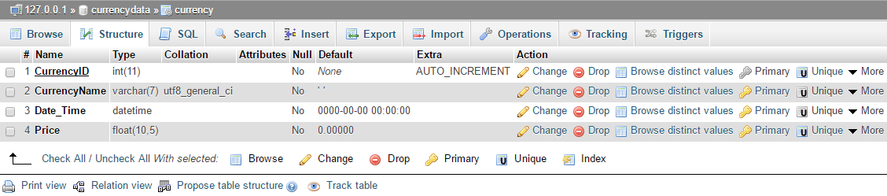

To fill in the created table, I click on STRUCTURE and after that I clicked on INSERT to fill in the variable.

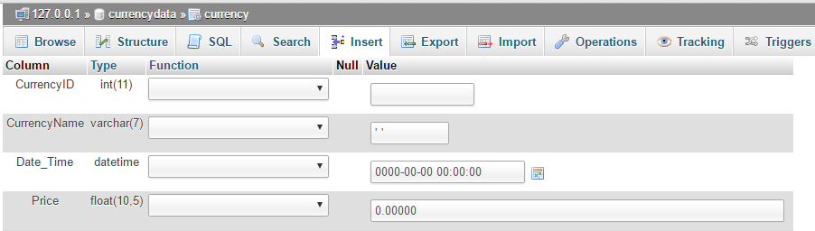

Here also is designer picture of my database

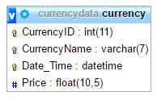

When database is ready, I proceed to the next level. I launched NetBeans and I begin to write my project code on php.

<?php
error_reporting(E_ALL);
$link = mysql_connect('localhost', 'root', '');
if (!$link) {
echo "-ERR MySQL Error: " . mysql_error();
mysql_close($link);
exit();
}
if (!(mysql_select_db("currencydata"))){
echo "-ERR no selected DB MySQL Error: ". mysql_error();
mysql_close($link);
exit();
}
$smsID = $_GET["smsID"];
$MSISDN = $_GET["MSISDN"];
$mobileSP = $_GET["msp"];
$smsCurrency = $_GET["smsCurrency"];
$smsCurrency = str_replace(" ", "", $smsCurrency);
$smsID = addslashes($smsID);
$MSISDN = addslashes($MSISDN);
$mobileSP = addslashes($mobileSP);
$smsCurrency = addslashes($smsCurrency);

$argArr=explode(':', $smsCurrency );
$Npar=count($argArr);
if ($Npar==2){
$smsCurrency=$argArr[0] ;
$Amount=$argArr[1] ;
if ( !is_numeric($Amount) )
{
echo "+OK Invalid type of amount ( Amount=$Amount )";
mysql_close($link);
exit();
}
}
$selectSQL = "
SELECT
*
FROM
Currency
WHERE
CurrencyName = '$smsCurrency'
order by `Date_Time` DESC
";
$rSelect = mysql_query($selectSQL);
if ($rSelect == false) {
echo "-ERR MySQL Error: " . mysql_error() . "\nSQL: $selectSQL";
mysql_close($link);
exit();
} else {
$count = mysql_num_rows($rSelect);
if ($count == 0) {

echo "+OK Invalid CurrencyName.";
mysql_close($link);
exit();
}
$row = mysql_fetch_array($rSelect);
$CurrencyName = $row['CurrencyName'];
$Price= $row['Price'];
$DateTime=$row['Date_Time'];
if ($Npar==2){
$AmountConverted=$Price*$Amount;
echo " +OK The converted amount for" . $CurrencyName. " is " .$AmountConverted. " at " . $DateTime;
} else {
echo " +OK The rate of " . $CurrencyName. " is " . $Price . " at " . $DateTime;
}
}
mysql_close($link);
?>

How my php code works
From my php code ,

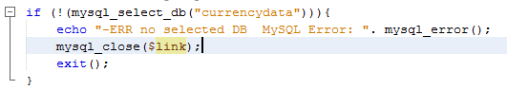
If my database is link to, then the program continues and get the request of the client from database and return answer.

And if my database cannot be found ( e.g, I omitted last letter from my database name)
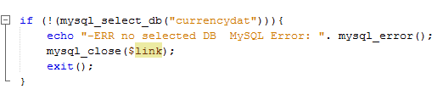

Below is my display:

Before I proceed, I will like to briefly explain a method and functions below which I used when writing my php code.

$_GET: This is an associative global array of variables passed to the current script via HTTP GET method.

str_replace : The str_replace() function replaces some characters with some other characters in a string. For example:

<?php
echo str_replace("CurrencyName","amount","Invalid CurrencyName!");
?>

Display: Invalid amount!

In the above example, we search for the string "Invalid CurrencyName!", find the value "CurrencyName" and then replace the value with "amount".

addslashes :The addslashes() function returns a string with backslashes in front of predefined characters.

exploded: The explode() function breaks a string into an array. Returns and array of strings, each of which is a substring of string formed by splitting it on boundaries formed by the string delimiter.

is_numeric: This function find whether a variable is a number or a numeric string. (Numeric strings consist of optional sign, any number of digits, optional decimal part and optional exponential part.) And it returns TRUE if var is a number or a numeric string, and FALSE if otherwise.

Here below is my code illustration with a diagram

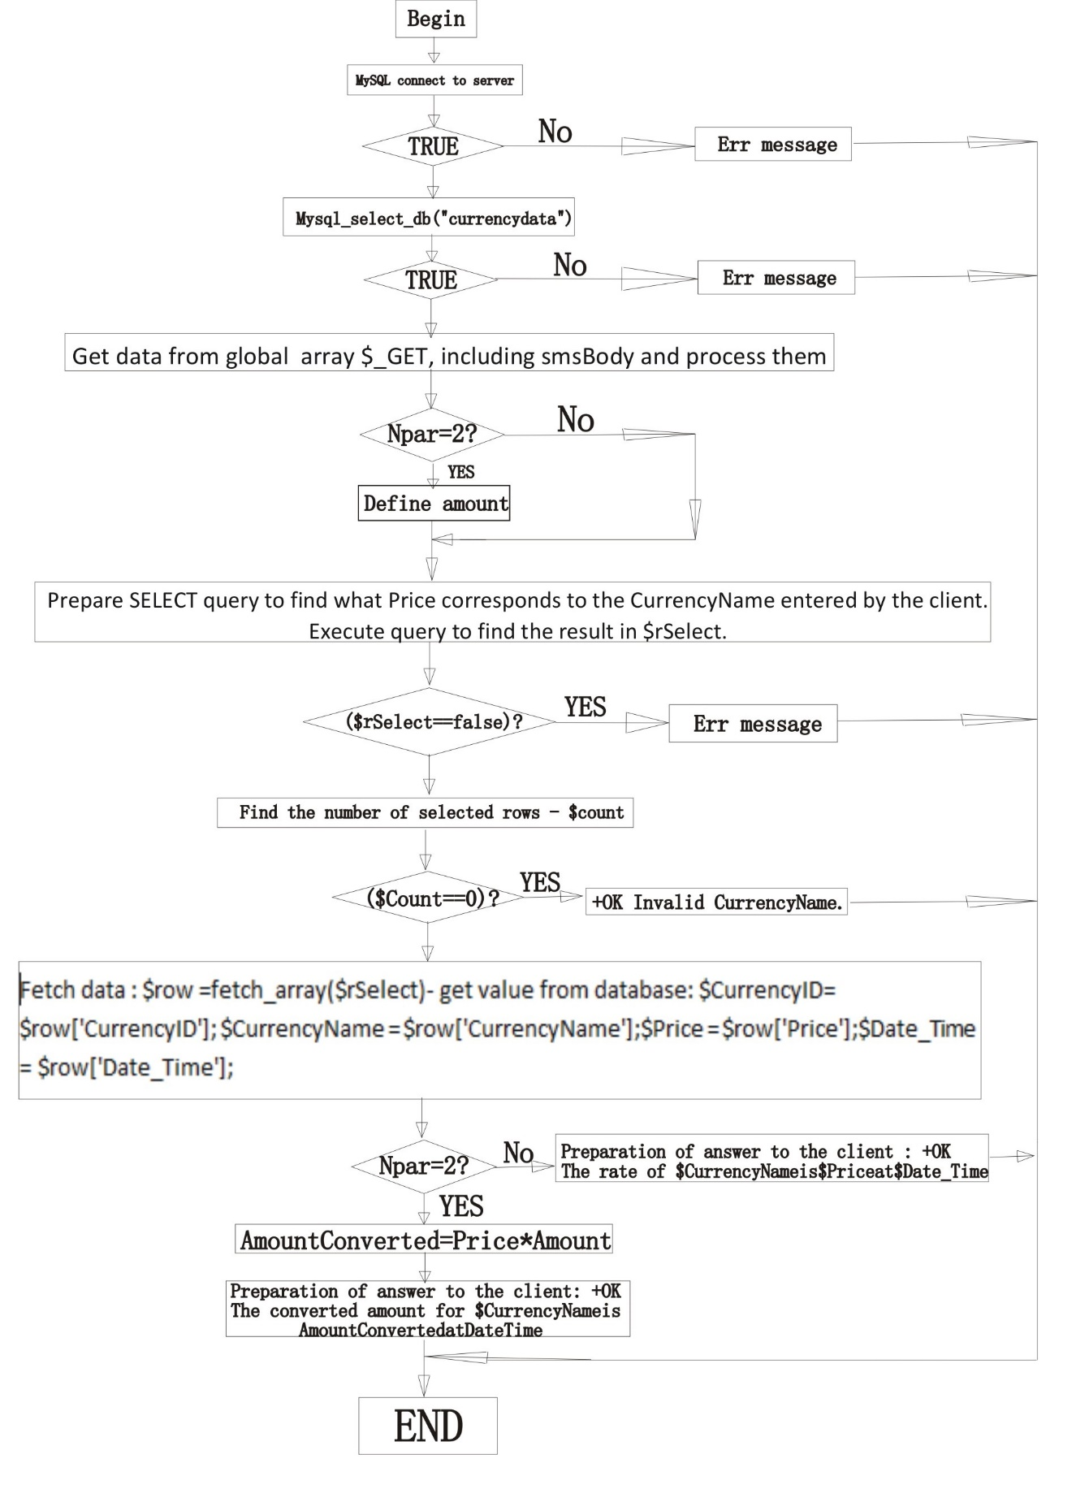

Also, when an invalid amount to be converted is inputted, an invalid message will be returned as shown below:

And if otherwise, a valid message will be returned as shown below:

Moreover, if the client only wants to check the currency price and inputted a valid CurrencyName, a valid message will be returned as shown below:

And if otherwise, an invalid message will be returned as shown below:

CONCLUSION
This project has made so many things known to me. Starting from the use of XAMPP, to phpMyAdmin, to NetBeans. During my project, I understand the connectivity between them all, XAMPP_control must be up running, to start the internet server APACHE and MySQL server. NetBeans gives a user-friendly interface, options for arguments setting, context colored source code, warnings for syntax errors and easy run and test.

After all is ready and working perfectly, using GitHub is another amazing platform which was also connected to SmartGit, where files uploaded on the project files in the computer are fetched through SmartGit and sent to GitHub with the help of commit and push function in SmartGit.

Have also learn how to modify quickly through the edit button on GitHub and commit below to safe file.

References

1. https://secure.php.net/manual/en/manual.php

2. Luke Welling, Laura Thompson, PHP and MySQL Web Development,
http://ahvaz.ist.unomaha.edu/azad/temp/softarch/05-welling-php-mysql-web.pdf

3. http://www.w3schools.com/php/

4. http://www.tutorialspoint.com/php/

Appendix 1
Database currencydata

-- phpMyAdmin SQL Dump
-- version 3.5.2.2
-- http://www.phpmyadmin.net
--
-- Host: 127.0.0.1
-- Generation Time: May 26, 2016 at 10:17 AM
-- Server version: 5.5.27
-- PHP Version: 5.4.7

SET SQL_MODE="NO_AUTO_VALUE_ON_ZERO";
SET time_zone = "+00:00";

/*!40101 SET @OLD_CHARACTER_SET_CLIENT=@@CHARACTER_SET_CLIENT */;
/*!40101 SET @OLD_CHARACTER_SET_RESULTS=@@CHARACTER_SET_RESULTS */;
/*!40101 SET @OLD_COLLATION_CONNECTION=@@COLLATION_CONNECTION */;
/*!40101 SET NAMES utf8 */;

--
-- Database: `currencydata`
--

-- --------------------------------------------------------

--
-- Table structure for table `currency`
--

CREATE TABLE IF NOT EXISTS `currency` (
`CurrencyID` int(11) NOT NULL AUTO_INCREMENT,
`CurrencyName` varchar(7) NOT NULL DEFAULT ''' ''',
`Date_Time` datetime NOT NULL DEFAULT '0000-00-00 00:00:00',
`Price` float(10,5) NOT NULL DEFAULT '0.00000',
PRIMARY KEY (`CurrencyID`),
UNIQUE KEY `CurrencyName` (`CurrencyName`,`Date_Time`)
) ENGINE=InnoDB DEFAULT CHARSET=utf8 AUTO_INCREMENT=14 ;

--
-- Dumping data for table `currency`
--

INSERT INTO `currency` (`CurrencyID`, `CurrencyName`, `Date_Time`, `Price`) VALUES
(1, 'EUR/JPY', '2016-04-25 01:09:37', 124.88600),
(2, 'USD/CAD', '2016-04-25 02:08:26', 1.26836),
(3, 'USD/JPY', '2016-04-25 03:21:31', 111.12700),
(4, 'EUR/AUD', '2016-04-25 04:05:23', 1.45873),
(5, 'AUD/USD', '2016-04-25 04:46:35', 0.77987),
(6, 'EUR/USD', '2016-04-25 05:15:25', 1.13767),
(7, 'GBP/USD', '2016-04-25 06:25:40', 1.44467),
(8, 'EUR/CHF', '2016-04-25 07:18:17', 1.09872),
(9, 'USD/CHF', '2016-04-25 09:20:09', 0.97897),
(10, 'EUR/USD', '2016-04-25 10:31:26', 1.13755),
(11, 'EUR/GBP', '2016-04-25 16:20:33', 0.77876),
(12, 'EUR/BGN', '2016-05-24 03:17:28', 1.95610),
(13, 'USD/BGN', '2016-05-26 08:29:10', 1.75360);

/*!40101 SET CHARACTER_SET_CLIENT=@OLD_CHARACTER_SET_CLIENT */;
/*!40101 SET CHARACTER_SET_RESULTS=@OLD_CHARACTER_SET_RESULTS */;
/*!40101 SET COLLATION_CONNECTION=@OLD_COLLATION_CONNECTION */;
Appendix 2
currencydata php code

<?php

error_reporting(E_ALL);

$link = mysql_connect('localhost', 'root', '');

if (!$link) {
echo "-ERR MySQL Error: " . mysql_error();
mysql_close($link);
exit();
}

if (!(mysql_select_db("currencydata"))){
echo "-ERR no selected DB MySQL Error: ". mysql_error();
exit();
}
$smsID = $_GET["smsID"];
$MSISDN = $_GET["MSISDN"];
$mobileSP = $_GET["msp"];
$smsCurrency = $_GET["smsCurrency"];
$smsCurrency = str_replace(" ", "", $smsCurrency);
$smsID = addslashes($smsID);
$MSISDN = addslashes($MSISDN);
$mobileSP = addslashes($mobileSP);
$smsCurrency = addslashes($smsCurrency);

$argArr=explode(':', $smsCurrency );
$Npar=count($argArr);
if ($Npar==2){
$smsCurrency=$argArr[0] ;
$Amount=$argArr[1] ;
if ( !is_numeric($Amount) )
{
echo "+OK Invalid type of amount ( Amount=$Amount )";
mysql_close($link);
exit();
}
}

$selectSQL = "
SELECT
*
FROM
Currency
WHERE
CurrencyName = '$smsCurrency'
order by `Date_Time` DESC
";

$rSelect = mysql_query($selectSQL);
if ($rSelect == false) {
echo "-ERR MySQL Error: " . mysql_error() . "\nSQL: $selectSQL";
mysql_close($link);
exit();
} else {
$count = mysql_num_rows($rSelect);
if ($count == 0) {

echo "+OK Invalid CurrencyName.";
mysql_close($link);

exit();
}
$row = mysql_fetch_array($rSelect);
$CurrencyName = $row['CurrencyName'];
$Price= $row['Price'];
$DateTime=$row['Date_Time'];
if ($Npar==2){
$AmountConverted=$Price*$Amount;
echo " +OK The converted amount for" . $CurrencyName. " is " .$AmountConverted. " at " . $DateTime;
} else
{
echo " +OK The rate of " . $CurrencyName. " is " . $Price . " at " . $DateTime;
}
}
mysql_close($link);
?>

