Small mammal species community structures vary importantly by land-use type in a Lassa fever endemic region of Sierra Leone.

Author list:
David Simons, Dianah Sondufu, Joyce Lamin, James Koninga, Momoh *, Mike Dawson, Joseph Lahai, Rashid Ansumana, Umaru Bangura, Rory Gibb, Kate E. Jones, Deborah Watson-Jones, Richard Kock.

Abstract
Lassa mammarenavirus, the causative agent of Lassa fever is endemic to Eastern Sierra Leone. The principal reservoir species (Mastomys natalensis), is considered abundant in human dominated habitats, however, rodent species’ assemblages in this context are not well described. We conducted three monthly small-mammal trapping to describe these rodent assemblages, their structure and their associations with land use. We modelled the effect of land use on rodent species occurrence along a land use gradient and produced species distribution maps of the study region to understand the current and potential Lassa mammarenavirus spillover hazard.
We found that M. natalensis were more likely to occur in areas of human habitation and agricultural settings although there was important variability between different study villages. M. natalensis co-occurred with other other small mammals including the two invasive rodent species (Rattus rattus and Mus musculus). We found evidence that the presence of M. musculus, but not R. rattus reduced the probability of occurrence of M. natalensis. This finding potentially goes some way to explain the observation of lower than expected human cases of Lassa fever from urban settings in endemic regions. Other native rodent species’ within these assemblages were found to diversify into distinct habitat niches. Species distribution maps identified areas of expected occurrence and non-occurrence of our species of interest M. natalensis and potential geographic isolation of populations.
We identify a complex system within rodent species assemblages co-located with human communities in Eastern Sierra Leone. We show the habitat occupancy patterns for each species of interest and use these observations to produce species distribution maps that explain the limited geographic radiation of outbreaks of Lassa fever. These data can help inform higher resolution models of rodent distributions across West Africa which are of particular importance for rodent zoonotic diseases such as Lassa fever and highlight the spatially heterogeneous distribution of important rodent species with implications for public health interventions to reduce the impact of Lassa fever.

Introduction
Lassa fever, caused by Lassa mammarenavirus (LASV) is an endemic zoonotic infectious disease in West Africa, with an estimated 100,000-900,000 annual human infections (McCormick et al. 1987; Basinski et al. 2021). The majority of these remain undetected and it is estimated that up-to 80% of these are pauci- or asymptomatic infections (McCormick et al. 1987). However, outcomes in confirmed cases remain poor, with a reported case fatality rate of 18.5% among confirmed cases identified between 2017 and 2020 in Nigeria (Yaro et al. 2021). Changing land-use and climate are hypothesised to increase the suitable area for both the primary reservoir of LASV (Mastomys natalensis) and environmental suitability for the virus itself, together increasing opportunities for viral spillover into growing human populations (Redding et al. 2016, 2021; Klitting et al. 2021). Lassa fever is currently classified as endemic in eight West African countries (Nigeria, Guinea, Sierra Leone, Liberia, Mali, Benin, Ghana and Togo) (World Health Organisation 2022). The location, scale and frequency of Lassa fever outbreaks in human communities is highly spatially heterogeneous. In Sierra Leone, Lassa fever is typically reported from rural settings but, the potential drivers of this have not been systematically investigated.
The persistence, or lack of persistence, of LASV infection in rodent communities is one factor driving spatial differences of outbreaks in human populations. In a well-mixed, isolated rodent population (i.e. rural settings), once introduced, LASV would be expected to rapidly infect susceptible populations. Infected rodents do not develop clinical symptoms, with antibody-mediated resistance developing following acute infection. This could lead to local elimination of the virus from these rodent populations. Conversely in highly-connected, diverse and poorly mixed rodent communities (i.e. urban settings) LASV persistence would be expected to be prolonged with viral transmission maintained through the rapid reproduction rate of rodents maintaining a large population of rodents susceptible to infection. In this way the suitability of both habitat type, climate and resource availability for both the primary reservoir and incidental reservoirs can drive the observed spatial clustering of Lassa fever outbreaks within Sierra Leone.
M. natalensis is found in 13 of 14 continental West African nations (the species has not been reported from the Gambia) and in all other sub-Saharan African countries (IUCN 2016). It is considered a commensal rodent species and is abundant in and around areas of human-dominated landscapes where it is considered a pest species (Leirs, Verhagen, and Verheyen 1993). The introduction of non-native commensal rodent species (i.e. Rattus rattus and Mus musculus) has led to increased competition for resources and displacement of M. natalensis from some locations within its natural range (Cuypers et al. 2017; Garba et al. 2014). Population dynamics within this reservoir species, correlated with resource availability and rainfall, are associated with outbreaks of Lassa fever in human populations (Redding et al. 2021). Few studies to date have used longitudinal, high intensity rodent trapping to characterise rodent species assemblages in Lassa fever endemic regions (reference scoping review manuscript). Understanding the true spatial distribution of M. natalensis and their population dynamics in the context of competing rodent species is vital to guide investigations of the epidemiology of Lassa fever (Basinski et al. 2021). Further, descriptions of rodent abundance and diversity along land use gradients are required to better understand the spatio-temporal hazard of Lassa fever outbreaks under changing land use pressures (Klitting et al. 2021). Together, this information can be used to guide the implementation of contextually relevant public health responses, allocation of healthcare resources and the identification of suitable sites for future Lassa fever vaccine studies.
Here, we use data from a repeat, standardised, rodent trapping survey based in the Lassa fever endemic region of Eastern Sierra Leone and conducted along a land-use gradient to understand the association between land-use on the occurrence of M. natalensis and more generally, the rodent species assemblage structure. We first report the occurrence of rodent species at our trapping sites and describe these species assemblages, producing networks of co-located species. Second, we model the association of land-use with the probability of species occupancy at trapping sites. Third, we model the probability of co-occurrence between different species detected in our study to understand competition between small mammal species in our study region. Together these analyses further our understanding of rodent species assemblage structures in this heterogeneous landscape and the hazard of Lassa fever outbreaks based on host species occurrence.

Methods

Study area
Rodent trapping was conducted at up-to 7 trapping sites within each of 4 villages in the Lassa fever endemic zone of the Eastern Province of Sierra Leone. We surveyed the rodent community in forested, fallowand agricultural areas and also in areas of human occupation (within and outside of homes), along an anthropogenic land use gradient. Current land-use was classified at the level of trapping site as Agriculture, Fallow-land and Forested. Traps placed within villages were further defined as being within human dwellings (Village inside) and outside permanent structures (Village outside). The village sites were enrolled based on accessibility to the sites during all seasons, discussions with the Lassa fever outreach team at Kenema Government Hospital and acceptability of the protocol to the village community. Villages and trapping sites were selected to be representative at the study level for land use in Eastern Sierra Leone.
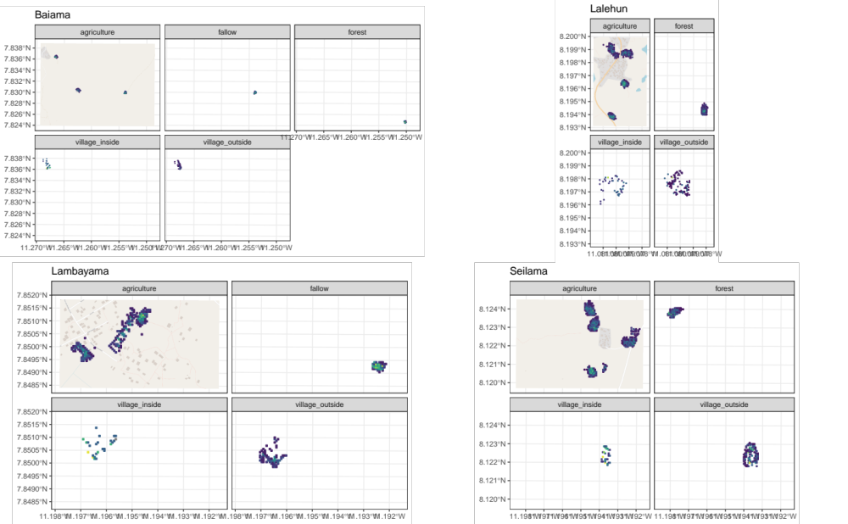
Figure 1. Locations of trapping grids within each village site. The trapping grids are shown in each land-use type with the colour of each 49m² grid indicating the number of trap nights at that location.
Trap sites were geo-located for repeated trapping activities, changes to land-use at the trapping site were recorded at each visit. Within each study site, 49 individual Sherman traps (size and reference) were baited with a locally produced mixture of oats, palm oil and dried fish for 4 consecutive nights. Each morning the traps were checked and closed for the day prior to re-baiting during the evening. Individual traps placed during each visit were associated with standardised 7m by 7m grid squares (49m²) within trapping sites. The number of trap nights and the number of trapped small-mammals by species within each grid square were aggregated.

Rodent sampling
Trapped rodents were sedated with halothane and euthanised prior to obtaining morphological measurements and samples of blood and tissue (reference to RVC and local ethics approval) following published guidance (Fichet-Calvet 2014). Rodents were sexed based on external and internal genitalia. Age estimation was performed through description of the rodent’s reproductive status (identification of perforate or imperforate vagina, scarring from prior embryo development, current pregnancy status or descent of testes and seminal vesicle development) and weighing of dried eye lenses. Carcasses were disposed and processed in the field to eliminate risk of pathogen transmission.
Molecular identification of species was performed on dried blood spots that were stored at -20°C until processing. Genomic DNA was extracted using QIAGEN DNAeasy kits as per the manufacturer’s instructions [ref]. DNA extracts were amplified using platinum Taq polymerase (Invitrogen) and cytochrome B primers. DNA amplification was assessed through gel electrophoreisis with successful amplification products undergoing Sanger sequencing. Obtained sequences were compared using BLAST against NCBI records for rodent cytochrome B.

Statistical analysis

Rodent occurrence and species assemblage structure
A total of 40,152 trap-nights over 10 trapping visits was obtained between 2020-11-30 and 2023-04-28. Trapping effort was assessed using species accumulation curves (Supplementary figure 1.), suggesting adequate effort to detect rodent species within each village site. We constructed detection/non-detection histories for all identified rodent species, assigning “1” when the species was detected and “0” otherwise, aggregated to standardised grid squares. We augmented data by creating all-zero detection histories of rodent species that have been previously described as occurring in the region and were never recorded in our study.
We describe species assemblages at multiple geographic scales. First, all species identified across all village sites and land-use types. Second, all species identified within a village. Third, all species identified within a single land-use type across multiple trapping sites and villages.

Rodent species networks
To understand potential contact between individual small mammal species we produced a buffer zone, with a radius of 50m, around each trapped individual. All other individuals trapped within this area were identified as potentially co-located individuals. We equated co-location to potential contact between rodents as individuals were trapped in temporally and spatially overlapping sites. The sf package in the R statistical computing language was used for geospatial manipulation and analysis (Pebesma 2018; R Core Team 2021). The proportion of these individuals from each species were calculated and compared to a null model where co-located species were randomly allocated with equal probability weighted by the number of individuals of each species detected across the study period. We then compared whether the proportion of each co-located was greater or lesser than this null model.

Estimating the effect of land use on species occurrence and richness
To understand the association of small mammal species and land-use types, we adopted a Bayesian multi-species occupancy framework to model occupancy from rodent trapping data in the presence of incomplete detection. Models were defined using the spOccupancy package in the R statistical computing language (Doser et al. 2022). This approach models the true presence or absence ($z$) of a species ($i$), at site ($j$) as arising from a Bernoulli process (Equation 1.). Where $ψ_{j}$ is the probability of occurrence of a species at a site during a given replicate. This is modelled using a logit link where $β_{i}$ are the regression coefficients, including an intercept that describes the effects of covariates $x_{i,j}$ with $​^{⊤}$ representing the transposition of column vector $x_{i,j}$ (Equation 2.).
$$z_{i,j}∼Bernoulli\left(ψ_{i,j}\right)$$
$$logit\left(ψ_{i,j}\right)=x_{i,j}^{⊤}β_{i}$$
The regression coefficients in these multi-species occupancy models are described as random effects arising from a common community level distribution (Equation 3.). Where $μ_{β}$ represents the community level mean effect for each occurrence covariate effect and $T_{β}$ is a diagonal matrix representing the variability of these among species in the community.
$$β_{i}∼\text{Normal}\left(μ_{β},T_{β}\right)$$
The detection component estimates the unobserved $z_{i,j}$. Here, $y_{i,j,k}$ is the observed detection or non-detection of a species $i$, at site $j$, during replicate $k$ (Equation 4.). This is approached as arising from a Bernoulli process conditional on the true latent occurrence process $p_{i,j,k}$. The probability of a species being detected at a site, during a replicate (given it is present at site $j$), is a function of site and replicate specific covariates $V$ and a set of species-specific regression coefficients $α_{i}$ (Equation 5.).
$$y_{i,j,k}∼Bernoulli\left(p_{i,j,k}z_{i,j}\right)$$
$$logit\left(p_{i,j,k}\right)=v_{i,j,k}^{⊤}α$$
Similarly to Equation 3. these coefficients are described as random effects arising from a common community level distribution, where $μ_{α}$ represents the community level mean effect for each detection covariate effect and $T_{α}$ is a diagonal matrix representing the variability of these among species in the community (Equation 6.).
$$α_{i}∼\text{Normal}\left(μ_{α},T_{α}\right)$$
Minimally informative priors were specified for community and species level coefficients ($α$ and $β$, a normal prior of mean = 0, variance = 2.72) and for community level occurrence and detection variance parameters ($T_{α}$ and $T_{β}$, 0.1 for the scale and shape parameters of the inverse Gamma prior).
We included covariates in the model based on a pre-specified Directed Acyclic Graph and after assessing for co-linearity (defined as strong correlation >0.8) among variables (Supplementary Figure 2.). Continuous variables were standardised by scaling to values between 0-1. The fully specified model is defined in Equation 6 and 7.
$$Probability of occurrence \sim Landuse + Village + scale(Distance to permanent structure) +scale(Distance to village centre) + scale(Elevation)$$
$$\text{Probability of detection}∼\text{scale}\left(\text{Monthly precipitation}\right)+\text{Moon fraction}+\text{scale}\left(\text{Number of trap nights}\right)$$
Using this model, we calculate the effect of land-use as the difference in occupancy probability for each species between each of the four land use classifications. Only estimates for species with at least X records to avoid inference from limited data. Occupancy is interpreted here as the species’ probability of being detected through a successful trapping event during the study. Model selection using WAIC will be shown in a supplementary table, not done yet.

Co-occurrence of species (This approach may change)
To investigate the presence of competitive exclusion by rodent species in this setting, we adopted a Binomial joint likelihood model fit using Integrated Nested Laplace Approximation (INLA) in the R statistical computing language (Rue, Martino, and Chopin 2009; Martins et al. 2013). Co-occurrence models were set up to estimate the probability of detection of two species $Y_{a}$ and $Y_{b}$ (Equation 8). Here, $γ$ is the species specific intercept for species $a$ and $b$ respectively. $A.co.B$ and $B.co.A$ represent the co-occurrence of species $a$ with species $b$ and species $b$ with species $a$ respectively. Minimally informative priors were set for the intercept and species co-occurrence variables with a mean of 0 and precision of 1.

Results

Rodent occurrence and species assemblage structure
During the study period 749 small mammals were obtained from 40,152 trap-nights across the four study villages (1.9% trap-success (TS)). The greatest number of small mammals were detected in agricultural settings. These communities also had the greatest species richness and Shannon diversity. However, the greatest TS was obtained from traps set within households, although in these settings species richness and diversity was lower (Table 1a). The communities of Seilama and Lalehun had the highest overall TS, species richness and Shannon diversity although the land-use types with the highest values of these metrics differed between the villages. Lambayama, the most urbanised village, had the lowest species richness and Shannon diversity with the majority of rodents trapped within households.
Table 1a. The number of individual small mammals (N), the number of trap nights (TN), trap-success (TS %), species richness and Shannon diversity by village and land use type.
Village | Land use | N | TN (TS %) | Species richness | Shannon diversity
All villages
 | Village (inside) | 182 | 4168 (4.4%) | 6 | 1.23
 | Village (outside) | 87 | 5176 (1.7%) | 7 | 1.62
 | Agriculture | 420 | 23840 (1.8%) | 10 | 1.82
 | Fallow land | 4 | 2344 (0.2%) | 2 | 0.69
 | Forest | 62 | 4624 (1.3%) | 8 | 1.66
Baiama
 | Village (inside) | 64 | 1152 (5.6%) | 4 | 0.79
 | Village (outside) | 10 | 1176 (0.9%) | 3 | 1.05
 | Agriculture | 44 | 3912 (1.1%) | 5 | 1.31
 | Fallow land | 2 | 776 (0.3%) | 1 | 0.00
 | Forest | 2 | 1568 (0.1%) | 1 | 0.00
 | Combined | 122 | 8584 (1.4%) | 7 | 1.44
Lalehun
 | Village (inside) | 26 | 928 (2.8%) | 3 | 1.01
 | Village (outside) | 21 | 944 (2.2%) | 6 | 1.54
 | Agriculture | 111 | 7384 (1.5%) | 9 | 1.68
 | Forest | 10 | 1568 (0.6%) | 2 | 0.67
 | Combined | 168 | 10824 (1.6%) | 9 | 1.77
Lambayama
 | Village (inside) | 88 | 1160 (7.6%) | 3 | 0.29
 | Village (outside) | 12 | 1160 (1%) | 4 | 1.24
 | Agriculture | 20 | 4704 (0.4%) | 3 | 0.80
 | Fallow land | 2 | 1568 (0.1%) | 1 | 0.00
 | Combined | 122 | 8592 (1.4%) | 4 | 0.89
Seilama
 | Village (inside) | 4 | 928 (0.4%) | 2 | 0.69
 | Village (outside) | 44 | 1896 (2.3%) | 6 | 1.55
 | Agriculture | 245 | 7840 (3.1%) | 10 | 1.82
 | Forest | 50 | 1488 (3.4%) | 7 | 1.50
 | Combined | 343 | 12152 (2.8%) | 12 | 1.96
The most commonly detected rodent species was M. natalensis (N = 144, 19.2%), followed by R. rattus (N = 90, 12%), M. musculus (N = 86, 11.5%) and Lophuromys rostratus (N = 74, 9.9%) (Table 1b.). M. natalensis and R. rattus were detected in all villages M. natalensis was not detected in fallow or forest settings. Conversely, Hybomys planifrons and Gerbilliscus kempii were only detected in a single village and in forest and fallow settings respectively. The invasive rodent M. musculus was only detected in Lambayama and Seilama village settings. We found little variation in species richness by season. However, the prevalence of species (measured by trap-success) fell for most species, except M. natalensis which was more commonly trapped (greater trap-success) during the wet season in indoor settings across the three village sites in which it was prevalent (Supplementary Table 1. Not done yet).
Table 1b. The location of detection of individual small mammals by species. Values in paranthesis are the TS % for that species in the village and land use for the associated traps.
Species | Village | Combined | Village (inside) | Village (outside) | Agriculture | Fallow land | Forest
Crocidura spp
 | Baiama | 12 (<0.1%) | - | 2 (0.2%) | 10 (0.3%) | - | -
 | Lalehun | 61 (0.6%) | 4 (0.4%) | 8 (0.8%) | 43 (0.6%) | - | 6 (0.4%)
 | Lambayama | 24 (0.3%) | 2 (0.2%) | 6 (0.5%) | 14 (0.3%) | 2 (0.1%) | -
 | Seilama | 53 (0.4%) | - | 4 (0.2%) | 44 (0.6%) | - | 5 (0.3%)
Gerbillinae spp
 | Seilama | 2 (<0.1%) | - | - | 2 (<0.1%) | - | -
Gerbilliscus spp
 | Baiama | 2 (<0.1%) | - | - | - | 2 (0.3%) | -
Hybomys spp
 | Seilama | 7 (<0.1%) | - | - | - | - | 7 (0.5%)
Hylomyscus spp
 | Baiama | 2 (<0.1%) | 2 (0.2%) | - | - | - | -
 | Lalehun | 3 (<0.1%) | - | 2 (<0.1%) | 1 (<0.1%) | - | -
 | Seilama | 5 (<0.1%) | - | - | 2 (<0.1%) | - | 3 (<0.1%)
Lemniscomys spp
 | Lalehun | 2 (<0.1%) | - | - | 2 (<0.1%) | - | -
 | Seilama | 7 (<0.1%) | - | - | 5 (<0.1%) | - | 2 (<0.1%)
Lophuromys spp
 | Baiama | 10 (<0.1%) | - | - | 10 (0.3%) | - | -
 | Lalehun | 22 (0.2%) | - | 1 (0.1%) | 21 (0.3%) | - | -
 | Seilama | 42 (0.3%) | - | 4 (0.2%) | 38 (0.5%) | - | -
Malacomys spp
 | Lalehun | 2 (<0.1%) | - | - | 2 (<0.1%) | - | -
 | Seilama | 11 (<0.1%) | - | - | 4 (<0.1%) | - | 7 (<0.1%)
Mastomys spp
 | Baiama | 38 (0.4%) | 14 (1.2%) | 4 (0.3%) | 20 (0.5%) | - | -
 | Lalehun | 26 (0.2%) | 10 (1.1%) | 4 (0.4%) | 12 (0.2%) | - | -
 | Lambayama | 10 (<0.1%) | 4 (<0.1%) | 2 (<0.1%) | 4 (<0.1%) | - | -
 | Seilama | 70 (0.6%) | 2 (0.2%) | 19 (1%) | 49 (0.6%) | - | -
Mus minutoides
 | Lalehun | 25 (0.2%) | - | - | 21 (0.3%) | - | 4 (0.3%)
 | Seilama | 25 (0.2%) | - | - | 25 (0.3%) | - | -
Mus musculus
 | Lambayama | 84 (1%) | 82 (7.1%) | 2 (0.2%) | - | - | -
 | Seilama | 2 (<0.1%) | - | 2 (<0.1%) | - | - | -
Praomys spp
 | Baiama | 6 (<0.1%) | 2 (<0.1%) | - | 2 (<0.1%) | - | 2 (<0.1%)
 | Lalehun | 7 (<0.1%) | - | 1 (<0.1%) | 6 (<0.1%) | - | -
 | Seilama | 99 (0.8%) | - | 5 (0.3%) | 69 (0.9%) | - | 25 (1.7%)
Rattus spp
 | Baiama | 52 (0.6%) | 46 (<0.1%) | 4 (<0.1%) | 2 (<0.1%) | - | -
 | Lalehun | 20 (0.2%) | 12 (<0.1%) | 5 (<0.1%) | 3 (<0.1%) | - | -
 | Lambayama | 4 (<0.1%) | - | 2 (<0.1%) | 2 (<0.1%) | - | -
 | Seilama | 14 (<0.1%) | 2 (<0.1%) | 6 (<0.1%) | 5 (<0.1%) | - | 1 (<0.1%)

Rodent species networks
The densest rodent contact networks were produced from areas dominated by human activity (Village (indoors) and Village (outside)), consistent with low observed species richness but high numbers of trapped rodents (Supplementary figures 3-6). The most complex networks were found in agricultural settings where rodents typically found in human dominated landscapes and in less disturbed landscapes were both found. Rodent species networks varied by village and habitat type (Need to think a bit more on what metrics to use to present this).
Contact between different species is potentially important for the maintenance of viral transmission and risk of pathogen spillover into human populations. Figure 3 shows the proportion of contacts between different species compared to the null model. For the majority of species, contacts between individuals occurred at greater than expected proportions, this was not the case for rarer species. Positive values represent greater than expected contacts between rodent species, for example M. natalensis and R. rattus would come into contact at greater rates than would otherwise be expected, suggesting that competitive exclusion is not occurring between these species. In contrast M. musculus has fewer contacts than would be expected, of particular importance are the reduced contacts with M. natalensis and R. rattus that would be expected to be found in the same environment. This pattern is suggestive that M. musculus displaces these species in areas where it is present.
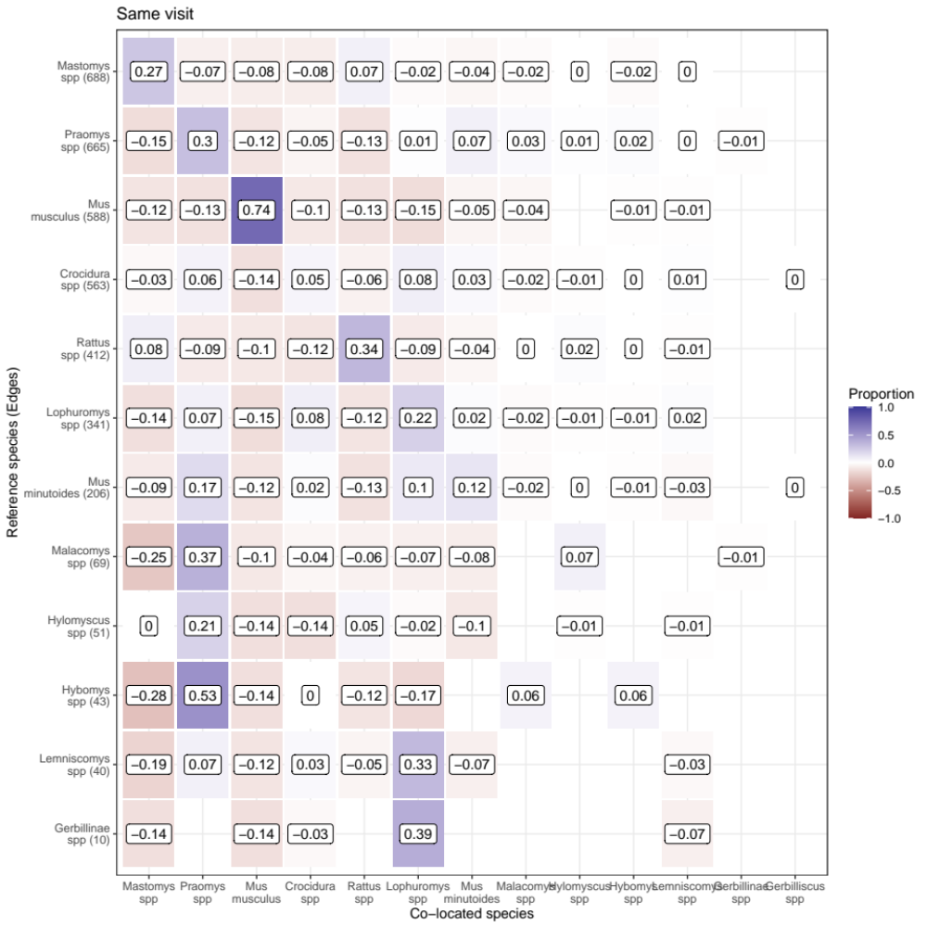
Figure 3. The proportion of co-located rodents for each species detected in the current study. The reference species for the contact is shown on the Y-axis with the number of edges representing all contacts for that species with individuals of species shown on the X-axis. Positive values represent the difference between the observed proportion of contacts minus the proportion expected from the null model (i.e. proportional excess contacts).

Estimating the effect of land use on species occurrence and richness
We modelled the association of land-use type on the occurrence of small mammal species in a multi-species framework, incorporating incomplete detection adjusting for co-variates that could influence species occurrence. We found that several species occurred solely within human dominated landscapes (Villages, either within or without buildings, or Agriculture) or within minimally disturbed land use types (Forested areas) (Figure 4.). No species showed high probability of occurrence across all land-use types. This suggests that heterogenenous land-use may limit dispersal of individuals from one region to another.
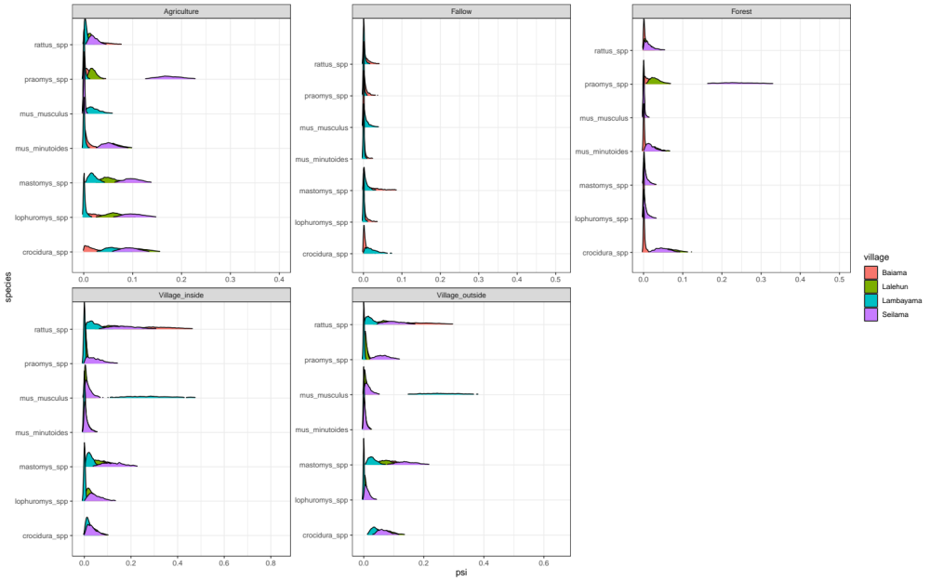
Figure 4. The sampled probability of occurrence (psi), within different land-use types, for the seven most commonly trapped small mammals. Colours signify the village site to highlight the observed heterogeneity between village sites in the occurrence of these species.
We found high heterogeneity in the probability of occurrence within different land-use types by study village. For example, the median probability of occurrence of M. musculus within a trapping grid in village settings was 0.30 (95% Credible Interval (C.I.) = 0.12-0.57) within buildings and 0.27 (95% C.I. = 0.15-0.43) outside buildings in Lambayama but 0.01 (95% C.I. = <0.01-0.05) and 0.01 (95% C.I. = <0.01-0.04) respectively in all other villages. The probability of occurrence of M. natalensis across all village sites was less heterogeneous, with a median probability of occurrence within buildings of 0.10 (95% C.I. = 0.02-0.19), outside buildings 0.08 (95% C.I. = 0.02-0.19) and agricultural settings 0.07 (95% C.I. = 0.01-0.13).The probability of occurrence in forested settings for this species was less than 0.01 (95% C.I. = <0.01-0.02).

Co-occurrence of species (Needs more work)
Finally, we found that species co-occurrence differed between species pairs. The probability of occurrence of M. natalensis in the absence of M. musculus was 0.28; the presence of M. musculus at a nearby trapping grid reduced this to 0.16. This antagonism was greater than that observed for another invasive rodent species, R. rattus, where probability of occurrence of M. natalensis in the absence of R. rattus was 0.24 and the presence of R. rattus reduced this to 0.18. These findings further suggest a strong displacement effect of M. musculus which is not seen with R. rattus at our study sites.

Discussion (Will need developing further)
Here, we have presented the results from a systematic small-mammal trapping study in Eastern Sierra Leone performed to characterise the rodent species assemblages in a Lassa fever endemic region. We found that species richness and diversity is greater than that reported from other regions of the Lassa fever endemic zone and that there is a strong association of land-use on the species composition of these rodent assemblages.
Rodent species richness was found to be greatest in agricultural settings where small-mammals with greatest occurrence in human dominated land-use types and those in forested settings were found to occur. These settings may provide opportunity for Lassa mammarenavirus transmission between rodent species and providing a method for introduction of the virus into populations with limited dispersal ranges. Within human dominated settings
We identified highly connected networks for rodents trapped in agricultural and village land-use types. Contact between individuals is likely greatest in agricultural settings. The true contact rates between rodents within houses is potentially lower as while rodents where located within close proximity to others there may be limited true movement outside of colonised buildings.
Across most of our village study sites we identified high occurrence of the principal rodent reservoir of Lassa mammarenavirus, with this species concentrated in areas of significant anthropogenic disturbance (i.e. Villages, within and outside of buildings and in agricultural land). However, in Lambayama, our most urban site, this species was found to have low occurrence with probable displacement by the invasive rodent, M. musculus. These findings suggest that the hazard of human exposure to Lassa mammarenavirus is concentrated in more rural village settings and in those villages at low risk of M. musculus invasion and establishment.

Conclusion
We present data on rodent species assembalges within a Lassa fever endemic region and identifiy high occurrence of rodent species suitable as reservoirs for Lassa mammarenavirus which vary importantly by land-use type and village study site. We are able to recreate potential contact networks between individual rodents within these settings which may explain the spatial and temporal heterogeneity of Lassa fever outbreaks in endemic regions. Further research is required to link these rodent population structures with viral transmission in these landscapes.

Supplementary figures.
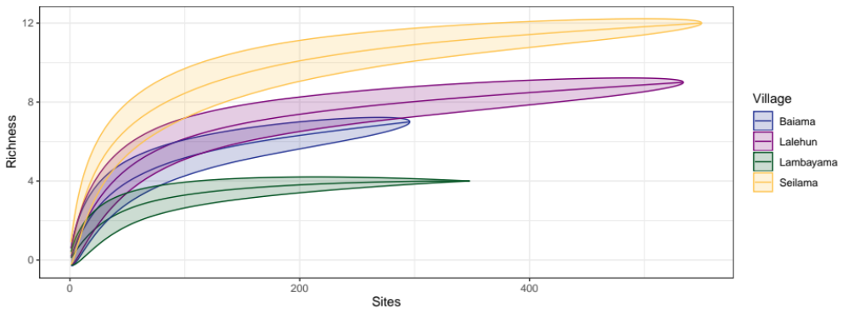
Supplementary figure 1. Species accumulation curves for each village site
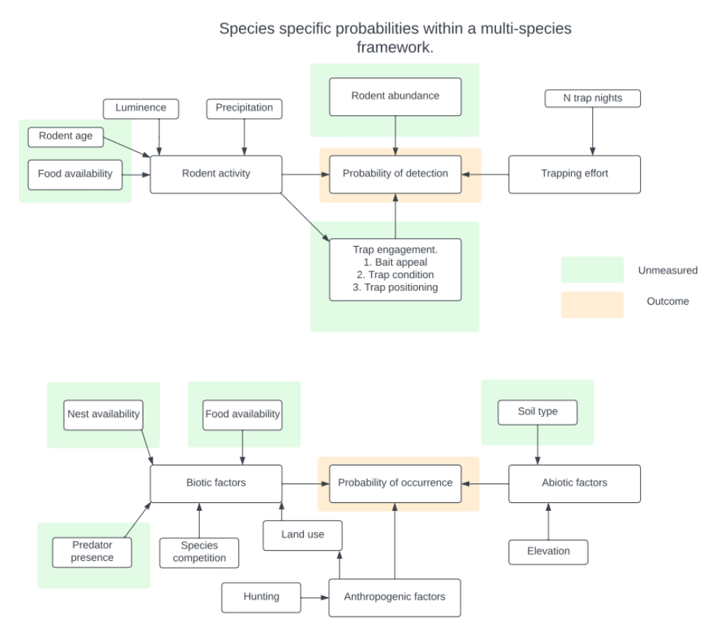
Supplementary figure 2. Directed Acyclic Graph used for occupancy and detection model specification
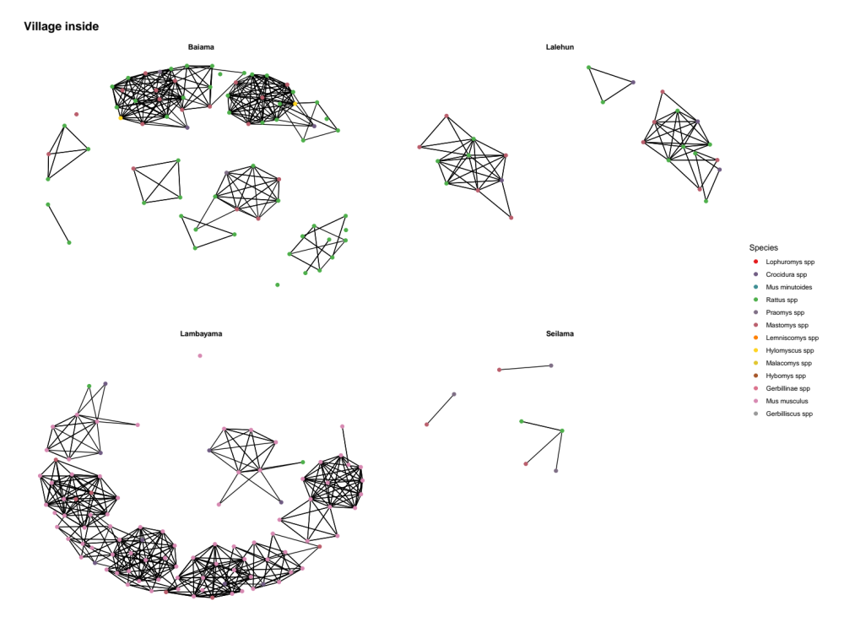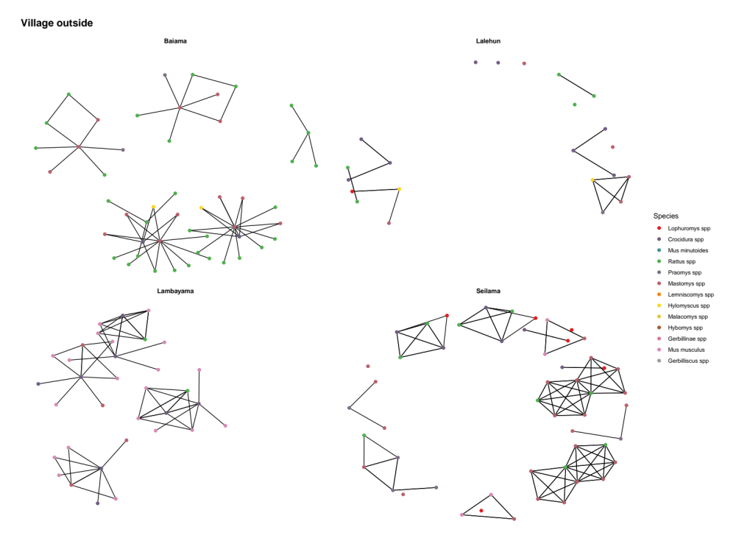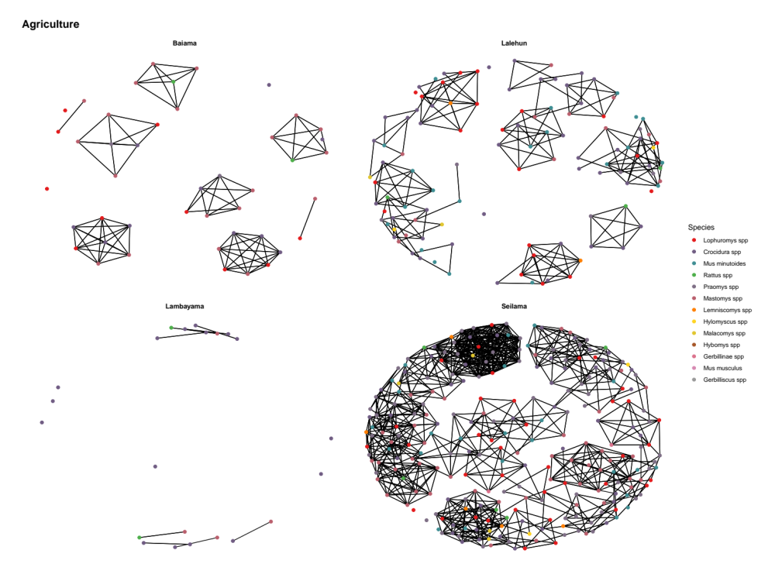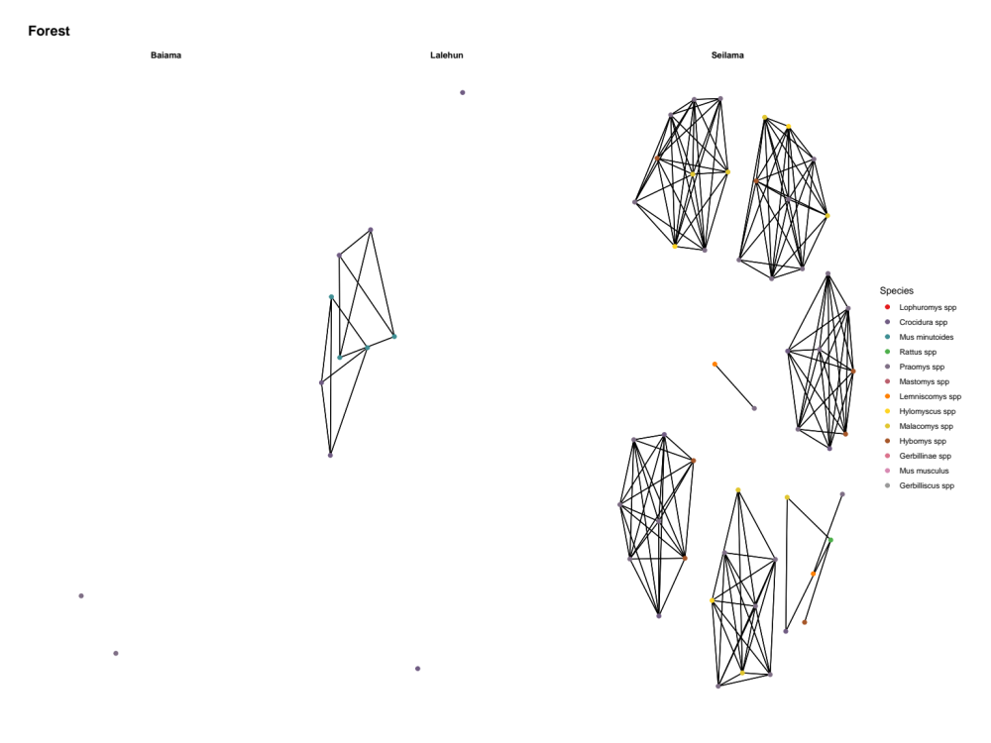

References
Basinski, Andrew J., Elisabeth Fichet-Calvet, Anna R. Sjodin, Tanner J. Varrelman, Christopher H. Remien, Nathan C. Layman, Brian H. Bird, et al. 2021. “Bridging the Gap: Using Reservoir Ecology and Human Serosurveys to Estimate Lassa Virus Spillover in West Africa.” Edited by Amy Wesolowski. PLOS Computational Biology 17 (3): e1008811. https://doi.org/10.1371/journal.pcbi.1008811.
Cuypers, Laura N, Wim L Cuypers, Amélie Gildemyn-Blomme, Laura Abraham, Senne Aertbeliën, Apia W Massawe, Benny Borremans, Sophie Gryseels, and Herwig Leirs. 2017. “No Evidence for Avoidance of Black Rat Scent by the Presumably Less Competitive Natal Multimammate Mouse in a Choice Experiment.” African Zoology 52 (2): 119–23. https://doi.org/10.1080/15627020.2017.1307139.
Doser, Jeffrey W., Andrew O. Finley, Marc Kéry, and Elise F. Zipkin. 2022. “spOccupancy: An r Package for Single-Species, Multi-Species, and Integrated Spatial Occupancy Models.” Methods in Ecology and Evolution. https://doi.org/10.1111/2041-210X.13897.
Fichet-Calvet, Elisabeth. 2014. “Chapter 5 - Lassa Fever: A Rodent-Human Interaction.” In The Role of Animals in Emerging Viral Diseases, edited by Nicholas Johnson, 89–123. Boston: Academic Press. https://doi.org/10.1016/B978-0-12-405191-1.00005-3.
Garba, Madougou, Ambroise Dalecky, Ibrahima Kadaoure, Mamadou Kane, Karmadine Hima, Sophie Veran, Sama Gagare, et al. 2014. “Spatial Segregation Between Invasive and Native Commensal Rodents in an Urban Environment: A Case Study in Niamey, Niger.” PLOS ONE 9 (11): e110666. https://doi.org/10.1371/journal.pone.0110666.
IUCN. 2016. “The IUCN Red List of Threatened Species 2016: Mastomys Natalensis.” International Union for Conservation of Nature. https://doi.org/10.2305/IUCN.UK.2016-3.RLTS.T12868A22425266.en.
Klitting, Raphaëlle, Liana E. Kafetzopoulou, Wim Thiery, Gytis Dudas, Sophie Gryseels, Anjali Kotamarthi, Bram Vrancken, et al. 2021. “Predicting the Evolution of Lassa Virus Endemic Area and Population at Risk over the Next Decades.” Preprint. Microbiology. https://doi.org/10.1101/2021.09.22.461380.
Leirs, Herwig, Ron Verhagen, and Walter Verheyen. 1993. “Productivity of Different Generations in a Population of Mastomys Natalensis Rats in Tanzania.” Oikos 68 (1): 53–60. https://doi.org/10.2307/3545308.
Martins, Thiago G., Daniel Simpson, Finn Lindgren, and Håvard Rue. 2013. “Bayesian Computing with INLA: New Features.” Computational Statistics & Data Analysis 67 (November): 68–83. https://doi.org/10.1016/j.csda.2013.04.014.
McCormick, J B, P A Webb, J W Krebs, K M Johnson, and E S Smith. 1987. “A Prospective Study of the Epidemiology and Ecology of Lassa Fever.” The Journal of Infectious Diseases 155 (3): 437–44. https://doi.org/10.1093/infdis/155.3.437.
Pebesma, Edzer. 2018. “Simple Features for r: Standardized Support for Spatial Vector Data.” The R Journal 10 (1): 439–46. https://doi.org/10.32614/RJ-2018-009.
R Core Team. 2021. R: A Language and Environment for Statistical Computing. Vienna, Austria: R Foundation for Statistical Computing. https://www.R-project.org/.
Redding, David W., Rory Gibb, Chioma C. Dan-Nwafor, Elsie A. Ilori, Rimamdeyati Usman Yashe, Saliu H. Oladele, Michael O. Amedu, et al. 2021. “Geographical Drivers and Climate-Linked Dynamics of Lassa Fever in Nigeria.” Nature Communications 12 (1): 5759. https://doi.org/10.1038/s41467-021-25910-y.
Redding, David W., Lina M. Moses, Andrew A. Cunningham, James Wood, and Kate E. Jones. 2016. “Environmental-Mechanistic Modelling of the Impact of Global Change on Human Zoonotic Disease Emergence: A Case Study of Lassa Fever.” Methods in Ecology and Evolution 7 (6): 646–55. https://doi.org/10.1111/2041-210X.12549.
Rue, Håvard, Sara Martino, and Nicolas Chopin. 2009. “Approximate Bayesian Inference for Latent Gaussian Models by Using Integrated Nested Laplace Approximations.” Journal of the Royal Statistical Society: Series b (Statistical Methodology) 71 (2): 319–92.
World Health Organisation. 2022. “Lassa Fever.” 2022. https://www.who.int/westernpacific/health-topics/lassa-fever.
Yaro, Clement Ameh, Ezekiel Kogi, Kenneth Nnamdi Opara, Gaber El-Saber Batiha, Roua S. Baty, Ashraf Albrakati, Farag M. A. Altalbawy, Innocent Utenwojo Etuh, and James Paul Oni. 2021. “Infection Pattern, Case Fatality Rate and Spread of Lassa Virus in Nigeria.” BMC Infectious Diseases 21 (1): 149. https://doi.org/10.1186/s12879-021-05837-x.

