Land use gradients drive spatial variation in Lassa fever host assemblages in Eastern Sierra Leone.

2023-01-12

### Author list

David Simons, Rory Gibb, Umaru Bangura, Dianah Sondufu, Joyce Lamin, James Koninga, Momoh *, Mike Dawson, Joseph Lahai, Rashid Ansumana, Deborah Watson-Jones, Richard Kock, Kate E. Jones.

# Abstract

The natal multimammate mouse (*Mastomys natalensis*) is the primary reservoir species of the zoonotic infectious disease, Lassa fever (*Lassa mammarenavirus*). This disease is endemic to Sierra Leone with the highest incidence of human infection reported from the Eastern Province. The spatial occurrence and abundance of this rodent species is regulated by the human environment and biotic interactions within small mammal communities, little is known about these effects even in highly endemic areas of Lassa fever. We conducted a rodent trapping study at four village study sites between 2020-2023, comprising 40,152 trap nights to understand how *M. natalensis* is distributed across a gradient of landuse types and how this may be influenced by the broad small mammal community structure. We conducted a Bayesian multiple species occupancy model, accounting for imperfect detection, to test the hypothesis that *M. natalensis* were more likely to occur within human dominated landuse types. We found that *M. natalensis* occurrence increased from less to more human dominated landscapes. We further found that this effect was not replicated across scales as the probability of occurrence in peri-urban settings was lower than in rural settings. Interactions within the small mammal community appeared to moderate the occurrence of *M. natalensis*, with the presence of *Mus musculus*, but not *Rattus rattus* reducing the probability of occurrence of *M. natalensis*. This finding may explain prior observations of lower-than-expected human cases of Lassa Fever fever from urban settings in endemic regions. Our findings highlight the spatially heterogeneous distribution of rodent species across landuse gradients with implications for the hazard of Lassa fever outbreaks.

# Introduction

Lassa fever, caused by *Lassa mammarenavirus* (LASV) is an endemic zoonotic infectious disease in West Africa. There are large uncertainties around estimates of the annual number human of infections in the region of between 100,000-4,383,600 (McCormick et al. 1987; Basinski et al. 2021). The majority of infections remain undetected and it is estimated that up-to 80% of these are pauci- or asymptomatic infections (McCormick et al. 1987). Few infections are expected to lead to clinically severe cases but outcomes in confirmed clinical cases remains poor, with a reported case fatality rate of 16.5% (**simons_underreporting_2022?**). Anthropogenic landuse change and changing climate are proposed to increase the suitable area for both the primary reservoir of LASV (*Mastomys natalensis*) and environmental suitability for the virus itself (i.e. increased temperature and precipitation), together increasing opportunities for viral spillover into growing human populations (Redding et al. 2016, 2021; Klitting et al. 2021). Lassa fever is currently considered endemic in eight West African countries (Nigeria, Guinea, Sierra Leone, Liberia, Mali, Benin, Ghana and Togo) (World Health Organisation 2022). The location, scale and frequency of Lassa fever outbreaks in human communities is highly spatially heterogeneous within these countries. For example, within Sierra Leone, Lassa Fever is typically reported from rural settings in the East of the country. The drivers of spatial clustering of human cases are unknown, in part due to geographical biases in reporting and research effort, but also because the potential drivers of this heterogeneity in Lassa fever risk have rarely been systematically studied (**simons_2022_scoping?**).

The persistence, or lack of persistence, of LASV infection in rodent communities may be one factor driving the observed spatial clustering of zoonosis spillover into human populations. Persistence of the pathogen within *M. natalensis* communities may not occur if these populations are geographically isolated and below a critical density or abundance. Anthropogenic landuse change regulates small mammal communities through local abiotic environments and biotic interactions with other small mammal species.

*M. natalensis* is found in 13 of 14 continental West African nations (the species has not been reported from The Gambia) and in all other sub-Saharan African countries (IUCN 2016). It is a commensal rodent species and is abundant in and around areas of human-dominated landscapes where it is considered a pest species (Leirs, Verhagen, and Verheyen 1993). The introduction of non-native commensal rodent species (i.e., *Rattus rattus* and *Mus musculus*) has led to increased competition for resources and displacement of *M. natalensis* from some locations within its natural range (Cuypers et al. 2017; Garba et al. 2014). Population dynamics within this reservoir species, correlated with resource availability and rainfall pulses (with increased abundance at the beginning of the dry season), are associated with outbreaks of Lassa fever in human populations (Redding et al. 2021). Few studies to date have used longitudinal, high intensity rodent trapping to characterise rodent species assemblages in Lassa fever endemic regions ((**simons_2022_scoping?**)). Understanding the spatial distribution of *M. natalensis* and their population dynamics in the context of competing rodent species is vital to guide investigations of the epidemiology of Lassa fever (Basinski et al. 2021).

The occurrence of *M. natalensis* in human dominated habitats has been reported from Guinea, Nigeria and Sierra Leone []. Few studies have investigated their occurrence systematically along landuse gradients of anthropogenic disturbance [].

Here, we conducted repeated, systematic, rodent trapping in the Eastern province of Sierra Leone, along a land-use gradient to model the association of landuse and occurrence of *M. natalensis* and more generally small mammal communities. We aimed to investigate several questions. First, what is the diversity of rodent assemblages in varied landuse types in Eastern Sierra Leone? Second, how do patterns of landuse affect the occupancy of *M. natalensis* and other sympatric rodents? Finally, is there evidence that the local spatial distribution of *M. natalensis* is regulated by biotic interactions with co-occurring species? We expect these analyses to further our understanding of rodent species assemblage structures that may explain observed patterns of Lassa fever spillover.

# Methods

## Data collection

We conducted rodent trapping surveys between October 2020-April 2023 within and around four village study sites (Baiama; latitude = 7.8375, longitude = -11.2683, Lalehun; latitude = 8.1973, longitude = -11.0803, Lambayama; latitude = 7.8505, longitude = -11.1969, and Seilama; latitude = 8.1224, longitude = -11.1936) in the Lassa fever endemic zone of the Eastern Province of Sierra Leone (Figure 1A.). Surveys were conducted in trapping grids along a land use gradient of anthropogenic disturbance comprising, forest, agriculture (including fallow and currently in use areas), and villages (within and outside of permanent structures) (See Supplementary Material 1 for images of trapping grid locations). Trapping grids were designated during the initial trapping survey session, one grid was deployed in forest land use, three to four grids were deployed in agricultural land with two grids deployed in village land use. For one village study site, Lambayama, there were no local forest areas, so this land use type was omitted (Figure 1B-E). Trapping survey sessions within each village occurred four times annually with two sessions in each of the rainy and dry seasons (May to November and December to April, respectively), giving a total of 10 trapping sessions over the study period (Figure 1F).

Village study sites and trapping grids within the village study sites were selected to be representative of land use in the Eastern Province of Sierra Leone and based on accessibility to the sites during all seasons and acceptability of the study protocol to the village study site community. At each trapping grid 49 Sherman traps [**size and reference**] were placed in a 7 trap by 7 trap grid, traps were placed 10 metres apart in a regular grid conforming to the local landscape (mean area = 2208 m2) (Figure 1G). For traps placed within permanent structures trap placement varied from this approach. Permanent structures were selected at random at each visit from a grid projected over the village area, with four traps placed within each structure. The location of each individual trap within trapping grids was geolocated for subsequent data processing. Traps were baited with a locally produced mixture of oats, palm oil and dried fish. Each morning the traps were checked and closed for the day prior to re-baiting during the evening. Each trapping survey session consisted of four consecutive trap nights (TN) at each trapping grid within the village study site. We collected a total of 40,152 trap-nights over 10 trapping visits between 2020-11-30 and 2023-04-28.

The location data of individual traps were harmonised to standardised trapping grid cells as a data cleaning step. First, the spatial extent of individual traps, with a 1 metre buffer, within a trapping grid across all trapping sessions was obtained. Second, a regular grid was constructed to overlay this area with a cell size of 49 m2, individual traps were allocated to this grid cell if they were contained within its borders. Finally, centroids of these grid cells were assigned to the trap to allow for aggregation over multiple trapping sessions. The sf package in the R statistical computing language was used for geospatial manipulation and analysis (Pebesma 2018; R Core Team 2021). The four consecutive trap nights obtained from each trap during a single survey are aggregated as a single replicate for the subsequent statistical analysis.

Trapped rodents were handled by trained fieldworkers, sedated with halothane and euthanised prior to obtaining morphological measurements and samples of blood and tissue (**reference to RVC and local ethics approval**) following published guidance (Fichet-Calvet 2014). The rodents sex was determined based on external and internal genitalia. Age estimation was performed through description of the rodents reproductive status (identification of perforate or imperforate vagina, scarring from prior embryo development, current pregnancy status or descent of testes and seminal vesicle development) and weighing of dried eye lenses [ref]. Carcasses were destroyed through incineration to eliminate risk of pathogen transmission.

Taxonomic identification was performed in the field based on external characteristics using an adapted taxonomic key (Supplementary Material 2.). This key included external morphological measurements and characteristics from Kingdon and Monadjem references, using the taxonomic references of … Morphological identification is unable to distinguish some small-mammal species within the study area to sub-genera level. Therefore, molecular identification of individuals to species level was performed on whole blood, tissue or dried blood spots. Samples were stored at -20°C until processing, genomic DNA was extracted using QIAGEN DNAeasy kits as per the manufacturers instructions [ref]. DNA extracts were amplified using platinum *Taq* polymerase (Invitrogen) and cytochrome B primers [reference Elisabeths primers]. DNA amplification was assessed through gel electrophoreisis with successful amplification products undergoing Sanger sequencing. Classification of obtained sequences was through BLAST compared to NCBI records for rodent cytochrome B [reference process]. Protocols for rodent trapping and sampling are included as supplementary material.

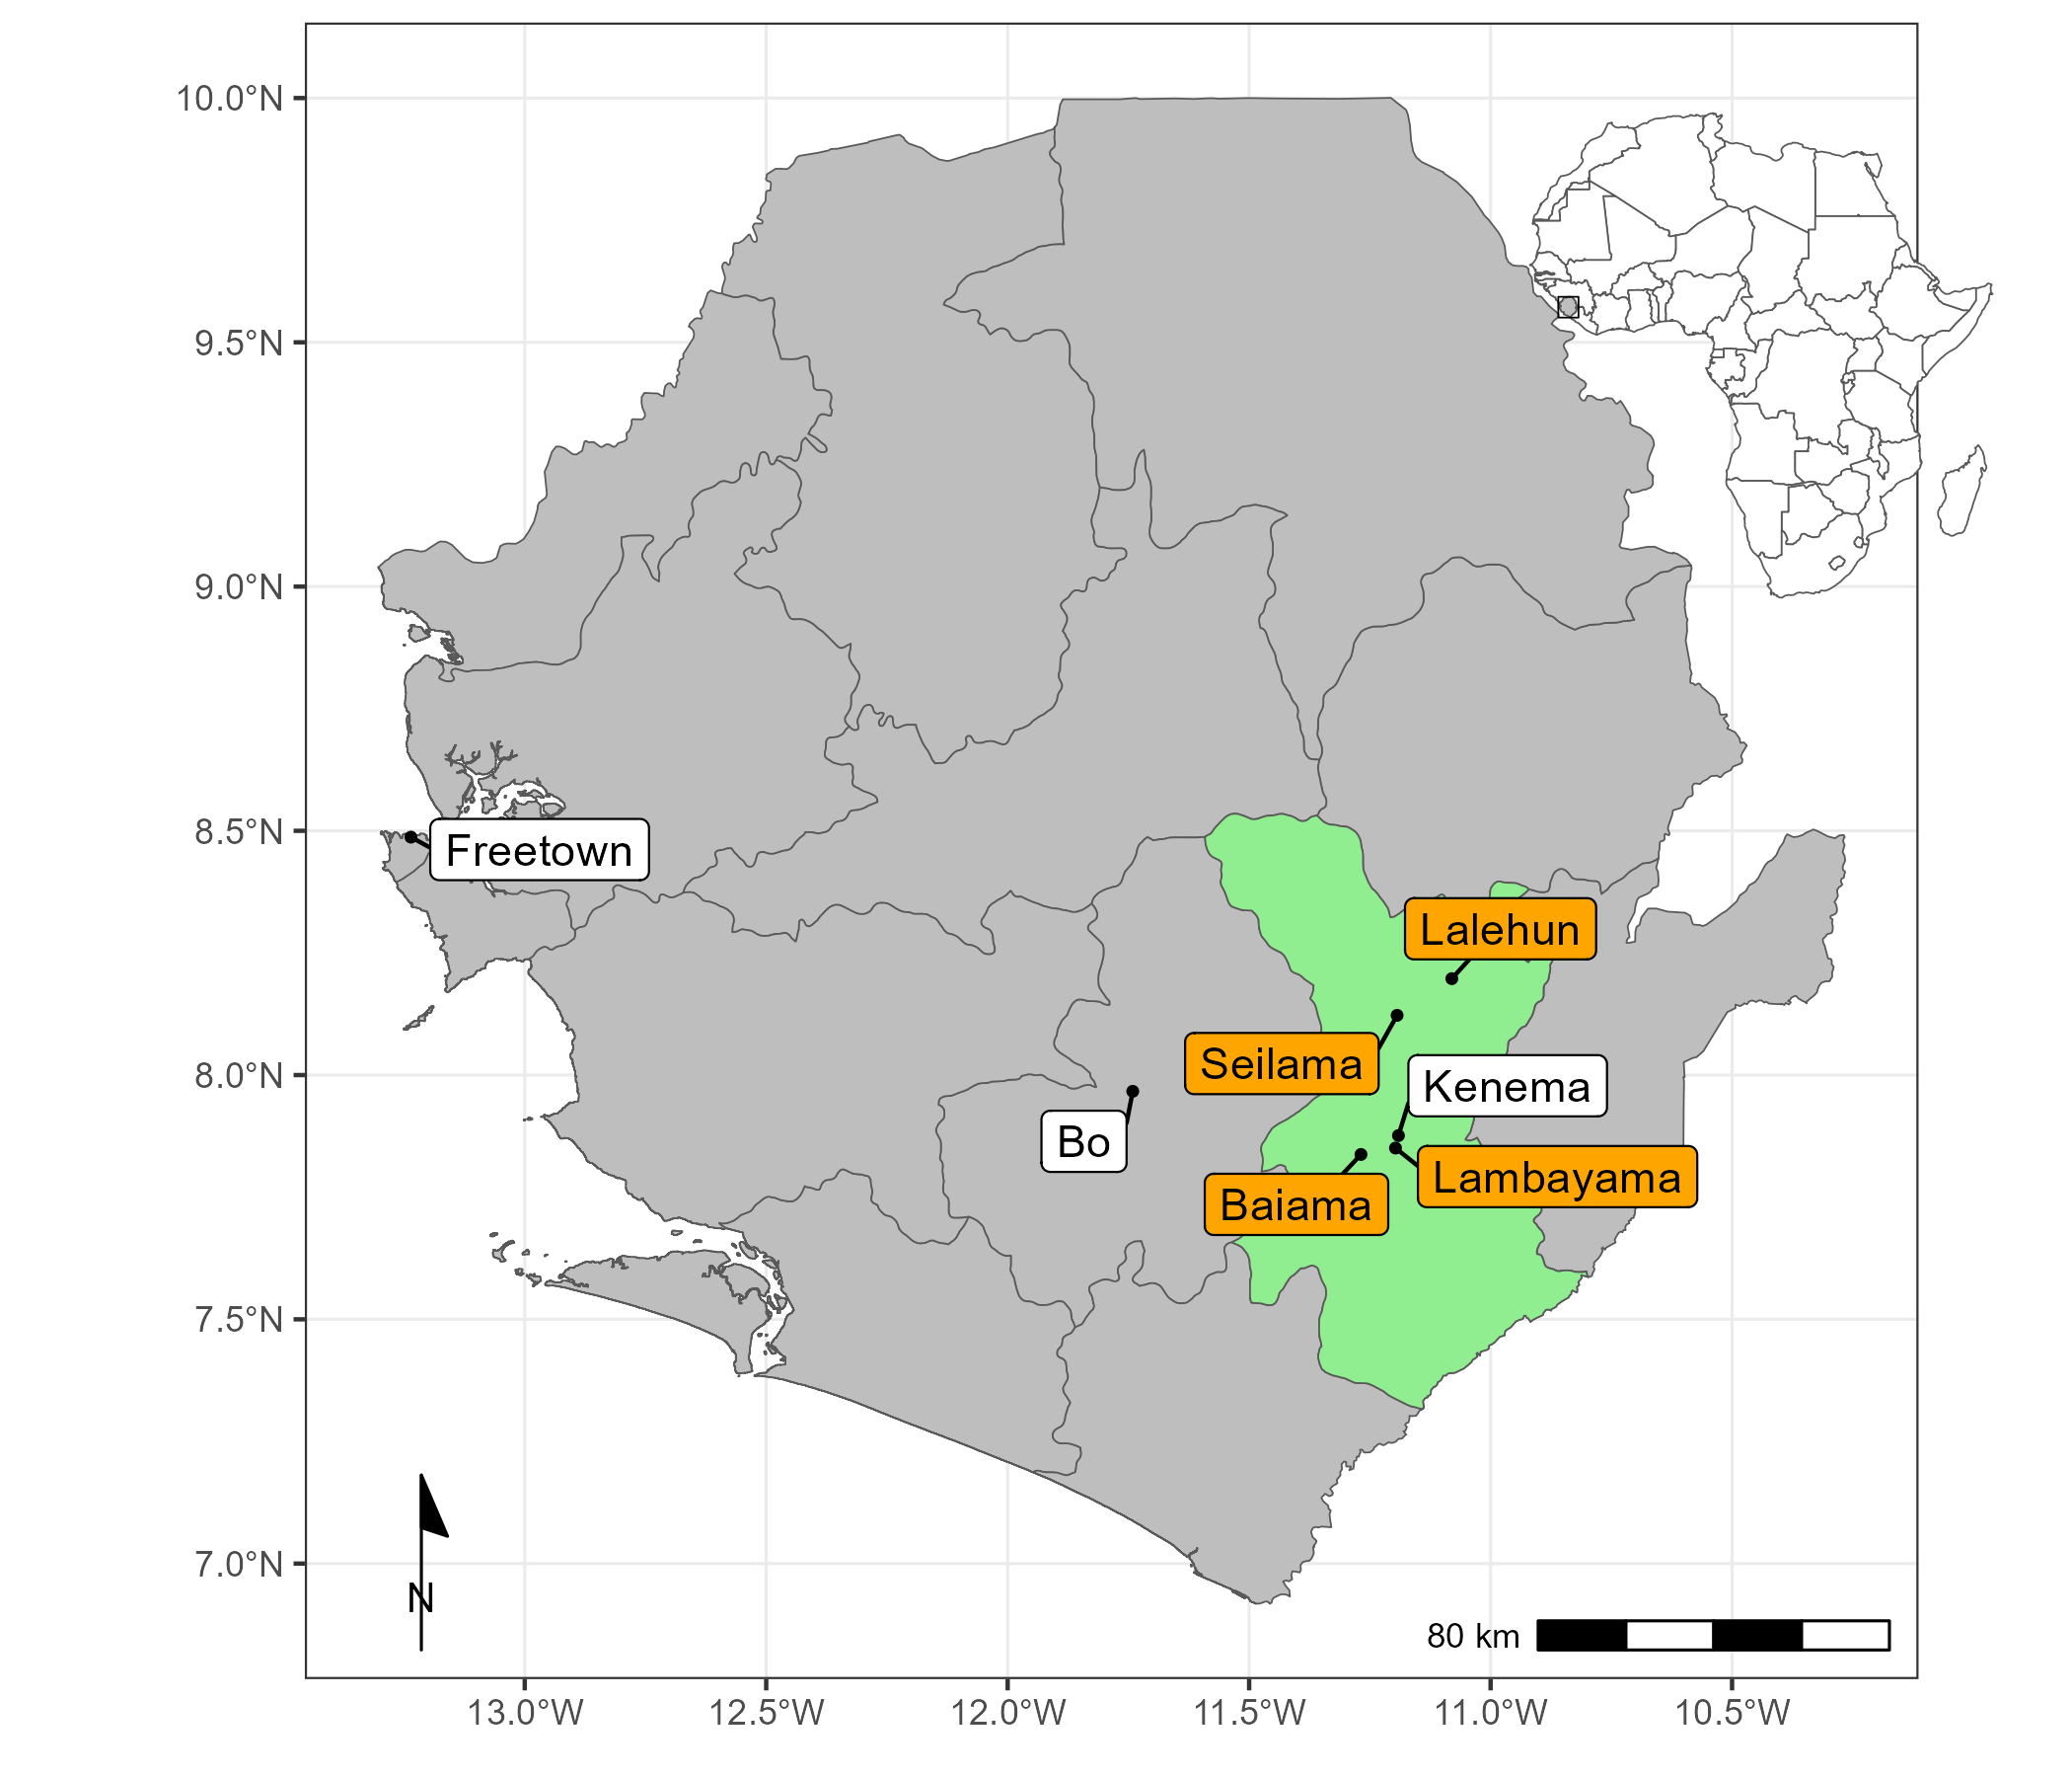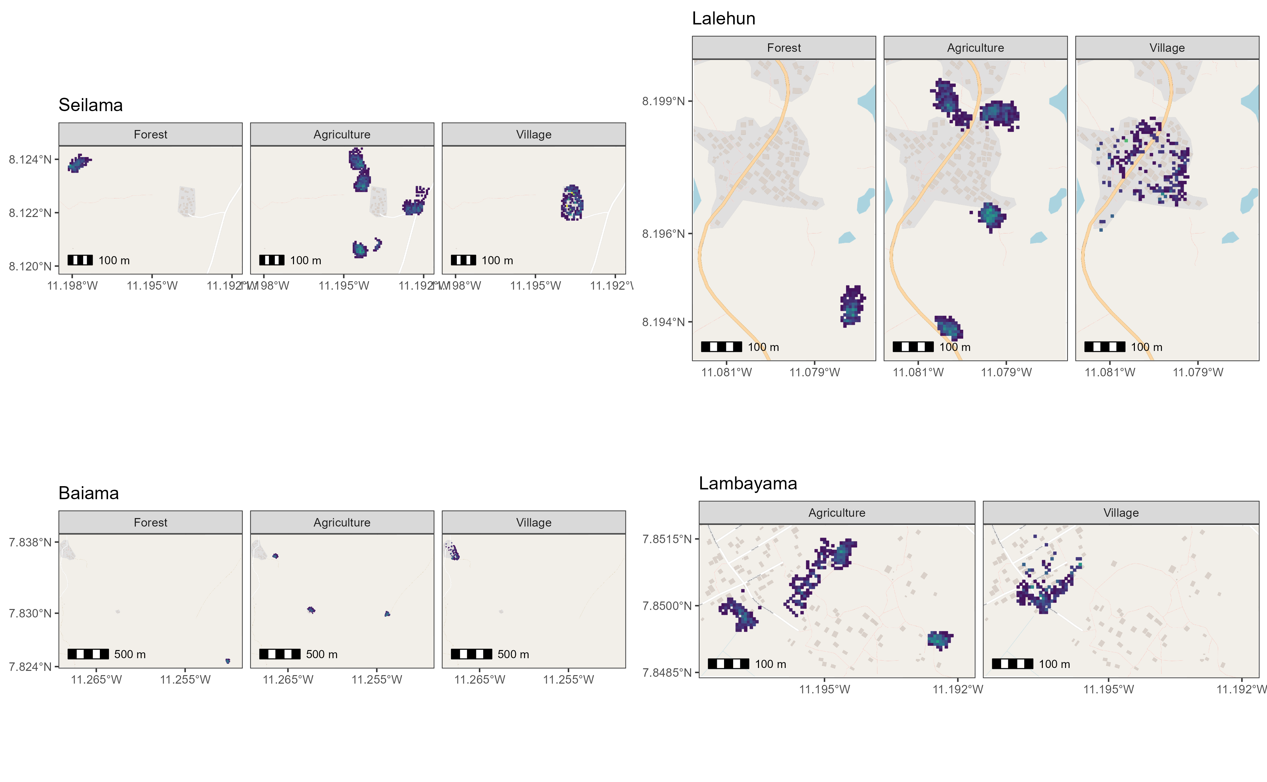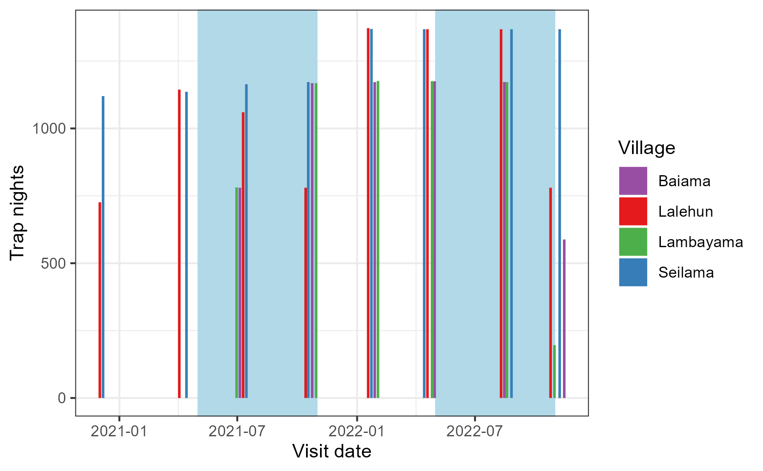

## Analysis

### Description of rodent detection and species assemblage structure

Adequacy of trapping effort was assessed using species accumulation curves produced for each village study site and each land use type with a village study site (Supplementary Material 3.), suggesting sufficient effort to detect expected rodent species within each village site. We constructed detection/non-detection histories for each individual trap and rodent species, assigning “1” when the species was detected and “0” otherwise. We calculated species assemblages at multiple spatial scales. First, all species identified across all village sites and land use types. Second, all species identified within a village study site. Third, all species identified within a single land use type within a single village study site. We report species richness and Shannon diversity $H$ at these different spatial scales (Equation 1.), where

$$H=−∑\left(p_{i}\right)*ln\left(p_{i}\right)$$

Here $p_{i}$ is the proportion of the entire community made up of species $i$.

### Estimating the effect of land use on species occurrence and richness

To incorporate differential probabilities of detection that may be driven by environmental conditions durinng the trapping surveys and between species, we use a Bayesian multi-species occupancy framework to understand the association of small mammal species and land use types. Variable selection was informed from a pre-specified Directed Acyclic Graph (Supplementary Material 4.). Models were defined using the spOccupancy package in the R statistical computing language (Doser et al. 2022). This approach defines the true presence or absence ($z$) of a species ($i$), at site ($j$) as arising from a Bernoulli process (Equation 2.). Where $ψ_{j}$ is the probability of occurrence of a species at a site during a given replicate. This is modelled using a logit link where $β_{i}$ are the regression coefficients, including an intercept that describes the effects of covariates $x_{i,j}$ with $​^{⊤}$ representing the transposition of column vector $x_{i,j}$ (Equation 3.).

$$z_{i,j}∼Bernoulli\left(ψ_{i,j}\right)$$

$$logit\left(ψ_{i,j}\right)=x_{i,j}^{⊤}β_{i}$$

The regression coefficients in these multi-species occupancy models are described as random effects arising from a common community level distribution (Equation 4.). Where $μ_{β}$ represents the community level mean effect for each occurrence covariate effect and $T_{β}$ is a diagonal matrix representing the variability of these among species in the community.

$$β_{i}∼\text{Normal}\left(μ_{β},T_{β}\right)$$

The detection component estimates the unobserved $z_{i,j}$. Here, $y_{i,j,k}$ is the observed detection or non-detection of a species $i$, at site $j$, during replicate $k$ (Equation 5.). This is approached as arising from a Bernoulli process conditional on the true latent occurrence process $p_{i,j,k}$. The probability of a species being detected at a site, during a replicate (given it is present at site $j$), is a function of site and replicate specific covariates $V$ and a set of species-specific regression coefficients $α_{i}$ (Equation 6.).

$$y_{i,j,k}∼Bernoulli\left(p_{i,j,k}z_{i,j}\right)$$

$$logit\left(p_{i,j,k}\right)=v_{i,j,k}^{⊤}α$$

Similarly to Equation 3., these coefficients are described as random effects arising from a common community level distribution, where $μ_{α}$ represents the community level mean effect for each detection covariate effect and $T_{α}$ is a diagonal matrix representing the variability of these among species in the community (Equation 7.).

$$α_{i}∼\text{Normal}\left(μ_{α},T_{α}\right)$$

Minimally informative priors were specified for community and species level coefficients ( $α$ and $β$, a normal prior of mean = 0, variance = 2.72) and for community level occurrence and detection variance parameters ( $T_{α}$ and $T_{β}$, 0.1 for the scale and shape parameters of the inverse Gamma prior).

We included covariates in the model based on a pre-specified Directed Acyclic Graph and after assessing for co-linearity (defined as strong correlation >0.8) among variables (Supplementary Figure 2.). Continuous variables were standardised by scaling to values between 0-1. The fully specified model is defined in Equation 6 and 7.

$$
\text{Probability of occurrence} \sim \text{Land use type} + \text{Village} + \text{scale}(\text{Distance to permanent structure}) + \\
\text{scale}(\text{Distance to village centre}) + \text{scale}(\text{Elevation}) \tag{8}
$$

$$\text{Probability of detection}∼\text{scale}\left(\text{Monthly precipitation}\right)+\text{Moon fraction}+\text{scale}\left(\text{Number of trap nights}\right)$$

Using this model, we estimate occupancy probability for each species in different land use types. Only estimates for species with detections from at least X trapping grid cells are included to avoid inference from limited data. We estimate species richness in each habitat type by obtaining the sum of species at a trapping site for each iteration of the Bayesian sampling process to compare rodent assemblage associations with land use classification.

### Co-occurrence of species (**This approach may change**)

To investigate the presence of competitive exclusion by rodent species in this setting we adopted a Binomial joint likelihood model fit using Integrated Nested Laplace Approximation (INLA) in the R statistical computing language (Rue, Martino, and Chopin 2009; Martins et al. 2013). Co-occurrence models were set up to estimate the probability of detection of two species $Γ_{a}$ and $Γ_{b}$ (Equation 10 and Equation 11). Here, $γ$ is the species specific intercept for species $a$ and $b$ respectively. $A.co.B$ and $B.co.A$ represent the co-occurrence of species $a$ with species $b$ and species $b$ with species $a$ respectively.

$$Γ_{a}∼γ_{a}+A.co.B$$

$$Γ_{b}∼γ_{b}+B.co.A$$

Minimally informative priors were set for the intercept and species co-occurrence variables with a mean of 0 and precision of 1.

# Results

## Rodent occurrence and species assemblage structure

During the study period Y individuals were obtained from 30,628 trap-nights across the four village study sites (1.7% trap-success (TS)). The greatest number of individuals, highest species richness and Shannon diversity values were detected in agricultural land use type. The greatest TS was obtained from traps set within village land use (i.e. within and outside of permanent structures), although in these settings species richness and Shannon diversity was lower (Table 1). The village study sites of Seilama and Lalehun had the highest overall TS, species richness and Shannon diversity although the land use types with the highest values of these metrics differed between the villages. Lambayama, the village study site located within the expanding boundaries of Kenema city, had the lowest species richness and Shannon diversity with the majority of rodents trapped within the village land use type.

Table 1. The number of individual small mammals (N), the number of trap nights (TN), trap-success (TS %), species richness and Shannon diversity by village and landuse type.

| Village | Landuse | N | TN (TS %) | Species richness | Shannon diversity |
| --- | --- | --- | --- | --- | --- |
| All villages |  |  |  |  |  |
|  | Village | 193 | 7972 (2.4%) | 7 | 1.52 |
|  | Agriculture | 297 | 19168 (1.5%) | 13 | 1.87 |
|  | Forest | 39 | 3488 (1.1%) | 8 | 1.63 |
| Baiama |  |  |  |  |  |
|  | Village | 53 | 1552 (3.4%) | 5 | 0.86 |
|  | Agriculture | 32 | 3324 (1%) | 8 | 1.67 |
|  | Forest | 1 | 980 (0.1%) | 1 | 0.00 |
|  | Combined | 86 | 5856 (1.5%) | 9 | 1.46 |
| Lalehun |  |  |  |  |  |
|  | Village | 41 | 2100 (2%) | 6 | 1.36 |
|  | Agriculture | 81 | 5652 (1.4%) | 9 | 1.69 |
|  | Forest | 5 | 1176 (0.4%) | 2 | 0.67 |
|  | Combined | 127 | 8928 (1.4%) | 9 | 1.78 |
| Lambayama |  |  |  |  |  |
|  | Village | 65 | 1744 (3.7%) | 4 | 0.49 |
|  | Agriculture | 26 | 3920 (0.7%) | 5 | 0.95 |
|  | Combined | 91 | 5664 (1.6%) | 6 | 1.05 |
| Seilama |  |  |  |  |  |
|  | Village | 34 | 2576 (1.3%) | 6 | 1.52 |
|  | Agriculture | 158 | 6272 (2.5%) | 10 | 1.81 |
|  | Forest | 33 | 1332 (2.5%) | 7 | 1.48 |
|  | Combined | 225 | 10180 (2.2%) | 12 | 1.95 |

The most commonly detected rodent species across all village study sites and land use types was *M. natalensis* (N = 144, 19.2%), followed by *R. rattus* (N = 90, 12%), *M. musculus* (N = 86, 11.5%) and *Lophuromys rostratus* (N = 74, 9.9%) (Supplementary Material 5.). *M. natalensis* and *R. rattus* were detected in all village study sites *M. natalensis* was not detected in forest land use types (Figure 2.). Conversely, *Hybomys planifrons* and *Gerbilliscus kempii* were only detected in a single village study site, with *H. planifrons* detected in forest land use and *G. kempii* in agricultural land use types. The invasive rodent species *M. musculus* was only detected in Lambayama and Seilama village study sites within village land use types. The detection rate (the number of individuals detected per 1000 TN) varied by species, land use type and village study site. The greatest rate of detection was for *M. musculus* in the Lambayama village study site, with the other commensal species *M. natalensis* and *R. rattus* high across multiple village study sites within village land use types. *Praomys spp.* and *Crocidura spp.* had the highest detection rates in forest and agricultural land use types.

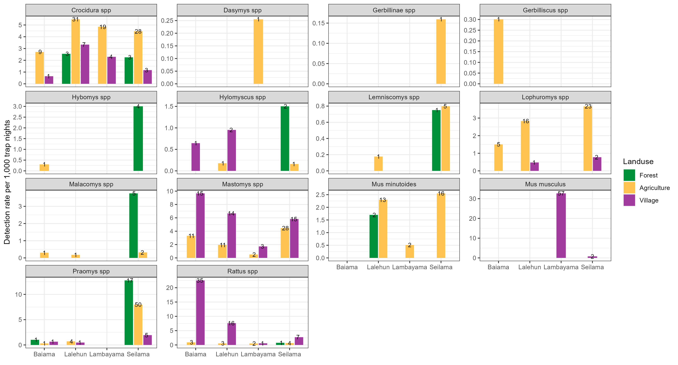

Figure 2. Detection rate of rodent species in land use type. The detection rate per 1000 TN and the number of detections of each rodent species in the three land use types across all four village study sites are shown. The scale for detection rate per 1000 TN on the y-axis varies by species. The number on the column is the number of individuals trapped within this setting. The greater rate if detection of *M. musculus* within village land use types are clearly shown with the other commensal rodent species being detected in more frequently in non-village land use types and accross more village study sites. Rodent species that were not detected in village land use types were generally less frequently detected throughout the study (i.e. *Lemniscomys spp.*, *Malacomys spp.* and *M. minutoides*)

There was little observed variation in species richness by season. The prevalence of a species (measured as the number of positive detections for a constant trapping effort), not accounting for incomplete detection, did not show a clear trend for all species. *M. natalensis*, *M. musculus*, *L. sikapusi* and *R. rattus* had higher prevalence in village settings during the rainy season compared to the dry season. Consistent with these observations *M. natalensis* and *L. sikapusi*, had lower prevalence in agricultural settings during the rainy season. No difference in agricultural settings was observed for *R. rattus* and *M. musculus* was never detected in non-village settings (Supplementary Material 6.).

## Estimating the effect of land use on species occurrence and richness

Posterior samples were drawn from the most parsimonious Bayesian occupancy model incorporating spatial autocorrelation (Supplementary Material 7.). Occurrence terms include land use type, village study site as a fixed effect, and terms for distance to the nearest permanent structure and elevation. Detection terms include precipitation, trapping effort (TN) and the moon fraction. We found three patterns of probability of occurrence ($ψ$) within a trapping grid cell for the seven included species with more than 10 detection across the different land use types (Figure 3.). First, *Praomys spp.* had higher probability of occurrence in forest land use with lower probabilities in agricultural and village land use types. Second, *Crocidura sp.*, *Lophuromys sp.* and *Mus minutoides* had highest probabilities of occurrence in agricultural land use with lower probabilities of occurrence in forest and village land use. Third, *M. natalensis*, *R. rattus* and *M. musculus* had highest probabilities of occurrence in village land use with lower occurrence probabilities in agricultural and village land use types. No species showed high probability of occurrence across all land use types, consistent with species being adapted to distinct ecological niches.

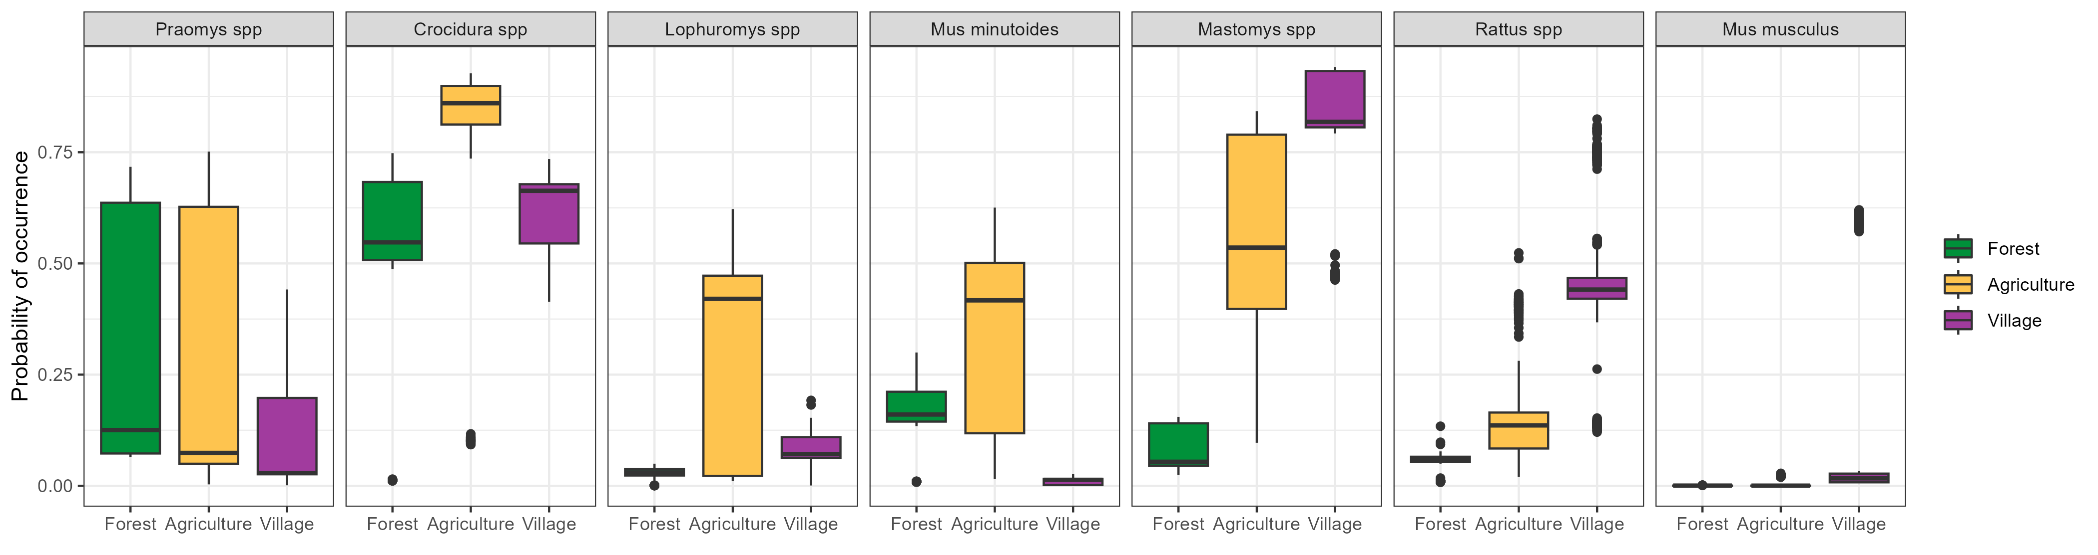

Figure 3. Probability of species occurrence across a land use gradient. The probability of occurrence ($ψ$), within different land use types, for the seven small mammal species with more than 10 detections is shown. The solid black horizontal line within the boxplot is the median values of the samples from the posterior distribution of psi. The hinges represent the 25th and 75th percentiles. Black points represent outliers to the box plots.

The probability of occurrence within a trapping grid cell of some species within the same land use types differed by village study site as suggested by the outliers in Figure 3. For example, the probability of occurrence of *Praomys spp.* at trapping grid cells within forest (median = 0.64, Inter-Quartile Range (IQR) = 0.001) and agricultural (median = 0.64, IQR = 0.04) land use types is greater at Seilama village study site than at the same land use types in other village study sites (median < 0.13). For the commensal rodent species *M. natalensis* and *R. rattus* probability of occurrence followed a consistent pattern of higher probability of occurrence within village land use than compared to agricultural land use within village study sites, although probabilities were lower for the Lambayama village study site. For *M. musculus* the probability of occurrence was generally low in all land use types except village land use at the Lambayama village study site. The occurrence probabilities for these three commensal species (*M. natalensis*, *R. rattus* and *M. musculus*) suggest that competition may be reducing the occurrence of *M. natalensis* and *R. rattus* in the presence of *M. musculus* which in it’s absence have high occurrence probabilities in village land use types.

**I am not sure the best representation for this section. Does it work better as land use type split by village for each species (A) or by village study site split by land use type for each species (B)? An alternative representation would be splitting by urbanisation based on human population density at the sites which splits it into Lambayama as the peri-urban and all others as rural (C). All convey the same data it’s just trying to decide which is a clearer representation of the message.**

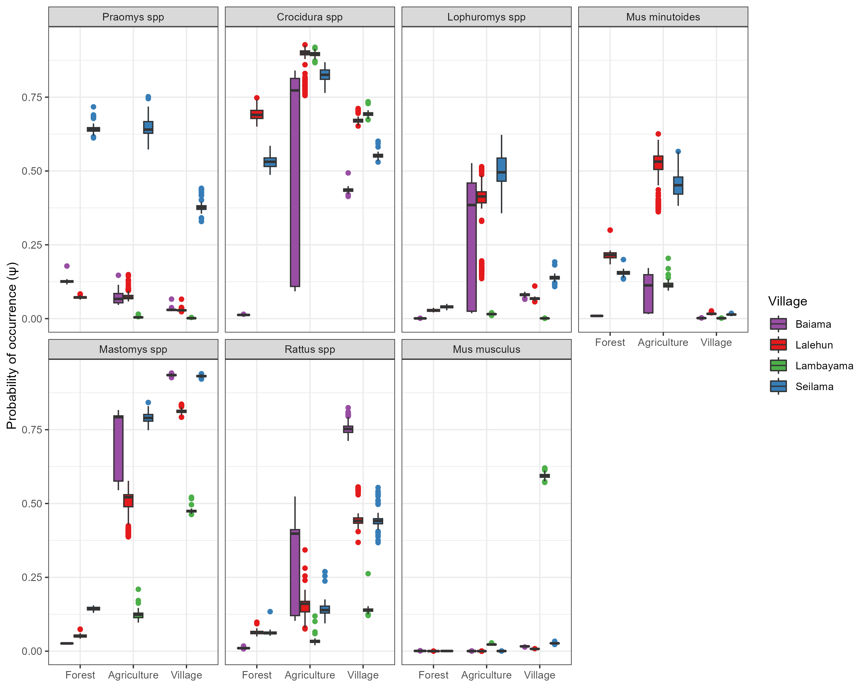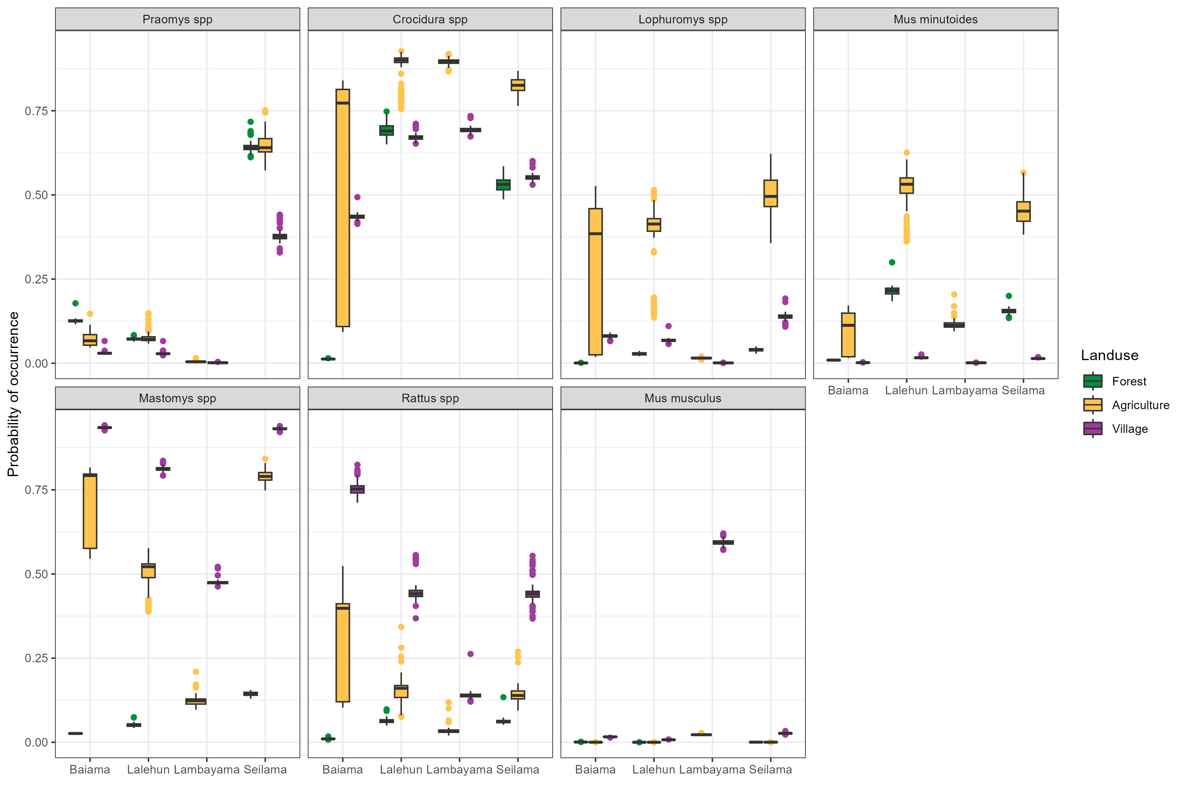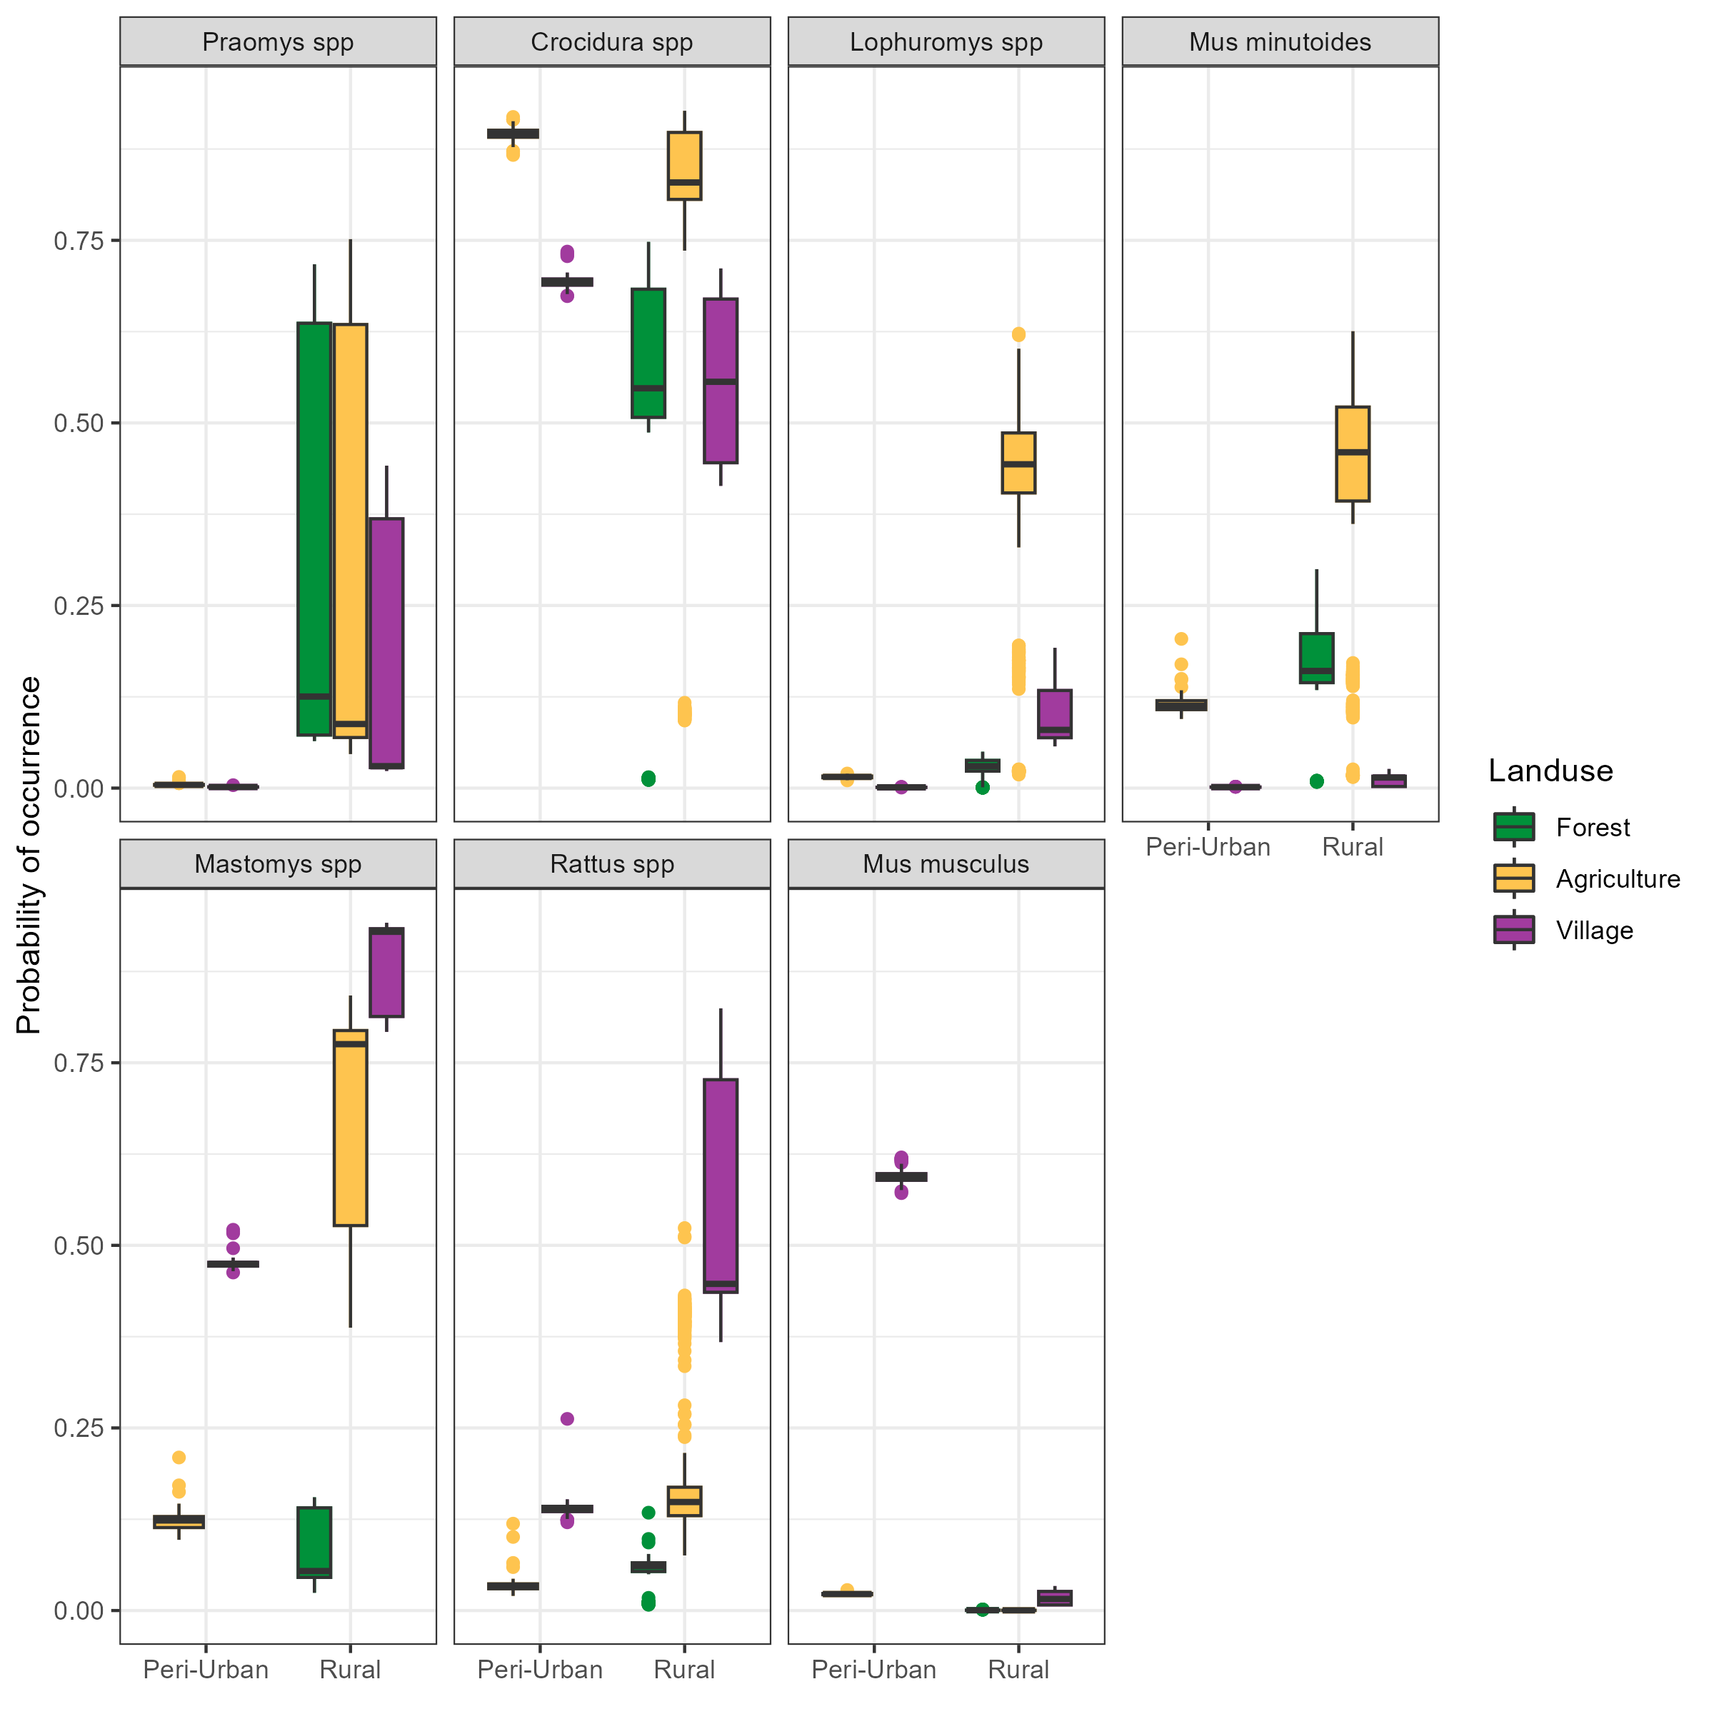

## Co-occurrence of species (**Needs more work**)

We found that species co-occurrence differed between species pairs. The probability of occurrence of *M. natalensis* in the absence of *M. musculus* was 0.28, the presence of *M. musculus* at a nearby trapping grid reduced this to 0.16. This antagonism was greater than that observed for another invasive rodent species *R. rattus* where probability of occurrence of *M. natalensis* in the absence of *R. rattus* was 0.24, the presence of *R. rattus* reduced this to 0.18. These findings further suggest a strong displacement effect of *M. musculus* which is not seen with *R. rattus* at our study sites.

# Discussion (**Bullet points for now**)

Here, we have presented the results from a systematic small-mammal trapping study in Eastern Sierra Leone performed to characterise the rodent species assemblages in a Lassa fever endemic region. We found that species richnness and diversity is greater than that reported from other regions of the Lassa fever endemic zone and that there is a strong association of land-use on the species composition of these rodent assemblages.

Trap success rate, while comparable to other studies was low. This may have been due to the higher number of trap-nights in this study obtained from non-village settings 22,656 trap-nights (74%), compared to other studies within the region that have placed a higher proportion of traps within household [ref umaru, elisabeth and happi]. Within buildings a trap-success rate of 4.6% is comparable to 3% obtained from a study in Bo, Sierra Leone [ref umaru].

We did not observe that *M. natalensis* was more prevalent in village settings during the dry season, as has been reported from elsewhere in Sierra Leone [ref. umaru], and more generally in the region [ref. elisabeth]. Our finding of similar or increased prevalence of *M. natalensis* was consistent across our village study sites, it may be that in this region different agricultural practices or food storage behaviour by communities may result in different rodent behaviour to elsewhere in its range. Further ecological studies to confirm this observation could be beneficial as prevalence of *M. natalensis* within households is likely to modify the hazard of Lassa fever infection in humans and may limit the generalisability of *M. natalensis* studies from across their range.

Rodent trapping studies typically do not account for variable detection of rodents when reporting observations of individuals references. With trap success rate generally used to account for trapping effort. The probability of a rodent entering a trap and being detected will be influenced by several factors beyond trapping effort that may be time varying and have different impact between species. For example, local activity of rodents may vary by season or light levels. Previous studies have suggested that birth pulses associated with rainfall may increase species abundance which will alter the number of individuals available for detection through increased density of individuals [ref]. Other research has shown that small mammal activity varies by nocturnal light levels, with decreased activity during periods of relatively high luminance (i.e. full moons), resulting from predation pressure [ref]. Here, we have attempted to account for this expected variability in detection probability by including a probability of detection component to our occupancy models. This component including values for trapping effort (number of trap nights), seasonal effects (precipitation), and luminance (moon fraction) within each trapping session.

We found that at the community level there was a positive association between the number of trap nights conducted and the probability of detection of an individual, supporting the approach of high intensity sampling of habitats to accurately characterise species assemblages. Trapping effort remained an important component of detection across all species with a small degree of species specific change in magnitude. The intensity of trapping effort (particularly removal trapping) must balance the priorities of accurately sampling a population but also not impacting the population dynamics of the communities being sampled. Other covariates of the detection component of our model (precipitation and moon fraction) had a lesser effect on the community level and species specific probabilities of detection. Increasing moon fraction and increasing precipitation reduced the probability of detection of small mammals at our study sites relative to low light and low precipitation periods. Together this suggests that utilising trapping effort alone as a measure of detection probability is not sufficient in these settings.

Rodent species richness was found to be greatest in agricultural settings where small-mammals with greatest occurrence in human dominated land-use types alongside those typically occurring in forested settings were found to occur. These settings may provide opportunity for *Lassa mammarenavirus* transmission between a more diverse set of rodent species and providing a method for introduction of the virus into populations with limited dispersal ranges.

The segregation of rodent species into distinct ecological niches of human dominated (village and agriculture) or non-human dominated (forest) settings may have implications for the movement of individuals of these species across the landscape in the fractured habitats of Eastern Sierra Leone. We found a low probability of *M. natalensis* within forest land use types in the region which could limit the connectivity between different groups of this species. This may have important implications for the transmission of *Lassa mammarenavirus*, if competent reservoirs exist in disconnected populations, particularly if those populations are not large enough or have population dynamics that would prevent local extinction of this pathogen. Further research is required in this setting to elucidate where sylvatic rodent species are competent hosts of this pathogen and can act to convey it isolated *M. natalensis* populations across the region. Contact between sylvatic rodents and commensal rodents such as *M. natalensis*, *Praomys spp.* and *Crocidura spp.* in agricultural land use (where species richness was observed to be greatest) may provide opportunity for the pathogen to be introduced to village settings where the risk of contact with susceptible humans would be greatest.

Across most of our village study sites we identified high occurrence of the principle rodent reservoir of *Lassa mammarenavirus* with this species concentrated in areas of significant anthropogenic disturbance (i.e. Villages, within and outside of buildings and in agricultural land). However, in Lambayama, our most urban site this species was found to have low occurrence with probable displacement by the invasive rodent *M. musculus*. These findings suggest that the hazard of human exposure to *Lassa mammarenavirus* is concentrated in more rural village settings and in those villages at low risk of *M. musculus* invasion and establishment.

Our finding that *M. natalensis* and *R. rattus* had high probabilities of co-occurrence within village land use types was consistent with findings from a study conducted within the same region. This suggests that these rodents do not directly compete for resources and that the presence of one species does not preclude the presence of the other. This may not be true for interactions between *M. musculus* and both *R. rattus* and *M. natalensis*. The presence of *M. musculus* within village land use in peri-urban settings was associated with an important decrease in the probability of occurrence of both *M. natalensis* and *R. rattus*, further *M. musculus* was absent in village land use types in rural settings where *R. rattus* and *M. natalensis* had high probabilities of occurring. This may go some way to explaining why human cases of Lassa fever are reduced in peri-urban settings as *M. musculus* is not known to be a compenent host of *Lassa mammarenavirus* and may be displacing competent hosts in these settings. Further research will be required to confirm this observation with paired human serological studies and longer term rodent ecological sampling in settings of both *M. musculus* and *M. natalensis* occupancy.

# Conclusion

We present data on rodent species assembalges within a Lassa fever endemic region and identify high occurrence of rodent species suitable as reservoirs for *Lassa mammarenavirus* which vary importantly by land-use type and village study site. We are able to recreate potential contact networks between individual rodents within these settings which may explain the spatial and temporal heterogeneity of Lassa fever outbreaks in endemic regions. Further research is required to link these rodent population structures with viral transmission in these landscapes.

# Supplementary figures.

# References

Basinski, Andrew J., Elisabeth Fichet-Calvet, Anna R. Sjodin, Tanner J. Varrelman, Christopher H. Remien, Nathan C. Layman, Brian H. Bird, et al. 2021. “Bridging the Gap: Using Reservoir Ecology and Human Serosurveys to Estimate Lassa Virus Spillover in West Africa.” Edited by Amy Wesolowski. *PLOS Computational Biology* 17 (3): e1008811. <https://doi.org/10.1371/journal.pcbi.1008811>.

Cuypers, Laura N, Wim L Cuypers, Amélie Gildemyn-Blomme, Laura Abraham, Senne Aertbeliën, Apia W Massawe, Benny Borremans, Sophie Gryseels, and Herwig Leirs. 2017. “No Evidence for Avoidance of Black Rat Scent by the Presumably Less Competitive Natal Multimammate Mouse in a Choice Experiment.” *African Zoology* 52 (2): 119–23. <https://doi.org/10.1080/15627020.2017.1307139>.

Doser, Jeffrey W., Andrew O. Finley, Marc Kéry, and Elise F. Zipkin. 2022. “spOccupancy: An r Package for Single-Species, Multi-Species, and Integrated Spatial Occupancy Models.” *Methods in Ecology and Evolution*. <https://doi.org/10.1111/2041-210X.13897>.

Fichet-Calvet, Elisabeth. 2014. “Chapter 5 - Lassa Fever: A Rodent-Human Interaction.” In *The Role of Animals in Emerging Viral Diseases*, edited by Nicholas Johnson, 89–123. Boston: Academic Press. <https://doi.org/10.1016/B978-0-12-405191-1.00005-3>.

Garba, Madougou, Ambroise Dalecky, Ibrahima Kadaoure, Mamadou Kane, Karmadine Hima, Sophie Veran, Sama Gagare, et al. 2014. “Spatial Segregation Between Invasive and Native Commensal Rodents in an Urban Environment: A Case Study in Niamey, Niger.” *PLOS ONE* 9 (11): e110666. <https://doi.org/10.1371/journal.pone.0110666>.

IUCN. 2016. “The IUCN Red List of Threatened Species 2016: Mastomys Natalensis.” International Union for Conservation of Nature. <https://doi.org/10.2305/IUCN.UK.2016-3.RLTS.T12868A22425266.en>.

Klitting, Raphaëlle, Liana E. Kafetzopoulou, Wim Thiery, Gytis Dudas, Sophie Gryseels, Anjali Kotamarthi, Bram Vrancken, et al. 2021. “Predicting the Evolution of Lassa Virus Endemic Area and Population at Risk over the Next Decades.” Preprint. Microbiology. <https://doi.org/10.1101/2021.09.22.461380>.

Leirs, Herwig, Ron Verhagen, and Walter Verheyen. 1993. “Productivity of Different Generations in a Population of Mastomys Natalensis Rats in Tanzania.” *Oikos* 68 (1): 53–60. <https://doi.org/10.2307/3545308>.

Martins, Thiago G., Daniel Simpson, Finn Lindgren, and Håvard Rue. 2013. “Bayesian Computing with INLA: New Features.” *Computational Statistics & Data Analysis* 67 (November): 68–83. <https://doi.org/10.1016/j.csda.2013.04.014>.

McCormick, J B, P A Webb, J W Krebs, K M Johnson, and E S Smith. 1987. “A Prospective Study of the Epidemiology and Ecology of Lassa Fever.” *The Journal of Infectious Diseases* 155 (3): 437–44. <https://doi.org/10.1093/infdis/155.3.437>.

Pebesma, Edzer. 2018. “Simple Features for r: Standardized Support for Spatial Vector Data.” *The R Journal* 10 (1): 439–46. <https://doi.org/10.32614/RJ-2018-009>.

R Core Team. 2021. *R: A Language and Environment for Statistical Computing*. Vienna, Austria: R Foundation for Statistical Computing. <https://www.R-project.org/>.

Redding, David W., Rory Gibb, Chioma C. Dan-Nwafor, Elsie A. Ilori, Rimamdeyati Usman Yashe, Saliu H. Oladele, Michael O. Amedu, et al. 2021. “Geographical Drivers and Climate-Linked Dynamics of Lassa Fever in Nigeria.” *Nature Communications* 12 (1): 5759. <https://doi.org/10.1038/s41467-021-25910-y>.

Redding, David W., Lina M. Moses, Andrew A. Cunningham, James Wood, and Kate E. Jones. 2016. “Environmental-Mechanistic Modelling of the Impact of Global Change on Human Zoonotic Disease Emergence: A Case Study of Lassa Fever.” *Methods in Ecology and Evolution* 7 (6): 646–55. <https://doi.org/10.1111/2041-210X.12549>.

Rue, Håvard, Sara Martino, and Nicolas Chopin. 2009. “Approximate Bayesian Inference for Latent Gaussian Models by Using Integrated Nested Laplace Approximations.” *Journal of the Royal Statistical Society: Series b (Statistical Methodology)* 71 (2): 319–92.

World Health Organisation. 2022. “Lassa Fever.” 2022. <https://www.who.int/westernpacific/health-topics/lassa-fever>.