Contact networks of small mammals highlight potential transmission foci of *Lassa mammarenavirus*.

# Authors

David Simons 1,2,3, Umaru Bangura 4,5, Ravi Goyal 6,7, Ben Rushton 8, Dianah Sondufu 5, Joyce Lamin 5, James Koninga 9, Momoh Jimmy 9, Mike Dawson 5, Joseph Lahai 5, Rashid Ansumana 5, Richard Kock 1, Deborah Watson-Jones 2,10, Kate E. Jones 3

1 Centre for Emerging, Endemic and Exotic Diseases, The Royal Veterinary College, London, United Kingdom

2 Centre for Biodiversity and Environment Research, Department of Genetics, Evolution and Environment, University College London, London, United Kingdom

3 Clinical Research Department, London School of Hygiene and Tropical Medicine, London, United Kingdom

4 X, Bernard-Nocht Institute for Tropical Medicine

5 X, Njala University, Bo, Sierra Leone

6 X, University of California, San Diego

7 X, University of Colorado

8 Diagnostics Development Lab, Bernard-Nocht Institute for Tropical Medicine

9 Kenema Government Hospital, Kenema, Sierra Leone

10 Mwanza Intervention Trials Unit, National Institute for Medical Research, Mwanza, Tanzania

# Abstract

Lassa fever, caused by *Lassa mammarenavirus* (LASV), is a zoonotic infectious disease endemic in several West African countries. Human infection is caused by spillover from rodent hosts, the primary reservoir being *Mastomys natalensis*, a commensal rodent species. In addition to the primary reservoir a further 11 rodent and shrew species have been found to be acutely infected or to have evidence of prior infection with the virus. These species rich small mammal communities are structured along land use gradients which is expected to moderate the risk of Lassa fever disease spillover into human populations. Here, we use a rodent trapping study, conducted over 43,266 trap nights, detecting 684 individual rodents to reconstruct rodent contact networks within the Lassa fever endemic Eastern Province, Sierra Leone. We found that rodent communities were larger in village and agricultural settings compared to forests, although contact rates were similar across these habitats. The structure of these networks differed by land use with villages containing more disconnected networks than agricultural settings. Specifically, we found an increased odds of intra-specific contact among *M. natalensis* within agricultural settings compared to villages. Our results suggest, that among small mammals, LASV transmission may occur differentially within species rich agricultural settings than within villages. Finally, we report a LASV seroprevalence of 3.3% among these small mammal communities with antibodies detected within 6 rodent and shrew species. Expanding rodent trapping to incorporate these different pathogen transmission settings in village and agricultural land may elucidate the rodent and shrew species that are important for the maintenance of viral populations and the subsequent risk of zoonotic spillover into human populations.

# Introduction

Lassa fever caused by *Lassa mammarenavirus* (LASV) is a rodent borne endemic zoonotic disease, estimated to cause 100,000-900,000 annual infections across West Africa (McCormick et al. 1987; Basinski et al. 2021). Compared to regular outbreaks in Nigeria cases are only sporadically reported from the Lassa fever endemic countries of Guinea, Liberia and Sierra Leone (Jetoh et al. 2022; Shaffer et al. 2021; Bausch et al. 2001). Within Sierra Leone disease outbreaks commonly go undetected. This is consistent with recent findings of up to 80% seropositivity to LASV among human communities in regions of the country previously not considered endemic for Lassa fever (Grant et al. 2023). Human infections are typically caused by pathogen spillover from rodent hosts, with limited subsequent human-to-human transmission (Lo Iacono et al. 2015). Therefore, characterising the interactions within small mammal communities through which pathogen transmission occurs and is maintained are vital to understanding LASV transmission in the endemic setting.

The primary host of LASV, *Mastomys natalensis* is a native, commensal rodent species, which occurs throughout sub-Saharan Africa. Pathogen challenge studies conducted on captive and natural *M. natalensis* colonies have found that acute infection does not result in significantly altered rodent behaviour or cause clinical pathology (Walker et al. 1975; Mariën et al. 2017; Safronetz et al. 2022). LASV is transmitted between infected and susceptible individuals at low infectious doses, this supports the hypothesised transmission routes being through both direct contact (i.e., a superficial wound caused by an infected conspecific) or indirect contact (i.e., through exposure to an environmental contaminant) (Safronetz et al. 2022). Within the rodent host viral RNA is detectable 3 days post-infection, peaking within 1 to 2 weeks and resolving within 40 days (Safronetz et al. 2022). RNA persistence is observed in *M. natalensis* testes beyond this 40-day period suggesting that prolonged sexually mediated transmission may exist in natural settings (Mariën et al. 2017). The relatively short period of acute infection is one of the reasons many studies have focussed on detecting antibodies to LASV rather than circulating virus (Demby et al. 2001; Kernéis et al. 2009; Fichet-Calvet et al. 2014).

The dynamics of antibody responses in infected rodents are not currently known. Based on a similar arenavirus (Morogoro virus), seroconversion is expected to occur 7 days post infection, with detectable antibodies (IgG) remaining beyond the point where circulating RNA has declined (i.e., 40 days post-infection) (Borremans et al. 2015). Most rodents infected with LASV are assumed to develop lifelong immunity to disease following development of LASV specific antibodies (Mariën et al. 2017; Safronetz et al. 2022). Whether these rodents are still able to participate in transmission networks despite this immunity is not currently known. Antibody based studies are therefore an imperfect tool, but the higher prevalence of seropositivity than acute infections is helpful for characterising the dynamics of LASV in the endemic region. A recent study conducted in Bo district, Sierra Leone reported a 2.8% prevalence of LASV antibodies while the prevalence of LASV acute infection (using PCR) was only 0.3% highlighting the challenges of detecting acute infection in these rodent populations (Bangura et al. 2021).

While *M. natalensis* is considered the primary reservoir for LASV, 11 further rodent species have been identified to be acutely or previously infected with LASV in endemic regions (Monath et al. 1974; Fichet-Calvet et al. 2014; Olayemi et al. 2016; Simons et al. 2023). The contribution of these additional species to pathogen spillover into human populations, and viral transmission or maintenance among rodent communities is unknown. Direct and indirect contact between rodents in species rich environments may produce incidental infections of non-reservoir species which are subsequently detected through surveillance activities, despite having little impact on viral transmission or maintenance (Gilbert et al. 2013). Alternatively, these species may facilitate transfer of this pathogen across the landscape, linking geographically isolated *M. natalensis* populations and causing reintroduction of virus into populations of the reservoir species (Caron et al. 2015; Cardenas et al. 2022). There is increasing awareness that multi-species host systems exist for many zoonoses (Keesing and Ostfeld 2021). To understand the prevalence and dynamics of of rodent associated zoonoses among hosts in their natural environment it is therefore important to expand sampling to the entire rodent community rather than focusing on a single species (Albery et al. 2021). In this study, we characterise these potential interactions as a network, which we refer to as rodent contact networks. The nodes of a network represent individual rodents and the potential interactions are represented as connections (or edges) between these rodents.

Host network structure can determine the dynamics of pathogens. Pathogens are more likely to persist in dense, well-connected networks where frequency dependent transmission dominates (Begon et al. 1999). In segmented or discontinuous networks, pathogens with limited environmental transmission will become locally extinct as the number of susceptible individuals is rapidly depleted (Swinton et al. 1998; Almberg et al. 2012). Networks containing individuals that are particularly important (i.e., high node betweenness), can have an inflated role on pathogen transmission and maintenance within discontinuous networks (i.e., super-spreaders) (Clay et al. 2009; VanderWaal and Ezenwa 2016).

The composition of rodent contact networks in Lassa fever endemic regions has not been systematically reported. Previous studies have produced summary descriptions of wider rodent populations which cannot be readily transformed into contact networks (Fichet‐Calvet et al. 2010; Bangura et al. 2021; Happi et al. 2022). However, the rich geolocation and temporal data provided by systematic rodent trapping allows the estimation of direct or indirect rodent contacts by inferring shared space utilisation over short time periods (Perkins et al. 2009; Clay et al. 2009). Contact networks produced from wildlife data have previously been used to study pathogen transmission and is particularly amenable to investigating the importance of community structure or the effect of contact rate heterogeneity between species in multi-host pathogen systems (Böhm, Hutchings, and White 2009; Drewe et al. 2011; White, Forester, and Craft 2017).

Rodent communities are structured along anthropogenic land use gradients in the Lassa fever endemic region (**Chapter 3**; (Fichet-Calvet et al. 2014)). The risk of LASV spillover into human populations is also expected to follow this gradient (Klitting et al. 2022; Grant et al. 2023; Longet et al. 2023). The prevalence of typically synanthropic rodent hosts of LASV within human dominated land use types is expected to be higher in response to increased food availability, shelter availability and reduced predation pressure (Ecke et al. 2022). These factors also moderate rodent abundance and population dynamics which may promote increased pathogen persistence, as has been reported in several rodent associated zoonoses systems (Sauvage et al. 2003; Laverty and Adler 2009; Salkeld et al. 2010). Understanding whether rodent contact networks, like rodent occurrence and abundance, vary along these anthropogenic land use gradients can elucidate the potentially different pathogen transmission networks in these settings. We therefore, hypothesised that rodent contact rates, underlying pathogen transmission networks, are greater in anthropogenically dominated habitats where nutritional resources are more concentrated.

Specific contact network properties can promote pathogen persistence within a population. For example, networks containing nodes with high betweenness (i.e., nodes that are focal points in pathways between other nodes) have the potential to become disconnected if these nodes are removed, leading to limited pathogen transmission due to the creation of disconnected sub-networks (VanderWaal et al. 2014). However, if these nodes instead are infectious there is a greater potential for the pathogen to transmit through the entire network (i.e., superspreading) (Chen et al. 2014). Further, if most rodent contacts are within competent intra-specific contacts (i.e, between two members of the same species) pathogen transmission can occur at greater rates (Faust et al. 2017; Young et al. 2017). We therefore hypothesised that spatial clustering of conspecifics and the increased abundance of commensal species in anthropogenically dominated settings will result in greater intra-specific contact rates compared to inter-specific contact rates.

Here, we use rodent trapping data from a three-year study conducted in a Lassa fever endemic region, the Eastern Province of Sierra Leone, to reconstruct the contact networks of small mammal communities. We investigate contact rates within species across an anthropogenic land use gradient. We use these networks to understand which species’ encounter each other and how this varies across the land use gradient. We then model the rates of contact within the rodent networks with a particular focus on inter- and intra-specific contact rates of the primary host of LASV (*M. natalensis*). Finally, we report the prevalence of antibodies against LASV among rodents in our study region, exploring the association of contact rates with seropositivity.

# Methods

## Study area

Rodent trapping surveys were conducted between October 2020-April 2023 within and around four village study sites (Baiama; latitude = 7.8375, longitude = -11.2683, Lalehun; latitude = 8.1973, longitude = -11.0803, Lambayama; latitude = 7.8505, longitude = -11.1969, and Seilama; latitude = 8.1224, longitude = -11.1936) in the Lassa fever endemic zone of the Eastern Province of Sierra Leone (Figure 1.). Surveys were conducted within trapping grids along a land use gradient of anthropogenic disturbance comprising, forest, agriculture (including fallow and currently in-use areas), and villages (within and outside of permanent structures). Trapping survey sessions occurred four times annually with two trapping surveys in each of the rainy and dry seasons (May to November and December to April, respectively), producing a total of 10 trapping sessions over the study period.

Study sites were selected to be representative of land use in the Eastern Province of Sierra Leone and based on accessibility to the sites during all seasons alongside acceptability of the study protocol to the village study site communities (see **Supplementary Text 1** for more details). Briefly, at each trapping grid 49 Sherman traps (7.62cm x 8.89cm x 22.86cm) (H.B. Sherman Traps, Tallahasee, USA), were placed in a 7 trap by 7 trap grid, traps were placed 10 metres apart in a grid conforming to the local landscape (median trapping grid area = 4,813m2). For traps placed within permanent structures trap placement deviated from the grid structure. Permanent structures were selected randomly at each visit from a grid projected over the village area, with four traps placed within each structure. The location of each individual trap within trapping grids was geolocated. Traps were baited with a locally produced mixture of oats, palm oil and dried fish. Each morning the traps were checked and closed for the day prior to re-baiting during the evening. Each trapping survey session consisted of four consecutive trap-nights (TN) at each trapping grid within the village study site. Trapped rodents and shrews were associated with the coordinates of the trap they were detected in.

The sf package in the R statistical computing language (R version 4.1.2) was used for geospatial manipulation and analysis (Pebesma 2018; R Core Team 2021). All rodent handling was performed by trained researchers. Rodents and shrews were sedated with halothane and euthanised prior to obtaining morphological measurements and samples of blood and tissue following published guidance (Fichet-Calvet 2014). The study protocol was approved by the Clinical Research Ethical Review Board and Animal Welfare Ethical Review Board of the Royal Veterinary College, United Kingdom (URN: 2019 1949-3), and by the Research Ethics Committee of Njala University, Sierra Leone. Carcasses were incinerated after sample collection to eliminate the risk of onward pathogen transmission.

Figure 1: Location of study villages within Eastern province, Sierra Leone. Satellite imagery obtained from Google maps, copyright 2023 Airbus, Maxar Technologies.

## Species identification

Species identification was performed in the field based on external characteristics using a taxonomic key, including external morphological measurements and characteristics, following Kingdon and Happold (Happold and Kingdon 2013) and Monadjem *et al.* (Monadjem et al. 2015) (**Supplementary Text 2**) Morphological identification alone is unable to distinguish some small-mammal species within the study area at species level. Therefore, molecular identification was performed on whole blood, tissue or dried blood spots. Samples were stored at -20°C until processing, genomic DNA was extracted using QIAGEN DNAeasy kits as per the manufacturers instructions (QIAGEN 2023) (Supplementary Text 2). DNA extracts were amplified using platinum *Taq* polymerase (Invitrogen) and cytochrome B primers (Bangura et al. 2021). DNA amplification was assessed through gel electrophoreisis with successful amplification products undergoing Sanger sequencing. Attribution of obtained sequences to rodent species was through the BLAST programme comparing NCBI species records for rodent cytochrome B to our sample sequences (Altschul et al. 1990) (**Supplementary Text 1**).

## Describing small mammal community networks

Species contact networks were reconstructed from the trapping data. Capture-mark-recapture (CMR) methods have previously been used to identify space-sharing by individuals (Carslake et al. 2005; Clay et al. 2009; Wanelik and Farine 2022). Within our study system a CMR design was not possible due to the risk of releasing an infected individual back into a human community. We therefore consider that rodents experience direct or indirect contacts with other individuals through detections at trapping locations co-located in time and space (Perkins et al. 2009). We assumed these potential contacts were sufficient to transmit LASV if they were trapped within a buffer zone of 30m radius (2,828 m2) from the location of the trap during the same 4 trap night session. A 30m radius was selected to encompass the potential home range of an individual. A strong assumption underlying this approach is that an individual was trapped at the center of their home range (Wanelik and Farine 2022). This buffer was applied to all species, further assuming that each species shared the same size home range.

We assessed the appropriateness of the choice of 30m as our buffer radius using the HomeRange R package (version 1.0.2) (Broekman et al. 2023). This software contains a dataset on the home ranges of 960 species, including 265 rodent and 17 shrew species. Four of these rodent species are included in our trapping data namely, *M. natalensis* our primary species of interest, *Lemnisomys striatus*, *Mus musculus* and *Rattus rattus*. For these species a 30m buffer is expected to contain the entirety of *M. natelensis* home ranges (mean home range = 419m2) and greater than 50% of the area of the home range of the remaining species (*L. striatus* = 83%, *M. musculus* = 92%, *R. rattus* = 52%) (**Supplementary Figure 1.**). To assess the importance of the assumption of buffer radius defining contacts and subsequent analyses we performed sensitivity analyses using buffer areas of 15m and 50m (**Supplementary Text 2**).

Networks were constructed from observed individuals (nodes) and the presence or absence of contacts between them (edges). Data were aggregated for land use type and sampling visit producing a potential 32 distinct networks from 201 trapping grid, village and visit combinations. However, as there were no detected rodents in three of the networks produced from forest sites, only 29 networks were used in subsequent analysis.

We first explore these network properties stratified by land use type, reporting species richness (number of different species), the number of nodes, the number of edges, mean node degree (i.e., the number of connections to other nodes in the network), and mean node betweenness (i.e., the number of times a node lies on the shortest path between other nodes) (**Supplementary Figure 3.1-3.29**). We then describe these contact networks stratified by small mammal species, reporting the degree distribution of contacts by species and investigating differences across a land use gradient. We finally explore these species level network characteristics by reporting the proportion of contacts each species has with other species (i.e., proportion of total inter- and intra-specific contacts) stratified by land use.

## Modelling the probablity of inter- and intra-specific contact rates in *Mastomys natalensis* across a land use gradient

To investigate whether land use and species are associated with the probability of a contact between two individuals we model these contacts as Exponential-Family Random Graphs (ERGM) (Hunter et al. 2008). We limit this analysis to *Mastomys natalensis*, the primary rodent host of LASV. Estimation of ERGM parameters provide an Odds Ratio (OR) for the probability of an edge in a network based on network properties included in the model and nodal attributes. Within our trapping grids only a subset of all individuals are detected in traps. Including unobserved individuals, and therefore unobserved contacts between these individuals aids interpretation of network models, by providing a measure of the total population size that our analytic sample is derived from.

### Incorporating unobserved individuals for modelling inter- and intra-specific *Mastomys natalensis* contacts

Prior analysis of our study system suggests a probability of detection at each trap of less than 10% for 4 trap nights if the species is present in the trapping grid (**Chapter 3**). Therefore to estimate the abundance of individuals of each species within a trapping grid we modelled abundance (total population size) from repeated count data using an N-mixture model implemented in the unmarked R package (version 1.2.5) (Royle 2004; Fiske and Chandler 2011). The latent abundance distribution can be modelled as a Poisson, negative binomial or zero-inflated Poisson random variable. The abundance distribution was modelled with the number of trap nights and season as replicate dependent detection covariates in addition to location (whether a site was based in a rural or peri-urban setting) and land use type (forest, agriculture or village) as occurrence covariates.

To select the most appropriate model for each species, the AIC of each of the Poisson, negative binomial or zero-inflated Poisson abundance distribution models were compared, with the best fitting model used to derive the estimated abundance. The median estimated abundance from the produced distribution at a trapping grid was then used to generate the unobserved individuals within each network aggregated to land use type (**Supplementary Figure 2.1-2.12**). The number of observed individuals was then subtracted from the abundance to derive the number of unobserved individuals of each species. These unobserved individuals were explicitly set to have missing (i.e., unobserved) edge values.

Finally, the constructed adjacency matrices were converted to networks using the network R package (version 1.13.0.1) for subsequent ERGM modelling (Butts 2008).

### Network models to estimate the probability of inter- and intra-specific contact rates

ERGMs were specified for each of our inferred contact networks to compare the probabilities of edges forming based on rodent characteristics (i.e., species). The general model is shown in Equation 1:

Where is the number of terms in the model, the values of the coefficients represent the size and direction of the effects of the covariates on the overall probability of an edge being present in the network. At the edge level the expression for the probability of the entire graph can be re-expressed as the conditional log-odds of a single edge between two nodes (a contact between two rodents) as in Equation 2.

Here is the random variable for the state of the node pair and signifies all dyads in the network other than . is the coefficient for the change production of an edge between the two nodes conditional on all other dyads remaining the same ().

ERGMs are implemented using the ergm package (version 4.3.2) in R (Handcock et al. 2022). Three terms were included in the final ERGM to model the probability of the formation of ties (Equation 3.). The first term (edges), describes the density of the network and is the probability of a tie being observed in the network. The second term (species), is the conditional probability of a tie forming conditional on the species of the nodes. The third term (species homophily), is the conditional probability of a tie forming accounting for intraspecific tie formation among rodent individuals (i.e., the conditional probability of two individuals of the same species forming a tie). To reduce linear dependency of the nodal terms and due to data sparsity within our inferred networks all non-*M. natalensis* are grouped as “Other species” through the levels term of the nodal covariates for the analysis of the effect of land use on the probability of inter- or intra-specific contacts for *M. natalensis*.

ERGMs were implemented on the individual networks for each land use type at each visit. We pooled the effect sizes of each model through random-effects meta-analysis stratified by land use to produce a land use specific summary effect size for each coefficient (Riley, Higgins, and Deeks 2011). Inclusion in meta-analysis was limited to ERGMs producing stable estimates for each of the model terms (i.e., sufficient detections of *M. natalensis* within the network). Random-effects models were conducted using the metafor package (version 4.0.0) in R (Viechtbauer 2010). The amount of heterogeneity was assessed using the -test for heterogeneity and restricted maximum-likelihood estimator () with a prediction interval for the true outcomes produced (Cochran 1954; Riley, Higgins, and Deeks 2011). Weights for each network included in meta-analysis were assigned using inverse-variance weights (Borenstein et al. 2010). The presence of influential networks was assessed using Cook’s distance, for models including influential networks leave-one-out sensitivity analysis were performed (Cheung 2019). Forest plots were produced to visualise the summary OR of the probability of a tie for each model term stratified by land use type.

Models with unstable estimates for the species homophily term were not included in the random-effects meta-analysis. No contact networks from forest land use contributed to meta-analysis as no *M. natalensis* were detected in these settings. Five models from agricultural settings and eight from village settings were included in meta-analysis.

## Quantifying *Lassa mammarenavirus* seroprevalence within small mammal communities

The BLACKBOX® LASV IgG ELISA Kit developed by the Diagnostics Development Laboratory hosted at the Bernhard Nocht Institute for Tropical Medicine and validated for rodent samples was used to determine serological status of trapped rodents (Gabriel et al. 2018; Soubrier et al. 2022). The full protocol is available as Supplementary Material 1. Briefly, 1 µL of whole blood was inactivated by mixing with the provided sample dilution buffer (1:50). Where whole blood was unavailable, blood was extracted from dried blood spots stored on filter paper by incubating with phosphate-buffered saline containing 0.08% Sodium Azide and 0.05% Tween-20 (Gruner et al. 2015). Samples alongside negative and positive controls were incubated on the provided ELISA plates for 24 hours at 4-8 °C in a wet chamber. Following incubation, the plates were washed and incubated for a further hour with 1:10,000 diluted HRP-labelled streptavidin. A final wash was performed prior to the addition of 100µL of 3,3’,5,5’-Tetramethylbenzidine (TMB) substrate to wells, with incubation for 10 min. The colorimetric reaction was stopped by adding 100µL of a stop solution.

A deviation from the kit protocol occurred due to the local availability of ELISA plate readers. We measured the optical density (OD) at 450nm and 630nm, as opposed to 450nm and 620nm, this was not expected to have an important effect on absorbance patterns. The index value was produced from the OD difference (OD450-OD630) divided by the cut-off values (the mean values of the negative controls + 0.150). Samples were considered positive with index values greater or equal to 1.1, negative results less than or equal to 0.9, and inconclusive results when the index value lay between 0.9 and 1.1. Inconclusive results were repeated as advised by the kit manufacturers.

We investigated whether small mammal species with individuals seropositive for LASV were more likely to have an increased number of observed contacts (i.e., increased degree) or if these positive individuals were members of more densely connected networks (i.e., increased betweenness).

# Results

Overall 684 small mammals were trapped from 43,266 trap-nights. Seventeen species were identified, 13 of which were rodent species (76%) with four species of insectivorous shrews identified (24%). *Mastomys natalensis* was the most commonly detected species (N = 113, 16.5%), followed by *Crocidura olivieri* (N = 105, 15.3%) and *Praomys rostratus* (N = 102, 15%) (Table 1.).

Table : The number of individuals detected and antibodies to Lassa mammarenavirus among those individuals.

| Species | Indviduals (N) | LASV Antibody detected (%) | Percentage of all positive individuals |
| --- | --- | --- | --- |
| *Mastomys natalensis* | 113 | 6 (5.3%) | 30% |
| *Crocidura olivieri* | 105 | 5 (4.8%) | 25% |
| *Lophuromys sikapusi* | 57 | 3 (5.3%) | 15% |
| *Mus setulosus* | 43 | 3 (7%) | 15% |
| *Rattus rattus* | 88 | 1 (1.1%) | 5% |
| *Malacomys edwardsi* | 11 | 1 (9.1%) | 5% |
| *Mastomys erythroleucus* | 4 | 1 (25%) | 5% |
| *Praomys rostratus* | 102 | 0 (0%) | 0% |
| *Mus musculus* | 90 | 0 (0%) | 0% |
| *Crocidura buettikoferi* | 23 | 0 (0%) | 0% |
| *Crocidura grandiceps* | 15 | 0 (0%) | 0% |
| *Lemniscomys striatus* | 11 | 0 (0%) | 0% |
| *Hylomyscus simus* | 9 | 0 (0%) | 0% |
| *Hybomys planifrons* | 7 | 0 (0%) | 0% |
| *Crocidura theresae* | 3 | 0 (0%) | 0% |
| *Gerbilliscus guineae* | 2 | 0 (0%) | 0% |
| *Dasymys rufulus* | 1 | 0 (0%) | 0% |

## Small mammal community contact networks

Networks constructed from rodents trapped in agricultural land use contained the highest species richness (12), followed by villages (9) and forests (6). More individuals (nodes) were detected in agricultural land use (N = 379) than villages (261) and forests (44). The mean number of contacts of each node within the network (i.e., mean degree) was positively associated with the number of nodes within the network. Networks in village settings had the highest mean degree (mean degree = 6.2, standard deviation (SD) = 4.6) compared to forest and agricultural settings (mean = 5.1, SD 3.3 and mean = 4.9, SD = 5.4 respectively). Agricultural and village settings contained the individual nodes with the highest degree (24 and 20 respectively). Betweenness, followed an anthropogenic land use gradient, it was highest in villages (mean betweenness = 3.06, standard deviation (SD) = 10.2), followed by agriculture (0.46, SD = 2.6) and forest (0.07, SD = 0.16).

There was substantial variability in node level degree within detected rodents and shrew species. Species more commonly found in agricultural settings had the highest number of detected contacts. Individuals from *Lophuromys sikapusi*, *Mus setulosus*, *Praomys rostratus* and *Crocidura olivieri*, three native rodent species and a shrew species had degrees of up to 24, although most individuals of these species had a lower degree (Table 1. and Figure 2.). Within villages *Mus musculus*, an invasive, synanthropic rodent species had nodal degrees up to 20 and a high median degree across all individuals of the species. Interestingly, *M. natalensis*, while commonly detected in both agricultural and village settings had a lower maximum degree of 12 in villages and 9 in agriculture. The median degree of individuals was similar across village and agricultural settings (5 and 4 respectively)

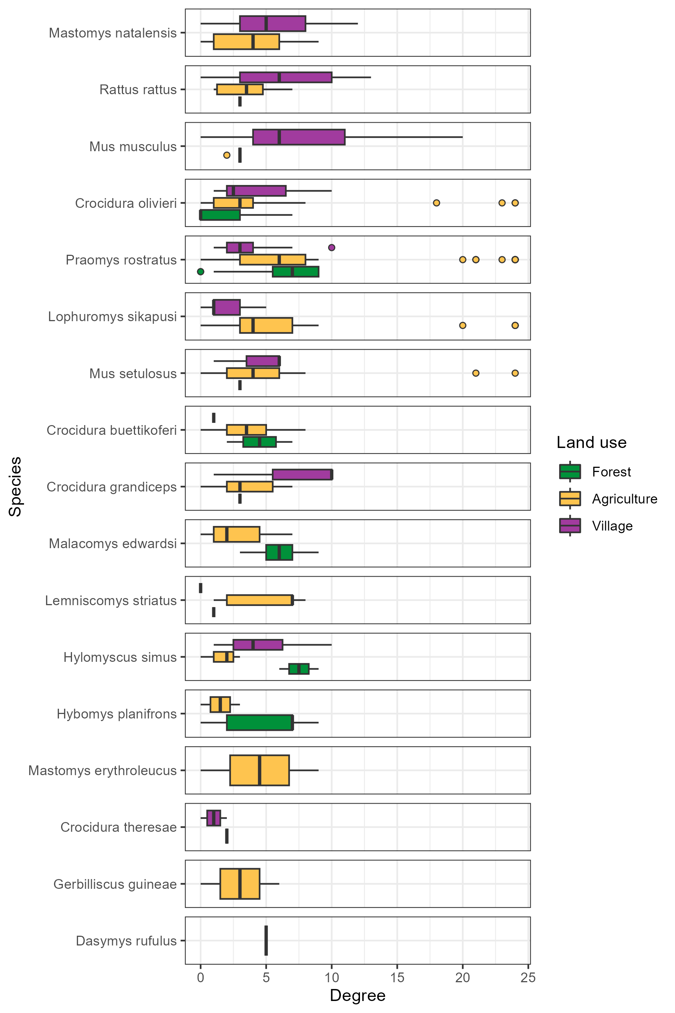

Figure 2: The degree of individual small mammals stratified by species and land use type. Boxes contain the median and inter-quartile range of the degree distribution. Whiskers include the upper and lower quartile with outliers shown as points.

There was no consistent trend across all species of degree varying with a land use gradient (Figure 2.). For commensal species including *M. natalensis*, *R. rattus* and *M. musculus* median nodal degree was increased in villages but for *M. natalensis* and *R. rattus* there was no statistically significant difference between the degree distribution by land use.

## Describing inter- and intra-specific contact within small mammal communities

Generally, species with more detected individuals had a greater number of contacts with other species (*r(15)* = 0.62, *p* = 0.007). For example, the frequently detected species, *M. natalensis*, *P. rostratus* and *R. rattus* had contact with more than 13 other species. *Mus musculus* is an important outlier to this trend, it was the fourth most observed species but only had observed contacts with four other species (Figure 3. and **Supplementary Figure 4A-B**).

Intra-specific contacts were common for most species. However, there was some important difference across land use type. *Mastomys natalensis* had contact with 13 other species in agricultural land use, but 45% of all observed contacts to this species were from other individuals of the same species (Figure 3.). However, in villages where fewer other species were contacted (9), the percentage of intra-specific contacts was lower at 31% (**Supplementary Figure 4B**). Not all species were were observed to have a majority of intra-specific contacts. In comparison, *L. sikapusi* in agricultural settings also had contact with 13 other species, but a similar proportion of contacts to individuals of this species came from *P. rostratus* (27%) as from other individuals of *L. sikapusi* (26%).

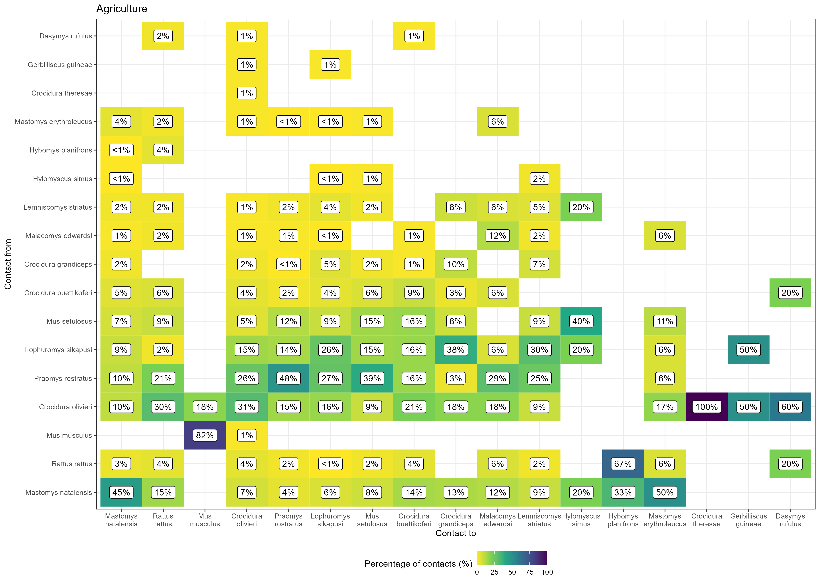

Figure 3: The proportion of contacts between individual small mammals in agricultural land use. Darker colours indicate increasing proportions of observed contacts to a species (Contact to) from named species (Contact from). Numbers in the cells correspond to the proportion of contacts to a species from a named species. Percentages sum to 100% in the Contact to axis (**Will make this landscape and larger)**

## The probability of inter- and intraspecific contact rates of *Mastomys natalensis* across a land use gradient

Limiting our analysis of the probability of a contact being observed to the primary reservoir species of LASV, *M. natalensis*, resulted in 12 ERGM models of the constructed networks being suitable for random effects meta-analysis. The odds of a contact being observed in these networks were generally low with similar odds across both agricultural (Odds Ratio = 0.14, 95% Confidence Interval = 0.09-0.23, *p* < 0.001) and village land use (OR = 0.24, 95% C.I. = 0.17-0.36, *p* < 0.001) (Figure 4A.). There were high levels of heterogeneity in the odds of a contact being observed between networks from different visits for both agricultural and village settings ( = 0.26, = 112, *p* < 0.001 and = 0.23, = 54, *p* < 0.001). Compared to other rodent species *M. natalensis* formed fewer contacts.

*Mastomys natalensis* had a non-statistically significant reduced odds of having contact with a different species (i.e., an inter-specific contact) in agricultural (OR = 0.49, 95% C.I. = 0.24-1.01, *p* = 0.054) and village settings (OR = 0.74, 95% C.I. = 0.55-1.01, *p* = 0.055) when compared to inter-specific contacts among other species in these communities (the reference). There were high levels of heterogeneity in the odds of inter-specific contacts being observed between networks ( = 0.59, = 31, *p* < 0.001 and = 0.09, = 15, *p* = 0.03). *Mastomys natalensis* did not importantly differ from other species in their probability for inter-specific contacts, with no observed effect of land use.

Finally, *M. natalensis* had a statistically significantly increased odds of forming contacts with other *M. natalensis* individuals (i.e., an intra-specific contact) in agricultural (OR = 7.5, 95% C.I. = 3.42-16.5, *p* < 0.001) but not in village settings (OR = 1.69, 95% C.I. = 0.85-3.36, *p* = 0.13) when compared to inter-specific contacts among non-*M. natalensis* species. There was no substantial heterogeneity in the analysis of the odds of intra-specific contacts ( = 0.22, = 5.6, *p* = 0.23 and = 0.39, = 12, *p* = 0.1) in both land use types. *Mastomys natalensis* compared to other small mammal species was more likely to have intra-specific contacts within communities in agricultural but not village settings.

In the first sensitivity analysis, altering the radius in which a contact was defined, there was no change in direction of the effect sizes for the random-effects meta-analysis (**Supplementary Text 3**). There were no important changes in effect size direction or magnitude in leave-one-out sensitivity testing for meta-analyses containing influential networks. The results of these sensitivity analyses suggest that our results are robust to the assumption of contact range and changes to the rodent community over study visits.

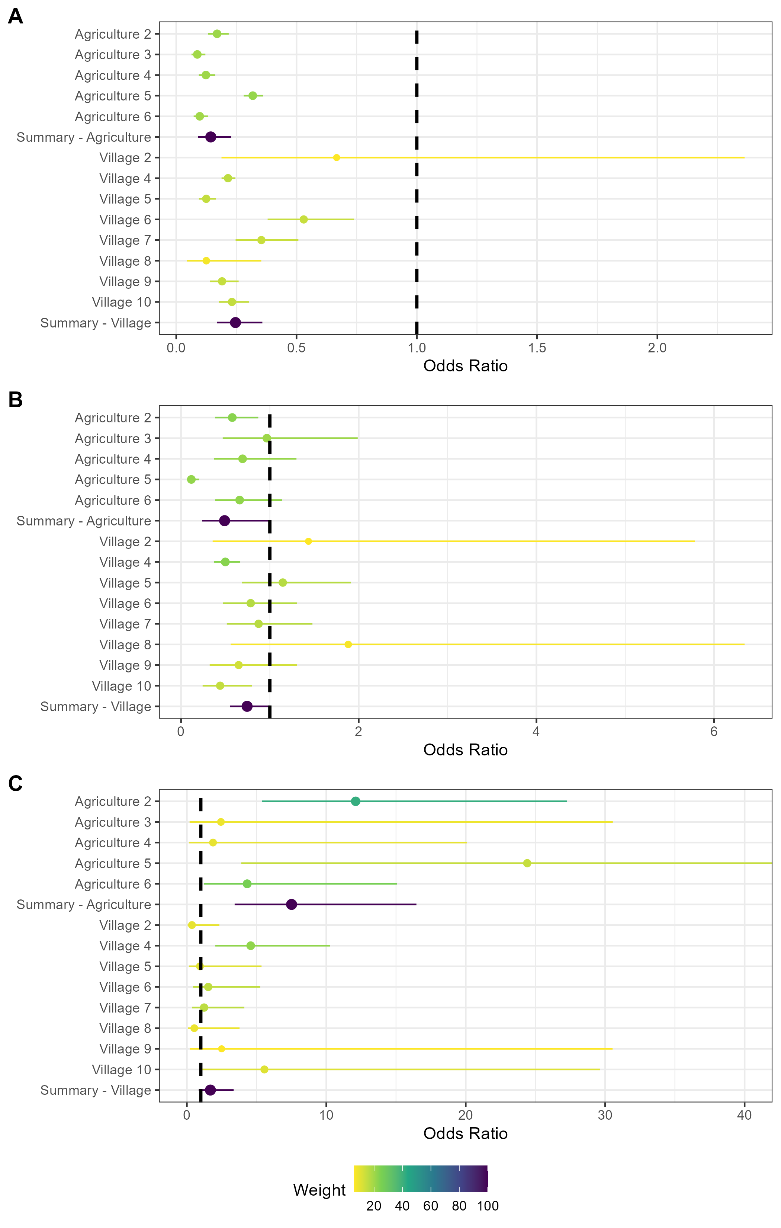

Figure 4: Random effects meta-analysis of ERGM network models reporting the odds of a contact being observed for M natalensis. A) The odds ratio of a contact being observed for M. natalensis in Agricultural or Village land use types. B) The odds ratio of a contact being observed between M. natalensis and an individual of a different rodent species. C) The odds ratio of a contact being observed between M. natalensis and another M. natalensis.

## Prevalence of *Lassa mammarenavirus* antibodies within small mammal communities

At time of writing serology results are available for 404 individuals (59%) (**expecting the remaining soon**). Antibodies to LASV were identified in 20 rodents (20/684, 3.3%) from 6 species, including *M. natalensis* (6/20, 30%), 5 *C. olivieri* (5/20, 25%), 3 *L. sikapusi* (3/20, 15%) and 3 *Mus setulosus* (3/20, 15%) (Table 1.). The highest proportion of positivity was observed in *Malacomys edwardsi* (1/11, 9%), *Mus setulosus* (3/38, 7.9%) and *M. natalensis* (6/102, 5.9%).

Rodents with antibodies to LASV were detected in three of the study villages, Lalehun (N = 11, 55%), Seilama (N = 8, 40%) and Baiama (N = 1, 5%). Lalehun had the highest percentage of antibody positive rodents (11/146, 7.5%), followed by Seilama (8/247, 3.2%) and Baiama (1/96, 1%), no positive rodents were detected in the most urbanised village Lambayama.

Antibody positive rodents were detected in all land use types, most positive rodents were trapped in agricultural (13/20, 65%), followed by village (6/20, 30%) and forest (1/20, 5%) settings. The proportion of antibody positive individuals among all rodents trapped were similar across forest (1/40, 2.5%), agricultural (13/339, 3.8%) and village (6/222, 2.7%) land use types. Antibody positive rodents were detected during sampling visits 1-6, the proportion of rodents testing positive were similar between the dry (11/364, 3%) and rainy (9/237, 3.8%) seasons.

All six species containing individuals found to be LASV antibody positive in this study were found to potentially have contact with *M. natalensis*, the primary reservoir of LASV, either in agricultural or village settings. We did not observe any difference in the degree or betweenness for individuals that were LASV antibody positive.

# Discussion

In our study within the Eastern province of Sierra Leone, we found that small mammal community contact networks while generally larger in village and agricultural settings had similar rates of contact across a land use gradient from forest, through agriculture to villages. We found that while some individual rodents had a high number of contacts, most had fewer than 5 contacts, indicating sparse networks. There was no clear difference in median node degree by species across different land use types. For *M. natalensis* specifically, we a high probability of intra-specific contacts preferentially occurring within agricultural settings. Finally, we found low prevalence of seropositivity to LASV within these small mammal communities in four villages in the Eastern province of Sierra Leone. Antibodies to LASV were detected in 6 rodent and shrew species with the majority of seropositive individuals belonging to *M. natalensis*. The finding of increased intra-specific contact rates among the primary reservoir species in agricultural settings may suggest that these locations are the foci of LASV transmission.

We hypothesised that rodent contact rates would be greater in anthropogenically dominated habitats. Our findings did not support this with equivalent network level mean degree across a land use gradient. Despite this, the individuals with the highest node degree were detected in village and agricultural settings. The idiosyncratic nature of these networks is likely masked when only interpreting network level descriptive metrics.

These idiosyncrasies can be observed through the different structures of these networks across the land use gradient. The higher betweenness found in villages, compared to agricultural or forest settings indicates that these larger networks are more discontinuous and fragmented. The high betweenness of these networks suggests that their complex structure may be important for pathogen transmission as some individuals have important roles in connecting the components of the network.

Small mammal communities had higher species richness in agricultural land. Species detected within these settings encountered a greater number of species and had a generally higher proportion of inter-specific contacts. Several native rodent species, particularly in agricultural settings, appeared to form more densely connected networks of the rodent community evidenced by relatively high nodal degrees for specific individuals.

The results of our community level and species level analysis suggest that contact within small mammal communities occurs at similar rates in different land use types but that networks within villages are more discontinuous. Agricultural habitats provide opportunities for synanthropic and sylvatic species to interact, as evidenced by the high proportion of inter-specific contacts for most species in these locations. Combined with the low betweenness of nodes in agricultural land it is likely that pathogen transmission among competent hosts would effectively spread through these well-connected networks.

*Mastomys natalensis* was found to have fewer contacts than the other rodent species within the small mammal communities in agricultural and village settings. When contacts were observed for this species in agricultural settings, they had a higher odds of being intra-specific contacts. This was not replicated in village settings suggesting that interactions with other species were more common in villages. This is supported by prior research showing that *M. natalensis* does not exhibit strong territorial responses, similar to *R. rattus* but unlike *M. musculus* (Anderson 1961; Whisson, Quinn, and Collins 2007; Borremans et al. 2014).

Homophily in contacts of *M. natalensis* (i.e., intra-specific contacts) may be important for viral transmission if other species are not as effective hosts for LASV replication and transmission. For example, if an infected individual resides in an agricultural setting it may have higher odds of experiencing a contact sufficient to transmit LASV during the infectious period compared with an individual that was located in a village. This may result in different pathogen dynamics by land use type. This is an important avenue for future research as such differences could impact the effectiveness of rodent control interventions to reduce zoonotic spillover risk.

In agricultural settings a greater force of infection may exist where following viral introduction susceptible individuals are infected during a shorter period but, population level immunity is rapidly reached, leading to local pathogen extinction (Messinger and Ostling 2009). The same may not be the case in village settings where an infected rodent may have fewer contacts and thus LASV transmits at a slower rate but is able to persist due to rapid replenishment of susceptible individuals (Peel et al. 2014). This may be complicated further by migration of individuals between agricultural and village settings based on resource availability as has been reported in this species from studies conducted in Guinea (Mari Saez et al. 2018). The changing risk to human populations from outbreaks of Lassa fever is thus likely governed by dynamic contacts among susceptible rodents in the local environment.

The number and proportion of seropositive rodents detected in the current study, while low (3.3%), was similar (2.8%) to that reported by another study that sampled rodent populations in Eastern Sierra Leone (Bangura et al. 2021). Comparison of these studies is limited by different sampling design (e.g., as we sampled rodents in forest environments and locations more distant from areas of human habitation). The proportion of all seropositive individuals that were *M. natalensis* (30%) was lower in our study than in the study conducted in the neighbouring district (75%) although the proportion of all *M. natalensis* that were antibody positive was more similar (5.3% compared to 8%). We similarly identified antibodies in other rodent species including, *L. sikapusi* and *R. rattus*. Antibodies to LASV were identified in three further species, *Crocidura olivieri*, *Mus setulosus* and *Mastomys erythroleucus* that were not reported from the Bangura study (Bangura et al. 2021). Antibodies to LASV have not previously been reported in *M. setulosus*, although they have been detected in other pygmy mice species (i.e., *Mus musculoides*) (Bangura et al. 2021). Our results support previous studies’ findings that evidence of prior acute infection is present in multiple species simultaneously within rodent communities in the Lassa fever endemic region (Demby et al. 2001; Agbonlahor et al. 2017; Bangura et al. 2021).

We did not detect a sufficient number of seropositive individuals to directly model the transmission networks of LASV through our rodent communities in these different land use settings. Ideally transmission networks would be developed from acute infection data rather than seroprevalence, given the time varying structure of dynamic contact networks. Based on studies suggesting that fewer individuals will be PCR positive than seropositive, it is unlikely that sufficient data would be available to parameterise models of transmission networks without increasing the number of sampling periods and locations. Future studies in the Eastern province of Sierra Leone will benefit from recent studies, including this one, when estimating sample sizes required to parameterise transmission models.

Several important assumptions were made that must be considered when contextualising the results of this research. First, we were unable to explicitly observe direct and indirect contacts among rodents in our study. To infer these contacts, we utilised co-location of trapped individuals in time and space (Perkins et al. 2009). This assumed that individuals were detected at the centroid of their home range and that they spend an equivalent amount of time at all points within the area of their home range (Wanelik and Farine 2022). It is unlikely that this assumption holds true in our study system and this will lead to different contact rates than we infer in our networks (Wanelik and Farine 2022). Modifications to the current study design to explore the impact of these assumptions could include radio tagging or fluorescent marking to monitor rodent contacts in real-time (Mohr et al. 2007; Clay et al. 2009; Borremans et al. 2017). Second, only a small proportion of rodents active within a study site would be detected by our trapping activity (Parmenter et al. 2003; Moore and Swihart 2005). We account somewhat for the impact this will have on our network models by inferring the total abundance of species within these sites (Silk and Fisher 2017; Vega Yon, Slaughter, and Haye 2021). However, if individuals that were detected display importantly different behaviours than those not detected then inferring across these populations may be problematic. For example, if trap shyness is associated with inter- or intra-specific space sharing then detection of less trap shy individuals may overestimate the number of contacts individuals of a species are likely to make. It would be illustrative to replicate the findings of this study on rodent networks elsewhere in the Lassa fever endemic region to assess the impact of these assumptions among others.

In conclusion this study has highlighted the variability of inter- and intra-specific contact rates between different rodent species in different land use types in a setting of rodent borne zoonotic disease risk. We propose that the wider rodent community produces a more complex transmission network for LASV than previously assumed. These findings may highlight the mechanism through which the wide variety of rodent species found to be seropositive for LASV may have been infected. This could have important implications for the control of Lassa fever risk to human populations as there is likely to be a complex interaction between pathogen transmission within differently structured rodent networks in areas of human habitation and the wider landscape.

# Supplementary material

## Supplementary Material 1

Attached to the email, contains the protocols for the trapping and lab work.

## Supplementary Material 2

Attached to the email, contains the morphological taxonomic key.

## Supplementary Figure 1

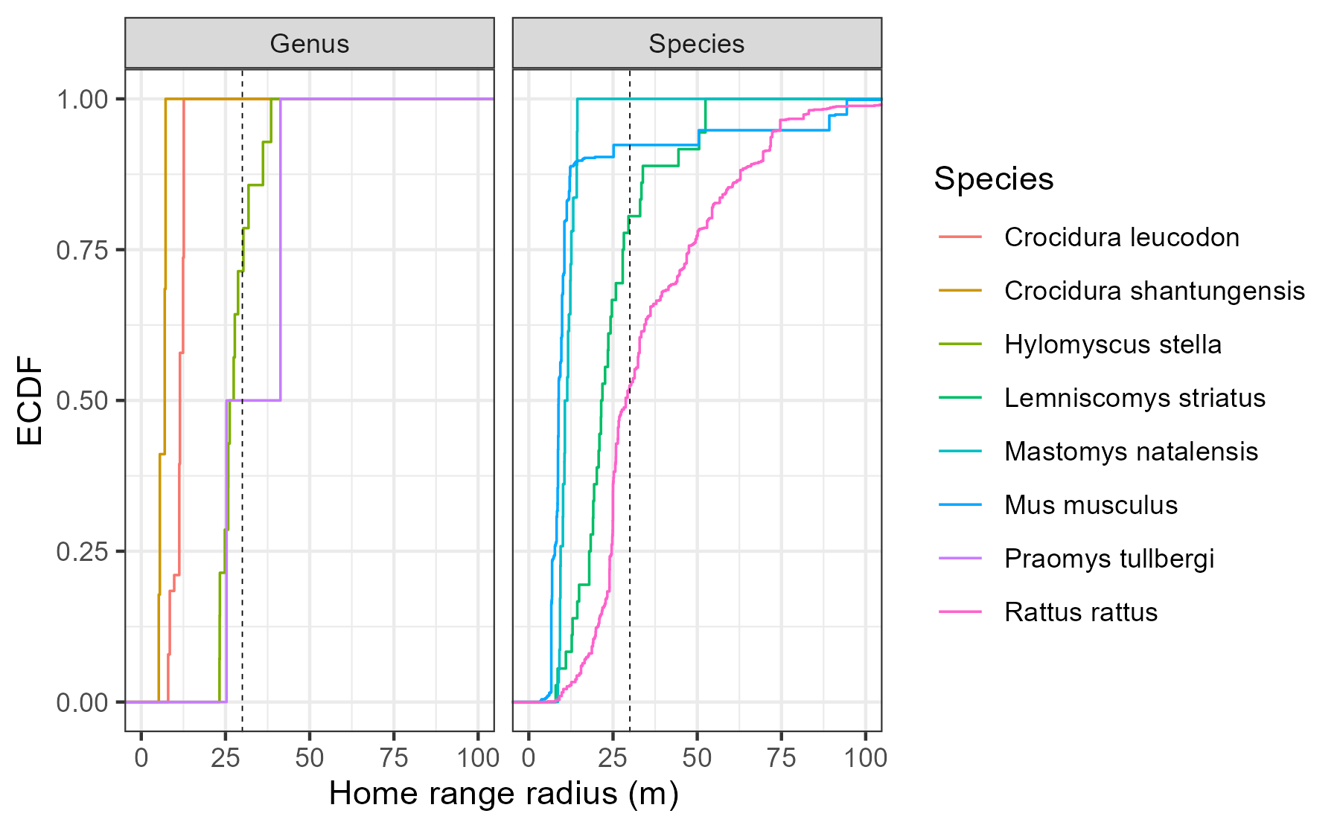

Supplementary Figure 1: Empirical Cumulative Density Function of the home range radius of rodent and shrew species with data available in the HomeRange dataset. Species that match detected genera in our study include two shrew species Crocidura leucodon and Crocidura shantungensis and two rodent species Hylomyscus stella and Praomys tullbergi. Four species matches to rodent species detected in our study were also included Lemniscomys striatus, Mastomys natalensis, Mus musculus and Rattus rattus. Only Lemniscomys striatus and Mastomys natalensis contain data from Africa (Uganda and Tanzania respectively). The dashed line represents the 30m range radius used for the primary analysis in the current study.

## Supplementary Figure 2A-F

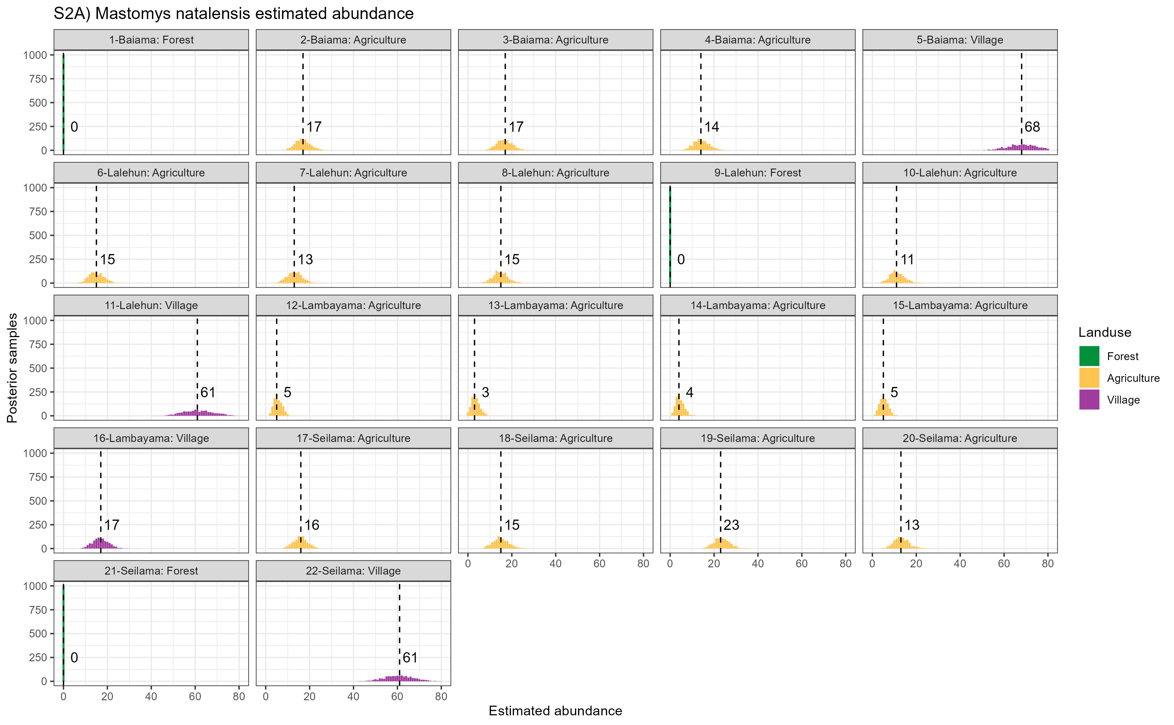

Supplementary Figure 2A: Estimated abundance at each sampling site for Mastomys natalensis. The dashed line and number is the median abundance used to infer the population size at this study site.

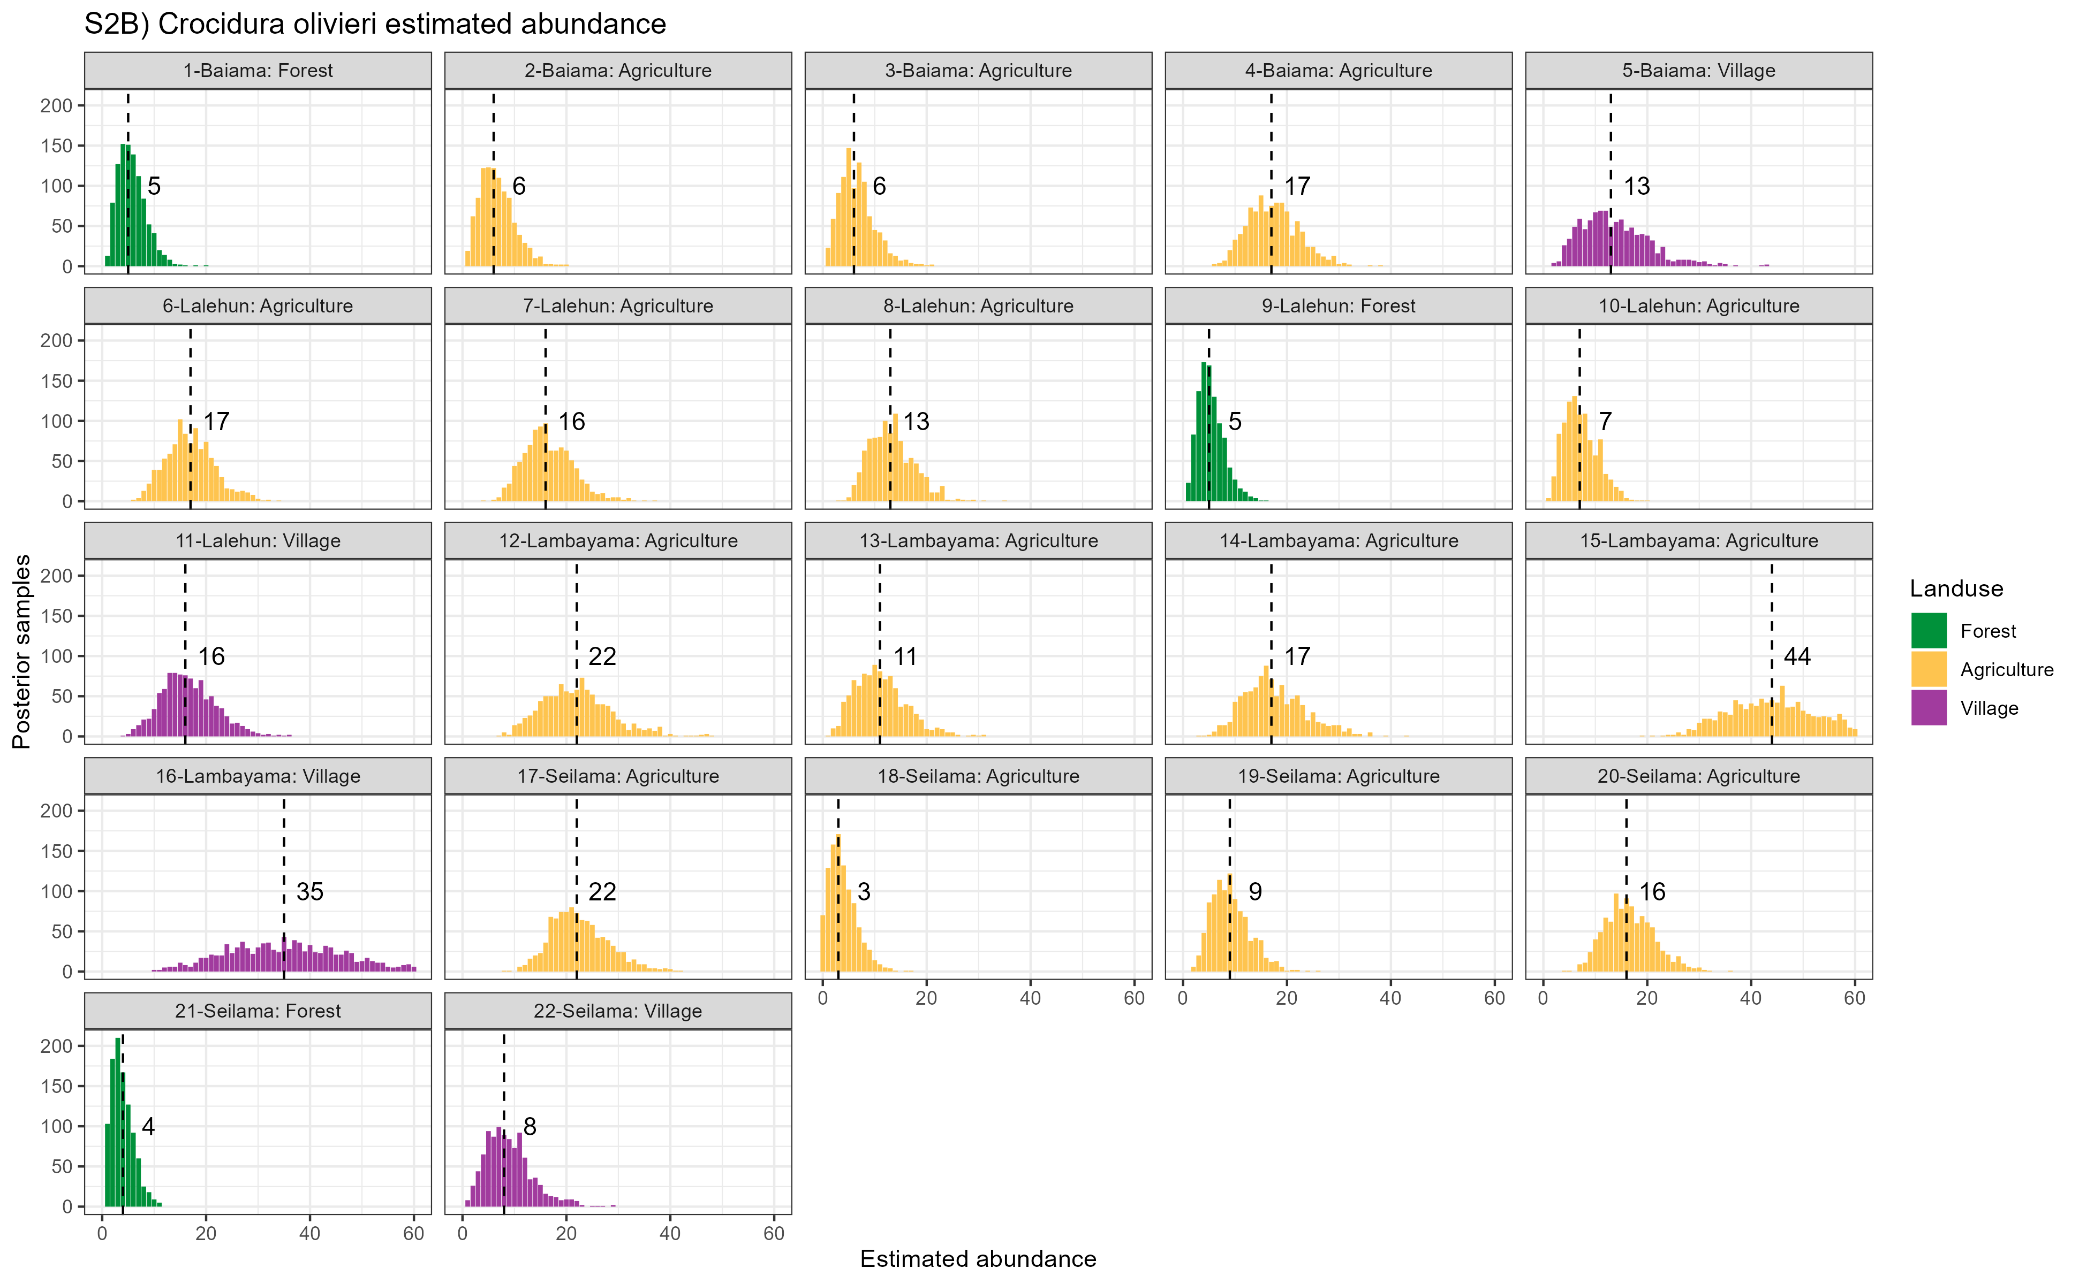

Supplementary Figure 2B: Estimated abundance at each sampling site for Mus musculus. The dashed line and number is the median abundance used to infer the population size at this study site.

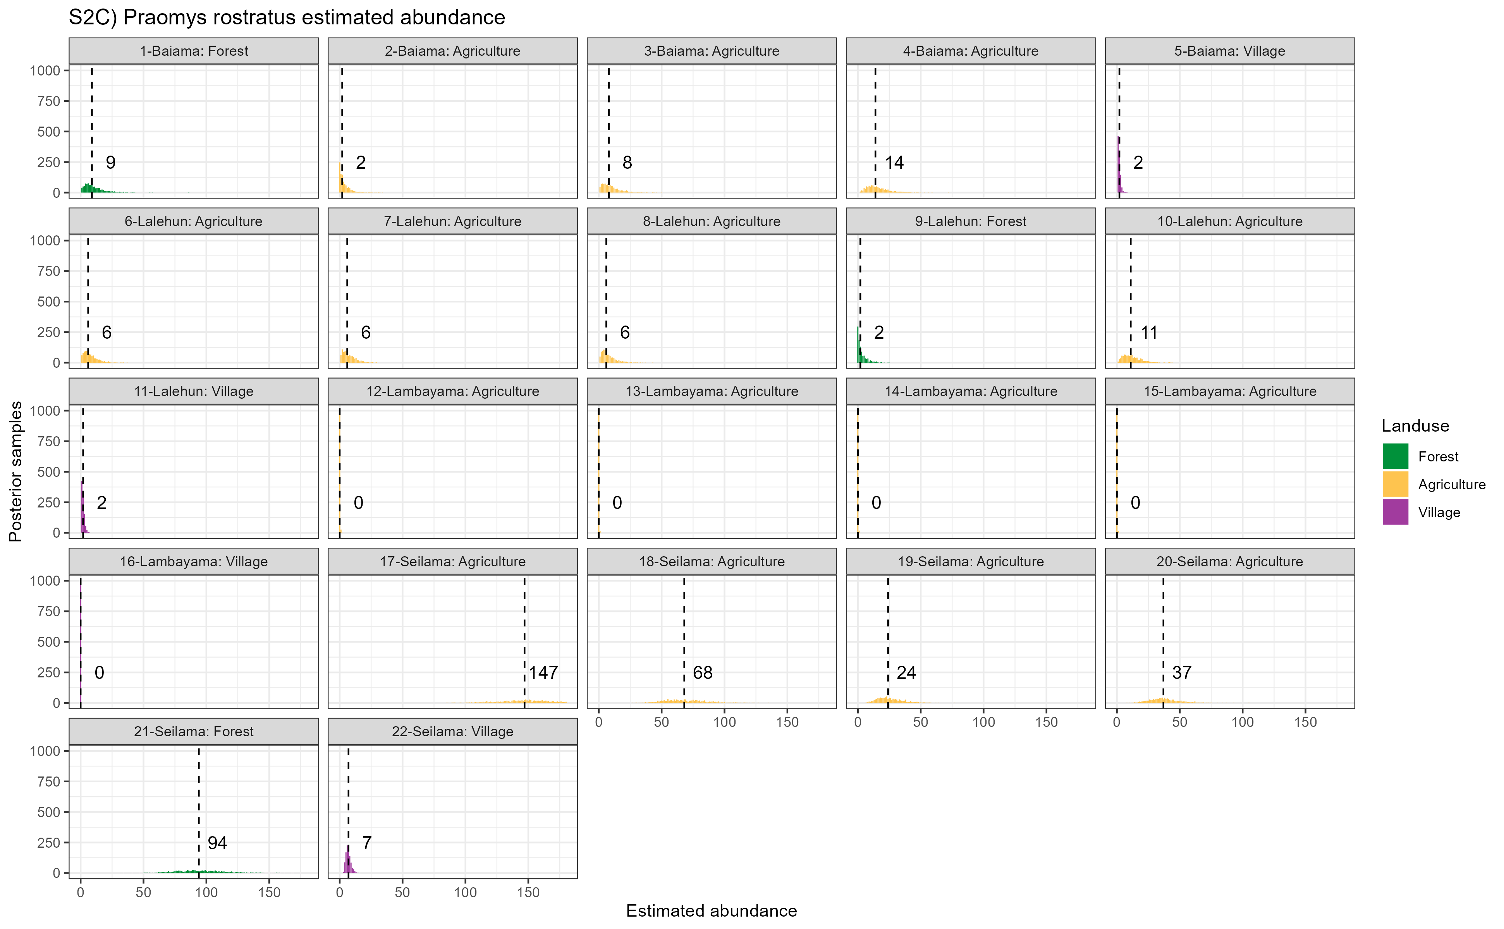

Supplementary Figure 2C: Estimated abundance at each sampling site for Rattus rattus. The dashed line and number is the median abundance used to infer the population size at this study site.

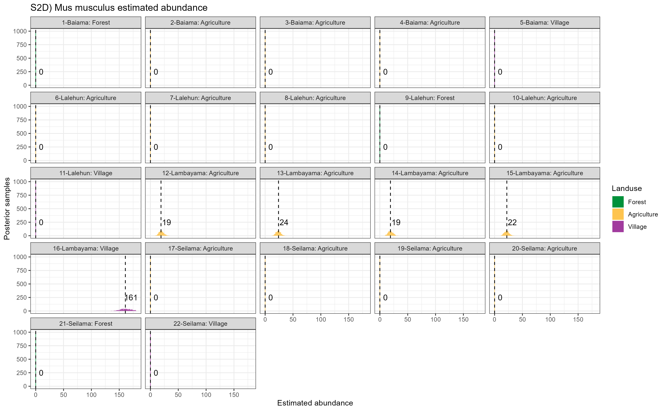

Supplementary Figure 2D: Estimated abundance at each sampling site for Crocidura spp. The dashed line and number is the median abundance used to infer the population size at this study site.

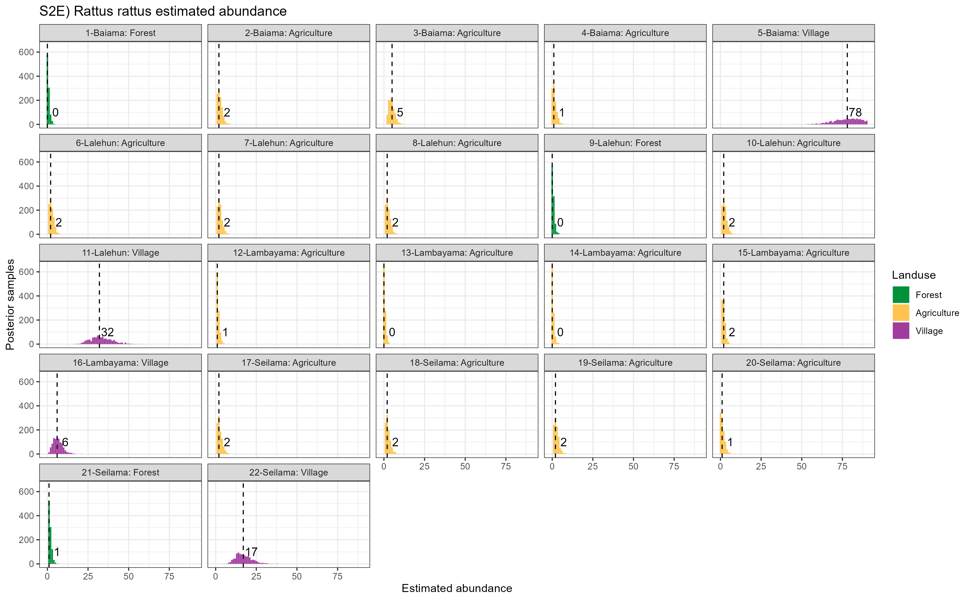

Supplementary Figure 2E: Estimated abundance at each sampling site for Praomys spp. The dashed line and number is the median abundance used to infer the population size at this study site.

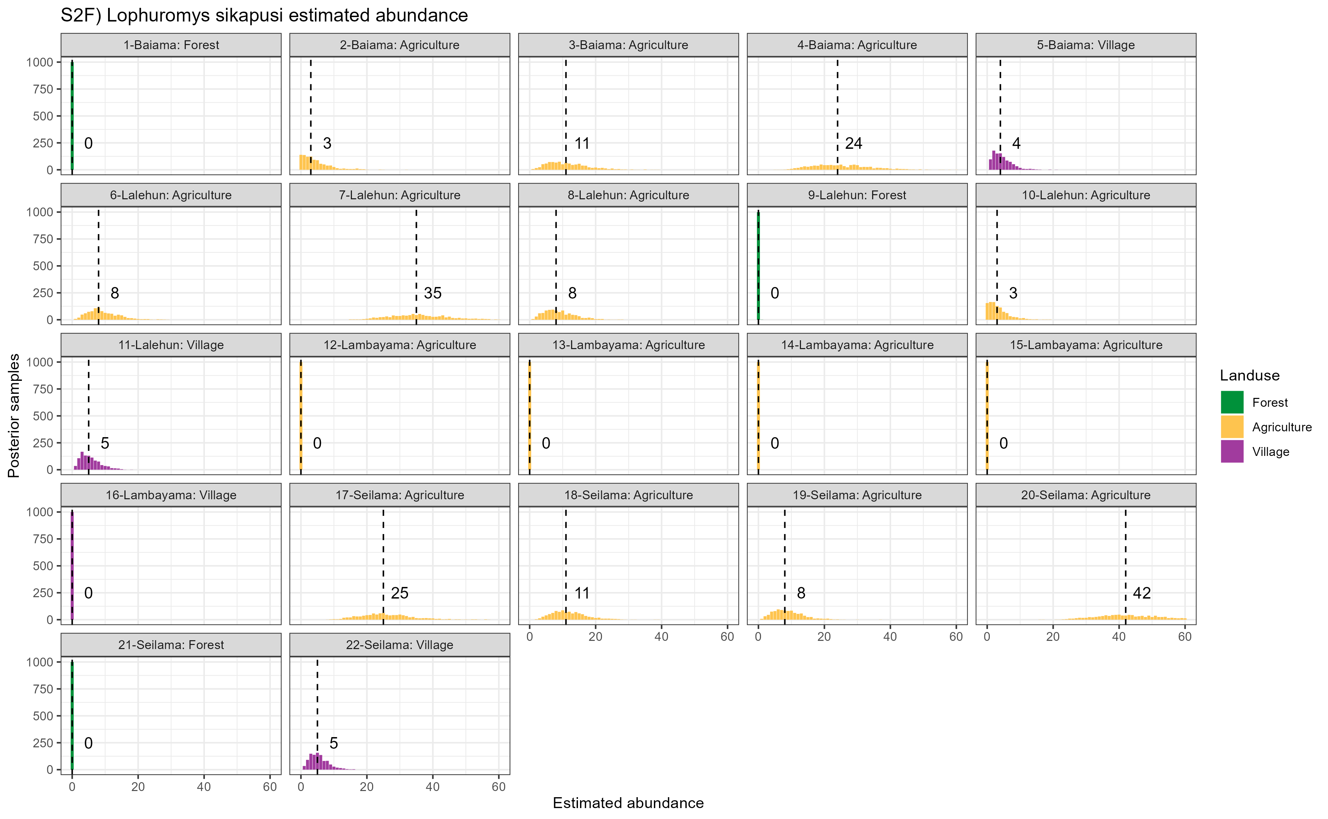

Supplementary Figure 2F: Estimated abundance at each sampling site for all other species (species with fewer than 20 observations). The dashed line and number is the median abundance used to infer the population size at this study site.

## Supplementary Figure 3A-W

These are the networks produced for each land use type and visit. I have not included them in this file but they are attached to the email in a .zip file if of interest.

# References

Agbonlahor, D. E., A. Erah, I. M. Agba, F. E. Oviasogie, A. F. Ehiaghe, M. Wankasi, O. A. Eremwanarue, et al. 2017. “Prevalence of Lassa Virus Among Rodents Trapped in Three South-South States of Nigeria.” *Journal of Vector Borne Diseases* 54 (2): 146. <http://www.jvbd.org/article.asp?issn=0972-9062;year=2017;volume=54;issue=2;spage=146;epage=150;aulast=Agbonlahor;type=0>.

Albery, Gregory F., Daniel J. Becker, Liam Brierley, Cara E. Brook, Rebecca C. Christofferson, Lily E. Cohen, Tad A. Dallas, et al. 2021. “The Science of the Host–Virus Network.” *Nature Microbiology* 6 (12): 1483–92. <https://doi.org/10.1038/s41564-021-00999-5>.

Almberg, Emily S., Paul C. Cross, Andrew P. Dobson, Douglas W. Smith, and Peter J. Hudson. 2012. “Parasite Invasion Following Host Reintroduction: A Case Study of Yellowstone’s Wolves.” *Philosophical Transactions of the Royal Society B: Biological Sciences* 367 (1604): 2840–51. <https://doi.org/10.1098/rstb.2011.0369>.

Altschul, S. F., W. Gish, W. Miller, E. W. Myers, and D. J. Lipman. 1990. “Basic Local Alignment Search Tool.” *Journal of Molecular Biology* 215 (3): 403–10. <https://doi.org/10.1016/S0022-2836(05)80360-2>.

Anderson, P. K. 1961. “Density, Social Structure, and Nonsocial Environment in House-Mouse Populations and the Implications for Regulation of Numbers.” *Transactions of the New York Academy of Sciences* 23 (March): 447–51. <https://doi.org/10.1111/j.2164-0947.1961.tb01373.x>.

Bangura, Umaru, Jacob Buanie, Joyce Lamin, Christopher Davis, Gedeon Ngiala Bongo, Michael Dawson, Rashid Ansumana, et al. 2021. “Lassa Virus Circulation in Small Mammal Populations in Bo District, Sierra Leone.” *BIOLOGY-BASEL* 10 (1). <https://doi.org/10.3390/biology10010028>.

Basinski, Andrew J., Elisabeth Fichet-Calvet, Anna R. Sjodin, Tanner J. Varrelman, Christopher H. Remien, Nathan C. Layman, Brian H. Bird, et al. 2021. “Bridging the Gap: Using Reservoir Ecology and Human Serosurveys to Estimate Lassa Virus Spillover in West Africa.” Edited by Amy Wesolowski. *PLOS Computational Biology* 17 (3): e1008811. <https://doi.org/10.1371/journal.pcbi.1008811>.

Bausch, D. G., A. H. Demby, M. Coulibaly, J. Kanu, A. Goba, A. Bah, N. Condé, et al. 2001. “Lassa Fever in Guinea: I. Epidemiology of Human Disease and Clinical Observations.” *Vector Borne and Zoonotic Diseases (Larchmont, N.Y.)* 1 (4): 269–81. <https://doi.org/10.1089/15303660160025903>.

Begon, M., S. M. Hazel, D. Baxby, K. Bown, R. Cavanagh, J. Chantrey, T. Jones, and M. Bennett. 1999. “Transmission Dynamics of a Zoonotic Pathogen Within and Between Wildlife Host Species.” *Proceedings of the Royal Society of London. Series B: Biological Sciences* 266 (1432): 1939–45. <https://doi.org/10.1098/rspb.1999.0870>.

Böhm, Monika, Michael R. Hutchings, and Piran C. L. White. 2009. “Contact Networks in a Wildlife-Livestock Host Community: Identifying High-Risk Individuals in the Transmission of Bovine TB Among Badgers and Cattle.” *PLOS ONE* 4 (4): e5016. <https://doi.org/10.1371/journal.pone.0005016>.

Borenstein, Michael, Larry V. Hedges, Julian P. T. Higgins, and Hannah R. Rothstein. 2010. “A Basic Introduction to Fixed-Effect and Random-Effects Models for Meta-Analysis.” *Research Synthesis Methods* 1 (2): 97–111. <https://doi.org/10.1002/jrsm.12>.

Borremans, Benny, Nelika K. Hughes, Jonas Reijniers, Vincent Sluydts, Abdul A. S. Katakweba, Loth S. Mulungu, Christopher A. Sabuni, Rhodes H. Makundi, and Herwig Leirs. 2014. “Happily Together Forever: Temporal Variation in Spatial Patterns and Complete Lack of Territoriality in a Promiscuous Rodent.” *Population Ecology* 56 (1): 109–18. <https://doi.org/10.1007/s10144-013-0393-2>.

Borremans, Benny, Jonas Reijniers, Nelika K. Hughes, Stephanie S. Godfrey, Sophie Gryseels, Rhodes H. Makundi, and Herwig Leirs. 2017. “Nonlinear Scaling of Foraging Contacts with Rodent Population Density.” *Oikos* 126 (6): 792–800. <https://doi.org/10.1111/oik.03623>.

Borremans, Benny, Raphaël Vossen, Beate Becker-Ziaja, Sophie Gryseels, Nelika Hughes, Mats Van Gestel, Natalie Van Houtte, Stephan Günther, and Herwig Leirs. 2015. “Shedding Dynamics of Morogoro Virus, an African Arenavirus Closely Related to Lassa Virus, in Its Natural Reservoir Host Mastomys Natalensis.” *Scientific Reports* 5 (1): 10445. <https://doi.org/10.1038/srep10445>.

Broekman, Maarten Jaap Erik, Selwyn Hoeks, Rosa Freriks, Merel M. Langendoen, Katharina M. Runge, Ecaterina Savenco, Ruben ter Harmsel, Mark A. J. Huijbregts, and Marlee A. Tucker. 2023. “HomeRange: A Global Database of Mammalian Home Ranges.” *Global Ecology and Biogeography* 32 (2): 198–205. <https://doi.org/10.1111/geb.13625>.

Butts, Carter T. 2008. “**Network** : A Package for Managing Relational Data in *r*.” *Journal of Statistical Software* 24 (2). <https://doi.org/10.18637/jss.v024.i02>.

Cardenas, Nicolas C., Abagael L. Sykes, Francisco P. N. Lopes, and Gustavo Machado. 2022. “Multiple Species Animal Movements: Network Properties, Disease Dynamics and the Impact of Targeted Control Actions.” *Veterinary Research* 53 (1): 14. <https://doi.org/10.1186/s13567-022-01031-2>.

Caron, Alexandre, Julien Cappelle, Graeme S. Cumming, Michel de Garine-Wichatitsky, and Nicolas Gaidet. 2015. “Bridge Hosts, a Missing Link for Disease Ecology in Multi-Host Systems.” *Veterinary Research* 46 (1): 83. <https://doi.org/10.1186/s13567-015-0217-9>.

Carslake, David, Malcolm Bennett, Kevin Bown, Sarah Hazel, Sandra ℡fer, and Michael Begon. 2005. “Space–Time Clustering of Cowpox Virus Infection in Wild Rodent Populations.” *Journal of Animal Ecology* 74 (4): 647–55. <https://doi.org/10.1111/j.1365-2656.2005.00966.x>.

Chen, Shi, Brad J. White, Michael W. Sanderson, David E. Amrine, Amiyaal Ilany, and Cristina Lanzas. 2014. “Highly Dynamic Animal Contact Network and Implications on Disease Transmission.” *Scientific Reports* 4 (March): 4472. <https://doi.org/10.1038/srep04472>.

Cheung, Mike W.-L. 2019. “A Guide to Conducting a Meta-Analysis with Non-Independent Effect Sizes.” *Neuropsychology Review* 29 (4): 387–96. <https://doi.org/10.1007/s11065-019-09415-6>.

Clay, Christine A., Erin M. Lehmer, Andrea Previtali, Stephen St. Jeor, and M. Denise Dearing. 2009. “Contact Heterogeneity in Deer Mice: Implications for Sin Nombre Virus Transmission.” *Proceedings of the Royal Society B: Biological Sciences* 276 (1660): 1305–12. <https://doi.org/10.1098/rspb.2008.1693>.

Cochran, William G. 1954. “The Combination of Estimates from Different Experiments.” *Biometrics* 10 (1): 101–29. <https://doi.org/10.2307/3001666>.

Demby, Austin H., Alphonse Inapogui, Kandeh Kargbo, James Koninga, Kerfalla Kourouma, James Kanu, Mamadi Coulibaly, et al. 2001. “Lassa Fever in Guinea: II. Distribution and Prevalence of Lassa Virus Infection in Small Mammals.” *Vector-Borne and Zoonotic Diseases* 1 (4): 283–97. <https://doi.org/10.1089/15303660160025912>.

Drewe, Julian A., Ken T. D. Eames, Joah R. Madden, and Gareth P. Pearce. 2011. “Integrating Contact Network Structure into Tuberculosis Epidemiology in Meerkats in South Africa: Implications for Control.” *Preventive Veterinary Medicine* 101 (1): 113–20. <https://doi.org/10.1016/j.prevetmed.2011.05.006>.

Ecke, Frauke, Barbara A. Han, Birger Hörnfeldt, Hussein Khalil, Magnus Magnusson, Navinder J. Singh, and Richard S. Ostfeld. 2022. “Population Fluctuations and Synanthropy Explain Transmission Risk in Rodent-Borne Zoonoses.” *Nature Communications* 13 (1): 7532. <https://doi.org/10.1038/s41467-022-35273-7>.

Faust, Christina L., Andrew P. Dobson, Nicole Gottdenker, Laura S. P. Bloomfield, Hamish I. McCallum, Thomas R. Gillespie, Maria Diuk-Wasser, and Raina K. Plowright. 2017. “Null Expectations for Disease Dynamics in Shrinking Habitat: Dilution or Amplification?” *Philosophical Transactions of the Royal Society B: Biological Sciences* 372 (1722): 20160173. <https://doi.org/10.1098/rstb.2016.0173>.

Fichet-Calvet, Elisabeth. 2014. “Chapter 5 - Lassa Fever: A Rodent-Human Interaction.” In *The Role of Animals in Emerging Viral Diseases*, edited by Nicholas Johnson, 89–123. Boston: Academic Press. <https://doi.org/10.1016/B978-0-12-405191-1.00005-3>.

Fichet-Calvet, Elisabeth, Beate Becker-Ziaja, Lamine Koivogui, and Stephan Günther. 2014. “Lassa Serology in Natural Populations of Rodents and Horizontal Transmission.” *Vector Borne and Zoonotic Diseases* 14 (9): 665–74. <https://doi.org/10.1089/vbz.2013.1484>.

Fichet‐Calvet, Elisabeth, Leen Audenaert, Patrick Barrière, and Erik Verheyen. 2010. “Diversity, Dynamics and Reproduction in a Community of Small Mammals in Upper Guinea, with Emphasis on Pygmy Mice Ecology.” *African Journal of Ecology* 48 (3): 600–614. <https://doi.org/10.1111/j.1365-2028.2009.01144.x>.

Fiske, Ian, and Richard Chandler. 2011. “Unmarked: An r Package for Fitting Hierarchical Models of Wildlife Occurrence and Abundance.” *Journal of Statistical Software* 43 (10): 1–23. <https://doi.org/10.18637/jss.v043.i10>.

Gabriel, Martin, Donatus I. Adomeh, Jacqueline Ehimuan, Jennifer Oyakhilome, Emmanuel O. Omomoh, Yemisi Ighodalo, Thomas Olokor, et al. 2018. “Development and Evaluation of Antibody-Capture Immunoassays for Detection of Lassa Virus Nucleoprotein-Specific Immunoglobulin m and g.” *PLOS Neglected Tropical Diseases* 12 (3): e0006361. <https://doi.org/10.1371/journal.pntd.0006361>.

Gilbert, Amy T., A. R. Fooks, D. T. S. Hayman, D. L. Horton, T. Müller, R. Plowright, A. J. Peel, et al. 2013. “Deciphering Serology to Understand the Ecology of Infectious Diseases in Wildlife.” *EcoHealth* 10 (3): 298–313. <https://doi.org/10.1007/s10393-013-0856-0>.

Grant, Donald S., Emily J. Engel, Nicole Roberts Yerkes, Lansana Kanneh, James Koninga, Michael A. Gbakie, Foday Alhasan, et al. 2023. “Seroprevalence of Anti-Lassa Virus IgG Antibodies in Three Districts of Sierra Leone: A Cross-Sectional, Population-Based Study.” *PLOS Neglected Tropical Diseases* 17 (2): e0010938. <https://doi.org/10.1371/journal.pntd.0010938>.

Handcock, Mark S., David R. Hunter, Carter T. Butts, Steven M. Goodreau, Pavel N. Krivitsky, and Martina Morris. 2022. “Ergm: Fit, Simulate and Diagnose Exponential-Family Models for Networks.” The Statnet Project (https://statnet.org). <https://CRAN.R-project.org/package=ergm>.

Happi, Anise N., Testimony J. Olumade, Olusola A. Ogunsanya, Ayotunde E. Sijuwola, Seto C. Ogunleye, Judith U. Oguzie, Cecilia Nwofoke, et al. 2022. “Increased Prevalence of Lassa Fever Virus-Positive Rodents and Diversity of Infected Species Found During Human Lassa Fever Epidemics in Nigeria.” *Microbiology Spectrum* 10 (4): e0036622. <https://doi.org/10.1128/spectrum.00366-22>.

Happold, David C. D., and Jonathan Kingdon, eds. 2013. *Mammals of Africa. Vol. 3: Rodents, Hares and Rabbits*. London: Bloomsbury.

Hunter, David R., Mark S. Handcock, Carter T. Butts, Steven M. Goodreau, and Martina Morris. 2008. “Ergm: A Package to Fit, Simulate and Diagnose Exponential-Family Models for Networks.” *Journal of Statistical Software* 24 (3): 1–29. <https://doi.org/10.18637/jss.v024.i03>.

Jetoh, Ralph Weah, Shruti Malik, Bode Shobayo, Fahn Taweh, Trokon Omarley Yeabah, Josiah George, Burgess Gbelee, et al. 2022. “Epidemiological Characteristics of Lassa Fever Cases in Liberia: A Retrospective Analysis of Surveillance Data, 2019-2020.” *International Journal of Infectious Diseases*, July. <https://doi.org/10.1016/j.ijid.2022.07.006>.

Keesing, Felicia, and Richard S. Ostfeld. 2021. “Impacts of Biodiversity and Biodiversity Loss on Zoonotic Diseases.” *Proceedings of the National Academy of Sciences* 118 (17): e2023540118. <https://doi.org/10.1073/pnas.2023540118>.

Kernéis, Solen, Lamine Koivogui, N’Faly Magassouba, Kekoura Koulemou, Rosamund Lewis, Aristide Aplogan, Rebecca F. Grais, Philippe J. Guerin, and Elisabeth Fichet-Calvet. 2009. “Prevalence and Risk Factors of Lassa Seropositivity in Inhabitants of the Forest Region of Guinea: A Cross-Sectional Study.” *PLOS Neglected Tropical Diseases* 3 (11): e548. <https://doi.org/10.1371/journal.pntd.0000548>.

Klitting, Raphaelle, Liana E. Kafetzopoulou, Wim Thiery, Gytis Dudas, Sophie Gryseels, Anjali Kotamarthi, Bram Vrancken, et al. 2022. “Predicting the Evolution of the Lassa Virus Endemic Area and Population at Risk over the Next Decades.” *Nature Communications* 13 (1): 5596. <https://doi.org/10.1038/s41467-022-33112-3>.

Laverty, Sean M., and Frederick R. Adler. 2009. “The Role of Age Structure in the Persistence of a Chronic Pathogen in a Fluctuating Population.” *Journal of Biological Dynamics* 3 (2): 224–34. <https://doi.org/10.1080/17513750802452544>.

Lo Iacono, Giovanni, Andrew A. Cunningham, Elisabeth Fichet-Calvet, Robert F. Garry, Donald S. Grant, Sheik Humarr Khan, Melissa Leach, et al. 2015. “Using Modelling to Disentangle the Relative Contributions of Zoonotic and Anthroponotic Transmission: The Case of Lassa Fever.” *PLOS NEGLECTED TROPICAL DISEASES* 9 (1). <https://doi.org/10.1371/journal.pntd.0003398>.

Longet, Stephanie, Cristina Leggio, Joseph Akoi Bore, Stephanie Key, Tom Tipton, Yper Hall, Fara Raymond Koundouno, et al. 2023. “Influence of Landscape Patterns on Exposure to Lassa Fever Virus, Guinea.” *Emerging Infectious Diseases* 29 (2): 304–13. <https://doi.org/10.3201/eid2902.212525>.

Mari Saez, Almudena, Mory Cherif Haidara, Amara Camara, Fodé Kourouma, Mickaël Sage, N’Faly Magassouba, and Elisabeth Fichet-Calvet. 2018. “Rodent Control to Fight Lassa Fever: Evaluation and Lessons Learned from a 4-Year Study in Upper Guinea.” Edited by Manuel Schibler. *PLOS Neglected Tropical Diseases* 12 (11): e0006829. <https://doi.org/10.1371/journal.pntd.0006829>.

Mariën, Joachim, Benny Borremans, Sophie Gryseels, Barré Soropogui, Luc De Bruyn, Gédéon Ngiala Bongo, Beate Becker-Ziaja, et al. 2017. “No Measurable Adverse Effects of Lassa, Morogoro and Gairo Arenaviruses on Their Rodent Reservoir Host in Natural Conditions.” *Parasites & Vectors* 10 (1): 210. <https://doi.org/10.1186/s13071-017-2146-0>.

McCormick, J B, P A Webb, J W Krebs, K M Johnson, and E S Smith. 1987. “A Prospective Study of the Epidemiology and Ecology of Lassa Fever.” *The Journal of Infectious Diseases* 155 (3): 437–44. <https://doi.org/10.1093/infdis/155.3.437>.

Messinger, Susanna M., and Annette Ostling. 2009. “The Consequences of Spatial Structure for the Evolution of Pathogen Transmission Rate and Virulence.” *The American Naturalist* 174 (4): 441–54. <https://doi.org/10.1086/605375>.

Mohr, Katrine, Herwig Leirs, Abdul Katakweba, and Robert Machang’u. 2007. “Monitoring Rodents Movements with a Biomarker Around Introduction and Feeding Foci in an Urban Environment in Tanzania.” *African Zoology* 42 (2): 294–98. [https://doi.org/10.3377/1562-7020(2007)42[294:MRMWAB]2.0.CO;2](https://doi.org/10.3377/1562-7020(2007)42%5b294:MRMWAB%5d2.0.CO;2).

Monadjem, Ara, Peter J. Taylor, Christiane Denys, and Fenton P. D. Cotterill. 2015. *Rodents of Sub-Saharan Africa: A Biogeographic and Taxonomic Synthesis*. Berlin, München, Boston: DE GRUYTER. <https://doi.org/10.1515/9783110301915>.

Monath, T. P., V. F. Newhouse, G. E. Kemp, H. W. Setzer, and A. Cacciapuoti. 1974. “Lassa Virus Isolation from Mastomys Natalensis Rodents During an Epidemic in Sierra Leone.” *Science* 185 (4147): 263–65. <https://doi.org/10.1126/science.185.4147.263>.

Moore, Jeffrey E., and Robert K. Swihart. 2005. “Modeling Patch Occupancy by Forest Rodents: Incorporating Detectability and Spatial Autocorrelation with Hierarchically Structured Data.” *The Journal of Wildlife Management* 69 (3): 933–49. [https://doi.org/10.2193/0022-541X(2005)069[0933:MPOBFR]2.0.CO;2](https://doi.org/10.2193/0022-541X(2005)069%5b0933:MPOBFR%5d2.0.CO;2).

Olayemi, Ayodeji, Daniel Cadar, N’Faly Magassouba, Adeoba Obadare, Fode Kourouma, Akinlabi Oyeyiola, Samuel Fasogbon, et al. 2016. “New Hosts of the Lassa Virus.” *Scientific Reports* 6 (1): 25280. <https://doi.org/10.1038/srep25280>.

Parmenter, Robert R., Terry L. Yates, David R. Anderson, Kenneth P. Burnham, Jonathan L. Dunnum, Alan B. Franklin, Michael T. Friggens, et al. 2003. “Small-Mammal Density Estimation: A Field Comparison of Grid-Based Vs. Web-Based Density Estimators.” *Ecological Monographs* 73 (1): 1–26. [https://doi.org/10.1890/0012-9615(2003)073[0001:SMDEAF]2.0.CO;2](https://doi.org/10.1890/0012-9615(2003)073%5b0001:SMDEAF%5d2.0.CO;2).

Pebesma, Edzer. 2018. “Simple Features for r: Standardized Support for Spatial Vector Data.” *The R Journal* 10 (1): 439–46. <https://journal.r-project.org/archive/2018/RJ-2018-009/index.html>.

Peel, A. J., J. R. C. Pulliam, A. D. Luis, R. K. Plowright, T. J. O’Shea, D. T. S. Hayman, J. L. N. Wood, C. T. Webb, and O. Restif. 2014. “The Effect of Seasonal Birth Pulses on Pathogen Persistence in Wild Mammal Populations.” *Proceedings of the Royal Society B: Biological Sciences* 281 (1786): 20132962. <https://doi.org/10.1098/rspb.2013.2962>.

Perkins, Sarah E., Francesca Cagnacci, Anna Stradiotto, Daniele Arnoldi, and Peter J. Hudson. 2009. “Comparison of Social Networks Derived from Ecological Data: Implications for Inferring Infectious Disease Dynamics.” *Journal of Animal Ecology* 78 (5): 1015–22. <https://doi.org/10.1111/j.1365-2656.2009.01557.x>.

QIAGEN. 2023. “DNeasy Blood & Tissue Kits.” January 20, 2023. <https://www.qiagen.com/us/products/discovery-and-translational-research/dna-rna-purification/dna-purification/genomic-dna/dneasy-blood-and-tissue-kit>.

R Core Team. 2021. “R: A Language and Environment for Statistical Computing.” Vienna, Austria: R Foundation for Statistical Computing. <https://www.R-project.org/>.

Riley, Richard D., Julian P. T. Higgins, and Jonathan J. Deeks. 2011. “Interpretation of Random Effects Meta-Analyses.” *BMJ* 342 (February): d549. <https://doi.org/10.1136/bmj.d549>.

Royle, J. Andrew. 2004. “N-Mixture Models for Estimating Population Size from Spatially Replicated Counts.” *Biometrics* 60 (1): 108–15. <https://doi.org/10.1111/j.0006-341X.2004.00142.x>.

Safronetz, David, Kyle Rosenke, Kimberley Meade-White, Angela Sloan, Ousmane Maiga, Sidy Bane, Cynthia Martellaro, Dana P Scott, Nafomon Sogoba, and Heinz Feldmann. 2022. “Temporal Analysis of Lassa Virus Infection and Transmission in Experimentally Infected Mastomys Natalensis.” *PNAS Nexus* 1 (3): pgac114. <https://doi.org/10.1093/pnasnexus/pgac114>.

Salkeld, Daniel J., Marcel Salathé, Paul Stapp, and James Holland Jones. 2010. “Plague Outbreaks in Prairie Dog Populations Explained by Percolation Thresholds of Alternate Host Abundance.” *Proceedings of the National Academy of Sciences* 107 (32): 14247–50. <https://doi.org/10.1073/pnas.1002826107>.

Sauvage, Frank, Michel Langlais, Nigel G. Yoccoz, and Dominique Pontier. 2003. “Modelling Hantavirus in Fluctuating Populations of Bank Voles: The Role of Indirect Transmission on Virus Persistence.” *Journal of Animal Ecology* 72 (1): 1–13. <https://doi.org/10.1046/j.1365-2656.2003.00675.x>.

Shaffer, Jeffrey G., John S. Schieffelin, Mambu Momoh, Augustine Goba, Lansana Kanneh, Foday Alhasan, Michael Gbakie, et al. 2021. “Space-Time Trends in Lassa Fever in Sierra Leone by ELISA Serostatus, 2012–2019.” *Microorganisms* 9 (3): 586. <https://doi.org/10.3390/microorganisms9030586>.

Silk, Matthew J., and David N. Fisher. 2017. “Understanding Animal Social Structure: Exponential Random Graph Models in Animal Behaviour Research.” *Animal Behaviour* 132 (October): 137–46. <https://doi.org/10.1016/j.anbehav.2017.08.005>.

Simons, David, Lauren A Attfield, Kate E Jones, Deborah Watson-Jones, and Richard Kock. 2023. “Rodent Trapping Studies as an Overlooked Information Source for Understanding Endemic and Novel Zoonotic Spillover.” *PLOS Neglected Tropical Diseases* 17 (1): e0010772. <https://doi.org/10.1371/journal.pntd.0010772>.

Soubrier, Hugo, Umaru Bangura, Chris Hoffmann, Ayodeji Olayemi, Adetunji Samuel Adesina, Stephan Günther, Lisa Oestereich, and Elisabeth Fichet-Calvet. 2022. “Detection of Lassa Virus-Reactive IgG Antibodies in Wild Rodents: Validation of a Capture Enzyme-Linked Immunological Assay.” *Viruses* 14 (5): 993. <https://doi.org/10.3390/v14050993>.

Swinton, J., J. Harwood, B. T. Grenfell, and C. A. Gilligan. 1998. “Persistence Thresholds for Phocine Distemper Virus Infection in Harbour Seal Phoca Vitulina Metapopulations.” *Journal of Animal Ecology* 67 (1): 54–68. <https://doi.org/10.1046/j.1365-2656.1998.00176.x>.

VanderWaal, Kimberly L., Edward R. Atwill, Lynne A. Isbell, and Brenda McCowan. 2014. “Quantifying Microbe Transmission Networks for Wild and Domestic Ungulates in Kenya.” *Biological Conservation* 169 (January): 136–46. <https://doi.org/10.1016/j.biocon.2013.11.008>.

VanderWaal, Kimberly L., and Vanessa O. Ezenwa. 2016. “Heterogeneity in Pathogen Transmission: Mechanisms and Methodology.” *Functional Ecology* 30 (10): 1606–22. <https://doi.org/10.1111/1365-2435.12645>.

Vega Yon, George G., Andrew Slaughter, and Kayla de la Haye. 2021. “Exponential Random Graph Models for Little Networks.” *Social Networks* 64 (January): 225–38. <https://doi.org/10.1016/j.socnet.2020.07.005>.

Viechtbauer, Wolfgang. 2010. “Conducting Meta-Analyses in r with the Metafor Package.” *Journal of Statistical Software* 36 (3): 1–48. <https://doi.org/10.18637/jss.v036.i03>.

Walker, D. H., H. Wulff, J. V. Lange, and F. A. Murphy. 1975. “Comparative Pathology of Lassa Virus Infection in Monkeys, Guinea-Pigs, and Mastomys Natalensis.” *Bulletin of the World Health Organization* 52 (4): 523–34. <https://www.ncbi.nlm.nih.gov/pmc/articles/PMC2366626/>.

Wanelik, Klara M., and Damien R. Farine. 2022. “A New Method for Characterising Shared Space Use Networks Using Animal Trapping Data.” *Behavioral Ecology and Sociobiology* 76 (9): 127. <https://doi.org/10.1007/s00265-022-03222-5>.

Whisson, Desley A., Jessica H. Quinn, and Kellie C. Collins. 2007. “Home Range and Movements of Roof Rats (Rattus Rattus) in an Old-Growth Riparian Forest, California.” *Journal of Mammalogy* 88 (3): 589–94. <https://doi.org/10.1644/06-MAMM-A-239R1.1>.

White, Lauren A., James D. Forester, and Meggan E. Craft. 2017. “Using Contact Networks to Explore Mechanisms of Parasite Transmission in Wildlife.” *Biological Reviews* 92 (1): 389–409. <https://doi.org/10.1111/brv.12236>.

Young, Hillary S., Ingrid M. Parker, Gregory S. Gilbert, Ana Sofia Guerra, and Charles L. Nunn. 2017. “Introduced Species, Disease Ecology, and Biodiversity–Disease Relationships.” *Trends in Ecology & Evolution* 32 (1): 41–54. <https://doi.org/10.1016/j.tree.2016.09.008>.