Contact networks of small mammals highlight potential transmission foci of *Lassa mammarenavirus*.

2023-11-03

# Authors

David Simons 1,2,3, Ravi Goyal 4,5, Umaru Bangura 6,7, Rory Gibb 2,8 Ben Rushton 9, Dianah Sondufu 7, Joyce Lamin 7, James Koninga 10, Momoh Jimmy 10, Mike Dawson 7, Joseph Lahai 7, Rashid Ansumana 7, Richard Kock 1, Deborah Watson-Jones 2,11, Kate E. Jones 3,8

1 Centre for Emerging, Endemic and Exotic Diseases, The Royal Veterinary College, London, United Kingdom

2 Centre for Biodiversity and Environment Research, Department of Genetics, Evolution and Environment, University College London, London, United Kingdom

3 Clinical Research Department, London School of Hygiene and Tropical Medicine, London, United Kingdom

4 X, University of California, San Diego

5 X, University of Colorado

6 X, Bernard-Nocht Institute for Tropical Medicine

7 X, Njala University, Bo, Sierra Leone

8 People & Nature Lab, UCL East, Department of Genetics, Evolution and Environment, University College London, London, United Kingdom

9 Diagnostics Development Lab, Bernard-Nocht Institute for Tropical Medicine

10 Kenema Government Hospital, Kenema, Sierra Leone

11 Mwanza Intervention Trials Unit, National Institute for Medical Research, Mwanza, Tanzania

# Abstract

Lassa fever, caused by *Lassa mammarenavirus* (LASV), is an endemic zoonosis in several West African countries. Human infection is caused by spillover from rodent hosts, the reservoir species is *Mastomys natalensis*, a synanthropic rodent. In addition to the reservoir species a further 11 rodent and shrew species have been found to be acutely infected or to have evidence of prior infection with LASV. Within Sierra Leone species rich, small-mammal communities are structured along land use gradients. These community structures are expected to moderate the risk of Lassa fever disease spillover into human populations. Risk of human infection is presumed greatest in areas of human habitation, it is not known if these settings are also associated with substantial LASV transmission among small mammals. Here, I use a rodent trapping study, conducted over 43,266 trap nights, detecting 684 individual rodents and shrews to reconstruct contact networks within the Lassa fever endemic Eastern Province, Sierra Leone. We investigated whether these contact networks differ by land use type and whether some settings may be more conducive to viral transmission among host species. We found that small-mammal communities were larger in village and agricultural settings compared to forests, although contact rates were similar across these habitats. The structure of these networks differed by land use, with villages containing more disconnected networks than agricultural settings. Specifically, we found an increased odds of intra-specific contact among *M. natalensis* within agricultural settings compared to villages. This analysis suggests, that among these small-mammal communities, LASV transmission may occur with different dynamics within agricultural settings compared to villages. Finally, we report a LASV seroprevalence of 5.7% among these small-mammal communities with antibodies detected from nine rodent and shrew species. We anticipate that systematically expanding rodent surveillance to incorporate the likely different pathogen transmission dynamics in villages and agricultural habitats will improve the understanding of LASV transmission within endemic regions. More systematic approaches to LASV surveillance in rodent and shrew species will reveal host species which are important for the maintenance of viral populations and the subsequent risk of zoonosis to human populations.

# Introduction

Lassa fever caused by *Lassa mammarenavirus* (LASV) is a rodent associated endemic zoonosis, estimated to cause 100,000-900,000 annual infections across West Africa (McCormick et al. 1987; Basinski et al. 2021). Compared to regular outbreaks in Nigeria, cases are only sporadically reported from the Lassa fever endemic countries of Guinea, Liberia and Sierra Leone (Jetoh et al. 2022; Shaffer et al. 2021; Bausch et al. 2001). Within Sierra Leone disease outbreaks commonly go undetected. This is consistent with recent findings of up to 80% seropositivity to LASV among human communities in regions of the country previously not considered endemic for Lassa fever (Grant et al. 2023). Human infections are typically caused by pathogen spillover from rodent hosts, with limited subsequent human-to-human transmission (Lo Iacono et al. 2015). Therefore, characterising the interactions within small-mammal communities through which pathogen transmission occurs and is maintained are vital to understanding LASV transmission in the endemic setting.

The reservoir host of LASV, *Mastomys natalensis* is a native, commensal rodent species, which occurs throughout sub-Saharan Africa. Pathogen challenge studies conducted on captive and natural *M. natalensis* colonies have found that acute infection does not result in significantly altered rodent behaviour or cause clinical pathology (Walker et al. 1975; Mariën et al. 2017; Safronetz et al. 2022). LASV is transmitted between infected and susceptible individuals at low infectious doses, which supports the hypothesised transmission routes being through both direct contact (i.e., a superficial wound caused by an infected conspecific) or indirect contact (i.e., through exposure to an environmental contaminant) (Safronetz et al. 2022). The role of vertical transmission (i.e., from mother to pup) in natural settings is expected to occur based on transmission modelling of a similar arenavirus elsewhere in Africa, however, the impact of this mode of transmission on LASV ecology is unknown (Borremans et al. 2015). Within the rodent host viral RNA is detectable 3 days post-infection, peaking within 1 to 2 weeks and resolving within 40 days (Safronetz et al. 2022). RNA persistence is observed in *M. natalensis* testes beyond this 40-day period suggesting that prolonged sexually mediated transmission may exist in natural settings (Mariën et al. 2017). The relatively short period of acute infection is one reason why many studies have focussed on detecting antibodies to LASV rather than circulating virus (Demby et al. 2001; Kerneis et al. 2009; Fichet-Calvet et al. 2014).

The dynamics of antibody responses of LASV in infected rodents are not currently known. Based on a similar arenavirus (Morogoro virus), seroconversion is expected to occur 7 days post infection, with detectable antibodies (i.e., IgG) remaining beyond the point where circulating RNA has declined (i.e., 40 days post-infection) (Borremans et al. 2015). Most rodents infected with LASV are assumed to develop lifelong immunity to disease following development of LASV specific antibodies (Mariën et al. 2017; Safronetz et al. 2022). Whether these rodents are still able to participate in transmission networks despite this immunity is not currently known. Antibody based studies are therefore an imperfect tool, but the higher prevalence of seropositivity than acute infections is helpful for characterising the dynamics of LASV in the endemic region. A recent study conducted in Bo district, Sierra Leone reported a 2.8% prevalence of LASV antibodies among rodent and shrew species while the prevalence of LASV acute infection (using PCR) was only 0.3% highlighting the challenges of detecting acute infection in these rodent populations (Bangura et al. 2021).

While *M. natalensis* is considered the main host species of LASV, 11 further rodent species have been identified to be acutely or previously infected with LASV in endemic regions (Monath et al. 1974; Fichet-Calvet et al. 2014; Olayemi et al. 2016; Simons et al. 2023). The contribution of these additional species to pathogen spillover into human populations, and viral transmission or maintenance among these species communities is unknown. Direct and indirect contact between individuals in species rich environments may produce incidental infections of non-reservoir species which are subsequently detected through surveillance activities, despite having little impact on viral transmission or maintenance (Gilbert et al. 2013). Alternatively, these species may facilitate transfer of this pathogen across the landscape, linking geographically isolated *M. natalensis* populations and causing reintroduction of virus into populations of the reservoir species (Caron et al. 2015; Cardenas et al. 2022). There is increasing awareness that multi-species host systems exist for many zoonoses (Keesing and Ostfeld 2021). To understand the prevalence and dynamics of rodent associated zoonoses among hosts in their natural environment it is therefore important to expand sampling to the entire community rather than focusing on a single species (Albery et al. 2021).

Host network structure can determine the dynamics of pathogens. Pathogens are more likely to persist in dense, well-connected networks where frequency dependent transmission dominates (Begon et al. 1999). In segmented or discontinuous networks, pathogens with limited environmental transmission will become locally extinct as the number of susceptible individuals is rapidly depleted (Swinton et al. 1998; Almberg et al. 2012). Networks containing individuals that are particularly important (i.e., high node betweenness), can have an inflated role on pathogen transmission and maintenance within discontinuous networks (i.e., super-spreaders) (Clay et al. 2009; VanderWaal and Ezenwa 2016). Although networks containing nodes with high betweenness (i.e., nodes that are focal points in pathways between other nodes) have the potential to become disconnected if these nodes are removed, leading to interrupted pathogen transmission as disconnected sub-networks are created (VanderWaal et al. 2014). In contrast, if these high betweenness nodes are infectious there is a greater potential for the pathogen to transmit through the entire network as they are connected to more individual nodes than average (Chen et al. 2014). Finally, the rate of transmission following a contact event will be dependent on host competence and is therefore associated with the type of contact (e.g., inter-specific or intra-specific) (Faust et al. 2017; Young et al. 2017). The composition of rodent contact networks in Lassa fever endemic regions has not been systematically reported but could illustrate potential transmission networks in the absence of direct observation of transmission events. Previous studies have produced summary descriptions of wider rodent populations which cannot be readily transformed into contact networks (Fichet‐Calvet et al. 2010; Bangura et al. 2021; Happi et al. 2022).

Small-mammal communities are structured along anthropogenic land use gradients in the Lassa fever endemic region (Fichet-Calvet et al. 2014). The risk of LASV spillover into human populations is also expected to follow this gradient (Klitting et al. 2022; Grant et al. 2023; Longet et al. 2023). The prevalence of typically synanthropic rodent hosts of LASV within human dominated land use types is expected to be higher in response to increased food availability, shelter availability and reduced predation pressure (Ecke et al. 2022). These factors also moderate rodent abundance and population dynamics which may promote increased pathogen persistence, as has been reported in several rodent associated zoonoses systems (Sauvage et al. 2003; Laverty and Adler 2009; Salkeld et al. 2010). Understanding whether rodent contact networks, like rodent occurrence and abundance, vary along these anthropogenic land use gradients can elucidate the potentially different pathogen transmission networks in these settings. We therefore, hypothesised that rodent contact rates, underlying pathogen transmission networks, are greater in anthropogenically dominated habitats where nutritional resources are more concentrated.

The rich geolocation and temporal data provided by systematic rodent trapping allows the estimation of direct or indirect rodent contacts by inferring shared space utilisation over short time periods (Perkins et al. 2009; Clay et al. 2009). Contact networks produced from wildlife data have previously been used to study pathogen transmission and is particularly amenable to investigating the importance of community structure or the effect of contact rate heterogeneity between species in multi-host pathogen systems (Böhm, Hutchings, and White 2009; Drewe et al. 2011; White, Forester, and Craft 2017).

Here, we use rodent and shrew trapping data from a three-year study conducted in a Lassa fever endemic region, the Eastern Province of Sierra Leone, to reconstruct the contact networks of small-mammal communities. We characterise potential interactions (i.e., direct and indirect contacts) within the small-mammal community as a network. The nodes of a network represent the individual rodents or shrews and potential interactions are represented as connections (or edges) between these individuals. We hypothesised that spatial clustering of conspecifics and the increased abundance of commensal species in anthropogenically dominated settings will result in greater intra-specific contact rates compared to inter-specific contact rates within these communities. Contact rates within and between species are used to explore how these vary across an anthropogenic land use gradient with a special focus on *M. natalensis*. Finally, we report the prevalence of antibodies against LASV among individual small mammals in the study region, exploring the association of contact rates with seropositivity.

# Methods

## Study area

Rodent trapping surveys were conducted between October 2020-April 2023 within and around four village study sites (Baiama; latitude = 7.8375, longitude = -11.2683, Lalehun; latitude = 8.1973, longitude = -11.0803, Lambayama; latitude = 7.8505, longitude = -11.1969, and Seilama; latitude = 8.1224, longitude = -11.1936) in the Lassa fever endemic zone of the Eastern Province of Sierra Leone (Figure 1). Surveys were conducted within trapping grids along a land use gradient of anthropogenic disturbance comprising, forest, agriculture (including fallow and currently in-use areas), and villages (within and outside of permanent structures). Trapping survey sessions occurred four times annually with two trapping surveys in each of the rainy and dry seasons (May to November and December to April, respectively), producing a total of 10 trapping sessions over the study period.

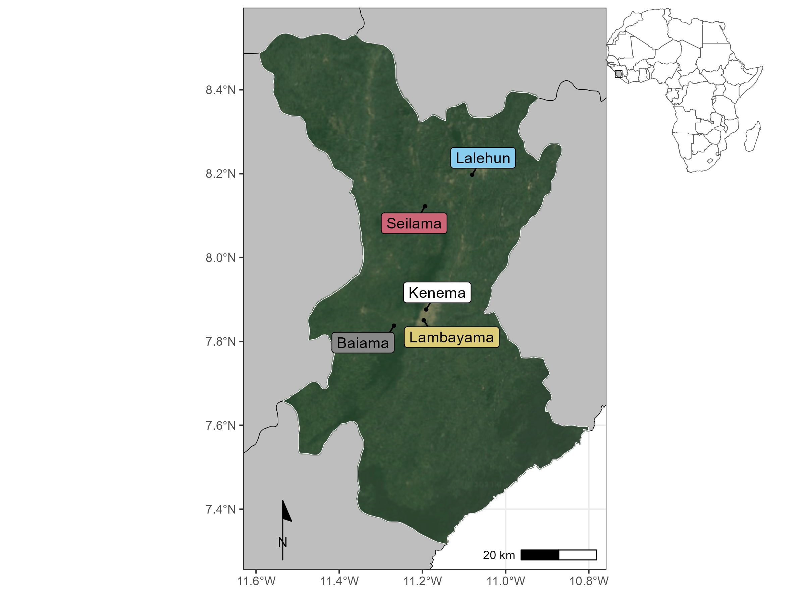

Figure 1: Location of rodent trapping study communities within Eastern Province, Sierra Leone. Satellite imagery copyright of TerraMetrics 2023

Study sites were selected to be representative of land use in the Eastern Province of Sierra Leone and based on accessibility to the sites during all seasons alongside acceptability of the study protocol to the village study site communities (**Supplementary Material 1**). Briefly, at each trapping grid 49 Sherman traps (7.62cm x 8.89cm x 22.86cm) (H.B. Sherman Traps, Tallahasee, USA), were placed in a 7 trap by 7 trap grid, traps were placed 10 metres apart in a grid conforming to the local landscape (median trapping grid area = 4,813m2). For traps placed within permanent structures trap placement deviated from the grid structure. Permanent structures were selected randomly at each visit from a grid projected over the village area, with four traps placed within each structure. The location of each individual trap within trapping grids was geolocated. Traps were baited with a locally produced mixture of oats, palm oil and dried fish. Each morning the traps were checked and closed for the day prior to re-baiting during the evening. Each trapping survey session consisted of four consecutive trap-nights (TN) at each trapping grid within the village study site. Trapped rodents and shrews were associated with the coordinates of the trap they were detected in. The sf package in the R statistical computing language (R version 4.1.2) was used for geospatial manipulation and analysis (Pebesma 2018; R Core Team 2021).

All small-mammal handling was performed by trained researchers. Rodents and shrews were sedated with halothane and euthanised prior to obtaining morphological measurements and samples of blood and tissue following published guidance (Fichet-Calvet 2014). The study protocol was approved by the Clinical Research Ethical Review Board and Animal Welfare Ethical Review Board of the Royal Veterinary College, United Kingdom (URN: 2019 1949-3), and by the Research Ethics Committee of Njala University, Sierra Leone. All carcasses were incinerated after sample collection to eliminate the risk of onward pathogen transmission.

## Species identification

Species identification was performed in the field based on external characteristics using a taxonomic key, including external morphological measurements and characteristics, following Kingdon and Happold (Happold and Kingdon 2013) and Monadjem *et al.* (Monadjem et al. 2015) (**Supplementary Material 2**) Morphological identification alone is unable to distinguish some small-mammal species within the study area at species level. Therefore, molecular identification was performed on whole blood, tissue or dried blood spots. Samples were stored at -20°C until processing, genomic DNA was extracted using QIAGEN DNAeasy kits as per the manufacturers instructions (QIAGEN 2023) (**Supplementary Material 1**). DNA extracts were amplified using platinum *Taq* polymerase (Invitrogen) and cytochrome B primers (Bangura et al. 2021). DNA amplification was assessed through gel electrophoreisis with successful amplification products undergoing Sanger sequencing. Attribution of obtained sequences to rodent species was through the BLAST programme comparing NCBI species records for rodent cytochrome B to our sample sequences (Altschul et al. 1990).

## Investigating *Lassa mammarenavirus* seroprevalence within small-mammal communities

The BLACKBOX® LASV IgG ELISA Kit (Diagnostics Development Laboratory, Bernhard Nocht Institute for Tropical Medicine), validated for rodent samples was used to determine serological status of trapped rodents and shrews (Gabriel et al. 2018; Soubrier et al. 2022). The full protocol is available as **Supplementary Material 1**. Briefly, 1µL of whole blood was inactivated by mixing with the provided sample dilution buffer (1:50). Where whole blood was unavailable, blood was extracted from dried blood spots stored on filter paper by incubating with phosphate-buffered saline containing 0.08% Sodium Azide and 0.05% Tween-20 (Grüner, Stambouli, and Ross 2015). Samples, alongside negative and positive controls, were incubated on the provided ELISA plates for 24 hours at 4-8 °C in a wet chamber. Following incubation, the plates were washed and incubated for a further hour with 1:10,000 diluted HRP-labelled streptavidin. A final wash was performed prior to the addition of 100µL of 3,3’,5,5’-Tetramethylbenzidine (TMB) substrate to wells, with incubation for 10 minutes. The colorimetric reaction was stopped by adding 100µL of a stop solution.

A deviation from the kit protocol occurred due to the capabilities of local ELISA plate readers. We measured the optical density (OD) at 450nm and 630nm, as opposed to 450nm and 620nm, this was not expected to have an important effect on absorbance patterns, as advised by the manufacturer The index value was produced from the OD difference (OD450-OD630) divided by the cut-off values (the mean values of the negative controls + 0.150). Samples were considered positive with index values greater or equal to 1.1, negative results less than or equal to 0.9, and inconclusive results when the index value lay between 0.9 and 1.1. Inconclusive results were repeated as advised by the kit manufacturers.

The prevalence of seropositive individuals is reported aggregated at species level. A Bayesian logistic regression model was constructed, using the brms package, to estimate the Odds Ratio (OR) of seropositivity by species compared to *M. natalensis* as the reference species (Bürkner 2017). A Bernoulli regression with normal, uninformative priors used for population-level effects, was used with a dependent variable of binary seropositivity for an individual with an independent variable of small-mammal species. Only species with more than 10 individuals assayed for antibodies to LASV were included in this model. We present the posterior distributions in graphical format alongside the posterior mean value and 95% Credible Interval (CrI).

## Describing small-mammal community networks

Species contact networks were reconstructed from the trapping data. Capture-mark-recapture (CMR) methods have previously been used to identify space-sharing by individuals (Carslake et al. 2005; Clay et al. 2009; Wanelik and Farine 2022). Within our study system a CMR design was not possible due to the risk of releasing an infected individual back into a human community. We therefore consider that rodents experience direct or indirect contacts with other individuals through detections at trapping locations co-located in time and space (Perkins et al. 2009). We assumed these potential contacts were sufficient to transmit LASV if they were trapped within a buffer zone of 30m radius (2,828 m2) from the location of the trap during the same 4 trap night session. A 30m radius was selected to encompass the potential home range of an individual. A strong assumption underlying this approach is that an individual was trapped at the center of their home range (Wanelik and Farine 2022). This buffer was applied to all species, further assuming that each species shared the same size home range.

We assessed the appropriateness of the choice of 30m as our buffer radius using the HomeRange R package (version 1.0.2) (Broekman et al. 2023). This software contains a dataset on the home ranges of 960 species, including 265 rodent and 17 shrew species. Four of these rodent species are included in our trapping data namely, *M. natalensis* our primary species of interest, *Lemnisomys striatus*, *Mus musculus* and *Rattus rattus*. For these species a 30m buffer is expected to contain the entirety of *M. natelensis* home ranges (mean home range = 419m2) and greater than 50% of the area of the home range of the remaining species (*L. striatus* = 83%, *M. musculus* = 92%, *R. rattus* = 52%) (**Supplementary Figure 1.**). To assess the importance of the assumption of buffer radius defining contacts and subsequent analyses we performed sensitivity analyses using buffer areas of 15m and 50m (**Supplementary Material 2**).

Networks were constructed from observed individuals (nodes) and the presence or absence of contacts between them (edges). Data were aggregated for land use type and sampling visit producing a potential 32 distinct networks from 201 trapping grid, village and visit combinations. However, as there were no detected rodents in three of the networks produced from forest sites, only 29 networks were used in subsequent analysis.

We first explore the properties of these network stratified by land use type, reporting species richness (number of different species), the number of nodes, the number of edges, mean node degree (i.e., the number of connections to other nodes in the network), and mean betweenness centrality (i.e., the number of times a node lies on the shortest path between other nodes) (**Supplementary Figure 3.1-3.29**). Descriptions of degree are reported at the global (i.e., network-level) and node-level (i.e., degree centrality). We then describe these contact networks stratified by small mammal species, reporting the degree distribution of contacts by species and investigating differences across a land use gradient. We finally explore these species level network characteristics by reporting the proportion of contacts each species has with other species (i.e., proportion of total inter- and intra-specific contacts) stratified by land use.

## Modelling the probablity of inter- and intra-specific contact rates in *Mastomys natalensis* across a land use gradient

To investigate whether land use and species are associated with the probability of a contact between two individuals we model these contacts as Exponential-Family Random Graphs (ERGM) (Hunter et al. 2008). We limit this analysis to *Mastomys natalensis*, the primary rodent host of LASV. Estimation of ERGM parameters provide an Odds Ratio (OR) for the probability of an edge in a network based on network properties included in the model and nodal attributes. Within our trapping grids only a subset of all individuals are detected in traps. Including unobserved individuals, and therefore unobserved contacts between these individuals aids interpretation of network models, by providing a measure of the total population size that our analytic sample is derived from.

### Incorporating unobserved individuals for modelling inter- and intra-specific *Mastomys natalensis* contacts

Previous analysis of our study system suggests a probability of detection at each trap of less than 10% for 4 trap nights if the species is present in the trapping grid (*Simons et al. 2023, in preparation*). Therefore to estimate the abundance of individuals of each species within a trapping grid we modelled abundance (total population size) from repeated count data using an N-mixture model implemented in the unmarked R package (version 1.2.5) (Royle 2004; Fiske and Chandler 2011). The latent abundance distribution can be modelled as a Poisson, negative binomial or zero-inflated Poisson random variable. The abundance distribution was modelled with the number of trap nights and season as replicate dependent detection covariates in addition to location (whether a site was based in a rural or peri-urban setting) and land use type (forest, agriculture or village) as occurrence covariates.

To select the most appropriate model for each species, the Akaike Information Criterion (AIC) of each of the Poisson, negative binomial or zero-inflated Poisson abundance distribution models were compared, with the best fitting model used to derive the estimated abundance. The median estimated abundance from the produced distribution at a trapping grid was then used to generate the unobserved individuals within each network aggregated to land use type (**Supplementary Figure 2.1-2.12**). The number of observed individuals was then subtracted from the predicted abundance to derive the number of unobserved individuals of each species. These unobserved individuals were explicitly set to have missing (i.e., unobserved) edge values.

Finally, the constructed adjacency matrices were converted to networks using the network R package (version 1.13.0.1) for subsequent ERGM modelling (Butts 2008).

### Network models to estimate the probability of inter- and intra-specific contact rates

ERGMs were specified for each of our inferred contact networks to compare the probabilities of edges forming based on rodent characteristics (i.e., species). The general model is shown in Equation 1:

Where is the number of terms in the model, the values of the coefficients represent the size and direction of the effects of the covariates on the overall probability of an edge being present in the network. At the edge level the expression for the probability of the entire graph can be re-expressed as the conditional log-odds of a single edge between two nodes (a contact between two rodents) as in Equation 2.

Here is the random variable for the state of the node pair and signifies all dyads in the network other than . is the coefficient for the change production of an edge between the two nodes conditional on all other dyads remaining the same ().

ERGMs are implemented using the ergm package (version 4.3.2) in R (Handcock et al. 2022). Three terms were included in the final ERGM to model the probability of the formation of ties (Equation 3.). The first term (edges), describes the density of the network and is the probability of a tie being observed in the network. The second term (species), is the conditional probability of a tie forming conditional on the species of the nodes. The third term (species homophily), is the conditional probability of a tie forming accounting for intraspecific tie formation among rodent individuals (i.e., the conditional probability of two individuals of the same species forming a tie). To reduce linear dependency of the nodal terms and due to data sparsity within our inferred networks all non-*M. natalensis* are grouped as “Other species” through the levels term of the nodal covariates for the analysis of the effect of land use on the probability of inter- or intra-specific contacts for *M. natalensis*.

ERGMs were implemented on the individual networks for each land use type at each visit. We pooled the effect sizes of each model through random-effects meta-analysis stratified by land use to produce a land use specific summary effect size for each coefficient (Riley, Higgins, and Deeks 2011). Inclusion in meta-analysis was limited to ERGMs producing stable estimates for each of the model terms (i.e., sufficient detections of *M. natalensis* within the network). Random-effects models were conducted using the metafor package (version 4.0.0) in R (Viechtbauer 2010). The amount of heterogeneity was assessed using the -test for heterogeneity and restricted maximum-likelihood estimator () with a prediction interval for the true outcomes produced (Cochran 1954; Riley, Higgins, and Deeks 2011). Weights for each network included in meta-analysis were assigned using inverse-variance weights (Borenstein et al. 2010). The presence of influential networks was assessed using Cook’s distance, for models including influential networks leave-one-out sensitivity analysis were performed (Cheung 2019). Forest plots were produced to visualise the summary OR of the probability of a tie for each model term stratified by land use type.

Models with unstable estimates for the species homophily term were not included in the random-effects meta-analysis. No contact networks from forest land use contributed to meta-analysis as no *M. natalensis* were detected in these settings. Five models from agricultural settings and eight from village settings were included in meta-analysis.

## Association of *Lassa mammarenavirus* seropositivity and position within a small-mammal community contact network

To investigate pathogen transmission within our networks using our proxy of seropositivity for prior exposure we first report the small-mammal species found contain individuals seropositive for LASV. We then compared the nodal degree of seropositive and seronegative individuals using a Wilcoxon rank sum test with continuity correction (Bauer 1972). We repeated this analysis stratifying by species to investigate if contact rates are associated with an individual being seropositive. Finally, we compared the node-level betweenness of seropositive and seronegative individuals to investigate whether an individuals position within a structured contact network was associated with prior exposure to LASV.

# Results

Overall 684 small mammals were trapped from 43,266 trap-nights. Seventeen species were identified, 13 of which were rodent species (76%) with four species of insectivorous shrews identified (24%). *M. natalensis* was the most commonly detected species (N = 113, 16.5%), followed by *Crocidura olivieri* (N = 105, 15.3%) and *Praomys rostratus* (N = 102, 15%) (Table 1.).

## Prevalence of *Lassa mammarenavirus* antibodies within small mammal communities

Antibodies to LASV were identified in 39 rodents and shrews (39/684, 5.7%) from 9 species, including *M. natalensis* (11/39, 28%), 5 *C. olivieri* (8/39, 21%), 8 *Lophuromys sikapusi* (8/39, 21%) and 4 *Rattus rattus* (4/39, 10%) (Table 1.). The highest proportion of positivity was observed in *Mastomys erythroleucus* (1/4, 25%), *Hybomys planifrons* (1/7, 14.3%), *L. sikapusi* (8/57, 14%) and *M. natalensis* (11/113, 10%). Compared to the rodent host of LASV (*M. natalensis*), *L. sikapusi* (OR = 0.74, 95% Credible Interval (CrI) = -0.14 - 1.6) was more likely to be seropositive for LASV antibodies, with slightly weaker evidence for increased seropositivity among *C. olivieri* (OR = 0.16, 95% CrI = -0.74 - 0.97) (Figure 2.). Conversely *M. musculus* (OR = -1.52, 95% CrI = -2.9 - -0.3) and *P. rostratus* (OR = -0.93, 95% CrI = -2.14 - 0.13) were less likely to be positive for antibodies against LASV than *M. natalensis*. The wide posterior distributions produced in this analysis are driven by the overall low antibody prevalence, the relatively small number of samples from each species and uninformative priors used in the model.

Table 1: The number of individuals detected and antibodies to Lassa mammarenavirus among those individuals.

| Species | Individuals (N) | LASV Antibody detected (%) | Percentage of all positive individuals | OR (95% CrI) |
| --- | --- | --- | --- | --- |
| *Mastomys natalensis* | 113 | 11 (9.7%) | 28.2% | *ref* |
| *Crocidura olivieri* | 105 | 8 (7.6%) | 20.5% | 0.16 (-0.74-0.97) |
| *Lophuromys sikapusi* | 57 | 8 (14%) | 20.5% | 0.74 (-0.14-1.59) |
| *Rattus rattus* | 88 | 4 (4.5%) | 10.3% | -0.33 (-1.32-0.59) |
| *Mus setulosus* | 43 | 3 (7%) | 7.7% | 0.02 (-1.16-1.09) |
| *Praomys rostratus* | 102 | 2 (2%) | 5.1% | -0.93 (-2.14-0.13) |
| *Malacomys edwardsi* | 11 | 1 (9.1%) | 2.6% | 0.07 (-1.55-1.5) |
| *Hybomys planifrons* | 7 | 1 (14.3%) | 2.6% | - |
| *Mastomys erythroleucus* | 4 | 1 (25%) | 2.6% | - |
| *Mus musculus* | 90 | 0 (0%) | 0% | -1.52 (-2.86--0.29) |
| *Crocidura buettikoferi* | 23 | 0 (0%) | 0% | -0.83 (-2.4-0.64) |
| *Crocidura grandiceps* | 15 | 0 (0%) | 0% | -0.66 (-2.41-0.9) |
| *Lemniscomys striatus* | 11 | 0 (0%) | 0% | -0.53 (-2.16-0.98) |
| *Hylomyscus simus* | 9 | 0 (0%) | 0% | - |
| *Crocidura theresae* | 3 | 0 (0%) | 0% | - |
| *Gerbilliscus guineae* | 2 | 0 (0%) | 0% | - |
| *Dasymys rufulus* | 1 | 0 (0%) | 0% | - |

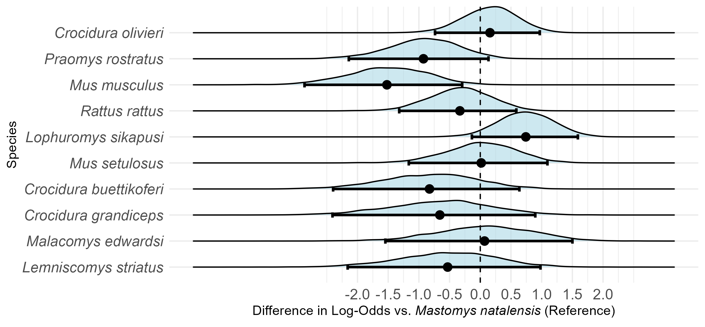

Figure 2: Odds Ratios of seropositivity to LASV among small-mammal species, compared to Mastomys natalensis. Only species with more than 10 individuals assayed for antibodies to LASV were included in this analysis.

Small mammals with antibodies to LASV were detected in three of the study villages, Lalehun (N = 18, 46%), Seilama (N = 12, 31%) and Baiama (N = 9, 23%). Lalehun had the highest percentage of antibody positive rodents (18/157, 12%), followed by Baiama (9/121, 7%) and Seilama (12/263, 5%), no positive individuals were detected in the most urbanised village study site Lambayama.

Antibody positive small mammals were detected in all land use types, most positive individuals were trapped in agricultural (24/39, 62%), followed by village (13/39, 33%) and forest (2/39, 5%) settings. The proportion of antibody positive individuals among all small mammals trapped were similar across forest (2/44, 4.5%), agricultural (24/379, 6.3%) and village (13/261, 5%) land use types. Antibody positive individuals were detected during all study visits except visit 9 (2023-February), the proportion of seropositive individuals were significantly greater in the rainy season (23/240, 9.6%) than the dry season (16/444, 3.6%) ( = 9.28, *p* = 0.002).

## Small-mammal community contact networks

Networks constructed from small mammals trapped in agricultural land use contained the highest species richness (12), followed by villages (9) and forests (6). More individuals (nodes) were detected in agricultural land use (N = 379) than villages (261) and forests (44). The mean global degree within a network was positively associated with the number of nodes within the network. Networks in village settings had the highest global degree (mean degree = 6.2, standard deviation (SD) = 4.6) compared to forest and agricultural settings (mean = 5.1, SD 3.3 and mean = 4.9, SD = 5.4 respectively). Agricultural and village settings contained the individual nodes with the highest degree centrality (24 and 20 respectively). Mean betweenness centrality, followed an anthropogenic land use gradient, it was highest in villages (mean betweenness = 3.06, standard deviation (SD) = 10.2), followed by agriculture (mean = 0.46, SD = 2.6) and forest (mean = 0.07, SD = 0.16).

There was substantial variability in degree centrality within detected rodents and shrew species. Species more commonly found in agricultural settings had the highest number of detected contacts. Individuals from *L. sikapusi*, *M. setulosus*, *P. rostratus* and *C. olivieri*, three native rodent species and a shrew species had a degree centrality of up to 24, although most individuals of these species had a lower degree (Table 1. and Figure 2.). Within villages *Mus musculus*, an invasive, synanthropic rodent species had a degree centrality of up to 20 and a high median degree across all individuals of the species. Interestingly, *M. natalensis*, while commonly detected in both agricultural and village settings had a lower maximum degree centrality of 12 in villages and 9 in agriculture. The median degree centrality was similar across village and agricultural settings (5 and 4 respectively).

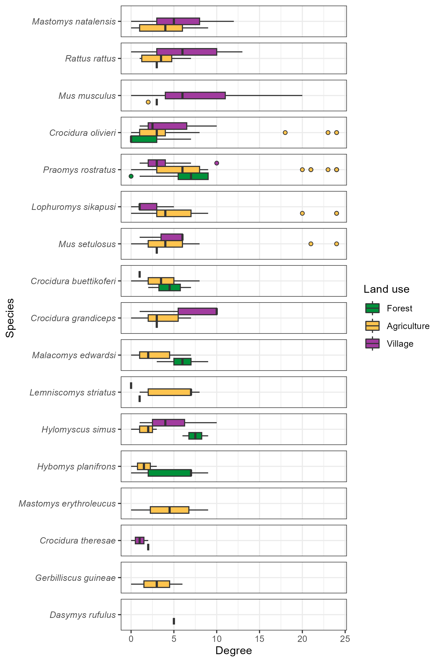

Figure 3: The degree of individual small mammals stratified by species and land use type. Boxes contain the median and inter-quartile range of the degree distribution. Whiskers include the upper and lower quartile with outliers shown as points.

There was no consistent trend across all species of degree centrality varying with a land use gradient (Figure 3.). For commensal species including *M. natalensis*, *Rattus rattus* and *M. musculus* median nodal degree was increased in villages but for *M. natalensis* and *R. rattus* there was no statistically significant difference between the degree distribution stratified by land use.

## Describing inter- and intra-specific contact within small mammal communities

Generally, species with more detected individuals had a greater number of contacts with other species (*r(15)* = 0.62, *p* = 0.007). For example, the frequently detected species, *M. natalensis*, *P. rostratus* and *R. rattus* had contact with more than 13 other species. *M. musculus* is an important outlier to this trend, it was the fourth most observed species but only had observed contacts with four other species (Figure 3. and **Supplementary Figure 4A-B**).

Intra-specific contacts were common for most species. However, there was some important difference across land use type. *Mastomys natalensis* had contact with 13 other species in agricultural land use, but 45% of all observed contacts to this species were from other individuals of the same species (Figure 4.). However, in villages where fewer other species were contacted (9), the percentage of intra-specific contacts was lower at 31% (**Supplementary Figure 4B**). Not all species were observed to have a majority of intra-specific contacts. In comparison, *L. sikapusi* in agricultural settings also had contact with 13 other species, but a similar proportion of contacts to individuals of this species came from *P. rostratus* (27%) as from other individuals of *L. sikapusi* (26%).

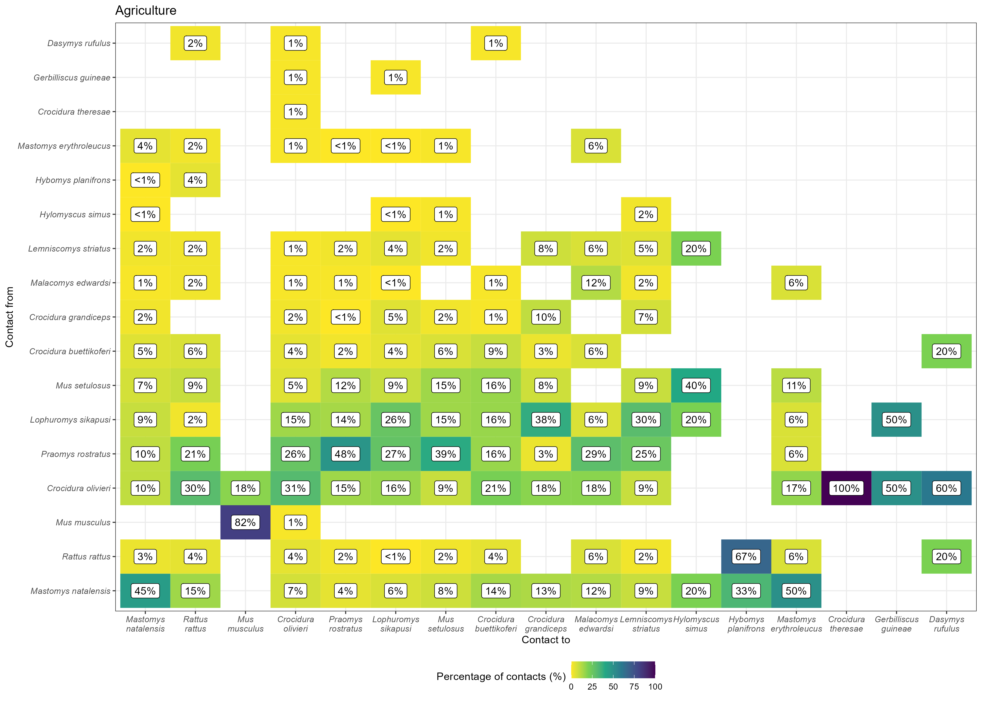

Figure 4: The proportion of contacts between individual small mammals in agricultural land use. Darker colours indicate increasing proportions of observed contacts to a species (Contact to) from named species (Contact from). Numbers in the cells correspond to the proportion of contacts to a species from a named species. Percentages sum to 100% in the Contact to axis

## The probability of inter- and intraspecific contact rates of *Mastomys natalensis* across a land use gradient

Limiting the analysis of the probability of a contact being observed to the reservoir species of LASV, *M. natalensis*, resulted in 12 ERGM models of the constructed networks being suitable for random effects meta-analysis. The odds of a contact being observed in these networks were generally low with similar odds across both agricultural (Odds Ratio = 0.14, 95% Confidence Interval = 0.09-0.23, *p* < 0.001) and village land use (OR = 0.24, 95% C.I. = 0.17-0.36, *p* < 0.001) (Figure 5A). There were high levels of heterogeneity in the odds of a contact being observed between networks from different visits for both agricultural and village settings ( = 0.26, = 112, *p* < 0.001 and = 0.23, = 54, *p* < 0.001). Compared to other rodent species *M. natalensis* formed fewer contacts.

*Mastomys natalensis* had a non-statistically significant reduced odds of having contact with a different species (i.e., an inter-specific contact) in agricultural (OR = 0.49, 95% C.I. = 0.24-1.01, *p* = 0.054) and village settings (OR = 0.74, 95% C.I. = 0.55-1.01, *p* = 0.055) when compared to inter-specific contacts among other species in these communities (Figure @ref(fig:figure-4-4)B). There were high levels of heterogeneity in the odds of inter-specific contacts being observed between networks ( = 0.59, = 31, *p* < 0.001 and = 0.09, = 15, *p* = 0.03). *Mastomys natalensis* did not importantly differ from other species in their probability for inter-specific contacts, with no observed effect of land use.

Finally, *M. natalensis* had a statistically significantly increased odds of forming contacts with other *M. natalensis* individuals (i.e., an intra-specific contact) in agricultural (OR = 7.5, 95% C.I. = 3.42-16.5, *p* < 0.001) but not in village settings (OR = 1.69, 95% C.I. = 0.85-3.36, *p* = 0.13) when compared to inter-specific contacts among non-*M. natalensis* species (Figure @ref(fig:figure-4-4)C). There was no substantial heterogeneity in the analysis of the odds of intra-specific contacts ( = 0.22, = 5.6, *p* = 0.23 and = 0.39, = 12, *p* = 0.1) in both land use types. *Mastomys natalensis* compared to other small mammal species was more likely to have intra-specific contacts within communities in agricultural but not village settings.

In the first sensitivity analysis, altering the radius in which a contact was defined, there was no change in direction of the effect sizes for the random-effects meta-analysis (**Supplementary Material 3**). There were no important changes in effect size direction or magnitude in leave-one-out sensitivity testing for meta-analyses containing influential networks. The results of these sensitivity analyses suggest that the results are robust to the assumption of contact buffer range and changes to the rodent community over study visits.

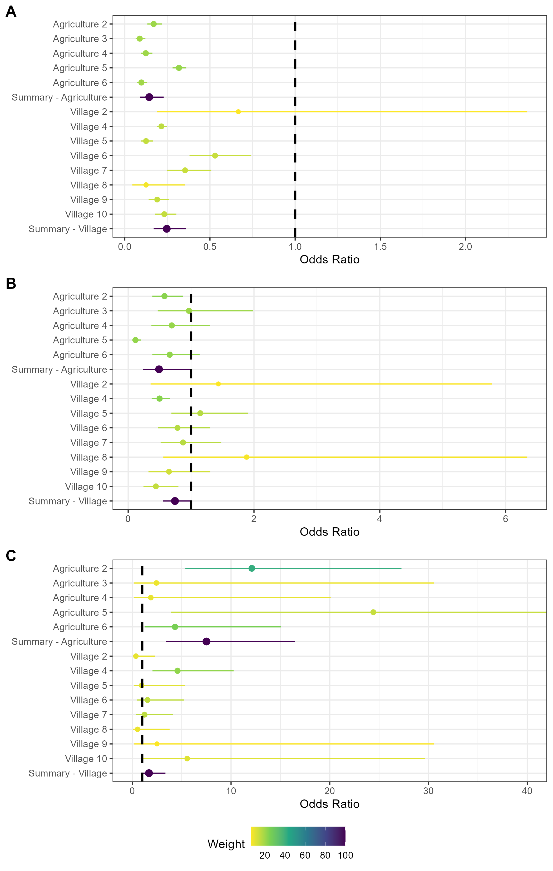

Figure 5: Random effects meta-analysis of ERGM network models reporting the odds of a contact being observed for M natalensis. A) The odds ratio of a contact being observed for M. natalensis in Agricultural or Village land use types. B) The odds ratio of a contact being observed between M. natalensis and an individual of a different rodent species. C) The odds ratio of a contact being observed between M. natalensis and another M. natalensis.

## Association of *Lassa mammarenavirus* seropositivity and position within a small-mammal community contact network

The mean degree centrality of LASV seropositive rodents and shrews (mean = 3.7, SD = 2.9) was statistically significantly lower than the seronegative mean degree (mean = 5.5, SD = 5.1) (W = 9834.5, *p* = 0.049). Statistical tests to investigate the degree of seropositive and seronegative individuals stratified by species were only performed for three species with more than five seropositive individuals (i.e., *M. natalensis*, *L. sikapusi* and *C. olivieri*). There was no statistically significant difference in the degree centrality of LASV seropositive and seronegative individuals for *M. natalensis* (W = 160.5, *p* = 0.51) or *C. olivieri* (W = 0.98, *p* = 0.43) but seropositive *L. sikapusi* had statistically significantly lower degree centrality than seronegative individuals (W = 92, *p* = 0.02).

There was no statistically significant difference in the betweenness centrality of seropositive and seronegative individuals, nor when compared between seropositive and seronegative individuals within species for those with more than five seropositive individuals.

# Discussion

In our study within the Eastern province of Sierra Leone, we found that small-mammal community contact networks while generally larger in village and agricultural settings had similar rates of contact across a land use gradient from forest, through agriculture to villages. We found that while some individual rodents and shrews had a high number of contacts, most had fewer than 5 contacts, indicating sparse networks. There was no clear difference in degree centrality by species across different land use types. For *M. natalensis* specifically, we observed a high probability of the formation of intra-specific contacts preferentially occurring within agricultural settings. The finding of increased intra-specific contact rates among the primary reservoir species in agricultural settings may suggest that these locations are the foci of LASV transmission. Finally, we found low prevalence of seropositivity to LASV within these small-mammal communities in four villages in the Eastern Province of Sierra Leone. Antibodies to LASV were detected in 6 rodent and shrew species with the majority of seropositive individuals belonging to *M. natalensis*. We found that seropositive individuals had reduced degree centrality, but that this population-wide association wasn’t replicated when stratified by species.

We hypothesised that rodent contact rates would be greater in anthropogenically dominated habitats. Our findings did not support this, with an equivalent global degree observed across a land use gradient. However, the individuals with the highest degree centrality were detected in village and agricultural settings. The node-level heterogeneity of these networks is masked when only considering aggregated global descriptive metrics.

Small-mammal communities were found to have higher species richness in agricultural land. Species detected within these settings encountered a greater number of distinct species and had a generally higher proportion of inter-specific contacts. Several native rodent species (e.g., *P. rostratus*), particularly in agricultural settings, appeared to contain individuals that were members of more densely connected sub-components of the networks within these small-mammal communities, evidenced by high degree centrality for specific individuals. It may be that contact rates within species are heterogeneous and species-level measurements will mask the individual-level differences in contact rates (Farine and Whitehead 2015).

The idiosyncratic nature of these networks is also shown through their different structures across the land use gradient. For example, we found higher betweenness centrality in villages, compared to agricultural or forest settings. This indicates that these networks have a structure that is more discontinuous and fragmented than those in other land use settings. The high betweenness centrality in village settings, will moderate pathogen transmission through the network as some individuals are more influential in bridging sub-components of the network.

The results of our descriptive network analysis suggest that contact within small mammal communities occurs at similar rates across different land use types but that networks within villages are more discontinuous. Agricultural habitats provide opportunities for synanthropic and sylvatic species to interact, as evidenced by the high proportion of inter-specific contacts for most species in these locations. This, combined with the low betweenness centrality of nodes in agricultural land suggest that a pathogen (i.e., LASV) would be effectively transmitted among competent hosts within these well-connected networks.

*Mastomys natalensis* was found to have fewer contacts than the other rodent species within small-mammal communities in agricultural and village settings. When contacts were observed for this species in agricultural settings, they had a higher odds of being intra-specific contacts. This was not replicated in village settings where inter-specific contacts were more common. This is supported by prior research showing that *M. natalensis* does not exhibit strong territorial responses, similar to *R. rattus* but in contrast to *M. musculus* (Anderson 1961; Whisson, Quinn, and Collins 2007; Borremans et al. 2014).

Homophily in contacts of *M. natalensis* (i.e., intra-specific contacts) may be important for viral transmission if other species are not as effective hosts for LASV replication and transmission (Luis et al. 2018). For example, if an infected individual *M. natalensis* resides in an agricultural setting it will have higher odds of transmitting LASV to a contact capable of maintaining a chain of transmission (i.e., another individual of *M. natalensis*), compared to an individual that was located in a village that would have higher odds of contacting a non-*M. natalensis* individual. This may result in different pathogen dynamics by land use type. This is an important avenue for future research as such differences could impact the effectiveness of rodent control interventions to reduce zoonotic spillover risk (Garry 2023).

Local pathogen extinction may be more likely in agricultural settings following viral introduction. High connectivity within the networks in these settings could lead to a greater force-of-infection where a single infected individual leads to an increased number of secondary infections (Keeling and Eames 2005). If this transmission were to occur at a faster rate than population births (i.e., replenishment of susceptible individuals), population level immunity would be rapidly reached, leading to local pathogen extinction (Messinger and Ostling 2009). The same may not be the case in village settings where an infected rodent will have fewer contacts, thus LASV transmission may be at a rate below the rate of replenishment of susceptible individuals (Peel et al. 2014). In this scenario, the pathogen would be maintained in the population. This may be complicated further by migration of individuals between agricultural and village settings based on resource availability as has been reported elsewhere in the Lassa fever endemic region (Mari Saez et al. 2018). The risk of Lassa fever outbreaks in human communities is therefore likely governed by dynamic contacts among susceptible and infectious rodents in the local environment.

The number and proportion of seropositive rodents and shrews detected in the current study, while low (5.7%), was similar (2.8%) to that reported by another study that sampled small-mammal populations in Eastern Sierra Leone (Bangura et al. 2021). Comparison of these studies is limited by different sampling design, for example, the current study sampled rodents in forest environments and locations more distant from areas of human habitation. The proportion of all seropositive individuals that were *M. natalensis* (28%) was lower in this study than in the study conducted in the neighbouring district (75%) although the proportion of all *M. natalensis* that were antibody positive was more similar (9.7% compared to 8%). We similarly identified antibodies in other rodent species including, *L. sikapusi* and *R. rattus*. Antibodies to LASV were identified in four further rodent and shrew species, *C. olivieri*, *M. setulosus*, *Hybomys planifrons* and *Mastomys erythroleucus* that were not reported from the Bangura study (Bangura et al. 2021). Antibodies to LASV have not previously been reported in *M. setulosus*, although they have been detected in other pygmy mice species (e.g., *Mus musculoides*) (Bangura et al. 2021). These results support previous studies’ findings that evidence of prior acute infection is present in multiple species simultaneously within small-mammal communities in the Lassa fever endemic region (Demby et al. 2001; Agbonlahor et al. 2017; Bangura et al. 2021).

We did not detect a sufficient number of seropositive individuals to directly model the transmission networks of LASV through our small-mammal communities in these different land use settings. Ideally transmission networks would be developed from acute infection data rather than seroprevalence, given the time varying structure of dynamic contact networks. Based on studies suggesting that fewer individuals will be PCR positive than seropositive, it is unlikely that sufficient data would be available to parameterise models of transmission networks without substantially increasing the number of sampling periods and locations (Demby et al. 2001; Olayemi et al. 2016; Bangura et al. 2021). Future studies in the Eastern province of Sierra Leone will benefit from recent studies, including this one, when estimating sample sizes required to parameterise transmission models.

Several important assumptions were made that must be considered when contextualising the results of this research. First, we were unable to explicitly observe direct and indirect contacts among rodents in our study. To infer these contacts, we utilised co-location of trapped individuals in time and space (Perkins et al. 2009). This assumed that individuals were detected at the centroid of their home range and that they spend an equivalent amount of time at all points within the area of their home range (Wanelik and Farine 2022). It is unlikely that this assumption holds true in our study system and this will lead to different contact rates than we infer in our networks (Wanelik and Farine 2022). Modifications to the current study design to explore the impact of these assumptions could include radio tagging or fluorescent marking to monitor rodent contacts in real-time (Mohr et al. 2007; Clay et al. 2009; Borremans et al. 2017). Second, only a small proportion of rodents and shrews active within a study site would be detected by our trapping activity (Parmenter et al. 2003; Moore and Swihart 2005). We account somewhat for the impact this will have on our network models by inferring the total abundance of species within these sites (Silk and Fisher 2017; Vega Yon, Slaughter, and Haye 2021). However, if individuals that were detected display importantly different behaviours than those not detected then inferring across these populations may be problematic. For example, if trap shyness is associated with inter- or intra-specific space sharing then detection of less trap shy individuals may overestimate the number of contacts individuals of a species are likely to make. It would be illustrative to replicate the findings of this study on small-mammal networks elsewhere in the Lassa fever endemic region to assess the impact of these assumptions among others.

In conclusion this study has highlighted the variability of inter- and intra-specific contact rates between different rodent and shrew species in different land use types in a setting of rodent associated zoonotic disease risk. We propose that the wider small-mammal community produces a more complex transmission network for LASV than previously assumed. These findings may highlight the mechanism through which the wide variety of rodent and shrew species found to be seropositive for LASV may have been infected. This could have important implications for the control of Lassa fever risk to human populations as there is likely to be a complex interaction between pathogen transmission within differently structured rodent networks in areas of human habitation and the wider landscape.

# Supplementary material

## Supplementary Material 1

Attached to the email, contains the protocols for the trapping and lab work.

## Supplementary Material 2

Attached to the email, contains the morphological taxonomic key.

## Supplementary Figure 1

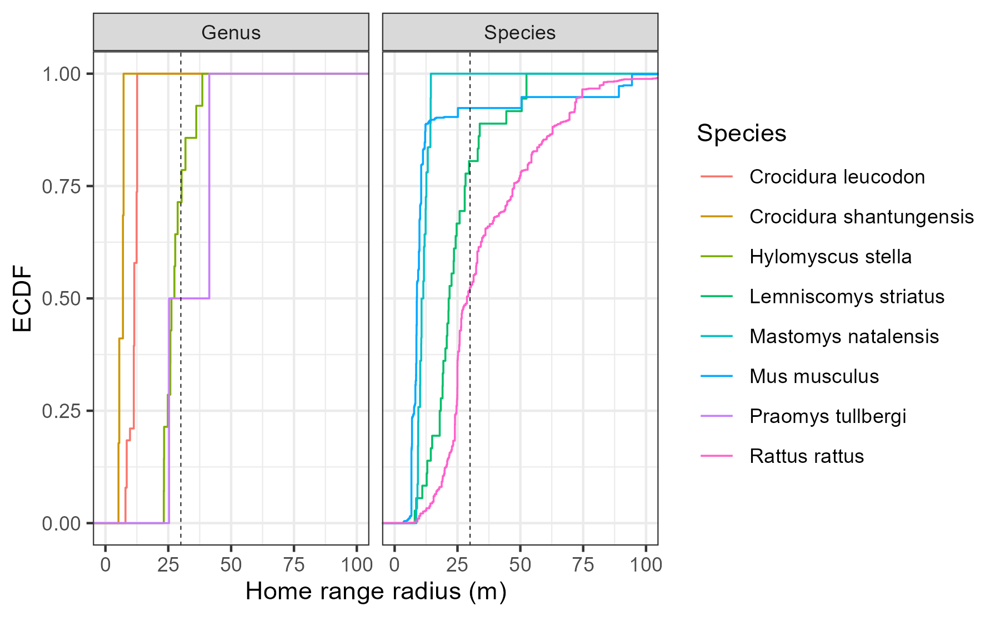

Supplementary Figure 1: Empirical Cumulative Density Function of the home range radius of rodent and shrew species with data available in the HomeRange dataset. Species that match detected genera in our study include two shrew species Crocidura leucodon and Crocidura shantungensis and two rodent species Hylomyscus stella and Praomys tullbergi. Four species matches to rodent species detected in our study were also included Lemniscomys striatus, Mastomys natalensis, Mus musculus and Rattus rattus. Only Lemniscomys striatus and Mastomys natalensis contain data from Africa (Uganda and Tanzania respectively). The dashed line represents the 30m range radius used for the primary analysis in the current study.

## Supplementary Figure 2A-F

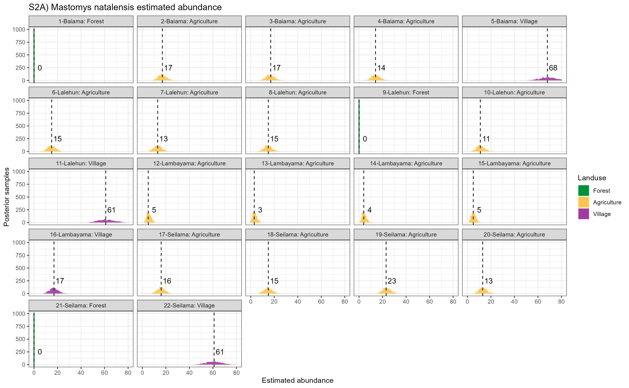

Supplementary Figure 2A: Estimated abundance at each sampling site for Mastomys natalensis. The dashed line and number is the median abundance used to infer the population size at this study site.

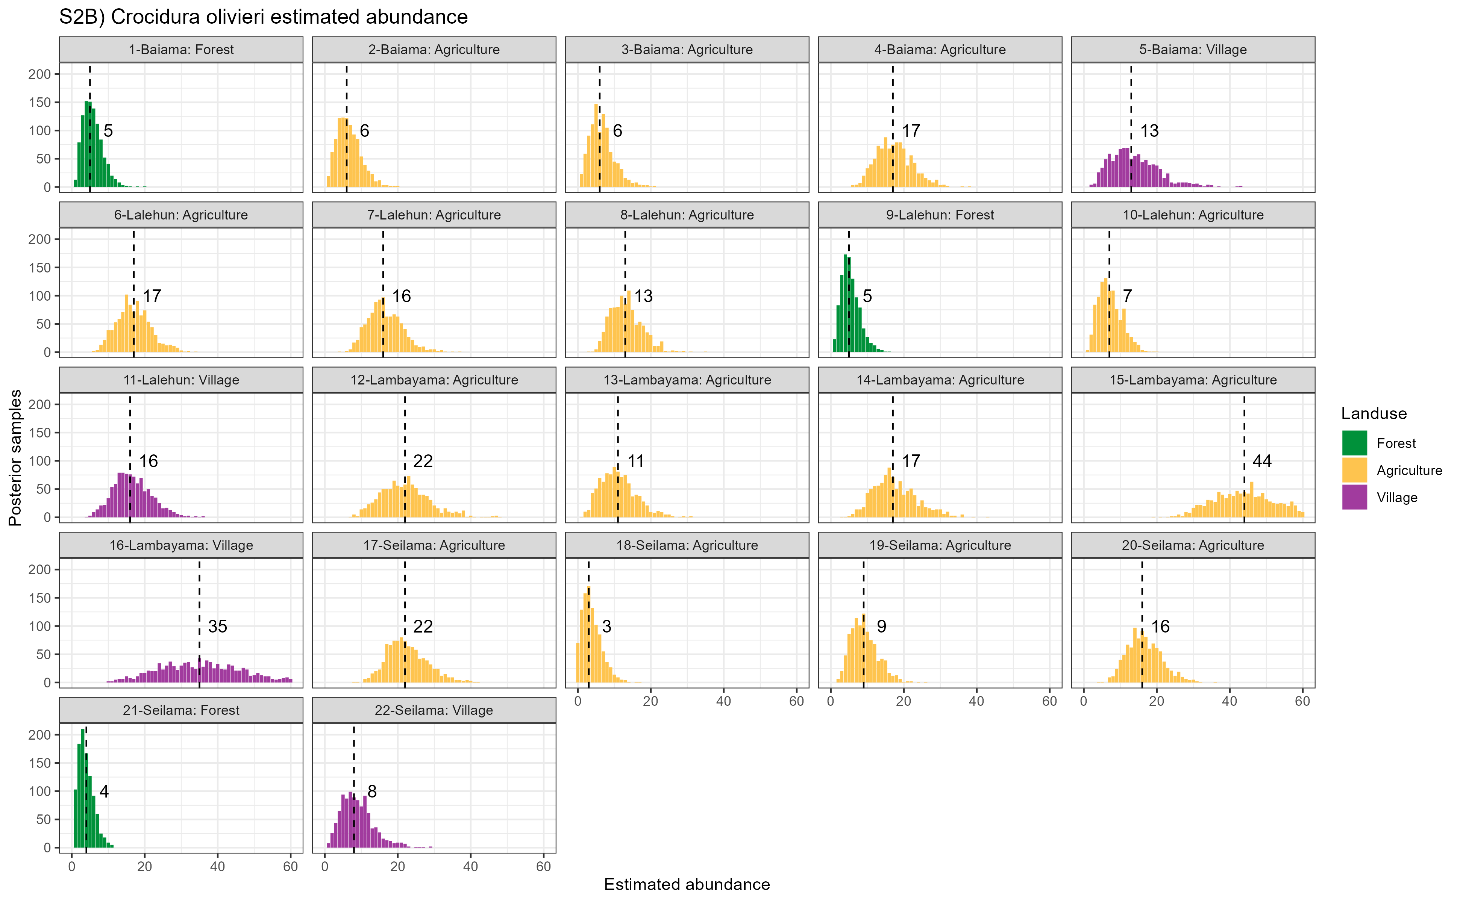

Supplementary Figure 2B: Estimated abundance at each sampling site for Mus musculus. The dashed line and number is the median abundance used to infer the population size at this study site.

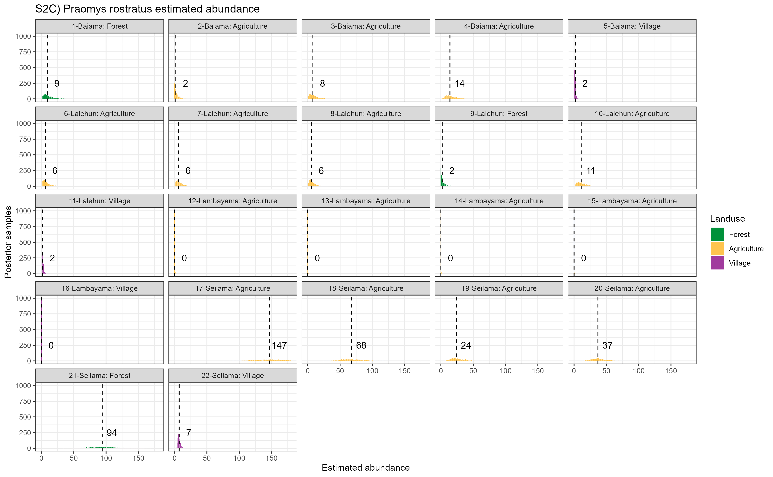

Supplementary Figure 2C: Estimated abundance at each sampling site for Rattus rattus. The dashed line and number is the median abundance used to infer the population size at this study site.

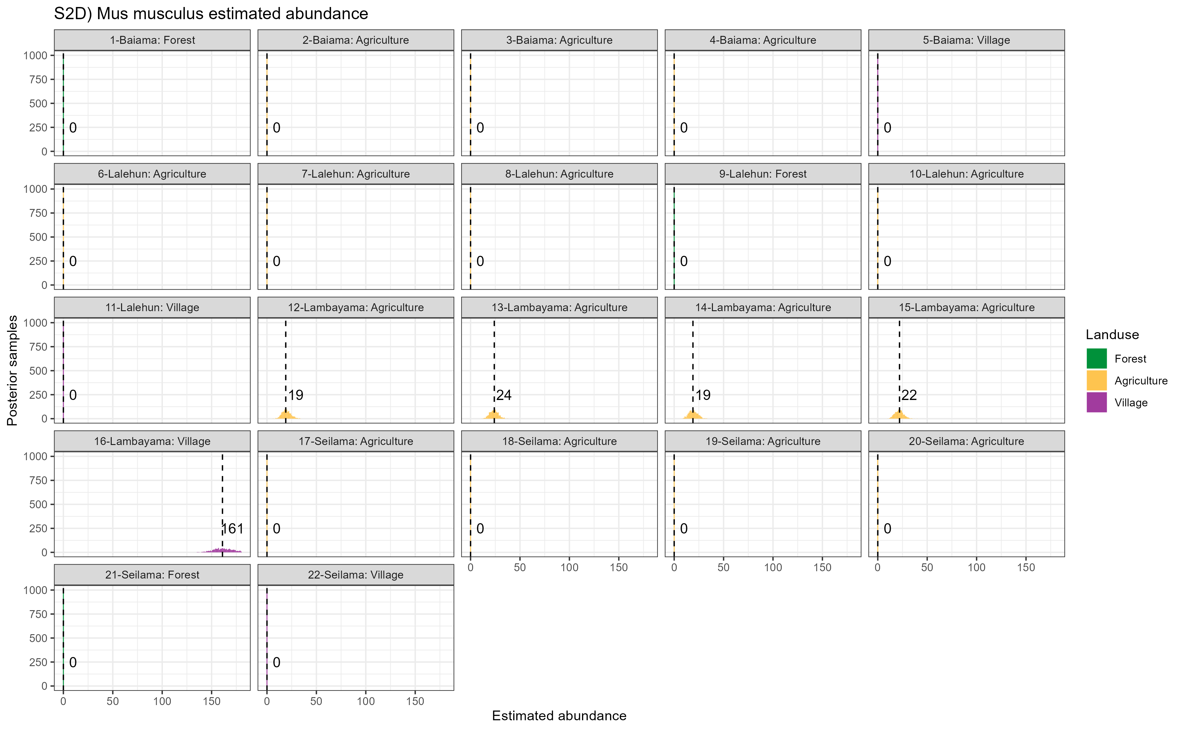

Supplementary Figure 2D: Estimated abundance at each sampling site for Crocidura spp. The dashed line and number is the median abundance used to infer the population size at this study site.

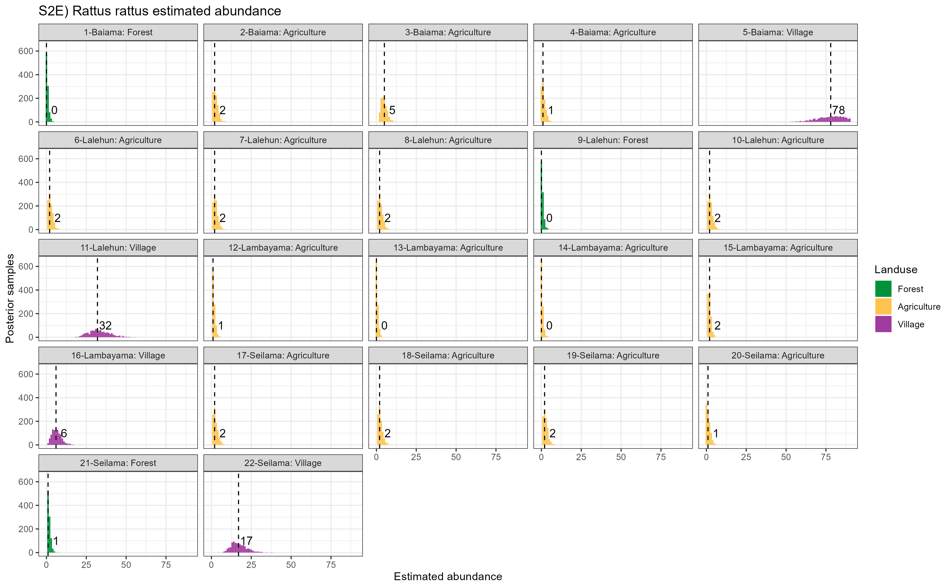

Supplementary Figure 2E: Estimated abundance at each sampling site for Praomys spp. The dashed line and number is the median abundance used to infer the population size at this study site.

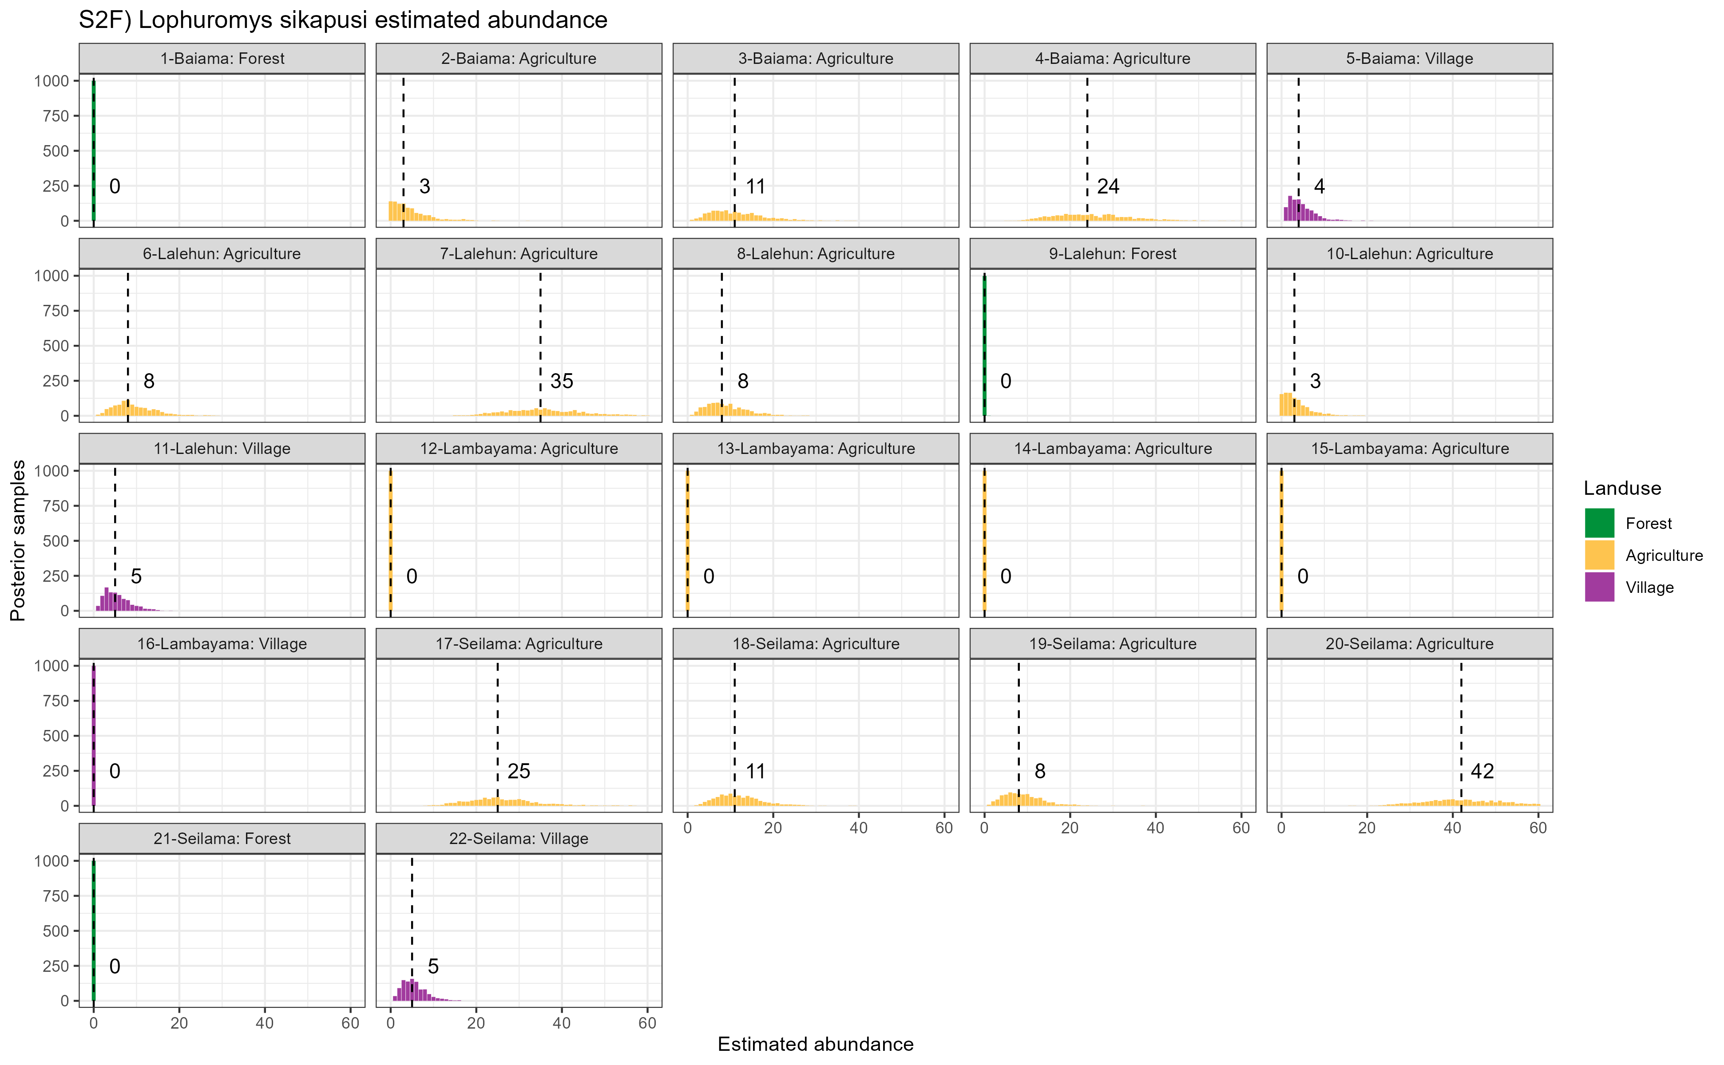

Supplementary Figure 2F: Estimated abundance at each sampling site for all other species (species with fewer than 20 observations). The dashed line and number is the median abundance used to infer the population size at this study site.

## Supplementary Figure 3A-W

These are the networks produced for each land use type and visit. I have not included them in this file but they are attached to the email in a .zip file if of interest.

# References

Agbonlahor, D. E., A. Erah, I. M. Agba, F. E. Oviasogie, A. F. Ehiaghe, M. Wankasi, O. A. Eremwanarue, et al. 2017. “Prevalence of Lassa Virus Among Rodents Trapped in Three South-South States of Nigeria.” *Journal of Vector Borne Diseases* 54 (2): 146. <http://www.jvbd.org/article.asp?issn=0972-9062;year=2017;volume=54;issue=2;spage=146;epage=150;aulast=Agbonlahor;type=0>.

Albery, Gregory F., Daniel J. Becker, Liam Brierley, Cara E. Brook, Rebecca C. Christofferson, Lily E. Cohen, Tad A. Dallas, et al. 2021. “The Science of the Host–Virus Network.” *Nature Microbiology* 6 (12): 1483–92. <https://doi.org/10.1038/s41564-021-00999-5>.

Almberg, Emily S., Paul C. Cross, Andrew P. Dobson, Douglas W. Smith, and Peter J. Hudson. 2012. “Parasite Invasion Following Host Reintroduction: A Case Study of Yellowstone’s Wolves.” *Philosophical Transactions of the Royal Society B: Biological Sciences* 367 (1604): 2840–51. <https://doi.org/10.1098/rstb.2011.0369>.

Altschul, S. F., W. Gish, W. Miller, E. W. Myers, and D. J. Lipman. 1990. “Basic Local Alignment Search Tool.” *Journal of Molecular Biology* 215 (3): 403–10. <https://doi.org/10.1016/S0022-2836(05)80360-2>.

Anderson, P. K. 1961. “Density, Social Structure, and Nonsocial Environment in House-Mouse Populations and the Implications for Regulation of Numbers.” *Transactions of the New York Academy of Sciences* 23 (March): 447–51. <https://doi.org/10.1111/j.2164-0947.1961.tb01373.x>.

Bangura, Umaru, Jacob Buanie, Joyce Lamin, Christopher Davis, Gedeon Ngiala Bongo, Michael Dawson, Rashid Ansumana, et al. 2021. “Lassa Virus Circulation in Small Mammal Populations in Bo District, Sierra Leone.” *BIOLOGY-BASEL* 10 (1). <https://doi.org/10.3390/biology10010028>.

Basinski, Andrew J., Elisabeth Fichet-Calvet, Anna R. Sjodin, Tanner J. Varrelman, Christopher H. Remien, Nathan C. Layman, Brian H. Bird, et al. 2021. “Bridging the Gap: Using Reservoir Ecology and Human Serosurveys to Estimate Lassa Virus Spillover in West Africa.” Edited by Amy Wesolowski. *PLOS Computational Biology* 17 (3): e1008811. <https://doi.org/10.1371/journal.pcbi.1008811>.

Bauer, David F. 1972. “Constructing Confidence Sets Using Rank Statistics.” *Journal of the American Statistical Association* 67 (339): 687–90. <https://doi.org/10.1080/01621459.1972.10481279>.

Bausch, D. G., A. H. Demby, M. Coulibaly, J. Kanu, A. Goba, A. Bah, N. Condé, et al. 2001. “Lassa Fever in Guinea: I. Epidemiology of Human Disease and Clinical Observations.” *Vector Borne and Zoonotic Diseases (Larchmont, N.Y.)* 1 (4): 269–81. <https://doi.org/10.1089/15303660160025903>.

Begon, M., S. M. Hazel, D. Baxby, K. Bown, R. Cavanagh, J. Chantrey, T. Jones, and M. Bennett. 1999. “Transmission Dynamics of a Zoonotic Pathogen Within and Between Wildlife Host Species.” *Proceedings of the Royal Society of London. Series B: Biological Sciences* 266 (1432): 1939–45. <https://doi.org/10.1098/rspb.1999.0870>.

Böhm, Monika, Michael R. Hutchings, and Piran C. L. White. 2009. “Contact Networks in a Wildlife-Livestock Host Community: Identifying High-Risk Individuals in the Transmission of Bovine TB Among Badgers and Cattle.” *PLOS ONE* 4 (4): e5016. <https://doi.org/10.1371/journal.pone.0005016>.

Borenstein, Michael, Larry V. Hedges, Julian P. T. Higgins, and Hannah R. Rothstein. 2010. “A Basic Introduction to Fixed-Effect and Random-Effects Models for Meta-Analysis.” *Research Synthesis Methods* 1 (2): 97–111. <https://doi.org/10.1002/jrsm.12>.

Borremans, Benny, Nelika K. Hughes, Jonas Reijniers, Vincent Sluydts, Abdul A. S. Katakweba, Loth S. Mulungu, Christopher A. Sabuni, Rhodes H. Makundi, and Herwig Leirs. 2014. “Happily Together Forever: Temporal Variation in Spatial Patterns and Complete Lack of Territoriality in a Promiscuous Rodent.” *Population Ecology* 56 (1): 109–18. <https://doi.org/10.1007/s10144-013-0393-2>.

Borremans, Benny, Jonas Reijniers, Nelika K. Hughes, Stephanie S. Godfrey, Sophie Gryseels, Rhodes H. Makundi, and Herwig Leirs. 2017. “Nonlinear Scaling of Foraging Contacts with Rodent Population Density.” *Oikos* 126 (6): 792–800. <https://doi.org/10.1111/oik.03623>.

Borremans, Benny, Raphaël Vossen, Beate Becker-Ziaja, Sophie Gryseels, Nelika Hughes, Mats Van Gestel, Natalie Van Houtte, Stephan Günther, and Herwig Leirs. 2015. “Shedding Dynamics of Morogoro Virus, an African Arenavirus Closely Related to Lassa Virus, in Its Natural Reservoir Host Mastomys Natalensis.” *Scientific Reports* 5 (1): 10445. <https://doi.org/10.1038/srep10445>.

Broekman, Maarten Jaap Erik, Selwyn Hoeks, Rosa Freriks, Merel M. Langendoen, Katharina M. Runge, Ecaterina Savenco, Ruben ter Harmsel, Mark A. J. Huijbregts, and Marlee A. Tucker. 2023. “HomeRange: A Global Database of Mammalian Home Ranges.” *Global Ecology and Biogeography* 32 (2): 198–205. <https://doi.org/10.1111/geb.13625>.

Bürkner, Paul-Christian. 2017. “brms: An R Package for Bayesian Multilevel Models Using Stan.” *Journal of Statistical Software* 80 (1): 1–28. <https://doi.org/10.18637/jss.v080.i01>.

Butts, Carter T. 2008. “**Network** : A Package for Managing Relational Data in *r*.” *Journal of Statistical Software* 24 (2). <https://doi.org/10.18637/jss.v024.i02>.

Cardenas, Nicolas C., Abagael L. Sykes, Francisco P. N. Lopes, and Gustavo Machado. 2022. “Multiple Species Animal Movements: Network Properties, Disease Dynamics and the Impact of Targeted Control Actions.” *Veterinary Research* 53 (1): 14. <https://doi.org/10.1186/s13567-022-01031-2>.

Caron, Alexandre, Julien Cappelle, Graeme S. Cumming, Michel de Garine-Wichatitsky, and Nicolas Gaidet. 2015. “Bridge Hosts, a Missing Link for Disease Ecology in Multi-Host Systems.” *Veterinary Research* 46 (1): 83. <https://doi.org/10.1186/s13567-015-0217-9>.

Carslake, David, Malcolm Bennett, Kevin Bown, Sarah Hazel, Sandra ℡fer, and Michael Begon. 2005. “Space–Time Clustering of Cowpox Virus Infection in Wild Rodent Populations.” *Journal of Animal Ecology* 74 (4): 647–55. <https://doi.org/10.1111/j.1365-2656.2005.00966.x>.

Chen, Shi, Brad J. White, Michael W. Sanderson, David E. Amrine, Amiyaal Ilany, and Cristina Lanzas. 2014. “Highly Dynamic Animal Contact Network and Implications on Disease Transmission.” *Scientific Reports* 4 (March): 4472. <https://doi.org/10.1038/srep04472>.

Cheung, Mike W.-L. 2019. “A Guide to Conducting a Meta-Analysis with Non-Independent Effect Sizes.” *Neuropsychology Review* 29 (4): 387–96. <https://doi.org/10.1007/s11065-019-09415-6>.

Clay, Christine A., Erin M. Lehmer, Andrea Previtali, Stephen St. Jeor, and M. Denise Dearing. 2009. “Contact Heterogeneity in Deer Mice: Implications for Sin Nombre Virus Transmission.” *Proceedings of the Royal Society B: Biological Sciences* 276 (1660): 1305–12. <https://doi.org/10.1098/rspb.2008.1693>.

Cochran, William G. 1954. “The Combination of Estimates from Different Experiments.” *Biometrics* 10 (1): 101–29. <https://doi.org/10.2307/3001666>.

Demby, Austin H., Alphonse Inapogui, Kandeh Kargbo, James Koninga, Kerfalla Kourouma, James Kanu, Mamadi Coulibaly, et al. 2001. “Lassa Fever in Guinea: II. Distribution and Prevalence of Lassa Virus Infection in Small Mammals.” *Vector-Borne and Zoonotic Diseases* 1 (4): 283–97. <https://doi.org/10.1089/15303660160025912>.

Drewe, Julian A., Ken T. D. Eames, Joah R. Madden, and Gareth P. Pearce. 2011. “Integrating Contact Network Structure into Tuberculosis Epidemiology in Meerkats in South Africa: Implications for Control.” *Preventive Veterinary Medicine* 101 (1): 113–20. <https://doi.org/10.1016/j.prevetmed.2011.05.006>.

Ecke, Frauke, Barbara A. Han, Birger Hörnfeldt, Hussein Khalil, Magnus Magnusson, Navinder J. Singh, and Richard S. Ostfeld. 2022. “Population Fluctuations and Synanthropy Explain Transmission Risk in Rodent-Borne Zoonoses.” *Nature Communications* 13 (1): 7532. <https://doi.org/10.1038/s41467-022-35273-7>.

Farine, Damien R., and Hal Whitehead. 2015. “Constructing, Conducting and Interpreting Animal Social Network Analysis.” *Journal of Animal Ecology* 84 (5): 1144–63. <https://doi.org/10.1111/1365-2656.12418>.

Faust, Christina L., Andrew P. Dobson, Nicole Gottdenker, Laura S. P. Bloomfield, Hamish I. McCallum, Thomas R. Gillespie, Maria Diuk-Wasser, and Raina K. Plowright. 2017. “Null Expectations for Disease Dynamics in Shrinking Habitat: Dilution or Amplification?” *Philosophical Transactions of the Royal Society B: Biological Sciences* 372 (1722): 20160173. <https://doi.org/10.1098/rstb.2016.0173>.

Fichet-Calvet, Elisabeth. 2014. “Chapter 5 - Lassa Fever: A Rodent-Human Interaction.” In *The Role of Animals in Emerging Viral Diseases*, edited by Nicholas Johnson, 89–123. Boston: Academic Press. <https://doi.org/10.1016/B978-0-12-405191-1.00005-3>.

Fichet-Calvet, Elisabeth, Beate Becker-Ziaja, Lamine Koivogui, and Stephan Gunther. 2014. “Lassa Serology in Natural Populations of Rodents and Horizontal Transmission.” *Vector Borne & Zoonotic Diseases* 14 (9): 665–74. <https://doi.org/10.1089/vbz.2013.1484>.

Fichet‐Calvet, Elisabeth, Leen Audenaert, Patrick Barrière, and Erik Verheyen. 2010. “Diversity, Dynamics and Reproduction in a Community of Small Mammals in Upper Guinea, with Emphasis on Pygmy Mice Ecology.” *African Journal of Ecology* 48 (3): 600–614. <https://doi.org/10.1111/j.1365-2028.2009.01144.x>.

Fiske, Ian, and Richard Chandler. 2011. “Unmarked: An r Package for Fitting Hierarchical Models of Wildlife Occurrence and Abundance.” *Journal of Statistical Software* 43 (10): 1–23. <https://doi.org/10.18637/jss.v043.i10>.

Gabriel, Martin, Donatus I. Adomeh, Jacqueline Ehimuan, Jennifer Oyakhilome, Emmanuel O. Omomoh, Yemisi Ighodalo, Thomas Olokor, et al. 2018. “Development and Evaluation of Antibody-Capture Immunoassays for Detection of Lassa Virus Nucleoprotein-Specific Immunoglobulin m and g.” *PLOS Neglected Tropical Diseases* 12 (3): e0006361. <https://doi.org/10.1371/journal.pntd.0006361>.

Gilbert, Amy T., A. R. Fooks, D. T. S. Hayman, D. L. Horton, T. Müller, R. Plowright, A. J. Peel, et al. 2013. “Deciphering Serology to Understand the Ecology of Infectious Diseases in Wildlife.” *EcoHealth* 10 (3): 298–313. <https://doi.org/10.1007/s10393-013-0856-0>.

Grant, Donald S., Emily J. Engel, Nicole Roberts Yerkes, Lansana Kanneh, James Koninga, Michael A. Gbakie, Foday Alhasan, et al. 2023. “Seroprevalence of Anti-Lassa Virus IgG Antibodies in Three Districts of Sierra Leone: A Cross-Sectional, Population-Based Study.” *PLOS Neglected Tropical Diseases* 17 (2): e0010938. <https://doi.org/10.1371/journal.pntd.0010938>.

Grüner, Nico, Oumaima Stambouli, and R. Stefan Ross. 2015. “Dried Blood Spots - Preparing and Processing for Use in Immunoassays and in Molecular Techniques.” *Journal of Visualized Experiments : JoVE*, no. 97 (March): 52619. <https://doi.org/10.3791/52619>.

Handcock, Mark S., David R. Hunter, Carter T. Butts, Steven M. Goodreau, Pavel N. Krivitsky, and Martina Morris. 2022. “Ergm: Fit, Simulate and Diagnose Exponential-Family Models for Networks.” The Statnet Project (https://statnet.org). <https://CRAN.R-project.org/package=ergm>.

Happi, Anise N., Testimony J. Olumade, Olusola A. Ogunsanya, Ayotunde E. Sijuwola, Seto C. Ogunleye, Judith U. Oguzie, Cecilia Nwofoke, et al. 2022. “Increased Prevalence of Lassa Fever Virus-Positive Rodents and Diversity of Infected Species Found During Human Lassa Fever Epidemics in Nigeria.” *Microbiology Spectrum* 10 (4): e0036622. <https://doi.org/10.1128/spectrum.00366-22>.

Happold, David C. D., and Jonathan Kingdon, eds. 2013. *Mammals of Africa. Vol. 3: Rodents, Hares and Rabbits*. London: Bloomsbury.

Hunter, David R., Mark S. Handcock, Carter T. Butts, Steven M. Goodreau, and Martina Morris. 2008. “Ergm: A Package to Fit, Simulate and Diagnose Exponential-Family Models for Networks.” *Journal of Statistical Software* 24 (3): 1–29. <https://doi.org/10.18637/jss.v024.i03>.

Jetoh, Ralph Weah, Shruti Malik, Bode Shobayo, Fahn Taweh, Trokon Omarley Yeabah, Josiah George, Burgess Gbelee, et al. 2022. “Epidemiological Characteristics of Lassa Fever Cases in Liberia: A Retrospective Analysis of Surveillance Data, 2019-2020.” *International Journal of Infectious Diseases*, July. <https://doi.org/10.1016/j.ijid.2022.07.006>.

Keeling, Matt J, and Ken T. D Eames. 2005. “Networks and Epidemic Models.” *Journal of the Royal Society Interface* 2 (4): 295–307. <https://doi.org/10.1098/rsif.2005.0051>.

Keesing, Felicia, and Richard S. Ostfeld. 2021. “Impacts of Biodiversity and Biodiversity Loss on Zoonotic Diseases.” *Proceedings of the National Academy of Sciences* 118 (17): e2023540118. <https://doi.org/10.1073/pnas.2023540118>.

Kerneis, Solen, Lamine Koivogui, N’Faly Magassouba, Kekoura Koulemou, Rosamund Lewis, Aristide Aplogan, Rebecca F. Grais, Philippe J. Guerin, and Elisabeth Fichet-Calvet. 2009. “Prevalence and Risk Factors of Lassa Seropositivity in Inhabitants of the Forest Region of Guinea: A Cross-Sectional Study.” *PLoS Neglected Tropical Diseases [Electronic Resource]* 3 (11): e548. <https://doi.org/10.1371/journal.pntd.0000548>.

Klitting, Raphaelle, Liana E. Kafetzopoulou, Wim Thiery, Gytis Dudas, Sophie Gryseels, Anjali Kotamarthi, Bram Vrancken, et al. 2022. “Predicting the Evolution of the Lassa Virus Endemic Area and Population at Risk over the Next Decades.” *Nature Communications* 13 (1): 5596. <https://doi.org/10.1038/s41467-022-33112-3>.

Laverty, Sean M., and Frederick R. Adler. 2009. “The Role of Age Structure in the Persistence of a Chronic Pathogen in a Fluctuating Population.” *Journal of Biological Dynamics* 3 (2): 224–34. <https://doi.org/10.1080/17513750802452544>.

Lo Iacono, Giovanni, Andrew A. Cunningham, Elisabeth Fichet-Calvet, Robert F. Garry, Donald S. Grant, Sheik Humarr Khan, Melissa Leach, et al. 2015. “Using Modelling to Disentangle the Relative Contributions of Zoonotic and Anthroponotic Transmission: The Case of Lassa Fever.” *PLOS NEGLECTED TROPICAL DISEASES* 9 (1). <https://doi.org/10.1371/journal.pntd.0003398>.

Longet, Stephanie, Cristina Leggio, Joseph Akoi Bore, Stephanie Key, Tom Tipton, Yper Hall, Fara Raymond Koundouno, et al. 2023. “Influence of Landscape Patterns on Exposure to Lassa Fever Virus, Guinea.” *Emerging Infectious Diseases* 29 (2): 304–13. <https://doi.org/10.3201/eid2902.212525>.

Mari Saez, Almudena, Mory Cherif Haidara, Amara Camara, Fodé Kourouma, Mickaël Sage, N’Faly Magassouba, and Elisabeth Fichet-Calvet. 2018. “Rodent Control to Fight Lassa Fever: Evaluation and Lessons Learned from a 4-Year Study in Upper Guinea.” Edited by Manuel Schibler. *PLOS Neglected Tropical Diseases* 12 (11): e0006829. <https://doi.org/10.1371/journal.pntd.0006829>.

Mariën, Joachim, Benny Borremans, Sophie Gryseels, Barré Soropogui, Luc De Bruyn, Gédéon Ngiala Bongo, Beate Becker-Ziaja, et al. 2017. “No Measurable Adverse Effects of Lassa, Morogoro and Gairo Arenaviruses on Their Rodent Reservoir Host in Natural Conditions.” *Parasites & Vectors* 10 (1): 210. <https://doi.org/10.1186/s13071-017-2146-0>.

McCormick, J B, P A Webb, J W Krebs, K M Johnson, and E S Smith. 1987. “A Prospective Study of the Epidemiology and Ecology of Lassa Fever.” *The Journal of Infectious Diseases* 155 (3): 437–44. <https://doi.org/10.1093/infdis/155.3.437>.

Messinger, Susanna M., and Annette Ostling. 2009. “The Consequences of Spatial Structure for the Evolution of Pathogen Transmission Rate and Virulence.” *The American Naturalist* 174 (4): 441–54. <https://doi.org/10.1086/605375>.

Mohr, Katrine, Herwig Leirs, Abdul Katakweba, and Robert Machang’u. 2007. “Monitoring Rodents Movements with a Biomarker Around Introduction and Feeding Foci in an Urban Environment in Tanzania.” *African Zoology* 42 (2): 294–98. [https://doi.org/10.3377/1562-7020(2007)42[294:MRMWAB]2.0.CO;2](https://doi.org/10.3377/1562-7020(2007)42%5b294:MRMWAB%5d2.0.CO;2).

Monadjem, Ara, Peter J. Taylor, Christiane Denys, and Fenton P. D. Cotterill. 2015. *Rodents of Sub-Saharan Africa: A Biogeographic and Taxonomic Synthesis*. Berlin, München, Boston: DE GRUYTER. <https://doi.org/10.1515/9783110301915>.

Monath, T. P., V. F. Newhouse, G. E. Kemp, H. W. Setzer, and A. Cacciapuoti. 1974. “Lassa Virus Isolation from Mastomys Natalensis Rodents During an Epidemic in Sierra Leone.” *Science* 185 (4147): 263–65. <https://doi.org/10.1126/science.185.4147.263>.

Moore, Jeffrey E., and Robert K. Swihart. 2005. “Modeling Patch Occupancy by Forest Rodents: Incorporating Detectability and Spatial Autocorrelation with Hierarchically Structured Data.” *The Journal of Wildlife Management* 69 (3): 933–49. [https://doi.org/10.2193/0022-541X(2005)069[0933:MPOBFR]2.0.CO;2](https://doi.org/10.2193/0022-541X(2005)069%5b0933:MPOBFR%5d2.0.CO;2).

Olayemi, Ayodeji, Daniel Cadar, N’Faly Magassouba, Adeoba Obadare, Fode Kourouma, Akinlabi Oyeyiola, Samuel Fasogbon, et al. 2016. “New Hosts of the Lassa Virus.” *Scientific Reports* 6 (1): 25280. <https://doi.org/10.1038/srep25280>.

Parmenter, Robert R., Terry L. Yates, David R. Anderson, Kenneth P. Burnham, Jonathan L. Dunnum, Alan B. Franklin, Michael T. Friggens, et al. 2003. “Small-Mammal Density Estimation: A Field Comparison of Grid-Based Vs. Web-Based Density Estimators.” *Ecological Monographs* 73 (1): 1–26. [https://doi.org/10.1890/0012-9615(2003)073[0001:SMDEAF]2.0.CO;2](https://doi.org/10.1890/0012-9615(2003)073%5b0001:SMDEAF%5d2.0.CO;2).

Pebesma, Edzer. 2018. “Simple Features for r: Standardized Support for Spatial Vector Data.” *The R Journal* 10 (1): 439–46. <https://journal.r-project.org/archive/2018/RJ-2018-009/index.html>.

Peel, A. J., J. R. C. Pulliam, A. D. Luis, R. K. Plowright, T. J. O’Shea, D. T. S. Hayman, J. L. N. Wood, C. T. Webb, and O. Restif. 2014. “The Effect of Seasonal Birth Pulses on Pathogen Persistence in Wild Mammal Populations.” *Proceedings of the Royal Society B: Biological Sciences* 281 (1786): 20132962. <https://doi.org/10.1098/rspb.2013.2962>.

Perkins, Sarah E., Francesca Cagnacci, Anna Stradiotto, Daniele Arnoldi, and Peter J. Hudson. 2009. “Comparison of Social Networks Derived from Ecological Data: Implications for Inferring Infectious Disease Dynamics.” *Journal of Animal Ecology* 78 (5): 1015–22. <https://doi.org/10.1111/j.1365-2656.2009.01557.x>.

QIAGEN. 2023. “DNeasy Blood & Tissue Kits.” January 20, 2023. <https://www.qiagen.com/us/products/discovery-and-translational-research/dna-rna-purification/dna-purification/genomic-dna/dneasy-blood-and-tissue-kit>.

R Core Team. 2021. “R: A Language and Environment for Statistical Computing.” Vienna, Austria: R Foundation for Statistical Computing. <https://www.R-project.org/>.

Riley, Richard D., Julian P. T. Higgins, and Jonathan J. Deeks. 2011. “Interpretation of Random Effects Meta-Analyses.” *BMJ* 342 (February): d549. <https://doi.org/10.1136/bmj.d549>.

Royle, J. Andrew. 2004. “N-Mixture Models for Estimating Population Size from Spatially Replicated Counts.” *Biometrics* 60 (1): 108–15. <https://doi.org/10.1111/j.0006-341X.2004.00142.x>.

Safronetz, David, Kyle Rosenke, Kimberley Meade-White, Angela Sloan, Ousmane Maiga, Sidy Bane, Cynthia Martellaro, Dana P Scott, Nafomon Sogoba, and Heinz Feldmann. 2022. “Temporal Analysis of Lassa Virus Infection and Transmission in Experimentally Infected Mastomys Natalensis.” *PNAS Nexus* 1 (3): pgac114. <https://doi.org/10.1093/pnasnexus/pgac114>.

Salkeld, Daniel J., Marcel Salathé, Paul Stapp, and James Holland Jones. 2010. “Plague Outbreaks in Prairie Dog Populations Explained by Percolation Thresholds of Alternate Host Abundance.” *Proceedings of the National Academy of Sciences* 107 (32): 14247–50. <https://doi.org/10.1073/pnas.1002826107>.

Sauvage, Frank, Michel Langlais, Nigel G. Yoccoz, and Dominique Pontier. 2003. “Modelling Hantavirus in Fluctuating Populations of Bank Voles: The Role of Indirect Transmission on Virus Persistence.” *Journal of Animal Ecology* 72 (1): 1–13. <https://doi.org/10.1046/j.1365-2656.2003.00675.x>.

Shaffer, Jeffrey G., John S. Schieffelin, Mambu Momoh, Augustine Goba, Lansana Kanneh, Foday Alhasan, Michael Gbakie, et al. 2021. “Space-Time Trends in Lassa Fever in Sierra Leone by ELISA Serostatus, 2012–2019.” *Microorganisms* 9 (3): 586. <https://doi.org/10.3390/microorganisms9030586>.

Silk, Matthew J., and David N. Fisher. 2017. “Understanding Animal Social Structure: Exponential Random Graph Models in Animal Behaviour Research.” *Animal Behaviour* 132 (October): 137–46. <https://doi.org/10.1016/j.anbehav.2017.08.005>.

Simons, David, Lauren A Attfield, Kate E Jones, Deborah Watson-Jones, and Richard Kock. 2023. “Rodent Trapping Studies as an Overlooked Information Source for Understanding Endemic and Novel Zoonotic Spillover.” *PLOS Neglected Tropical Diseases* 17 (1): e0010772. <https://doi.org/10.1371/journal.pntd.0010772>.

Soubrier, Hugo, Umaru Bangura, Chris Hoffmann, Ayodeji Olayemi, Adetunji Samuel Adesina, Stephan Günther, Lisa Oestereich, and Elisabeth Fichet-Calvet. 2022. “Detection of Lassa Virus-Reactive IgG Antibodies in Wild Rodents: Validation of a Capture Enzyme-Linked Immunological Assay.” *Viruses* 14 (5): 993. <https://doi.org/10.3390/v14050993>.

Swinton, J., J. Harwood, B. T. Grenfell, and C. A. Gilligan. 1998. “Persistence Thresholds for Phocine Distemper Virus Infection in Harbour Seal Phoca Vitulina Metapopulations.” *Journal of Animal Ecology* 67 (1): 54–68. <https://doi.org/10.1046/j.1365-2656.1998.00176.x>.

VanderWaal, Kimberly L., Edward R. Atwill, Lynne A. Isbell, and Brenda McCowan. 2014. “Quantifying Microbe Transmission Networks for Wild and Domestic Ungulates in Kenya.” *Biological Conservation* 169 (January): 136–46. <https://doi.org/10.1016/j.biocon.2013.11.008>.

VanderWaal, Kimberly L., and Vanessa O. Ezenwa. 2016. “Heterogeneity in Pathogen Transmission: Mechanisms and Methodology.” *Functional Ecology* 30 (10): 1606–22. <https://doi.org/10.1111/1365-2435.12645>.

Vega Yon, George G., Andrew Slaughter, and Kayla de la Haye. 2021. “Exponential Random Graph Models for Little Networks.” *Social Networks* 64 (January): 225–38. <https://doi.org/10.1016/j.socnet.2020.07.005>.

Viechtbauer, Wolfgang. 2010. “Conducting Meta-Analyses in r with the Metafor Package.” *Journal of Statistical Software* 36 (3): 1–48. <https://doi.org/10.18637/jss.v036.i03>.

Walker, D. H., H. Wulff, J. V. Lange, and F. A. Murphy. 1975. “Comparative Pathology of Lassa Virus Infection in Monkeys, Guinea-Pigs, and Mastomys Natalensis.” *Bulletin of the World Health Organization* 52 (4): 523–34. <https://www.ncbi.nlm.nih.gov/pmc/articles/PMC2366626/>.

Wanelik, Klara M., and Damien R. Farine. 2022. “A New Method for Characterising Shared Space Use Networks Using Animal Trapping Data.” *Behavioral Ecology and Sociobiology* 76 (9): 127. <https://doi.org/10.1007/s00265-022-03222-5>.

Whisson, Desley A., Jessica H. Quinn, and Kellie C. Collins. 2007. “Home Range and Movements of Roof Rats (Rattus Rattus) in an Old-Growth Riparian Forest, California.” *Journal of Mammalogy* 88 (3): 589–94. <https://doi.org/10.1644/06-MAMM-A-239R1.1>.

White, Lauren A., James D. Forester, and Meggan E. Craft. 2017. “Using Contact Networks to Explore Mechanisms of Parasite Transmission in Wildlife.” *Biological Reviews* 92 (1): 389–409. <https://doi.org/10.1111/brv.12236>.

Young, Hillary S., Ingrid M. Parker, Gregory S. Gilbert, Ana Sofia Guerra, and Charles L. Nunn. 2017. “Introduced Species, Disease Ecology, and Biodiversity–Disease Relationships.” *Trends in Ecology & Evolution* 32 (1): 41–54. <https://doi.org/10.1016/j.tree.2016.09.008>.