# Introduction

## Zoonotic infectious diseases

Zoonotic infectious diseases are diseases of humans caused by pathogens transmitted from animal hosts. Specifically, a “zoonoses” is any disease or infection that is shared between animals - including livestock, wildlife, and pets - and people, either through direct or indirect pathways (World Health Organization, Food and Agriculture Organization of the United Nations, and World Organisation for Animal Health 2019). Zoonoses include bacterial, fungal, parasitic and viral microorganisms. Examples of direct zoonotic transmission include, bites and scratches (e.g., *Rabies lyssavirus* and *Bartonella hanselae*) while indirect transmission can occur via arthropod vectors (e.g., *Orentia tsustsugamushi*, Scrub typhus), environmental contamination (e.g., Leptospirosis) and through food (e.g., Salmonellosis). The wider term “zoonotic disease” is often used for a disease that first originated in non-human animals, even when disease transmission is currently entirely within the human population in the absence of animals or an animal reservoir (e.g., HIV) (Kock and Caceres-Escobar 2022). Individual transmission events from vertebrate animal populations into human populations - spillover events - can, under certain circumstances, lead to sustained outbreaks that may progress to localised epidemics or global pandemics (Plowright et al. 2017). These zoonotic pathogens may - or may not - cause clinical disease in their animal hosts. For example, *Lassa mammarenavirus* (LASV), the causative agent of Lassa fever in humans is not thought to cause significant clinical disease in rodent host species’ as measured through organ dysfunction, weight loss or behavioural change (Safronetz et al. 2022). Meanwhile, in humans LASV infection can lead to severe clinical symptoms and death (Safronetz et al. 2022). In contrast, Highly Pathogenic Avian Influenza, caused by *Influenza A virus* (subtype H5N1), leads to significant morbidity and mortality in infected bird species alongside pathogenicity in humans (Haider et al. 2017; Writing Committee of the Second World Health Organization Consultation on Clinical Aspects of Human Infection with Avian Influenza A (H5N1) Virus 2008).

Zoonoses display a range of patterns of “spillover” from wild or domestic animals and transmission in human populations. Nipah virus infection (*Nipah henipavirus*) and Lassa fever (LASV) spillover into human populations from wild animal sources occur at relatively frequent intervals but result in limited, onward human-to-human transmission leading to small-sized, geographically constrained outbreaks of human disease (Luby et al. 2009; Lo Iacono et al. 2015). Ebola virus disease (*Sudan ebolavirus* and *Zaire ebolavirus*) and mpox (formerly Monkeypox caused by the *Mpox virus*) exhibit sustained human-to-human transmission following spillover from wild or domestic animals, but due to the transmission dynamics of these pathogens, outbreaks are generally constrained to local epidemics (Legrand et al. 2007; Fine et al. 1988). Finally, some pathogens may be better adapted, or able to become better adapted, to transmission among humans due to their pathogen properties or similarities between human physiology and their primary vertebrate reservoir, these are able to rapidly expand beyond the geographic region of the initial spillover event via human transmission chains and may become zoonotic diseases with no further important transmission from wild or domestic animal populations (e.g., HIV and SARS-CoV-2) (Ye et al. 2020; Marx, Apetrei, and Drucker 2004). There is also evidence to suggest that spillover may not be be limited to a single direction of animal to human and that “spillback” can play potentially important roles in maintaining pathogen endemicity with subsequent “secondary spillover” into human populations or can lead to morbidity and mortality in animal populations (Fagre et al. 2022).

These different patterns of spillover can be observed through phylogenetic analysis of viral sequences from human populations. For example, phylogenetic analysis of the SARS-CoV-2 virus suggest an initial spillover event into human populations in October and November of 2019 with establishment in the local human population ultimately leading to a global pandemic beginning in 2020 (Pekar et al. 2021). Similarly the multi-country mpox outbreak in 2022 is proposed to be secondary to human-to-human sustained transmission following a single origin endemic country, either directly linked to a spillover event or cryptic transmission among local human populations (Isidro et al. 2022). A contrast to these recent outbreaks is observed in Lassa fever where phylogenetic analysis of LASV sequences indicated the most common recent ancestor of viruses circulating in Nigeria was >1000 years prior, while sequences from Guinea and Sierra Leone suggest a more recent introduction of 220 and 150 years respectively (Andersen et al. 2015). This findings are consistent with repeated spillover events into human populations from pathogens circulating within reservoir species. While the 2022 mpox outbreak and ongoing SARS-CoV-2 pandemic are important examples of zoonoses causing epidemics and pandemics beyond their host species’ ranges, these remain relatively rare events when compared to recurrent spillover events within endemic regions (Dudas et al. 2018; Lloyd-Smith et al. 2009). The situation of LASV highlights the ongoing hazard of local spillover into human populations in endemic regions and reinforces the importance of surveillance of known zoonoses.

When considering interventions to reduce the health impact of zoonoses in endemic settings an approach that incorporates knowledge of multiple interacting systems are required. Understanding the role of environmental, wildlife and human factors on the hazard and risk of spillover events are necessary. This is often termed the “One Health” approach, a “collaborative, multisectoral, and transdisciplinary approach - working at the local, regional, national and global levels - with the goal of achieving optimal health outcomes recognizing the interconnection between people, animals, plants, and their shared environment.” (“One Health CDC” 2022). This framework is particularly useful when considering how spillover of zoonoses occur in a setting of ongoing climate, landuse and biodiversity change.

## Global change and zoonoses

Anthropogenic climate change is hypothesised to modify the risk of zoonoses to human populations through several mechanisms (B. A. Jones et al. 2013; Daszak, Cunningham, and Hyatt 2001). Changes in mean temperature and precipitation will alter environmental suitability for both pathogens and hosts leading to expansion or contraction of endemic regions (Mills, Gage, and Khan 2010). Environmentally transmitted zoonoses such as Leptospira will become better able to persist in the environment under changes that increase ambient temperature in the presence of increased precipitation, leading to increased prevalence and incidence of infection (Lau et al. 2010; Llop et al. 2022). Vector borne zoonoses such as West Nile Virus are currently demonstrating range expansion as both mosquito vector abundance and occurrence is increased across a larger geographic range (Farooq et al. 2022; Hoover and Barker 2016).

Climate change is one component of anthropogenic global change but is occurring in step with anthropogenic landuse change. Human driven conversion of natural landscapes towards human dominated use occurs at both a local and global scale through direct and indirect human actions (i.e., agricultural development, natural resource extraction, and urbanisation) (Gottdenker et al. 2014). The association of landuse change and pathogen transmission is complex, with increasing, decreasing and no change in pathogen transmission reported from primarily observational studies (Gottdenker et al. 2014). Encroachment of human activity into zoonotic host animal ranges, as can occur under landuse change, has been hypothesised to increase the risk of spillover events into human populations, through increasing the animal-human interface raising the probability of direct and indirect contact with infected hosts of zoonoses (Murray and Daszak 2013). Additionally, increased interactions between wildlife and domesticated animals may also increase the risk of subsequent zoonosis spillover into human populations where wild sylvatic animals are hosts of pathogens that may be amplified in domesticated animals following transmission (e.g., Nipah and Hendra virus) (Plowright et al. 2015; Epstein et al. 2006). Together climate and landuse change can also modify species’ home ranges. This can drive contact events between current hosts of zoonoses and potential future hosts of a pathogen, increasing the potential for cross-species pathogen transmission and the subsequent expansion of a zoonoses’ endemic range (Carlson et al. 2022). This phenomenon has been observed in Hendra virus where a Southern range expansion of the black fruit bat host (*Pteropus alecto*) has resulted in domesticated horses in Australia being infected, with subsequent spillover events into human populations (Yuen et al. 2021).

An additional mechanism through which zoonosis spillover risk is modulated is animal biodiversity. Several mechanisms for the association of animal biodiversity and zoonosis risk have been proposed. The “Dilution effect” - initially applied to the Lyme disease (*Borrelia burgdorferi*) zoonosis system which comprises several vectors and animal hosts - posits that in settings of low species diversity (measured as species richness) that infection rates increase in a host species, the inverse being that higher levels of animal biodiversity reduces the rate of zoonosis spillover into human populations (Ostfeld and Keesing 2000). This theory has been supported by investigations of a range of zoonoses including parasites, bacteria, viruses and fungi (Keesing et al. 2010; Civitello et al. 2015). There is ongoing debate as to whether this is a general property of zoonosis systems, as several studies have suggested the inverse, an “Amplification effect”, where increasing biodiversity, particularly through introduction of a new host, or more competent host species can increase the rate of infection in hosts and potentially the risk of zoonosis spillover (Johnson and Hoverman 2012; Halliday et al. 2017). These two effects may exist as a spectrum where dominance of one over the other is dependent on the specific disease context (Gómez-Hernández et al. 2023).

Climate, landuse and biodiversity change are interacting components within an ecosystem and attributing an effect of each independently to the risk of zoonosis spillover is challenging (Gibb, Franklinos, et al. 2020). A synthesis of the effect of landuse change on biodiversity across multiple scales and zoonosis systems found that species richness of host species of zoonosis increased but not non-host species, along an anthropogenic landuse gradient (Gibb, Redding, et al. 2020). These changes are also occurring at different rates globally. Climate, landuse and biodiversity change occurring in regions associated with a greater diversity of known zoonotic pathogens may potentially have a greater impact on the risk of zoonosis spillover than in settings of low diversity of zoonotic pathogens.

## Zoonoses discovery

The majority of microorganisms are non-pathogenic to humans or animals and provide vital ecosystem services. The small subset of microorganisms (<1%) that are pathogenic are typically able to replicate in multiple hosts (Editors 2011; Cleaveland, Laurenson, and Taylor 2001; Mark E. J. Woolhouse, Taylor, and Haydon 2001). For example, 60% of emerging human infectious diseases are associated with known zoonoses, i.e., able to infect both animals and humans, a human infectious disease being a zoonoses is therefore not rare (K. E. Jones et al. 2008). Pathogen discovery is variable across mammalian taxa, with sampling effort increased in orders with increased human interaction, i.e., primates and livestock species. A recently compiled dataset (CLOVER), demonstrates an increased number of described pathogens in Primates, Artiodactlya (ungulates) and Carnivora alongside Rodentia and Chiroptera (Gibb, Albery, Becker, et al. 2021; Gibb, Carlson, and Farrell 2021). @ref(fig:host-pathogen-associations) shows the number of known pathogens Of these, Rodentia contain the greatest number of pathogens known to be zoonotic (85) (Han, Kramer, and Drake 2016).

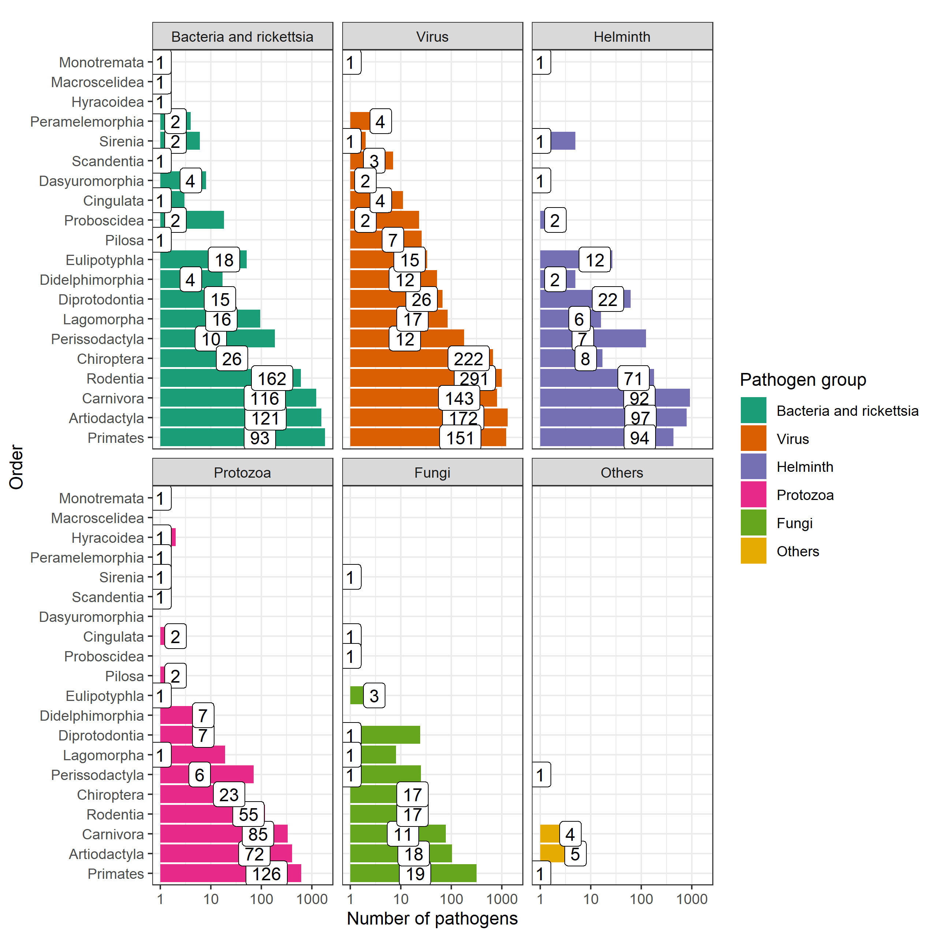

The sampling of the global host-pathogen system is incomplete, and sparse. Bars indicate the number of known pathogens within different mammalian orders, the values within the bars indicate the number of species within the order known to host these pathogens. Data obtained from CLOVER.

The discovery of zoonoses are biased by both our ability to detect them and the sampling effort of animal species for pathogens (Grange et al. 2021; Gibb, Albery, Mollentze, et al. 2021). The discovery rate of viral zoonoses, an important subset of all zoonoses, has increased with improvements in the technical means to identify them (Mark E. J. Woolhouse et al. 2008). The rate of discovery has exceeded prior expectations of viral biodiversity, but, continues to remain taxonomically and geographically biased, limiting inference able to be drawn from current datasources (Wille, Geoghegan, and Holmes 2021). Similar limitations are likely for other zoonoses taxa including bacteria, fungi and parasites. The general trend of increasing pathogen discovery are shown for Rodentia in @ref(fig:rodent-pathogen-discovery).

## Warning: Removed 89 rows containing non-finite values (`stat_count()`).

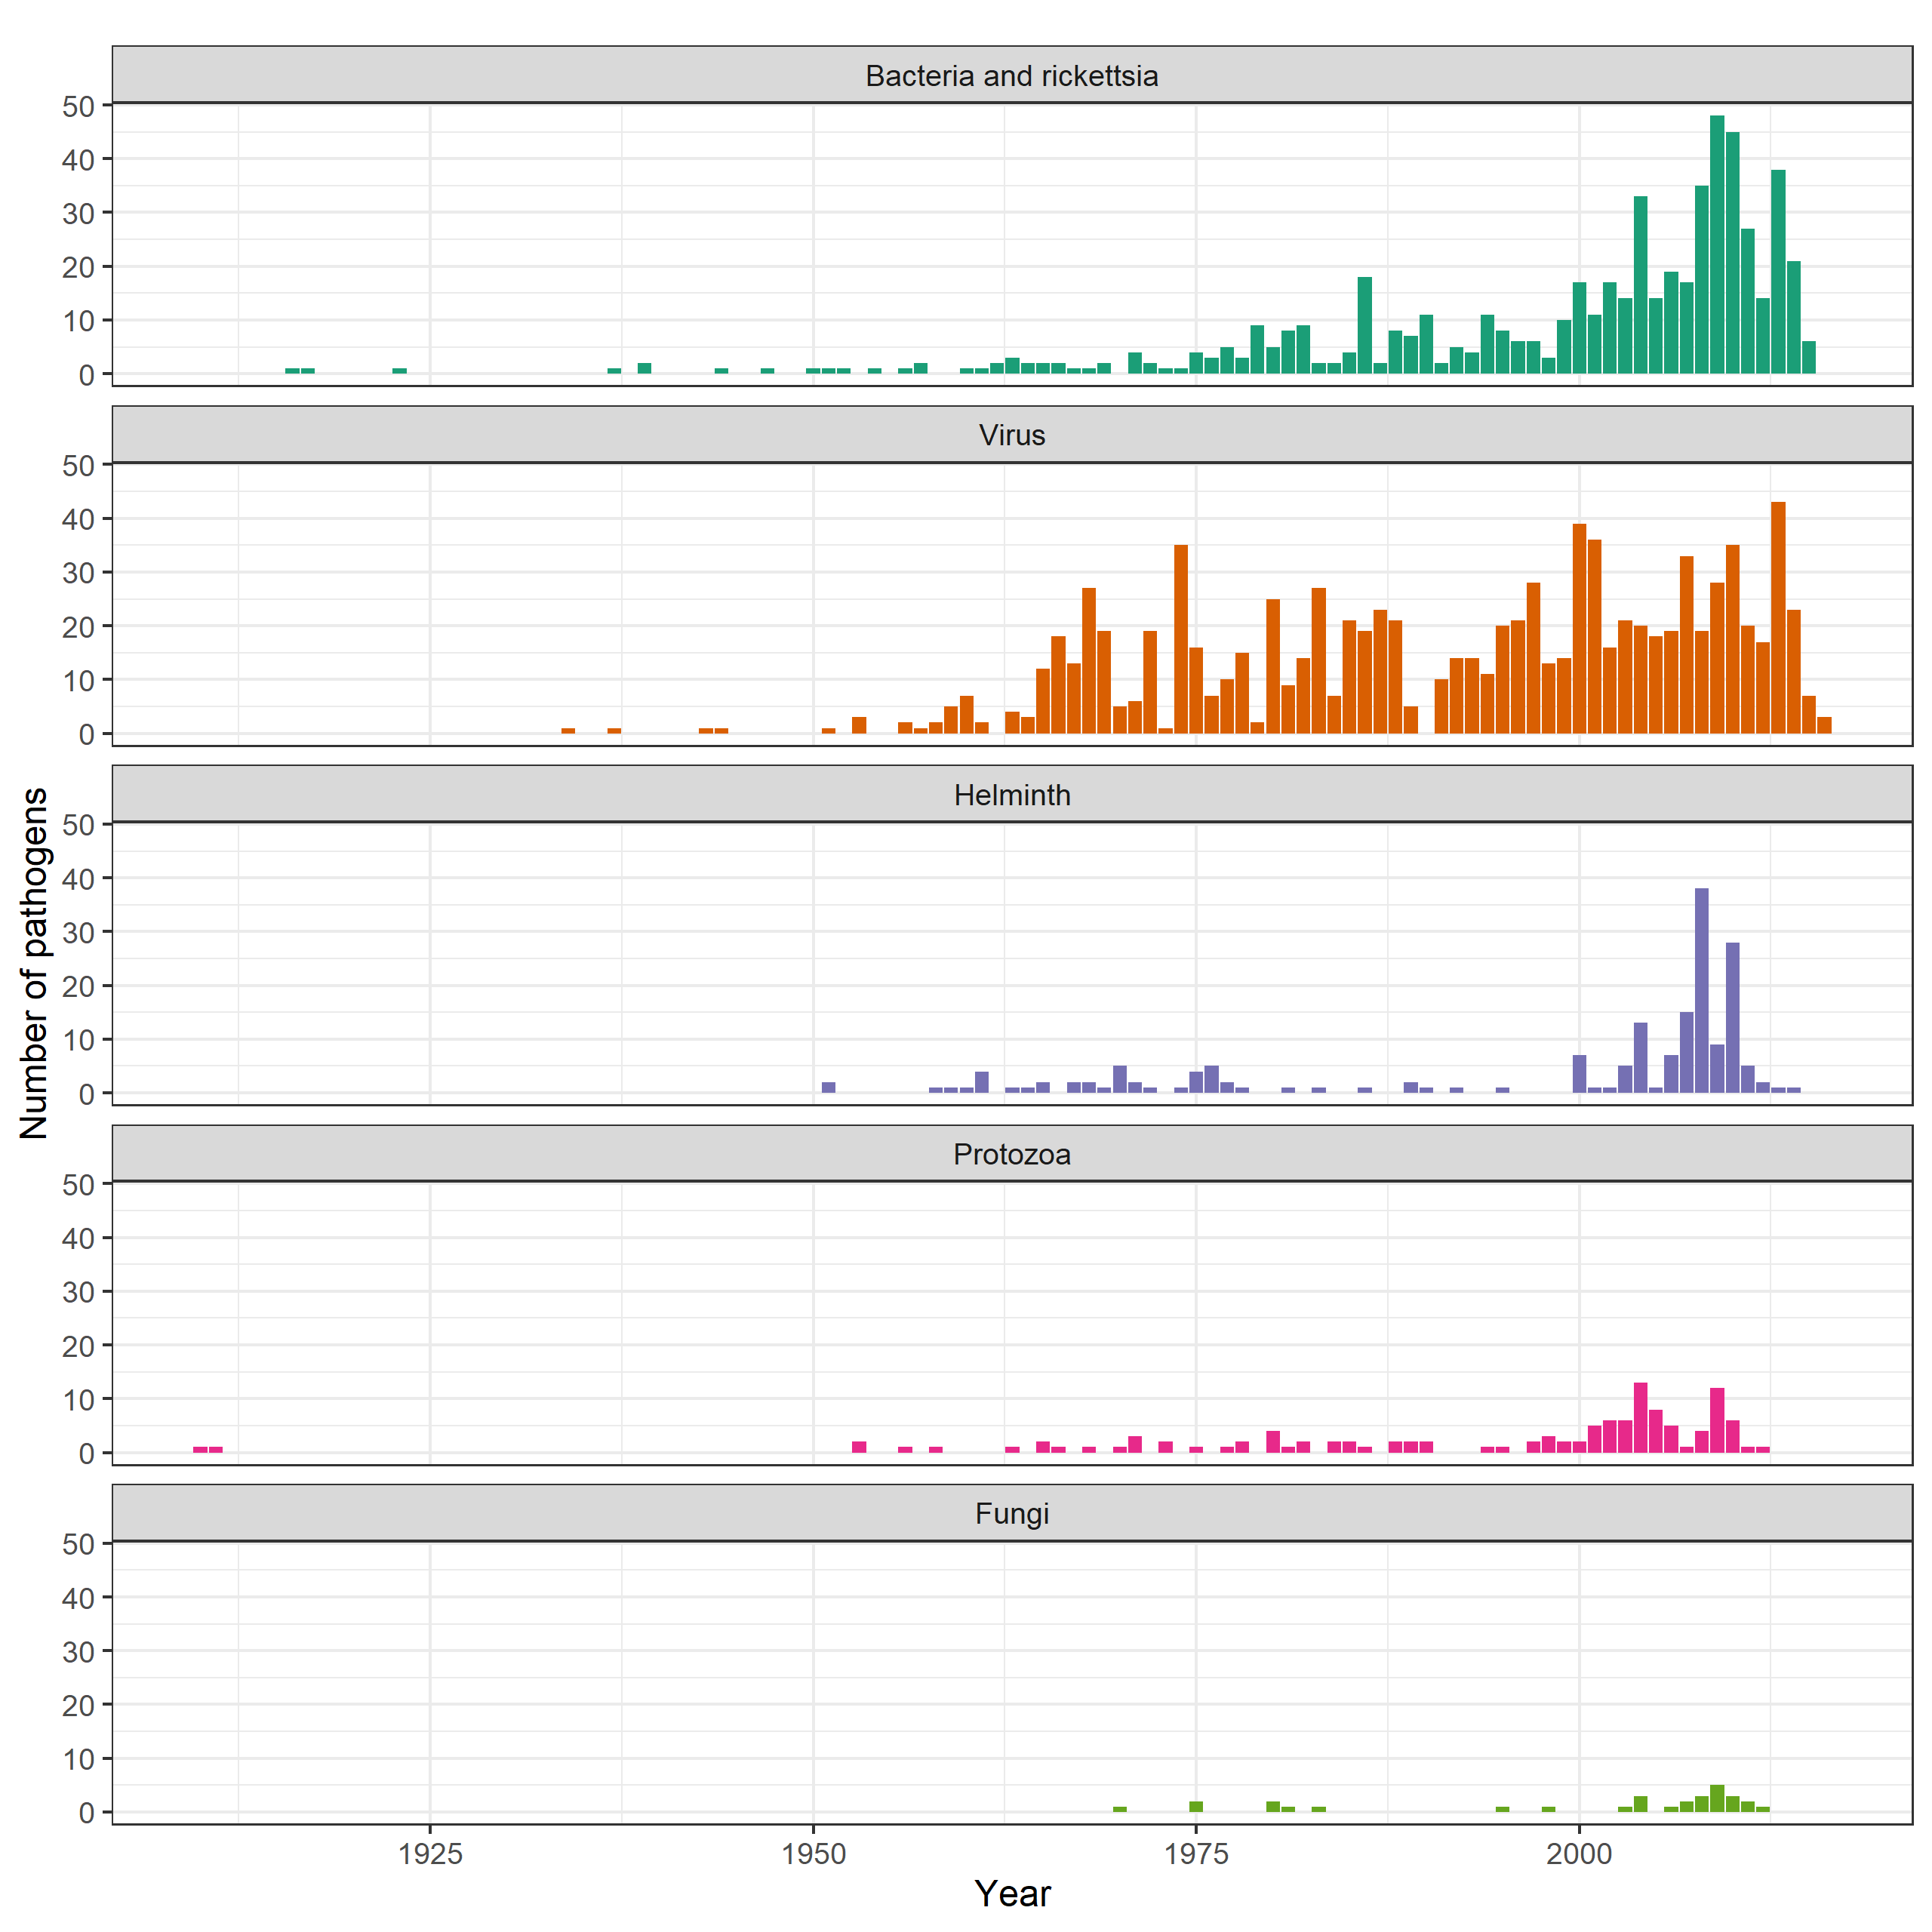

Discovery of pathogens in Rodentia, the order containing the greatest number of zoonotic pathogens, has increased over time. Data obtained from CLOVER.

Zoonoses are known to exist in the majority of terrestrial mammal orders (21/27) with the number of hosts of zoonotic pathogens related to the species richness of these orders (Han, Kramer, and Drake 2016). The two mammalian taxa of Rodentia and Chiroptera are associated with the greatest number of species that are hosts of zoonoses and number of zoonoses (Han et al. 2015). It is unclear whether these taxa represent special reservoirs that lead to an increased proportion of zoonotic viruses circulating within these species or make them more likely to transmit pathogens to humans, or whether the increased number of zoonoses associated with these taxa is driven by their increased species richness (Olival et al. 2012; Wolfe, Dunavan, and Diamond 2007; Luis et al. 2013; Mollentze and Streicker 2020). Because of this geographic hotspots of zoonotic disease risk are predicted to occur where mammalian host species richness is greatest, e.g., in the tropics (Han, Kramer, and Drake 2016).

West Africa is one such location of high mammalian biodiversity (Ceballos and Ehrlich 2006). This region is also undergoing significant anthropogenic change, driven by increasing human populations, agricultural development, urbanisation and resource extraction alongside effects of anthropogenic climate change such as desertification and changes in precipitation dynamics (Haggblade, Diarra, and Traoré 2022; Maconachie 2012; Walther 2021; Nicholson, Tucker, and Ba 1998; Bongaarts 2009). It has also been the location of several recent zoonosis epidemics and outbreaks, for example, the 2014 Ebola epidemic and ongoing Lassa fever outbreaks.

## West Africa as a hotspot of zoonosis risk

While the number of zoonotic infectious disease outbreaks and, human morbidity and mortality associated with them, has been observed to rise in West Africa this must be viewed in the local context of anthropogenic change described above where the number of people at risk of infection is continuing to increase (Makoni 2020). Alongside this change pathogen discovery, improved access to diagnostics, increasing healthcare access and improved reporting will together lead to an apparent increase in the burden of zoonotic infectious diseases in the region. An example of intensifying pathogen discovery is the PREDICT programme, conducted between 2009 and 2020, it tested in excess of 164,000 samples from animals and humans in 14 African countries and 12 Asian countries identifying 949 novel viruses including 217 known zoonoses including the detection of Marburg virus for the first time in Sierra Leone, West Africa (“About PREDICT. School of Veterinary Medicine” 2019; Amman et al. 2020). Improved diagnostics and reporting of zoonoses are evident in the case of Lassa fever, particularly in Nigeria. Here, the Nigerian Center for Disease Control (NCDC) have expanded the availability of testing for this disease. Prior to 2005 molecular diagnosis of Lassa fever infection was not possible in the country with samples transferred to the Lassa fever unit at Kenema General Hospital, Sierra Leone (Naidoo and Ihekweazu 2020). Between 2005 and 2012 testing was established in Lagos and Irrua, Nigeria with further laboratory capacity established at the National Reference Laboratory in Abuja and in Ebonyi state in 2018. The expansion of testing capacity has led to in excess of 20,000 individuals being tested for Lassa fever between 2018 and 2021, any trends in the number of reported cases of this disease from Nigeria need to be considered in light of this (Dalhat et al. 2022).

Current detection of zoonotic infectious disease outbreaks generally rely upon clinical case detection of infected humans within healthcare settings (i.e., real-time surveillance and reporting) rather than monitoring transmission among wild or domestic animals (i.e., zoonotic disease surveillance). No public health systems have implemented active surveillance systems by testing of animal populations in West Africa. Elsewhere, for example in *West Nile virus*, active surveillance in birds and horses is conducted in several European countries to inform risk assessments of human disease outbreaks (Gossner et al. 2017). The Global Health Security Index measured activities conducted by countries to assess their ability to respond to an emerging outbreak of a zoonotic infectious disease (Global Health Security Index 2022). Figure @ref(fig:global-zoonotic-disease-surveillance) shows some results of these surveys highlighting that few African countries have widely implemented real-time surveillance or zoonotic disease surveillance in animals. Suggesting that these countries may be more vulnerable to oubtreaks. Despite several recent oubreaks and epidemics of zoonotic infectious diseases in West Africa, i.e., Ebola, Lassa fever, Monkeypox and Leptospirosis, few health systems are assessed as being able to rapidly respond to these threats. Zoonotic diseases surveillance among animal host species in West Africa is currently limited to academic or programmatic research which informs local policy and identifies regions at potentially greater risk for spillover events. This information is also used in public health to aid risk stratification of patients that present with symptoms consistent with these diseases, based on when, where and why they present to local healthcare services (Leski et al. 2015; Happi et al. 2022). Few countries globally, with none in West Africa, have surveillance systems that combine animal and human data (Wendt, Kreienbrock, and Campe 2015).

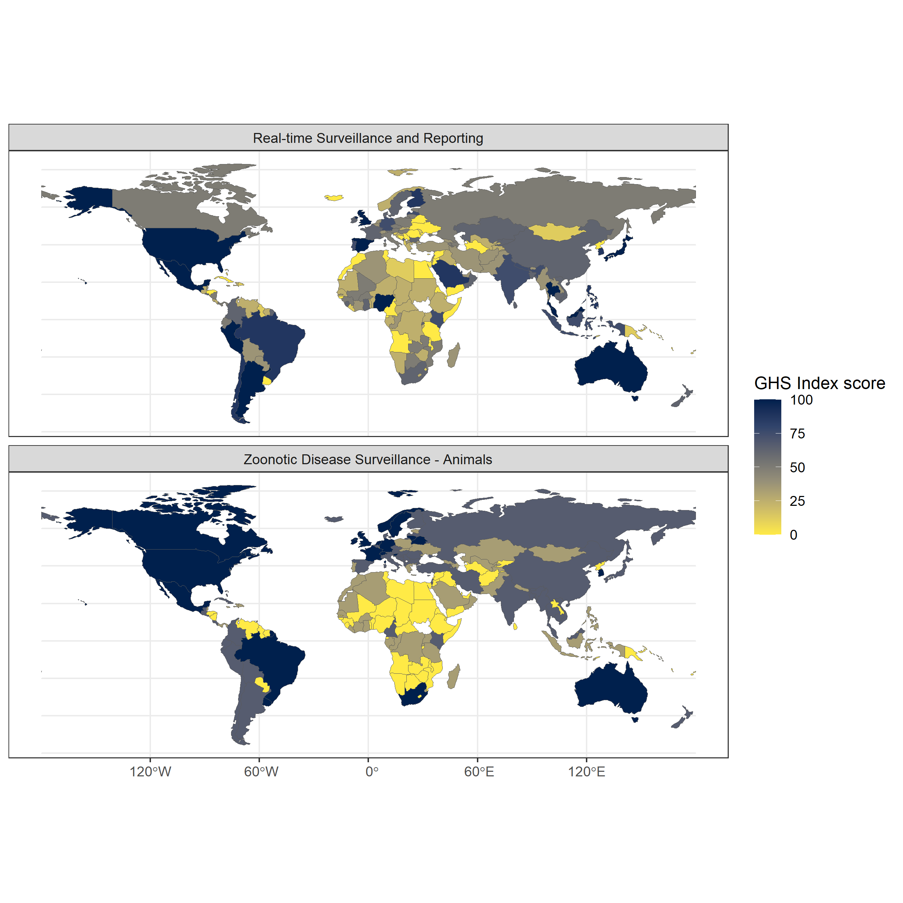

Global Health Security Index country scores for the sub-domains of2.3) Real-time surveillance and reporting (top) and 1.2.2) Zoonotic disease surveillance (bottom). Real-time surveillance and reporting for epidemics of potential international concern is rated highly in several North and South American countries and countries in East and South East Asia and Oceania. Zoonotic disease surveillance in animals is rated highly in European, North and South American countries and Oceania. Generally surveillance for zoonotic infectious disease is limited across much of Africa, with the notable exception of Nigeria for real-time surveillance and reporting. Data obtained from the Global Health Security Index.

## Rodent borne zoonoses

Rodents are a diverse, globally distributed mammalian order that provide important and beneficial ecosystem services including pest regulation and seed dispersal (Fischer et al. 2018). Of the almost 2,600 species, representing 40% of all mammalian species, 282 species (~11%) have been identified to be reservoirs of 95 known zoonoses, a greater number than other mammal orders (D’Elía, Fabre, and Lessa 2019; Ecke et al. 2022; Han, Kramer, and Drake 2016). The majority of these zoonoses are viruses (34) and bacteria (26) with the remaining including helminths, protozoa and fungi. As discussed above this may be driven by the high species richness of this order, rather than any inherent properties of the order Rodentia (Mollentze and Streicker 2020).

Within the order, the prevalence of zoonoses are disproportionally high in species that demonstrate “fast” life history strategies, although the effect of sampling biases and confounding effects such as synanthropy may be producing some of this observed effect (Han et al. 2015; Albery and Becker 2021). Fast-lived rodent species (i.e., those prioritising reproduction over survival and longevity), are typically small, abundant and are more commonly urban-adapted (Albery and Becker 2021). It has been proposed that these species favour inexpensive, nonspecific immune defenses, which may make them more likely to be hosts of zoonoses, although whether these properties are consistent within genera is unclear and whether these findings hold in wild, as opposed to laboratory, animals is unknown (Martin, Weil, and Nelson 2007; Viney and Riley 2017).

Irrespective of the causal drivers of high zoonoses prevalence among rodent species, components of their life histories increase the risk of spillover into human populations. Synanthropy, an organism that lives near and benefits from humans and their environmental modifications, is common among rodent species, more so among rodent species known to be reservoirs of zoonoses (95%) (Ecke et al. 2022). These species tend to be highly abundant in locations in which they occur, with high population densities and dynamic population fluctuations in response to resource availability, which promotes both fequency- and density-dependent transmission of pathogens among rodents (Ecke et al. 2022). The high abundance of these species in human dominated landscapes increases the rate of contact with humans which provides increased opportunities for both direct- and indirect transmission of rodent borne zoonoses (Morand et al. 2019; Iacono et al. 2016).

Rodent species that have wide ranges may display heterogeneity across their range in both their biology and behaviour. For example, studies in *Clethrionomys* voles, hosts of Puumala orthohantavirus, have been observed to display different population dynamics across a latitudinal gradient from Northern Finland to Central Europe, affecting pathogen dynamics within these populations (Turchin and Hanski 1997; Henttonen and Wallgren 2001). Similarly, while the primary reservoir species of Lassa fever, *Mastomys natalensis*, has been observed to have dramatic population fluctuations in the Eastern extent of its range (Tanzania), the same amplitude of population fluctuations have not been observed in West African populations (i.e., Guinea) where they host LASV (Fichet-Calvet et al. 2008; Leirs et al. 1997). This may impact the generalisability of studies conducted in within a rodents range when attempting to understand the risk of rodent borne zoonosis spillover.

## Lassa fever: A case study of a rodent borne zoonosis in West Africa

The above sections have introduced zoonotic infectious diseases, the effect of a changing world on potential disease emergence, the particular risk of emergence and outbreaks in West Africa and the role of rodents in zoonotic infectious disease transmission. The remainder of this introduction will focus on the case study of this thesis, Lassa fever, in West Africa and more specifically Sierra Leone.

### *Lassa mammarenavirus* and Lassa fever

*Lassa mammarenavirus* an enveloped, bisegmented, single stranded RNA virus of the Arenaviridae family is a zoonotic pathogen and is the causative agent of Lassa fever in humans. Lassa fever is a potentially lethal viral haemorrhagic fever, first identified from a case series of infected patients originating near Jos, Nigeria in 1969, (Frame et al. 1970). Human infection is caused by spillover of the virus from infected rodents and their excreta, with a limited role of human-to-human secondary transmission (J. B. McCormick et al. 1987; Lo Iacono et al. 2015). The primary host of LASV has been identified as the multimammate rat (*M. natalensis*) following an outbreak in Sierra Leone between 1970-2 (Monath et al. 1974). This synanthropic rodent species is found across much of sub-Saharan Africa, however, outside of West Africa no individuals of this species have been found to be infected with this virus (Grobbelaar et al. 2021; Bellocq et al. 2020; Colangelo et al. 2013).

*Lassa mammarenavirus* has four confirmed lineages (I-IV) and three additional lineages (V-VII) based on geographic and phylogenetic analysis (Y. Li 2023). Lineages I, II, III and VI are located within Nigeria, lineage IV contains all isolates from the Mano River region of Guinea, Liberia and Sierra Leone, lineage V contains samples from Mali and Ivory Coast with lineage VII containing recently sampled sequences from Togo (Ehichioya et al. 2019; Andersen et al. 2015; Manning, Forrester, and Paessler 2015; Whitmer et al. 2018). Lineage I are believed to be the most ancient, originating around 1,000 years ago in the North East of Nigeria, with subsequent radiation and establishment of lineages II and III in Southern and Central areas of the country respectively (Ehichioya et al. 2019; Andersen et al. 2015). Lineage IV represents a Westward expansion of the virus into the Mano River region, dated around 350 years ago (Andersen et al. 2015).

Host cell entry of the virus is mediated by a trimeric glycoprotein complex that leads to receptor recognition and fusion of the viral and host membranes, *in vivo* this protein undergoes substantial host-derived glycosylation, effectively reducing available antibody binding domains (Hastie and Saphire 2018). Once within the host cell the viral nucleoprotein associates with viral RNAs forming ribonucleoprotein complexes facilitating transcription and replication of viral RNA within the host cell cytoplasm (Hass et al. 2004). The process of viral entry into host cells is expected to lead to the observed tissue tropism in experimental infection models in guinea pigs and *M. natalensis* (Torriani, Galan-Navarro, and Kunz 2017). Within infected guinea pigs and *M. natalensis* Lassa viral load was highest transiently in the lymph nodes with sustained high titres in the lungs and spleen (Jahrling et al. 1982; Safronetz et al. 2022). Minimal pathological changes were observed in guinea pigs or *M. natalensis*, with no evidence of clinical disease in these animals.

Among infected humans with clinical symptoms the viral incubation period is between 7 and 18 days (J. B. McCormick et al. 1987). Initial symptoms are non-specific with fever, weakness, malaise, cough, sore throat and a typically frontal headache (Knobloch et al. 1980). The majority of symptomatic patients will go on to develop joint and lumbar pain, a non-productive cough with many developing severe retrosternal chest pain, nausea with vomiting and diarrhoea and abdominal pain (J. B. McCormick and Fisher-Hoch 2002). Up to a third of hospitalised patients will significantly decline 6-8 post onset of fever with a minority developing haemorrhagic syndome with bleeding from the mucosal surfaces. Severe pulmonary oedema and soft tissue oedematous changes in the head and neck are common in fatal cases (Knobloch et al. 1980). The vast majority of infections, commonly reported as 80%, are asymptomatic although in the absence of long term prospective studies the proportion of asymptomatic infections is difficult to estimate (J. B. McCormick et al. 1987). There is some limited evidence that disease severity may vary by infecting lineage (Garry 2023).

Treatment options for acute cases of Lassa fever is limited. Ribavirin is the standard of care for treating acute cases although the effectiveness of this treatment is questionnable (Salam et al. 2022). Supportive care is the mainstay of treatment for hospitalised individuals. There are no currently available vaccinations for Lassa fever, although three candidate vaccines have begun clinical trials (Salami et al. 2019; Inovio Pharmaceuticals 2022, 2020; International AIDS Vaccine Initiative 2023; Themis Bioscience GmbH 2022).

The case-fatality rate of Lassa fever has been reported to be as high as 29.7% although this varies by country and year (Kenmoe et al. 2020). This estimate is based on a systematic review of the published scientific literature and does not include data from epidemiological reports or WHO bulletins. I conducted a review of epidemiological reports and the published literature to estimate the case-fatality rate among confirmed cases to estimate the scale of underreporting in Lassa fever producing an estimated case-fatality rate of 16.5% (+/- 5%) (Simons 2022). Importantly this estimate is sensitive to biases in reporting and is likely a grossly inflated rate of mortality. Severe cases are more likely to come into contact with healthcare services and be tested for Lassa fever, these cases are also more likely to result in disease associated mortality. Therefore this case-fatality rate should be considered a severe disease case-fatality rate, the majority of mildly symptomatic cases will have a dramatically reduced probability of mortality.

Survivors of symptomatic Lassa fever may have lasting effects of the disease. Sensorineural hearing loss is reported to occur in up to a third of Lassa fever survivors and may cause a significant social and public health burden in the region that has not been well studied (Mateer et al. 2018). Additional neurological sequealae reported in Lassa fever survivors include cerebellar ataxia and visual impairment, although few patients have been assessed for these complications and progression over time is unclear (A. L. Li et al. 2020; Ezeomah et al. 2019). Most hospitalised patients, following recovery, rapidly clear viral RNA. Most patient sera tests negative for viral RNA at hospital discharge, however, up to 50% of male survivors have detectable viral loads in seminal fluid at 3 months post-hospitalisation raising concerns that human-to-human sexual transmission may be possible in this cohort (Thielebein et al. 2022).

### Lassa fever epidemiology

Annual Lassa fever incidence is unknown, with estimates ranging between 150,000 to 4,300,000 cases per year cases annually (J. B. McCormick et al. 1987; Basinski et al. 2021). The wide uncertainty surrounding these estimates is due to a combination of few serological studies, limited disease surveillance and an overlap between the symptomatology of Lassa fever with other infectious diseases in these endemic regions (e.g., malaria). Lassa fever is currently considered endemic in 8 West African countries: Benin, Ghana, Guinea, Liberia, Mali, Nigeria, Sierra Leone and Togo by the World Health Organisation (WHO) (World Health Organisation 2022). Sporadic cases in Burkina Faso and Ivory Coast have also been reported (@ref(fig:lassa-endemic)). The endemic region is consistent with the expected range of the primary reservoir species *M. natalensis*. Imported cases have been reported from non-West African countries such as the United Kingdom, Germany and the United States of America (Tuite et al. 2019; Wolf et al. 2020).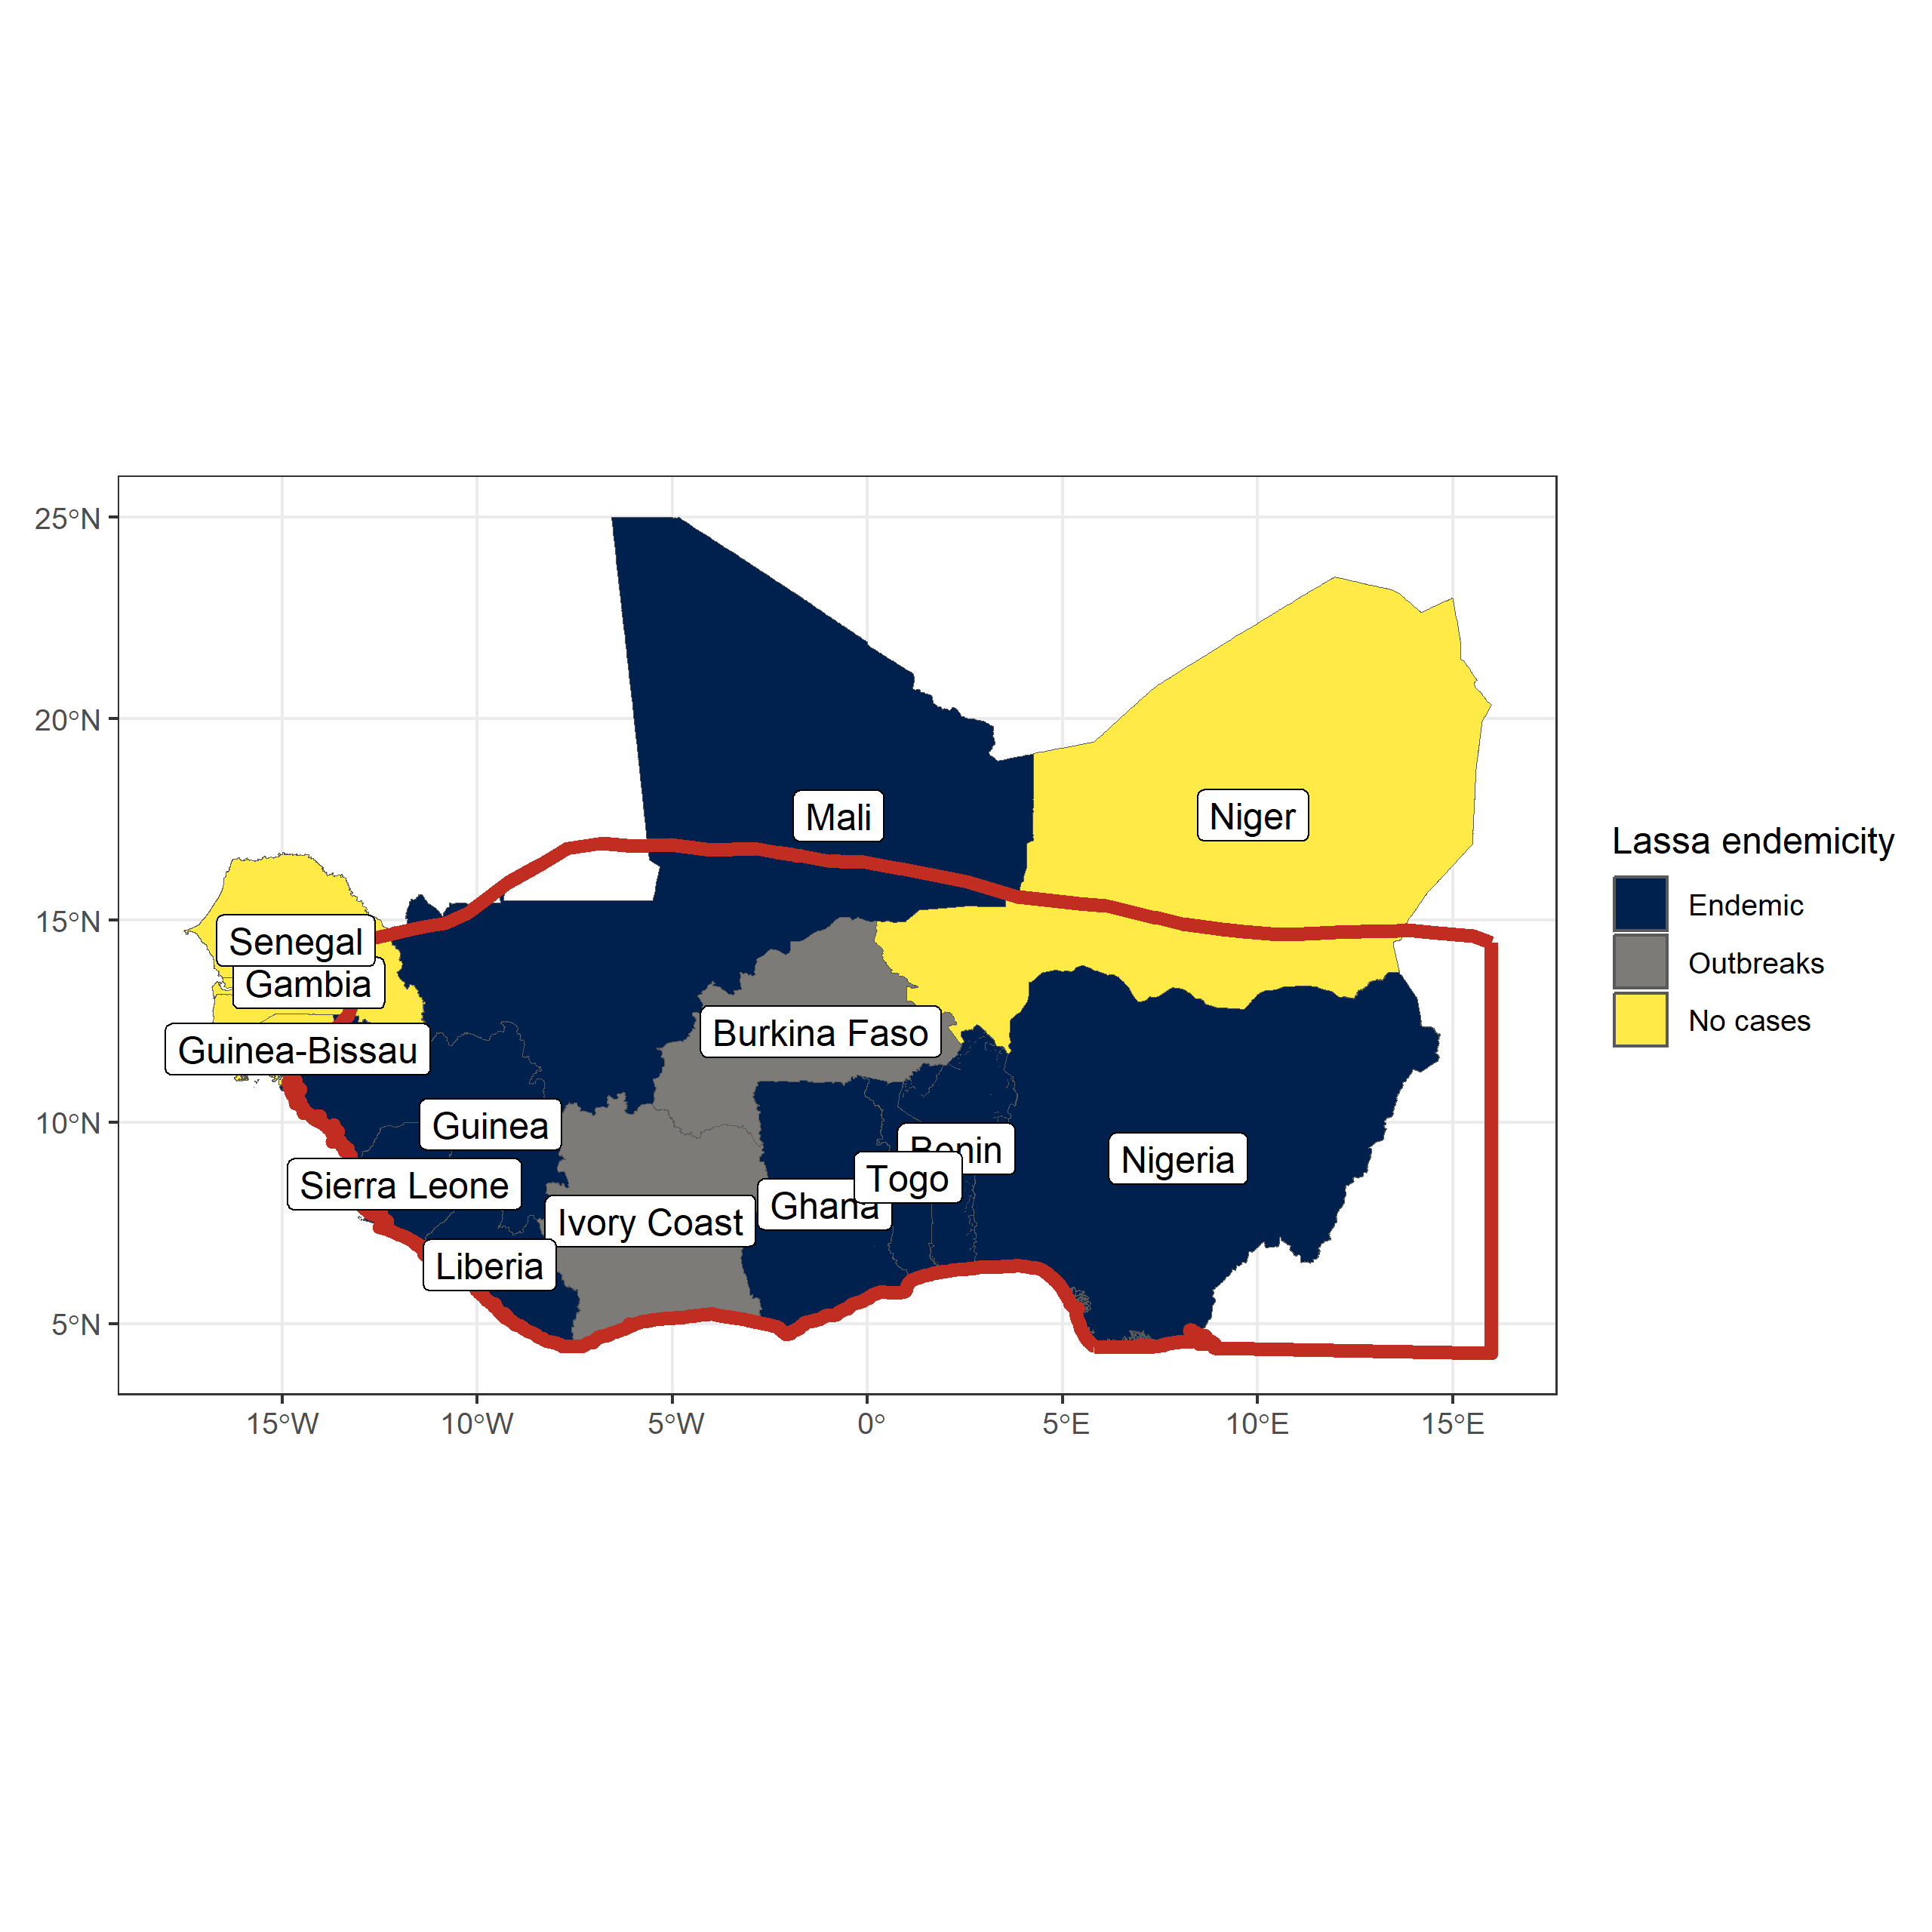

Lassa fever is considered endemic in eight West African countries, sporadic outbreaks have been reported from a further two countries within the region. The red border indicates the range of Mastomys natalensis in West Africa, it’s range extends East and South across the continent. Data on Lassa fever endemicity is obtained from the WHO, data on Mastomys natalensis range is obtained from the International Union for Conservation of Nature Red List.

Nigeria and Sierra Leone have historically reported the greatest number of Lassa fever cases (@ref(fig:lassa-cases)). This is potentially due to increased availability of testing for acute cases in these countries. Human seroepidemiological surveys in Guinea, Mali and Ivory Coast, countries that have generally reported few acute cases, report seroprevalence in excess of 20% suggestive of undetected localised transmission of Lassa fever (Kerneis et al. 2009; Bausch et al. 2001; Sogoba et al. 2016; Safronetz et al. 2017; Akoua-Koffi et al. 2006). The number of reported cases declined during the Ebola and SARS-CoV-2 epidemic where changes in healthcare seeking behaviour and availability of Lassa fever testing may have changed. The number of cases reported in Nigeria has generally increased and there has been a dramatic fall in cases reported from Sierra Leone, whether these represent changes in the underlying spillover risk is currently unclear.

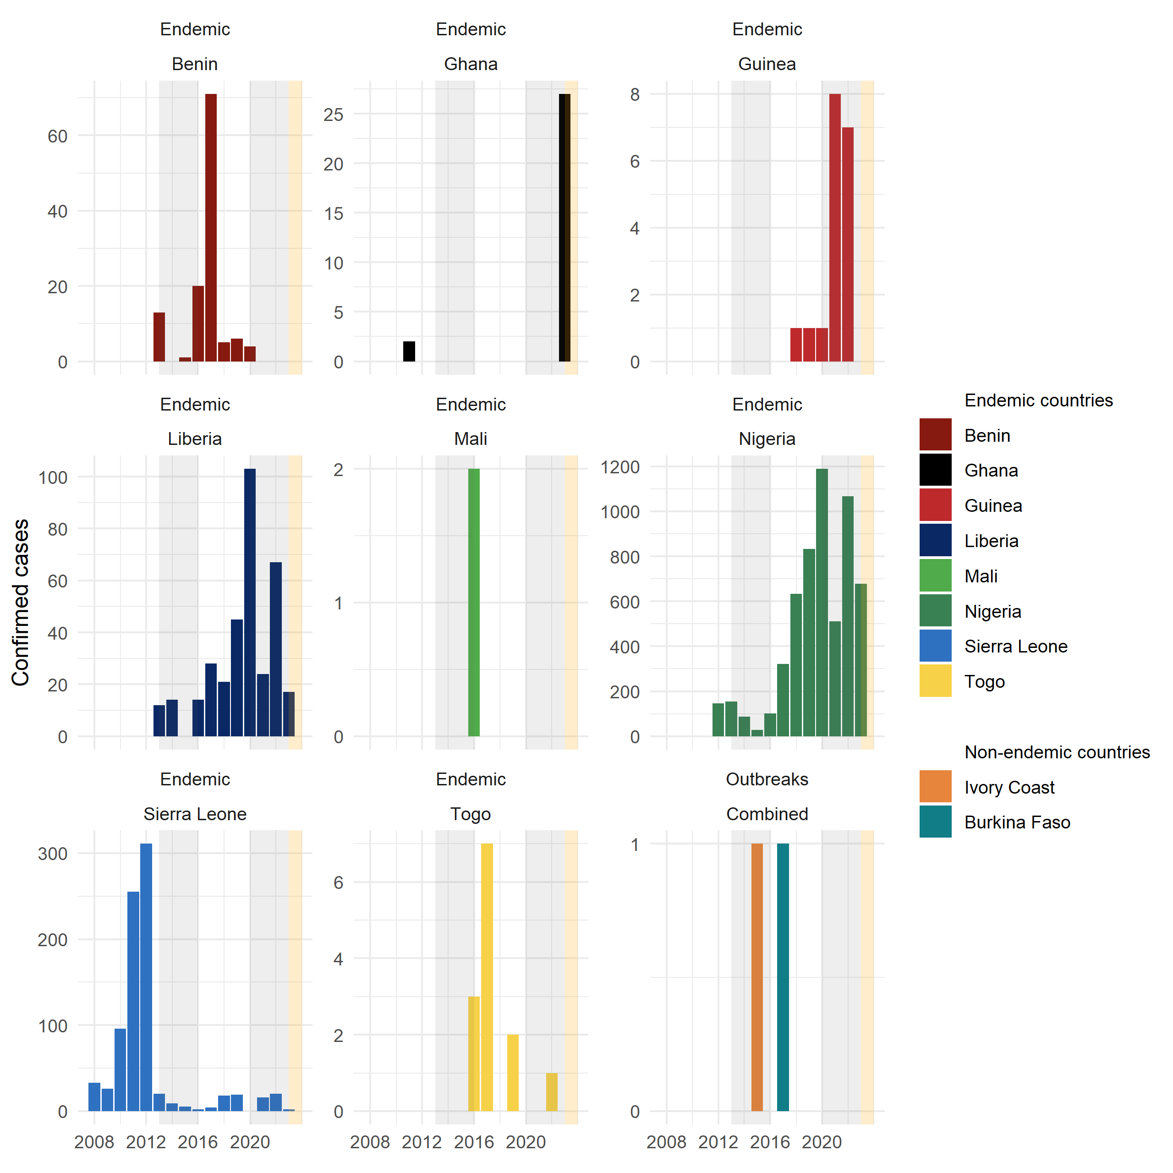

Confirmed Lassa fever cases from countries in West Africa 2008-2023. Confirmed cases show variability by year with the greatest number of cases reported from Nigeria, Sierra Leone and Liberia. Grey shaded regions represent periods of regional or global epidemics which may have affected Lassa fever reporting (i.e., the Ebola epidemic and SARS-CoV-2 pandemic). The yellow shaded region represents 2023 where an incomplete year is shown. Data compiled from multiple sources.

The number of reported confirmed cases of Lassa fever in endemic countries is likely significantly underreported. Cases tend to occur in rural and remote locations where healthcare access is generally low, with financial and societal costs of accessing healthcare relatively high (Bhadelia 2019; Nnaji et al. 2021). Additionally while clinicians in endemic settings have good awareness of symptoms that may indicate acute Lassa fever infection, access to testing and timely reporting were identified as factors that could lead to diagnostic delay, worse patient outcomes and public health responses to outbreaks (Olowookere et al. 2014; Rohan 2022). An estimate of the degree of underreporting has been conducted using reported Lassa fever disease associated mortality, assuming a consistent 16.5% case-fatality rate across the region. Using this approach Nigeria was found to report the highest proportion of all expected cases (63%) while countries with generally fewer observed outbreaks reported significantly fewer than expected cases (e.g., Ghana - 17%, Guinea - 25%) (Simons 2022).

Human seroepidemiological studies conducted in several regions of Sierra Leone suggest that despite the observed fall in human cases of disease infection remains prevalent (Grant et al. 2023).This study in Sierra Leone is also suggestive that widespread transmission of LASV is occurring outside the traditionally considered endemic region of Eastern Sierra Leone. A large scale serological study conducted by the Coalition for Epidemic Preparedness Innovations across Benin, Guinea, Liberia, Nigeria and Sierra Leone to understand the prevalence to antibodies against LASV has been implemented and results are awaited (Penfold et al. 2023).

### Rodent hosts of *Lassa mammarenavirus*

While *M. natalensis* is considered the primary reservoir of LASV 11 other rodent species have been found to be acutely infected or have antibodies to the virus (Simons et al. 2023). The role of the wider rodent species community in viral transmission in endemic areas is not currently well understood. Further, evidence exists for prior exposure to LASV in non-rodent species, including domestic dogs, non-human primates and shrews the role of these species is even less clear (Kenmoe et al. 2020).

*Mastomys natalensis* is a synanthropic rodent species, native to Africa. This species is considered a pest species across much of its range, as it lives within and around human communities consuming grain within the fields and in stores (Swanepoel et al. 2017). Describe life history. Describe breeding patterns in Tanzania. Potentially not the same in West Africa.

Describe locations of this species and interactions with invasive rodents and other native rodents. The potential importance of this for viral transmission.

Describe the different clades and other arenaviruses and how that may limit expansion outside of West Africa.

Figure of seroprevalence among sampled *M. natalensis* and other species.

Describe other native rodent species.

Describe invasion of mus and rattus.

Describe limited systematic rodent sampling.

Describe that we cannot truly understand what the effects of changing systems will be on rodent occurrence and abundance due to data sparsity.

### Predicting current and future Lassa fever risk

Describe current understanding of spatial risk

Describe potential future spatial risk

Limitations and biases

Summary paragraph

## Aims of the thesis

The first aim of this thesis is to synthesise information on rodent and pathogen sampling from rodent trapping studies across West Africa to quantify the biases in currently available data. I hypothesise that rodent and pathogen sampling is spatially and taxonomically biased which will have implications on inference able to be drawn from currently available data about the hazard of zoonosis spillover risk across the region. I test the null hypothesis that rodent and pathogen sampling is conducted randomly in space across the region and propose an alternative hypothesis that rodent sampling is spatially clustered. I describe the occurrence of known and potential hosts of zoonosis from presence and absence data and compare this to currently available resources and produce host-pathogen associations from these data.

The second aim of this thesis is to investigate the association of rodent species diversity and landuse type in a Lassa fever endemic region of Eastern Sierra Leone. I hypothesise that known hosts of Lassa fever occur preferentially in human dominated landuse types with higher rodent species diversity in less disturbed landuse types. I test the null hypothesis that the probability of occurrence of rodent species does not change across landuse types and propose an alternative hypothesis that hosts of Lassa fever have a higher probability of occurrence in human dominated landuse types.

The final aim of this thesis is to recreate Lassa fever transmission networks among rodent species. Using rodent trapping data

“About PREDICT. School of Veterinary Medicine.” 2019. January 17, 2019. <https://ohi.sf.ucdavis.edu/programs-projects/predict-project/about>.

Akoua-Koffi, C, J Ter Meulen, D Legros, V Akran, M Aïdara, N Nahounou, P Dogbo, and A Ehouman. 2006. “[[Detection of Anti-Lassa Antibodies in the Western Forest Area of the Ivory Coast]](https://www.ncbi.nlm.nih.gov/pubmed/17201291).” *Medecine Tropicale* 66 (5): 465–68.

Albery, Gregory F., and Daniel J. Becker. 2021. “Fast-Lived Hosts and Zoonotic Risk.” *Trends in Parasitology* 37 (2): 117–29. <https://doi.org/10.1016/j.pt.2020.10.012>.

Amman, Brian R., Brian H. Bird, Ibrahim A. Bakarr, James Bangura, Amy J. Schuh, Jonathan Johnny, Tara K. Sealy, et al. 2020. “Isolation of Angola-Like Marburg Virus from Egyptian Rousette Bats from West Africa.” *Nature Communications* 11 (1): 510. <https://doi.org/10.1038/s41467-020-14327-8>.

Andersen, Kristian G., B. Jesse Shapiro, Christian B. Matranga, Rachel Sealfon, Aaron E. Lin, Lina M. Moses, Onikepe A. Folarin, et al. 2015. “Clinical Sequencing Uncovers Origins and Evolution of Lassa Virus.” *Cell* 162 (4): 738–50. <https://doi.org/10.1016/j.cell.2015.07.020>.

Basinski, Andrew J., Elisabeth Fichet-Calvet, Anna R. Sjodin, Tanner J. Varrelman, Christopher H. Remien, Nathan C. Layman, Brian H. Bird, et al. 2021. “Bridging the Gap: Using Reservoir Ecology and Human Serosurveys to Estimate Lassa Virus Spillover in West Africa.” Edited by Amy Wesolowski. *PLOS Computational Biology* 17 (3): e1008811. <https://doi.org/10.1371/journal.pcbi.1008811>.

Bausch, D. G., A. H. Demby, M. Coulibaly, J. Kanu, A. Goba, A. Bah, N. Condé, et al. 2001. “Lassa Fever in Guinea: I. Epidemiology of Human Disease and Clinical Observations.” *Vector Borne and Zoonotic Diseases (Larchmont, N.Y.)* 1 (4): 269–81. <https://doi.org/10.1089/15303660160025903>.

Bellocq, Joëlle Goüy De, Anna Bryjová, Aleksey A. Martynov, and Leonid A. Lavrenchenko. 2020. “Dhati Welel Virus, the Missing Mammarenavirus of the Widespread Mastomys Natalensis.” *Journal of Vertebrate Biology* 69 (2): 20018.1. <https://doi.org/10.25225/jvb.20018>.

Bhadelia, Nahid. 2019. “Understanding Lassa Fever.” *Science* 363 (6422): 30–30. <https://doi.org/10.1126/science.aav8958>.

Bongaarts, John. 2009. “Human Population Growth and the Demographic Transition.” *Philosophical Transactions of the Royal Society B: Biological Sciences* 364 (1532): 2985–90. <https://doi.org/10.1098/rstb.2009.0137>.

Carlson, Colin J., Gregory F. Albery, Cory Merow, Christopher H. Trisos, Casey M. Zipfel, Evan A. Eskew, Kevin J. Olival, Noam Ross, and Shweta Bansal. 2022. “Climate Change Increases Cross-Species Viral Transmission Risk.” *Nature* 607 (7919): 555–62. <https://doi.org/10.1038/s41586-022-04788-w>.

Carlson, Colin J., Maxwell J. Farrell, Zoe Grange, Barbara A. Han, Nardus Mollentze, Alexandra L. Phelan, Angela L. Rasmussen, et al. 2021. “The Future of Zoonotic Risk Prediction.” *Philosophical Transactions of the Royal Society B: Biological Sciences* 376 (1837): 20200358. <https://doi.org/10.1098/rstb.2020.0358>.

Ceballos, Gerardo, and Paul R. Ehrlich. 2006. “Global Mammal Distributions, Biodiversity Hotspots, and Conservation.” *Proceedings of the National Academy of Sciences* 103 (51): 19374–79. <https://doi.org/10.1073/pnas.0609334103>.

Civitello, David J., Jeremy Cohen, Hiba Fatima, Neal T. Halstead, Josue Liriano, Taegan A. McMahon, C. Nicole Ortega, et al. 2015. “Biodiversity Inhibits Parasites: Broad Evidence for the Dilution Effect.” *Proceedings of the National Academy of Sciences* 112 (28): 8667–71. <https://doi.org/10.1073/pnas.1506279112>.

Cleaveland, S., M. K. Laurenson, and L. H. Taylor. 2001. “Diseases of Humans and Their Domestic Mammals: Pathogen Characteristics, Host Range and the Risk of Emergence.” Edited by M. E. J. Woolhouse and C. Dye. *Philosophical Transactions of the Royal Society of London. Series B: Biological Sciences* 356 (1411): 991–99. <https://doi.org/10.1098/rstb.2001.0889>.

Colangelo, Paolo, Erik Verheyen, Herwig Leirs, Caroline Tatard, Christiane Denys, Gauthier Dobigny, Jean-Marc Duplantier, Carine Brouat, Laurent Granjon, and Emilie Lecompte. 2013. “A Mitochondrial Phylogeographic Scenario for the Most Widespread African Rodent, Mastomys Natalensis.” *Biological Journal of the Linnean Society* 108 (4): 901–16. <https://doi.org/10.1111/bij.12013>.

D’Elía, Guillermo, Pierre-Henri Fabre, and Enrique P Lessa. 2019. “Rodent Systematics in an Age of Discovery: Recent Advances and Prospects.” *Journal of Mammalogy* 100 (3): 852–71. <https://doi.org/10.1093/jmammal/gyy179>.

Dalhat, Mahmood M., Adebola Olayinka, Martin M. Meremikwu, Chioma Dan-Nwafor, Akanimo Iniobong, Lorretta F. Ntoimo, Ikenna Onoh, et al. 2022. “Epidemiological Trends of Lassa Fever in Nigeria, 2018–2021.” *PLOS ONE* 17 (12): e0279467. <https://doi.org/10.1371/journal.pone.0279467>.

Daszak, P., A. A. Cunningham, and A. D. Hyatt. 2001. “Anthropogenic Environmental Change and the Emergence of Infectious Diseases in Wildlife.” *Acta Tropica* 78 (2): 103–16. <https://doi.org/10.1016/S0001-706X(00)00179-0>.

Dudas, Gytis, Luiz Max Carvalho, Andrew Rambaut, and Trevor Bedford. 2018. “MERS-CoV Spillover at the Camel-Human Interface.” Edited by Neil M Ferguson. *eLife* 7 (January): e31257. <https://doi.org/10.7554/eLife.31257>.

Ecke, Frauke, Barbara A. Han, Birger Hörnfeldt, Hussein Khalil, Magnus Magnusson, Navinder J. Singh, and Richard S. Ostfeld. 2022. “Population Fluctuations and Synanthropy Explain Transmission Risk in Rodent-Borne Zoonoses.” *Nature Communications* 13 (1): 7532. <https://doi.org/10.1038/s41467-022-35273-7>.

Editors, ed. 2011. “Microbiology by Numbers.” *Nature Reviews Microbiology* 9 (9): 628–28. <https://doi.org/10.1038/nrmicro2644>.

Ehichioya, Deborah U., Simon Dellicour, Meike Pahlmann, Toni Rieger, Lisa Oestereich, Beate Becker-Ziaja, Daniel Cadar, et al. 2019. “Phylogeography of Lassa Virus in Nigeria.” *Journal of Virology* 93 (21): e00929–19. <https://doi.org/10.1128/JVI.00929-19>.

Epstein, Jonathan H., Hume E. Field, Stephen Luby, Juliet R. C. Pulliam, and Peter Daszak. 2006. “Nipah Virus: Impact, Origins, and Causes of Emergence.” *Current Infectious Disease Reports* 8 (1): 59–65. <https://doi.org/10.1007/s11908-006-0036-2>.

Ezeomah, Chiomah, Adeyi Adoga, Chikwe Ihekweazu, Slobodan Paessler, Irma Cisneros, Oyewale Tomori, and David Walker. 2019. “Sequelae of Lassa Fever: Postviral Cerebellar Ataxia.” *Open Forum Infectious Diseases* 6 (12): ofz512. <https://doi.org/10.1093/ofid/ofz512>.

Fagre, Anna C., Lily E. Cohen, Evan A. Eskew, Max Farrell, Emma Glennon, Maxwell B. Joseph, Hannah K. Frank, Sadie J. Ryan, Colin J Carlson, and Gregory F. Albery. 2022. “Assessing the Risk of Human-to-Wildlife Pathogen Transmission for Conservation and Public Health.” *Ecology Letters* 25 (6): 1534–49. <https://doi.org/10.1111/ele.14003>.

Farooq, Zia, Joacim Rocklöv, Jonas Wallin, Najmeh Abiri, Maquines Odhiambo Sewe, Henrik Sjödin, and Jan C. Semenza. 2022. “Artificial Intelligence to Predict West Nile Virus Outbreaks with Eco-Climatic Drivers.” *The Lancet Regional Health - Europe* 17 (June): 100370. <https://doi.org/10.1016/j.lanepe.2022.100370>.

Fichet-Calvet, Elisabeth, Emilie Lecompte, Lamine Koivogui, Stéphane Daffis, and Jan ter Meulen. 2008. “Reproductive Characteristics of Mastomys Natalensis and Lassa Virus Prevalence in Guinea, West Africa.” *Vector Borne and Zoonotic Diseases (Larchmont, N.Y.)* 8 (1): 41–48. <https://doi.org/10.1089/vbz.2007.0118>.

Fine, P E M, Z Jezek, B Grab, and H Dixon. 1988. “The Transmission Potential of Monkeypox Virus in Human Populations.” *International Journal of Epidemiology* 17 (3): 643–50. <https://doi.org/10.1093/ije/17.3.643>.

Fischer, Christina, Christoph Gayer, Kornélia Kurucz, Friederike Riesch, Teja Tscharntke, and Péter Batáry. 2018. “Ecosystem Services and Disservices Provided by Small Rodents in Arable Fields: Effects of Local and Landscape Management.” *Journal of Applied Ecology* 55 (2): 548–58. <https://doi.org/10.1111/1365-2664.13016>.

Frame, John D., John M. Baldwin, David J. Gocke, and Jeanette M. Troup. 1970. “Lassa Fever, a New Virus Disease of Man from West Africa: I. Clinical Description and Pathological Findings.” *The American Journal of Tropical Medicine and Hygiene* 19 (4): 670–76. <https://doi.org/10.4269/ajtmh.1970.19.670>.

Garry, Robert F. 2023. “Lassa Fever — the Road Ahead.” *Nature Reviews Microbiology* 21 (2): 87–96. <https://doi.org/10.1038/s41579-022-00789-8>.

Gibb, Rory, Gregory F Albery, Daniel J Becker, Liam Brierley, Ryan Connor, Tad A Dallas, Evan A Eskew, et al. 2021. “Data Proliferation, Reconciliation, and Synthesis in Viral Ecology.” *BioScience* 71 (11): 1148–56. <https://doi.org/10.1093/biosci/biab080>.

Gibb, Rory, Gregory F. Albery, Nardus Mollentze, Evan A. Eskew, Liam Brierley, Sadie J. Ryan, Stephanie N. Seifert, and Colin J. Carlson. 2021. “Mammal Virus Diversity Estimates Are Unstable Due to Accelerating Discovery Effort.” *Biology Letters* 18 (1): 20210427. <https://doi.org/10.1098/rsbl.2021.0427>.

Gibb, Rory, Colin J. Carlson, and Maxwell J Farrell. 2021. *Viralemergence/Clover: VIRION Release* (version v1.0.0). Zenodo. <https://doi.org/10.5281/ZENODO.5167655>.

Gibb, Rory, Lydia H. V. Franklinos, David W. Redding, and Kate E. Jones. 2020. “Ecosystem Perspectives Are Needed to Manage Zoonotic Risks in a Changing Climate.” *BMJ* 371 (November): m3389. <https://doi.org/10.1136/bmj.m3389>.

Gibb, Rory, David W. Redding, Kai Qing Chin, Christl A. Donnelly, Tim M. Blackburn, Tim Newbold, and Kate E. Jones. 2020. “Zoonotic Host Diversity Increases in Human-Dominated Ecosystems.” *Nature* 584 (7821): 398–402. <https://doi.org/10.1038/s41586-020-2562-8>.

Global Health Security Index. 2022. “GHS Index Report and Data. GHS Index.” November 23, 2022. <https://www.ghsindex.org/report-model/>.

Gómez-Hernández, Enith A., Felipe N. Moreno-Gómez, Moisés Bravo-Gaete, and Fernando Córdova-Lepe. 2023. “Concurrent Dilution and Amplification Effects in an Intraguild Predation Eco-Epidemiological Model.” *Scientific Reports* 13 (1): 6425. <https://doi.org/10.1038/s41598-023-33345-2>.

Gossner, Céline M, Laurence Marrama, Marianne Carson, Franz Allerberger, Paolo Calistri, Dimitrios Dilaveris, Sylvie Lecollinet, et al. 2017. “West Nile Virus Surveillance in Europe: Moving Towards an Integrated Animal-Human-Vector Approach.” *Eurosurveillance* 22 (18): 30526. <https://doi.org/10.2807/1560-7917.ES.2017.22.18.30526>.

Gottdenker, Nicole L., Daniel G. Streicker, Christina L. Faust, and C. R. Carroll. 2014. “Anthropogenic Land Use Change and Infectious Diseases: A Review of the Evidence.” *EcoHealth* 11 (4): 619–32. <https://doi.org/10.1007/s10393-014-0941-z>.

Grange, Zoë L., Tracey Goldstein, Christine K. Johnson, Simon Anthony, Kirsten Gilardi, Peter Daszak, Kevin J. Olival, et al. 2021. “Ranking the Risk of Animal-to-Human Spillover for Newly Discovered Viruses.” *Proceedings of the National Academy of Sciences* 118 (15): e2002324118. <https://doi.org/10.1073/pnas.2002324118>.

Grant, Donald S., Emily J. Engel, Nicole Roberts Yerkes, Lansana Kanneh, James Koninga, Michael A. Gbakie, Foday Alhasan, et al. 2023. “Seroprevalence of Anti-Lassa Virus IgG Antibodies in Three Districts of Sierra Leone: A Cross-Sectional, Population-Based Study.” *PLOS Neglected Tropical Diseases* 17 (2): e0010938. <https://doi.org/10.1371/journal.pntd.0010938>.

Grobbelaar, Antoinette A., Jocelyn Jardine, Felicity J. Burt, Alasdair J. Shepherd, Susan P. Shepherd, Patricia A. Leman, Alan Kemp, et al. 2021. “Mammarenaviruses of Rodents, South Africa and Zimbabwe.” *Emerging Infectious Diseases* 27 (12): 3092–102. <https://doi.org/10.3201/eid2712.211088>.

Haggblade, Steven, Amadou Diarra, and Abdramane Traoré. 2022. “Regulating Agricultural Intensification: Lessons from West Africa’s Rapidly Growing Pesticide Markets.” *Development Policy Review* 40 (1): e12545. <https://doi.org/10.1111/dpr.12545>.

Haider, N., K. Sturm-Ramirez, S. U. Khan, M. Z. Rahman, S. Sarkar, M. K. Poh, H. L. Shivaprasad, et al. 2017. “Unusually High Mortality in Waterfowl Caused by Highly Pathogenic Avian Influenza a(H5N1) in Bangladesh.” *Transboundary and Emerging Diseases* 64 (1): 144–56. <https://doi.org/10.1111/tbed.12354>.

Halliday, Fletcher W., Robert W. Heckman, Peter A. Wilfahrt, and Charles E. Mitchell. 2017. “A Multivariate Test of Disease Risk Reveals Conditions Leading to Disease Amplification.” *Proceedings of the Royal Society B: Biological Sciences* 284 (1865): 20171340. <https://doi.org/10.1098/rspb.2017.1340>.

Han, Barbara A., Andrew M. Kramer, and John M. Drake. 2016. “Global Patterns of Zoonotic Disease in Mammals.” *Trends in Parasitology* 32 (7): 565–77. <https://doi.org/10.1016/j.pt.2016.04.007>.

Han, Barbara A., John Paul Schmidt, Sarah E. Bowden, and John M. Drake. 2015. “Rodent Reservoirs of Future Zoonotic Diseases.” *Proceedings of the National Academy of Sciences* 112 (22): 7039–44. <https://doi.org/10.1073/pnas.1501598112>.

Happi, Anise N., Testimony J. Olumade, Olusola A. Ogunsanya, Ayotunde E. Sijuwola, Seto C. Ogunleye, Judith U. Oguzie, Cecilia Nwofoke, et al. 2022. “Increased Prevalence of Lassa Fever Virus-Positive Rodents and Diversity of Infected Species Found During Human Lassa Fever Epidemics in Nigeria.” *Microbiology Spectrum* 10 (4): e0036622. <https://doi.org/10.1128/spectrum.00366-22>.

Hass, Meike, Uta Gölnitz, Stefanie Müller, Beate Becker-Ziaja, and Stephan Günther. 2004. “Replicon System for Lassa Virus.” *Journal of Virology* 78 (24): 13793–803. <https://doi.org/10.1128/JVI.78.24.13793-13803.2004>.

Hastie, Kathryn M, and Erica Ollmann Saphire. 2018. “Lassa Virus Glycoprotein: Stopping a Moving Target.” *Current Opinion in Virology*, Virus structure and expression • viral evolution, 31 (August): 52–58. <https://doi.org/10.1016/j.coviro.2018.05.002>.

Henttonen, H, and H Wallgren. 2001. “Small Rodent Dynamics and Communities in the Birch Forest Zone of Northern Fennoscandia.” *Nordic Mountain Birch Ecosystems. UNESCO, Paris and Parthenon Publishing Group, New York and London/Ed. Wielgolaski, FE*.

Hoover, Kara C., and Christopher M. Barker. 2016. “West Nile Virus, Climate Change, and Circumpolar Vulnerability.” *WIREs Climate Change* 7 (2): 283–300. <https://doi.org/10.1002/wcc.382>.

Iacono, Giovanni Lo, Andrew A. Cunningham, Elisabeth Fichet-Calvet, Robert F. Garry, Donald S. Grant, Melissa Leach, Lina M. Moses, et al. 2016. “A Unified Framework for the Infection Dynamics of Zoonotic Spillover and Spread.” *PLOS Neglected Tropical Diseases* 10 (9): e0004957. <https://doi.org/10.1371/journal.pntd.0004957>.

Inovio Pharmaceuticals. 2020. “Study to Evaluate the Safety, Tolerability and Immunogenicity of INO-4500 in Healthy Volunteers.” Clinical trial registration NCT03805984. clinicaltrials.gov. <https://clinicaltrials.gov/ct2/show/NCT03805984>.

———. 2022. “Dose-Ranging Study to Evaluate the Safety, Tolerability and Immunogenicity of INO-4500 in Combination with Electroporation in Healthy Volunteers in Ghana.” Clinical trial registration NCT04093076. clinicaltrials.gov. <https://clinicaltrials.gov/ct2/show/NCT04093076>.

International AIDS Vaccine Initiative. 2023. “A Phase 1 Randomized, Double-Blinded, Placebo-Controlled, Dose-Escalation Clinical Trial to Evaluate the Safety and Immunogenicity of rVSV∆g-LASV-GPC Vaccine in Adults in Good General Heath.” Clinical trial registration NCT04794218. clinicaltrials.gov. <https://clinicaltrials.gov/ct2/show/NCT04794218>.

Isidro, Joana, Vítor Borges, Miguel Pinto, Daniel Sobral, João Dourado Santos, Alexandra Nunes, Verónica Mixão, et al. 2022. “Phylogenomic Characterization and Signs of Microevolution in the 2022 Multi-Country Outbreak of Monkeypox Virus.” *Nature Medicine* 28 (8): 1569–72. <https://doi.org/10.1038/s41591-022-01907-y>.

Jahrling, P B, S Smith, R A Hesse, and J B Rhoderick. 1982. “Pathogenesis of Lassa Virus Infection in Guinea Pigs.” *Infection and Immunity* 37 (2): 771–78. <https://doi.org/10.1128/iai.37.2.771-778.1982>.

Johnson, Pieter T. J., and Jason T. Hoverman. 2012. “Parasite Diversity and Coinfection Determine Pathogen Infection Success and Host Fitness.” *Proceedings of the National Academy of Sciences of the United States of America* 109 (23): 9006–11. <https://doi.org/10.1073/pnas.1201790109>.

Jones, Bryony A., Delia Grace, Richard Kock, Silvia Alonso, Jonathan Rushton, Mohammed Y. Said, Declan McKeever, et al. 2013. “Zoonosis Emergence Linked to Agricultural Intensification and Environmental Change.” *Proceedings of the National Academy of Sciences* 110 (21): 8399–8404. <https://doi.org/10.1073/pnas.1208059110>.

Jones, Kate E., Nikkita G. Patel, Marc A. Levy, Adam Storeygard, Deborah Balk, John L. Gittleman, and Peter Daszak. 2008. “Global Trends in Emerging Infectious Diseases.” *Nature* 451 (7181): 990–93. <https://doi.org/10.1038/nature06536>.

Keesing, Felicia, Lisa K. Belden, Peter Daszak, Andrew Dobson, C. Drew Harvell, Robert D. Holt, Peter Hudson, et al. 2010. “Impacts of Biodiversity on the Emergence and Transmission of Infectious Diseases.” *Nature* 468 (7324): 647–52. <https://doi.org/10.1038/nature09575>.

Kenmoe, Sebastien, Serges Tchatchouang, Jean Thierry Ebogo-Belobo, Aude Christelle Ka’e, Gadji Mahamat, Raïssa Estelle Guiamdjo Simo, Arnol Bowo-Ngandji, et al. 2020. “Systematic Review and Meta-Analysis of the Epidemiology of Lassa Virus in Humans, Rodents and Other Mammals in Sub-Saharan Africa.” *PLOS Neglected Tropical Diseases* 14 (8): e0008589. <https://doi.org/10.1371/journal.pntd.0008589>.

Kerneis, Solen, Lamine Koivogui, N’Faly Magassouba, Kekoura Koulemou, Rosamund Lewis, Aristide Aplogan, Rebecca F. Grais, Philippe J. Guerin, and Elisabeth Fichet-Calvet. 2009. “Prevalence and Risk Factors of Lassa Seropositivity in Inhabitants of the Forest Region of Guinea: A Cross-Sectional Study.” *PLoS Neglected Tropical Diseases [Electronic Resource]* 3 (11): e548. <https://doi.org/10.1371/journal.pntd.0000548>.

Knobloch, J., J. B. McCormick, P. A. Webb, M. Dietrich, H. H. Schumacher, and E. Dennis. 1980. “[Clinical Observations in 42 Patients with Lassa Fever](https://www.ncbi.nlm.nih.gov/pubmed/7233535).” *Tropenmedizin Und Parasitologie* 31 (4): 389–98.

Kock, Richard, and Hernan Caceres-Escobar. 2022. *Situation Analysis on the Roles and Risks of Wildlife in the Emergence of Human Infectious Diseases*. IUCN, Interntaional Union for Conservation of Nature. <https://doi.org/10.2305/IUCN.CH.2022.01.en>.

Lau, Colleen L., Lee D. Smythe, Scott B. Craig, and Philip Weinstein. 2010. “Climate Change, Flooding, Urbanisation and Leptospirosis: Fuelling the Fire?” *Transactions of The Royal Society of Tropical Medicine and Hygiene* 104 (10): 631–38. <https://doi.org/10.1016/j.trstmh.2010.07.002>.

Legrand, J., R. F. Grais, P. Y. Boelle, A. J. Valleron, and A. Flahault. 2007. “Understanding the Dynamics of Ebola Epidemics.” *Epidemiology & Infection* 135 (4): 610–21. <https://doi.org/10.1017/S0950268806007217>.

Leirs, Herwig, Nils Chr Stenseth, James D. Nichols, James E. Hines, Ron Verhagen, and Walter Verheyen. 1997. “Stochastic Seasonality and Nonlinear Density-Dependent Factors Regulate Population Size in an African Rodent.” *Nature* 389 (6647): 176–80. <https://doi.org/10.1038/38271>.

Leski, Tomasz A, Michael G Stockelman, Lina M Moses, Matthew Park, David A Stenger, Rashid Ansumana, Daniel G Bausch, and Baochuan Lin. 2015. “Sequence Variability and Geographic Distribution of Lassa Virus, Sierra Leone.” *Emerging Infectious Diseases* 21 (4): 609–18. <https://doi.org/10.3201/eid2104.141469>.

Li, Alexa L., Donald Grant, Michael Gbakie, Lansana Kanneh, Ibrahim Mustafa, Nell Bond, Emily Engel, et al. 2020. “Ophthalmic Manifestations and Vision Impairment in Lassa Fever Survivors.” *PLOS ONE* 15 (12): e0243766. <https://doi.org/10.1371/journal.pone.0243766>.

Li, Yan. 2023. “Genetic Basis Underlying Lassa Fever Endemics in the Mano River Region, West Africa.” *Virology* 579 (February): 128–36. <https://doi.org/10.1016/j.virol.2023.01.006>.

Llop, María José, Andrea Gómez, Pamela Llop, María Soledad López, and Gabriela V. Müller. 2022. “Prediction of Leptospirosis Outbreaks by Hydroclimatic Covariates: A Comparative Study of Statistical Models.” *International Journal of Biometeorology* 66 (12): 2529–40. <https://doi.org/10.1007/s00484-022-02378-z>.

Lloyd-Smith, James O., Dylan George, Kim M. Pepin, Virginia E. Pitzer, Juliet R. C. Pulliam, Andrew P. Dobson, Peter J. Hudson, and Bryan T. Grenfell. 2009. “Epidemic Dynamics at the Human-Animal Interface.” *Science* 326 (5958): 1362–67. <https://doi.org/10.1126/science.1177345>.

Lo Iacono, Giovanni, Andrew A. Cunningham, Elisabeth Fichet-Calvet, Robert F. Garry, Donald S. Grant, Sheik Humarr Khan, Melissa Leach, et al. 2015. “Using Modelling to Disentangle the Relative Contributions of Zoonotic and Anthroponotic Transmission: The Case of Lassa Fever.” *PLOS NEGLECTED TROPICAL DISEASES* 9 (1). <https://doi.org/10.1371/journal.pntd.0003398>.

Luby, Stephen P., M. Jahangir Hossain, Emily S. Gurley, Be-Nazir Ahmed, Shakila Banu, Salah Uddin Khan, Nusrat Homaira, et al. 2009. “Recurrent Zoonotic Transmission of Nipah Virus into Humans, Bangladesh, 2001–2007.” *Emerging Infectious Diseases* 15 (8): 1229–35. <https://doi.org/10.3201/eid1508.081237>.

Luis, Angela D, David TS Hayman, Thomas J O’Shea, Paul M Cryan, Amy T Gilbert, Juliet RC Pulliam, James N Mills, et al. 2013. “A Comparison of Bats and Rodents as Reservoirs of Zoonotic Viruses: Are Bats Special?” *Proceedings of the Royal Society B: Biological Sciences* 280 (1756): 20122753. <https://doi.org/10.1098/rspb.2012.2753>.

Maconachie, Roy. 2012. “Diamond Mining, Urbanisation and Social Transformation in Sierra Leone.” *Journal of Contemporary African Studies* 30 (4): 705–23. <https://doi.org/10.1080/02589001.2012.724872>.

Makoni, Munyaradzi. 2020. “Africa’s $100-Million Pathogen Genomics Initiative.” *The Lancet Microbe* 1 (8): e318. <https://doi.org/10.1016/S2666-5247(20)30206-8>.

Manning, John T., Naomi Forrester, and Slobodan Paessler. 2015. “Lassa Virus Isolates from Mali and the Ivory Coast Represent an Emerging Fifth Lineage.” *Frontiers in Microbiology* 6. <https://doi.org/10.3389/fmicb.2015.01037>.

Martin, Lynn B., Zachary M. Weil, and Randy J. Nelson. 2007. “IMMUNE DEFENSE AND REPRODUCTIVE PACE OF LIFE IN PEROMYSCUS MICE.” *Ecology* 88 (10): 2516–28. <https://doi.org/10.1890/07-0060.1>.

Marx, Preston A., Cristian Apetrei, and Ernest Drucker. 2004. “AIDS as a Zoonosis? Confusion over the Origin of the Virus and the Origin of the Epidemics.” *Journal of Medical Primatology* 33 (5): 220–26. <https://doi.org/10.1111/j.1600-0684.2004.00078.x>.

Mateer, Elizabeth J., Cheng Huang, Nathan Y. Shehu, and Slobodan Paessler. 2018. “Lassa Fever–Induced Sensorineural Hearing Loss: A Neglected Public Health and Social Burden.” *PLOS Neglected Tropical Diseases* 12 (2): e0006187. <https://doi.org/10.1371/journal.pntd.0006187>.

McCormick, J B, P A Webb, J W Krebs, K M Johnson, and E S Smith. 1987. “A Prospective Study of the Epidemiology and Ecology of Lassa Fever.” *The Journal of Infectious Diseases* 155 (3): 437–44. <https://doi.org/10.1093/infdis/155.3.437>.

McCormick, J. B., and S. P. Fisher-Hoch. 2002. “[Lassa Fever.](https://www.ncbi.nlm.nih.gov/pubmed/11987809)” *Current Topics in Microbiology & Immunology* 1: 75–109.

Mills, James N., Kenneth L. Gage, and Ali S. Khan. 2010. “Potential Influence of Climate Change on Vector-Borne and Zoonotic Diseases: A Review and Proposed Research Plan.” *Environmental Health Perspectives* 118 (11): 1507–14. <https://doi.org/10.1289/ehp.0901389>.

Mollentze, Nardus, and Daniel G. Streicker. 2020. “Viral Zoonotic Risk Is Homogenous Among Taxonomic Orders of Mammalian and Avian Reservoir Hosts.” *Proceedings of the National Academy of Sciences* 117 (17): 9423–30. <https://doi.org/10.1073/pnas.1919176117>.

Monath, T. P., V. F. Newhouse, G. E. Kemp, H. W. Setzer, and A. Cacciapuoti. 1974. “Lassa Virus Isolation from Mastomys Natalensis Rodents During an Epidemic in Sierra Leone.” *Science* 185 (4147): 263–65. <https://doi.org/10.1126/science.185.4147.263>.

Morand, Serge, Kim Blasdell, Frédéric Bordes, Philippe Buchy, Bernard Carcy, Kittipong Chaisiri, Yannick Chaval, et al. 2019. “Changing Landscapes of Southeast Asia and Rodent-Borne Diseases: Decreased Diversity but Increased Transmission Risks.” *Ecological Applications* 29 (4): e01886. <https://doi.org/10.1002/eap.1886>.

Morse, Stephen S, Jonna AK Mazet, Mark Woolhouse, Colin R Parrish, Dennis Carroll, William B Karesh, Carlos Zambrana-Torrelio, W Ian Lipkin, and Peter Daszak. 2012. “Prediction and Prevention of the Next Pandemic Zoonosis.” *The Lancet* 380 (9857): 1956–65. <https://doi.org/10.1016/S0140-6736(12)61684-5>.

Murray, Kris A, and Peter Daszak. 2013. “Human Ecology in Pathogenic Landscapes: Two Hypotheses on How Land Use Change Drives Viral Emergence.” *Current Opinion in Virology*, Virus entry / environmental virology, 3 (1): 79–83. <https://doi.org/10.1016/j.coviro.2013.01.006>.

Naidoo, Dhamari, and Chikwe Ihekweazu. 2020. “Nigeria’s Efforts to Strengthen Laboratory Diagnostics - Why Access to Reliable and Affordable Diagnostics Is Key to Building Resilient Laboratory Systems.” *African Journal of Laboratory Medicine* 9 (2): 1–5. <https://doi.org/10.4102/ajlm.v9i2.1019>.

Nicholson, S. E., C. J. Tucker, and M. B. Ba. 1998. “Desertification, Drought, and Surface Vegetation: An Example from the West African Sahel.” *Bulletin of the American Meteorological Society* 79 (5): 815–30. [https://doi.org/10.1175/1520-0477(1998)079<0815:DDASVA>2.0.CO;2](https://doi.org/10.1175/1520-0477(1998)079%3c0815:DDASVA%3e2.0.CO;2).

Nnaji, Nnabueze Darlington, Helen Onyeaka, Rine Christopher Reuben, Olivier Uwishema, Chinasa Valerie Olovo, and Amarachukwu Anyogu. 2021. “The Deuce-Ace of Lassa Fever, Ebola Virus Disease and COVID-19 Simultaneous Infections and Epidemics in West Africa: Clinical and Public Health Implications.” *Tropical Medicine and Health* 49 (1): 102. <https://doi.org/10.1186/s41182-021-00390-4>.

Olival, Kevin J, Jonathan H Epstein, Lin-Fa Wang, Hume E Field, and Peter Daszak. 2012. “Are Bats Exceptional Viral Reservoirs.” *New Directions in Conservation Medicine: Applied Cases of Ecological Health*, 195–212.

Olowookere, Samuel Anu, Akinola Ayoola Fatiregun, Olalere Omoyosola Gbolahan, and Ebenezer Gbenga Adepoju. 2014. “Diagnostic Proficiency and Reporting of Lassa Fever by Physicians in Osun State of Nigeria.” *BMC Infectious Diseases* 14 (1): 344. <https://doi.org/10.1186/1471-2334-14-344>.

“One Health CDC.” 2022. November 29, 2022. <https://www.cdc.gov/onehealth/index.html>.

Ostfeld, Richard S., and Felicia Keesing. 2000. “Biodiversity and Disease Risk: The Case of Lyme Disease.” *Conservation Biology* 14 (3): 722–28. <https://doi.org/10.1046/j.1523-1739.2000.99014.x>.

Pekar, Jonathan, Michael Worobey, Niema Moshiri, Konrad Scheffler, and Joel O. Wertheim. 2021. “Timing the SARS-CoV-2 Index Case in Hubei Province.” *Science* 372 (6540): 412–17. <https://doi.org/10.1126/science.abf8003>.

Penfold, Suzanne, Ayola Akim Adegnika, Danny Asogun, Olufemi Ayodeji, Benedict N. Azuogu, William A. Fischer Ii, Robert F. Garry, et al. 2023. “A Prospective, Multi-Site, Cohort Study to Estimate Incidence of Infection and Disease Due to Lassa Fever Virus in West African Countries (the Enable Lassa Research Programme)–Study Protocol.” *PLOS ONE* 18 (3): e0283643. <https://doi.org/10.1371/journal.pone.0283643>.

Plowright, Raina K., Peggy Eby, Peter J. Hudson, Ina L. Smith, David Westcott, Wayne L. Bryden, Deborah Middleton, et al. 2015. “Ecological Dynamics of Emerging Bat Virus Spillover.” *Proceedings of the Royal Society B: Biological Sciences* 282 (1798): 20142124. <https://doi.org/10.1098/rspb.2014.2124>.

Plowright, Raina K., Colin R. Parrish, Hamish McCallum, Peter J. Hudson, Albert I. Ko, Andrea L. Graham, and James O. Lloyd-Smith. 2017. “Pathways to Zoonotic Spillover.” *Nature Reviews Microbiology* 15 (8): 502–10. <https://doi.org/10.1038/nrmicro.2017.45>.

Rohan, Hana. 2022. “Beyond Lassa Fever: Systemic and Structural Barriers to Disease Detection and Response in Sierra Leone.” *PLOS Neglected Tropical Diseases* 16 (5): e0010423. <https://doi.org/10.1371/journal.pntd.0010423>.

Safronetz, David, Kyle Rosenke, Kimberley Meade-White, Angela Sloan, Ousmane Maiga, Sidy Bane, Cynthia Martellaro, Dana P Scott, Nafomon Sogoba, and Heinz Feldmann. 2022. “Temporal Analysis of Lassa Virus Infection and Transmission in Experimentally Infected Mastomys Natalensis.” *PNAS Nexus* 1 (3): pgac114. <https://doi.org/10.1093/pnasnexus/pgac114>.

Safronetz, David, Nafomon Sogoba, Sory Ibrahim Diawara, Sidy Bane, Kyle Rosenke, Ousmane Maiga, Matt Boisen, et al. 2017. “Annual Incidence of Lassa Virus Infection in Southern Mali.” *The American Journal of Tropical Medicine and Hygiene* 96 (4): 944–46. <https://doi.org/10.4269/ajtmh.16-0821>.

Salam, Alex P., Alexandre Duvignaud, Marie Jaspard, Denis Malvy, Miles Carroll, Joel Tarning, Piero L. Olliaro, and Peter W. Horby. 2022. “Ribavirin for Treating Lassa Fever: A Systematic Review of Pre-Clinical Studies and Implications for Human Dosing.” *PLoS Neglected Tropical Diseases* 16 (3): e0010289. <https://doi.org/10.1371/journal.pntd.0010289>.

Salami, Kolawole, Dimitrios Gouglas, Connie Schmaljohn, Melanie Saville, and Nadia Tornieporth. 2019. “A Review of Lassa Fever Vaccine Candidates.” *Current Opinion in Virology*, Viruses and the microbiome • special section: Lassa viruses, 37 (August): 105–11. <https://doi.org/10.1016/j.coviro.2019.07.006>.

Simons, David. 2022. “Lassa Fever Cases Suffer from Severe Underreporting Based on Reported Fatalities.” *International Health*, November, ihac076. <https://doi.org/10.1093/inthealth/ihac076>.

Simons, David, Lauren A Attfield, Kate E Jones, Deborah Watson-Jones, and Richard Kock. 2023. “Rodent Trapping Studies as an Overlooked Information Source for Understanding Endemic and Novel Zoonotic Spillover.” *PLOS Neglected Tropical Diseases* 17 (1): e0010772. <https://doi.org/10.1371/journal.pntd.0010772>.

Sogoba, Nafomon, Kyle Rosenke, Jennifer Adjemian, Sory Ibrahim Diawara, Ousmane Maiga, Moussa Keita, Drissa Konaté, et al. 2016. “Lassa Virus Seroprevalence in Sibirilia Commune, Bougouni District, Southern Mali.” *Emerging Infectious Diseases* 22 (4): 657–63. <https://doi.org/10.3201/eid2204.151814>.

Swanepoel, Lourens H., Corrie M. Swanepoel, Peter R. Brown, Seth J. Eiseb, Steven M. Goodman, Mark Keith, Frikkie Kirsten, et al. 2017. “A Systematic Review of Rodent Pest Research in Afro-Malagasy Small-Holder Farming Systems: Are We Asking the Right Questions?” *PLOS ONE* 12 (3): e0174554. <https://doi.org/10.1371/journal.pone.0174554>.

Themis Bioscience GmbH. 2022. “A Randomized, Placebo-Controlled Trial to Evaluate the Optimal Dose of MV-LASV, a New Vaccine Against LASSA Virus Infection, Regarding Safety, Tolerability & Immunogenicity in Healthy Volunteers Consisting of an Unblinded Dose Escalation & an Observer-Blinded Treatment Phase.” Clinical trial registration NCT04055454. clinicaltrials.gov. <https://clinicaltrials.gov/ct2/show/NCT04055454>.

Thielebein, Anke, Yemisi Ighodalo, Abubakar Taju, Thomas Olokor, Racheal Omiunu, Rita Esumeh, Paulson Ebhodaghe, et al. 2022. “Virus Persistence After Recovery from Acute Lassa Fever in Nigeria: A 2-Year Interim Analysis of a Prospective Longitudinal Cohort Study.” *The Lancet Microbe* 3 (1): e32–40. <https://doi.org/10.1016/S2666-5247(21)00178-6>.

Torriani, Giulia, Clara Galan-Navarro, and Stefan Kunz. 2017. “Lassa Virus Cell Entry Reveals New Aspects of Virus-Host Cell Interaction.” *Journal of Virology* 91 (4): e01902–16. <https://doi.org/10.1128/JVI.01902-16>.

Tuite, Ashleigh R., Alexander G. Watts, Moritz U. G. Kraemer, Kamran Khan, and Isaac I. Bogoch. 2019. “Potential for Seasonal Lassa Fever Case Exportation from Nigeria.” *The American Journal of Tropical Medicine and Hygiene* 100 (3): 647–51. <https://doi.org/10.4269/ajtmh.18-0753>.

Turchin, Peter, and Ilkka Hanski. 1997. “An Empirically Based Model for Latitudinal Gradient in Vole Population Dynamics.” *The American Naturalist* 149 (5): 842–74. <https://doi.org/10.1086/286027>.

Viney, Mark, and Eleanor M. Riley. 2017. “The Immunology of Wild Rodents: Current Status and Future Prospects.” *Frontiers in Immunology* 8 (November): 1481. <https://doi.org/10.3389/fimmu.2017.01481>.

Walther, Olivier J. 2021. “Urbanisation and Demography in North and West Africa, 1950-2020.” Paris: OECD. <https://doi.org/10.1787/4fa52e9c-en>.

Wendt, A., L. Kreienbrock, and A. Campe. 2015. “Zoonotic Disease Surveillance – Inventory of Systems Integrating Human and Animal Disease Information.” *Zoonoses and Public Health* 62 (1): 61–74. <https://doi.org/10.1111/zph.12120>.

Whitmer, Shannon L. M., Thomas Strecker, Daniel Cadar, Hans-Peter Dienes, Kelly Faber, Ketan Patel, Shelley M. Brown, et al. 2018. “New Lineage of Lassa Virus, Togo, 2016.” *Emerging Infectious Diseases* 24 (3): 599–602. <https://doi.org/10.3201/eid2403.171905>.

Wille, Michelle, Jemma L. Geoghegan, and Edward C. Holmes. 2021. “How Accurately Can We Assess Zoonotic Risk?” *PLoS Biology* 19 (4): e3001135. <https://doi.org/10.1371/journal.pbio.3001135>.

Wolf, Timo, Regina Ellwanger, Udo Goetsch, Nils Wetzstein, and Rene Gottschalk. 2020. “Fifty Years of Imported Lassa Fever: A Systematic Review of Primary and Secondary Cases.” *Journal of Travel Medicine* 27 (4). <https://doi.org/10.1093/jtm/taaa035>.

Wolfe, Nathan D., Claire Panosian Dunavan, and Jared Diamond. 2007. “Origins of Major Human Infectious Diseases.” *Nature* 447 (7142): 279–83. <https://doi.org/10.1038/nature05775>.

Woolhouse, Mark E. J, Richard Howey, Eleanor Gaunt, Liam Reilly, Margo Chase-Topping, and Nick Savill. 2008. “Temporal Trends in the Discovery of Human Viruses.” *Proceedings of the Royal Society B: Biological Sciences* 275 (1647): 2111–15. <https://doi.org/10.1098/rspb.2008.0294>.

Woolhouse, Mark E. J., Louise H. Taylor, and Daniel T. Haydon. 2001. “Population Biology of Multihost Pathogens.” *Science* 292 (5519): 1109–12. <https://doi.org/10.1126/science.1059026>.

World Health Organisation. 2022. “Lassa Fever.” 2022. <https://www.who.int/health-topics/lassa-fever#tab=tab_1>.

World Health Organization, Food and Agriculture Organization of the United Nations, and World Organisation for Animal Health. 2019. *Taking a Multisectoral, One Health Approach: A Tripartite Guide to Addressing Zoonotic Diseases in Countries*. World Health Organization.

Writing Committee of the Second World Health Organization Consultation on Clinical Aspects of Human Infection with Avian Influenza A (H5N1) Virus. 2008. “Update on Avian Influenza a (H5N1) Virus Infection in Humans.” *New England Journal of Medicine* 358 (3): 261–73. <https://doi.org/10.1056/NEJMra0707279>.

Yadouleton, Anges, Caroline Picard, Toni Rieger, Frederic Loko, Daniel Cadar, Emile Cossi Kouthon, Emmanuel Obolli Job, et al. 2020. “Lassa Fever in Benin: Description of the 2014 and 2016 Epidemics and Genetic Characterization of a New Lassa Virus.” *Emerging Microbes & Infections* 9 (1): 1761–70. <https://doi.org/10.1080/22221751.2020.1796528>.

Ye, Zi-Wei, Shuofeng Yuan, Kit-San Yuen, Sin-Yee Fung, Chi-Ping Chan, and Dong-Yan Jin. 2020. “Zoonotic Origins of Human Coronaviruses.” *International Journal of Biological Sciences* 16 (10): 1686–97. <https://doi.org/10.7150/ijbs.45472>.

Yuen, Ka Y., Natalie S. Fraser, Joerg Henning, Kim Halpin, Justine S. Gibson, Lily Betzien, and Allison J. Stewart. 2021. “Hendra Virus: Epidemiology Dynamics in Relation to Climate Change, Diagnostic Tests and Control Measures.” *One Health* 12 (June): 100207. <https://doi.org/10.1016/j.onehlt.2020.100207>.