Contact networks of small mammals highlight potential transmission foci of *Lassa mammarenavirus*.

# Authors

David Simons* 1,2,3, Ravi Goyal 4, Umaru Bangura 5,6, Rory Gibb 2,7, Ben Rushton 8, Dianah Sondufu 6, Joyce Lamin 6, James Koninga 9, Momoh Jimmy 9, Mike Dawson 6, Joseph Lahai 6, Rashid Ansumana 6, Elisabeth Fichet-Calvet 5, Richard Kock 1, Deborah Watson-Jones 3,10, Kate E. Jones 2,7

1 Centre for Emerging, Endemic and Exotic Diseases, The Royal Veterinary College, London, United Kingdom

2 Centre for Biodiversity and Environment Research, Department of Genetics, Evolution and Environment, University College London, London, United Kingdom

3 Department of Clinical Research, London School of Hygiene and Tropical Medicine, London, United Kingdom

4 Department of Medicine, University of California, San Diego, USA

5 Implementation Research, Zoonoses control, Bernard-Nocht Institute for Tropical Medicine, Hamburg, Germany

6 Njala University, Bo, Sierra Leone

7 People & Nature Lab, UCL East, Department of Genetics, Evolution and Environment, University College London, London, United Kingdom

8 Panadea Diagnostics GmbH, Hamburg, Germany

9 Kenema Government Hospital, Kenema, Sierra Leone

10 Mwanza Intervention Trials Unit, National Institute for Medical Research, Mwanza, Tanzania

Corresponding author: David Simons, ([dzs6259@psu.edu](mailto:dzs6259@psu.edu))

Word count (abstract): 248

Word count (text): 6831

Figures: 5

Tables: 1

Supplementary Information: 2 pdf files

Supplementary Figures: 20

Key words: Rodent associated zoonoses; Mastomys natalensis; Disease ecology; Transmission networks; Land use; Sierra Leone

# Abstract

Lassa fever, caused by *Lassa mammarenavirus* (LASV), is an endemic zoonosis in several West African countries. Human infections primarily result from transmission from rodent hosts, with the primary reservoir species being *Mastomys natalensis*, a synanthropic rodent. In Sierra Leone, small-mammal communities are structured along land use gradients, and this structure is hypothesized to influence the risk of Lassa fever outbreaks in human populations. However, whether anthropogenic habitats facilitate significant LASV transmission among small mammals is not well understood.

To address this, we conducted rodent sampling over 43,266 trap nights, detecting 684 rodents and shrews in the Lassa fever-endemic Eastern Province of Sierra Leone. We reconstructed small-mammal contact networks to investigate whether contact rates and network structures differed by land use to identify settings more conducive to viral transmission. We found that small-mammal communities were larger in villages and agricultural settings than in forests, but contact rates were similar across habitats. Network structures differed by land use, with villages exhibiting more disconnected networks compared to agricultural settings. Notably, intra-specific contact among *M. natalensis* was more likely in agricultural environments than in villages, suggesting that land use type influences LASV transmission dynamics.

Overall, LASV seroprevalence was 5.7% across the small-mammal communities, with LASV antibodies detected in nine rodent and shrew species. These findings underscore the importance of expanding rodent surveillance across various habitats to understand habitat-specific pathogen transmission dynamics. A more systematic approach to LASV surveillance in villages and agricultural settings will help identify key host species driving pathogen dynamics.

# Introduction

Lassa fever caused by *Lassa mammarenavirus* (LASV) is a rodent-associated zoonoses endemic to West Africa, with an estimated 100,000-900,000 infections annually (McCormick et al. 1987; Basinski et al. 2021). Unlike the outbreaks in Nigeria, cases in other endemic countries - Guinea, Liberia and Sierra Leone - are sporadically documented (Jetoh et al. 2022; Shaffer et al. 2021; Bausch et al. 2001). In Sierra Leone disease outbreaks frequently go undetected, consistent with findings of up to 80% LASV seropositivity among human communities in regions previously not considered endemic (Grant et al. 2023). Human infections typically result from transmission from rodent hosts, with limited subsequent human-to-human transmission (Lo Iacono et al. 2015). Understanding LASV transmission in endemic settings requires a detailed characterization of small-mammal community interactions, through which pathogen transmission occurs and is maintained.

The primary reservoir of LASV, *Mastomys natalensis* is a native synanthropic rodent species, widespread across sub-Saharan Africa. Pathogen challenge studies on *M. natalensis* colonies, suggest that acute infection does not significantly alter rodent behaviour or cause clinical pathology (Walker et al. 1975; Safronetz et al. 2022; Hoffmann et al. 2024). LASV is transmitted through both direct contact (e.g., superficial wounds caused by infected conspecifics) and indirect contact (e.g., exposure to contaminated environments), at low infectious doses (Safronetz et al. 2022). Vertical transmission (mother-to-pup) may also contribute to transmission dynamics (Borremans et al. 2015; Hoffmann et al. 2024). Infected adult rodents exhibit detectable viral RNA as early as 3 days post-infection, with viral loads peaking within 1-2 weeks and resolving by 40 days (Safronetz et al. 2022). Rodents infected within the first 2 weeks of life have viral RNA that is detectable up to 16-months post infection (Hoffmann et al. 2024). The transient nature of acute infection - outside of neonatal infections - has led many studies to focus on LASV-specific antibody detection, rather than circulating virus (Demby et al. 2001; Kerneis et al. 2009; Fichet-Calvet et al. 2014).

The antibody response dynamics to LASV in rodents are not yet well understood. Based on data from a similar arenavirus, Morogoro virus, seroconversion is expected to occur by 7 days post-infection, with antibodies (e.g., IgG) persisting beyond the decline of detectable RNA (Borremans et al. 2015). LASV-infected rodents are presumed to develop lifelong immunity to reinfection upon seroconversion, however, the efficacy of neutralizing antibodies is unclear and the role of immune or partially immune individuals in rodent transmission networks is not known (Mariën et al. 2017; Safronetz et al. 2022; Hoffmann et al. 2024). Although antibody-based studies have limitations, the higher prevalence of LASV seropositivity compared to acute infections provides valuable insights into viral dynamics within endemic regions. For example, a recent study in Bo district, Sierra Leone, reported a 2.8% LASV IgG seroprevalence among rodents and shrews, with a 0.3% prevalence within this population of acute infection detected via PCR, underscoring the challenges of identifying acute infections in small-mammal populations (Bangura et al. 2021).

While *M. natalensis* is considered the primary host species of LASV, 10 further rodent species have been identified as acutely or previously infected with LASV in endemic regions (Monath et al. 1974; Fichet-Calvet et al. 2014; Olayemi et al. 2016; Simons et al. 2023). The contribution of these additional species to pathogen transmission into human populations - and their role in viral transmission or maintenance within their species communities - remains unclear. In species-rich environments, both direct and indirect contact among rodents may result in incidental infections of non-reservoir species, which are subsequently detected through surveillance. Incidental infections of non-primary host species may have little impact on viral transmission or maintenance (Gilbert et al. 2013). Alternatively, these species could facilitate the transfer of LASV across landscapes, linking geographically isolated *M. natalensis* populations and causing reintroduction of the virus into reservoir species populations (Caron et al. 2015; Cardenas et al. 2022). Increasing recognition of multi-species host systems in zoonoses underscores the importance of expanding surveillance efforts to the wider community in which the host resides to better understand pathogen prevalence and dynamics (Keesing and Ostfeld 2021; Albery et al. 2021).

Host network structure is a key determinant of pathogen dynamics. Pathogens are more likely to persist in dense, well-connected networks where frequency dependent transmission dominates (Begon et al. 1999). In contrast, pathogens with limited environmental transmission are likely to become isolated in fragmented or discontinuous networks (Swinton et al. 1998; Almberg et al. 2012; Kozakiewicz et al. 2023). Networks that contain nodes (i.e., individual humans or rodents) with high node betweenness — nodes which stand between other nodes, acting as crucial focal points between other nodes — can significantly influence pathogen transmission and maintenance, especially in discontinuous networks where they may be the only linkage between network subcomponents (i.e., super-spreaders) (Clay et al. 2009; VanderWaal and Ezenwa 2016). While the removal of these high-betweenness nodes can fragment the network and interrupt pathogen transmission, the presence of infectious high-betweenness nodes can enhance pathogen spread through the entire network due to their connections with a greater number of individuals than average (Chen et al. 2014). Moreover, the rate of transmission following a contact event is influenced by host competence and the type of contact (e.g., inter-specific or intra-specific) (Faust et al. 2017; Young et al. 2017). An understanding of the composition of rodent contact networks in LASV-endemic regions has not been systematically reported and could offer valuable insights into potential transmission networks, even in the absence of direct observation of transmission events. Previous studies have provided general descriptions of rodent populations but these cannot be readily translated into detailed contact networks (Fichet‐Calvet et al. 2010; Bangura et al. 2021; Happi et al. 2022). Ethical concerns regarding the release of potentially infectious individuals into human communities limit the feasibility of capture-mark-release experiments, which are otherwise effective for directly observing contact networks among tagged individuals.

Small-mammal communities in LASV-endemic regions are structured along anthropogenic land use gradients (Fichet-Calvet et al. 2014; Simons et al. 2025). As such, the risk of Lassa fever outbreaks in human populations is expected to correlate with these gradients (Klitting et al. 2022; Grant et al. 2023; Longet et al. 2023). Within human-dominated land use types, the prevalence of typically synanthropic rodent hosts of LASV is anticipated to be higher due to increased food availability, shelter, and reduced predation pressure (Gibb et al. 2020; Albery et al. 2022; Ecke et al. 2022). These factors influence rodent abundance and population dynamics which in turn may promote greater pathogen persistence, as observed in several other rodent-associated zoonosis systems (Sauvage et al. 2003; Laverty and Adler 2009; Salkeld et al. 2010). Understanding how rodent contact networks, like rodent occurrence and abundance, vary along these anthropogenic gradients could reveal potentially distinct pathogen transmission networks in different habitats. We hypothesize that rodent contact rates — and the associated pathogen transmission networks — are greater in human-dominated habitats where resources are concentrated.

The rich geolocation and temporal data obtained from systematic rodent trapping enables the estimation of direct or indirect rodent contacts by inferring shared space utilisation over short time periods (Perkins et al. 2009; Clay et al. 2009). Contact networks derived from wildlife data have been successfully employed to study pathogen transmission. These networks are particularly valuable for investigating the role of community structure and the impact of contact rate heterogeneity between species in multi-host pathogen systems (Böhm, Hutchings, and White 2009; Drewe et al. 2011; White, Forester, and Craft 2017).

In this study, we leverage rodent and shrew trapping data collected over three years in the Lassa fever-endemic region of Eastern Sierra Leone to reconstruct the contact networks of small-mammal communities. We characterize potential interactions — both direct and indirect — within these communities as a network, where the nodes represent rodents or shrews, and the connections (or edges) between them represent potential interactions. We hypothesize that the spatial clustering of conspecifics and the increased abundance of commensal species in anthropogenically dominated environments will lead to higher intra-specific contact rates compared to inter-specific contact rates within these communities. We use contact rates within and between species to explore their variation along an anthropogenic land use gradient with a particular focus on *M. natalensis*. Finally, we report the prevalence of antibodies against LASV among individual small mammals in the study region and investigate the association between contact rates with seropositivity.

# Methods

## Study area

Rodent trapping surveys were conducted between October 2020-April 2023 within and around four village study sites (Baiama, Lalehun, Lambayama, and Seilama) in the Lassa fever endemic zone of the Eastern Province of Sierra Leone (Figure 1A). Surveys were conducted within trapping grids along a land use gradient of anthropogenic disturbance comprising, forest, agriculture (including fallow and currently in-use areas), and villages (within and outside of permanent structures) (see Supplementary Information 1 for study site and trap grid locations). Trapping survey sessions occurred four times annually with two trapping surveys in each of the rainy and dry seasons (May to November and December to April, respectively), producing a total of 10 trapping sessions over the study period.

Figure 1: A Location of village study sites (circles) in the Eastern Province of Sierra Leone. Kenema, the largest city in the province, and the national capital, Freetown, are also shown (+). The inset map highlights the location of Sierra Leone within West Africa. B) An example of a rodent contact network derived from trapping data during visit 5 in village land use. Each coloured node represents an individual small mammal, with lines (edges) indicating inferred contacts between individuals. The number of edges connected to a node represents its degree. Betweenness reflects the importance of a node in connecting different parts of the network. Pale nodes indicate unobserved individuals, for whom contacts (edges) were not recorded. Species listed in the legend without colours were never detected in village land use types.

Study sites were selected to represent the range of land use in the Eastern Province of Sierra Leone, considering both accessibility throughout the year and acceptability of the study protocol to the village communities (Supplementary Information 1). At each trapping grid 49 Sherman traps (7.62cm x 8.89cm x 22.86cm) (H.B. Sherman Traps, Tallahasee, USA) were arranged in a 7 x 7 grid, with traps placed 7 metres apart in a grid conforming to the local landscape (median trapping grid area = 3,882 m2). In permanent structures, trap placement deviated from the grid structure. At each visit, permanent structures were randomly selected from a grid projected over the village area, with four traps placed within each structure. The location of each trap within the grid was geolocated. Traps were baited with a locally produced mixture of oats, palm oil and dried fish. Each morning, traps were checked, closed for the day, and re-baited in the evening. Each trapping survey session consisted of four consecutive trap-nights (TN) at each trapping grid within the village study site. Rodents and shrews were associated with the coordinates of the trap they were detected. Geospatial processing was performed using the sf package R (version 4.1.2) (Pebesma 2018; R Core Team 2021).

All small mammals were handled by trained researchers using appropriate personal protective equipment. Animals were sedated using halothane and euthanized according to established protocols (Fichet-Calvet 2014). Morphological measurements and samples of blood and tissue (skin, liver and spleen) were collected. The study was approved by the Clinical Research Ethical Review Board and Animal Welfare Ethical Review Board of the Royal Veterinary College, UK (URN: 2019 1949-3), and the ethics committee of Njala University, Sierra Leone. The study adhered to national and institutional ethical guidelines for the humane treatment of animals and safe handling of zoonotic pathogens. Trapping and sampling protocols were designed to minimize stress to the animals and reduce the risk of pathogen exposure to researchers and communities. Community engagement sessions were conducted to ensure understanding and acceptance of the study objectives, and all work complied with the principles outlined in the ARRIVE guidelines (v2) (Percie Du Sert et al. 2020). All carcasses were incinerated to mitigate pathogen transmission risks.

## Species identification

Species identification was performed in the field based on external morphological characteristics, including body length, tail length, ear length, and pelage colouration, following the taxonomic keys of Happold and Kingdon (Happold and Kingdon 2013) and Monadjem *et al.* (Monadjem et al. 2015) (Supplementary Information 2). Field identification was supplemented by molecular methods to confirm species identity for animals identified morphologically as *Mastomys sp.*, *Mus sp.*, *Rattus sp.* and *Crocidura sp.* alongside a random subset of remaining animals (50% of remaining samples).

All samples remained in Sierra Leone and were stored at -20°C until processing. Genomic DNA was extracted using QIAGEN DNAeasy kits as per the manufacturers instructions (QIAGEN 2023) (Supplementary Information 1). DNA extracts were amplified using platinum *Taq* polymerase (Invitrogen) and *cytochrome B* primers (Bangura et al. 2021). DNA amplification was assessed through gel electrophoreisis, and successful amplification products were Sanger sequenced (performed by Eurofins Genomics). The sequences were attributed to rodent species using the BLAST program, comparing the obtained sequences to *cytochrome B* records in the NCBI database (accessed 2023-06-30) (Altschul et al. 1990).

## *Lassa mammarenavirus* seroprevalence

Serological status of trapped rodents and shrews was determined using the BLACKBOX® LASV IgG ELISA Kit (Diagnostics Development Laboratory, Bernhard Nocht Institute for Tropical Medicine, Germany), which has been validated for rodent samples (Gabriel et al. 2018; Soubrier et al. 2022). The protocol is reproduced in Supplementary Information 1. Briefly, 1µL of whole blood was inactivated by mixing with the provided sample dilution buffer (1:50). Where whole blood was unavailable (21 samples, 3%), blood was extracted from dried blood spots stored on filter paper by incubating with phosphate-buffered saline containing 0.08% Sodium Azide and 0.05% Tween-20 (Grüner, Stambouli, and Ross 2015). Samples, alongside negative and positive controls, were incubated on the ELISA kit plates for 24 hours at 4-8 °C in a wet chamber. Following incubation, the plates were washed and incubated for a further hour with 1:10,000 diluted HRP-labelled streptavidin. A final wash was performed prior to the addition of 100µL of 3,3’,5,5’-Tetramethylbenzidine (TMB) substrate to wells, with incubation for 10 minutes. The colorimetric reaction was stopped by adding 100µL of a stop solution.

A deviation from the kit protocol occurred due to local ELISA plate reader limitations. We measured the optical density (OD) at 450nm and 630nm, as opposed to 450nm and 620nm but this was not expected to have an important effect on absorbance patterns, as advised by the manufacturer. The index value was calculated by subtracting OD630 from OD450 and dividing by the cut-off value (the mean values of the negative controls + 0.150). Samples were classified as positive if the index value was greater than or equal to 1.1, negative if the index value was less than or equal to 0.9, and inconclusive if the index value was between 0.9 and 1.1. Inconclusive results were retested.

The prevalence of seropositive animals aggregated by species is reported. A Bayesian logistic regression model was constructed, using the brms package, to estimate the Odds Ratio (OR) of seropositivity for each species compared to *M. natalensis*, which served as the reference species (Bürkner 2017). Specifically, a Bernoulli regression with normal, uninformative priors for population-level effects was used, with a binary dependent variable for seropositivity and an independent variable of small mammal species. Only species with more than 10 individuals assayed for antibodies to LASV were included in this model. Posterior distributions are presented in graphical format, alongside the posterior mean and 95% Credible Interval (CrI). Unlike frequentist approaches, Bayesian inference does not rely on p-values; rather, statistical support for an effect is assessed based on the posterior distribution, with associations interpreted in terms of the central tendency (e.g., OR) and whether the CrI excludes the null value (OR = 1).

In addition to the species-level seroprevalence analysis, we conducted post-hoc exploratory analyses to assess differences in LASV seroprevalence by village and land use type. These analyses employed Bayesian logistic regression models analogous to those used in species-level comparisons, with results interpreted cautiously given their non-pre-specified nature.

## Small-mammal community networks

Species contact networks were reconstructed from the trapping data. Capture-mark-recapture (CMR) methods have previously been used to identify space-sharing by individuals (Carslake et al. 2005; Clay et al. 2009; Wanelik and Farine 2022). In our study system, a CMR design was not feasible due to the risk of releasing an infected animal back into a human community. Therefore, we considered that rodents experience direct or indirect contacts with other rodents through detections at trapping locations that overlap in both time and space (Perkins et al. 2009). We assumed these potential contacts were sufficient to transmit LASV if they were trapped within a buffer zone of 30 meter radius (2,828 m2) from the location of the trap during the same 4 trap night session. The 30 meter buffer was chosen to encompass the typical home range of an individual. A key assumption underlying this approach is that an individual was trapped at the center of their home range (Wanelik and Farine 2022). This buffer was applied uniformly across species, assuming that all species shared the same home range size.

We evaluated the appropriateness of selecting 30 meter as the buffer radius for the primary analysis using the HomeRange R package (version 1.0.2) (Broekman et al. 2023). Four rodent species from our study system had available home range data: *M. natalensis* (our primary species of interest), *Lemnisomys striatus*, *Mus musculus* and *Rattus rattus*. The 30 meter buffer is expected to encompass the entire home range of *M. natelensis* (mean home range = 419m2) and more than 50% of the area of the home range of the remaining species (*L. striatus* = 83%, *M. musculus* = 92%, *R. rattus* = 52%) (Supplementary Figure 1). We further assessed the impact of this assumption on produced contact networks by performing pre-specified sensitivity analyses with buffer radii of 15 and 50 meters.

Networks were constructed from observed animals (nodes) and the presence or absence of contact between them (edges). Data were aggregated by land use type and sampling visit, producing a potential 32 distinct networks from 201 trapping grid, village and visit combinations (see Figure 1B for an example network). However, as no rodents were detected in three networks derived from forest sites, only 29 networks were used in subsequent analysis.

We first explored the properties of these networks, stratified by land use type, reporting species richness (number of different species), the number of nodes (number of individual animals), the number of edges (number of contacts between individual animals), mean node degree (i.e., the mean number of connections to other nodes for each animal), and mean betweenness centrality (i.e., the mean number of times a node lies on the shortest path between other nodes). Descriptions of degree were reported at the global (i.e., network-level) and node-level. We then describe the contact networks stratified by small mammal species, reporting the degree distribution of contacts by species and investigating differences across the land use gradient. Finally, we explore the species-level network characteristics by reporting the proportion of contacts each species has with other species (i.e., the proportion of total inter- and intra-specific contacts) stratified by land use.

## Modelling the probablity of inter- and intra-specific contact rates in *Mastomys natalensis* across a land use gradient

To examine the association between land use and species with the probability of a contact between two individuals, we modelled these contacts using Exponential-Family Random Graph Models (ERGMs) (Hunter et al. 2008). The analysis was limited to *M. natalensis*, the primary rodent host of LASV. Estimation of ERGM parameters provide an OR for the probability of an edge in a network – conditional on the rest of the network - based on network properties included in the model and nodal attributes. Within our trapping grids, only a subset of all individuals are detected in traps. Including unobserved individuals — and thus, unobserved contacts — enhances the interpretability and generalizability of the network models. This approach allows for a more accurate estimation of the total population size by accounting for missing data, thereby making the network models more representative of the entire population from which the analytic sample was derived.

### Incorporating unobserved individuals for modelling inter- and intra-specific *Mastomys natalensis* contacts

Previous analysis of our study system suggests that the probability of detecting a rodent at each trap is less than 10% for 4 trap nights, provided that the species is present in the trapping grid (Simons et al. 2025). To estimate the abundance of individuals of each species within a trapping grid, we modelled abundance (i.e., total population size) from repeated count data using an N-mixture model implemented in the unmarked R package (version 1.2.5) (Royle 2004; Fiske and Chandler 2011). The latent abundance distribution was modelled using Poisson, negative binomial or zero-inflated Poisson random variables. The abundance model included the number of trap nights and season as a replicate-dependent detection covariates, as well as location (rural vs. peri-urban setting) and land use type (forest, agriculture or village) as occurrence covariates.

To select the most appropriate model for each species, we compared the Akaike Information Criterion (AIC) of the Poisson, negative binomial, and zero-inflated Poisson models. The best-fitting model was then used to derive the estimated abundance. The median estimated abundance from the distribution produced for each trapping grid was used to estimate the number of unobserved individuals in each network, aggregated by land use type (Supplementary Figures 2.1-2.12). The number of observed individuals was subtracted from the predicted abundance to derive the number of unobserved individuals for each species. These unobserved individuals were explicitly set to have missing (i.e., unobserved) edge values.

Finally, the constructed adjacency matrices were converted to networks using the network R package (version 1.13.0.1) for subsequent ERGM modelling (Butts 2008) (Figure 1B) and Supplementary Figures 3.1-3.3).

### Network models to estimate the probability of inter- and intra-specific contact rates

ERGMs were specified for each of our inferred contact networks to compare the probabilities of edges forming based on rodent characteristics (i.e., species). The general model is shown in Equation 1:

$$\text{P}\left(\text{Y}=\text{y}\right)∝exp\left(θ_{1}g_{1}\left(\text{y}\right)+θ_{2}g_{2}\left(\text{y}\right)+...+θ_{p}g_{p}\left(\text{y}\right)\right) \left(1\right)$$

Where $p$ is the number of terms in the model, and the values of the coefficients $θ$ represent the size and direction of the effects of the covariates $g\left(\text{y}\right)$ on the overall probability of an edge being present in the network. At the edge level the expression for the probability of the entire graph can be re-expressed as the conditional log-odds of a single edge between two nodes (a contact between two rodents) as shown in Equation 2.

$$logit\left(\text{P}\left({\text{Y}}_{ij}=1|{\text{y}}_{ij}^{c}\right)\right)=θ'δ\left({\text{y}}_{ij}\right) \left(2\right)$$

Where ${\text{Y}}_{ij}$ is the random variable for the state of the node pair $ij$ and $y_{i,j}^{c}$ signifies all dyads in the network other than $y_{i,j}$. $θ'$ is the coefficient for the change production of an edge between the two nodes conditional on all other dyads remaining the same ($δ\left({\text{y}}_{ij}\right)$).

ERGMs are implemented using the ergm package (version 4.3.2) in R (Handcock et al. 2022). Three terms were included in the final ERGM to model the probability of the formation of ties (Equation 3). The first term (edges), describes the density of the network, representing the probability of a tie being observed in the network. The second term (species) represents the conditional probability of a tie forming, stratified by species. The third term (species homophily) acccounts for intraspecific tie formation among rodent individuals (i.e., the conditional probability of two individuals of the same species forming a tie). To reduce linear dependency of the nodal terms and due to data sparsity within our inferred networks all non-*M. natalensis* are grouped as “Other species” through the levels term of the nodal covariates for the analysis of the effect of land use on the probability of inter- or intra-specific contacts for *M. natalensis*.

$$\text{P}\left(\text{Y}=\text{y}\right)∝exp\left(θ_{\text{edges}}g_{\text{edges}}\left(\text{y}\right)+θ_{\text{species}}g_{\text{species}}\left(\text{y}\right)+θ_{\text{homophily}}g_{\text{homophily}}\left(\text{y}\right)\right) \left(3\right)$$

ERGMs were implemented on the individual networks for each land use type at each visit. The effect sizes from each model were pooled through random-effects meta-analysis, stratified by land use, to produce a land use-specific summary effect size for each coefficient (Riley, Higgins, and Deeks 2011). Inclusion in meta-analysis was restricted to ERGMs that produced stable estimates for each of the model terms (i.e., sufficient detections of *M. natalensis* within the network). Random-effects models were conducted using the metafor package (version 4.0.0) in R (Viechtbauer 2010). Heterogeneity across models was assessed using the $Q$-test and the restricted maximum-likelihood estimator ($τ^{2}$) with a prediction interval for the true outcomes produced (Cochran 1954; Riley, Higgins, and Deeks 2011). The -test assesses whether there is greater variability among effect sizes than expected by chance, with a significant result indicating substantial heterogeneity. The $τ^{2}$ statistic estimates the between-study variance, quantifying the degree of heterogeneity rather than just testing for its presence. Weights for each network included in meta-analysis were assigned using inverse-variance weights (Borenstein et al. 2010).

The presence of influential networks was assessed using Cook’s distance, for models including influential networks leave-one-out sensitivity analysis were performed (Cheung 2019). Forest plots were generated to visualize the summary OR of the probability of a tie for each model term, stratified by land use type.

Models with unstable estimates for the species homophily term were not included in the random-effects meta-analysis. No contact networks from forest land use contributed to meta-analysis as no *M. natalensis* were detected in these settings. Five models from agricultural settings and eight from village settings were included in meta-analysis.

## Association of *Lassa mammarenavirus* seropositivity and position within a small-mammal community contact network

To investigate pathogen transmission within our networks, using seropositivity as a proxy for prior exposure to LASV, we first report the small-mammal species found to contain individuals that were seropositive for LASV. We then compared the nodal degree of seropositive and seronegative individuals using a Wilcoxon rank-sum test with continuity correction (Bauer 1972). This analysis was repeated stratified by species to assess whether contact rates were associated with an individual being seropositive. Finally, we compared the node-level betweenness of seropositive and seronegative individuals to determine whether an individual’s position within a structured contact network was associated with prior exposure to LASV.

# Results

Overall 684 small mammals were trapped from 43,266 trap-nights. Seventeen species were identified, 13 of which were rodent species (76%) along with four species of insectivorous shrews (24%). *M. natalensis* was the most commonly detected species (N = 113, 16.5%), followed by *Crocidura olivieri* (N = 105, 15.3%) and *Praomys rostratus* (N = 102, 15%) (Table 1).

## Prevalence of *Lassa mammarenavirus* antibodies within small-mammal communities

Antibodies to LASV were identified in 39 rodents and shrews (39/684, 5.7%) from 9 species, including *M. natalensis* (11/39, 28%), *C. olivieri* (8/39, 21%), *Lophuromys sikapusi* (8/39, 21%) and *Rattus rattus* (4/39, 10%) (Table 1).

Compared to the primary rodent host of LASV (*M. natalensis*), the likelihood of LASV seropositivity was higher in *L. sikapusi* (OR = 2.09, 95% Credible Interval (CrI) = 0.86-4.78) but with wide credible intervals suggesting uncertainty in this result (Figure 2). There was weaker evidence for increased seropositivity in the sole positive shrew species *C. olivieri* (OR = 1.15, 95% CrI = 0.47-2.66). In contrast *M. musculus* (OR = -0.31, 95% CrI = 0.22-0.057) and *P. rostratus* (OR = 0.39, 95% CrI = 0.13-1.11) were less likely to be positive for antibodies against LASV than *M. natalensis*. Wide posterior distributions in this analysis reflect the overall low antibody prevalence, relatively small sample sizes, and uninformative priors used in the model.

Table 1 provides the number of individuals tested and seroprevalence of LASV antibodies by species, while Figure 2 illustrates the odds ratios of seropositivty for species with sufficient sample sizes compared to *M. natalensis*.

Table 1: The number of individuals detected and antibodies to Lassa mammarenavirus among those individuals.

| Species | Order | Individuals (N) | LASV Antibody detected (%) | Percentage of all positive individuals | OR (95% CrI) |
| --- | --- | --- | --- | --- | --- |
| *Mastomys natalensis* | Rodentia | 113 | 11 (9.7%) | 28.2% | ref |
| *Crocidura olivieri* | Eulipotyphla | 105 | 8 (7.6%) | 20.5% | 1.15 (0.47-2.66) |
| *Praomys rostratus* | Rodentia | 102 | 2 (2%) | 5.1% | 0.39 (0.13-1.11) |
| *Mus musculus* | Rodentia | 90 | 0 (0%) | 0% | 0.22 (0.06-0.73) |
| *Rattus rattus* | Rodentia | 88 | 4 (4.5%) | 10.3% | 0.73 (0.27-1.85) |
| *Lophuromys sikapusi* | Rodentia | 57 | 8 (14%) | 20.5% | 2.09 (0.86-4.78) |
| *Mus setulosus* | Rodentia | 43 | 3 (7%) | 7.7% | 1.01 (0.31-2.96) |
| *Crocidura buettikoferi* | Eulipotyphla | 23 | 0 (0%) | 0% | 0.44 (0.09-1.78) |
| *Crocidura grandiceps* | Eulipotyphla | 15 | 0 (0%) | 0% | 0.51 (0.1-2.33) |
| *Malacomys edwardsi* | Rodentia | 11 | 1 (9.1%) | 2.6% | 1.08 (0.22-4.55) |
| *Lemniscomys striatus* | Rodentia | 11 | 0 (0%) | 0% | 0.59 (0.11-2.68) |
| *Hylomyscus simus* | Rodentia | 9 | 0 (0%) | 0% |  |
| *Hybomys planifrons* | Rodentia | 7 | 1 (14.3%) | 2.6% |  |
| *Mastomys erythroleucus* | Rodentia | 4 | 1 (25%) | 2.6% |  |
| *Crocidura theresae* | Eulipotyphla | 3 | 0 (0%) | 0% |  |
| *Gerbilliscus guineae* | Rodentia | 2 | 0 (0%) | 0% |  |
| *Dasymys rufulus* | Rodentia | 1 | 0 (0%) | 0% |  |

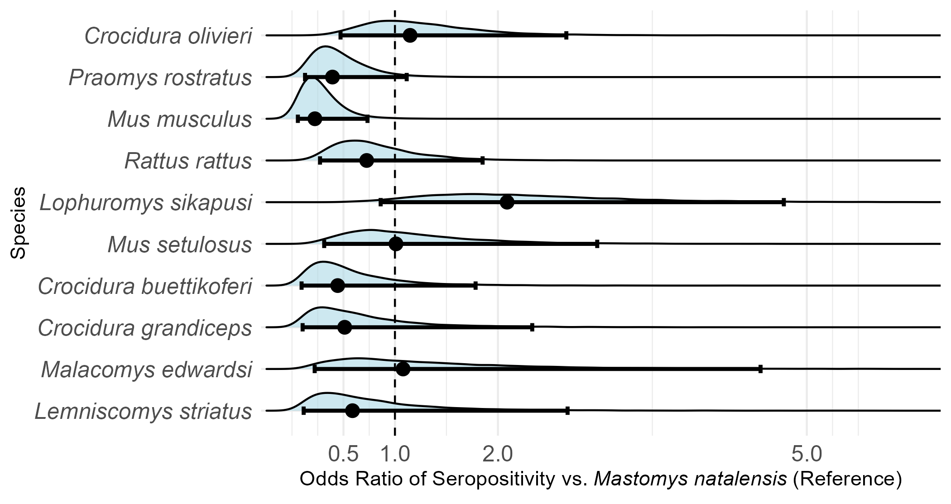

Figure 2: Odds Ratios of seropositivity to LASV among small-mammal species, compared to Mastomys natalensis (reference). Only species with more than 10 individuals assayed for antibodies to LASV were included in this analysis.

Small mammals with antibodies to LASV were detected in three of the study villages, Lalehun (N = 18, 46%), Seilama (N = 12, 31%) and Baiama (N = 9, 23%). Lalehun had the highest percentage of antibody positive rodents (18/157, 12%), followed by Baiama (9/121, 7%) and Seilama (12/263, 5%). No positive individuals were detected in Lambayama, the most urbanised village study site, suggesting a potential association between lower seroprevalence and urban settings. Antibody positive individuals were detected during all study visits except visit 9 (2023-February).

Antibody positive small mammals were detected in all land use types. The proportion of antibody positive individuals among all small mammals trapped were similar across forest (2/44, 4.5%), agricultural (24/379, 6.3%) and village (13/261, 5%) land use types.

In exploratory analyses conducted post hoc, we observed potential differences in LASV seroprevalence by village and land use type. While these analyses were not pre-specified and should be interpreted with caution, seroprevalence appeared to be higher in the most rural village, Lalehun (OR = 2.56, 95% CrI = 1.27-5.27), than the more urbanised village Lambayama (OR = 0.21, 95% CrI = 0.06-0.68). Baiama showed an intermediate level of seroprevalence (OR = 1.57, 95% CrI = 0.67-3.52). Similarly, agricultural land use (OR = 1.27, 95% CrI = 0.66-2.5) showed the highest proportion of LASV antibody-positive small mammals, with lower seroprevalence observed in forest settings (OR = 0.85, 95% CrI = 0.24-2.71). Differences for land use crossed an OR of 1 and so were not considered importantly different.

## Small-mammal community contact networks

Contact networks produced from observations in agricultural land use contained the highest small mammal species richness (12), followed by villages (9) and forests (6 species). The number of individuals (nodes) was also greatest in agricultural settings (n = 379) compared to villages (n = 261) and forests (n = 44). Networks in village settings exhibited the highest overall connectivity, as indicated by the highest mean degree (mean = 6.2, standard deviation (SD) = 4.6), followed by forests (mean = 5.1, SD = 3.3) and agricultural settings (mean = 4.9, SD = 5.4).

Additionally, the highest degree centrality values - indicating individuals with the greatest number of direct connections - were observed in agricultural (degree = 24) and village (degree = 20) settings. This suggests that while villages had the highest overall connectivity, certain individuals in agricultural settings acted as highly connected hubs within their networks.

Mean betweenness centrality followed an anthropogenic gradient, highest in villages (mean = 3.06, SD = 10.2), decreasing in agricultural settings (mean = 0.46, SD = 2.6) and lowest in forests (mean = 0.07, SD = 0.16). This suggests that animals in human-modified environments played a greater role in connecting otherwise separate parts of the network.

Degree centrality varied across species, with the highest values observed in species more common in agricultural settings. *L. sikapusi*, *M. setulosus*, *P. rostratus*, and *C. Olivieri* - three native rodents and one shrew - had individuals with degree centrality values up to 24, though most had lower values (Figure 3). In villages, *Mus musculus*, a synanthropic invasive species, had a maximum degree of 20 and a high median degree. In contrast, *M. natalensis*, despite being abundant in both agricultural and village settings, had a lower maximum degree (12 in villages, 9 in agriculture) and a similar median degree across both (5 and 4, respectively).

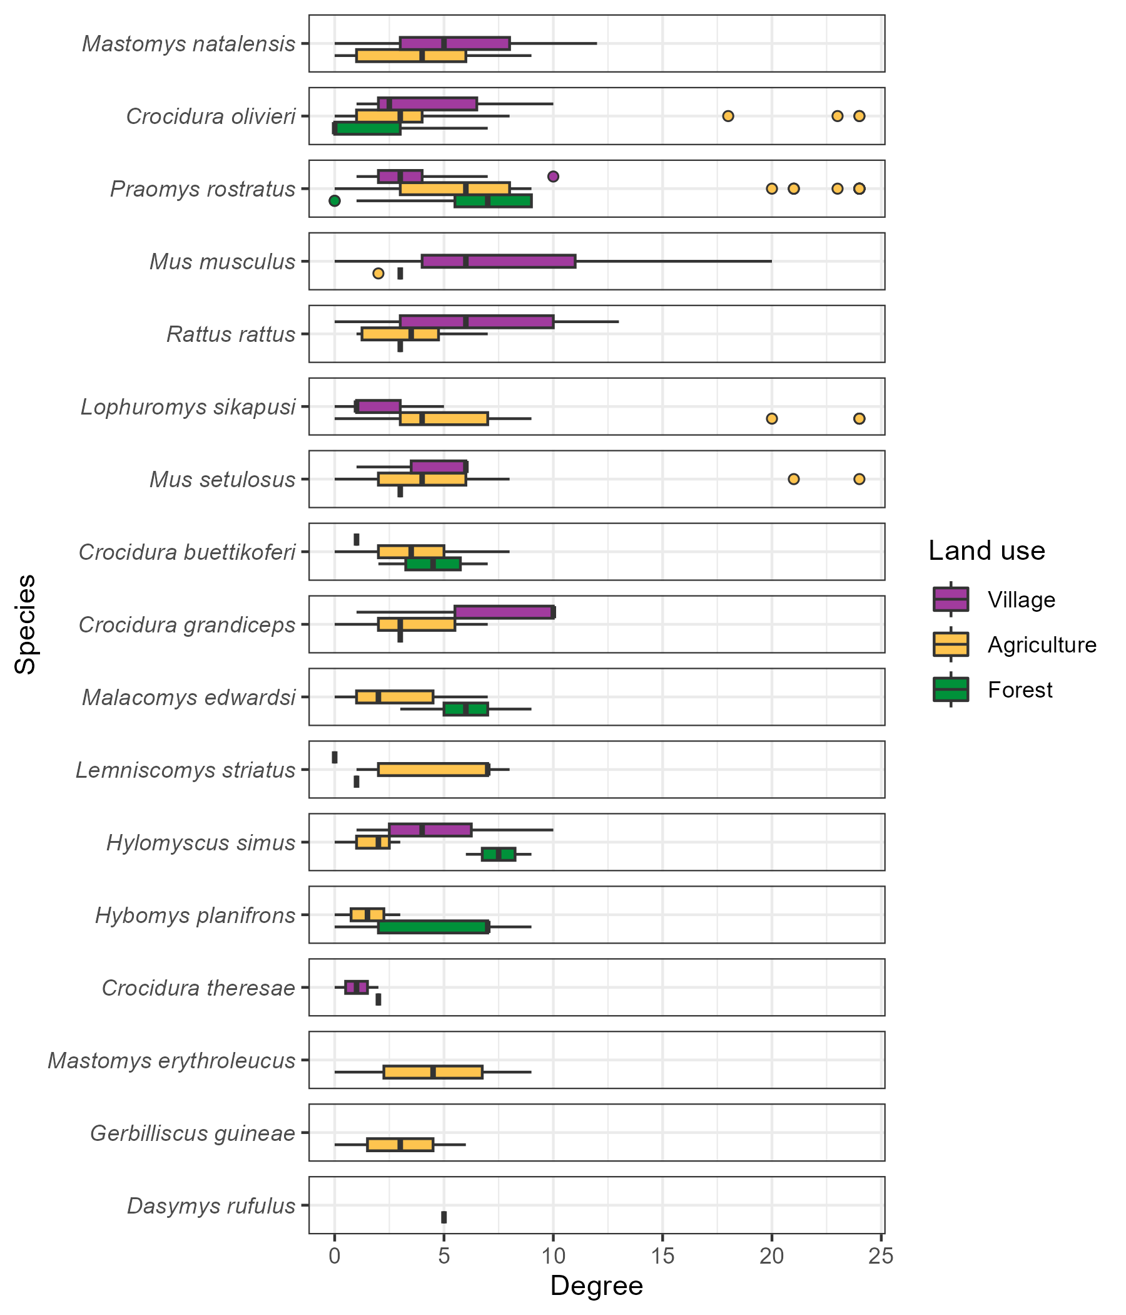

Figure 3: The degree (number of contacts) of individual small mammals stratified by species and land use type. Boxes contain the median and inter-quartile range of the degree distribution. Whiskers include the upper and lower quartile with outliers shown as points.

No consistent trend in degree centrality was observed across all species when stratified by land use type (Figure 3). For commensal species such as *M. natalensis*, *Rattus rattus* and *M. musculus* the median degree centrality was elevated in villages. However, for *M. natalensis* and *R. rattus*, no statistically significant differences were detected in degree distributions when stratified by land use.

## Describing inter- and intra-specific contact within small mammal communities

Species with more trapped individuals generally had more interspecific contacts (*r* = 0.62, *p* = 0.007, *n =* 15, Pearson correlation). For instance, the frequently detected species, *M. natalensis*, *P. rostratus* and *R. rattus* each had contacts with more than 12 other species. An exception to this trend was *M. musculus*, which, despite being the fourth most frequently detected species, only had observed contacts with four other species (Figure 4 and Supplementary Figures 4.1 and 4.2).

Intra-specific contacts were common for most species, but notable differences emerged across land use types. For example, *M. natalensis* interacted with 12 other species in agricultural land use settings, with 45% of all observed contacts involving other individuals of the same species (Figure 3). However, in village settings, where *M. natalensis* interacted with fewer species (9), the proportion of intra-specific contacts decreased to 31% (Supplementary Figure 4.2). Not all species showed a dominance of intra-specific contacts. For example, in agricultural areas, *L. sikapusi* interacted with 12 other species. However, a similar proportion of contacts for this species came from *P. rostratus* (27%) as from other individuals of *L. sikapusi* (26%).

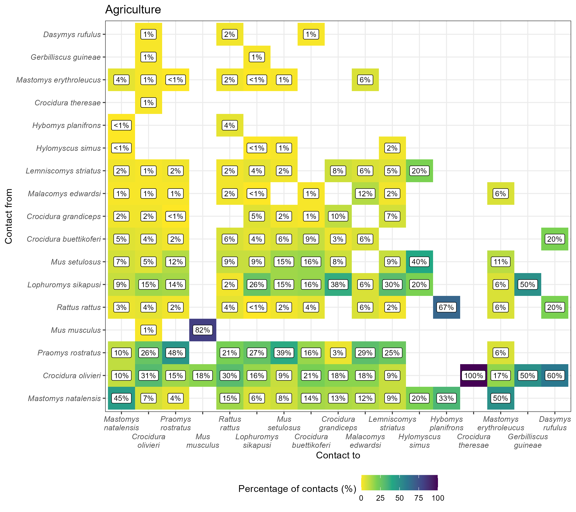

Figure 4: The proportion of contacts between individual small mammals in agricultural land use. Darker colours indicate increasing proportions of observed contacts to a species (Contact to) from named species (Contact from). Numbers in the cells correspond to the proportion of contacts to a species from a named species. For example, 45% of all contacts to Mastomys natalensis are from other M. natalensis while 9% of contacts are from Lophuromys sikapusi. Percentages sum to 100% in the Contact to axis, while they may exceed 100% in Contact from. Species are ordered by the total number detected in this study with M. natalensis (N = 113) in the bottom left.

## The probability of inter- and intraspecific contact rates of *Mastomys natalensis* across a land use gradient

Focusing on the reservoir species of LASV, *M. natalensis*, we analysed the probability of contact using 13 ERGM models (8/10 village networks, 5/10 agricultural networks), which were deemed suitable for random-effects meta-analysis. The odds of a contact being observed for *M. natalensis* were low compared to all potential contacts (observed and unobserved edges) and similar across both agricultural (Odds Ratio = 0.14, 95% Confidence Interval = 0.09-0.23, *p* < 0.001) and village land use (OR = 0.24, 95% C.I. = 0.17-0.36, *p* < 0.001) (Figure 5A). There was substantial heterogeneity in contact odds between networks across different visits for both land use types ( ${\hat{τ}}_{\text{agriculture}}^{2}$ = 0.26, $Q$ = 112, *p* < 0.001 and ${\hat{τ}}_{\text{village}}^{2}$ = 0.23, $Q$ = 54, *p* < 0.001). Compared to other rodent species *M. natalensis* was observed to form fewer contacts overall.

When examining inter-specific contacts, *M. natalensis* showed a marginally reduced, non-statistically significant odds of interacting with other species in agricultural (OR = 0.49, 95% C.I. = 0.24-1.01, *p* = 0.054) and village settings (OR = 0.74, 95% C.I. = 0.55-1.01, *p* = 0.055) compared to inter-specific contacts among other rodent species (Figure 5B). Notably, there was substantial heterogeneity in inter-specific contact odds between networks ( ${\hat{τ}}_{\text{agriculture}}^{2}$ = 0.59, $Q$ = 31, *p* < 0.001 and ${\hat{τ}}_{\text{village}}^{2}$ = 0.09, $Q$ = 15, *p* = 0.03). Land use type did not appear to significantly influence the probability of inter-specific contact for *M. natalensis* relative to other species.

Conversely, *M. natalensis* showed a statistically significantly increase in the odds of forming intra-specific contacts in agricultural settings (OR = 7.5, 95% C.I. = 3.42-16.5, *p* < 0.001), but not in village settings (OR = 1.69, 95% C.I. = 0.85-3.36, *p* = 0.13) (Figure 5C). Heterogeneity in intra-specific contact odds was low in both land use types ( ${\hat{τ}}_{\text{agriculture}}^{2}$ = 0.22, $Q$ = 5.6, *p* = 0.23 and ${\hat{τ}}_{\text{village}}^{2}$ = 0.39, $Q$ = 12, *p* = 0.1). These findings suggest that *M. natalensis* was statistically significantly more likely to engage in intra-specific interactions in agricultural settings compared to other small mammals but not in villages.

Sensitivity analyses revealed no changes in the direction of effect sizes when altering the contact radius (Supplementary Figures 5.1 and 5.2 , for 15 and 50 meters respectively). Additionally, leave-one-out sensitivity analyses for influential networks did not indicate meaningful changes in the effect size magnitude or direction. These results support the robustness of the findings concerning contact buffer assumptions and community composition changes across visits.

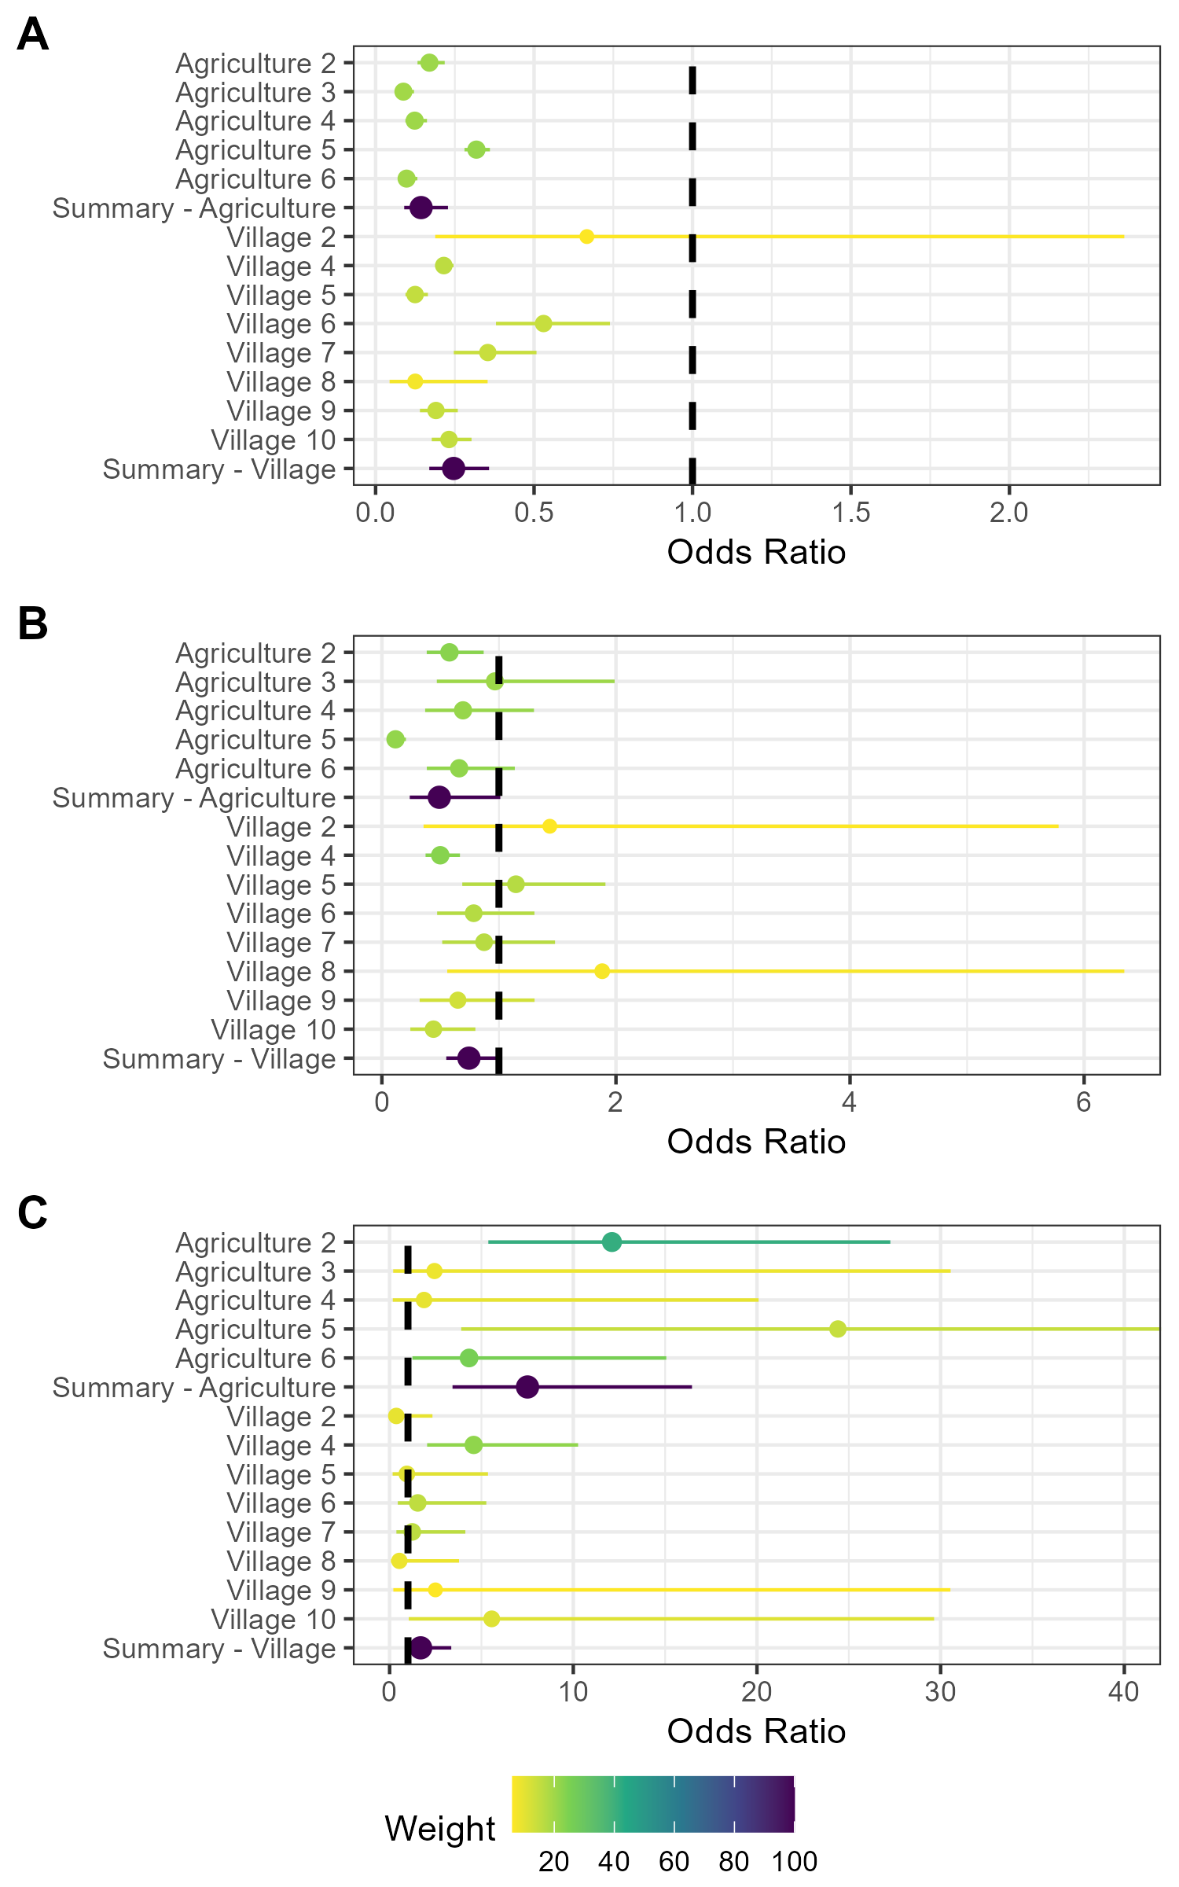

Figure 5: Random effects meta-analysis of ERGM network models reporting the odds of a contact being observed for M natalensis. A) The odds ratio of a contact being observed for M. natalensis in Agricultural or Village land use types. B) The odds ratio of a contact being observed between M. natalensis and an individual of a different rodent species. C) The odds ratio of a contact being observed between M. natalensis and another M. natalensis.

## Association of *Lassa mammarenavirus* seropositivity and position within a small-mammal community contact network

Rodents and shrews that were LASV seropositive had a significantly lower mean degree centrality (mean = 3.7, SD = 2.9) compared to seronegative individuals (mean = 5.5, SD = 5.1) (W = 10018, *p* = 0.039). Species-specific analyses, performed only for species with more than five seropositive individuals (*M. natalensis*, *L. sikapusi* and *C. olivieri*) showed significantly lower mean degree centrality in seropositive compared to seronegative individuals for *M. natalensis* (W = 354, *p* = 0.048) and *L. sikapusi* (W = 99.5, *p* = 0.03), but not for *C. olivieri* (W = 429.5, *p* = 0.54). In contrast, betweenness centrality did not differ significantly between seropositive and seronegative individuals, either overall or within any of the three species examined individually. This suggests that while seropositive individuals had fewer direct contacts (lower degree centrality), their role in connecting otherwise unconnected individuals within the network (betweenness centrality) was not substantially different from that of seronegative individuals.

The lower mean degree centrality observed in seropositive individuals suggests that individuals with fewer connections were more likely to be seropositive. Given the low overall seroprevalence, this pattern may reflect limited recent pathogen transmission within the population, potentially due to stochastic transmission events rather than sustained intraspecific transmission.

# Discussion

In the Eastern province of Sierra Leone, we found that small-mammal contact networks were generally larger in village and agricultural settings, yet overall contact rates were similar across land use types. Most individual animals had fewer than five contacts, forming relatively sparse networks. While degree centrality did not differ systematically by species, *M. natalensis* exhibited a high probability of intra-specific contacts in agricultural settings, suggesting that these areas may serve as focal points for LASV transmission, consistent with findings linking anthropogenic environments to zoonotic disease risk (Pei et al. 2024; Carlson et al. 2025). LASV seropositivity was detected at low prevalence across six rodent and shrew species, with *M. natalensis* comprising most seropositive individuals. However, seropositive individuals had lower degree centrality overall, though this pattern was not consistent within species.

We hypothesised that contact rates would be higher in anthropogenic habitats, but global degree centrality was similar across land use types. However, the highest-degree individuals were primarily found in village and agricultural settings, highlighting spatial heterogeneity within networks. This finding underscores the limitations of relying solely on aggregated network metrics in capturing individual-level variation, which is critical for understanding transmission pathways (Farine and Whitehead 2015; Silk and Fisher 2017).

Agricultural settings hosted the highest species richness, with a greater proportion of interspecific contacts, reflecting edge effects that promote interactions between synanthropic and sylvatic species (Despommier, Ellis, and Wilcox 2007; Pruvot et al. 2024). Notably, native rodent species such as *P. rostratus* in agricultural settings exhibited high degree centrality, suggesting that agricultural habitats may amplify interspecific interactions, potentially increasing zoonotic transmission risk (Gibb et al. 2020). These findings highlight the heterogeneity in contact rates within species, often obscured in aggregated analyses (Farine and Whitehead 2015).

Network structure also varied across land use types. Village networks exhibited higher betweenness centrality, indicating greater fragmentation, with key individuals bridging disconnected sub-components. These bottlenecks in network structure could constrain LASV transmission by limiting sustained contact chains (Keeling and Eames 2005). Conversely, the lower betweenness centrality in agricultural networks suggests more cohesive connectivity, potentially facilitating more efficient transmission.

Despite overall lower contacts, *M. natalensis* in agricultural settings exhibited strong intra-specific clustering, whereas in villages, interspecific contacts were more frequent. These findings align with prior studies showing that *M. natalensis* exhibits weak territorial behaviour, similar to *R. rattus* but contrasting with *M. musculus* (Anderson 1961; Whisson, Quinn, and Collins 2007; Borremans et al. 2014; Hoffmann et al. 2024). This intra-specific homophily in agricultural settings may promote LASV transmission within *M. natalensis* populations, where competent hosts can sustain transmission chains (Luis, Kuenzi, and Mills 2018). In contrast, higher interspecific contacts in villages could facilitate spillover but may not sustain transmission within *M. natalensis*. Rodent movement between habitats may further influence these dynamics (Marien et al. 2018).

The structure of agricultural networks could enable rapid LASV spread, potentially leading to local pathogen extinction if transmission exceeds population replenishment (Keeling and Eames 2005; Messinger and Ostling 2009). By contrast, fragmented village networks may allow for slower transmission and long-term persistence (Peel et al. 2014). These differences suggest interventions should be tailored to land use contexts, particularly given agriculture’s potential role in amplifying transmission.

The seroprevalence of LASV (5.7%), was consistent with prior estimates from Eastern Sierra Leone (Bangura et al. 2021). Our study included forest sites further from human habitation, yet the proportion of *M. natalensis* individuals testing positive was similar (~9%). However, *M. natalensis* represented a smaller fraction of total seropositive individuals (28% vs. 75%), and we detected LASV antibodies in additional species (*C. olivieri*, *M. setulosus*, *Hybomys planifrons*, *Mastomys erythroleucus*), suggesting broader host involvement than previously documented (Bangura et al. 2021). These findings align with evidence from other LASV-endemic regions, reinforcing the need for multispecies approaches to surveillance and control (Demby et al. 2001; Olayemi et al. 2016; Bangura et al. 2021).

Several key assumptions must be considered. First, direct and indirect contacts among rodents were inferred from co-location in space and time rather than directly observed (Perkins et al. 2009). This approach assumes individuals who are detected at the centroid of their home range move uniformly within it, which is unlikely to be accurate (Wanelik and Farine 2022). As a result, contact rates may be under- or overestimated, particularly for species with variable movement behaviours (Clay et al. 2009). Future studies using real-time tracking (e.g., radio tagging) could refine these estimates, though ethical challenges remain (Mohr et al. 2007; Borremans et al. 2017). Second, only a subset of rodents and shrews active at a study site were captured (Parmenter et al. 2003; Moore and Swihart 2005). We account somewhat for the impact this will have on our network models by inferring the total abundance of species within these sites (Silk and Fisher 2017; Vega Yon, Slaughter, and Haye 2021). If captured individuals behave differently from those not detected, network inferences may be biased. For example, if trap shyness influences space sharing, contact rates could be overestimated. Replicating this study across additional sites would help assess these potential biases.

In conclusion, this study highlights the variability in contact rates and network structures among rodent and shrew species across land-use types in LASV-endemic settings. The complex contact networks involving multiple species may facilitate LASV transmission in unexpected ways, particularly in agricultural settings where intra- and inter-specific interactions are frequent. These findings underscore the importance of tailoring control strategies to specific ecological contexts and host species behaviours to mitigate Lassa fever risks effectively.

# Acknowledgments

We acknowledge the support of the Lassa Fever Ward team at Kenema Government Hospital with whom we discussed study protocols for appropriateness of design. Consultations were held with community leaders of the study villages and the wider region before finalising the study design and enrolment of sites into the study.

# Financial Support

DS, RA, EF-C and RK acknowledge support from the Pan-African Network on Emerging and Re-Emerging Infections (PANDORA-ID-NET; <https://www.pandora-id.net/>) funded by the European and Developing Countries Clinical Trials Partnership (EDCTP) within the EU Horizon 2020 Framework Programme. DS was supported by a PhD studentship from the UK Biotechnology and Biological Sciences Research Council (BB/M009513/1). KEJ is supported by The Sentinel Forecasting System for Infectious Disease Risk project funded by the Trinity Challenge.

# Disclosures

At the time of the work, BR was an employee of the Bernhard-Nocht Institute for Tropical Medicine, which produced the BLACKBOX® LASV IgG ELISA kit used in this study. At the time of publishing, BR is a founder and shareholder of Panadea Diagnostics GmbH, which has commercialized this ELISA kit under the brand name Panadea LASV (NP) IgG ELISA Kit.

# References

Albery, Gregory F., Daniel J. Becker, Liam Brierley, Cara E. Brook, Rebecca C. Christofferson, Lily E. Cohen, Tad A. Dallas, et al. 2021. “The Science of the Host–Virus Network.” *Nature Microbiology* 6 (12): 1483–92. <https://doi.org/10.1038/s41564-021-00999-5>.

Albery, Gregory F., Colin J. Carlson, Lily E. Cohen, Evan A. Eskew, Rory Gibb, Sadie J. Ryan, Amy R. Sweeny, and Daniel J. Becker. 2022. “Urban-Adapted Mammal Species Have More Known Pathogens.” *Nature Ecology & Evolution* 6 (6): 794–801. <https://doi.org/10.1038/s41559-022-01723-0>.

Almberg, Emily S., Paul C. Cross, Andrew P. Dobson, Douglas W. Smith, and Peter J. Hudson. 2012. “Parasite Invasion Following Host Reintroduction: A Case Study of Yellowstone’s Wolves.” *Philosophical Transactions of the Royal Society B: Biological Sciences* 367 (1604): 2840–51. <https://doi.org/10.1098/rstb.2011.0369>.

Altschul, S. F., W. Gish, W. Miller, E. W. Myers, and D. J. Lipman. 1990. “Basic Local Alignment Search Tool.” *Journal of Molecular Biology* 215 (3): 403–10. <https://doi.org/10.1016/S0022-2836(05)80360-2>.

Anderson, P. K. 1961. “Density, Social Structure, and Nonsocial Environment in House-Mouse Populations and the Implications for Regulation of Numbers.” *Transactions of the New York Academy of Sciences* 23 (March): 447–51. <https://doi.org/10.1111/j.2164-0947.1961.tb01373.x>.

Bangura, Umaru, Jacob Buanie, Joyce Lamin, Christopher Davis, Gedeon Ngiala Bongo, Michael Dawson, Rashid Ansumana, et al. 2021. “Lassa Virus Circulation in Small Mammal Populations in Bo District, Sierra Leone.” *BIOLOGY-BASEL* 10 (1). <https://doi.org/10.3390/biology10010028>.

Basinski, Andrew J., Elisabeth Fichet-Calvet, Anna R. Sjodin, Tanner J. Varrelman, Christopher H. Remien, Nathan C. Layman, Brian H. Bird, et al. 2021. “Bridging the Gap: Using Reservoir Ecology and Human Serosurveys to Estimate Lassa Virus Spillover in West Africa.” Edited by Amy Wesolowski. *PLOS Computational Biology* 17 (3): e1008811. <https://doi.org/10.1371/journal.pcbi.1008811>.

Bauer, David F. 1972. “Constructing Confidence Sets Using Rank Statistics.” *Journal of the American Statistical Association* 67 (339): 687–90. <https://doi.org/10.1080/01621459.1972.10481279>.

Bausch, D. G., A. H. Demby, M. Coulibaly, J. Kanu, A. Goba, A. Bah, N. Condé, et al. 2001. “Lassa Fever in Guinea: I. Epidemiology of Human Disease and Clinical Observations.” *Vector Borne and Zoonotic Diseases (Larchmont, N.Y.)* 1 (4): 269–81. <https://doi.org/10.1089/15303660160025903>.

Begon, M., S. M. Hazel, D. Baxby, K. Bown, R. Cavanagh, J. Chantrey, T. Jones, and M. Bennett. 1999. “Transmission Dynamics of a Zoonotic Pathogen Within and Between Wildlife Host Species.” *Proceedings of the Royal Society of London. Series B: Biological Sciences* 266 (1432): 1939–45. <https://doi.org/10.1098/rspb.1999.0870>.

Böhm, Monika, Michael R. Hutchings, and Piran C. L. White. 2009. “Contact Networks in a Wildlife-Livestock Host Community: Identifying High-Risk Individuals in the Transmission of Bovine TB Among Badgers and Cattle.” *PLOS ONE* 4 (4): e5016. <https://doi.org/10.1371/journal.pone.0005016>.

Borenstein, Michael, Larry V. Hedges, Julian P. T. Higgins, and Hannah R. Rothstein. 2010. “A Basic Introduction to Fixed-Effect and Random-Effects Models for Meta-Analysis.” *Research Synthesis Methods* 1 (2): 97–111. <https://doi.org/10.1002/jrsm.12>.

Borremans, Benny, Nelika K. Hughes, Jonas Reijniers, Vincent Sluydts, Abdul A. S. Katakweba, Loth S. Mulungu, Christopher A. Sabuni, Rhodes H. Makundi, and Herwig Leirs. 2014. “Happily Together Forever: Temporal Variation in Spatial Patterns and Complete Lack of Territoriality in a Promiscuous Rodent.” *Population Ecology* 56 (1): 109–18. <https://doi.org/10.1007/s10144-013-0393-2>.

Borremans, Benny, Jonas Reijniers, Nelika K. Hughes, Stephanie S. Godfrey, Sophie Gryseels, Rhodes H. Makundi, and Herwig Leirs. 2017. “Nonlinear Scaling of Foraging Contacts with Rodent Population Density.” *Oikos* 126 (6): 792–800. <https://doi.org/10.1111/oik.03623>.

Borremans, Benny, Raphaël Vossen, Beate Becker-Ziaja, Sophie Gryseels, Nelika Hughes, Mats Van Gestel, Natalie Van Houtte, Stephan Günther, and Herwig Leirs. 2015. “Shedding Dynamics of Morogoro Virus, an African Arenavirus Closely Related to Lassa Virus, in Its Natural Reservoir Host Mastomys Natalensis.” *Scientific Reports* 5 (1): 10445. <https://doi.org/10.1038/srep10445>.

Broekman, Maarten Jaap Erik, Selwyn Hoeks, Rosa Freriks, Merel M. Langendoen, Katharina M. Runge, Ecaterina Savenco, Ruben ter Harmsel, Mark A. J. Huijbregts, and Marlee A. Tucker. 2023. “HomeRange: A Global Database of Mammalian Home Ranges.” *Global Ecology and Biogeography* 32 (2): 198–205. <https://doi.org/10.1111/geb.13625>.

Bürkner, Paul-Christian. 2017. “brms: An R Package for Bayesian Multilevel Models Using Stan.” *Journal of Statistical Software* 80 (1): 1–28. <https://doi.org/10.18637/jss.v080.i01>.

Butts, Carter T. 2008. “**Network** : A Package for Managing Relational Data in *r*.” *Journal of Statistical Software* 24 (2). <https://doi.org/10.18637/jss.v024.i02>.

Cardenas, Nicolas C., Abagael L. Sykes, Francisco P. N. Lopes, and Gustavo Machado. 2022. “Multiple Species Animal Movements: Network Properties, Disease Dynamics and the Impact of Targeted Control Actions.” *Veterinary Research* 53 (1): 14. <https://doi.org/10.1186/s13567-022-01031-2>.

Carlson, Colin J., Cole B. Brookson, Daniel J. Becker, Caroline A. Cummings, Rory Gibb, Fletcher W. Halliday, Alexis M. Heckley, et al. 2025. “Pathogens and Planetary Change.” *Nature Reviews Biodiversity* 1 (1): 32–49. <https://doi.org/10.1038/s44358-024-00005-w>.

Caron, Alexandre, Julien Cappelle, Graeme S. Cumming, Michel de Garine-Wichatitsky, and Nicolas Gaidet. 2015. “Bridge Hosts, a Missing Link for Disease Ecology in Multi-Host Systems.” *Veterinary Research* 46 (1): 83. <https://doi.org/10.1186/s13567-015-0217-9>.

Carslake, David, Malcolm Bennett, Kevin Bown, Sarah Hazel, Sandra ℡fer, and Michael Begon. 2005. “Space–Time Clustering of Cowpox Virus Infection in Wild Rodent Populations.” *Journal of Animal Ecology* 74 (4): 647–55. <https://doi.org/10.1111/j.1365-2656.2005.00966.x>.

Chen, Shi, Brad J. White, Michael W. Sanderson, David E. Amrine, Amiyaal Ilany, and Cristina Lanzas. 2014. “Highly Dynamic Animal Contact Network and Implications on Disease Transmission.” *Scientific Reports* 4 (March): 4472. <https://doi.org/10.1038/srep04472>.

Cheung, Mike W.-L. 2019. “A Guide to Conducting a Meta-Analysis with Non-Independent Effect Sizes.” *Neuropsychology Review* 29 (4): 387–96. <https://doi.org/10.1007/s11065-019-09415-6>.

Clay, Christine A., Erin M. Lehmer, Andrea Previtali, Stephen St. Jeor, and M. Denise Dearing. 2009. “Contact Heterogeneity in Deer Mice: Implications for Sin Nombre Virus Transmission.” *Proceedings of the Royal Society B: Biological Sciences* 276 (1660): 1305–12. <https://doi.org/10.1098/rspb.2008.1693>.

Cochran, William G. 1954. “The Combination of Estimates from Different Experiments.” *Biometrics* 10 (1): 101–29. <https://doi.org/10.2307/3001666>.

Demby, Austin H., Alphonse Inapogui, Kandeh Kargbo, James Koninga, Kerfalla Kourouma, James Kanu, Mamadi Coulibaly, et al. 2001. “Lassa Fever in Guinea: II. Distribution and Prevalence of Lassa Virus Infection in Small Mammals.” *Vector-Borne and Zoonotic Diseases* 1 (4): 283–97. <https://doi.org/10.1089/15303660160025912>.

Despommier, Dickson, Brett R. Ellis, and Bruce A. Wilcox. 2007. “The Role of Ecotones in Emerging Infectious Diseases.” *EcoHealth* 3 (4): 281–89. <https://doi.org/10.1007/s10393-006-0063-3>.

Drewe, Julian A., Ken T. D. Eames, Joah R. Madden, and Gareth P. Pearce. 2011. “Integrating Contact Network Structure into Tuberculosis Epidemiology in Meerkats in South Africa: Implications for Control.” *Preventive Veterinary Medicine* 101 (1): 113–20. <https://doi.org/10.1016/j.prevetmed.2011.05.006>.

Ecke, Frauke, Barbara A. Han, Birger Hörnfeldt, Hussein Khalil, Magnus Magnusson, Navinder J. Singh, and Richard S. Ostfeld. 2022. “Population Fluctuations and Synanthropy Explain Transmission Risk in Rodent-Borne Zoonoses.” *Nature Communications* 13 (1): 7532. <https://doi.org/10.1038/s41467-022-35273-7>.

Farine, Damien R., and Hal Whitehead. 2015. “Constructing, Conducting and Interpreting Animal Social Network Analysis.” *Journal of Animal Ecology* 84 (5): 1144–63. <https://doi.org/10.1111/1365-2656.12418>.

Faust, Christina L., Andrew P. Dobson, Nicole Gottdenker, Laura S. P. Bloomfield, Hamish I. McCallum, Thomas R. Gillespie, Maria Diuk-Wasser, and Raina K. Plowright. 2017. “Null Expectations for Disease Dynamics in Shrinking Habitat: Dilution or Amplification?” *Philosophical Transactions of the Royal Society B: Biological Sciences* 372 (1722): 20160173. <https://doi.org/10.1098/rstb.2016.0173>.

Fichet-Calvet, Elisabeth. 2014. “Chapter 5 - Lassa Fever: A Rodent-Human Interaction.” In *The Role of Animals in Emerging Viral Diseases*, edited by Nicholas Johnson, 89–123. Boston: Academic Press. <https://doi.org/10.1016/B978-0-12-405191-1.00005-3>.

Fichet-Calvet, Elisabeth, Beate Becker-Ziaja, Lamine Koivogui, and Stephan Gunther. 2014. “Lassa Serology in Natural Populations of Rodents and Horizontal Transmission.” *Vector Borne & Zoonotic Diseases* 14 (9): 665–74. <https://doi.org/10.1089/vbz.2013.1484>.

Fichet‐Calvet, Elisabeth, Leen Audenaert, Patrick Barrière, and Erik Verheyen. 2010. “Diversity, Dynamics and Reproduction in a Community of Small Mammals in Upper Guinea, with Emphasis on Pygmy Mice Ecology.” *African Journal of Ecology* 48 (3): 600–614. <https://doi.org/10.1111/j.1365-2028.2009.01144.x>.

Fiske, Ian, and Richard Chandler. 2011. “Unmarked: An r Package for Fitting Hierarchical Models of Wildlife Occurrence and Abundance.” *Journal of Statistical Software* 43 (10): 1–23. <https://doi.org/10.18637/jss.v043.i10>.

Gabriel, Martin, Donatus I. Adomeh, Jacqueline Ehimuan, Jennifer Oyakhilome, Emmanuel O. Omomoh, Yemisi Ighodalo, Thomas Olokor, et al. 2018. “Development and Evaluation of Antibody-Capture Immunoassays for Detection of Lassa Virus Nucleoprotein-Specific Immunoglobulin m and g.” *PLOS Neglected Tropical Diseases* 12 (3): e0006361. <https://doi.org/10.1371/journal.pntd.0006361>.

Gibb, Rory, David W. Redding, Kai Qing Chin, Christl A. Donnelly, Tim M. Blackburn, Tim Newbold, and Kate E. Jones. 2020. “Zoonotic Host Diversity Increases in Human-Dominated Ecosystems.” *Nature* 584 (7821): 398–402. <https://doi.org/10.1038/s41586-020-2562-8>.

Gilbert, Amy T., A. R. Fooks, D. T. S. Hayman, D. L. Horton, T. Müller, R. Plowright, A. J. Peel, et al. 2013. “Deciphering Serology to Understand the Ecology of Infectious Diseases in Wildlife.” *EcoHealth* 10 (3): 298–313. <https://doi.org/10.1007/s10393-013-0856-0>.

Grant, Donald S., Emily J. Engel, Nicole Roberts Yerkes, Lansana Kanneh, James Koninga, Michael A. Gbakie, Foday Alhasan, et al. 2023. “Seroprevalence of Anti-Lassa Virus IgG Antibodies in Three Districts of Sierra Leone: A Cross-Sectional, Population-Based Study.” *PLOS Neglected Tropical Diseases* 17 (2): e0010938. <https://doi.org/10.1371/journal.pntd.0010938>.

Grüner, Nico, Oumaima Stambouli, and R. Stefan Ross. 2015. “Dried Blood Spots - Preparing and Processing for Use in Immunoassays and in Molecular Techniques.” *Journal of Visualized Experiments : JoVE*, no. 97 (March): 52619. <https://doi.org/10.3791/52619>.

Handcock, Mark S., David R. Hunter, Carter T. Butts, Steven M. Goodreau, Pavel N. Krivitsky, and Martina Morris. 2022. “Ergm: Fit, Simulate and Diagnose Exponential-Family Models for Networks.” The Statnet Project (https://statnet.org). <https://CRAN.R-project.org/package=ergm>.

Happi, Anise N., Testimony J. Olumade, Olusola A. Ogunsanya, Ayotunde E. Sijuwola, Seto C. Ogunleye, Judith U. Oguzie, Cecilia Nwofoke, et al. 2022. “Increased Prevalence of Lassa Fever Virus-Positive Rodents and Diversity of Infected Species Found During Human Lassa Fever Epidemics in Nigeria.” *Microbiology Spectrum* 10 (4): e0036622. <https://doi.org/10.1128/spectrum.00366-22>.

Happold, David C. D., and Jonathan Kingdon, eds. 2013. *Mammals of Africa. Vol. 3: Rodents, Hares and Rabbits*. London: Bloomsbury.

Hoffmann, Chris, Susanne Krasemann, Stephanie Wurr, Kristin Hartmann, Elisa Adam, Sabrina Bockholt, Jonas Müller, Stephan Günther, and Lisa Oestereich. 2024. “Lassa Virus Persistence with High Viral Titers Following Experimental Infection in Its Natural Reservoir Host, Mastomys Natalensis.” *Nature Communications* 15 (1): 9319. <https://doi.org/10.1038/s41467-024-53616-4>.

Hunter, David R., Mark S. Handcock, Carter T. Butts, Steven M. Goodreau, and Martina Morris. 2008. “Ergm: A Package to Fit, Simulate and Diagnose Exponential-Family Models for Networks.” *Journal of Statistical Software* 24 (3): 1–29. <https://doi.org/10.18637/jss.v024.i03>.

Jetoh, Ralph Weah, Shruti Malik, Bode Shobayo, Fahn Taweh, Trokon Omarley Yeabah, Josiah George, Burgess Gbelee, et al. 2022. “Epidemiological Characteristics of Lassa Fever Cases in Liberia: A Retrospective Analysis of Surveillance Data, 2019-2020.” *International Journal of Infectious Diseases*, July. <https://doi.org/10.1016/j.ijid.2022.07.006>.

Keeling, Matt J, and Ken T. D Eames. 2005. “Networks and Epidemic Models.” *Journal of the Royal Society Interface* 2 (4): 295–307. <https://doi.org/10.1098/rsif.2005.0051>.

Keesing, Felicia, and Richard S. Ostfeld. 2021. “Impacts of Biodiversity and Biodiversity Loss on Zoonotic Diseases.” *Proceedings of the National Academy of Sciences* 118 (17): e2023540118. <https://doi.org/10.1073/pnas.2023540118>.

Kerneis, Solen, Lamine Koivogui, N’Faly Magassouba, Kekoura Koulemou, Rosamund Lewis, Aristide Aplogan, Rebecca F. Grais, Philippe J. Guerin, and Elisabeth Fichet-Calvet. 2009. “Prevalence and Risk Factors of Lassa Seropositivity in Inhabitants of the Forest Region of Guinea: A Cross-Sectional Study.” *PLoS Neglected Tropical Diseases [Electronic Resource]* 3 (11): e548. <https://doi.org/10.1371/journal.pntd.0000548>.

Klitting, Raphaelle, Liana E. Kafetzopoulou, Wim Thiery, Gytis Dudas, Sophie Gryseels, Anjali Kotamarthi, Bram Vrancken, et al. 2022. “Predicting the Evolution of the Lassa Virus Endemic Area and Population at Risk over the Next Decades.” *Nature Communications* 13 (1): 5596. <https://doi.org/10.1038/s41467-022-33112-3>.

Kozakiewicz, Christopher P, Christopher P Burridge, Justin S Lee, Simona J Kraberger, Nicholas M Fountain-Jones, Robert N Fisher, Lisa M Lyren, et al. 2023. “Habitat Connectivity and Host Relatedness Influence Virus Spread Across an Urbanising Landscape in a Fragmentation-Sensitive Carnivore.” *Virus Evolution* 9 (1): veac122. <https://doi.org/10.1093/ve/veac122>.

Laverty, Sean M., and Frederick R. Adler. 2009. “The Role of Age Structure in the Persistence of a Chronic Pathogen in a Fluctuating Population.” *Journal of Biological Dynamics* 3 (2): 224–34. <https://doi.org/10.1080/17513750802452544>.

Lo Iacono, Giovanni, Andrew A. Cunningham, Elisabeth Fichet-Calvet, Robert F. Garry, Donald S. Grant, Sheik Humarr Khan, Melissa Leach, et al. 2015. “Using Modelling to Disentangle the Relative Contributions of Zoonotic and Anthroponotic Transmission: The Case of Lassa Fever.” *PLOS NEGLECTED TROPICAL DISEASES* 9 (1). <https://doi.org/10.1371/journal.pntd.0003398>.

Longet, Stephanie, Cristina Leggio, Joseph Akoi Bore, Stephanie Key, Tom Tipton, Yper Hall, Fara Raymond Koundouno, et al. 2023. “Influence of Landscape Patterns on Exposure to Lassa Fever Virus, Guinea.” *Emerging Infectious Diseases* 29 (2): 304–13. <https://doi.org/10.3201/eid2902.212525>.

Luis, Angela D., Amy J. Kuenzi, and James N. Mills. 2018. “Species Diversity Concurrently Dilutes and Amplifies Transmission in a Zoonotic Host–Pathogen System Through Competing Mechanisms.” *Proceedings of the National Academy of Sciences* 115 (31): 7979–84. <https://doi.org/10.1073/pnas.1807106115>.

Marien, Joachim, Fode Kourouma, N’Faly Magassouba, Herwig Leirs, and Elisabeth Fichet-Calvet. 2018. “Movement Patterns of Small Rodents in Lassa Fever-Endemic Villages in Guinea.” *Ecohealth* 15 (2): 348–59. <https://doi.org/10.1007/s10393-018-1331-8>.

Mariën, Joachim, Benny Borremans, Sophie Gryseels, Barré Soropogui, Luc De Bruyn, Gédéon Ngiala Bongo, Beate Becker-Ziaja, et al. 2017. “No Measurable Adverse Effects of Lassa, Morogoro and Gairo Arenaviruses on Their Rodent Reservoir Host in Natural Conditions.” *Parasites & Vectors* 10 (1): 210. <https://doi.org/10.1186/s13071-017-2146-0>.

McCormick, J B, P A Webb, J W Krebs, K M Johnson, and E S Smith. 1987. “A Prospective Study of the Epidemiology and Ecology of Lassa Fever.” *The Journal of Infectious Diseases* 155 (3): 437–44. <https://doi.org/10.1093/infdis/155.3.437>.

Messinger, Susanna M., and Annette Ostling. 2009. “The Consequences of Spatial Structure for the Evolution of Pathogen Transmission Rate and Virulence.” *The American Naturalist* 174 (4): 441–54. <https://doi.org/10.1086/605375>.

Mohr, Katrine, Herwig Leirs, Abdul Katakweba, and Robert Machang’u. 2007. “Monitoring Rodents Movements with a Biomarker Around Introduction and Feeding Foci in an Urban Environment in Tanzania.” *African Zoology* 42 (2): 294–98. [https://doi.org/10.3377/1562-7020(2007)42[294:MRMWAB]2.0.CO;2](https://doi.org/10.3377/1562-7020(2007)42%5b294:MRMWAB%5d2.0.CO;2).

Monadjem, Ara, Peter J. Taylor, Christiane Denys, and Fenton P. D. Cotterill. 2015. *Rodents of Sub-Saharan Africa: A Biogeographic and Taxonomic Synthesis*. Berlin, München, Boston: DE GRUYTER. <https://doi.org/10.1515/9783110301915>.

Monath, T. P., V. F. Newhouse, G. E. Kemp, H. W. Setzer, and A. Cacciapuoti. 1974. “Lassa Virus Isolation from Mastomys Natalensis Rodents During an Epidemic in Sierra Leone.” *Science* 185 (4147): 263–65. <https://doi.org/10.1126/science.185.4147.263>.

Moore, Jeffrey E., and Robert K. Swihart. 2005. “Modeling Patch Occupancy by Forest Rodents: Incorporating Detectability and Spatial Autocorrelation with Hierarchically Structured Data.” *The Journal of Wildlife Management* 69 (3): 933–49. [https://doi.org/10.2193/0022-541X(2005)069[0933:MPOBFR]2.0.CO;2](https://doi.org/10.2193/0022-541X(2005)069%5b0933:MPOBFR%5d2.0.CO;2).

Olayemi, Ayodeji, Daniel Cadar, N’Faly Magassouba, Adeoba Obadare, Fode Kourouma, Akinlabi Oyeyiola, Samuel Fasogbon, et al. 2016. “New Hosts of The Lassa Virus.” *Scientific Reports* 6 (1): 25280. <https://doi.org/10.1038/srep25280>.

Parmenter, Robert R., Terry L. Yates, David R. Anderson, Kenneth P. Burnham, Jonathan L. Dunnum, Alan B. Franklin, Michael T. Friggens, et al. 2003. “Small-Mammal Density Estimation: A Field Comparison of Grid-Based Vs. Web-Based Density Estimators.” *Ecological Monographs* 73 (1): 1–26. [https://doi.org/10.1890/0012-9615(2003)073[0001:SMDEAF]2.0.CO;2](https://doi.org/10.1890/0012-9615(2003)073%5b0001:SMDEAF%5d2.0.CO;2).

Pebesma, Edzer. 2018. “Simple Features for r: Standardized Support for Spatial Vector Data.” *The R Journal* 10 (1): 439–46. <https://journal.r-project.org/archive/2018/RJ-2018-009/index.html>.

Peel, A. J., J. R. C. Pulliam, A. D. Luis, R. K. Plowright, T. J. O’Shea, D. T. S. Hayman, J. L. N. Wood, C. T. Webb, and O. Restif. 2014. “The Effect of Seasonal Birth Pulses on Pathogen Persistence in Wild Mammal Populations.” *Proceedings of the Royal Society B: Biological Sciences* 281 (1786): 20132962. <https://doi.org/10.1098/rspb.2013.2962>.

Pei, Shan, Pengbo Yu, Jayna Raghwani, Yuxin Wang, Ziyan Liu, Yidan Li, Yanchao Cheng, et al. 2024. “Anthropogenic Land Consolidation Intensifies Zoonotic Host Diversity Loss and Disease Transmission in Human Habitats.” *Nature Ecology & Evolution* 9 (1): 99–110. <https://doi.org/10.1038/s41559-024-02570-x>.

Percie Du Sert, Nathalie, Amrita Ahluwalia, Sabina Alam, Marc T. Avey, Monya Baker, William J. Browne, Alejandra Clark, et al. 2020. “Reporting Animal Research: Explanation and Elaboration for the ARRIVE Guidelines 2.0.” Edited by Isabelle Boutron. *PLOS Biology* 18 (7): e3000411. <https://doi.org/10.1371/journal.pbio.3000411>.

Perkins, Sarah E., Francesca Cagnacci, Anna Stradiotto, Daniele Arnoldi, and Peter J. Hudson. 2009. “Comparison of Social Networks Derived from Ecological Data: Implications for Inferring Infectious Disease Dynamics.” *Journal of Animal Ecology* 78 (5): 1015–22. <https://doi.org/10.1111/j.1365-2656.2009.01557.x>.

Pruvot, Mathieu, Sokha Chea, Vibol Hul, Samat In, Vuthy Buor, Jill-Lea Ramassamy, Caroline Fillieux, et al. 2024. “Small Mammals at the Edge of Deforestation in Cambodia: Transient Community Dynamics and Potential Pathways to Pathogen Emergence.” *One Earth* 7 (1): 123–35. <https://doi.org/10.1016/j.oneear.2023.11.003>.

QIAGEN. 2023. “DNeasy Blood & Tissue Kits.” January 20, 2023. <https://www.qiagen.com/us/products/discovery-and-translational-research/dna-rna-purification/dna-purification/genomic-dna/dneasy-blood-and-tissue-kit>.

R Core Team. 2021. “R: A Language and Environment for Statistical Computing.” Vienna, Austria: R Foundation for Statistical Computing. <https://www.R-project.org/>.

Riley, Richard D., Julian P. T. Higgins, and Jonathan J. Deeks. 2011. “Interpretation of Random Effects Meta-Analyses.” *BMJ* 342 (February): d549. <https://doi.org/10.1136/bmj.d549>.

Royle, J. Andrew. 2004. “N-Mixture Models for Estimating Population Size from Spatially Replicated Counts.” *Biometrics* 60 (1): 108–15. <https://doi.org/10.1111/j.0006-341X.2004.00142.x>.

Safronetz, David, Kyle Rosenke, Kimberley Meade-White, Angela Sloan, Ousmane Maiga, Sidy Bane, Cynthia Martellaro, Dana P Scott, Nafomon Sogoba, and Heinz Feldmann. 2022. “Temporal Analysis of Lassa Virus Infection and Transmission in Experimentally Infected Mastomys Natalensis.” *PNAS Nexus* 1 (3): pgac114. <https://doi.org/10.1093/pnasnexus/pgac114>.

Salkeld, Daniel J., Marcel Salathé, Paul Stapp, and James Holland Jones. 2010. “Plague Outbreaks in Prairie Dog Populations Explained by Percolation Thresholds of Alternate Host Abundance.” *Proceedings of the National Academy of Sciences* 107 (32): 14247–50. <https://doi.org/10.1073/pnas.1002826107>.

Sauvage, Frank, Michel Langlais, Nigel G. Yoccoz, and Dominique Pontier. 2003. “Modelling Hantavirus in Fluctuating Populations of Bank Voles: The Role of Indirect Transmission on Virus Persistence.” *Journal of Animal Ecology* 72 (1): 1–13. <https://doi.org/10.1046/j.1365-2656.2003.00675.x>.

Shaffer, Jeffrey G., John S. Schieffelin, Mambu Momoh, Augustine Goba, Lansana Kanneh, Foday Alhasan, Michael Gbakie, et al. 2021. “Space-Time Trends in Lassa Fever in Sierra Leone by ELISA Serostatus, 2012–2019.” *Microorganisms* 9 (3): 586. <https://doi.org/10.3390/microorganisms9030586>.

Silk, Matthew J., and David N. Fisher. 2017. “Understanding Animal Social Structure: Exponential Random Graph Models in Animal Behaviour Research.” *Animal Behaviour* 132 (October): 137–46. <https://doi.org/10.1016/j.anbehav.2017.08.005>.

Simons, David, Lauren A Attfield, Kate E Jones, Deborah Watson-Jones, and Richard Kock. 2023. “Rodent Trapping Studies as an Overlooked Information Source for Understanding Endemic and Novel Zoonotic Spillover.” *PLOS Neglected Tropical Diseases* 17 (1): e0010772. <https://doi.org/10.1371/journal.pntd.0010772>.

Simons, David, Rory Gibb, Umaru Bangura, Dianah Sondufu, Joyce Lamin, James Koninga, Momoh Jimmy, et al. 2025. “Land Use Gradients Drive Spatial Variation in Lassa Fever Host Communities in the Eastern Province of Sierra Leone.” <https://doi.org/10.32942/X2N33P>.

Soubrier, Hugo, Umaru Bangura, Chris Hoffmann, Ayodeji Olayemi, Adetunji Samuel Adesina, Stephan Günther, Lisa Oestereich, and Elisabeth Fichet-Calvet. 2022. “Detection of Lassa Virus-Reactive IgG Antibodies in Wild Rodents: Validation of a Capture Enzyme-Linked Immunological Assay.” *Viruses* 14 (5): 993. <https://doi.org/10.3390/v14050993>.

Swinton, J., J. Harwood, B. T. Grenfell, and C. A. Gilligan. 1998. “Persistence Thresholds for Phocine Distemper Virus Infection in Harbour Seal Phoca Vitulina Metapopulations.” *Journal of Animal Ecology* 67 (1): 54–68. <https://doi.org/10.1046/j.1365-2656.1998.00176.x>.

VanderWaal, Kimberly L., and Vanessa O. Ezenwa. 2016. “Heterogeneity in Pathogen Transmission: Mechanisms and Methodology.” *Functional Ecology* 30 (10): 1606–22. <https://doi.org/10.1111/1365-2435.12645>.

Vega Yon, George G., Andrew Slaughter, and Kayla de la Haye. 2021. “Exponential Random Graph Models for Little Networks.” *Social Networks* 64 (January): 225–38. <https://doi.org/10.1016/j.socnet.2020.07.005>.

Viechtbauer, Wolfgang. 2010. “Conducting Meta-Analyses in r with the Metafor Package.” *Journal of Statistical Software* 36 (3): 1–48. <https://doi.org/10.18637/jss.v036.i03>.

Walker, D. H., H. Wulff, J. V. Lange, and F. A. Murphy. 1975. “Comparative Pathology of Lassa Virus Infection in Monkeys, Guinea-Pigs, and Mastomys Natalensis.” *Bulletin of the World Health Organization* 52 (4): 523–34. <https://www.ncbi.nlm.nih.gov/pmc/articles/PMC2366626/>.

Wanelik, Klara M., and Damien R. Farine. 2022. “A New Method for Characterising Shared Space Use Networks Using Animal Trapping Data.” *Behavioral Ecology and Sociobiology* 76 (9): 127. <https://doi.org/10.1007/s00265-022-03222-5>.

Whisson, Desley A., Jessica H. Quinn, and Kellie C. Collins. 2007. “Home Range and Movements of Roof Rats (Rattus Rattus) in an Old-Growth Riparian Forest, California.” *Journal of Mammalogy* 88 (3): 589–94. <https://doi.org/10.1644/06-MAMM-A-239R1.1>.

White, Lauren A., James D. Forester, and Meggan E. Craft. 2017. “Using Contact Networks to Explore Mechanisms of Parasite Transmission in Wildlife.” *Biological Reviews* 92 (1): 389–409. <https://doi.org/10.1111/brv.12236>.

Young, Hillary S., Ingrid M. Parker, Gregory S. Gilbert, Ana Sofia Guerra, and Charles L. Nunn. 2017. “Introduced Species, Disease Ecology, and Biodiversity–Disease Relationships.” *Trends in Ecology & Evolution* 32 (1): 41–54. <https://doi.org/10.1016/j.tree.2016.09.008>.