A scoping review of rodent trapping studies to understand the prevalence of zoonotic disease in West Africa.

2021-09-29

# Abstract

Rodents are important reservoirs of zoonotic infectious diseases; 255 species are known hosts of 85 zoonotic pathogens. These reservoir species are globally distributed with West Africa containing multiple known and several further predicted reservoir species. Typically International Union for Conservation of Nature (IUCN) species distribution maps and Global Biodiversity Information Facility (GBIF) presence maps are used to determine regions at risk for zoonotic spillover events, however, these datasets are biased by incomplete sampling. To investigate the impact of rodent species sampling heterogeneity on zoonotic spillover risk we have systematically reviewed rodent trapping studies to produce a contextually rich dataset that can be used to explore this risk at finer spatial resolution. Here we show that sampling of rodents and their pathogens in the West African region are spatially biased by country and trapping habitat. We found that rodent trapping effort was associated with regional population density and was increased in habitats modified by human activity. We produce updated rodent species ranges compared to available IUCN maps and enrich GBIF data by including locations of rodent species absence and trapping effort. Furthermore, we report the spatial bias in the investigation of four important rodent zoonoses, Arenaviridae, *Borellia sp.*, *Bartonella sp.* and *Toxoplasma sp.*. Our results highlight that incorporating sampling bias is important when assessing the risk for zoonotic spillover events from rodents. The synthesis of contextually rich rodent trapping data contributes important information that is lacking in IUCN distribution maps and GBIF species presence data. We anticipate this dataset can support the production of more complete spatial risk assessments of zoonotic spillover events. For example, the inclusion of absence data and trapping effort can help identify regions where data sparsity may produce inappropriately predicted risk. Furthermore, this data specifies regions in need of comprehensive study for four targeted rodent zoonoses, Arenaviridae, *Borellia sp.*, *Bartonella sp.* and *Toxoplasma sp.*.

# Introduction

The potential effect of zoonotic infectious diseases outbreaks on human health and societies has been dramatically highlighted through the ongoing SARS-CoV-2 pandemic and recent Ebola virus outbreaks. The number of zoonotic spillover events are projected to increase under intensifying anthropogenic pressure such as, increased human populations (Allen et al. 2017), increasing urbanisation (Hassell et al. 2017), and global climate change (Morse et al. 2012). In addition, two taxa are proposed to contribute to the highest burden of potential zoonoses globally, rodents (Rodentia) and bats (Chiroptera) (Han et al. 2015). Of 2,220 extant rodent species, 244 (10.7%) are described as being reservoirs of 85 zoonotic pathogens (Han, Kramer, and Drake 2016). Specifically, West Africa has been identified as region at increased hazard for rodent-borne zoonotic spillover events under different projected scenarios (García-Peña et al. 2021). Rodents are implicated in the transmission pathways of several diseases in this region, including, Lassa fever, Schistosomiasis and Leptospirosis.

Rodent species form diverse assemblages providing important ecosystem services such as pest regulation and seed dispersal (Fischer et al. 2018). However, the role a minority of species play in zoonotic infectious disease spillover can be considered an ecosystem disservice. Rodents typically demonstrate “fast” life histories (Dobson and Oli 2007), these traits are also associated with a species being a reservoir of zoonotic pathogens (Han et al. 2015; Albery and Becker 2021). Further, these traits are prevalent in species that thrive in human dominated landscapes where they displace species that are less likely to be reservoirs of zoonotic disease (Gibb et al. 2020). The widespread occurrence of reservoir species and their proximity to human activity make the description of rodent species assemblages and host-pathogen interactions vitally important.

Rodent trapping studies provide a useful method to describe rodent population structures and survey for potential zoonoses. Studies have been conducted in West Africa to both identify novel potential zoonotic pathogens within rodents (USAID 2021) and to investigate the prevalence and burden of known pathogens within known rodent hosts (e.g. for Lassa fever (Fichet-Calvet et al. 2009) and Schistosomiasis (Catalano et al. 2020)). These studies provide contextually rich information on when, where and under what conditions rodents were trapped that are typically missing from the global datasets (Bovendorp, MCCleery, and Galetti 2017). Despite this, these global datasets (e.g. IUCN, GBIF and GIDEON) are typically used to inform species distribution maps and zoonotic disease spillover predictions (Han, Kramer, and Drake 2016; Smith et al. 2014; Pigott et al. 2014).

These studies have been used to identify potential geographic hotspots where virus and host species diversity may be expected to be at its greatest to predict regional zoonotic disease spillover risks. However, there remains the potential for important confounding in these spatial distributions through bias introduced by study design and selection of sampling sites. For example, systematically increased sampling (e.g. more intensive studies over longer time periods) or over-representation of certain habitats (e.g. periurban landscapes) could lead to an apparent association between locations and risk that is driven by these factors rather than an underlying host and virus association (Wille, Geoghegan, and Holmes 2021; Gibb et al. 2021). Conversely some regions may not be sampled adequately and therefore under-represented in these datasets due to sparse human populations or inaccessible habitats leading to these regions being reported to be at low risk of zoonotic disease spillover events.

Here, we identify rodent trapping studies performed across West Africa and identify the location and habitat types in which they have been conducted, the pathogens assessed and the host-pathogen associations that have been reported in order to quantify the potential bias and to identify regions requiring further focussed investigation.

# Methods

## Literature search

We conducted a search in Ovid MEDLINE, Web of Science (Core collection and Zoological Record), JSTOR, BioOne, African Journals Online, Global Health and the pre-print servers, BioRxiv and EcoEvoRxiv for the following terms as keywords, no date limits were set:

1. Rodent OR Rodent trap*
2. West Africa (or the individual countries)
   1. AND 2.

We searched other resources including the UN Official Documents System, Open Grey, AGRIS FAO and Google Scholar using combinations of the above terms. Searches were run on 2021-03-01.

We included studies if they met all of the following inclusion criteria; i) reported findings from trapping studies where the target was a small mammal, ii) described the type of trap used or the length of trapping activity or the location of the trapping activity, iii) included trapping activity from at least one West African country, iv) recorded the genus or species of trapped individuals, v) were published in a peer-reviewed journal or as a pre-print on a digital platform or as a report by a credible organisation. We excluded studies if they met any of the following exclusion criteria: i) reported data that were duplicated from a previously included study, ii) no full text available, iii) not available in English. One reviewer screened titles, abstracts and full texts against the inclusion and exclusion criteria. At each stage, a random subset (10%) was reviewed by a second reviewer.

## Data extraction

We extracted data from eligible studies into a Google sheets document. Extracted variables included i) study identifiers; ii) study aims; iii) trapping methodology; iv) geolocation data; v) method of speciation; vi) trapping locations and dates; vii) trapped species; viii) number of trap-nights and ix) microorganisms/pathogens of interest. The data extraction tool is archived and available in Supplementary Material 1.

### Location of rodent trapping studies and habitats studied

To geolocate trapped rodents we extracted GPS locations for the most precise setting presented (i.e. trap, trap-line, study site or study region). We recorded the habitat classification scheme a study used (e.g. IUCN Habitat Classification Scheme (Version 3.1)). For studies not using standardised recording, the explicit description from of the habitat in which the trap was placed was extracted. For studies reporting multiple habitat types (e.g. rice field, corn field and vegetable garden) for a single trap, trap-line or trapping grid, a higher order classification of habitat type was recorded (e.g. agricultural land).

### Rodent presence, absence, abundance

We mapped genus and species names to the species names used in the Global Biodiversity Information Facility (GBIF) taxonomy (GBIF: The Global Biodiversity Information Facility 2021). We extracted information on the presence, absence and number of trapped individuals. For studies reporting on all trapped individuals (i.e. not those only reporting on the presence of a specific species of interest), the pseudo-absence of a species reported as present elsewhere in the study was explicitly recorded as an absence at that trap location.

### Pathogen presence and absence

We extracted data on all pathogens assayed in studies investigating rodents for potential zoonoses. The number of rodents tested and the number of positive or negative samples were recorded alongside the type of assay used (e.g. Polymerase Chain Reaction (PCR), Enzyme Linked ImmunoSorbent Assay (ELISA) or viral culture). If studies reported indeterminate results this was noted. Where possible, pathogens were identified to species level. However, where an assay only allowed for attribution to a family of viruses or bacteria, the higher order grouping was used (e.g. Arenaviridae for a PCR using a non-specific arenavirus primer).

## Analysis

### Location and habitats of rodent trapping to investigate potential biases

We summarised the number of studies, the year in which trapping occurred and the country in which they were conducted. We used the GPS coordinates of single trap, trapping grid/line or study site and the number of trap nights to calculate trapping effort (trap night density) within level 2 administrative areas in West Africa. For studies not reporting the number of trap nights we imputed the number based on the median trap success rate from studies which reported the number of trap nights (matched to building or non-building based study sites). The median trap success rate for all rodents at a defined trap site was calculated separately for trap sites which included built environments and non-built environments. The number of rodents trapped at a trap site was then used in combination with these two values of trap success to impute the number of trap nights for trap sites with no reported trap nights. We summarised the habitat types of trap sites based on information reported in the study.

For studies investigating rodent zoonoses we compared the location of trapping sites with SEDAC Global Population Density estimates for 2005 - the median year studies were commenced. We used a Generalised Additive Model (GAM) incorporating a spatial interaction term to investigate the association of number of trap nights and human population density. The model structure was specified as:

* *Trap night density* ~ *Tweedie*(log(Population density (2005)) + (Longitude * Latitude))

We obtained land cover classifications from the European Space Agency Copernicus dataset at 300m2 spatial resolution (2005) we extracted the proportion of land cover classes within all regions of West Africa and all regions in which rodent trapping occurred for investigation of zoonotic diseases. We compared the proportion of possible land cover classes with those of regions where trapping occurred.

Finally, we mapped the presence and absence of rodent species and compared this to the presence and absence reported by both GBIF and IUCN to give a measure of the extent of each species range in which they have been sampled.

### Rodent pathogen associations

We summarised the presence and absence of microorganisms, the assays used, their host species and the locations from where the samples were obtained. We investigated the association between rodent species and the detection of potential pathogens and report the proportion of positive and negative tests for each species and pathogen pair.

# Results

## Included studies

We identified 4,282 relevant citations, with 126 rodent trapping studies included. The earliest included studies were published in 1974 with increasing numbers of studies being performed annually since 2005. The median length of rodent trapping activity was one year (IQR 0-2 years). The median time from completion of rodent trapping to publication is 3 years (IQR 2-5 years) (Figure 1.).

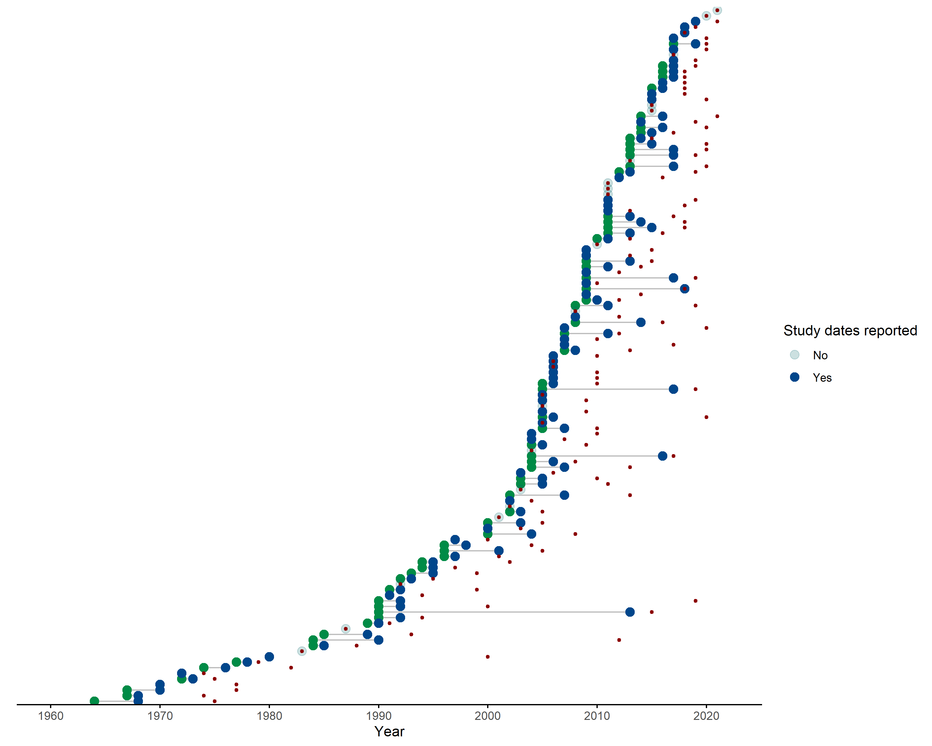

*Figure 1*: Each row represents one of the 126 included studies, green points designate the first year of data collection, blue points designate the end of data collection. For studies completed within one year the blue point completely overlies the green. Studies with a transparent grey point did not report the year in which trapping was conducted. The year of publication is shown by a red point.

## Location and habitats of rodent trapping studies to investigate potential biases

Rodent trapping took place at 1,331 trap sites with at least one trap site recorded from 14 West African countries. No rodent trapping studies were identified from Gambia or Togo. The most frequently studied countries were Senegal, Ghana, Guinea and Nigeria (more than 10 studies each). Fewer than 5 studies were conducted in Liberia, Burkina Faso and Guinea-Bissau. Thirty-one (25%) studies reported trapping at a single study site, 46 (37%) studies trapped at between two and five study sites, the remaining 49 studies trapped at between six and 93 study sites. Trap sites were situated in 273 (19.3%) of 1414 level 2 administrative regions in the 14 West African nations. The areas with highest trap night density included the capital cities of Niger (Niamey), Sierra Leone (Freetown), Senegal (Dakar), Mali (Bamako) and Ghana (Accra) and the largest cities of Côte d’Ivoire (Abidjan) and Benin (Cotonou). Outside of these cities, Northern Senegal (Fatique, Thies, Saint-Louis and Kedougou), Southern Guinea (Kindia and Nzerejore), Edo and Osun States in Nigeria and Eastern Sierra Leone had the highest density of trap nights (Figure 2. A).

Greater numbers of trap nights were conducted in areas with higher population densities (*R2* = 0.18) adjusting for spatial autocorrelation. In particular Mauritania, Northern Senegal, Eastern Sierra Leone, Eastern Guinea and South West Nigeria were trapped at higher rates than would be expected based on their population densities. South West Nigeria, Northern Nigeria, Liberia, Côte d’Ivoire, Ghana, Niger and Burkina Faso were trapped at lower rates than would be expected.

No studies reported trap habitats with reference to a standardised habitat classification scheme. Extracted habitat types were grouped into 30 categories (see Supplementary Material 2 for the habitat dictionary). At least one habitat was recorded for 17,122 trap sites (95%), with two or more habitats for a single trap site recorded for 4,403 (24%) sites. Single trap sites could span multiple habitat types resulting in 22,202 distinct habitat and trap sites. The most commonly trapped sites were in or around buildings (29%), in areas described as the rodents “natural habitat” (24%), in agricultural areas (13%) (e.g. rice fields, palm plantations), forests (8%) and in the area surrounding buildings (4%).



*Figure 2*: **Panel A:** Map of West Africa, countries where rodent trapping has occurred are mapped to level 2 administrative areas (where available). These regions are coloured by the total number of trap nights performed at trap sites within their boundaries. **Panel B:** (n.b. will not include map in final manuscript) The number of trap nights conducted is associated with a regions population density. The population density for all regions in West Africa is shown in the yellow box plot, the population density and trap night density for each region is show on the purple scatterplot. The line of best fit is a GAM model not incorporating spatial interactions. The map panel on the right is the product of the GAM model incorporating spatial interactions. **Panel C:** For each of the 10 land cover classes from the ESA dataset we measure the proportion of 300m2 pixels within a level 2 administrative area. Zoonotic trapping studies occurred in regions over-representative for Cropland, Mosaic landscapes and Shrubland while being under-representative for Bare and Sparse vegetation land cover classes.

## Rodent presence, absence, abundance

73,164 small mammals were trapped (592 were trapped outside of West African countries), 2,830 (4%) trapped individuals were identified to order level (Rodentia), 7,760 (11%) were identified to genus level, the remaining 62,574 (85%) were identified to species level. In studies reporting the number of trap nights the median trap success rate of traps placed in or around buildings was 13% (IQR 6-24%), this compares to a median trap success rate of 3% (IQR 1-9%) in other habitats. The majority of the 147 species trapped were Rodentia (112) (Supplementary Material 3), of these Muridae (82) were the largest family of rodents, followed by, Sciuridae (10), Gliridae and Nesomyidae (both 6), Ctenodactylidae, Anomaluridae, Dipodidae, Hystricidae and Thryonomidae (2 or fewer). The remaining 34 species were from the orders of Soricomorpha (30), Erinaceomorpha (2) and Afrosoricida (1).

*Mastomys sp.* were the most commonly trapped genus (27,079, 37.7%), followed by, *Rattus sp.* (11,472, 16.1%), *Mus sp.* (8,624, 12.0%), *Arvicanthis sp.* (5,821, 8.1%) and *Praomys sp.* (5,409, 7.5%). *Mastomys natalensis* were the most commonly trapped species (11,116, 17.4%), followed by, *Rattus rattus* (9,959, 15.6%), *Mastomys erythroleucus* (7,386, 11.6%), *Mus musculus* (6,245, 9.8%), *Arvicanthis niloticus* (5,497, 8.6%), *Mastomys huberti* (4,699, 7.4%) and *Praomys daltoni* (1,854, 2.9%).

Locations of points for the presence or absence of the seven most commonly trapped species are shown in Figure 3 (left column). Absence include true absences and pseudo-absences dependent on the trapping effort at the site. This are shown compared to species presence obtained from GBIF (centre column) and IUCN species range data (left column) (Figure 3).

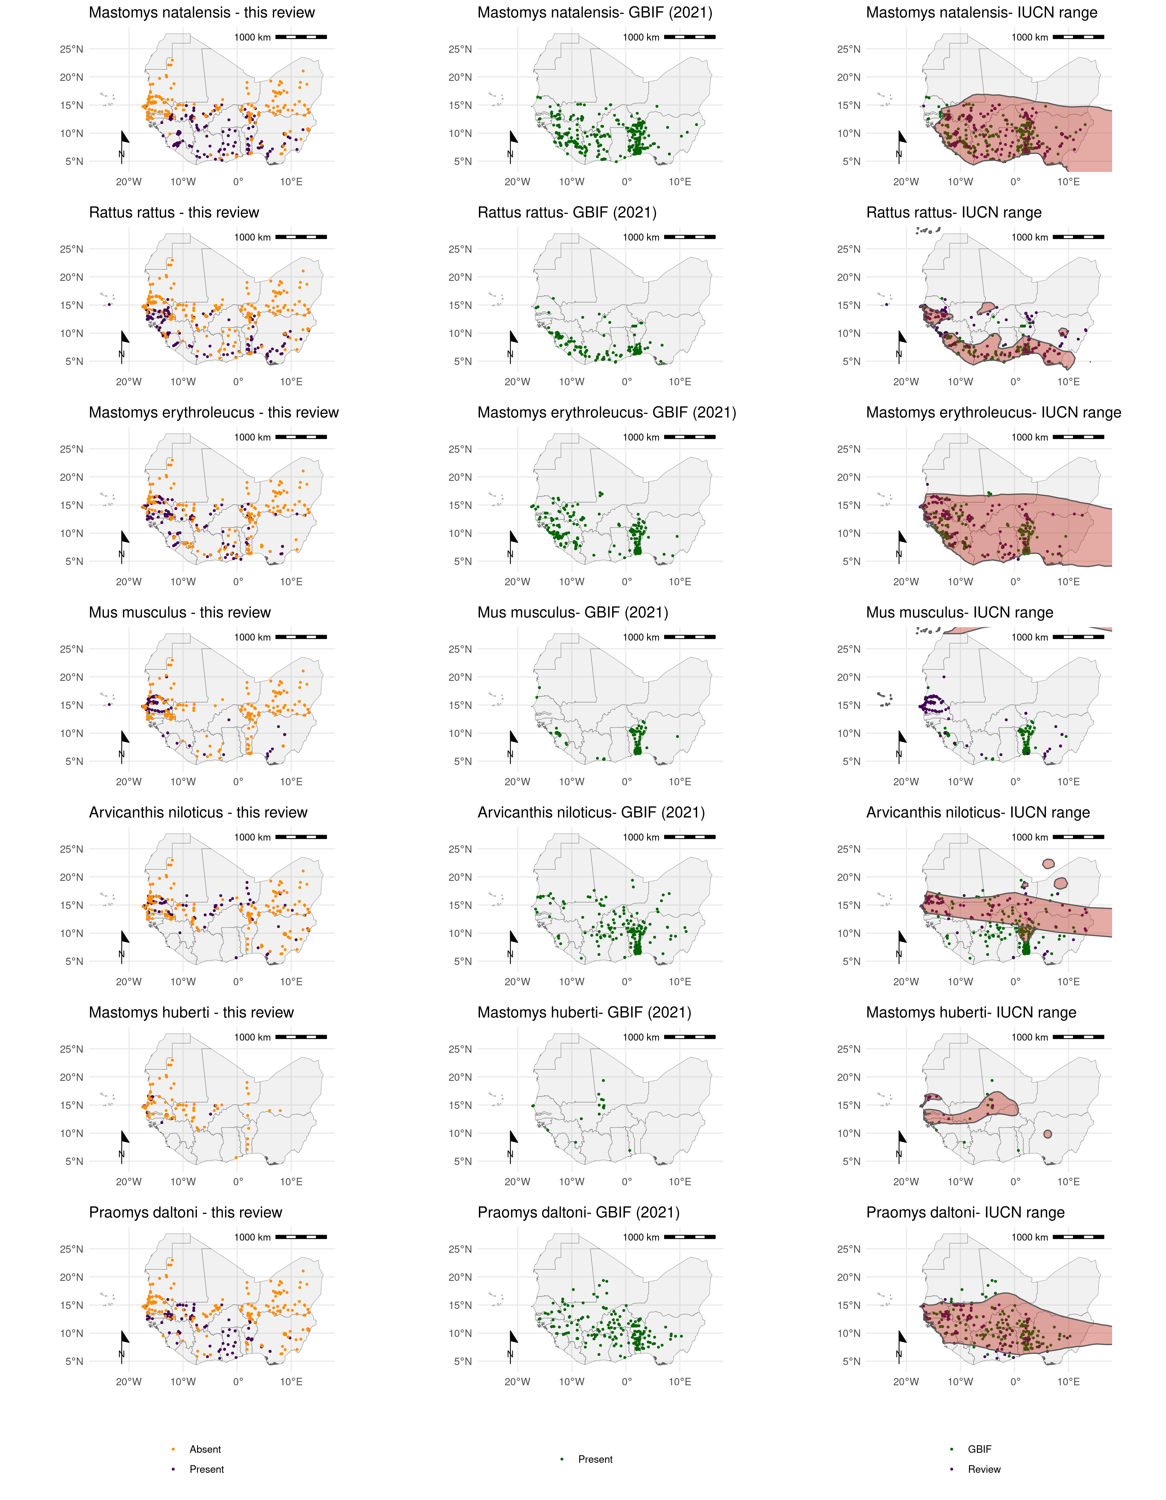

*Figure 3*: Each row corresponds to a single rodent species. The column on the left shows the presence and absence of a rodent species from the individual studies included in this review. The centre column shows the presence of a rodent species obtained from GBIF (September 2021) for records where longitude and latitude have been provided. The right column shows the range of rodent species as proposed by the IUCN (2021) (red shaded area), overlaid are the presence points from both this review and GBIF records.

## Pathogen presence and absence

Sixty-two studies presented data on microorganisms that infect or are carried by small mammal species in West Africa. Seven studies solely investigated pathogens of rodents, including Hydatigera species (previously Taenia species) and Trichuris species. Zoonotic pathogens and potentially zoonotic micro-organisms were investigated in 55 studies. Thirty-two microorganisms were tested for, 8 of these were specified to species level, the remaining 24 were specified at higher taxonomic classifications.

Polymerase Chain Reaction (PCR) was used in 32 studies to detect the presence of 22 different species or families of microorganisms from 21,953 rodent samples. The most common microorganisms assayed for using PCR were *Lassa mammarenavirus* or other Arenaviridae (31%) the bacteria *Borrelia sp.* (11.3%) and *Bartonella sp.* (6.5%), followed by Usutu virus (6.4%) and Hantaviridae (5.6%). Molecular tests (antibody or antigen based) were used in 11 studies to detect the presence of 9 different species or families of microorganisms from 11,430 rodent samples. The most common pathogens assessed for with serology were *Lassa mammarenavirus* or other Arenaviridae (78%), *Toxoplasma gondii* (10.6%), *Borrelia sp.* (6.3%) and *Leptospirosis sp.* (2.2%). Histological or direct visualisation assays were used in 8 studies investigating 11 parasitic or bacterial species from 11,229 rodent samples. The most common pathogens assessed for with histology or direct visualisation were *Borrelia sp.* (48.7%), *Schistosoma sp*. (20.4%) and other parasites. Direct culture of *Lassa mammarenavirus* or Leishmania species were reported from 3 studies to detect the presence of these pathogen in 643 rodent samples.

Most studies tested for a single microorganisms (39), 16 studies tested for two or more microorganisms. The most frequently investigated microorganisms were *Lassa mammarenavirus* (17 studies) or members of the Arenaviridae family (10), the spirochete bacteria *Borrelia sp.* (8), *Bartonella sp.* and *Toxoplasma gondii* (4), the remaining 25 microorganisms were reported in three or fewer studies.

The location of trapped rodents that were tested for the four most commonly assayed microorganisms did not encompass the entire range of these hosts. The presence and absence of Arenaviridae, predominantly *Lassa mammarenavirus*, in rodents was investigated in Benin, Côte d’Ivoire, Guinea, Mali, Nigeria and Sierra Leone. No studies investigated the prevalence of these pathogens in hosts from Burkina-Faso, Guinea-Bissau, Liberia, Niger, Senegal and Togo. Arenaviridae were detected in rodents from 17 of 54 species or genera assayed in all the countries it was investigated except Benin (Figure 4 top row). The presence and absence of *Bartonella sp.* was investigated in Mali and Nigeria and Senegal with positive samples detected in 11 of 11 species or genera of rodents obtained at most sites from these countries (Figure 4 second row). The presence and absence of *Borrelia sp.* was investigated in Benin, Mali, Mauritania, Niger and Senegal. *Borrelia sp.* were detected in 8 of 44 species or genera of rodents assayed in Mali with negative samples obtained from Benin, Mauritania, Niger and Senegal (Figure 4 third row). The presence of *Toxoplasma gondii* was only investigated in Senegal and was detected in 6 of 8 rodent species assayed (Figure 4 fourth row).

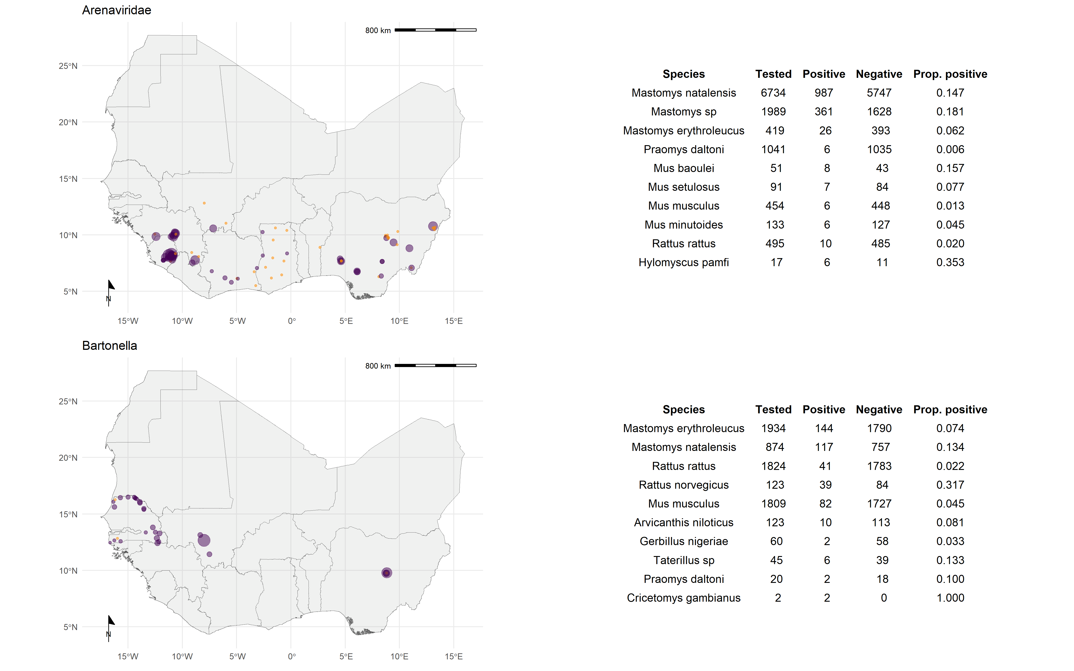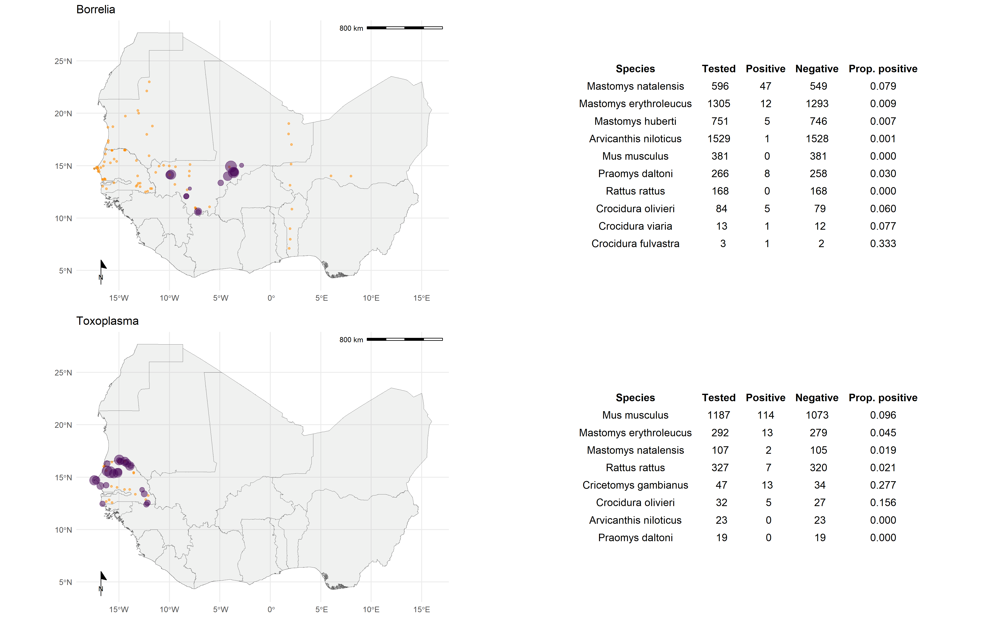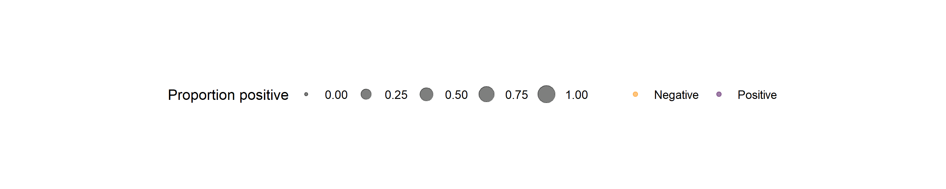

*Figure 4*: Presence/absence plots at each unique trapping site for the four most commonly assayed microorganisms Arenaviridae (top), *Bartonella sp.* (second row), *Borrelia sp.* (third row) and *Toxoplasma gondii* (fourth row). The tables to the right of each map highlight the 10 (or number applicable) most commonly positive and tested rodent species and genera assayed.

## Host-pathogen associations

Ninety-seven rodent species were investigated for the presence of a zoonotic pathogen, 42,940 assays were performed on 32,014 individual rodent samples. The rodent species most commonly assayed for zoonotic pathogens were, *Rattus rattus* (n = 2,977) assessed for 24 pathogens, *Mus musculus* (n = 3,402) for 23, *Mastomys natalensis* (n = 7,189) and *Mastomys erythroleucus* (n = 3,013) both 19 and *Arvicanthis niloticus* (n = 3,840) for 18. All remaining species were investigated for 10 or fewer pathogens.

*Lassa mammarenavirus* was detected in 14 species of rodents and Crocidura genera. *Mastomys natalensis* was the most common species to test positive (Figure 4.). Fifty-four species and genera were tested for arenaviruses, with 37 testing negative. *Bartonella sp.* infections were identified in all 11 species of rodents and shrews that were tested. *Mastomys erythroleucus* was the most common species to test positive. *Borrelia sp.* infections were identified in 13 species of rodents and shrews. *Mastomys natalensis* was the most common species to test positive. Forty-four species and genera were tested for *Borrelia sp.* with 36 testing negative. *Toxoplasma gondii* was detected in 6 species of rodents and shrews, with all individuals from two species *Arvicanthis niloticus* and *Praomys daltoni* testing negative. *Mus musculus* was the most common species to test positive. Finally, 38 species of Rodentia, 3 species of Soricomorpha and 2 species of Erinaceomorpha that were tested for pathogens had entirely negative results.

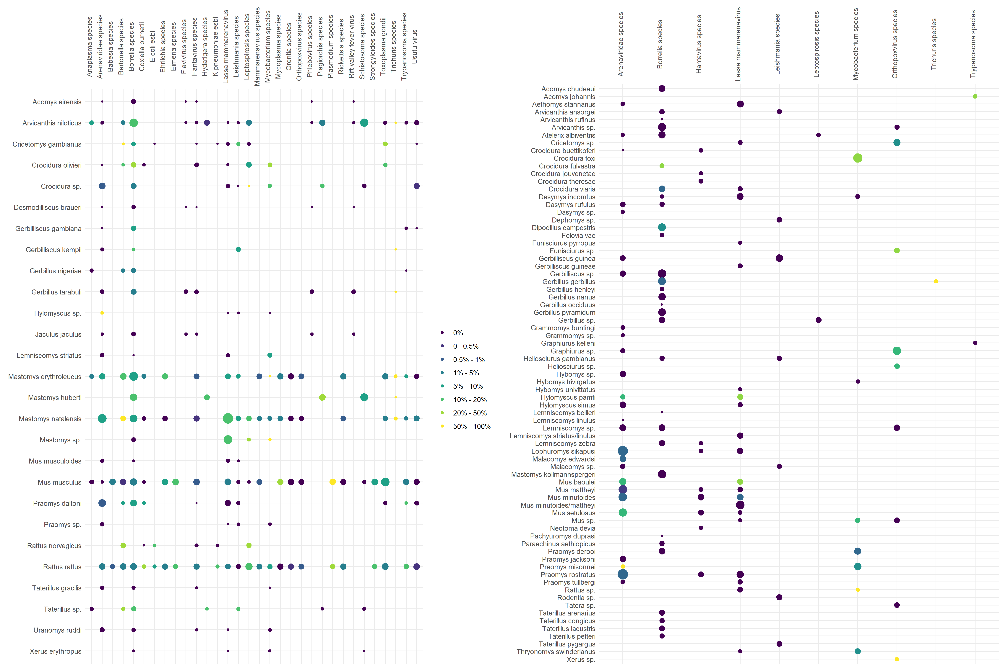

*Figure 5*: The percentage of assays from each included species and microorganism tested for is represented by colour. The size of a point relates to the square-root of the number of individuals assayed. The plot on the left is for species/genera assayed for four or more microorganisms, the plot on rights are for species/genera assayed for 3 or less microorganisms.

# Discussion

We identified 124 rodent trapping studies conducted in the West African region since 1965. These studies were conducted in 14 countries with 54 studies providing information about zoonotic pathogens in trapped rodents. Studies were conducted in all West African countries except Gambia and Togo with between- and within-country variability to the number of trap nights. Over 70,000 rodents identified to genus or species level were trapped from 112 species of Rodentia. Thirty-two potential pathogens were investigated across all studies, with 5 rodent species assayed for at least 18 potential pathogens. We identify important biases in the reporting of studies, the locations in which they’ve been conducted, the species investigated and the detection of pathogens of interest.

First, timing and location.

Second, reporting of presence and absence.

Third, pathogens assayed for.

Finally, host-pathogen associations.

## Implications

## Limitations

## Future research

# Conclusion

Albery, Gregory F., and Daniel J. Becker. 2021. “Fast-Lived Hosts and Zoonotic Risk.” *Trends in Parasitology* 37 (2): 117–29. <https://doi.org/10.1016/j.pt.2020.10.012>.

Allen, Toph, Kris A. Murray, Carlos Zambrana-Torrelio, Stephen S. Morse, Carlo Rondinini, Moreno Di Marco, Nathan Breit, Kevin J. Olival, and Peter Daszak. 2017. “Global Hotspots and Correlates of Emerging Zoonotic Diseases.” *Nature Communications* 8 (1): 1124. <https://doi.org/10.1038/s41467-017-00923-8>.

Bovendorp, Ricardo S., Robert A. MCCleery, and Mauro Galetti. 2017. “Optimising Sampling Methods for Small Mammal Communities in Neotropical Rainforests.” *Mammal Review* 47 (2): 148–58. <https://doi.org/10.1111/mam.12088>.

Catalano, Stefano, Elsa Leger, Cheikh B. Fall, Anna Borlase, Samba D. Diop, Duncan Berger, Bonnie L. Webster, et al. 2020. “Multihost Transmission of Schistosoma Mansoni in Senegal, 2015-2018.” *Emerging Infectious Diseases* 26 (6): 1234–42. <https://doi.org/10.3201/eid2606.200107>.

Dobson, F Stephen, and Madan K Oli. 2007. “Fast and Slow Life Histories of Rodents.” *Rodent Societies: An Ecological and Evolutionary Perspective*, 99–105. <https://www.jstor.org/stable/42902037>.

Fichet-Calvet, Elisabeth, Emilie Lecompte, Frederic Veyrunes, Patrick Barrière, Violaine Nicolas, and Kékoura Koulémou. 2009. “Diversity and Dynamics in a Community of Small Mammals in Coastal Guinea, West Africa.” *Belgian Journal of Zoology* 139 (2): 93–102. <http://www.vliz.be/nl/open-marien-archief?module=ref&refid=204614>.

Fischer, Christina, Christoph Gayer, Kornélia Kurucz, Friederike Riesch, Teja Tscharntke, and Péter Batáry. 2018. “Ecosystem Services and Disservices Provided by Small Rodents in Arable Fields: Effects of Local and Landscape Management.” *Journal of Applied Ecology* 55 (2): 548–58. <https://doi.org/10.1111/1365-2664.13016>.

García-Peña, Gabriel E., André V. Rubio, Hugo Mendoza, Miguel Fernández, Matthew T. Milholland, A. Alonso Aguirre, Gerardo Suzán, and Carlos Zambrana-Torrelio. 2021. “Land-Use Change and Rodent-Borne Diseases: Hazards on the Shared Socioeconomic Pathways.” *Philosophical Transactions of the Royal Society B: Biological Sciences* 376 (1837): 20200362. <https://doi.org/10.1098/rstb.2020.0362>.

GBIF: The Global Biodiversity Information Facility. 2021. “The Global Biodiversity Information Facility.” <https://www.gbif.org/>.

Gibb, Rory, Gregory F. Albery, Nardus Mollentze, Evan A. Eskew, Liam Brierley, Sadie J. Ryan, Stephanie N. Seifert, and Colin J. Carlson. 2021. “Mammal Virus Diversity Estimates Are Unstable Due to Accelerating Discovery Effort.” Preprint. Ecology. <https://doi.org/10.1101/2021.08.10.455791>.

Gibb, Rory, David W. Redding, Kai Qing Chin, Christl A. Donnelly, Tim M. Blackburn, Tim Newbold, and Kate E. Jones. 2020. “Zoonotic Host Diversity Increases in Human-Dominated Ecosystems.” *Nature* 584 (7821): 398–402. <https://doi.org/10.1038/s41586-020-2562-8>.

Han, Barbara A., Andrew M. Kramer, and John M. Drake. 2016. “Global Patterns of Zoonotic Disease in Mammals.” *Trends in Parasitology* 32 (7): 565–77. <https://doi.org/10.1016/j.pt.2016.04.007>.

Han, Barbara A., John Paul Schmidt, Sarah E. Bowden, and John M. Drake. 2015. “Rodent Reservoirs of Future Zoonotic Diseases.” *Proceedings of the National Academy of Sciences* 112 (22): 7039–44. <https://doi.org/10.1073/pnas.1501598112>.

Hassell, James M., Michael Begon, Melissa J. Ward, and Eric M. Fèvre. 2017. “Urbanization and Disease Emergence: Dynamics at the Wildlife–Livestock–Human Interface.” *Trends in Ecology & Evolution* 32 (1): 55–67. <https://doi.org/10.1016/j.tree.2016.09.012>.

Morse, Stephen S, Jonna AK Mazet, Mark Woolhouse, Colin R Parrish, Dennis Carroll, William B Karesh, Carlos Zambrana-Torrelio, W Ian Lipkin, and Peter Daszak. 2012. “Prediction and Prevention of the Next Pandemic Zoonosis.” *The Lancet* 380 (9857): 1956–65. <https://doi.org/10.1016/S0140-6736(12)61684-5>.

Pigott, David M, Nick Golding, Adrian Mylne, Zhi Huang, Andrew J Henry, Daniel J Weiss, Oliver J Brady, et al. 2014. “Mapping the Zoonotic Niche of Ebola Virus Disease in Africa.” *eLife* 3 (September): e04395. <https://doi.org/10.7554/eLife.04395>.

Smith, Katherine F., Michael Goldberg, Samantha Rosenthal, Lynn Carlson, Jane Chen, Cici Chen, and Sohini Ramachandran. 2014. “Global Rise in Human Infectious Disease Outbreaks.” *Journal of The Royal Society Interface* 11 (101): 20140950. <https://doi.org/10.1098/rsif.2014.0950>.

USAID. 2021. “One Health Surveillance.” *PREDICT Project*. <https://p2.predict.global/surveillance>.

Wille, Michelle, Jemma L. Geoghegan, and Edward C. Holmes. 2021. “How Accurately Can We Assess Zoonotic Risk?” Edited by Andy P. Dobson. *PLOS Biology* 19 (4): e3001135. <https://doi.org/10.1371/journal.pbio.3001135>.