Associations of environmental and human factors with altered rodent populations in West Africa: A scoping review

2021-03-29

## Introduction

Rodents (Rodentia) are abundant and diverse, representing around 40% of the total number of mammalian species (American Society of Mammologists 2021). Rodents typically demonstrate ‘fast’ life history strategies characterised by early maturation, short generation times, low juvenile and adult survival and high fecundity (Dobson and Oli 2007). There is a degree of between-species heterogeneity, with commensal species and those that are reservoirs of zoonoses having traits consistent with faster life histories (Han et al., 2015). Rodents often compete with humans for food produced in agricultural systems (Fiedler 1988), with 5-10% of rodent species classed as major pests. Commensal species thrive in human adapted landscapes nesting in houses and obtaining nutrition from human food storage and preparation areas. In sub-Saharan Africa, Mastomys spp. and Arvicanthis spp. are identified as causing a significant burden as agricultural pests (Stenseth et al. 2003). Crop loss within Afro-Malagasy small-holder farming communities is high, with 15% of pre-harvest crop being lost to rodent pest activity (Swanepoel et al. 2017).

Another important issue is the transmission of infectious diseases from rodents to humans. Zoonotic diseases (i.e. animal pathogens that impact human health) are transmitted via two pathways – a direct and an indirect pathway. The direct transmission pathway involves transmission of pathogens through rodents biting or scratching a human, or through contamination of food or water sources. The indirect pathway involves rodents acting as amplifying hosts for ectoparasites that themselves are vectors of zoonoses (Meerburg, Singleton, and Kijlstra 2009). Several rodent-borne pathogens are global in their distribution, including bacteria such as Lyme disease (caused by *Borrelia burgdorferi*) and Leptospirosis (caused by *Leptospira spp.*) and parasites such as Toxoplasmosis (caused by *Toxoplasma gondii*) and Leishmaniasis (caused by *Leishmania spp.*). However, most rodent-borne pathogens have more limited geographic distributions, particularly viral diseases such as Hantavirus pulmonary syndrome (caused by Hantaviridae) concentrated in the Americas and Lassa fever (caused by Arenaviridae) limited to West Africa.

Given the significant economic and public health burden of rodents, monitoring rodent distributions is therefore an ongoing focus of research efforts across multiple scientific disciplines, including (but not limited to) conservation science, development studies and infectious disease epidemiology. The distribution of rodent populations can be monitored via rodent trapping efforts, with traps deployed in habitats expected to contain rodent species of interest.

There is increasing interest in the link between environmental and human factors and rodent populations to land use change and human population change. A recent review of studies included in the PREDICTS database (Hudson et al. 2014) identified that land use change from primary (i.e. intact forests) to managed and urban systems is associated with a change in rodent assemblages towards species that are more likely to be hosts of zoonoses (Gibb et al. 2020). *Mastomys natalensis populations* in Tanzania, East Africa are sensitive to seasonal meteorological cycles, in years with below average rainfall and short wet seasons population density is lower (Makundi, Massawe, and Mulungu 2007). Future climate change projections include longer and wetter West African monsoon seasons which could lead to increased zoonotic disease host rodent populations (Akinsanola and Zhou 2019). As West Africa contains several known rodent zoonotic reservoirs (e.g. *Mastomys natalensis* and *Arvicanthus niloticus*) and several potential reservoirs of zoonotic diseases (e.g. *Lemniscomys striatus*), this will be the geographic region of interest in this work.

To date there has been no comprehensive overview of rodent trapping studies conducted in West Africa. The aim of this scoping review is therefore to synthesise the knowledge on rodent distributions throughout West Africa obtained from trapping studies.

We specifically aim to address the following research questions :

* RQ1: In which West African countries or regions have rodent trapping studies been performed?
* RQ2: What are the stated aims of these rodent trapping studies?
* RQ3: Which rodent species are being targeted for trapping activities? Are species with high potential for hosting zoonotic pathogens targeted at higher rates?
* RQ4: How is the type of land use and/or land use intensity classified in the literature and are classifications comparable across studies?
* RQ5: Is rodent trapping occurring in all habitat types or are some habitats targeted at higher rates?
* RQ6: Is there an association of land use change, human population change or the implementation of regulatory strategies with rodent species distributions?

## Methods

### Study design

* Scoping review
* Protocol pre-registered on the [Openscience Framework](...)

### Eligibility criteria

* Studies were included if:
  + Trapping of small mammals including at least one species of Rodentia.
  + Descriped trap used, length of trapping activity or location of trapping activity.
  + Included trapping activity from at least one West African country: Benin, Burkina-Faso, Cape Verde, Gambia, Ghana, Guinea, Guinea-Bissau, Cote d’Ivoire, Liberia, Mali, Mauritania, Niger, Nigeria, Senegal, Sierra Leone and Togo
  + Recorded as outcome genus or species of trapped individual
  + Were available in English
  + Published in a peer-reviewed journal, a pre-print manuscript or a report by a an identifiable organisation/consultancy
* Studies were excluded if:
  + Data were duplicated from a previously included study (i.e. secondary data analysis)
  + No full text were available

### Search strategy

The following terms were searched for in OVID Medline, Web of Science (Core collection and Zoological Record), JSTOR, BioOne, African Journals Online, Global Health and the pre-print servers BioRxiv and EcoEvoRxiv:

1. Rodent
2. West Africa
   1. AND 2.

Other resources including the UN Official Documents System, Open Grey, AGRIS FAO and Google Scholar were searched using combinations of the following terms:

1. Rodent
2. Rodent Trap*
3. West Africa

Additional articles were identified through references within included articles and reports known to the study team. Searches were completed on 2021-03-01.

### Selection of studies

One reviewer screened titles, abstracts and full texts against the inclusion criteria. A random subset of each of these (10%) were reviewed by a second reviewer.

### Data extraction

Data were extracted by one reviewer. A second reviewer verified a subset (10%) of included studies. A data extraction form was maintained on a Google sheets document. Data extracted included i) study identifiers; ii) study aims; iii) trapping methodology; iv) geolocation data; v) method of speciation; vi) trapping locations and dates; vii) trapped species; viii) number of trap-nights and ix) microorganisms of interest.

### Study aims

Where explicitly stated the study aims were extracted. For those with no recorded aims the specific aims were inferred from the background or conclusions of manuscript or report. The aims of the studies were broadly categorised as pertaining to rodent ecology research or studies on risk of zoonoses and further categorised into detailed aims.

### Geolocation of trapping activity

GPS locations were extracted for the most precise location presented i.e. trap, trap-line, study-site or study region. Locations were extracted in the format reported and converted to decimal degrees. Where no GPS location is reported coordinates will be matched to study locations using the National Geospatial Intelligence Agency NGA GEOnet Names Server [ref.] based on study site name/region and through maps presented in the manuscript.

### Trapping methodology

The brand or description of the rodent trap was obtained from each study. For those using multiple devices all types were recorded. Type of trapping method. Effort of trapping

### Habitat classification

### Genus and species definitions

Classification of species is variable over time as morphological and genetic information emerges. To handle species classification synonyms and reclassification the reported names of trapped species was compared to the Global Biodiversity Information Facility [ref.]. For species with updated taxonomies the synonym was converted to the accepted species name for all subsequent analyses. Where a subspecies is reported by study authors the species complex it belongs to will be used for subsequent analysis.

### Pathogen testing

## Results

A total of 2,200 records were identified, with 101 studies included in narrative synthesis (see Figure @ref(fig:prisma)). The characteristics of the included studies are shown in Table 1. The earliest studies identified were from 1974 with the majority (62%) published since 2010. Most of the included studies were classified as rodent ecology research (54%) with the remainder of studies on zoonotic diseases (46%).

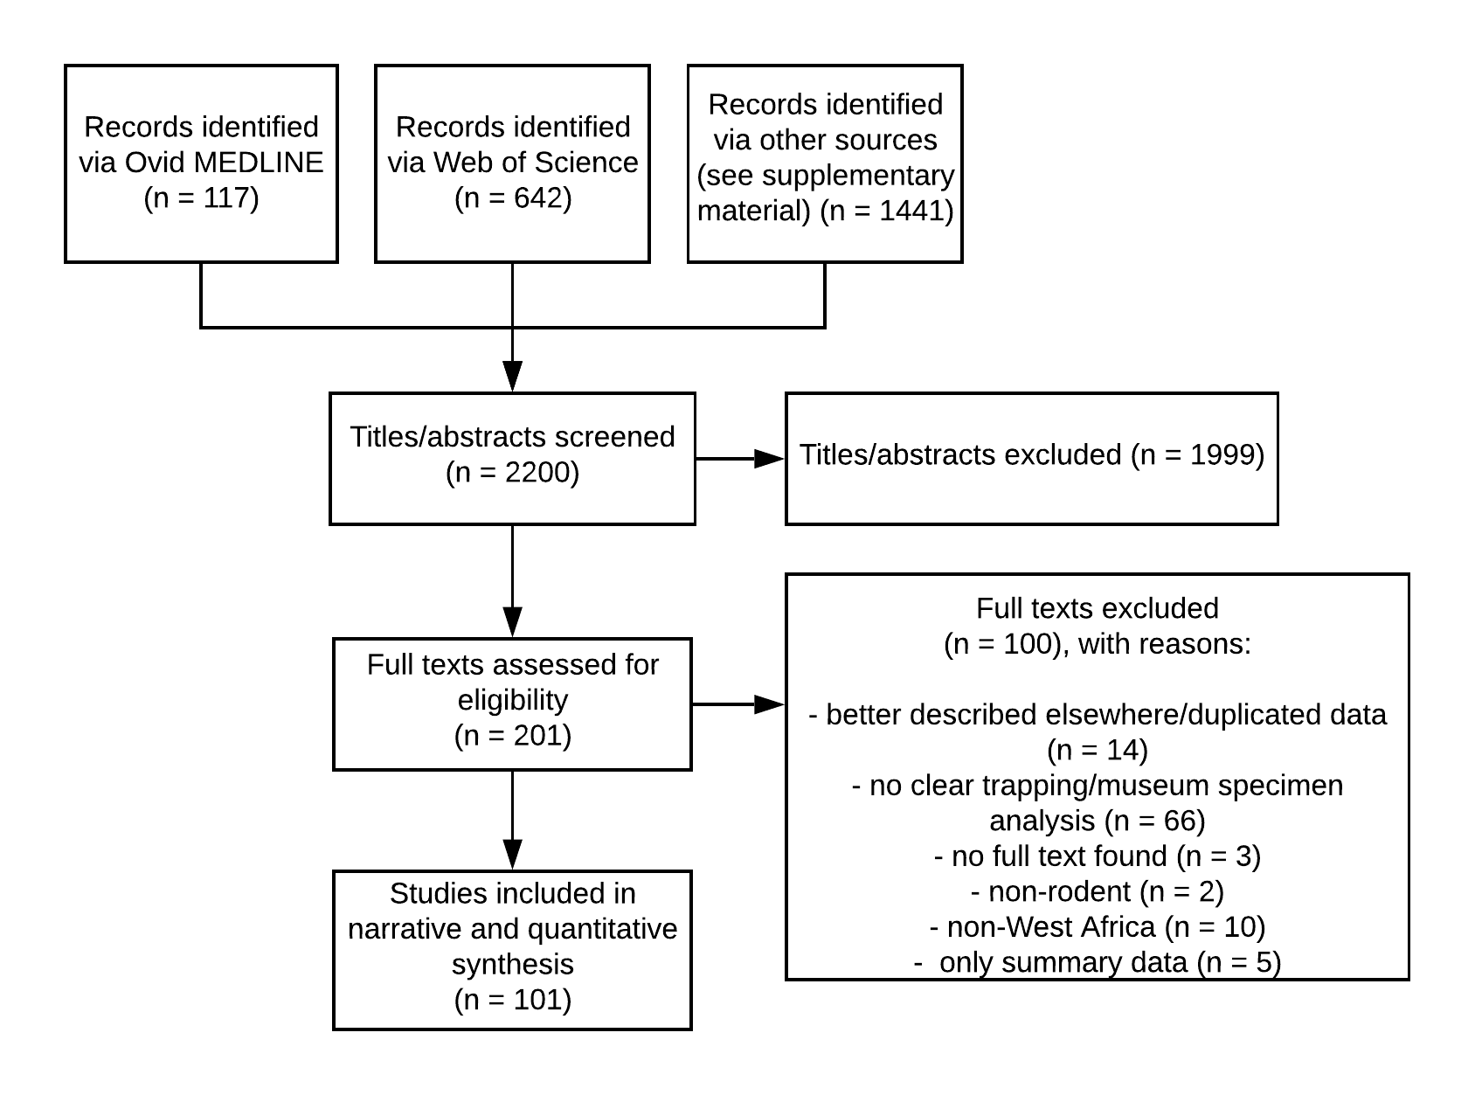

Flow diagram of records returned from the search strategy. Reasons for exclusion of studies at the full text stage are given.

### Aims of included studies

The detailed aims of the included studies are shown following division into the themes of ecological or zoonosis research. Biodiversity of rodents was a shared aim between the two themes with 37 ecological studies and 2 zoonoses studies investigating this. The remaining aims were more disparate with ecological studies investigating rodent population dynamics, rodent species assemblages, the genetics of rodents and their behaviours. Most zoonotic disease research focussed on prevalence of pathogens in rodent populations, the risk of spillover to human populations, the identity of pathogen reservoir species with fewer studies investigating the phylogenetics of pathogen strains (see Figure @ref(fig:aims).

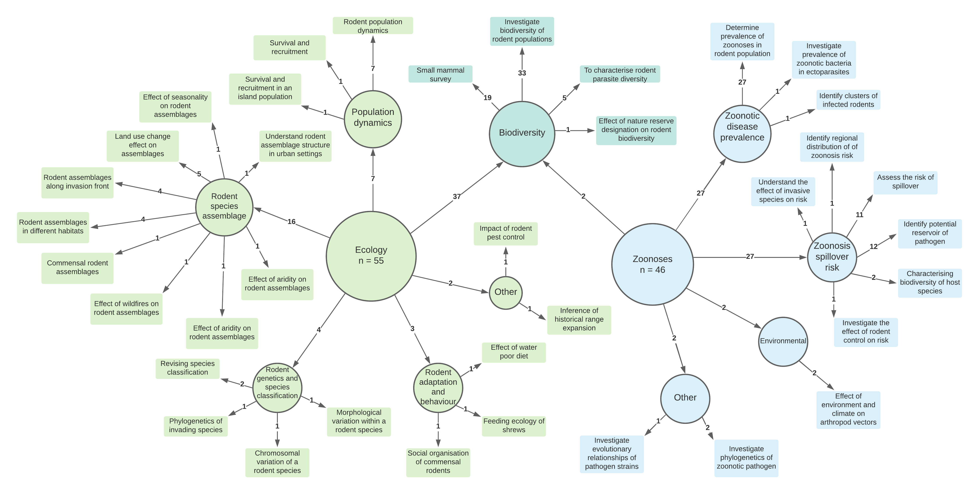

The aims of included studies following division into ecological and zoonotic infectious disease themes. Multiple aims were identified from each study, the number on the arrow indicates the number of distinct studies with that aim

### Location of studies

The included studies trapped in 16 countries, however, three countries were outside of the scope of this study (Cameroon, Chad and Morocco). At least a single trap site was recorded from 13 West African countries, with no rodent trapping reported from Gambia, Cape Verde or Togo.

Most studies (95%) were conducted in a single country, three studies were conducted in two countries, three studies were conducted in five countries and one study was conducted across six countries. This lead to 124 trapping activities being reported across the 13 West African countries. More trapping activity was reported from Senegal (20%) than any other country. Ghana (12%) and Guinea (12%) were the next most frequently trapped countries, followed by Nigeria (9%), Benin, Mali and Niger (7%), Sierra Leone (6%), Mauritania and the Ivory Coast (4%), Burkina Faso and Liberia (2%), Guinea-Bissau had a single recorded trapping activity.

The trapping activity from the included studies was spread across 1,171 study sites. Twenty-four (24%) studies reported trapping only occurring at a single study site, 34 (33%) studies trapped at between two and five study sites the remaining 44 studies trapped at between six and 93 study sites. Trap sites were mapped to level one country administrative regions and density of sites per million square kilometers was calculated (see Figure @ref(fig:density)). The areas with highest trapping densities included the capital cities of Niger, Sierra Leone, Senegal, Benin, Mali, Ghana and the Ivory Coast. Of the areas not incorporating capital cities Northern Senegal (Fatique, Thies, Saint-Louis and Kedougou), Southern Guinea (Kindia and Nzerejore) and Eastern Sierra Leone were most intensively studied. Mapping to level two administrative regions is displayed in Supplementary figure @ref(fig:supfig1).

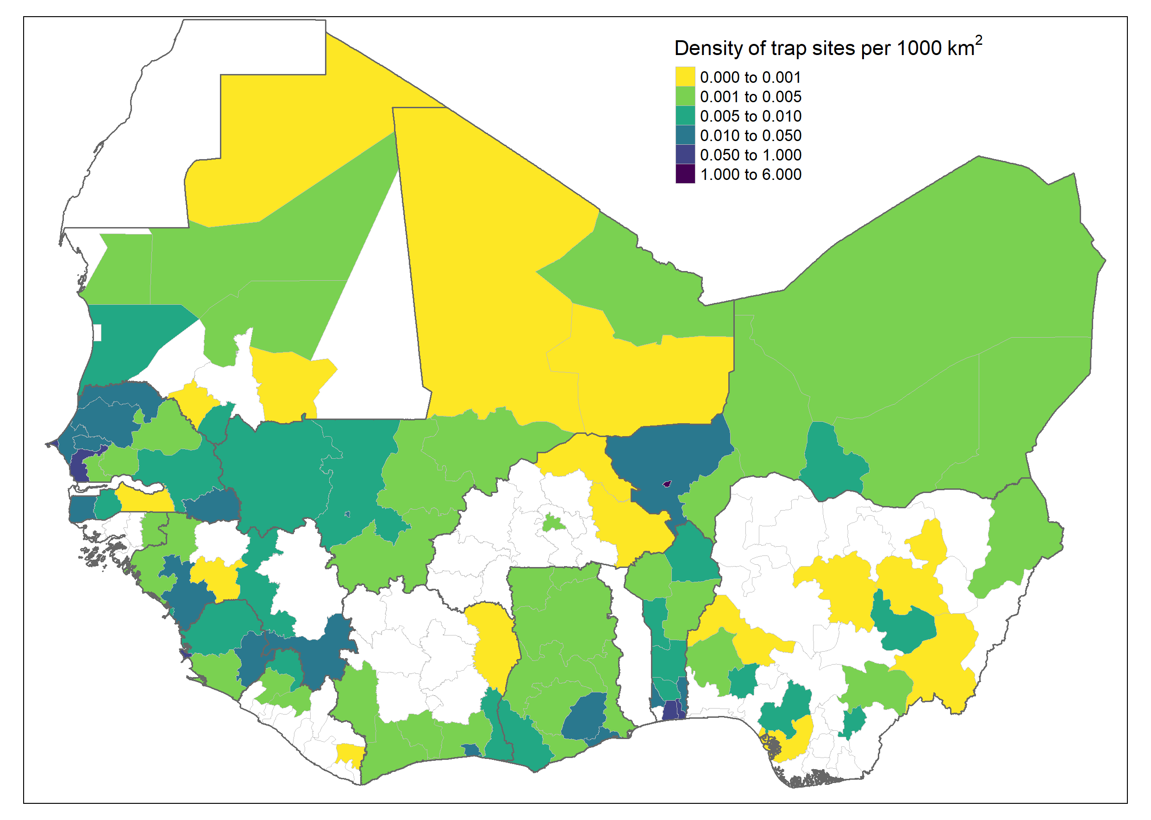

Density of trap sites per thousand km2

### Trap types

Of the included studies 15 did not state the type of trap used with three studies reporting supplementary hand trapping of rodents alongside trap use. For the remaining studies three used more than four types of rodent traps, seven used three types, 31 used two types the remaining 45 studies used a single trap type. The most commonly used trap was the Sherman trap (67%) [ref.] which is available in several sizes, locally made wire mesh traps were used in 29 studies (34%), less commonly used trap types included the Museum special, Tomahawk, Victor, Snaptraps and Firobind traps.

### Trap setup within the study area

Thirty-three studies did not describe the structure of the trap setup within the defined study area. Twenty five studies placed transect lines of traps through study sites with thirteen studies placing traps along a line but not clearly describing a transect across a defined site. Sixteen studies purposefully sampled houses, with four further studies purposefully placing traps in targeted locations (i.e. near rivers, in fields, by houses). Nine studies placed traps in a structured grid across a single or multiple specified habitat types. Three studies described a stratified or randomised approach to placing traps within a defined area. Trap setup was commonly reported in ecology studies (80%) with transect lines the most commonly used approach. Trap setup was reported in 53% of zoonoses risk studies with purposeful placement of traps in houses the most common approach (20%).

### Trapping effort

Trapping effort was variably reported across included studies. Thirty studies did not report any measures of trapping effort. Thirty-four studies reported a measure of trapping effort at the same level of detail at which they reported rodent captures (the unit of analysis) and were classified as complete reports. Thirty-seven studies had incomplete reports on trapping effort due to not presenting the number of trap nights at the appropriate unit of analysis (i.e. number of study nights only or total number of trap-nights). Trapping effort was more completely reported from ecology studies (51% complete information and 20% no information) compared to zoonoses risk studies (13% complete information and 41% no information).

Among studies that reported complete trap-night information the median number of trap-nights per study was 4,764 (Interquartile range (IQR) = 1,227-10,477) with a minimum of 240 trap-nights and maximum of 45,274 trap-nights. For studies reporting the number of trap-nights at the unit of analysis (typically study site or habitat type) the median number of trap-nights was 360 (IQR = 246-793). In studies with incomplete reports on trap-nights at the unit of analysis there was a median of 7,893 trap-nights (IQR = 1,401-10,331) conducted, for 21 studies reporting only on the number of days or nights trapping was performed on activities typically lasted between 1-4 nights.

### Habitat classification

No studies classified habitats with reference to a specific habitat classification scheme. Seven studies did not describe the local habitat where traps were placed (3 ecology, 4 zoonoses). The remaining studies used greater than 160 descriptions of the habitat type in which trapping was conducted, further, the resolution of the description ranged from the habitat of the location of the trap through to the study site. The 160 reported habitat types were combined into 32 categories (see Supplementary table 2 for the habitat dictionary) for further analysis. At least one habitat was recorded for 16,168 trap sites (95%), with two or more habitats for a single trap site recorded for 4,195 (26%) sites. Single trap sites could span multiple habitat types resulting in 20,369 habitat or trap sites. The most commonly trapped sites were in or around buildings (31%), in areas described as the rodents “natural habitat” (26%), in agricultural areas (13%) (e.g. rice fields, palm plantations), forests (6%) and within or around villages (5%).

Habitat type was more comprehensively reported from ecology studies, 31 habitat categories were reported from ecology studies with the most commonly investigated habitats being agriculture (23%), in or around buildings (18%) and within forests (15%). Among studies on zoonoses 15 habitat categories were reported, the most commonly reported classification was described as the rodents “natural habitat” (39%), within or around buildings (38%) and in agricultural settings (7%).

### Species identification

Nine included studies did not describe the method used to identify trapped rodents. Most studies (52%) relied solely on morphometric identification against taxonomic keys or museum voucher specimens. Eight studies described molecular identification of rodents with 30% using a combination of morphological and molecular techniques. In more recently published studies (since 2010) 54% used molecular techniques to assist with speciation, compared with less than 16% in studies published before 2010.

### Reported species and species abundance

Across all West African study sites there were 59,343 trapped small mammals (592 were trapped outside of West African countries), 2,830 (4.8%) trapped individuals were identified to order level (Rodentia), 5,329 (9%) were identified to genus level, the remaining 51,184 (86%) were identified to species level. Of the 124 distinct identified species trapped (see Supplementary table 1) the majority were from the order Rodentia (96) with Muridae (79) being the largest family of rodents, followed by Gliridae and Nesomyidae (both 4), Sciuridae (3), Ctenodactylidae (2) and Anomaluridae, Dipodidae, Hystricidae and Thryonomidae (all 1). The remaining 29 species came from the orders of the Soricomorpha (25), Erinaceomorpha (2) and Afrosoricida (1).

More individuals were trapped in studies conducted to investigate the risk of zoonoses (35,892, 60%) than from ecology studies (23,451 40%). Animals trapped as part of ecological research were more often identified to species level (93%) than those trapped in zoonoses research (82%). The most commonly trapped genera of rodents were *Mastomys sp.* (22,665, 39.7%), *Rattus sp.* (7,718, 13.5%), *Mus sp.* (7,324, 12.8%), *Praomys sp.* (4,977, 8.7%) and *Arvicanthis sp.* (4,408, 7.72%). At the species level *Mastomys natalensis* (10,351, 20.2%) and *Mastomys erythroleucus* (7,052, 13.8%) were the most commonly trapped rodents, *Rattus rattus* (6,228, 12.2%), *Mus musculus* (6,030, 11.8%), *Arvicanthis niloticus* (4,086, 8%) and *Mastomys huberti* (3,106, 6.1%) made up the next most commonly trapped species. Presence and absence maps for these six most commonly trapped species are shown in Figure @ref(fig:dist).

Trap success rates

### Rodent biodiversity

Diversity indices, accumulation measures

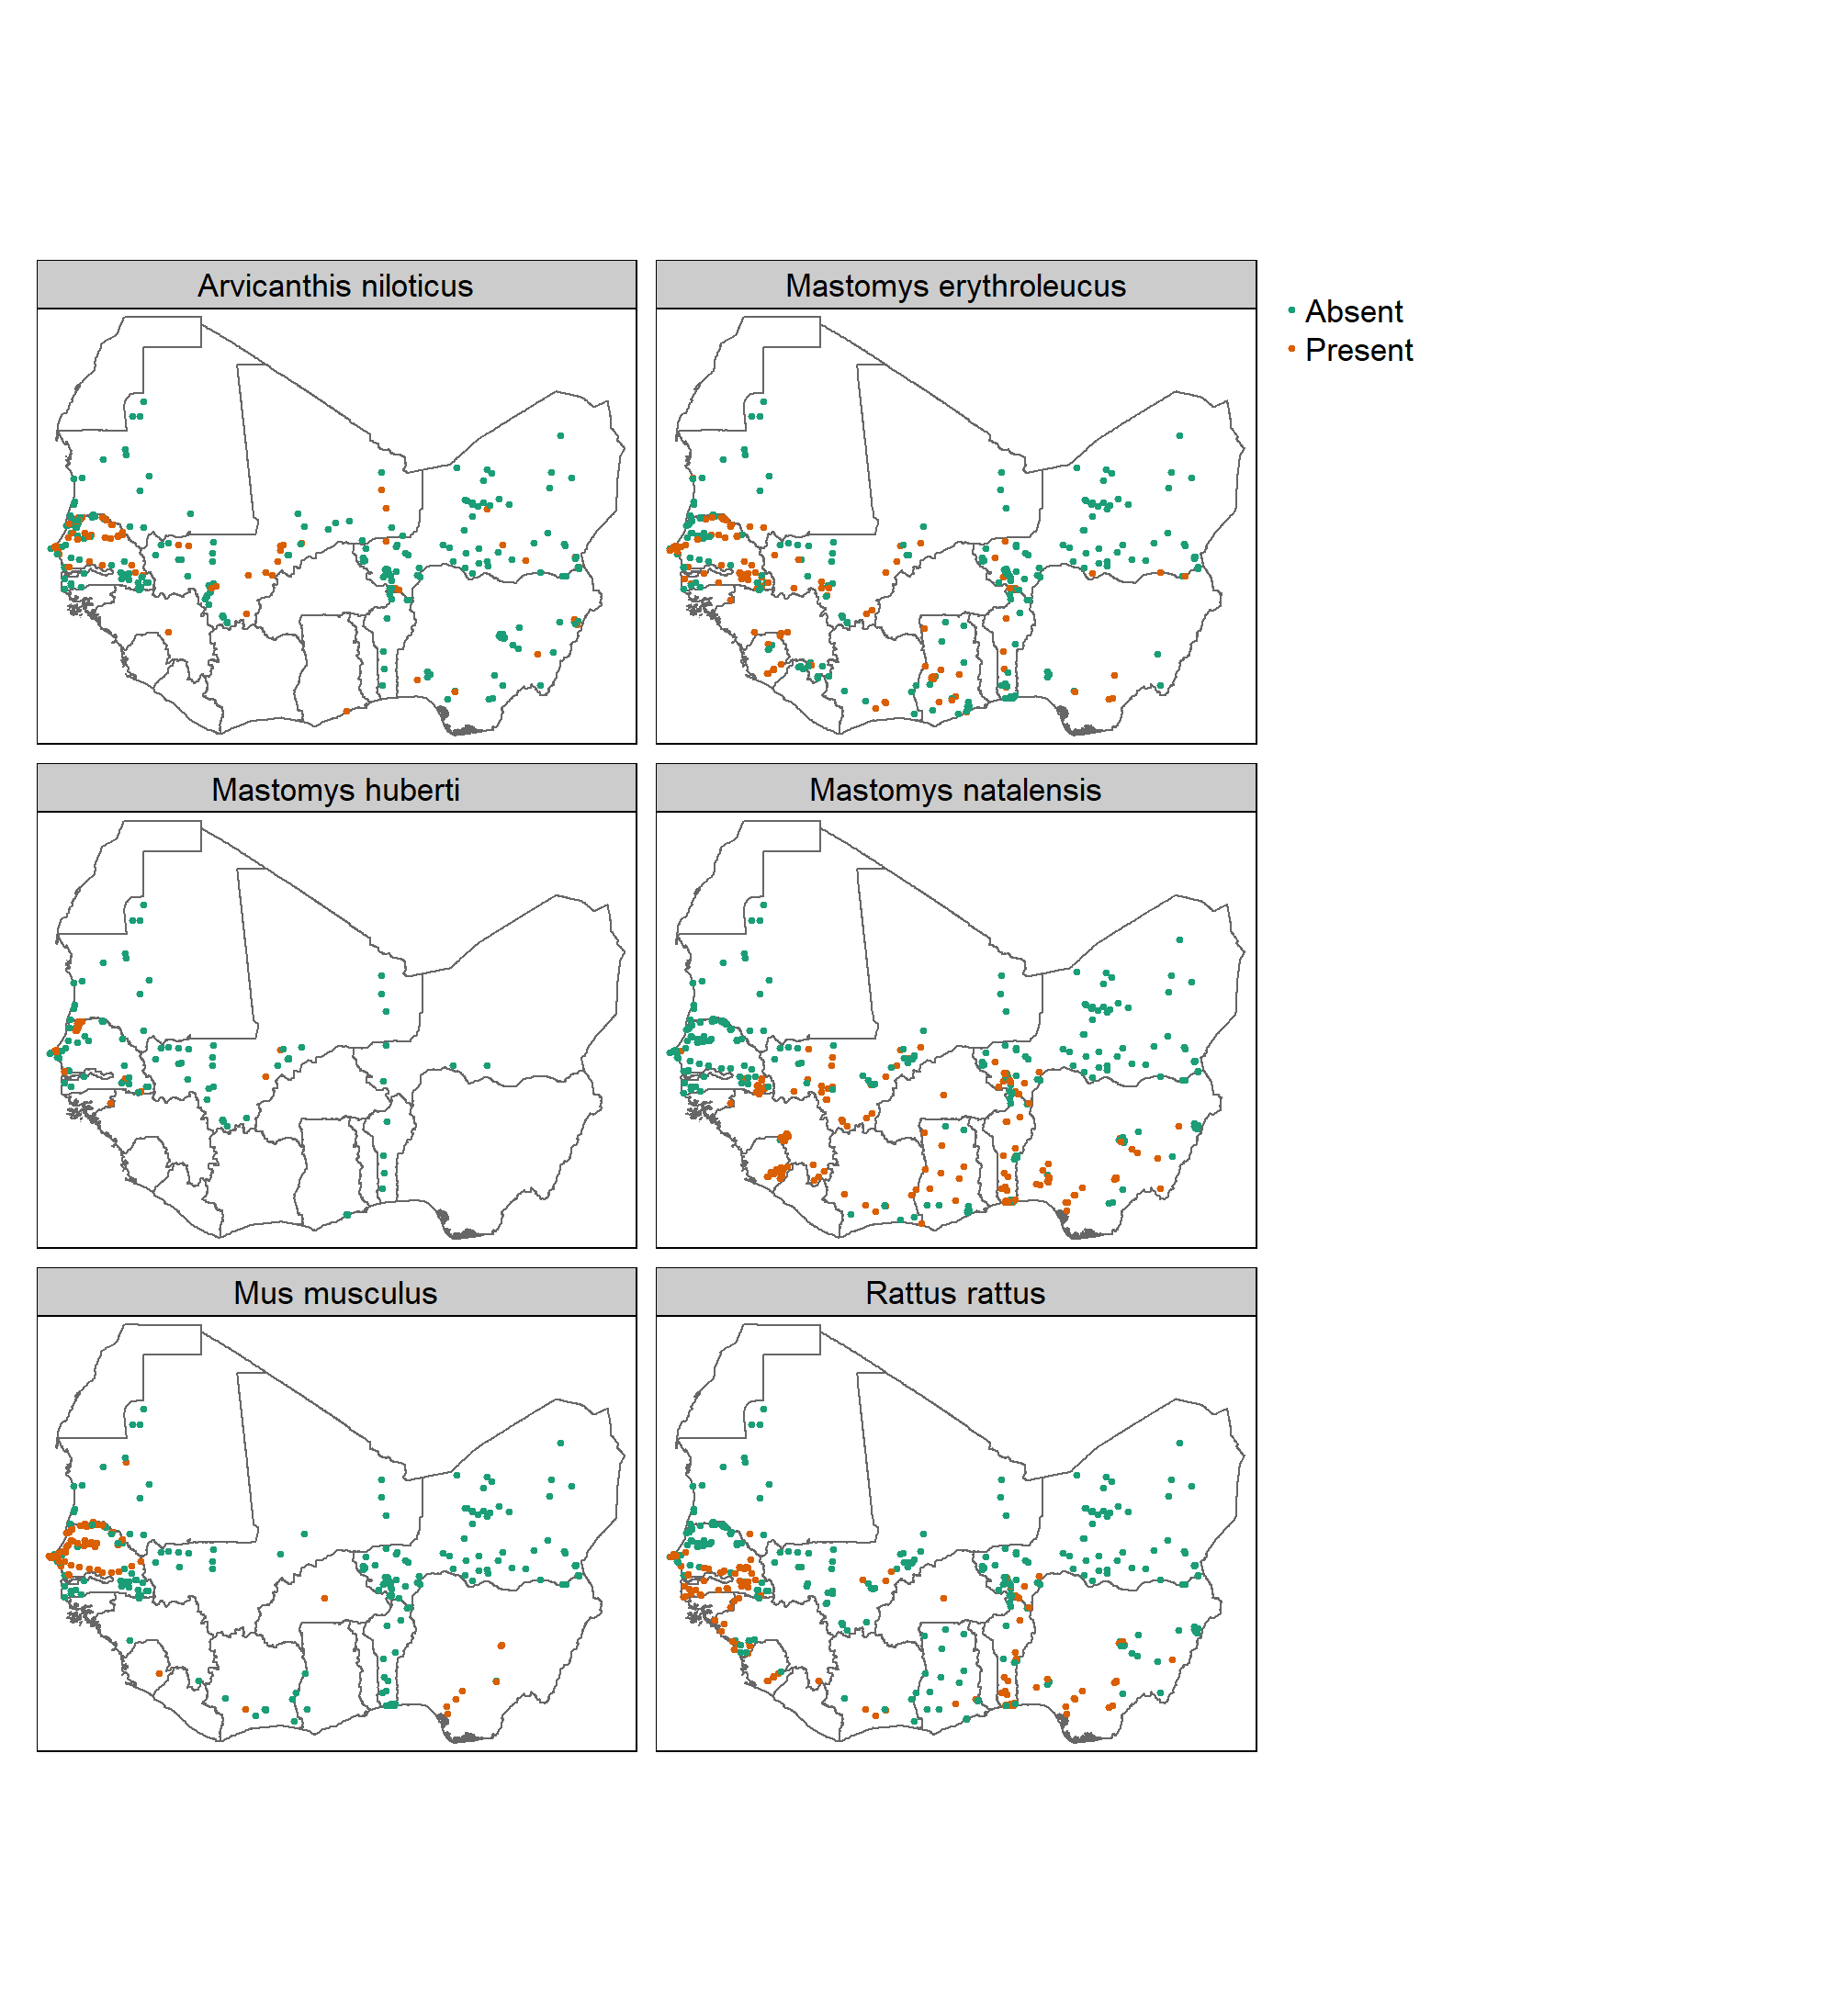

Presence and absence of the 6 most commonly trapped species in included studies, no adjustment made for trapping effort

### Pathogens

Fifty-one studies presented data on microorganisms that infect or are carried by small mammal species in West Africa. Data from a study previously excluded (Fichet-Calvet et al. 2007) due to duplicated data was incorporated as it provided the complementary pathogen data to the rodent trapping data. Six of the studies were solely investigated pathogens of rodents. The remaining 45 studies investigated organisms that were potentially zoonotic pathogens, pathogens of rodents or microbial organisms that were of uncertain significance to rodent or human health.

Twenty-six studies used Polymerase Chain Reaction (PCR) to detect the presence of 22 different species or families of microorganisms. Ten studies used antibody or antigen based molecular tests to detect the presence of 9 different species or families of microorganisms. Seven studies conducted histological or direct visualisation assays of samples for 10 parasitic or bacterial species. Two studies performed direct viral culture of *Lassa mammarenavirus* to detect the presence of the virus in rodent specimens.

The rodent pathogens investigated were *Hydatigera species* (previously *Taenia species*) and *Trichuris species* both of which are gastro-intestinal helminths and *Leishmania major* which is an intracellular pathogen causing disease in both rodents and humans.

Forty-two of the 45 studies reported prevalence of zoonotic pathogens at a level of detail beyond a study wide summary. These studies typically tested for a single pathogen (35), with two studies testing for two and three pathogens and three studies testing for five or more. The most frequently tested for pathogens were *Lassa mammarenavirus* (11) or members of the *Arenaviridae* family (7), the spirochete bacteria *Borrelia* was investigated in six studies, *Bartonella* and *Toxoplasma gondii* were investigated in three each, the remaining 28 pathogens were reported in two or fewer studies.

Ten of the studies reporting data on pathogen prevalence had incomplete data on the geolocation from which some of the animals tested were from. Six of these studies had no data on geolocation of the trapped rodents.

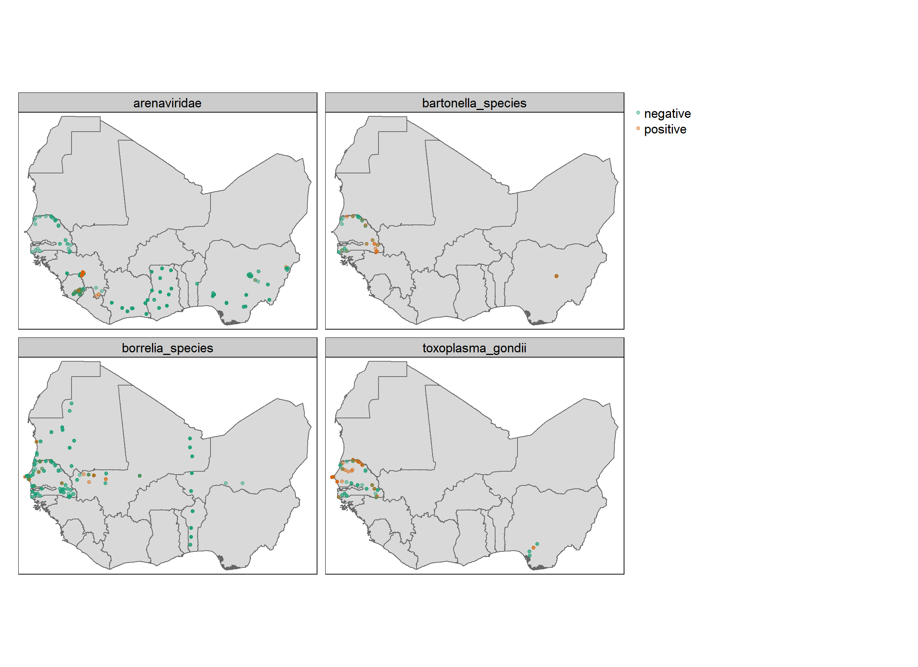

Presence and absence of the 4 most commonly tested for species in included studies, no adjustment made for trapping effort

## Supplementary material

#### Supplementary figure 1

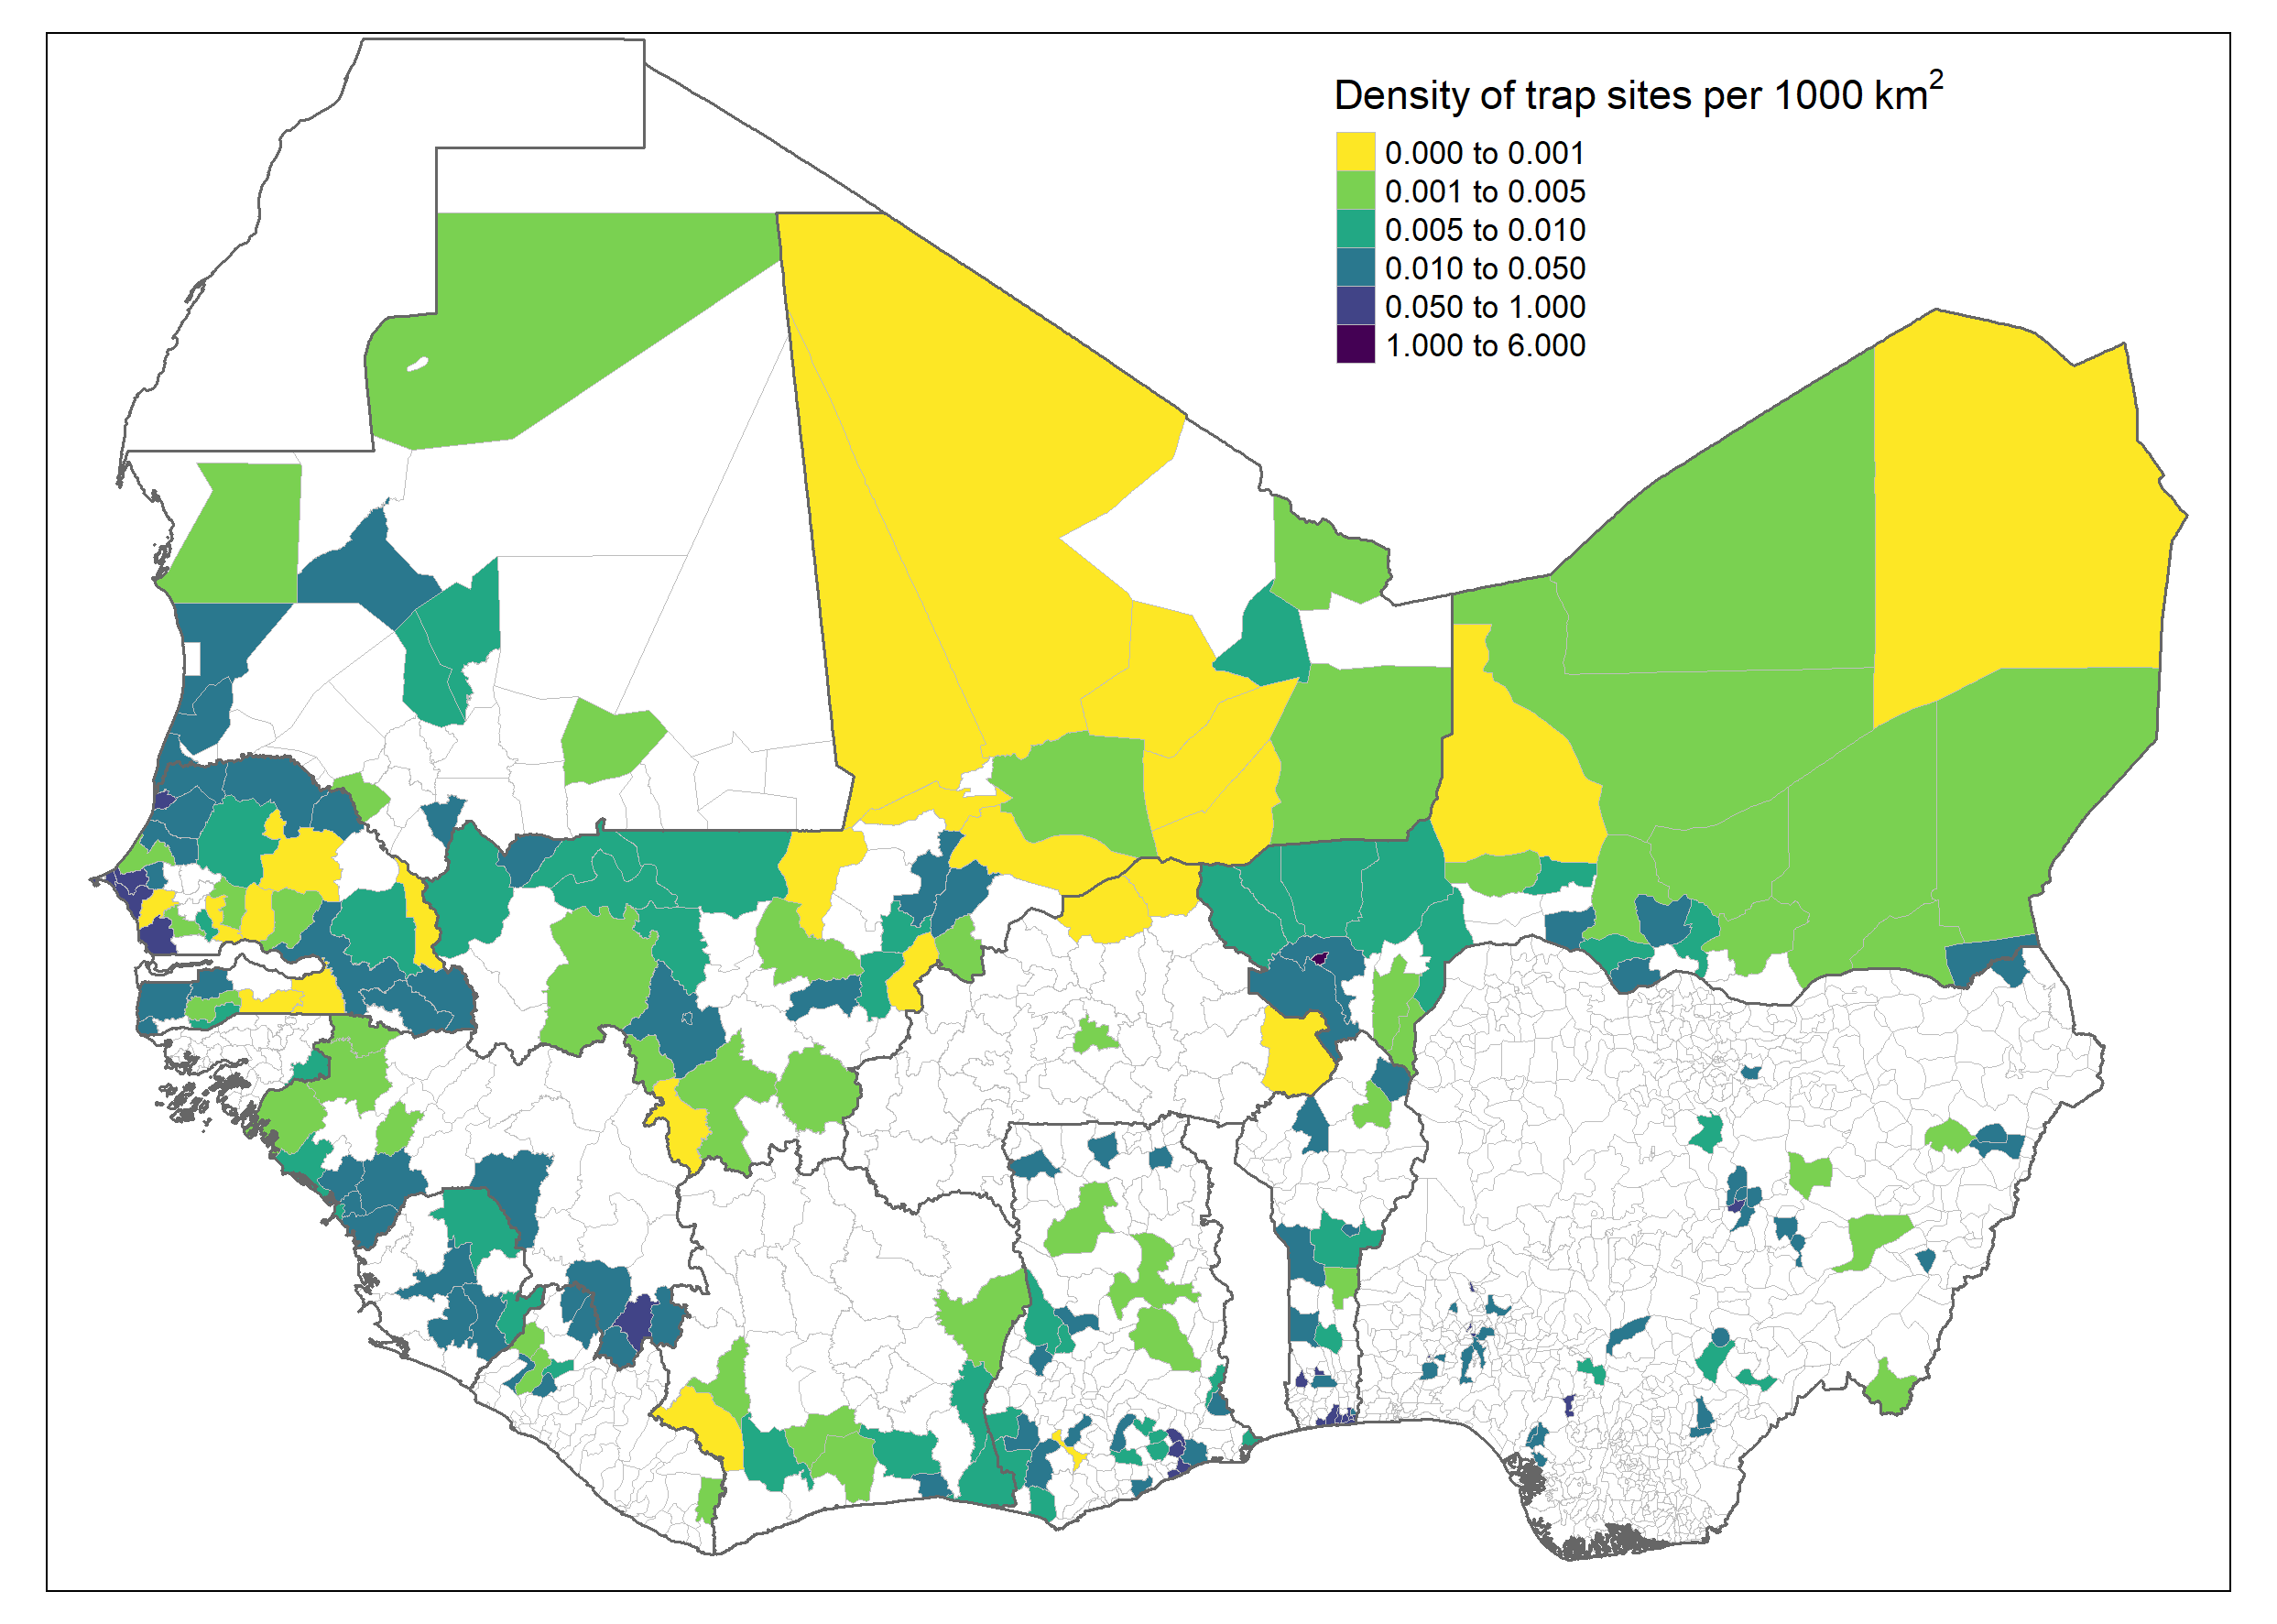

Density of trap sites per thousand km2

#### Supplementary table 1

The number and percentage of trapped rodents identified to species level

## PhantomJS not found. You can install it with webshot::install_phantomjs(). If it is installed, please make sure the phantomjs executable can be found via the PATH variable.

Akinsanola, A. A., and Wen Zhou. 2019. “Projection of West African Summer Monsoon Rainfall in Dynamically Downscaled CMIP5 Models.” *Climate Dynamics* 53 (1-2): 81–95. <https://doi.org/10.1007/s00382-018-4568-6>.

American Society of Mammologists. 2021. “ASM Mammal Diversity Database.” <https://www.mammaldiversity.org/>.

Dobson, F Stephen, and Madan K Oli. 2007. “Fast and Slow Life Histories of Rodents.” *Rodent Societies: An Ecological and Evolutionary Perspective*, 99–105.

Fichet-Calvet, Elisabeth, Emilie Lecompte, Lamine Koivogui, Barré Soropogui, Amadou Doré, Fodé Kourouma, Oumar Sylla, Stéphane Daffis, Kékoura Koulémou, and Jan Ter Meulen. 2007. “Fluctuation of Abundance and Lassa Virus Prevalence in Mastomys Natalensis in Guinea, West Africa.” *Vector Borne and Zoonotic Diseases* 7 (2): 119–28. <https://doi.org/10.1089/vbz.2006.0520>.

Fiedler, LA. 1988. “Rodent Pest Problems and Management in Eastern Africa.” *Bulletin Phytosanitaire de La FAO (FAO); Boletin Fitosanitario de La FAO (FAO)*.

Gibb, Rory, David W. Redding, Kai Qing Chin, Christl A. Donnelly, Tim M. Blackburn, Tim Newbold, and Kate E. Jones. 2020. “Zoonotic Host Diversity Increases in Human-Dominated Ecosystems.” *Nature* 584 (7821): 398–402. <https://doi.org/10.1038/s41586-020-2562-8>.

Hudson, Lawrence N., Tim Newbold, Sara Contu, Samantha L. L. Hill, Igor Lysenko, Adriana De Palma, Helen R. P. Phillips, et al. 2014. “The PREDICTS Database: A Global Database of How Local Terrestrial Biodiversity Responds to Human Impacts.” *Ecology and Evolution* 4 (24): 4701–35. <https://doi.org/10.1002/ece3.1303>.

Makundi, Rhodes H., Apia W. Massawe, and Loth S. Mulungu. 2007. “Reproduction and Population Dynamics of Mastomys Natalensis Smith, 1834 in an Agricultural Landscape in the Western Usambara Mountains, Tanzania.” *Integrative Zoology* 2 (4): 233–38. <https://doi.org/https://doi.org/10.1111/j.1749-4877.2007.00063.x>.

Meerburg, Bastiaan, Grant Singleton, and Aize Kijlstra. 2009. “Rodent-Borne Diseases and Their Risks for Public Health.” *Critical Reviews in Microbiology* 35 (July): 221–70. <https://doi.org/10.1080/10408410902989837>.

Stenseth, Nils Chr, Herwig Leirs, Anders Skonhoft, Stephen A. Davis, Roger P. Pech, Harry P. Andreassen, Grant R. Singleton, et al. 2003. “Mice, Rats, and People: The Bio-Economics of Agricultural Rodent Pests.” *Frontiers in Ecology and the Environment* 1 (7): 367–75. [https://doi.org/https://doi.org/10.1890/1540-9295(2003)001[0367:MRAPTB]2.0.CO;2](https://doi.org/https://doi.org/10.1890/1540-9295(2003)001%5B0367:MRAPTB%5D2.0.CO;2).

Swanepoel, Lourens H., Corrie M. Swanepoel, Peter R. Brown, Seth J. Eiseb, Steven M. Goodman, Mark Keith, Frikkie Kirsten, et al. 2017. “A Systematic Review of Rodent Pest Research in Afro-Malagasy Small-Holder Farming Systems: Are We Asking the Right Questions?” *PLOS ONE* 12 (3): e0174554. <https://doi.org/10.1371/journal.pone.0174554>.