Rodent trapping studies can improve our understanding of the hazards of zoonotic pathogen spillover and novel zoonotic pathogen emergence.

David Simons

Lauren A. Attfield

Kate E. Jones

Deborah Watson-Jones

Richard Kock

2022-03-09

# Abstract

**To complete after written**

# Introduction

Zoonotic infectious disease spillover events into human populations (animal-to-human transmission) can have important health and economic consequences at both the global and local level (e.g. SARS-CoV-2 and Ebola virus disease) [1]. The number of zoonotic disease spillover events and the emergence of novel zoonotic pathogens are projected to increase under intensifying anthropenic pressure driven by increased human populations, urbanisation, climate change and wildlife defaunation [2–5]. West Africa is identified as a nexus for these processes and a hotspot for both the risk of large epidemics of known zoonotic diseases and novel zoonotic pathogen emergence [2,6,7]. Further, two taxa - rodents (Rodentia) and bats (Chiroptera) - contribute the greatest number of predicted novel zoonotic pathogens and known zoonoses [8,9]. Of 2,220 extant rodent species, 244 (10.7%) are described as reservoirs of 85 zoonotic pathogens [7]. Specifically, West Africa is identified as a region at increased hazard for rodent-borne zoonotic disease spillover events under different projected future land-use change scenarios [4]. Currently in West Africa rodents are involved in the transmission of multiple zoonotic diseases with large burdens on human health, including, Lassa fever, Schistosomiasis, Leptospirosis and Toxoplasmosis [10,11].

Rodent species form diverse assemblages, which provide important and beneficial ecosystem services including pest regulation and seed dispersal [12]. The role of rodent species in zoonotic disease spillover or novel zoonotic pathogens emergence are examples of ecosystem disservices. Rodents typically demonstrate “fast” life histories [13] with traits such as early maturation and short gestation further associated with being zoonotic reservoirs [8,14]. Rodent species with “fast” life histories thrive in human dominated landscapes, displacing species less likely to be reservoirs of zoonotic pathogens [15]. The widespread occurrence of reservoir species and their proximity to human activity make the description of rodent species assemblages and host-pathogen associations vitally important to understanding the hazard of zoonotic disease spillover and novel zoonotic pathogen emergence [7].

Despite the importance of understanding these complex systems, current evidence on host-pathogen associations is affected by taxonomic and geographical sampling biases [9,16]. Studies identifying potential geographic hotspots of zoonotic disease spillover and novel pathogen emergence are based on global datasets of host species distributions and host-pathogen associations (e.g., IUCN, GBIF, GIDEON) that suffer from several biases [17,18]. For example, systematically increased sampling, over-representation of certain habitats and clustering around areas of high human population could lead to an apparent association between locations and hazard that is driven by these factors rather than underlying host-pathogen associations [9,19,20]. While other regions remain systematically undersampled (e.g., areas of sparse human populations), resulting in a reduced hazard of zoonotic spillover events or novel zoonotic pathogen emergence being attributed [21]. Predictions of zoonotic disease spillover and novel zoonotic pathogen emergence must account for these biases to understand the future hazard of zoonotic diseases [18].

Rodent trapping studies provide contextually rich information on when, where and under what conditions rodents were trapped, potentially enriching global datasets and counteracting their inherent biases [22]. Rodent trapping provides a useful method to describe rodent population assemblages, their geographic distribution and host-pathogen associations beyond what is currently available in global datasets. Studies have been conducted in West Africa to investigate the distribution of rodent species, their species assemblages, the prevalence of known zoonoses within rodent hosts (e.g., Lassa fever, Schistosomiasis) and to identify novel zoonotic pathogens [23–25]. However, data from these studies have not previously been synthesised for inclusion in assessments of zoonotic disease spillover and novel zoonotic pathogen emergence.

Here, we synthesise rodent trapping studies conducted across West African from a search of literature between 1964-2019. First, we investigate the geographic biases in the rodent trapping dataset in relation to human population density and land use classification. Second, we compare this to global host datasets (IUCN and GBIF) to understand differences in reported host geographic distributions. Third, we compare identified host-pathogen associations with global datasets (CLOVER) to understand discrepencies in rodent host-pathogen associations and report the proportion positive for pathogens of interest. Finally, within our dataset we investigate the spatial extent of current host-pathogen sampling to identify areas of undersampling of pathogens within their host ranges. We expect that rodent trapping studies will provide an important additional source of high resolution data that can be used to enrich global datasets to better understand the hazard of zoonotic disease spillover and novel zoonotic pathogen emergence across West Africa. We find that rodent trapping studies identify greater geographic ranges of important rodent hosts of zoonotic diseases than are reported from global datasets while also identifying locations and habitats in which further sampling is required. We also identify host-pathogen associations that are not reported in global host-pathogen association data, while identifying systematic undersampling for these pathogens across their host ranges.

# Methods

## Data sources

### Host and pathogen trapping data

We conducted a search in Ovid MEDLINE, Web of Science (Core collection and Zoological Record), JSTOR, BioOne, African Journals Online, Global Health and the pre-print servers, BioRxiv and EcoEvoRxiv for the following terms as keywords, no date limits were set: (1) Rodent OR Rodent trap* AND (2) West Africa (or the individual countries).

We searched other resources including the UN Official Documents System, Open Grey, AGRIS FAO and Google Scholar using combinations of the above terms. Searches were run on 2021-03-01, returning studies conducted between 1964-2019.

We included studies if they met all of the following inclusion criteria; i) reported findings from trapping studies where the target was a small mammal, ii) described the type of trap used or the length of trapping activity or the location of the trapping activity, iii) included trapping activity from at least one West African country, iv) recorded the genus or species of trapped individuals, v) were published in a peer-reviewed journal or as a pre-print on a digital platform or as a report by a credible organisation. We excluded studies if they met any of the following exclusion criteria: i) reported data that were duplicated from a previously included study, ii) no full text available, iii) not available in English. One reviewer screened titles, abstracts and full texts against the inclusion and exclusion criteria. At each stage, a random subset (10%) was reviewed by a second reviewer.

We extracted data from eligible studies using a standardised tool that was piloted on 5 studies (Supplementary Table 1.). Data was abstracted into a Google Sheets document, which was archived on completion of data extraction [ref to zenodo]. Extracted variables included i) study identifiers; ii) study aims; iii) trapping methodology; iv) geolocation data; v) method of speciation; vi) trapping locations and dates; vii) trapped species; viii) number of trap-nights and ix) microorganisms/pathogens of interest. We summarised the number of studies, the year in which trapping occurred and the country in which they were conducted.

We extracted GPS locations for the most precise location presented, converting to decimal degrees as required. For studies not using standardised habitat recording (e.g., IUCN Habitat Classification Scheme (Version 3.1)), the explicit description of the habitat in which the trap was placed was extracted. For studies reporting multiple habitat types for a single trap, trap-line or trapping grid, a higher order classification of habitat type was recorded.

We mapped genus and species names to those in the Global Biodiversity Information Facility (GBIF) taxonomy [26]. We extracted information on the detection, non-detection and number of trapped individuals.

We extracted data on all pathogens assayed. The number of rodents tested and the number of positive or negative samples were recorded alongside the type of assay used. If studies reported indeterminate results this was noted. Pathogens were identified to species level, however, where an assay only allowed for attribution to a family of viruses or bacteria, the higher order grouping was used.

### Spatial covariates

Boundaries of countries and level 2 administrative regions were obtained from GADM 4.0.4 for the study region [27]. Land cover classification in 2005, the median year in which trapping activity occurred, was obtained from Copernicus climate change service at ~300m resolution [28]. Proportion of land cover type within a level 2 administrative region was calculated. Human population density for 2005 was obtained from SEDAC at ~ 1km resolution, with median population density within each region extracted [29].

### Rodent species ranges and presence

Rodent species distributions were obtained as shapefiles from the IUCN redlist, shapefiles were cropped to the study region [30]. Rodent presence locations were obtained from GBIF as point data limited to the study region [31].

### Host pathogen associations

CLOVER a synthesis of four host-pathogen datasets (GMPD2, EID2, HP3 and Shaw 2020) was released in 2021 and represents a comprehensive global repository of host-pathogen associations for Bacteria, Viruses, Helminth, Protozoa and Fungi [32]. Data were obtained from an archived version of the dataset [33]. The dataset was limited to species trapped within our included studies, no spatial subsetting was possible.

## Included studies

We identified 4,282 relevant citations, with 126 rodent trapping studies included (Supplementary Table 2.). The earliest trapping studies were conducted in 1964, with increasing numbers of studies being performed annually. The median year of first trapping activity was 2005, with the median length of trapping activity being 1 year (IQR 0-2 years) (Supplementary Figure 1.). Studies were conducted in 14 West African countries with no studies reported from Gambia or Togo, at 1,331 sites (Figure 1A.). A minority (31, 25%) of studies trapped at a single study site, with 46 (37%) trapping at between two and five sites, the remaining 49 studies (38%) trapped at between six and 93 study sites. There were 581,426 reported trap nights, with 384,983 trap nights imputed for studies with no recording of trapping effort (Figure 1B.).

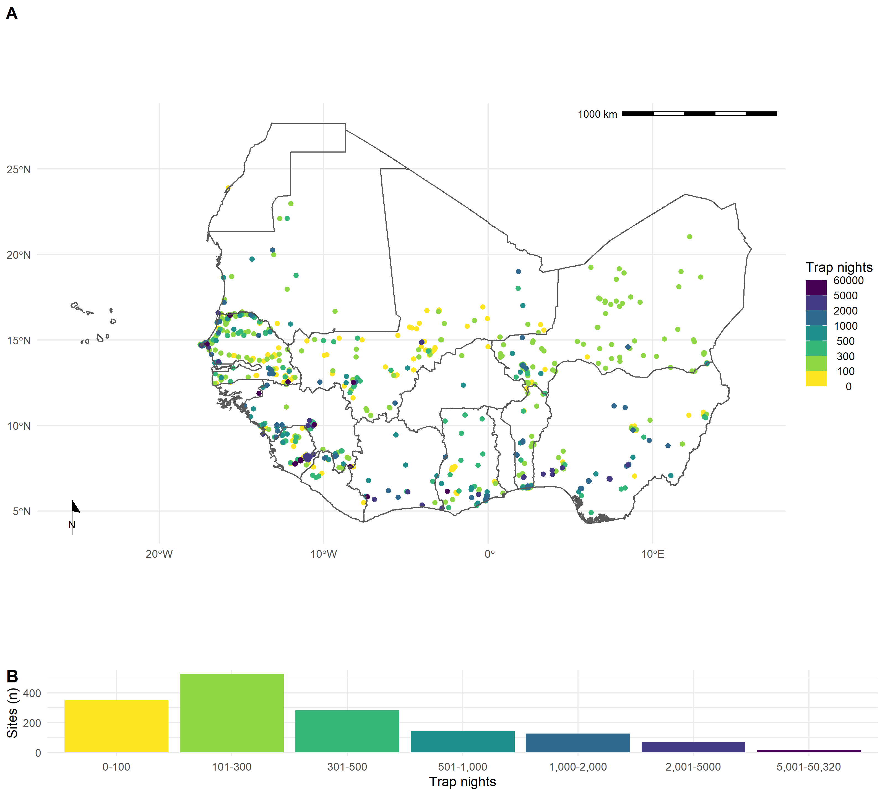

Figure 1: A) The location of trapping sites in West Africa. No sites were recorded from Togo or Gambia. There is important heterogeneity observed in the coverage of each country by trap night (colour) and location of sites. For example, Senegal, Mali and Sierra Leone have generally good coverage compared to Guinea and Burkina Faso. B) The distribution of trap nights performed at each study site on a log scale with a median of 244 trap nights (IQR 115-494) performed at each site

Within the included studies trap success varied importantly between traps placed in or around buildings (13%, IQR 6-24%) compared to other habitats (3%, IQR 1-9%). In total 73,164 small mammals were trapped with 62,574 (85%) identified to species level and 7,760 (11%) identified to genus. The majority of the 140 identified species were Rodentia (110, 76%) and Soricomorpha (30, 21%), of which Muridae (82, 73%) were the most common family.

62 studies tested for 32 microorganisms, defined to species or genus leve that are known or potential pathogens. The majority of studies tested for a single microorganism (39, 62%). The most frequently assayed microorganisms were *Lassa mammarenavirus* or Arenaviridae (27, 43%), *Borrelia sp.* (8, 13%), *Bartonella sp.* (4, 6%) and *Toxoplasma gondii* (4, 6%). The majority of studies used Polymerase Chain Reaction to detect microorganisms (32, 52%), with fewer studies using molecular based tests (11, 18%) or histological or direct visualisation assays (8, 13%). From 32,014 individual rodent samples we produced 339 host-pathogen pairs. With *Rattus rattus*, *Mus musculus*, *Mastomys erythroleucus*, *Mastomys natalensis* and *A. niloticus* being assayed for at least 18 microorganisms.

Further descriptive information from the included studies including geolocated trapping of species, their detection and non-detection alongside microorganism data has been made available online [34].

## Analysis

### What is the extent of spatial bias in the rodent trapping data?

We used the GPS coordinates of trapping locations and the number of trap nights to calculate trapping effort (trap night density) within level 2 administrative regions in West Africa. We imputed trap nights for studies with missing records using the number of trapped rodents and median trap success rate from studies reporting trapping effort stratified by habitat type. We calculated the proportion of land cover classes within each of these level 2 administrative, comparing surveyed regions to non-surveyed regions.

To better understand the potential bias associated with studies for zoonotic disease spillover or novel zoonotic pathogen emergence we limited further analyses to zoonotic pathogen studies only. We used a Generalised Additive Model (GAM) incorporating a spatial interaction term to investigate the association between number of trap nights, proportion of urban, cropland and forest land classification and human population density [35]. The model was constructed in *mgcv* using the R statistical programme [36,37], with selection of the most parsimonious model using the adjusted-R2 and Deviance explained outputs. We performed sensitivity analysis by removing sites with imputed trapping effort. The model structure was specified as:

$$\text{TN density}∼\text{Tweedie(log(Population density) + (Urban) + (Cropland) + (Shrubland) + (Forest) + (Longitude * Latitude))}$$

The model was used to identify locations of high and low trapping effort relative to population density and land use classification. Model inference was limited to regions around observed trap sites.

### What is the difference between global datasets rodent host distributions and distributions from trapping studies?

We assessed the taxonomic coverage of the trapped taxa and for the seven species with the most trap locations (*M. natalensis*, *R. rattus*, *M. erythroleucus*, *M. musculus*, *Arvicanthis niloticus*, *Praomys daltoni* and *Cricetomys gambianus*) we mapped the detection and non-detection of rodent species and compared this to detection data obtained from GBIF and species ranges from IUCN [30,31]. We identified rodent locations from GBIF and the rodent trapping studies within and outside the IUCN expected range. We located these to level 2 administrative regions to calculate the discrepencies between observed detections and non-detections with IUCN distributions.

### Are rodent trapping derived host-pathogen associations present in global zoonoses datasets?

For studies investigating rodent zoonoses we produced host-pathogen pairs. For each host-pathogen pair we compared our records with those available in CLOVER, reporting concordance and discordance. For host-pathogen pairs with assay results consistent with acute or prior infection we identify those not present in CLOVER. We expand the analysis to host-pathogen pairs with pathogens identified to genus level in Supplementary Figure 4.

### What is the spatial extent of pathogen testing within a hosts range?

For the four pathogens sampled at the most locations (Borreliaceae, Leptospiraceae, *Lassa mammarenavirus* and *Toxoplasma gondii*) we identify their potential host species. For the five species with most spatially complete sampling we associate their sampling locations with level 2 administrative regions and compare this to their IUCN range and rodent trapping detection range to calculate a measure sampling coverage.

# Results

## What is the extent of spatial bias in the rodent trapping data?

Trap sites were situated in 273 (19.3%) of 1,414 level 2 administrative regions in 14 West African nations. The areas with highest trap night density included the capital and large cities of Niger (Niamey), Sierra Leone (Freetown), Senegal (Dakar), Mali (Bamako), Ghana (Accra), Côte d’Ivoire (Abidjan), and Benin (Cotonou). Outside of these cities, regions in, Northern Senegal, Southern Guinea, Edo and Osun States in Nigeria and Eastern Sierra Leone had the highest density of trap nights (Figure 1A.).

Trapping sites were biased towards human modified landscapes (i.e., cropland, grassland and mosaic habitats), with under-representation of forest and bare habitats. However, urban habitats were comparitively undersampled (Supplementary Figure 2.).

Trapping effort, measured through trap nights, was biased with increased effort in areas with higher proportion of urban land use and no-significant association with proportion of forest cover. The spatial term of trapping bias highlighting bias towards trapping effort in Northern Senegal, Eastern Sierra Leone, Eastern Guinea and coastal regions of Nigeria, Benin and Ghana, in contrast South East Nigeria, Northern Nigeria and Liberia had lower than expected trapping effort (Figure 2). The most parsimonious GAM model (adjusted R2 = 0.523, Deviance explained = 61%) included terms for coordinates, proportion urban coverage and proportion tree coverage, model selection is shown in Supplementary Tables 3.1-3.4. In sensitivity analysis excluding sites with imputed trap nights reduced contributing data, however, Mauritania, Northern Senegal and Sierra Leone remained as regions trapped at higher than expected rates with Nigeria being trapped at lower than expected rates (Supplementary Figure 3.).

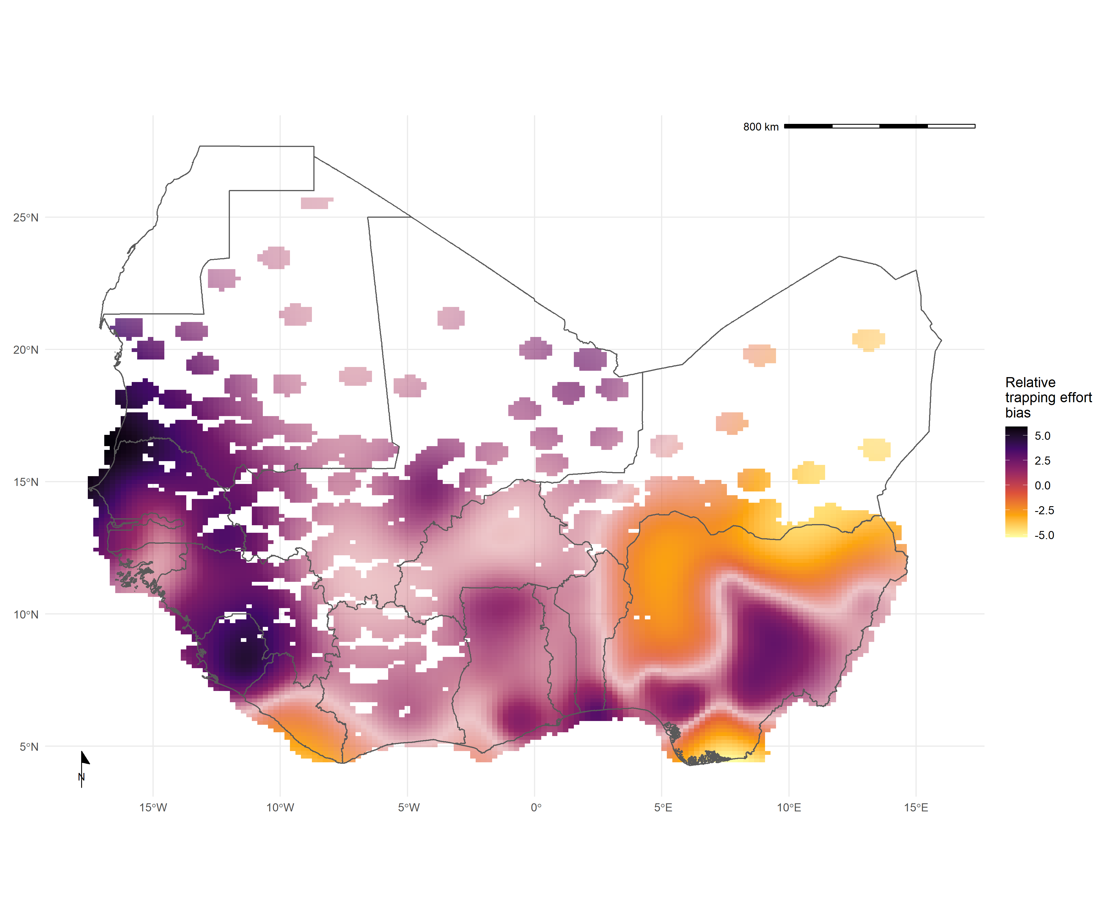

Figure 2. Relative trapping effort bias across West Africa from included studies adjusted for proportion urban land cover and proportion tree cover. Predictions are limited to areas around trap sites (coloured areas), uncertainty in the estimate of bias is represented by colour transparency/pallor. Purple regions represent areas with higher than expected trapping effort, yellow regions represent areas lower than expected trapping effort

## What is the difference between global datasets rodent host distributions and distributions from trapping studies?

For our species of interest, except *C. gambianus*, trapping studies provided more locations of detection and non-detection than were available from GBIF. For the West African endemic species IUCN ranges showed generally good concordance to both trapping studies and GBIF, although the range of *A. niloticus* and *P. daltoni* are greater than expected. The invasive species *R. rattus* and *M. musculus* are present in a much larger range than is expected (Figure 3A. and 3B.).

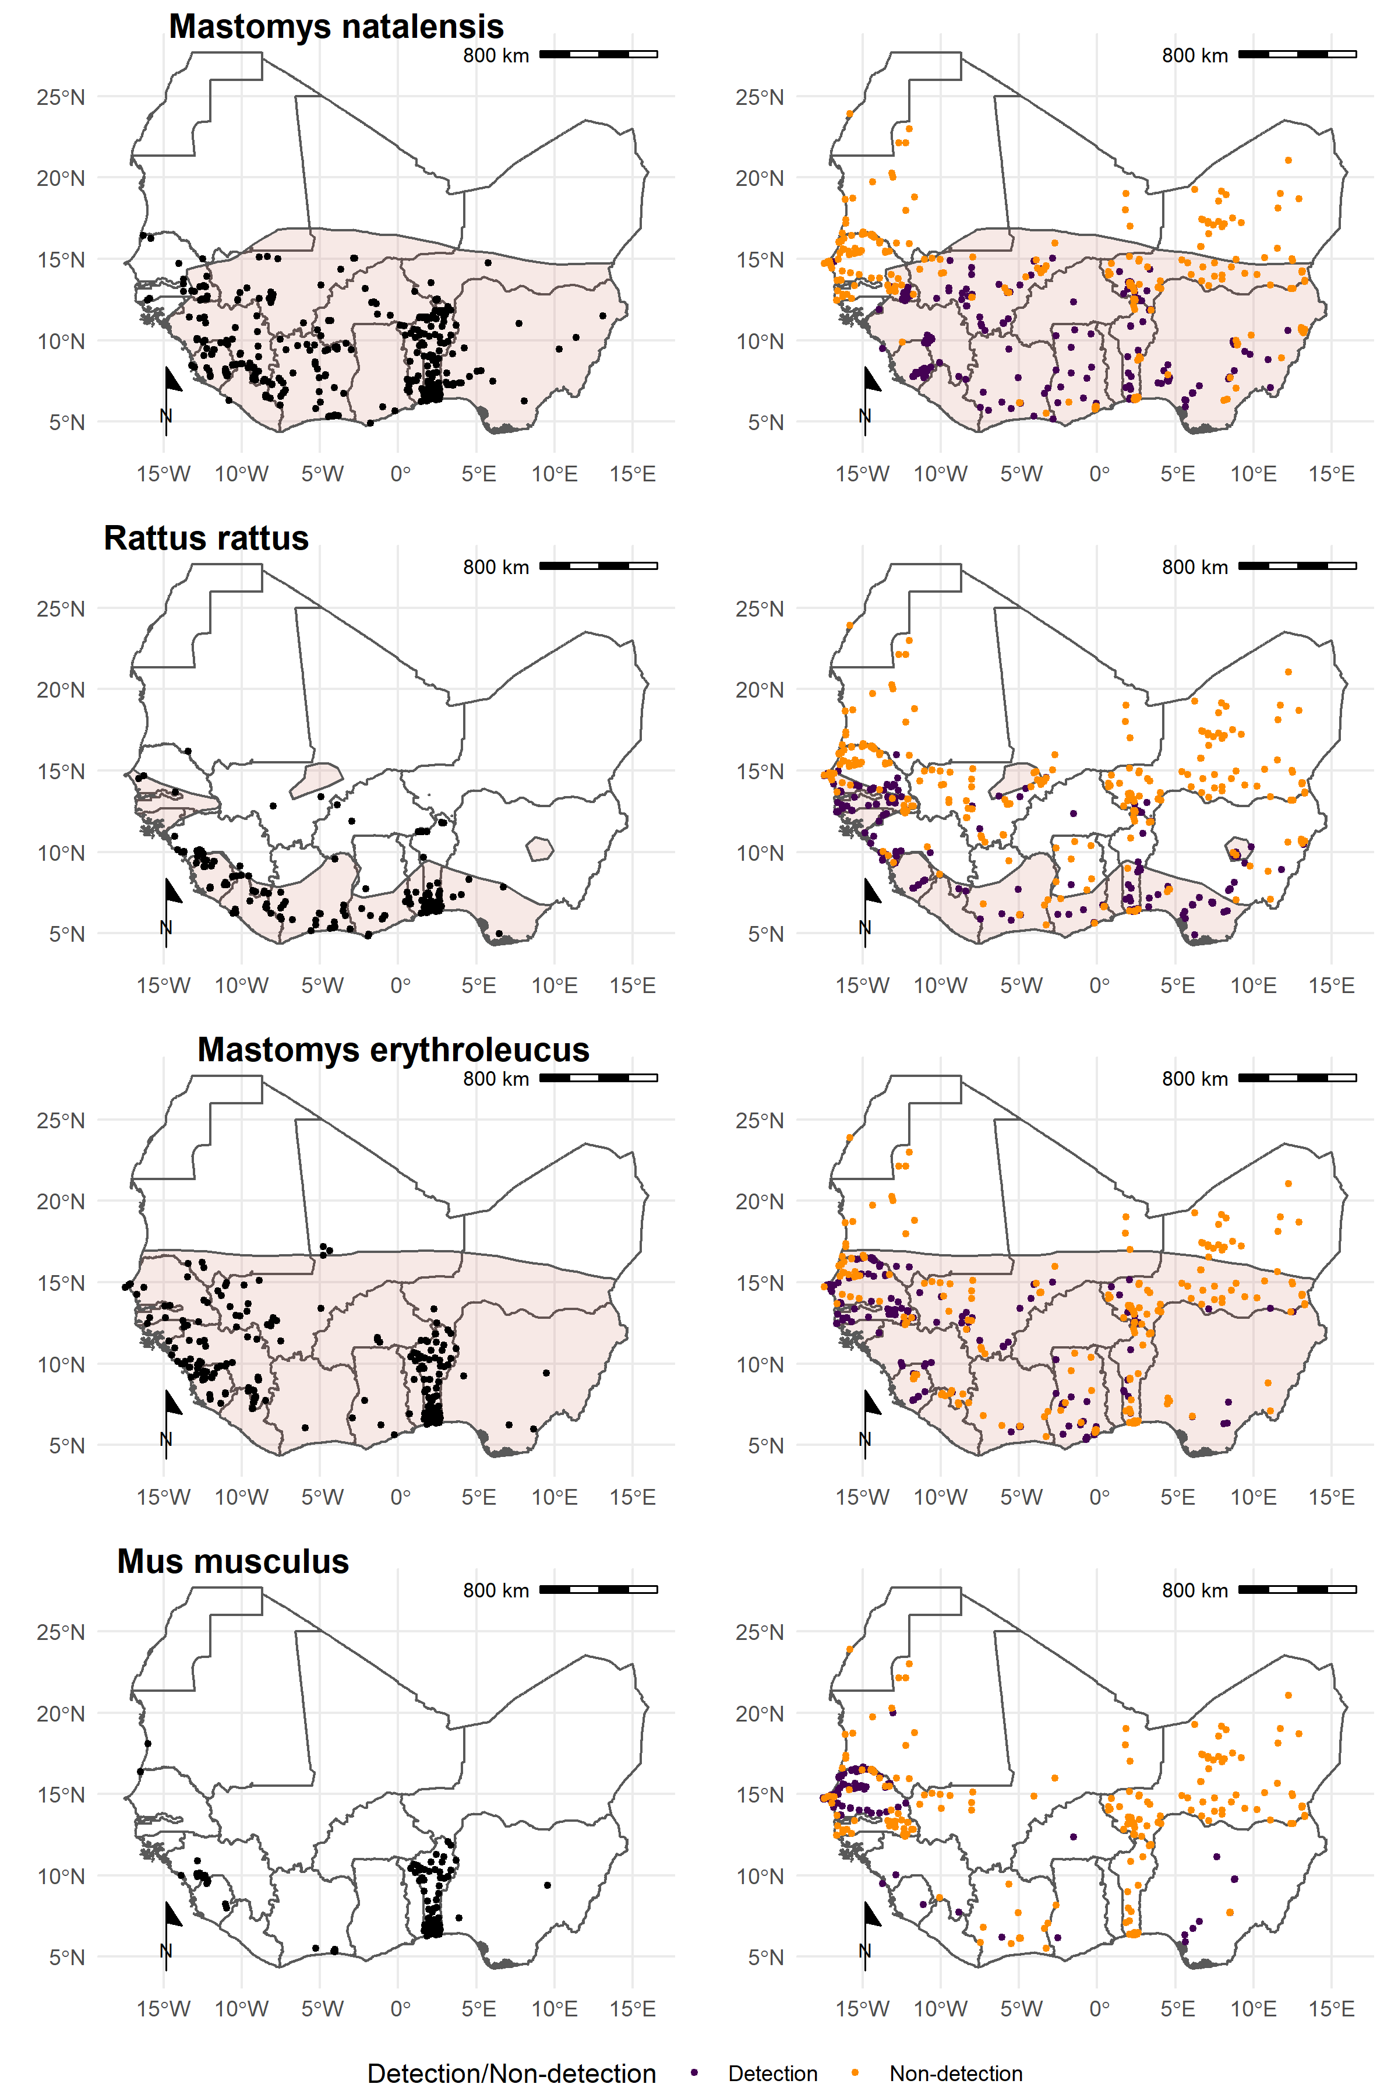

Figure 3A. Relative trapping effort bias across West Africa from included studies adjusted for proportion urban land cover and proportion tree cover. Predictions are limited to areas around trap sites (coloured areas), uncertainty in the estimate of bias is represented by colour transparency/pallor. Purple regions represent areas with higher than expected trapping effort, yellow regions represent areas lower than expected trapping effort.

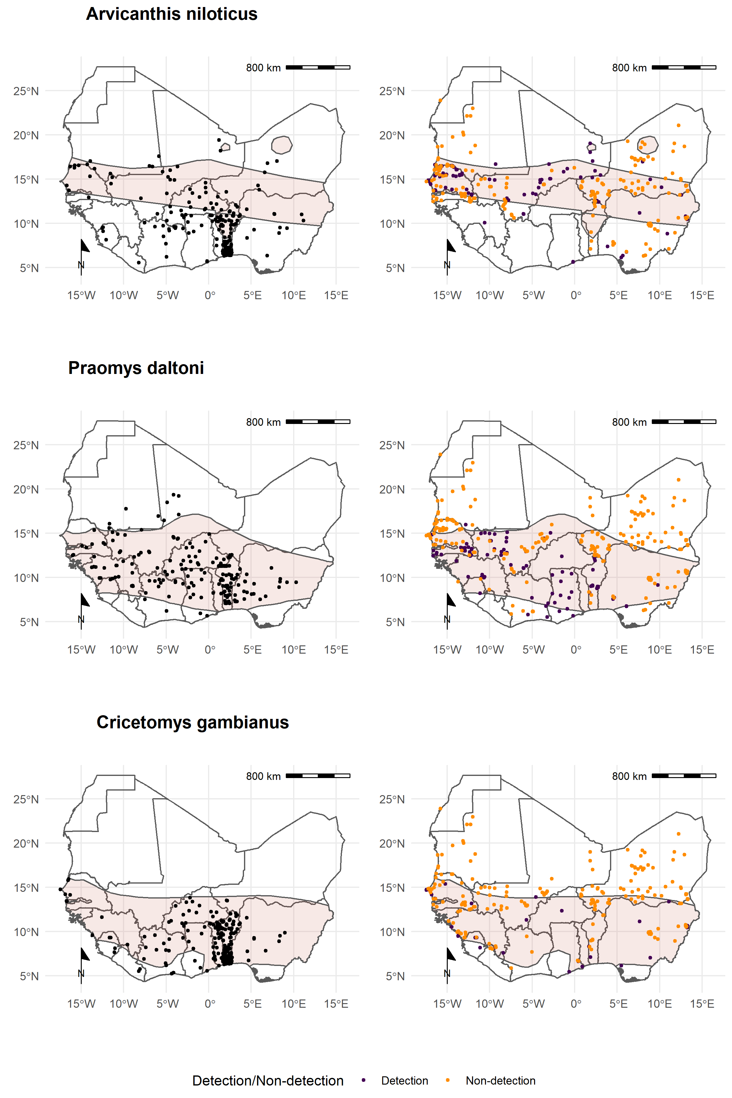

Figure 3B. Each row corresponds to a single rodent species. L) Presence recorded in GBIF overlaid on IUCN species range. R) Detection and non-detection from rodent trapping studies overlaid on IUCN species ranges.

We identified the proportion of a rodents expected range in which detections and non-detections occurred (Table 1.). GBIF sampling occurred over > 15% of a rodents expected range with detections occurring outside of IUCN ranges for all species, most noticeably for *A. niloticus* and *P. daltoni*. Trapping studies occurred over > 13% for all species except *C. gambianus* with detections occurring outside of IUCN ranges most noticeably for *A. niloticus* and *R. rattus*. Combining GBIF and trapping data increased coverage by a mean of 9% of the species range suggesting limited overlap between the regions studied. Non-detections of rodents occurred across large areas of their ranges with *A. niloticus* and *M. erythroleucus* not being detected in >15% of their expected range.

**Table** : Table 1: Comparison of IUCN, GBIF and rodent trapping ranges for the 7 species trapped at the most sites.

|  | IUCN | GBIF | | Trapping studies | | | Combined |
| --- | --- | --- | --- | --- | --- | --- | --- |
| Species | Range   (1,000 km2) | Range covered  (%) | Area outside range   (1,000 km2) | Range covered  detection (%) | Area outside range   (1,000 km2) | Range covered  non-detection (%) | Range covered  (%) |
| *Mastomys natalensis* | 3,257 | 26.0 | 42 | 17.6 | 12 | 10.3 | 34 |
| *Rattus rattus* | 1,019 | 22.1 | 112 | 17.2 | 217 | 6.5 | 32 |
| *Mastomys erythroleucus* | 3,736 | 15.7 | 100 | 13.9 | 19 | 16.9 | 23 |
| *Arvicanthis niloticus* | 1,830 | 21.0 | 805 | 24.2 | 801 | 22.2 | 41 |
| *Praomys daltoni* | 2,658 | 28.6 | 679 | 15.5 | 45 | 9.4 | 35 |
| *Cricetomys gambianus* | 2,476 | 17.1 | 34 | 4.3 | 23 | 12.8 | 20 |

## Are rodent trapping derived host-pathogen associations present in global zoonoses datasets?

When limited to confirmed pathogens and classification of both pathogen and host to species level we identified 21 host-pathogen pairs among 11 rodent and 6 pathogen species (Figure 4.). We identified negative associations for 41 host-pathogen pairs among 31 rodent and 7 pathogen species. CLOVER contained 8 (38%) of our identified host-pathogen associations and positive associations for 6 (15%) of the negative associations.

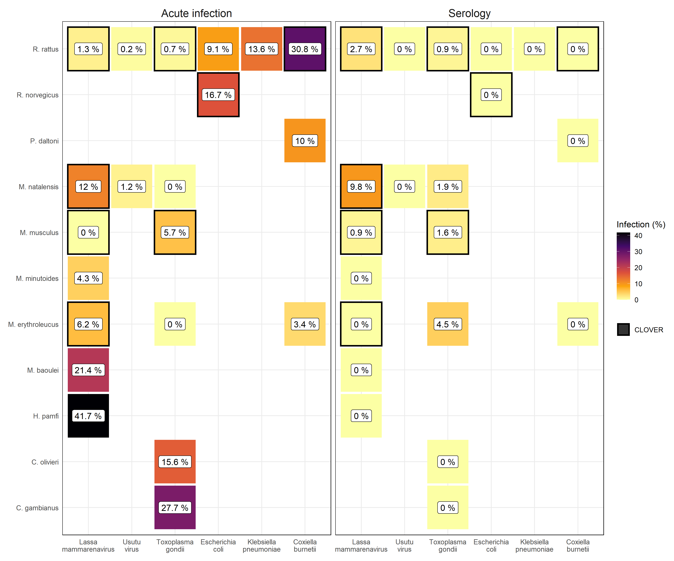

Figure 4. L) Identified species level host-pathogen associations through detection of acute infection (i.e. PCR, culture). Percentages and colour relate to the proportion of all assays that were positive. Associations with a black border are present in the CLOVER dataset. R) Identified species level host-pathogen associations through serological assays (i.e. ELISA). Percentages and colour relate to the proportion of all assays that were positive. Associations with a black border are present in the CLOVER dataset.

CLOVER included 399 host-pathogen associations we do not observe in rodent trapping studies among our included rodent species. The majority of these 329 (82%) pairs are from species with global distributions (*M. musculus*, *R. rattus* and *R. norvegicus*), or from wide ranging distributions in sub-Saharan Africa (31, 9%) (i.e., *A. niloticus*, *M. natalensis* and *A. albiventris*).

For pathogens not identified to species level (i.e. family or lower taxa) we identified 128 host-pathogen pairs among 32 rodent species and 25 pathogen families (Supplementary Figure 4.), with CLOVER containing 52 (41%) of these associations.

Rodent trapping studies identified rodent host species for six pathogens, *Toxoplasma gondii* (4), *Lassa mammarenavirus* (3), Usutu virus (2), *Coxiella burnetii* (2), *Escherichia coli* and *Klebsiella pneumoniae* (both 1), that were not present in this global host-pathogen association dataset.

## What is the spatial extent of pathogen testing within a hosts range?

The four most widely sampled pathogen species/families were were Borreliaceae, *Lassa mammarenavirus*, Leptospiraceae and *Toxoplasma gondii* (Table 2.). Infection with species of Borreliaceae was assessed in 42 species, with evidence of infection in 17 rodent species. Among species with more than 500 samples the highest rates of infection were among *A. niloticus* (16%), *M. huberti* (11%) and *M. erythroleucus* (8%). The five most widely assayed species were sampled from a relative small area of their species ranges (7.3-16%), however, there was good representation when compared to where rodent trapping studies have occurred (24-85%).

Infection with *Lassa mammarenavirus* was assessed in 28 species, with evidence of infection in 7 rodent species. Among species with more than 100 samples the highest rates of infection were among *M. natalensis* (22%), *M. erythroleucus* (6%) and *R. rattus* (4%). Species sampling occurred from limited areas within IUCN ranges (2-3%), however, sampling was more representative for rodent trapping studies (3-24%).

Infection with species of Leptospiraceae was assessed in 8 species, with evidence of infection in 5 rodent species. Among species with more than 100 samples *M. natalensis* (19%), *R. rattus* (11%) and *Crocidura olivieri* (10%) were most frequently infected. Species sampling occurred across less than 1% of these species IUCN ranges and for all except *R. norvegicus* for less than 1% of their detection range in included studies.

*Toxoplasma gondii* infection was assessed in 8 species, with evidence of infection in 6 rodent species. Among species with more than 100 samples *M. musculus* (7%), *M. erythroleucus* (4%) and *M. natalensis* (2%) were most commonly infected. Sampling occurred across less than 6% of their IUCN ranges, however, for *M. musculus*, *R. rattus* and *M. erythroleucus* sampling occurred across greater than 12% of their detection range.

**Table** : Table 2: Comparison of pathogen sampling ranges for the 4 most commonly sampled pathogens and the 5 most sampled potential rodent host species.

| Pathogen | Species | Administrative regions (n) | Tested (n) | Positive (n) | Area sampled  (1,000 km2) | IUCN area (%) | Trapped area (%) |
| --- | --- | --- | --- | --- | --- | --- | --- |
| Borrelia sp. |  |  |  |  |  |  |  |
|  | *M. erythroleucus* | 65 | 1,563 | 140 | 273.1 | 7.3 | 50.8 |
|  | *A. niloticus* | 36 | 1,528 | 244 | 293.2 | 16 | 23.6 |
|  | *M. natalensis* | 42 | 731 | 54 | 250.5 | 7.7 | 42.8 |
|  | *M. huberti* | 14 | 718 | 81 | 58.6 | 10.1 | 84.5 |
|  | *P. daltoni* | 30 | 264 | 19 | 234.2 | 8.8 | 51.3 |
| Lassa mammarenavirus |  |  |  |  |  |  |  |
|  | *M. natalensis* | 45 | 3,113 | 713 | 106.9 | 3.3 | 18.3 |
|  | *M. musculus* | 2 | 141 | 0 | 6.2 | * | 3.1 |
|  | *M. erythroleucus* | 7 | 139 | 9 | 55.9 | 1.5 | 10.4 |
|  | *R. rattus* | 12 | 88 | 2 | 34.5 | 3.4 | 8.8 |
|  | *H. pamfi* | 1 | 12 | 5 | 0.6 | 1.8 | 24.3 |
| Leptospira sp. |  |  |  |  |  |  |  |
|  | *R. rattus* | 54 | 626 | 65 | 3.3 | < 1 | < 1 |
|  | *A. niloticus* | 1 | 221 | 10 | 0.2 | < 1 | < 1 |
|  | *M. natalensis* | 34 | 126 | 24 | 1.6 | < 1 | < 1 |
|  | *C. olivieri* | 39 | 123 | 14 | 1.6 | < 1 | < 1 |
|  | *R. norvegicus* | 27 | 65 | 17 | 1.4 | * | 17.9 |
| Toxoplasma gondii |  |  |  |  |  |  |  |
|  | *M. musculus* | 32 | 1,548 | 115 | 77.5 | * | 38.1 |
|  | *R. rattus* | 18 | 428 | 8 | 61.7 | 6.1 | 15.7 |
|  | *M. erythroleucus* | 18 | 272 | 10 | 68.2 | 1.8 | 12.7 |
|  | *C. gambianus* | 3 | 47 | 13 | 2.4 | < 1 | 1.8 |
|  | *C. olivieri* | 2 | 32 | 5 | 0.5 | < 1 | < 1 |

# Discussion

We synthesised data from 126 rodent trapping studies containing information on more than 72,000 trapped rodents across 1,331 trapping sites producing an estimated 966,000 trap-nights. Trapping occurred across 14 West African countries, studies investigating known or potential zoonotic pathogens occurred within 19% of level 2 administrative regions across West Africa with important bias towards areas with high population density and human dominated landscapes. For several important rodent species we identified discordance between IUCN species ranges, GBIF presence data and detections and non-detections from rodent trapping studies, particularly among non-native species (*R. rattus* and *M. musculus*). We compared host-pathogen associations from rodent trapping studies with a global dataset and identified missing associations for several important zoonotic infectious diseases including, Lassa fever, Toxoplasmosis and Q fever in commonly occurring rodent species. Finally, we assessed the spatial coverage of testing for important zoonotic pathogens and found low representativeness across their host species range.

Rodent trapping studies provide important information on the distribution of rodent species and their assemblages, we have identified important bias in the locations in which studies to data have been performed with large regions of countries including Nigeria, Guinea and Cote d’Ivoire being understudied. Trapping sites are clustered in areas with relatively high human population density and anthropogenic land use which can importantly bias our understanding of the distribution of rodent species and their pathogens across West Africa. Further effort is required to minimise this bias by sampling currently undersampled regions.

Global datasets of rodent host distribution (e.g., IUCN) and presence (e.g., GBIF) provide useful resources to model the hazard of zoonotic disease spillover and novel pathogen emergence. We show here that non-detection data from rodent trapping studies can provide additional information to describe the heterogeneity of rodent assemblages across diverse habitats in West Africa. Combining presence data from GBIF and detection/non-detection data from rodent trapping studies can substantially increase coverage across a rodents range, allowing improved estimates of rodent host prevalence for zoonotic infectious disease studies.

Host-pathogen association datasets are becoming increasing comprehensive alongside increased access to molecular discovery techniques for potential pathogens. We show that currently available data from rodent trapping studies can enrich these resources, particularly with prevalence data and geolocation to better understand the potential hosts and reservoirs of known zoonotic pathogens. Rodent trapping data can support studies using these global datasets to predict novel pathogen emergence and to quantify the risk of known zoonotic disease spillover based on host distributions.

We have identified important limitations in the sampling of rodent zoonoses for known diseases across West Africa. For example, studies of *Lassa mammarenavirus* have taken place across 3% of *M. natalensis*’s range in West Africa. Lassa fever is known to be endemic in eight West African countries, although it is potentially more widely spread. Further studies are required to investigate this pathogen across a wider geographic range. Other important zoonotic diseases including Leptospirosis and Toxoplasmosis have been assessed over very limited regions of their hosts distribution.

Due to data sparsity we were unable to account for temporal change. Land use change and population density have changed dramatically over our study period in West Africa. We attempted to mitigate this by using the median year of trapping to understand the spatial biases in trapping activity, however, it is possible that land use and population density at trapping sites varied importantly between when the study was conducted and the situation in 2005. Despite this limitation, the finding that trapping is biased towards high density, human dominated landscapes is unlikely to change.

We propose that rodent trapping studies can provide important data to supplement global datasets to quantify the hazard of zoonotic disease spillover and novel pathogen emergence. They can reduce some of the bias in global datasets however, important limitations remain. Further effort is required to survey rodent populations in non-human dominated landscapes and to assay pathogens across more of a hosts range.

# References

[1] Judson SD, Rabinowitz PM. Zoonoses and global epidemics. Current Opinion in Infectious Diseases 2021;34:385–92. <https://doi.org/10.1097/QCO.0000000000000749>.

[2] Allen T, Murray KA, Zambrana-Torrelio C, Morse SS, Rondinini C, Di Marco M, et al. Global hotspots and correlates of emerging zoonotic diseases. Nature Communications 2017;8:1124. <https://doi.org/10.1038/s41467-017-00923-8>.

[3] Hassell JM, Begon M, Ward MJ, Fèvre EM. Urbanization and disease emergence: Dynamics at the wildlife–livestock–human interface. Trends in Ecology & Evolution 2017;32:55–67. <https://doi.org/10.1016/j.tree.2016.09.012>.

[4] García-Peña GE, Rubio AV, Mendoza H, Fernández M, Milholland MT, Aguirre AA, et al. Land-use change and rodent-borne diseases: Hazards on the shared socioeconomic pathways. Philosophical Transactions of the Royal Society B: Biological Sciences 2021;376:20200362. <https://doi.org/10.1098/rstb.2020.0362>.

[5] McMahon BJ, Morand S, Gray JS. Ecosystem change and zoonoses in the anthropocene. Zoonoses and Public Health 2018;65:755–65. <https://doi.org/10.1111/zph.12489>.

[6] Grace D, Mutua F, Ochungo P, Kruska R, Jones K, Brierley L, et al. Mapping of poverty and likely zoonoses hotspots 2012.

[7] Han BA, Kramer AM, Drake JM. Global patterns of zoonotic disease in mammals. Trends in Parasitology 2016;32:565–77. <https://doi.org/10.1016/j.pt.2016.04.007>.

[8] Han BA, Schmidt JP, Bowden SE, Drake JM. Rodent reservoirs of future zoonotic diseases. PNAS 2015;112:7039–44. <https://doi.org/10.1073/pnas.1501598112>.

[9] Gibb R, Albery GF, Mollentze N, Eskew EA, Brierley L, Ryan SJ, et al. Mammal virus diversity estimates are unstable due to accelerating discovery effort. Biology Letters 2021;18:20210427. <https://doi.org/10.1098/rsbl.2021.0427>.

[10] Meerburg B, Singleton G, Kijlstra A. Rodent-borne diseases and their risks for public health. Critical Reviews in Microbiology 2009;35:221–70. <https://doi.org/10.1080/10408410902989837>.

[11] Galeh TM, Sarvi S, Montazeri M, Moosazadeh M, Nakhaei M, Shariatzadeh SA, et al. [Global status of toxoplasma gondii seroprevalence in rodents: A systematic review and meta-analysis](https://www.frontiersin.org/article/10.3389/fvets.2020.00461). Frontiers in Veterinary Science 2020;7.

[12] Fischer C, Gayer C, Kurucz K, Riesch F, Tscharntke T, Batáry P. Ecosystem services and disservices provided by small rodents in arable fields: Effects of local and landscape management. Journal of Applied Ecology 2018;55:548–58. <https://doi.org/10.1111/1365-2664.13016>.

[13] Dobson FS, Oli MK. [Fast and slow life histories of rodents](https://www.jstor.org/stable/42902037). Rodent Societies: An Ecological and Evolutionary Perspective 2007:99–105.

[14] Albery GF, Becker DJ. Fast-lived hosts and zoonotic risk. Trends in Parasitology 2021;37:117–29. <https://doi.org/10.1016/j.pt.2020.10.012>.

[15] Gibb R, Redding DW, Chin KQ, Donnelly CA, Blackburn TM, Newbold T, et al. Zoonotic host diversity increases in human-dominated ecosystems. Nature 2020;584:398–402. <https://doi.org/10.1038/s41586-020-2562-8>.

[16] Gibb R, Franklinos LHV, Redding DW, Jones KE. Ecosystem perspectives are needed to manage zoonotic risks in a changing climate. BMJ 2020;371:m3389. <https://doi.org/10.1136/bmj.m3389>.

[17] Plowright RK, Becker DJ, McCallum H, Manlove KR. Sampling to elucidate the dynamics of infections in reservoir hosts. Philos Trans R Soc Lond B Biol Sci 2019;374:20180336. <https://doi.org/10.1098/rstb.2018.0336>.

[18] Carlson CJ, Farrell MJ, Grange Z, Han BA, Mollentze N, Phelan AL, et al. The future of zoonotic risk prediction. Philosophical Transactions of the Royal Society B: Biological Sciences 2021;376:20200358. <https://doi.org/10.1098/rstb.2020.0358>.

[19] Wille M, Geoghegan JL, Holmes EC. How accurately can we assess zoonotic risk? PLoS Biol 2021;19:e3001135. <https://doi.org/10.1371/journal.pbio.3001135>.

[20] Redding DW, Lucas TCD, Blackburn TM, Jones KE. Evaluating bayesian spatial methods for modelling species distributions with clumped and restricted occurrence data. PLOS ONE 2017;12:e0187602. <https://doi.org/10.1371/journal.pone.0187602>.

[21] Beck J, Böller M, Erhardt A, Schwanghart W. Spatial bias in the GBIF database and its effect on modeling species’ geographic distributions. Ecological Informatics 2014;19:10–5. <https://doi.org/10.1016/j.ecoinf.2013.11.002>.

[22] Bovendorp RS, MCCleery RA, Galetti M. Optimising sampling methods for small mammal communities in neotropical rainforests. Mammal Review 2017;47:148–58. <https://doi.org/10.1111/mam.12088>.

[23] Fichet-Calvet E, Lecompte E, Veyrunes F, Barrière P, Nicolas V, Koulémou K. [Diversity and dynamics in a community of small mammals in coastal guinea, west africa](http://www.vliz.be/nl/open-marien-archief?module=ref&refid=204614). Belgian Journal of Zoology 2009;139:93–102.

[24] Catalano S, Leger E, Fall CB, Borlase A, Diop SD, Berger D, et al. Multihost transmission of schistosoma mansoni in senegal, 2015-2018. Emerging Infectious Diseases 2020;26:1234–42. <https://doi.org/10.3201/eid2606.200107>.

[25] USAID. One health surveillance. PREDICT project 2021. <https://p2.predict.global/surveillance> (accessed September 27, 2021).

[26] GBIF: The Global Biodiversity Information Facility. The global biodiversity information facility 2021. <https://www.gbif.org/> (accessed April 25, 2021).

[27] Database of Global Administrative Areas. GADM 2022. <https://gadm.org/index.html> (accessed April 25, 2021).

[28] European Space Agency Climate Change Initiative. Land cover classification gridded maps from 1992 to present derived from satellite observations 2022. <https://cds.climate.copernicus.eu/cdsapp#!/dataset/satellite-land-cover?tab=overview> (accessed March 3, 2022).

[29] Socioeconomic Data and Applications Center. Gridded population of the world (GPW), v4 SEDAC 2021. <https://sedac.ciesin.columbia.edu/data/collection/gpw-v4> (accessed February 4, 2021).

[30] IUCN. [The IUCN red list of threatened species](https://www.iucnredlist.org). 2021.

[31] GBIF: The Global Biodiversity Information Facility. Occurrence download 2021. <https://doi.org/10.15468/DL.S52MEH>.

[32] Gibb R, Albery GF, Becker DJ, Brierley L, Connor R, Dallas TA, et al. Data proliferation, reconciliation, and synthesis in viral ecology. BioScience 2021;71:1148–56. <https://doi.org/10.1093/biosci/biab080>.

[33] Gibb R, Carlson CJ, Farrell MJ. Viralemergence/clover: Resubmission + zenodo. Zenodo; 2021. <https://doi.org/10.5281/zenodo.4945274>.

[34] Simons D. Rodents and potential zoonotic diseases in west africa 2022. <https://diddrog11.shinyapps.io/scoping_review_app/> (accessed March 2, 2022).

[35] Pedersen EJ, Miller DL, Simpson GL, Ross N. Hierarchical generalized additive models in ecology: An introduction with mgcv. PeerJ 2019;7:e6876. <https://doi.org/10.7717/peerj.6876>.

[36] Wood SN. Generalized additive models: An introduction with r. 2nd ed. Chapman; Hall/CRC; 2017.

[37] R Core Team. [R: A language and environment for statistical computing](https://www.R-project.org/). Vienna, Austria: R Foundation for Statistical Computing; 2020.

# Supplementary

## Supplementary Table 1

| Extraction tool | Variable | Description |
| --- | --- | --- |
| Study data |  |  |
|  | link | link to manuscript |
|  | year_publication | year of publication |
|  | title | title of manuscript |
|  | journal_name | journal |
|  | aim_1 | stated aim of study |
|  | aim_2 | stated aim of study |
|  | aim_3 | stated aim of study |
|  | first_author | first author of the study |
|  | reference_uid | DOI/ISSN/ISBN of the publication |
|  | unique_id | unique ID for the current study |
|  | metric | measurement of species presence abundance/presence |
|  | trap_types | type of rodent traps used |
|  | trapping_method | construction of the sampling grid |
|  | repeated_visit | whether there were multiple study visits to the same sites |
|  | geolocation_level | the level of geolocation reported |
|  | speciation | the level of speciation of trapped rodents |
|  | aim | aim of the study dichotomised to Ecology or Zoonotic risk |
|  | aim_detail_1 | categorisation of study aims |
|  | aim_detail_2 | whether a species accumulation curve to describe trapping effort is reported |
|  | species_accumulation | whether there is a measure of rodent species diversity reported |
|  | diversity_measurement | whether pathogens are assayed |
|  | trapping_effort | completeness of reported trapping effort |
| Rodent data |  |  |
|  | unique_id | unique ID for the current study |
|  | year_trapping | year rodent trapping occurred (range) |
|  | month_trapping | months trapping occurred (range) |
|  | country | country trapping occurred within |
|  | region | region trapping occurred within |
|  | town_village | name of towns or villages trapping occurred within |
|  | latitude_DMS_N | latitude of trapping site in degrees minutes seconds (North) |
|  | longitude_DMS_W | longitude of trapping site in degrees minutes seconds (West) |
|  | latitude_D_N | latitude of trapping site in decimal degrees (North) |
|  | longitude_D_E | longitude of trapping site in decimal degrees (East) |
|  | UTM_coordinates | location of trapping site in UTM coordinates |
|  | habitat | habitat type of trapping site |
|  | intensity_use | the intensity of human disturbance in the trapping site |
|  | genus | reported genus of trapped rodent/small mammal species |
|  | species | reported species of trapped rodent/small mammal species |
|  | number | number of trapped individuals |
|  | trap_nights | number of trap nights reported |
|  | capture_rate | rate of capture if reported |
|  | trap_night_unit | the unit of trap night measurement |
|  | study_nights | the number of study nights completed at the trap site |
| Pathogen data |  |  |
|  | unique_id | unique ID for the current study |
|  | year_trapping | year rodent trapping occurred (range) |
|  | month | months trapping occurred (range) |
|  | country | country trapping occurred within |
|  | region | region trapping occurred within |
|  | town_village | name of towns or villages trapping occurred within |
|  | habitat | habitat type of trapping site |
|  | genus | reported genus of trapped rodent/small mammal species |
|  | species | reported species of trapped rodent/small mammal species |
|  | pathogen_x | pathogens tested for, 1-7 possible columns |
|  | latitude_DMS_N | latitude of trapping site in degrees minutes seconds (North) |
|  | longitude_DMS_W | longitude of trapping site in degrees minutes seconds (West) |
|  | latitude_D_N | latitude of trapping site in decimal degrees (North) |
|  | longitude_D_E | longitude of trapping site in decimal degrees (East) |
|  | UTM_coordinates | location of trapping site in UTM coordinates |
|  | path_x_tested | number of individuals assayed for the corresponding pathogen, 1-7 possible columns |
|  | pcr_x_positive | number of individuals PCR positive for the corresponding pathogen, 1-7 possible columns |
|  | ab_ag_x_positive | number of individuals with positive serological assays for the corresponding pathogen, 1-7 possible columns |
|  | culture_x_positive | number of individuals culture positive for the corresponding pathogen, 1-7 possible columns |
|  | histo_x_positive | number of individuals histologically/histopathologically positive for the corresponding pathogen, 1-7 possible columns |

## Supplementary Table 2

**Table** : Supplementary Table 2: Included studies

| Publication link | Year | Author | Title | Journal | DOI/ISBN/ISSN | link |
| --- | --- | --- | --- | --- | --- | --- |
| [link](https%3A//doi.org/10.1515/mammalia-2020-0013) | 2021 | Mnqobi Mamba | Small mammals of a West African hotspot, the Ziama-Wonegizi-Wologizi transfrontier forest landscape | Mammalia | 10.1515/mammalia-2020-0013 | https://doi.org/10.1515/mammalia-2020-0013 |
| [link](https%3A//doi.org/10.3390/biology10010028) | 2021 | Umaru Bangura | Lassa virus circulation in small mammal populations in Bo district, Sierra Leone | Biology | 10.3390/biology10010028 | https://doi.org/10.3390/biology10010028 |
| [link](https%3A//doi.org/10.17420/ap6602.262) | 2020 | Adama Zida | Mastomys natalensis, Cricetomys gambianus and Taterillus sp. were found PCR positive for Leishmania major in Burkina Faso, West Africa | Annals of Parasitology | 10.17420/ap6602.262 | https://doi.org/10.17420/ap6602.262 |
| [link](https%3A//doi.org/10.25225/jvb.20009) | 2020 | Violaine Nicolas | Small mammal inventory in the Lama forest reserve (south Benin), with new cytogenetical data | Journal of Vertebrate Biology | 10.25225/jvb.20009 | https://doi.org/10.25225/jvb.20009 |
| [link](https%3A//doi.org/10.1080/22221751.2020.1766381) | 2020 | Joachim Marien | Households as hotspots of Lassa fever? Assessing the spatial distribution of Lassa virus-infected rodents in rural villages of Guinea | Emerging Microbes and Infections | 10.1080/22221751.2020.1766381 | https://doi.org/10.1080/22221751.2020.1766381 |
| [link](https%3A//doi.org/10.1007/s10530-020-02304-7) | 2020 | Christophe Diagne | Association between temporal patterns in helminth assemblages and successful range expansion of exotic Mus musculus domesticus in Senegal | Biological Invasions | 10.1007/s10530-020-02304-7 | https://doi.org/10.1007/s10530-020-02304-7 |
| [link](https%3A//doi.org/10.3390/pathogens9030202) | 2020 | Handi Dahmana | Rodents as hosts of pathogens and related zoonotic disease risk | Pathogens | 10.3390/pathogens9030202 | https://doi.org/10.3390/pathogens9030202 |
| [link](https%3A//doi.org/10.3201/eid2606.200107) | 2020 | Stefano Catalano | Multihost transmission of Schistosoma mansoni in Senegal, 2015-2018 | Emerging Infectious Diseases | 10.3201/eid2606.200107 | https://doi.org/10.3201/eid2606.200107 |
| [link](https%3A//dx.doi.org/10.24189/ncr.2020.005) | 2020 | Laurent Ahissa | Species composition and community structure of terrestrial small mammals in Tanoé-Ehy Swamp Forest (South-East Ivory Coast): implication for conservation | Nature Conservation Research | 10.24189/ncr.2020.005 | https://dx.doi.org/10.24189/ncr.2020.005 |
| [link](https%3A//doi.org/10.24072/pci.ecology.100044) | 2020 | Claire Stragier | Interplay between historical and current features of the cityscape in shaping the genetic structure of the house mouse ( Mus musculus domesticus) in Dakar (Senegal, West Africa) | Peer Community in Ecology | 10.1101/557066 | https://doi.org/10.24072/pci.ecology.100044 |
| [link](https%3A//doi.org/10.3897/BDJ.7.e34754) | 2019 | Natalie Weber | New records of bats and terrestrial small mammals from the Seli River in Sierra Leone before the construction of a hydroelectric dam | Biodiversity Data Journal | 10.3897/BDJ.7.e34754 | https://doi.org/10.3897/BDJ.7.e34754 |
| [link](https%3A//doi.org/10.1080/22221751.2019.1605846) | 2019 | Joachim Marien | Evaluation of rodent control to fight Lassa fever based on field data and mathematical modelling | Emerging Microbes and Infections | 10.1080/22221751.2019.1605846 | https://doi.org/10.1080/22221751.2019.1605846 |
| [link](https%3A//doi.org/10.3390/d11120238) | 2019 | Karmidine Hima | Native and invasive small mammals in urban habitats along the commercial axis connecting Benin and Niger, West Africa | Diversity | 10.3390/d11120238 | https://doi.org/10.3390/d11120238 |
| [link](https%3A//doi.org/10.3390/v11020181) | 2019 | Moussa Diagne | Usutu virus isolated from rodents in Senegal | Viruses | 10.3390/v11020181 | https://doi.org/10.3390/v11020181 |
| [link](https%3A//doi.org/10.1016/j.ijppaw.2019.02.003) | 2019 | Stefano Catalano | Plagiorchis sp. in small mammals of Senegal and the potential emergence of a zoonotic trematodiasis | IJP: Parasites and Wildlife | 10.1016/j.ijppaw.2019.02.003 | https://doi.org/10.1016/j.ijppaw.2019.02.003 |
| [link](https%3A//doi.org/10.1101/616466) | 2019 | L Karan | Lassa Virus in the Host Rodent Mastomys Natalensis within Urban Areas of N’zerekore, Guinea | bioRxiv | 10.1101/616466 | https://doi.org/10.1101/616466 |
| [link](https%3A//doi.org/10.3201/eid2510.180523) | 2019 | Agnes Yadouleton | Lassa Virus in Pygmy Mice, Benin, 2016–2017 | Emerging Infectious Diseases | 10.3201/eid2510.180523 | https://doi.org/10.3201/eid2510.180523 |
| [link](https%3A//doi.org/10.2478/foecol-2019-0001) | 2019 | Safianu Rabiu | Demographic response of the Gambian gerbil to seasonal changes in savannah fallow fields | Folio Oecologica | 10.2478/foecol-2019-0001 | https://doi.org/10.2478/foecol-2019-0001 |
| [link](https%3A//doi.org/10.11648/j.eeb.20190404.11) | 2019 | Karmidine Hima | Population Dynamics and Genetics of Gerbillus nigeriae in Central Sahel: Implications for Rodent Pest Control | Ecology and Evolutionary Biology | 10.11648/j.eeb.20190404.11 | https://doi.org/10.11648/j.eeb.20190404.11 |
| [link](https%3A//doi.org/10.3390/urbansci3030099) | 2019 | Gualbert Houemenou | Pathogenic Leptospira in Commensal Small Mammals from the Extensively Urbanized Coastal Benin | Urban Science | 10.3390/urbansci3030099 | https://doi.org/10.3390/urbansci3030099 |
| [link](https%3A//doi.org/10.3126/ijasbt.v7i4.25581) | 2019 | Kouame Akpatou | Assessment of Terrestrial Small Mammals in an Agro-industrial Company Concession, Western Liberia | International Journal of Applied Sciences and Biotechnology | 10.3126/ijasbt.v7i4.25581 | https://doi.org/10.3126/ijasbt.v7i4.25581 |
| [link](https%3A//doi.org/10.1016/j.ijpara.2018.11.004) | 2018 | Lokman Galal | Diversity of Toxoplasma gondii strains shaped by commensal communities of small mammals | International Journal for Parasitology | 10.1016/j.ijpara.2018.11.004 | https://doi.org/10.1016/j.ijpara.2018.11.004 |
| [link](https%3A//doi.org/10.1017/S0031182018001427) | 2018 | Stefano Catalano | Rodents of Senegal and their role as intermediate hosts of Hydatigera spp. (Cestoda: Taeniidae) | Parasitology | 10.1017/S0031182018001427 | https://doi.org/10.1017/S0031182018001427 |
| [link](https%3A//doi.org/10.3389/fmicb.2018.00150) | 2018 | Katharina Schaufler | Clinically relevant ESBL-producing K. pneumoniae ST307 and E. coli ST38 in an urban West African rat population | Frontiers in Microbiology | 10.3389/fmicb.2018.00150 | https://doi.org/10.3389/fmicb.2018.00150 |
| [link](https%3A//doi.org/10.1186/s13071-018-2991-5) | 2018 | Ayodeji Olayemi | Widespread arenavirus occurrence and seroprevalence in small mammals, Nigeria | Parasites and Vectors | 10.1186/s13071-018-2991-5 | https://doi.org/10.1186/s13071-018-2991-5 |
| [link](https%3A//doi.org/10.1051/parasite/2018036) | 2018 | Carine Brouat | Seroprevalence of Toxoplasma gondii in commensal rodents sampled across Senegal, West Africa | Parasite | 10.1051/parasite/2018036 | https://doi.org/10.1051/parasite/2018036 |
| [link](https%3A//doi.org/10.1007/s10661-018-6858-1) | 2018 | Benjamin Ofori | Urban green area provides refuge for native small mammal biodiversity in a rapidly expanding city in Ghana | Environmental Monitoring and Assessment | 10.1007/s10661-018-6858-1 | https://doi.org/10.1007/s10661-018-6858-1 |
| [link](https%3A//doi.org/10.1016/j.actatropica.2018.07.028) | 2018 | Joshua Kamani | Prevalence of Hepatozoon and Sarcocystis spp. in rodents and their ectoparasites in Nigeria | Acta Tropica | 10.1016/j.actatropica.2018.07.028 | https://doi.org/10.1016/j.actatropica.2018.07.028 |
| [link](http%3A//ncr-journal.bear-land.org/article/173) | 2018 | Kouame Akpatou | Terrestrial small mammal diversity and abundance in Taï National Park, Côte d'Ivoire | Nature Conservation Research | 10.24189/ncr.2018.067 | http://ncr-journal.bear-land.org/article/173 |
| [link](https%3A//doi.org/10.3347/kjp.2018.56.1.93) | 2018 | Isaac Clement | Endoparasites of Small Mammals in Edo State, Nigeria | The Korean Journal of Parasitology | 10.3347/kjp.2018.56.1.93 | https://doi.org/10.3347/kjp.2018.56.1.93 |
| [link](https%3A//doi.org/10.1007/s00436-017-5404-3) | 2017 | Alexis Ribas | Whipworm diversity in West African rodents: a molecular approach and the description of Trichuris duplantieri n. sp. (Nematoda: Trichuridae) | Parasitological Research | 10.1007/s00436-017-5404-3 | https://doi.org/10.1007/s00436-017-5404-3 |
| [link](https%3A//doi.org/10.1038/hdy.2017.18) | 2017 | C Lippens | Genetic structure and invasion history of the house mouse (Mus musculus domesticus) in Senegal, West Africa: a legacy of colonial and contemporary times. | Heredity | 10.1038/hdy.2017.18 | https://doi.org/10.1038/hdy.2017.18 |
| [link](https%3A//doi.org/10.1038/s41598-017-14880-1) | 2017 | Christophe Diagne | Ecological and sanitary impacts of bacterial communities associated to biological invasions in African commensal rodent communities | Scientific Reports | 10.1038/s41598-017-14880-1 | https://doi.org/10.1038/s41598-017-14880-1 |
| [link](https%3A//doi.org/10.1089/vbz.2017.2135) | 2017 | Christophe Diagne | Serological survey of zoonotic viruses in invasive and native commensal rodents in Senegal, West Africa | Vector-Borne and Zoonotic Diseases | 10.1089/vbz.2017.2135 | https://doi.org/10.1089/vbz.2017.2135 |
| [link](http%3A//link.springer.com/10.1007/s10661-017-5960-0) | 2017 | Daniel Attuquayefio | Impact of mining and forest regeneration on small mammal biodiversity in the Western Region of Ghana | Environmental Monitoring and Assessment | 10.1007/s10661-017-5960-0 | http://link.springer.com/10.1007/s10661-017-5960-0 |
| [link](https%3A//doi.org/10.3201/eid2104.141469) | 2015 | Thomasz Leski | Sequence Variability and Geographic Distribution of Lassa Virus, Sierra Leone | Emerging Infectious Diseases | 10.3201/eid2104.141469 | https://doi.org/10.3201/eid2104.141469 |
| [link](https%3A//doi.org/10.1016/j.actatropica.2015.08.016) | 2015 | Georges Diatta | Borrelia infection in small mammals in West Africa and its relationship with tick occurrence inside burrows | Acta Tropica | 10.1016/j.actatropica.2015.08.016 | https://doi.org/10.1016/j.actatropica.2015.08.016 |
| [link](https%3A//www.silvavir.com/wp-content/uploads/2011/06/SilvaVir_Chimbo_SmMammalsAmphibians_Boe_Report_2015_DEF_web.pdf) | 2015 | R Mol | Small terrestrial mammal and amphibian survey Boé region, Guinea-Bissau. | Silvavir Forest Consultants | osf.io/nj5v8/ | https://www.silvavir.com/wp-content/uploads/2011/06/SilvaVir_Chimbo_SmMammalsAmphibians_Boe_Report_2015_DEF_web.pdf |
| [link](https%3A//journals.plos.org/plosntds/article%3Fid%3D10.1371/journal.pntd.0003437) | 2015 | Charles Narh | Source Tracking Mycobacterium ulcerans Infections in the Ashanti Region, Ghana | PLOS NTD | 10.1371/journal.pntd.0003437 | https://journals.plos.org/plosntds/article?id=10.1371/journal.pntd.0003437 |
| [link](https%3A//www.omicsonline.org/open-access/detection-of-mycobacterium-ulcerans-in-mastomys-natalensis-and-potential-transmission-in-buruli-ulcer-endemic-areas-in-cte-divoire-2161-1068-1000184.php%3Faid%3D56074) | 2015 | Christelle Dassi | Detection of Mycobacterium ulcerans in Mastomys natalensis and Potential Transmission in Buruli ulcer Endemic Areas in Côte d'Ivoire | Mycobacterial Diseases | 10.4172/2161-1068.1000184 | https://www.omicsonline.org/open-access/detection-of-mycobacterium-ulcerans-in-mastomys-natalensis-and-potential-transmission-in-buruli-ulcer-endemic-areas-in-cte-divoire-2161-1068-1000184.php?aid=56074 |
| [link](https%3A//doi.org/10.1371/journal.pone.0110666) | 2014 | Madougou Garba | Spatial Segregation between invasive and native commensal rodents in an urban environment: a case study in Niamey, Niger | PLOS One | 10.1371/journal.pone.0110666 | https://doi.org/10.1371/journal.pone.0110666 |
| [link](http%3A//ugspace.ug.edu.gh/handle/123456789/6306) | 2014 | Benjamin Ofori | Preliminary checklist and aspects of the ecology of small mammals at the University of Ghana Botanical Garden, Accra Plains, Ghana | Journal of Biodiversity and Environmental Sciences | 2222-3045 | http://ugspace.ug.edu.gh/handle/123456789/6306 |
| [link](https%3A//doi.org/10.1371/journal.pone.0078473) | 2013 | Jean-Francois Trape | The epidemiology and geographic distribution of relapsing fever borreliosis in West and North Africa, with a review of the ornithodoros erraticus complex (Acari: Ixodida) | PLOS One | 10.1371/journal.pone.0078473 | https://doi.org/10.1371/journal.pone.0078473 |
| [link](https%3A//doi.org/10.1111/mec.12112) | 2013 | Adam Konecny | Invasion genetics of the introduced black rat (rattus rattus) in Senegal, West Africa | Molecular Ecology | 10.1111/mec.12112 | https://doi.org/10.1111/mec.12112 |
| [link](https%3A//doi.org/10.1371/journal.pntd.0002246) | 2013 | Joshua Kamani | Prevalence and diversity of Bartonella species in commensal rodents and ectoparasites from Nigeria, West Africa | PLOS NTD | 10.1371/journal.pntd.0002246 | https://doi.org/10.1371/journal.pntd.0002246 |
| [link](https%3A//doi.org/10.1515/mammalia-2012-0083) | 2013 | Blaise Kadjo | Assessment of terrestrial small mammals and a record of the critically endangered shrew Crocidura wimmeri in Banco National Park (Cote d'Ivoire) | Mammalia | 10.1515/mammalia-2012-0083 | https://doi.org/10.1515/mammalia-2012-0083 |
| [link](https%3A//doi.org/10.3201/eid1911.121491) | 2013 | Karl Kronmann | Two Novel Arenaviruses Detected in Pygmy Mice, Ghana | Emerging Infectious Diseases | 10.3201/eid1911.121491 | https://doi.org/10.3201/eid1911.121491 |
| [link](https%3A//doi.org/10.5402/2013/502638) | 2013 | Gualbert Houemenou | Leptospira spp. Prevalence in Small Mammal Populations in Cotonou, Benin | ISRN Epidemiology | 10.5402/2013/502638 | https://doi.org/10.5402/2013/502638 |
| [link](https%3A//doi.org/10.1111/aje.12055) | 2012 | Khalilou Ba | Ecology of a typical West African Sudanian savannah rodent community | African Journal of Ecology | 10.1111/aje.12055 | https://doi.org/10.1111/aje.12055 |
| [link](https%3A//doi.org/10.1371/journal.pntd.0001924) | 2012 | Tom Schwan | Endemic foci of tick-borne relapsing fever spirochete Borrelia crocidurae in Mali, West Africa and the potential for human infection | PLOS NTD | 10.1371/journal.pntd.0001924 | https://doi.org/10.1371/journal.pntd.0001924 |
| [link](https%3A//doi.org/10.1515/mammalia-2011-0012) | 2012 | Christiane Denys | On a new species of Dendromus (Rodentia, Nesomyidae) from Mount Nimba, Guinea | Mammalia | 10.1515/mammalia-2011-0012 | https://doi.org/10.1515/mammalia-2011-0012 |
| [link](https%3A//doi.org/10.1016/j.actao.2012.01.002) | 2012 | Laurent Crespin | Demographic aspects of the island syndrome in two Afrotropical Mastomys rodent species | Acta Oecologica | 10.1016/j.actao.2012.01.002 | https://doi.org/10.1016/j.actao.2012.01.002 |
| [link](https%3A//doi.org/10.1016/j.jaridenv.2011.04.029) | 2011 | M. Thiam | Capacity for water conservation in invasive (Gerbillus nigeriae) and declining rodents (Taterillus pygargus and Taterillus gracilis) that exhibit climate-induced distribution changes in Senegal | Journal of Arid Environments | 10.1016/j.jaridenv.2011.04.029 | https://doi.org/10.1016/j.jaridenv.2011.04.029 |
| [link](https%3A//doi.org/10.1111/j.1469-7998.2011.00803.x) | 2011 | Karmidine Hima | Extensive Robertsonian polymorphism in the African rodent Gerbillus nigeriae: geographic aspects and meiotic data | Journal of Zoology | 10.1111/j.1469-7998.2011.00803.x | https://doi.org/10.1111/j.1469-7998.2011.00803.x |
| [link](https%3A//doi.org/10.1016/j.mambio.2011.06.003) | 2011 | Laurent Granjon | Guinean biodiversity at the edge: Rodents in forest patchs of Southern Mali | Mammalian Biology | 10.1016/j.mambio.2011.06.003 | https://doi.org/10.1016/j.mambio.2011.06.003 |
| [link](https%3A//doi.org/10.1371/journal.pone.0020893) | 2011 | David Coulibaly-N'golo | Novel arenavirus sequences in Hylomyscus sp. and Mus (Nannomys) setulosus from Cote d'Ivoire: Implications for evolution of arenaviruses in Africa | PLOS One | 10.1371/journal.pone.0020893 | https://doi.org/10.1371/journal.pone.0020893 |
| [link](https%3A//doi.org/10.1111/j.1365-2028.2009.01144.x) | 2010 | Elisabeth Fichet-Calvet | Diversity, dynamics and reproduction in a community of small mammals in Upper Guinea, with emphasis on pygmy mice ecology | African Journal of Ecology | 10.1111/j.1365-2028.2009.01144.x | https://doi.org/10.1111/j.1365-2028.2009.01144.x |
| [link](https%3A//doi.org/10.1016/j.actatropica.2010.11.004) | 2010 | Gauthier Dobigny | Molecular survey of rodent-borne Trypanosoma in Niger with special emphasis on T. lewisi imported by invasive black rats | Acta Tropica | 10.1016/j.actatropica.2010.11.004 | https://doi.org/10.1016/j.actatropica.2010.11.004 |
| [link](https%3A//www.jstor.org/stable/40802598) | 2010 | R Sall-Drame | Variation in cestode assemblages of Mastomys and Arvicanthis species (Rodents: Muridae) from Lake Retba in Western Senegal | Journal of Parasitology | 10.1645/GE-2437.1 | https://www.jstor.org/stable/40802598 |
| [link](https%3A//doi.org/10.4269/ajtmh.2010.09-0716) | 2010 | Mary Reynolds | A silent enzootic of an orthopoxvirus in Ghana, West Africa: Evidence for multi-species involvement in the absence of widespread human disease | American Journal of Tropical Medicine and Hygiene | 10.4269/ajtmh.2010.09-0716 | https://doi.org/10.4269/ajtmh.2010.09-0716 |
| [link](https%3A//doi.org/10.1515/mamm.2010.026) | 2010 | Jan Decher | Small mammal survey in the upper Seli River valley, Sierra Leone | Mammalia | 10.1515/MAMM.2010.026 | https://doi.org/10.1515/mamm.2010.026 |
| [link](https%3A//doi.org/10.1128/AEM.00199-10) | 2010 | Lies Durnez | Terrestrial Small Mammals as Reservoirs of Mycobacterium ulcerans in Benin | Applied and Environmental Microbiology | 10.1128/AEM.00199-10 | https://doi.org/10.1128/AEM.00199-10 |
| [link](http%3A//www.aensiweb.net/AENSIWEB/rjabs/rjabs/2010/144-149.pdf) | 2010 | Edward Omudu | A Survey of Rats Trapped in Residential Apartments and Their Ectoparasites in Makurdi, Nigeria. | Research Journal of Agriculture and Biological Sciences | 1816-1561 | http://www.aensiweb.net/AENSIWEB/rjabs/rjabs/2010/144-149.pdf |
| [link](https%3A//doi.org/10.1111/j.1365-2028.2009.01144.x) | 2009 | Elisabeth Fichet-Calvet | Diversity and dynamics in a community of small mammals in coastal Guinea, West Africa | Belgian Journal of Zoology | 2295-0451 | https://doi.org/10.1111/j.1365-2028.2009.01144.x |
| [link](https%3A//doi.org/10.1080/11250000802616817) | 2009 | Christiane Denys | New data on the taxonomy and distribution of Rodentia (Mammalia) from the Western and coastal regions of Guinea West Africa | Italian Journal of Zoology | 10.1080/11250000802616817 | https://doi.org/10.1080/11250000802616817 |
| [link](https%3A//doi.org/10.1007/s10531-008-9389-1) | 2008 | Ayodeji Olayemi | Diversity and distribution of murid rodent populations between forest and derived savanna sites within south western Nigeria. | Biodiversity and Conservation | 10.1007/s10531-008-9389-1 | https://doi.org/10.1007/s10531-008-9389-1 |
| [link](http%3A//www.ajol.info/index.php/gjs/article/view/56252) | 2008 | D Attuquayefio | Biodiversity assessment (rodents and avifauna) of five forest reserves in the Brong-Ahafo Region, Ghana | Ghana Journal of Science | 10.4314/gjs.v48i1.56252 | http://www.ajol.info/index.php/gjs/article/view/56252 |
| [link](http%3A//197.255.68.203/handle/123456789/972) | 2008 | G Raczniak | Cutaneous leishmaniasis in the Volta district of Ghana: An uncertain reservoir for focal disease outbreak | The Libyan Journal of Infectious Diseases | osf.io/g3r2e/ | http://197.255.68.203/handle/123456789/972 |
| [link](https%3A//www.cambridge.org/core/product/identifier/S0266467408005105/type/journal_article) | 2008 | Laurent Crespin | Annual flooding, survival and recruitment in a rodent population from the Niger River plain in Mali | Journal of Tropical Ecology | 10.1017/S0266467408005105 | https://www.cambridge.org/core/product/identifier/S0266467408005105/type/journal_article |
| [link](https%3A//www.liebertpub.com/doi/10.1089/vbz.2006.0581) | 2007 | Joseph Fair | Lassa Virus-Infected Rodents in Refugee Camps in Guinea: A Looming Threat to Public Health in a Politically Unstable Region | Vector-Borne and Zoonotic Diseases | 10.1089/vbz.2006.0581 | https://www.liebertpub.com/doi/10.1089/vbz.2006.0581 |
| [link](http%3A//catalog.hathitrust.org/api/volumes/oclc/76905467.html) | 2006 | Ryan Norris | A rapid biological assessment of three classified forests in southeastern Guinea | RAP Bulletin of Biological Assessment 40 | 1-881173-48-8 | http://catalog.hathitrust.org/api/volumes/oclc/76905467.html |
| [link](https%3A//doi.org/10.1896/054.047.0116) | 2006 | Natalie Weber | A Rapid Biological Assessment of the Atewa Range Forest Reserve, Eastern Ghana | Conservation International | 10.1896/054.047.0116 | https://doi.org/10.1896/054.047.0116 |
| [link](https%3A//doi.org/10.1896/054.050.0114) | 2006 | Patrick Barriere | Rapid Survey of the Small Mammals of Ajenjua Bepo and Mamang River Forest Reserves, Ghana | Conservation International | 10.1896/054.050.0114 | https://doi.org/10.1896/054.050.0114 |
| [link](https%3A//www.researchgate.net/publication/237736690_Spatial_distribution_of_commensal_rodents_in_regions_with_high_and_low_Lassa_fever_prevalence_in_Guinea) | 2005 | Elisabeth Fichet-Calvet | Spatial distribution of commensal rodents in regions with high and low Lassa fever prevalence in Guinea | Belgian Journal of Zoology | 0777-6276 | https://www.researchgate.net/publication/237736690_Spatial_distribution_of_commensal_rodents_in_regions_with_high_and_low_Lassa_fever_prevalence_in_Guinea |
| [link](https%3A//doi.org/10.4314/gjs.v45i1.15906) | 2005 | D Attuquayefio | Preliminary biodiversity assessment (herpetofauna and mammals) of a coastal wetland in the Volta region, Ghana | Ghana Journal of Science | 10.4314/gjs.v45i1.15906 | https://doi.org/10.4314/gjs.v45i1.15906 |
| [link](https%3A//doi.org/10.1896/978-1-934151-01-3.47) | 2005 | Ara Monadjem | Rapid survey of bats of North Lorma, Gola and Grebo National Forests, with notes on shrews and rodents | Conservation International | 10.1896/978-1-934151-01-3.47 | https://doi.org/10.1896/978-1-934151-01-3.47 |
| [link](https%3A//press.uchicago.edu/ucp/books/book/distributed/B/bo4342936.html) | 2005 | Jan Decher | A biological assessment of the terrestrial ecosystems of the Draw River, Boi-Tano, Tano Nimiri and Krokosua Hills forest reserves, southwestern Ghana | Conservation International | 978-1-881173-90-8 | https://press.uchicago.edu/ucp/books/book/distributed/B/bo4342936.html |
| [link](https%3A//doi.org/10.1046/j.0305-0270.2003.00999.x) | 2004 | B. Sicard | Effects of climate and local aridity on the latitudinal and habitat distribution of Arvicanthis niloticus and Arvicanthis ansorgei (Rodentia, Murinae) in Mali | Journal of Biogeography | 10.1046/j.0305-0270.2003.00999.x | https://doi.org/10.1046/j.0305-0270.2003.00999.x |
| [link](https%3A//doi.org/10.1896/054.047.0116) | 2004 | Jan Decher | A rapid survey of terrestrial small mammals (shrews and rodents) of the Foret Classee du Pic de Fon, Guinea | Rapid Assessment Program | 1-881173-75-5 | https://doi.org/10.1896/054.047.0116 |
| [link](http%3A//link.springer.com/10.1007/BF03192504) | 2004 | Sara Churchfield | First results on the feeding ecology of sympatric shrews (Insectivora: Soricidae) in the Tai National Park, Ivory Coast | Acta Theriologica | 10.1007/BF03192504 | http://link.springer.com/10.1007/BF03192504 |
| [link](https%3A//doi.org/10.1046/j.1365-2907.2003.00007.x) | 2003 | Laurent Granjon | The importance of cytotaxonomy in understanding the biogeography of African rodents: Lake Chad murids as an example | Mammal Review | 10.1046/j.1365-2907.2003.00007.x | https://doi.org/10.1046/j.1365-2907.2003.00007.x |
| [link](https%3A//www.ajol.info/index.php/wajae/article/view/45582) | 2003 | D Attuquayefio | A study of bushfires in a Ghanaian coastal wetland. Impact on small mammals | African Journal of Applied Ecology | 0855-4307 | https://www.ajol.info/index.php/wajae/article/view/45582 |
| [link](https%3A//doi.org/10.1515/mamm.2002.66.4.495) | 2002 | Gauthier Dobigny | A cytotaxonomic survey of Rodents from Niger: implications for systematics, biodiversity and biogeography | Mammalia | 10.1515/mamm.2002.66.4.495 | https://doi.org/10.1515/mamm.2002.66.4.495 |
| [link](https%3A//doi.org/10.1089/15303660160025912) | 2001 | Austin Demby | Lassa Fever in Guinea: II. Distribution and Prevalence of Lassa Virus Infection in Small Mammals | Vector-Borne and Zoonotic Diseases | 10.1089/15303660160025912 | https://doi.org/10.1089/15303660160025912 |
| [link](https%3A//www.documentation.ird.fr/hor/fdi%3A010028452) | 2001 | Khalilou Ba | Preliminary study on some rodents of southern Mauritania as réservoir of human pathogenic viruses | African Small Mammals | 10028452 | https://www.documentation.ird.fr/hor/fdi:010028452 |
| [link](https%3A//doi.org/10.1017/S0022149X00000172) | 2000 | J Duplantier | Rodents as reservoir hosts in the transmission of Schistosoma mansoni in Richard-Toll, Senegal, West Africa | Journal of Helminthology | 10.1017/S0022149X00000172 | https://doi.org/10.1017/S0022149X00000172 |
| [link](https%3A//www.researchgate.net/publication/255414166) | 2000 | Adrian Barnett | Ecology of rodent commuities in agricultural habitats in Eastern Sierra Leone: Cocoa groves as forest refugia | Tropical Ecology | 0564-3295 | https://www.researchgate.net/publication/255414166 |
| [link](https%3A//www.zoologicalbulletin.de/BzB_Volumes/Volume_49_1_2_3_4/101_114_BZB49_1_2_3_4_Meinig_Holger.PDF) | 1999 | Holger Meinig | Notes on the mammal fauna of the southern part of the Republic of Mali, West Africa. | Bonn Zoological Bulletin | 0006-7172 | https://www.zoologicalbulletin.de/BzB_Volumes/Volume_49_1_2_3_4/101_114_BZB49_1_2_3_4_Meinig_Holger.PDF |
| [link](https%3A//doi.org/10.1111/j.1469-7998.1999.tb01002.x) | 1999 | Jan Decher | Diversity and structure of terrestrial small mammal communities in different vegetation types on the Accra Plains of Ghana | Journal of Zoology | 10.1111/j.1469-7998.1999.tb01002.x | https://doi.org/10.1111/j.1469-7998.1999.tb01002.x |
| [link](https%3A//doi.org/10.4269/ajtmh.1994.50.165) | 1994 | Bruno Godeluck | A longitudinal survey of Borrelia croidurae prevalence in rodents and insectivores in Senegal | American Journal of Tropical Medicine and Hygiene | 10.4269/ajtmh.1994.50.165 | https://doi.org/10.4269/ajtmh.1994.50.165 |
| [link](https%3A//rcin.org.pl/dlibra/doccontent%3Fid%3D12166) | 1993 | Laurent Granjon | Social structure in synanthropic populations of a murid rodent Mastomys natalensis in Senegal | Acta Theriologica | 10.4098/AT.arch.93-3 | https://rcin.org.pl/dlibra/doccontent?id=12166 |
| [link](https%3A//apps.dtic.mil/sti/citations/ADA254536) | 1992 | Brian Mahy | Mainenance support of a field station in Sierra Leone, West Africa | US Army Medical Research and Development Command | ADA254536 | https://apps.dtic.mil/sti/citations/ADA254536 |
| [link](https%3A//doi.org/10.1016/0140-6736%2891%2993404-W) | 1991 | J Trape | Tick-borne borreliosis in West Africa | The Lancet | 10.1016/0140-6736(91)93404-W | https://doi.org/10.1016/0140-6736(91)93404-W |
| [link](http%3A//doi.wiley.com/10.1111/j.1365-2028.1988.tb00970.x) | 1988 | J. Iyawe | Distribution of small rodents and shrews in a lowland rain forest zone of Nigeria, with observations on their reproductive biology | African Journal of Ecology | 10.1111/j.1365-2028.1988.tb00970.x | http://doi.wiley.com/10.1111/j.1365-2028.1988.tb00970.x |
| [link](https%3A//academic.oup.com/jid/article-lookup/doi/10.1093/infdis/155.3.437) | 1987 | Joseph McCormick | A Prospective Study of the Epidemiology and Ecology of Lassa Fever | Journal of Infectious Diseases | 10.1093/infdis/155.3.437 | https://academic.oup.com/jid/article-lookup/doi/10.1093/infdis/155.3.437 |
| [link](http%3A//dx.doi.org/10.1080/00034983.1979.11687282) | 1979 | J P Dedet | Isolation of Leishmania major from Mastomys erythroleucus and Tatera gambiana in Senegal (West Africa) | Annals of Tropical Medicine and Parasitology | 10.1080/00034983.1979.11687282 | http://dx.doi.org/10.1080/00034983.1979.11687282 |
| [link](https%3A//doi.org/10.2307/2402806) | 1977 | Sonia Jeffrey | Rodent ecology and land use in Western Ghana | Journal of Applied Ecology | 10.2307/2402806 | https://doi.org/10.2307/2402806 |
| [link](http%3A//hdl.handle.net/2042/58304) | 1977 | D. C. D. Happold | A population study on small rodents in the tropical rain forest of Nigeria | La Terre et la Vie | http://hdl.handle.net/2042/58304 | http://hdl.handle.net/2042/58304 |
| [link](https%3A//www.ncbi.nlm.nih.gov/pmc/articles/PMC2366652/) | 1975 | Herta Wulff | Recent isolations of Lassa virus from Nigerian rodents | Bulletin of the World Health Organisation | PMC2366652 | https://www.ncbi.nlm.nih.gov/pmc/articles/PMC2366652/ |
| [link](https%3A//doi.org/10.1126/science.185.4147.263) | 1974 | Thomas Monath | Lassa virus isolation from Mastomys natalensis rodents during an epidemic in Sierra Leone | Science | 10.1126/science.185.4147.263 | https://doi.org/10.1126/science.185.4147.263 |
| [link](https%3A//www.researchgate.net/profile/David-Happold/publication/329465563_The_small_Rodents_of_the_forest_savanna_farmland_association_near_Ibadan_Nigeria_with_observations_on_reproduction_biology/links/5c09ebd0299bf139c7446f63/The-small-Rodents-of-the-forest-savanna-farmland-association-near-Ibadan-Nigeria-with-observations-on-reproduction-biology.pdf) | 1974 | D. C. D. Happold | The small rodents of the forest-savanna-farmland association near Ibadan, Nigeria, with observations on reproduction biology | Revue de Zoologie et de Botanique Africaines | 329465563 | https://www.researchgate.net/profile/David-Happold/publication/329465563_The_small_Rodents_of_the_forest_savanna_farmland_association_near_Ibadan_Nigeria_with_observations_on_reproduction_biology/links/5c09ebd0299bf139c7446f63/The-small-Rodents-of-the-forest-savanna-farmland-association-near-Ibadan-Nigeria-with-observations-on-reproduction-biology.pdf |
| [link](https%3A//doi.org/10.1007/s11356-020-11325-7) | 2021 | Chibuisi Alimba | Wild black rats (Rattus rattus Linnaeus, 1758) as zoomonitor of genotoxicity and systemic toxicity induced by hazardous emissions from Abule Egba unsanitary landfill, Lagos, Nigeria. | Environmental science and pollution research international | 10.1007/s11356-020-11325-7 | https://doi.org/10.1007/s11356-020-11325-7 |
| [link](https%3A//doi.org/10.1007/s11262-019-01709-4) | 2020 | Leonce Kouadio | Detection of possible spillover of a novel hantavirus in a Natal mastomys from Guinea. | Virus genes | 10.1007/s11262-019-01709-4 | https://doi.org/10.1007/s11262-019-01709-4 |
| [link](https%3A//dx.doi.org/10.25518/1780-4507.18326) | 2020 | Henri-Joel Dossou | Invasive rodents and damages to food stocks: a study in the Autonomous Harbor of Cotonou, Benin. | Biotechnologie Agronomie Societe et Environnement | 10.25518/1780-4507.18326 | https://dx.doi.org/10.25518/1780-4507.18326 |
| [link](https%3A//dx.doi.org/10.4269/ajtmh.19-0727) | 2020 | Adama Diarra | Molecular Detection of Microorganisms Associated with Small Mammals and Their Ectoparasites in Mail | American Journal of Tropical Medicine and Hygiene | 10.4269/ajtmh.19-0727 | https://dx.doi.org/10.4269/ajtmh.19-0727 |
| [link](https%3A//doi.org/10.1007/s10393-018-1331-8) | 2018 | Marien Joachim | Movement Patterns of Small Rodents in Lassa Fever-Endemic Villages in Guinea | EcoHealth | 10.1007/s10393-018-1331-8 | https://doi.org/10.1007/s10393-018-1331-8 |
| [link](https%3A//doi.org/10.3201/eid2204.150155) | 2016 | Ayodeji Olayemi | Arenavirus Diversity and Phylogeography of Mastomys natalensis Rodents, Nigeria | Emerging Infectious Diseases | 10.3201/eid2204.150155 | https://doi.org/10.3201/eid2204.150155 |
| [link](https%3A//doi.org/10.1038/srep25280) | 2016 | Ayodeji Olayemi | New Hosts of The Lassa Virus | Scientific Reports | 10.1038/srep25280 | https://doi.org/10.1038/srep25280 |
| [link](https%3A//doi.org/10.1007/s10661-016-5320-5) | 2016 | Benjamin Ofori | Spatio-temporal variation in small mammal species richness, relative abundance and body mass reveal changes in a coastal wetland ecosystem in Ghana | Environmental Monitoring and Assessment | 10.1007/s10661-016-5320-5 | https://doi.org/10.1007/s10661-016-5320-5 |
| [link](http%3A//www.ojvr.org/index.php/ojvr/article/view/899/html) | 2015 | Pilar Foronda | Serological survey of antibodies to Toxoplasma gondii and Coxiella burnetii in rodents in north-western African islands (Canary Islands and Cape Verde). | Onderstepoort Journal of Veterinary Research | 10.4102/ojvr.v82i1.899 | http://www.ojvr.org/index.php/ojvr/article/view/899/html |
| [link](https%3A//www.researchgate.net/publication/261041768_Effect_of_habitat_change_through_infrastructural_development_on_small_mammal_diversity_and_abundance_on_the_Legon_campus_of_the_University_of_Ghana) | 2013 | Reuben Garshong | Effect of Habitat Change through Infrastructural Development on Small Mammal Diversity and Abundance on the Legon Campus of the University of Ghana. | West African Journal of Applied Ecology | 261041768 | https://www.researchgate.net/publication/261041768_Effect_of_habitat_change_through_infrastructural_development_on_small_mammal_diversity_and_abundance_on_the_Legon_campus_of_the_University_of_Ghana |
| [link](https%3A//doi.org/10.3201/eid1607.100146) | 2010 | David Safronetz | Detection of Lassa Virus, Mali | Emerging Infectious Diseases | 10.3201/eid1607.100146 | https://doi.org/10.3201/eid1607.100146 |
| [link](https%3A//doi.org/10.1111/j.1365-2028.2010.01221.x) | 2010 | Violaine Nicolas | Terrestrial small mammal diversity and abundance in central Benin: comparison between habitats, with conservation implications | African Journal of Ecology | 10.1111/j.1365-2028.2010.01221.x | https://doi.org/10.1111/j.1365-2028.2010.01221.x |
| [link](https%3A//doi.org/10.1111/j.1365-2028.2009.01169.x) | 2010 | Adam Konecny | Indications of higher diversity and abundance of small rodents in human-influenced Sudanian savannah than in the Niokolo Koba National Park (Senegal). | African Journal of Ecology | 10.1111/j.1365-2028.2009.01169.x | https://doi.org/10.1111/j.1365-2028.2009.01169.x |
| [link](https%3A//doi.org/10.4314/ari.v6i3.55986) | 2009 | Ivoke Njoku | Studies on the seasonal variations and prevalence of helminth fauna of the black rat, Rattus rattus (L) (Rodentia: Muridae) from different microhabitats in Nsukka, Nigeria. | Animal Research International | 10.4314/ari.v6i3.55986 | https://doi.org/10.4314/ari.v6i3.55986 |
| [link](https%3A//doi.org/10.1644/1545-1542%282005%2986%5B997%3APDOTMR%5D2.0.CO%3B2) | 2005 | Laurent Granjon | Population dynamics of the multimammate rat Mastomys huberti in an annually flooded agricultural region of central Mali | Journal of Mammology | 10.1644/1545-1542(2005)86[997:PDOTMR]2.0.CO;2 | https://doi.org/10.1644/1545-1542(2005)86[997:PDOTMR]2.0.CO;2 |
| [link](https%3A//doi.org/10.1017/S0952836904005977) | 2005 | Francesco Angelici | Patterns of specific diversity and population size in small mammals from arboreal and ground-dwelling guilds of a forest area in southern Nigeria | Journal of Zoology | 10.1017/S0952836904005977 | https://doi.org/10.1017/S0952836904005977 |
| [link](https%3A//doi.org/10.1046/j.0141-6707.2001.00353.x) | 2002 | Laurent Granjon | The small mammal community of a coastal site of south-west Mauritania | African Journal of Ecology | 10.1046/j.0141-6707.2001.00353.x | https://doi.org/10.1046/j.0141-6707.2001.00353.x |
| [link](https%3A//doi.org/10.1017/S0022149X00015947) | 1997 | C Mafiana | Gastrointestinal helminth parasites of the black rat (Rattus rattus) in Abeokuta, southwest Nigeria. | Journal of Helminthology | 10.1017/S0022149X00015947 | https://doi.org/10.1017/S0022149X00015947 |
| [link](https%3A//doi.org/10.1016/0035-9203%2895%2990642-8) | 1995 | E Ikeh | Mastomys natalensis and Tatera gambiana as probable reservoirs of human cutaneous leishmaniasis in Nigeria. | Transactions of the Royal Society of Tropical Medicine and Hygiene | 10.1016/0035-9203(95)90642-8 | https://doi.org/10.1016/0035-9203(95)90642-8 |
| [link](https%3A//doi.org/10.1016/0035-9203%2894%2990412-X) | 1994 | G Diatta | A comparative study of three methods of detection of Borrelia crocidurae in wild rodents in Senegal | Transactions of the Royal Society of Tropical Medicine and Hygiene | 10.1016/0035-9203(94)90412-X | https://doi.org/10.1016/0035-9203(94)90412-X |
| [link](https%3A//doi.org/10.4269/ajtmh.1983.32.624) | 1983 | C Robbins | Mastomys (rodentia: muridae) species distinguished by hemoglobin pattern differences. | The American journal of tropical medicine and hygiene | 10.4269/ajtmh.1983.32.624 | https://doi.org/10.4269/ajtmh.1983.32.624 |
| [link](https%3A//pubmed.ncbi.nlm.nih.gov/7043824/) | 1982 | A Diallo | Bacteriological survey of leptospirosis in Zaria, Nigeria. | Tropical and geographical medicine | 7043824 | https://pubmed.ncbi.nlm.nih.gov/7043824/ |
| [link](https%3A//doi.org/10.1515/mamm.1975.39.4.523) | 1975 | Malcolm Coe | Mammalian ecological studies on Mount Nimba, Liberia. | Mammalia | 10.1515/mamm.1975.39.4.523 | https://doi.org/10.1515/mamm.1975.39.4.523 |
| [link](https%3A//doi.org/10.1023/A%3A1008964000018) | 2000 | James Ryan | Mammal fauna of the Muni-Pomadze Ramsa site, Ghana | Biodiversity and Conservation | 10.1023/A:1008964000018 | https://doi.org/10.1023/A:1008964000018 |
| [link](https%3A//www.researchgate.net/publication/286729972_Effects_of_Urbanization_and_Agricultural_Expansion_on_the_Upsurge_of_Wild_Rats_Rattus_rattus_in_Yenagoa_Metropolis_of_Bayelsa_State_Nigeria) | 2012 | Amawulu Ebenezer | Effects of Urbanization and Agricultural Expansion on the Upsurge of Wild Rats (Rattus rattus) in Yenagoa Metropolis of Bayelsa State, Nigeria | Research Journal of Applied Sciences, Engineering and Technology | 91175577 | https://www.researchgate.net/publication/286729972_Effects_of_Urbanization_and_Agricultural_Expansion_on_the_Upsurge_of_Wild_Rats_Rattus_rattus_in_Yenagoa_Metropolis_of_Bayelsa_State_Nigeria |

## Supplementary Table 3

**Table** : Supplementary Table 3.1: GAM model Trap night density ~ Tweedie(coordinates)

| **Component** | **Term** | **Estimate** | **Std Error** | **t-value** | **p-value** |
| --- | --- | --- | --- | --- | --- |
| A. parametric coefficients | (Intercept) | -4.610 | 0.196 | -23.479 | *** |
| **Component** | **Term** | **edf** | **Ref. df** | **F-value** | **p-value** |
| B. smooth terms | s(x,y) | 82.101 | 118.551 | 2.513 | *** |
| Signif. codes: 0 <= '***' < 0.001 < '**' < 0.01 < '*' < 0.05 < '.' < 0.1 < '' < 1 | | | | | |
|  | | | | | |
| Adjusted R-squared: 0.242, Deviance explained 0.621 | | | | | |
| -REML : 556.996, Scale est: 6.574, N: 1450 | | | | | |

**Table** : Supplementary Table 3.2: GAM model Trap night density ~ Tweedie(log(population density) + coordinates)

| **Component** | **Term** | **Estimate** | **Std Error** | **t-value** | **p-value** |
| --- | --- | --- | --- | --- | --- |
| A. parametric coefficients | (Intercept) | -4.423 | 0.188 | -23.520 | *** |
| **Component** | **Term** | **edf** | **Ref. df** | **F-value** | **p-value** |
| B. smooth terms | s(log(pop_2005)) | 1.001 | 1.001 | 9.983 | ** |
| s(x,y) | 71.399 | 103.273 | 2.177 | *** |
| Signif. codes: 0 <= '***' < 0.001 < '**' < 0.01 < '*' < 0.05 < '.' < 0.1 < '' < 1 | | | | | |
|  | | | | | |
| Adjusted R-squared: 0.260, Deviance explained 0.601 | | | | | |
| -REML : 553.599, Scale est: 6.788, N: 1450 | | | | | |

**Table** : Supplementary Table 3.3: GAM model Trap night density ~ Tweedie(proportion cropland + proportion shrubland + proportion tree cover + proportion urban + coordinates)

| **Component** | **Term** | **Estimate** | **Std Error** | **t-value** | **p-value** |
| --- | --- | --- | --- | --- | --- |
| A. parametric coefficients | (Intercept) | -4.415 | 0.183 | -24.141 | *** |
| **Component** | **Term** | **edf** | **Ref. df** | **F-value** | **p-value** |
| B. smooth terms | s(cropland) | 1.000 | 1.000 | 1.907 |  |
| s(shrubland) | 1.000 | 1.001 | 0.157 |  |
| s(tree_cover) | 1.001 | 1.002 | 0.951 |  |
| s(urban) | 7.537 | 8.435 | 5.644 | *** |
| s(x,y) | 58.892 | 85.513 | 2.173 | *** |
| Signif. codes: 0 <= '***' < 0.001 < '**' < 0.01 < '*' < 0.05 < '.' < 0.1 < '' < 1 | | | | | |
|  | | | | | |
| Adjusted R-squared: 0.472, Deviance explained 0.601 | | | | | |
| -REML : 551.305, Scale est: 6.758, N: 1450 | | | | | |

**Table** : Supplementary Table 3.4: Final GAM model Trap night density ~ Tweedie(proportion tree cover + proportion urban + coordinates)

| **Component** | **Term** | **Estimate** | **Std Error** | **t-value** | **p-value** |
| --- | --- | --- | --- | --- | --- |
| A. parametric coefficients | (Intercept) | -4.449 | 0.183 | -24.312 | *** |
| **Component** | **Term** | **edf** | **Ref. df** | **F-value** | **p-value** |
| B. smooth terms | s(tree_cover) | 1.003 | 1.006 | 0.016 |  |
| s(urban) | 7.553 | 8.446 | 5.363 | *** |
| s(x,y) | 62.366 | 90.388 | 2.113 | *** |
| Signif. codes: 0 <= '***' < 0.001 < '**' < 0.01 < '*' < 0.05 < '.' < 0.1 < '' < 1 | | | | | |
|  | | | | | |
| Adjusted R-squared: 0.523, Deviance explained 0.610 | | | | | |
| -REML : 551.460, Scale est: 6.535, N: 1450 | | | | | |

## Supplementary Figure 1

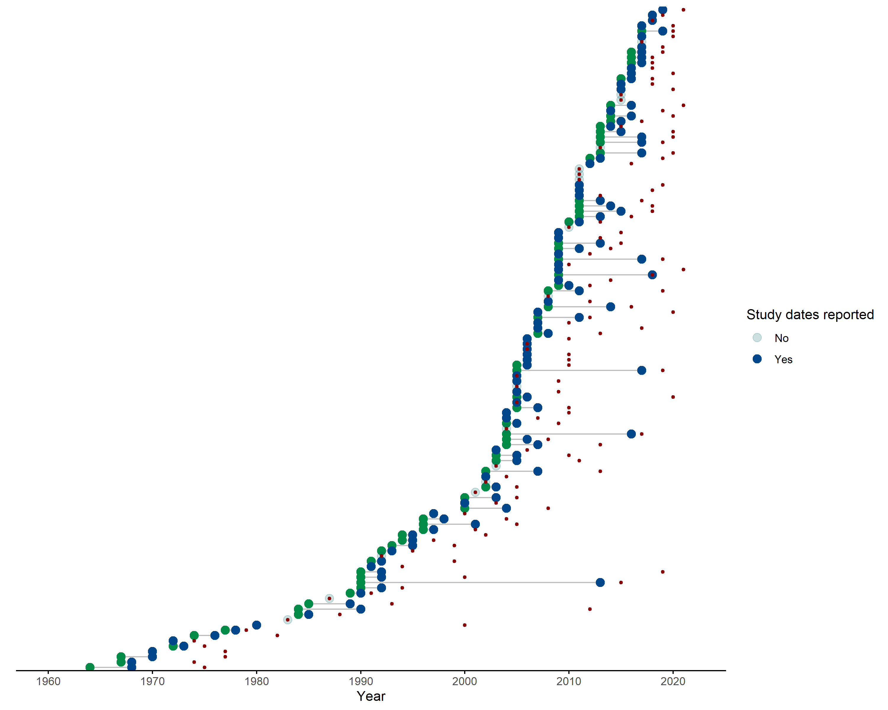

Supplementary Figure 1. Green points represent the start date of rodent trapping studies, blue points representing the final trapping activity. Red points indicate the publication of studies. Increasing numbers of studies have been published since 2000 with more studies being conducted over repeated visits.

## Supplementary Figure 2

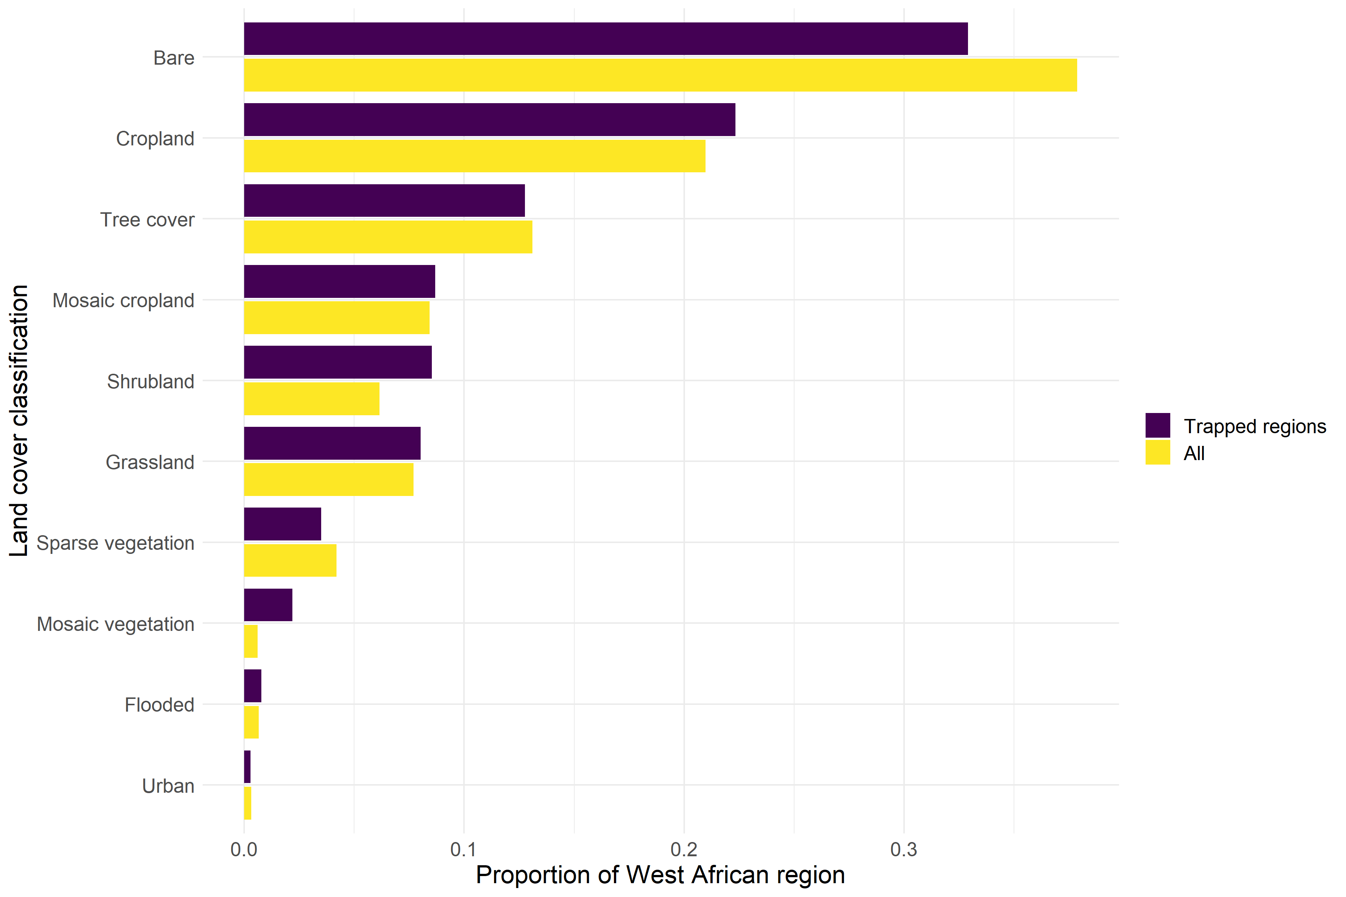

Supplementary Figure 2. Comparison between proportion of land use between regions trapped and all land use in West Africa. Cropland, Shrubland and Grassland were trapped at than representative rates while Bare habitats, Forested regions and Urban landscapes were trapped at lower than representative rates.

## Supplementary Figure 3

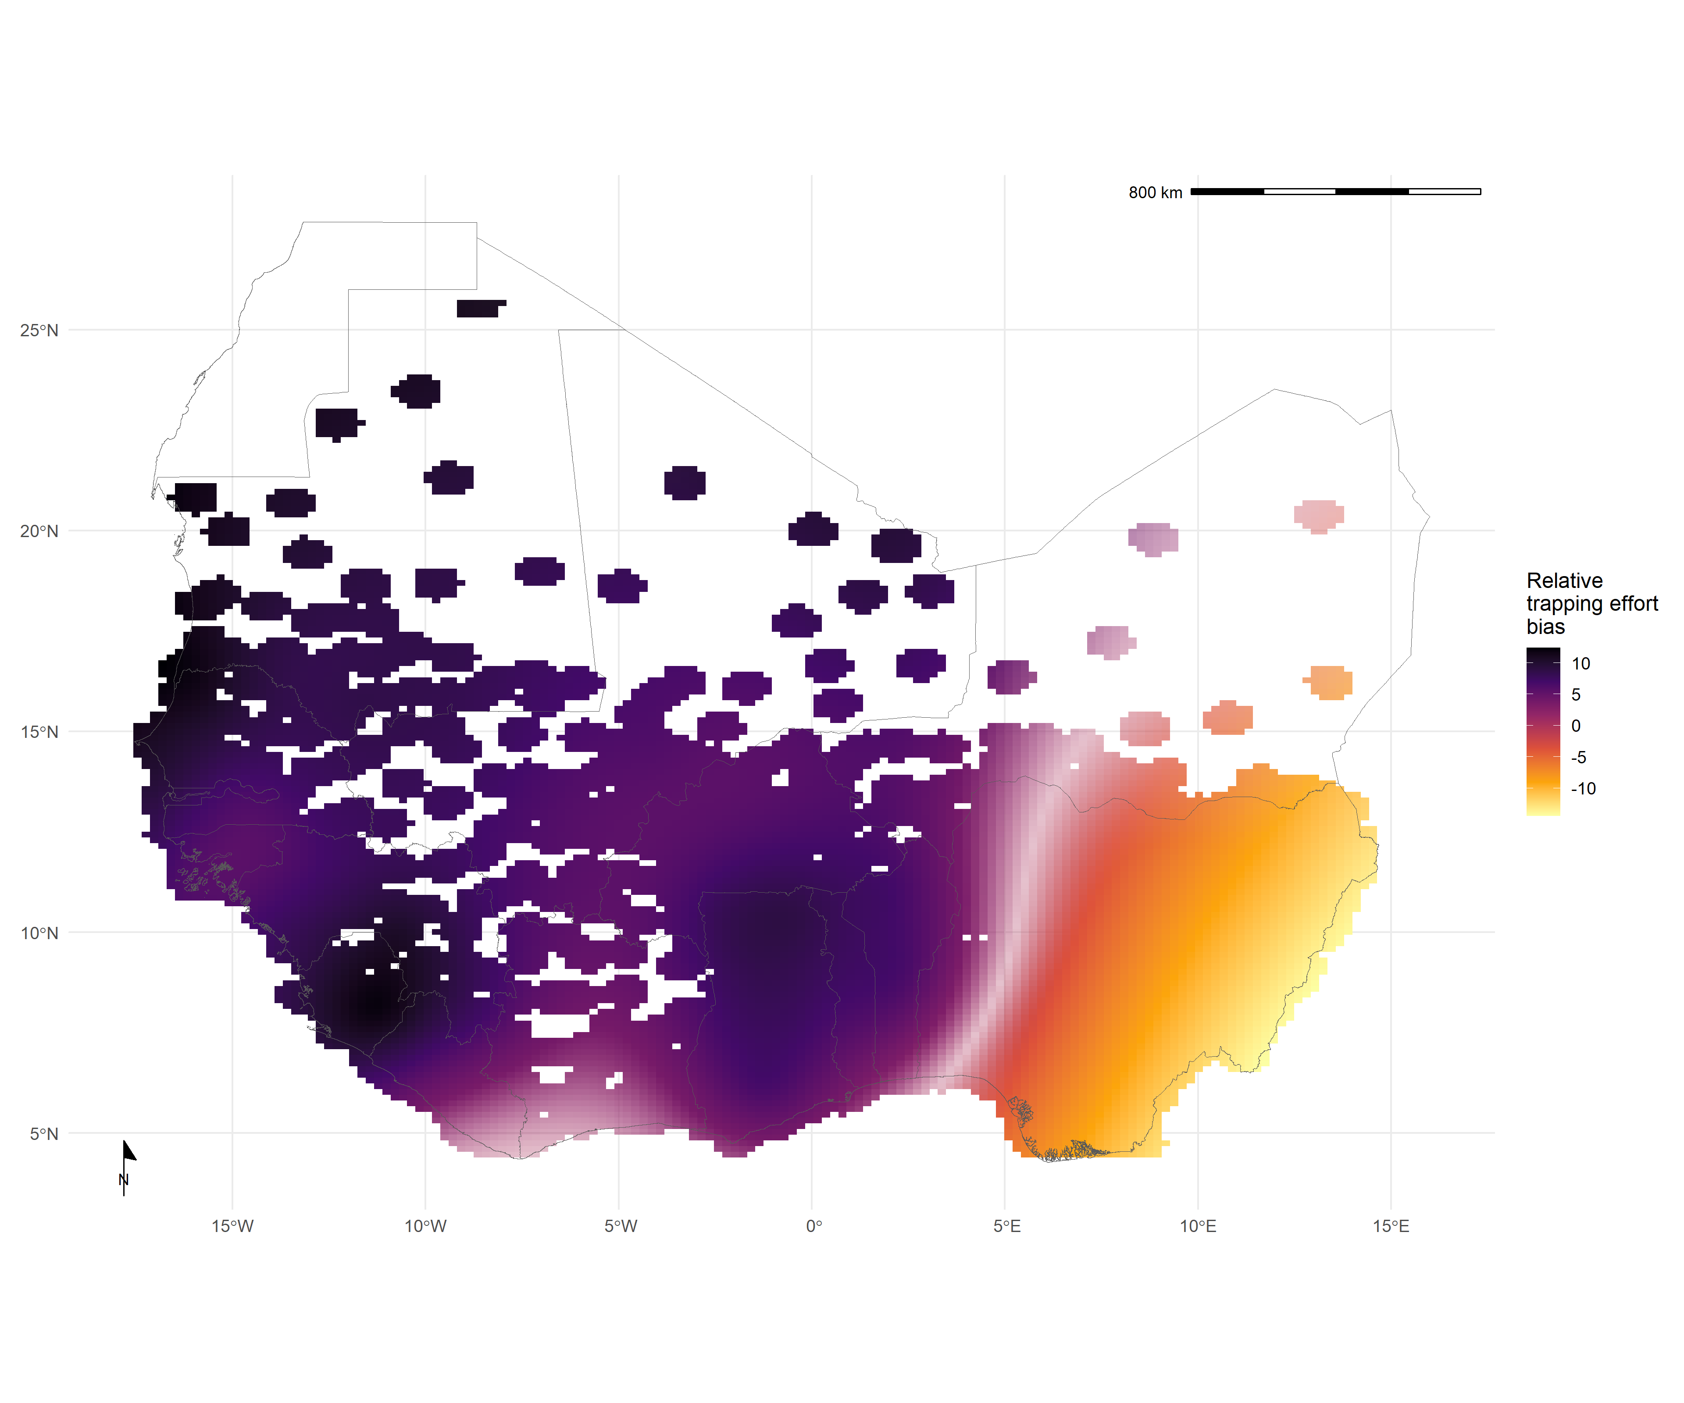

Supplementary Figure 3. Relative trapping effort bias across West Africa from the subset of included studies reporting trapping effort adjusted for proportion urban land cover and proportion tree cover. Predictions are limited to areas around trap sites (coloured areas), uncertainty in the estimate of bias is represented by colour transparency/pallor. Purple regions represent areas with higher than expected trapping effort, yellow regions represent areas lower than expected trapping effort

## Supplementary Figure 4

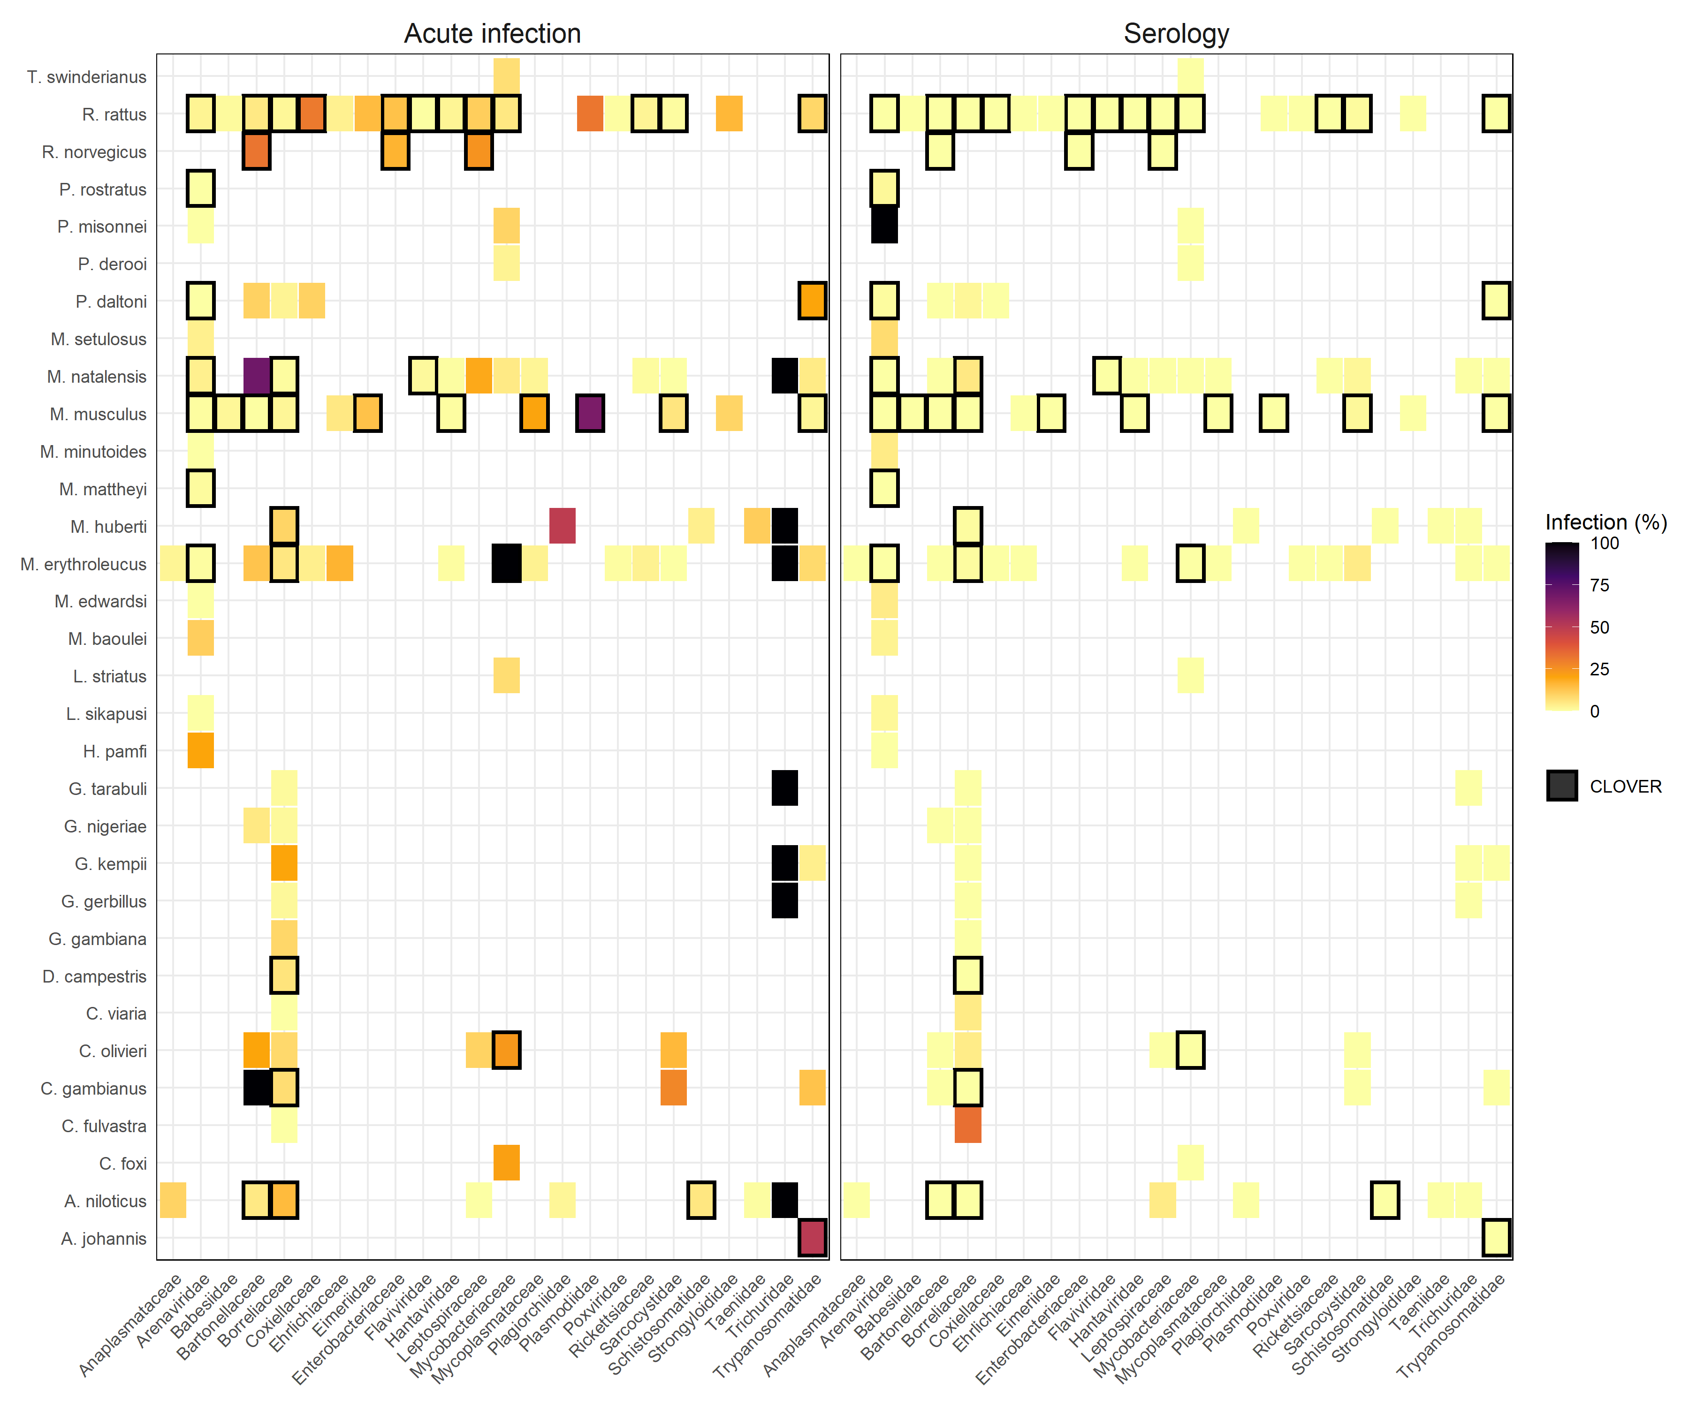

Supplementary Figure 4. L) Identified host-pathogen associations at pathogen family level through detection of acute infection (i.e. PCR, culture). Percentages and colour relate to the proportion of all assays that were positive. Associations with a black border are present in the CLOVER dataset. R) Identified host-pathogen associations at pathogen family level through serological assays (i.e. ELISA). Percentages and colour relate to the proportion of all assays that were positive. Associations with a black border are present in the CLOVER dataset.