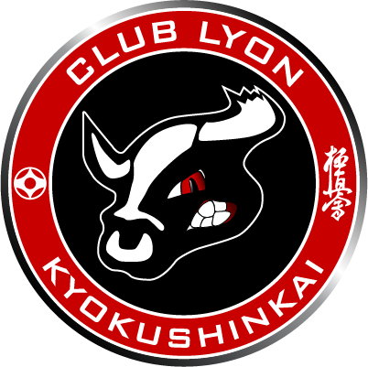

FRENCH OPEN 2025

4 to 6 APRIL – LYON, FRANCE



_________________________________________________________________________________Hôtels
- Mercure Saxe Lafayette – 29 Rue de Bonnel 69003 Lyon
- Ibis Part-Dieu Gare – 2 Place Pierre Renaudel 69003 Lyon
- Ibis Part-Dieu les Halles – 78 Rue de Bonnel 69003 Lyon
Excluding breakfast at an additional cost 13.90 € (include tax) + tourist tax at 1.65 €.
- 04/04 : 65€
- 05/04 : 65€
Rate only valid using the following link :
https://all.accor.com/lien_externe.svlt?goto=rech_resa&destination=1388&sourceid=LYOEV1&dayIn=4&monthIn=04&yearIn=2025&nightNb=2&preferredCode=LYOEV1&merchantid=par-accorFR

Organisation :

- Team registration - Hôtel Mercure Lyon Centre Saxe Lafayette ****
- Judge stage - Hôtel Mercure Lyon Centre Saxe Lafayette ****
- Competition – Maison du judo
- Training with Shihan Gorai and dan test – Maison du judo



