**Development Economics**

Homework 1

Author: Dídac Martí Pinto

CEMFI

25/01/2019

**Question 1. Inequality in consumption, income and wealth (CIW)**

1. **Report average CIW per household separately for rural and urban areas**

|  |  |  |  |
| --- | --- | --- | --- |
| **Mean C I W** | | | |
|  | All | Rural | Urban |
| C | 630.4 | 575.4 | 823.9 |
| I | 1145.6 | 970.9 | 1760.7 |
| W | 2194.1 | 1907.113 | 3204.3 |

We can see that in the three measures (C I and W) the values of urban areas are higher. The differences are more notable in wealth and income than in consumption. These results are similar to the ones for the urban and rural areas in Malawi that we saw in class and that appear in Magalhaes and Santaeulàlia-Llopis (2017); Uganda, however, seems to be slightly richer.

1. **CIW inequality:**

**(1) Show histogram for CIW separately for rural and urban areas**

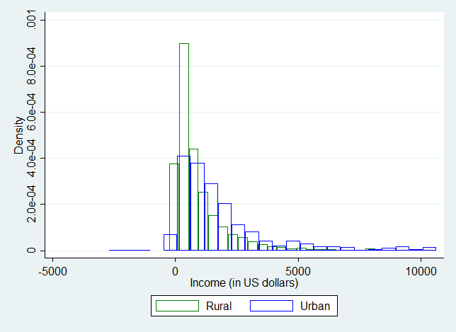

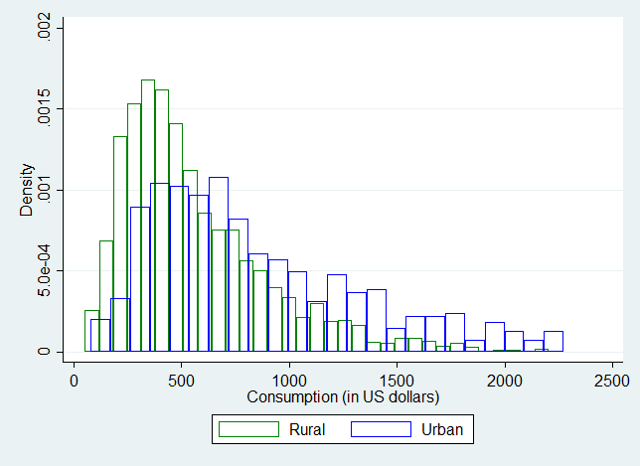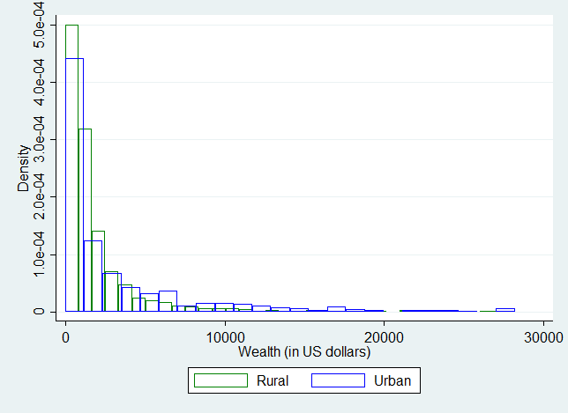

The shapes of the distributions in rural and urban areas are similar. However, the distributions for urban areas are shifted to the right with respect to urban areas; which implies that C I and W are larger in urban areas, as seen in part 1. It can also be seen, even though it is less clear, that the variance of W in urban areas is slightly larger, specially thanks to the presence of richer households. Again, these results seem to be in the same direction as the ones seen in class for Malawi.

**(2) Report the variance of logs for CIW separately for rural and urban areas**

|  |  |  |  |
| --- | --- | --- | --- |
| **Variance logs of C I W** | | | |
|  | All | Rural | Urban |
| C | 0.158 | 0.134 | 0.136 |
| I | 1.27 | 1.245 | 1.219 |
| W | 1.68 | 1.369 | 2.74 |

It can be seen that the dispersion in C is lower than the dispersion in I, which is lower than the dispersion in W (as in Malawi and the US). The dispersion in C and I are similar in urban and rural areas. However, there is a significantly larger dispersion in W in urban areas than in rural areas. These results are similar to the ones in Malawi (although in Malawi there was a larger difference in I dispersion between rural and urban areas).

Regarding the levels of inequality across countries, compared to the US, income inequality in Uganda is similar, but C and W inequality in Uganda are much smaller (especially in rural areas). How is that possible? It seems that there is some mechanism(s) difficulting the transmission of income inequality into wealth and consumption inequality. We commented some possibilities in class e.g. redistribution systems that equalize consumption and wealth, specially in rural areas. However, with these data, we do not know yet.

1. **Describe the joint cross-sectional behavior of CIW**

I understand that what is being asked in this question are the correlations between C I & W. Here they are:

|  |  |  |  |
| --- | --- | --- | --- |
| Rural | | | |
|  | C | I | W |
| C | 1 |  |  |
| I | 0.4641 | 1 |  |
| W | 0.4756 | 0.3332 | 1 |

|  |  |  |  |
| --- | --- | --- | --- |
| Urban | | | |
|  | C | I | W |
| C | 1 |  |  |
| I | 0.5655 | 1 |  |
| W | 0.4932 | 0.2858 | 1 |

|  |  |  |  |
| --- | --- | --- | --- |
| All | | | |
|  | C | I | W |
| C | 1 |  |  |
| I | 0.5425 | 1 |  |
| W | 0.5003 | 0.3380 | 1 |

The correlations in rural areas between CI and CW are smaller than in urban areas, which is similar to what we saw for Malawi, and which is also consistent with the comment in part 3 on the difficulty of transmitting income inequality into C and W inequality. However, here the correlation between IW seems to be lower in urban areas. This is not the same as we saw for Malawi, however this is probably due to some imperfection in the construction of the dataset.

Compared to the US in Uganda C and W are more correlated than in the US, but CI and IW are less correlated. Again this is consistent with the lack of transmission of I inequality into W and C inequality in Uganda and SSA in general.

1. **Describe the CIW level, inequality, and covariances over the lifecycle.**

Levels Inequality

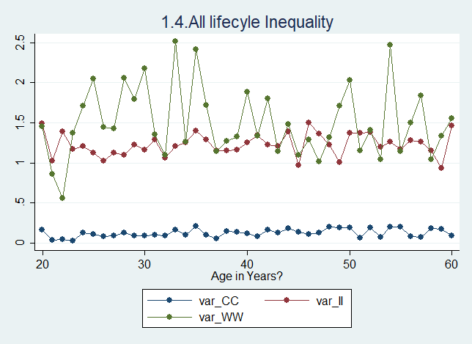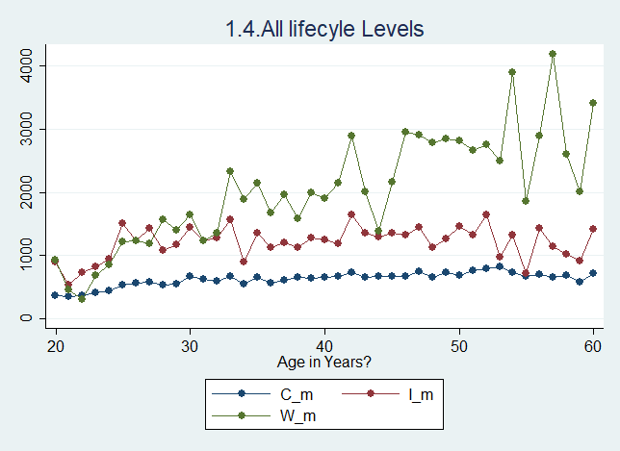

Covariances

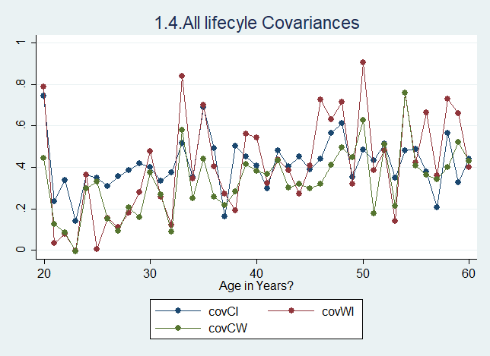

(In case you want to see in the folder of results there are the same graphs separated by urban and rural areas)

Regarding the graph in levels we can see that C and I are pretty flat over the lifecycle. There is some W accumulation, as it can be seen by the fact that W is larger for older ages. Income is not inverse-U shaped as in the US, this could be due to the fact that the levels of education are in general low, and as seen in the US, for these people I is quite flat over the lifecycle. This is analyzed in question 2.2.

Regarding the second graph in inequality we can see that inequality levels for C I and W are stable over the lifecycle. Again, this is very different than in the US, where inequality, specially for I and W, increases over the lifecycle.

In the last graph no clear pattern can be seen over the life-cycle. Correlations seem to be independent of age in Uganda.

1. **Rank your households by income, and discuss the behavior of the top and bottom of the consumption and wealth distributions conditional on income**

|  |  |  |
| --- | --- | --- |
|  | Top 10% | Bottom 10% |
| C | 1801.54 | 392.63 |
| I | 25191.29 | -39.41 |
| W | 13700.99 | 1708.13 |

Since it is not clear what top and bottom mean in the question I used the 10%’s. I did not top-code or bottom-code here, since I did not want to confuse outliers with true observations. In order to not be affected strongly by outliers I used the top and bottom 10%, instead of 1 or 2%.

The fact that I is negative for the bottom 10% should probably corrected in the dataset creation, since it is a quite strange result.

The differences in I and W between the two groups are very large compared to the differences in C. Recall that the mean C for Uganda is 630.4, so notice that the bottom is not far from the mean. It seems that even the poorest are not far from the average consumption. And the richest do not increase so much C even though they have much larger I and W than the rest of population.

**Question 2. Inequality in Labor Supply**

1. **Redo Question 1 for intensive and extensive margins of labor supply.**

I did not have time to complete this question yet.

1. **Redo separately for women and men, and by education groups (less than primary school completed, primary school completed, and secondary school completed or higher)**

All results are either in the .do file “ex2_2” or in the folder of “results” (in this folder there are graphs). Here I will focus only in some relevant statistics and graphs.

First let’s look at the general results on the means of CIW for the different groups:

|  |  |  |  |  |  |
| --- | --- | --- | --- | --- | --- |
| **Mean of C I W** | | | | | |
|  | Men | Women | Low educ | Med educ | High educ |
| C | 658.89 | 569.57 | 561.05 | 674.82 | 770.87 |
| I | 1245.08 | 933.27 | 858.93 | 1185.21 | 1699.02 |
| W | 2268.16 | 2035.74 | 1640.13 | 2649.78 | 2697.37 |

As in rich countries men have higher C I and W than women. And as it could be expected the higher is the level of education the higher is C I and W. Notice that the differences for education levels are not very large, as in the US or other developed economies.

In order to see if there are important inequality differences between groups we can look at the variances of log C I and W:

|  |  |  |  |  |  |
| --- | --- | --- | --- | --- | --- |
| **Variances of log C I W** | | | | | |
|  | Men | Women | Low educ | Med educ | High educ |
| C | 0.151 | 0.151 | 0.117 | 0.129 | 0.123 |
| I | 1.21 | 1.366 | 1.207 | 1.155 | 1.102 |
| W | 1.66 | 1.711 | 1.404 | 1.763 | 2.02 |

Men and women are pretty similar in terms of inequality. High educated individuals seem to have larger dispersion on wealth, but on the rest inequality is similar across education levels.

One characteristic of rich countries is that the higher is the level of education the more income increase over the lifecycle. We can analyze if this is true for Uganda by showing the lifecycle of individuals for different education levels:

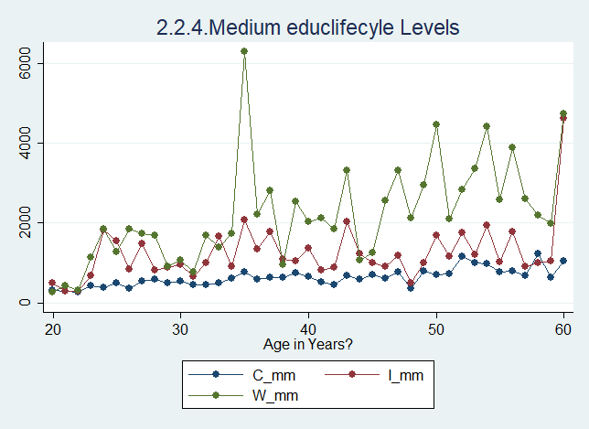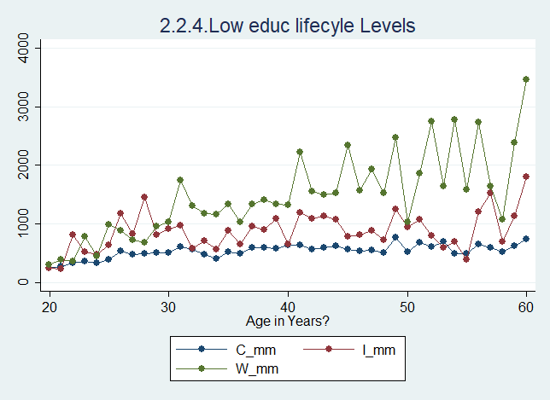

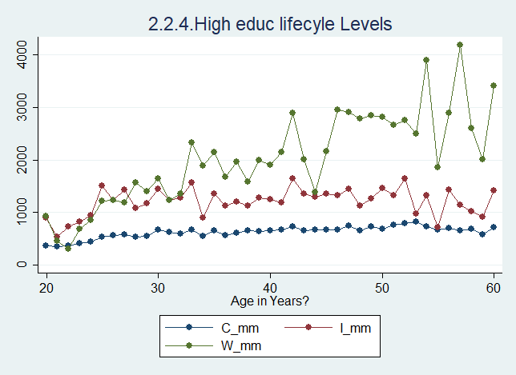

We do not see an increase income over the lifecycle for highly educated individual; we do see, however, some accumulation of wealth for high educated individuals, consistent with the results in the US.

For men and women lifecycles are very similar (see folder “results”)

**Question 3. Inequality Across Space**

For this question, since I have not done part 2.1 I cannot generate the plots with labor supply, all the others are here.

1. **Plot the level of CIW and labor supply by zone (or district) against the level of household income by zone.**

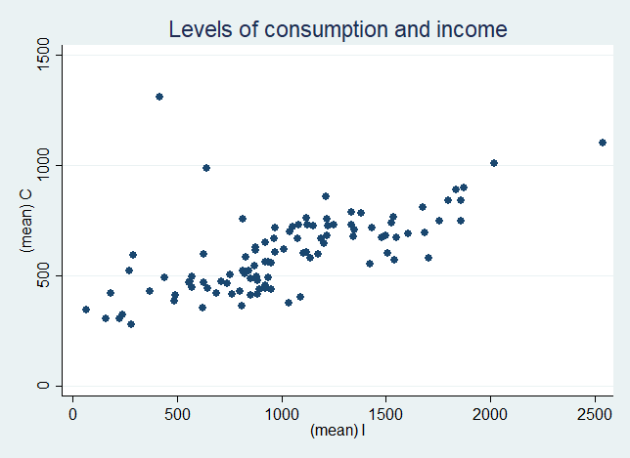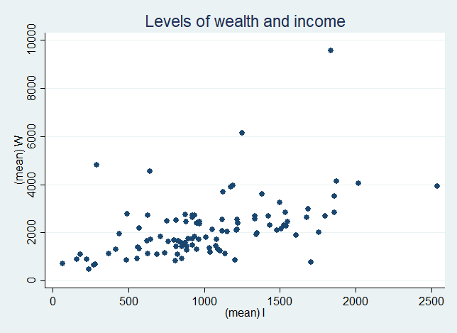

There is a correlation between C and I, and W and I; as we already saw in question 1. The correlation is pretty clear.

1. **Plot the inequality of CIW and labor supply by zone (or district) against the level of household income by zone.**

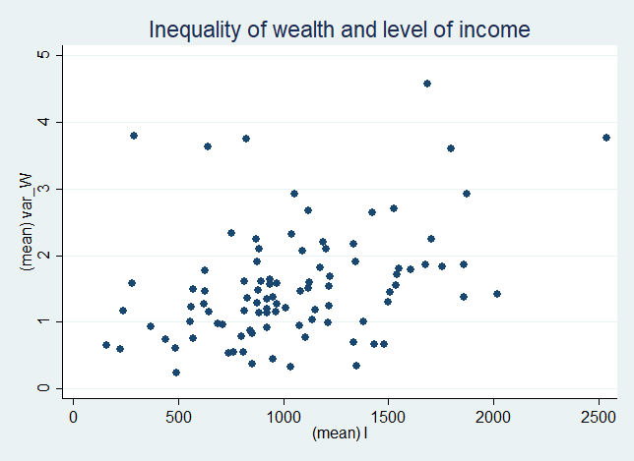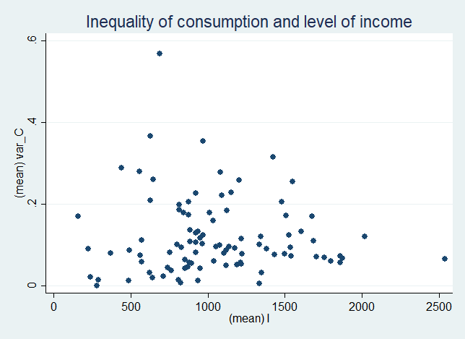

Inequality of C and W seem to increase the higher is I of a district. However, the correlation is weak. So richer districts are not very different in terms of inequality to poorer districts. This means that even when districts become richer as a whole it is difficult to generate a lot of differences in C or W across individuals (even though some inequality is generated since there is some correlation).

1. **Plot the covariances of CIW and labor supply by zone (or district) against the level of household income by zone.**

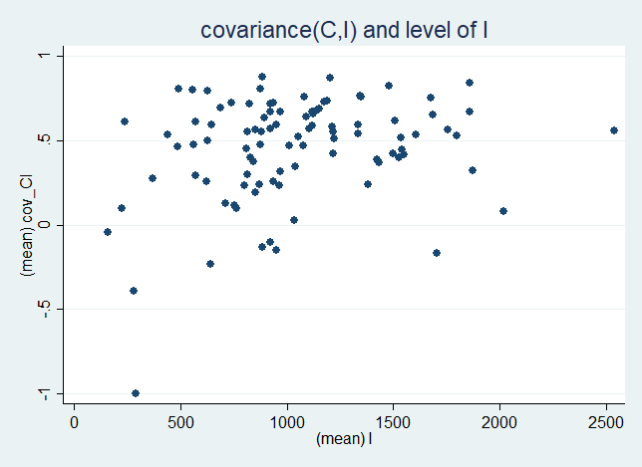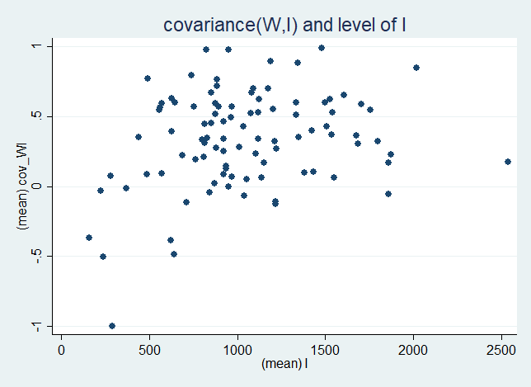

The two variables in the plots do not seem to be correlated very strongly. Slightly positive correlation, but not very significant. This means that when I increases in a district I does not become more important in determining W or C of individuals.