# Development Economics

Homework 3

Author: Dídac Martí Pinto

CEMFI

01/03/2019

# Question 1

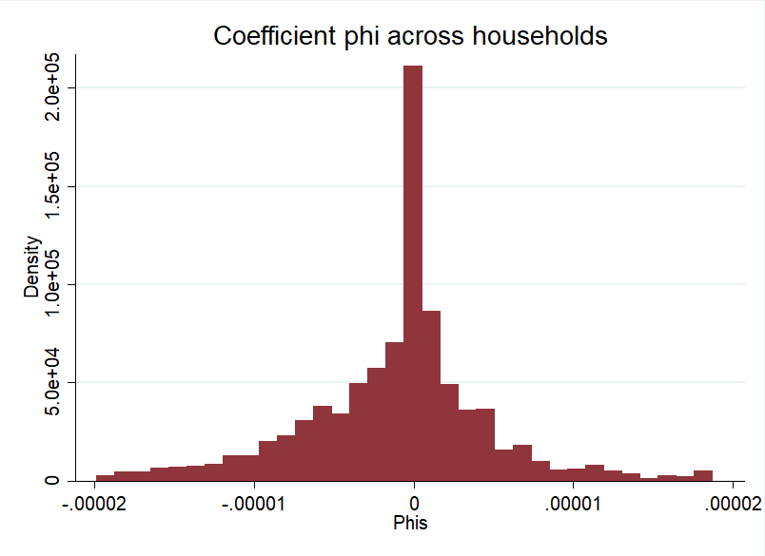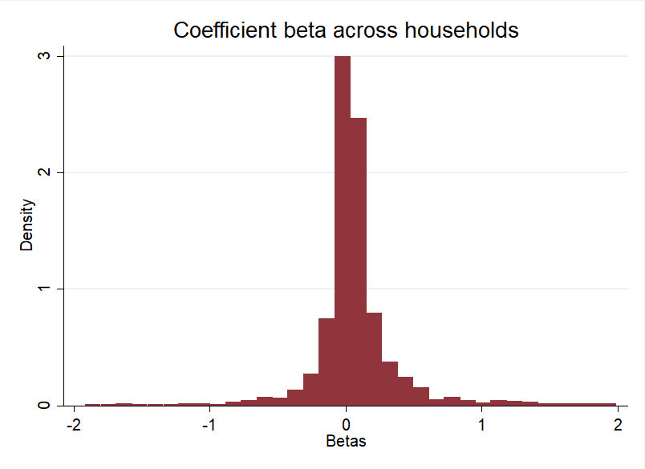Figure 1: Histogram of βi and φi

Table 1. Mean and Medians of βi and φi

|  |  |  |
| --- | --- | --- |
|  | Mean | Median |
| βi | .0705275 | .0368387 |
| φi | -1.04e-06 | -1.94e-22 |

Full risk sharing would be achieved when βi≈0 andφi>0. That means, when what matters in determining individual consumption is aggregate consumption and not the individual income. That would imply that there is some redistribution mechanism that allowed individuals be fully insured from individual income shocks.

Clearly this is not we see from these results. Here the average βi>0, so individual income seems important in determining consumption. And average φi≈0, so aggregate consumption seems irrelevant for individual consumption. Therefore, there seems to be no risk sharing.

One thing to notice is that we are using as aggregate consumption the aggregate consumption for all the country. Maybe if we used region/district/village aggregate consumption we would find some risk sharing. It is more likely that risk-sharing is taking place at village level than at country level.

# Question 2

Table 2. Mean and medians βi by income group, and mean and median income by βi group

|  |  |  |  |
| --- | --- | --- | --- |
|  | Group | Mean | Median |
| βi | 1st | .0440307 | .0208941 |
| 2nd | .0392014 | .0323387 |
| 3rd | .054303 | .0507627 |
| 4th | .1309663 | .0536938 |
| 5th | .1666759 | .0520851 |
| $$lny_{i,t}$$ | 1st | 7.142468 | 7.461186 |
| 2nd | 7.247264 | 7.562748 |
| 3rd | 7.140375 | 7.449161 |
| 4th | 7.357734 | 7.621355 |
| 5th | 7.310751 | 7.697758 |

# Regarding the first part of table 2 (Mean and medians βi by income group): the richer are individuals the higher is βi, so the richer are the individual the more important seems to be individual income in determining individual consumption. This seems to indicate that there is more risk sharing for poor households than rich households.

Regarding the second part of table 2 (mean and median income by βi): For those individuals with higher βi (so probably those for which there is less risk sharing since they rely more on individual income) the income is also higher. This is in line with the previous results.

# Question 3

Table 3. Results for regression (2)

|  |  |
| --- | --- |
| Depndnt var. | $$∆lnc_{i,t}$$ |
| β | 0.0513*** |
| se(β) | (0.00169) |
| φ | -1.81e-06*** |
| se(φ) | (2.08e-07) |
| Observations | 14,475 |
| R-squared | 0.063 |

The coefficients of β and φ are similar to the mean and median results of βi and φi of part 1. I think this is reasonable.

The interpretation is exactly the same as in 1. There seems to be no risk sharing. However, maybe by using aggregate consumption at village/region level results are different. Refer to question 1 for more explanation.

# Question 4.1

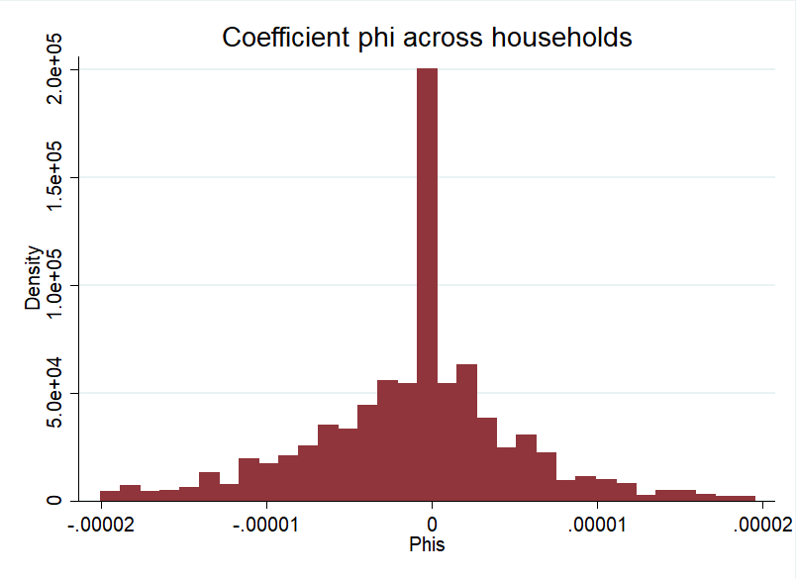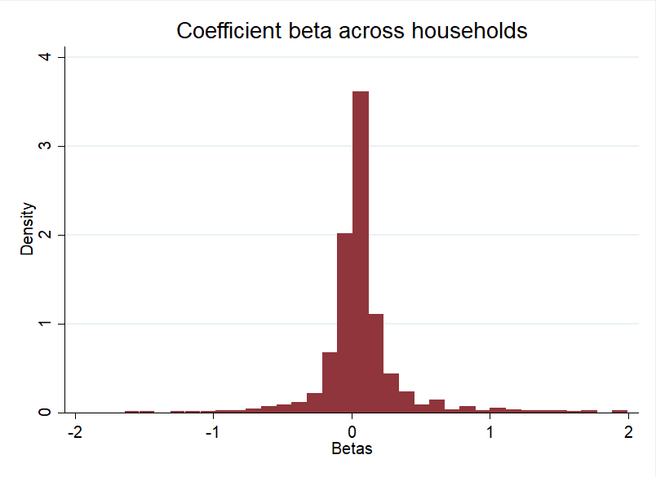Figure 2: Histogram of βi and φi - Rural

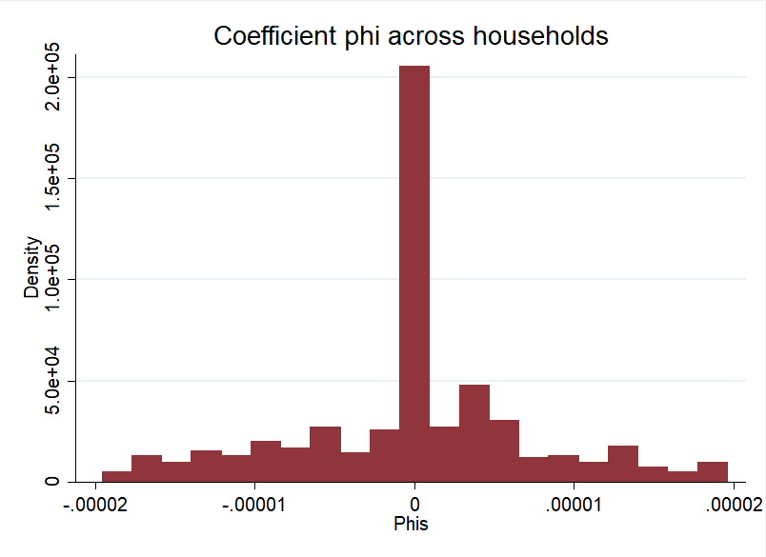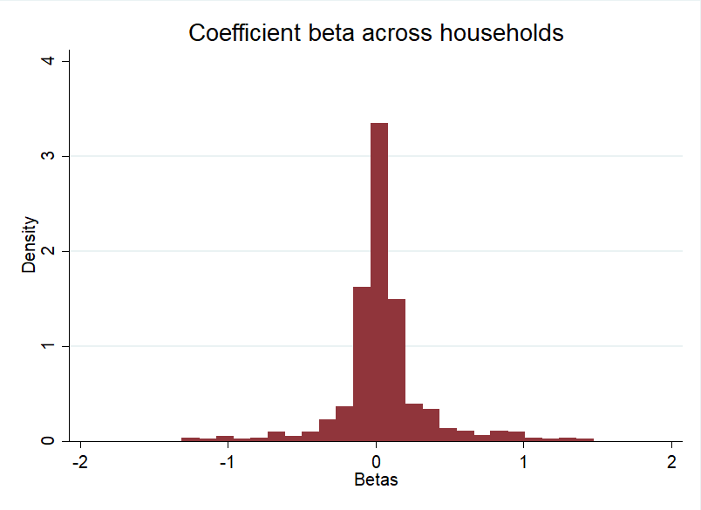Figure 3: Histogram of βi and φi - Urban

Table 4. Mean and Medians of βi and φi – Urban & Rural

|  |  |  |  |  |
| --- | --- | --- | --- | --- |
|  | Urban | | Rural | |
|  | Mean | Median | Mean | Median |
| βi | .0502229 | .0253321 | .0622319 | .0366803 |
| φi | -4.06e-08 | 0 | -9.98e-07 | -2.50e-22 |

Regarding βi’s they seem to be larger in rural than urban areas. That means, income seems to have stronger effects in consumption in rural than in urban areas. The reasons cannot be observed. Maybe in urban areas there is some risk-sharing and redistribution and because of that income is not so influential consumption. However, the coefficients of φi are close to 0 both for rural and urban areas, so the risk sharing story does not fit perfectly well here. Maybe redistribution happens at the city/region level, but we do not know. Furthermore, from my point of view it is strange that risk sharing is more significant in urban than rural areas. From this exercise it is impossible to tell what is driving this counter intuitive results.

# Question 4.2

Table 5. Mean and medians βi by income group, and mean and median income by βi group – Urban & Rural

|  |  |  |  |  |  |
| --- | --- | --- | --- | --- | --- |
|  |  | Urban | | Rural | |
|  | Group | Mean | Median | Mean | Median |
| βi | 1st | .0407079 | .0239025 | .0531637 | .0193986 |
| 2nd | .0123238 | .0247667 | .02992 | .0274978 |
| 3rd | .148154 | .0320223 | .104942 | .0439269 |
| 4th | .0500605 | .0237673 | .1588964 | .0530522 |
| 5th | .0196935 | .0248096 | .061756 | .0525387 |
| $$lny_{i,t}$$ | 1st | 7.737637 | 7.836784 | 7.134032 | 7.510934 |
| 2nd | 7.212472 | 7.581296 | 7.041716 | 7.369972 |
| 3rd | 6.937386 | 7.281227 | 7.15586 | 7.476838 |
| 4th | 7.558867 | 7.624016 | 7.322277 | 7.595161 |
| 5th | 7.519954 | 7.821862 | 7.26236 | 7.683129 |

# Regarding the first part of table 2 (Mean and medians βi by income group): the richer are individuals the higher is βi, so the richer are the individual the more important seems to be individual income in determining individual consumption. This seems to indicate that there is more risk sharing for poor households than rich households. Also this risk sharing seems to be stronger in urban than rural areas for any income level (despite the noisiness due to the small sample size). That is, as indicated in 4.1 βi’s are larger in rural than urban areas, and this is true for any income group.

Regarding the second part of table 2 (mean and median income by βi): For those individuals with higher βi (so probably those for which there is less risk sharing since they rely more on individual income) the income is also higher. For any βi group it seems to be that income is on average higher in urban than rural areas. This could be probably because income is on average higher in urban than rural.

# Question 4.3

Table 6. Results for regression (2)

|  |  |  |
| --- | --- | --- |
|  | Urban | Rural |
| Depndnt var. | $$∆lnc_{i,t}$$ | $$∆lnc_{i,t}$$ |
| β | 0.0290*** | 0.0437*** |
| se(β) | (0.00320) | (0.00173) |
| φ | -7.31e-06*** | -2.01e-06*** |
| se(φ) | (1.82e-06) | (2.78e-07) |
| Observations | 3,075 | 11,195 |
| R-squared | 0.029 | 0.056 |

In line with the results of part 3 and 4.1 the results of specification (2) are similar to the average coefficients of individual βi and φi, both for rural and urban areas. This makes sense from my point of view since are using exactly the same observations.