**Shape Optimization of Trapezoidal Labyrinth Weirs**

|  |  |  |
| --- | --- | --- |
| **Jad Abi Zaki** | **Danny Abraham** | **Badreddine Itani** |

Problem Description

Weirs are barriers across the length of a river that alter the flow characteristics of the water and raises the water level upstream. The flow rate of the water over the weir (Q) is determined by three factors, the length of the weir (L), the height of the water level above the crest of the weir (H), and a coefficient of discharge that depends on the geometry of the weir (C).

$$Q=C∙L∙H^{3/2}$$

In flood conditions however, the height (H) of the water level above the weir can increase greatly which can be dangerous. For this reason instead of building a straight weir from one side of the river to the other, a winding pattern is used to increase the length (L) of the weir, this allows the flow rate (Q) to increase with a weaker effect on the height of the water (H). One of the winding patterns used is a trapezoidal labyrinth weir.

The aim of the shape optimization of the trapezoidal labyrinth weir is to minimize the cost of the weir, while meeting the hydraulic criteria expected of the weir. These include upper and lower bounds on certain ratios of the weir’s dimensions.

Variables & Parameters

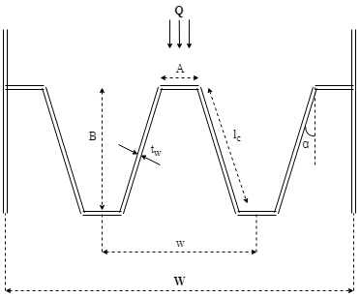

Objective Function

Constraints