Interactive Correlation Visualization for Store Sales Dataset

Abdallah Waked, Diego Bernal Olaya, Xavier Merino Mino

INFO-6151 Data Visualization for Machine Learning

Dr. Magdalene Ravichandran

Apr 3, 2025

Contents

preprocessing methods 3

Technical Classification of Libraries Used 4

Chart 1. Distribution of Store Area 5

Chart 5

Insights and Interpretations 5

Analysis and Visualization Techniques 5

Machine Learning Techniques Used 5

Chart 2. Relationship between Store Area and Daily Customer Count (Scatter Plot) 6

Chart 6

Insights and Interpretations 6

Analysis and Visualization Techniques 6

Machine Learning Techniques Used 6

Chart 3. Distribution of Items Available 7

Chart 7

Insights and Interpretations 7

Analysis and Visualization Techniques 7

Machine Learning Techniques Used 7

Chart 4. Relationship between Daily Customer Count and Store Sales 8

Chart 8

Insights and Interpretations 8

Analysis and Visualization Techniques 8

Machine Learning Techniques Used 8

Chart 5. Distribution of Store Sales 9

Chart 9

Insights and Interpretations 9

Analysis and Visualization Techniques 9

Machine Learning Techniques Used 9

Chart 6. Average Daily Customer Count by Store Area 10

Chart 10

Insights and Interpretations 10

Analysis and Visualization Techniques 10

Machine Learning Techniques Used 10

Chart 7. Store Sales Trend Over Time 11

Chart 11

Insights and Interpretations 12

Analysis and Visualization Techniques 12

Machine Learning Techniques Used 12

Chart 8. Correlation Matrix Heatmap 13

Chart 13

Insights and Interpretations 14

Analysis and Visualization Techniques 14

Machine Learning Techniques Used 14

# preprocessing methods

* Outlier Removal
* Date Conversion and Indexing
* Feature Engineering (Time Index, Rolling Mean)
* Data Normalization (Scaling)
* Numeric Column Filtering

# Technical Classification of Libraries Used

|  |  |  |  |  |  |  |  |  |
| --- | --- | --- | --- | --- | --- | --- | --- | --- |
| Classification of Libraries | Charts | | | | | | | |
| 1 | 2 | 3 | 4 | 5 | 6 | 7 | 8 |
| Data Analysis |  |  |  |  |  |  |  |  |
| pandas |  |  |  |  |  |  |  |  |
| numpy |  |  |  |  |  |  |  |  |
| |  | | --- | | statsmodels.tsa.seasonal  .seasonal_decompose |  |  | | --- | |  | |  |  |  |  |  |  |  |  |
|  |  |  |  |  |  |  |  |  |
| Visualization |  |  |  |  |  |  |  |  |
| plotly |  |  |  |  |  |  |  |  |
|  |  |  |  |  |  |  |  |  |
|  |  |  |  |  |  |  |  |  |
| Interactive Dashboard |  |  |  |  |  |  |  |  |
| streamlit |  |  |  |  |  |  |  |  |
|  |  |  |  |  |  |  |  |  |
|  |  |  |  |  |  |  |  |  |
| Machine Learning Algorithm |  |  |  |  |  |  |  |  |
| |  | | --- | | statsmodels.tsa.arima.model.ARIMA |  |  | | --- | |  | |  |  |  |  |  |  |  |  |
| r2_score |  |  |  |  |  |  |  |  |
| sklearn.linear_model.LinearRegression |  |  |  |  |  |  |  |  |
| Evaluation Metrics |  |  |  |  |  |  |  |  |
| sklearn.metrics.mean_squared_error |  |  |  |  |  |  |  |  |
|  |  |  |  |  |  |  |  |  |
|  |  |  |  |  |  |  |  |  |
| Data Preprocessing |  |  |  |  |  |  |  |  |
| sklearn.preprocessing.StandardScaler |  |  |  |  |  |  |  |  |
|  |  |  |  |  |  |  |  |  |

# Chart 1. Distribution of Store Area

* Use ML algorithms to analyse the distribution of store areas.
* Visualize the distribution using a histogram to show the frequency of different store area sizes.

## Chart

## Insights and Interpretations

## Analysis and Visualization Techniques

## Machine Learning Techniques Used

# Chart 2. Relationship between Store Area and Daily Customer Count (Scatter Plot)

* Perform predictive analysis to understand the relationship between store area and daily customer count using ML regression techniques.
* Develop a predictive model to estimate the daily customer count based on the store area.
* Create a scatter plot visualization to depict the relationship between store area and daily customer count.

## Chart

## Insights and Interpretations

## Analysis and Visualization Techniques

## Machine Learning Techniques Used

# Chart 3. Distribution of Items Available

* Aggregate stores by the number of items available using ML techniques.
* Visualize the distribution using a bar chart, where each bar represents a range of items available and the height represents the number of stores within each range.

## Chart

## Insights and Interpretations

## Analysis and Visualization Techniques

## Machine Learning Techniques Used

# Chart 4. Relationship between Daily Customer Count and Store Sales

* Analyse the relationship between daily customer count and store sales using machine learning regression techniques.
* Develop a predictive model to estimate store sales based on the daily customer count.
* Visualize the relationship using a line chart, where daily customer count is on the x-axis and store sales is on the y-axis.

## Chart

## Insights and Interpretations

## Analysis and Visualization Techniques

## Machine Learning Techniques Used

# Chart 5. Distribution of Store Sales

* Analyse the distribution of store sales using machine learning techniques.
* Visualize the distribution using a box plot to show the median, quartiles, and outliers of store sales.

## Chart

## Insights and Interpretations

## Analysis and Visualization Techniques

## Machine Learning Techniques Used

# Chart 6. Average Daily Customer Count by Store Area

* Aggregate the daily customer count by different ranges of store areas using machine learning techniques.
* Visualize the average daily customer count for each range using a bar chart, where each bar represents a range of store areas.

## Chart

## Insights and Interpretations

## Analysis and Visualization Techniques

## Machine Learning Techniques Used

# Chart 7. Store Sales Trend Over Time

* Analyse the trend of store sales over time using machine learning time series analysis techniques.
* Visualize the trend using a line chart, where the x-axis represents time (e.g., months or years) and the y-axis represents store sales.

## Chart

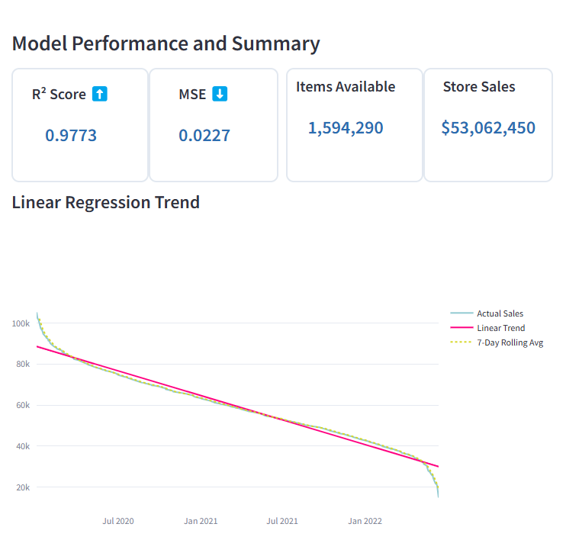

## Insights and Interpretations

* The sales trend shows a clear decline over time.
* The R² score (0.9773) and low MSE (0.0227) show that the trendline fits the data very well.
* The decomposition reveals:
  + Trend: Steady sales decrease.
  + Seasonality: Regular monthly patterns.
  + Residual: Random small fluctuations.
* The ARIMA forecast predicts sales will keep dropping in the next 30 days, from $14,321.99 down to $7,852.94.

## Analysis and Visualization Techniques

* Cleaned the data and removed outliers.
* Added a Time_Index to track sales over time.
* Used Linear Regression to analyze the trend.
* Decomposed the time series to show trend, seasonality, and noise.
* Forecasted future sales using the ARIMA model (1,1,1).
* Visualized everything using interactive line charts and summary cards in Streamlit.

## Machine Learning Techniques Used

* Linear Regression: To show the sales trend.
* ARIMA: To forecast future sales.
* StandardScaler: To normalize the data before applying the model.

# Chart 8. Correlation Matrix Heatmap

* Generate a correlation matrix using machine learning techniques to explore the relationships between different variables (store area, items available, daily customer count, store sales).
* Visualize the correlation matrix using a heatmap, where each cell represents the correlation coefficient between two variables.

## Chart

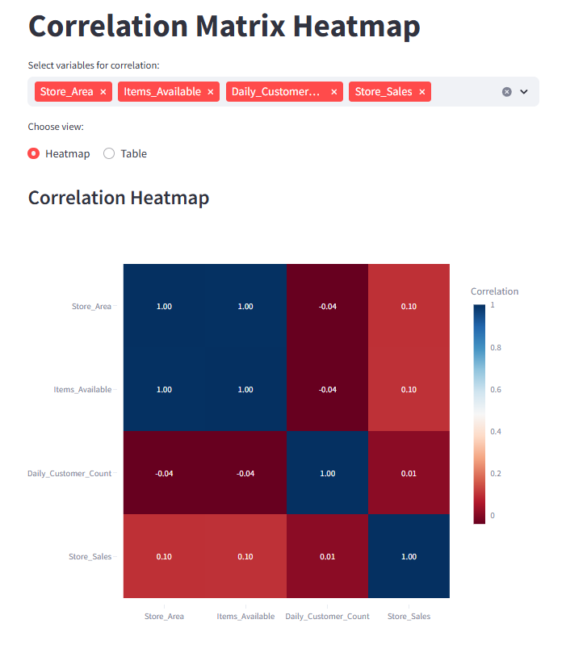

## Insights and Interpretations

* There is a perfect correlation (1.00) between Store Area and Items Available → These two features are directly related and may be duplicate.
* Store Area and Store Sales have a very weak positive correlation (0.10) → Bigger area does not strongly affect sales.
* Daily Customer Count shows almost no correlation with sales (0.01), suggesting customer count alone does not explain sales.
* Most variables have low or no strong correlation with each other.

## Analysis and Visualization Techniques

* Selected numeric columns for correlation analysis.
* Calculated Pearson correlation between variables using Pandas .corr().
* Built an interactive Streamlit app:
  + Allows users to select variables dynamically.
  + Provides two view options: Heatmap and Table.
* Visualized the correlation matrix using:
  + Plotly heatmap with color gradient to highlight strong/weak relationships.
  + Styled correlation table with color-coded values for better readability.

## Machine Learning Techniques Used

* Pearson Correlation Coefficient: A statistical method used to measure linear relationships between variables.
* Multiselect and Visualization: Although no predictive ML model was used here, the correlation matrix is a core step in ML data analysis to detect feature relationships and multicollinearity.