AI ASSISTED CODING
ASSIGNMENT-4.3
NAME:DIDDI KRISHNA SATHWIKA
ROLL NO:2303A52451
BATCH:50
Task 1: Zero-Shot Prompting – Leap Year Check
Scenario
Zero-shot prompting involves giving instructions without providing examples.
Task Description
Use zero-shot prompting to instruct an AI tool to generate a Python function that:
- Accepts a year as input
- Checks whether the given year is a leap year
- Returns an appropriate result
Note: No input-output examples should be provided in the prompt.
Expected Output
- AI-generated leap year checking function
- Correct logical conditions
- Sample input and output
- Screenshot of AI-generated response (if required)

PROMPT:
“Write a Python function that accepts a year as input, checks if it is a leap year, and returns the result”
OUTPUT:
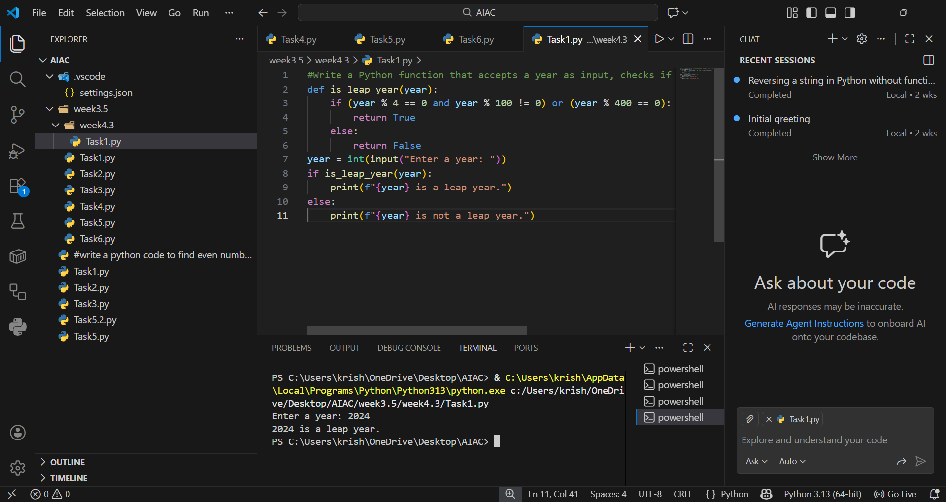

EXPLANATION:
In zero-shot prompting, the AI is given only instructions without any examples. The leap year function works by checking divisibility rules: years divisible by 400 are leap years, and years divisible by 4 but not by 100 are also leap years. This logic ensures correct identification of leap years like 2000 and 2024, while excluding non-leap years like 2023. The AI relies entirely on its built-in knowledge to generate the correct code.

Task 2: One-Shot Prompting – Centimeters to Inches Conversion
Scenario
One-shot prompting guides AI using a single example.
Task Description
Use one-shot prompting by providing one input-output example to generate a Python function that:
- Converts centimeters to inches
- Uses the correct mathematical formula
Example provided in prompt:
Input: 10 cm → Output: 3.94 inches
Expected Output
- Python function with correct conversion logic
- Accurate calculation
- Sample test cases and outputs
PROMPT:
“Write a Python function to convert centimeters to inches”
OUTPUT:
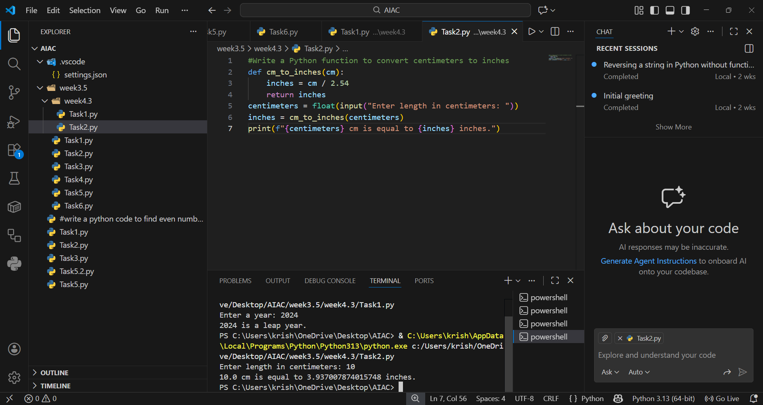

EXPLNATION:
One-shot prompting provides a single example to guide the AI’s response. By showing that 10 cm equals 3.94 inches, the AI understands the conversion formula of dividing centimeters by 2.54. The function uses round() to limit results to two decimal places, ensuring accuracy and readability. This single example anchors the AI to produce consistent and correct conversion logic.

Task 3: Few-Shot Prompting – Name Formatting
Scenario
Few-shot prompting improves accuracy by providing multiple examples.
Task Description
Use few-shot prompting with 2–3 examples to generate a Python function that:
- Accepts a full name as input
- Formats it as “Last, First”
Example formats:
- "John Smith" → "Smith, John"
- "Anita Rao" → "Rao, Anita"
Expected Output
- Well-structured Python function
- Output strictly following example patterns
- Correct handling of names
- Sample inputs and outputs

PROMPT:
“Write a Python function that formats names as 'Last, First'”

OUTPUT:
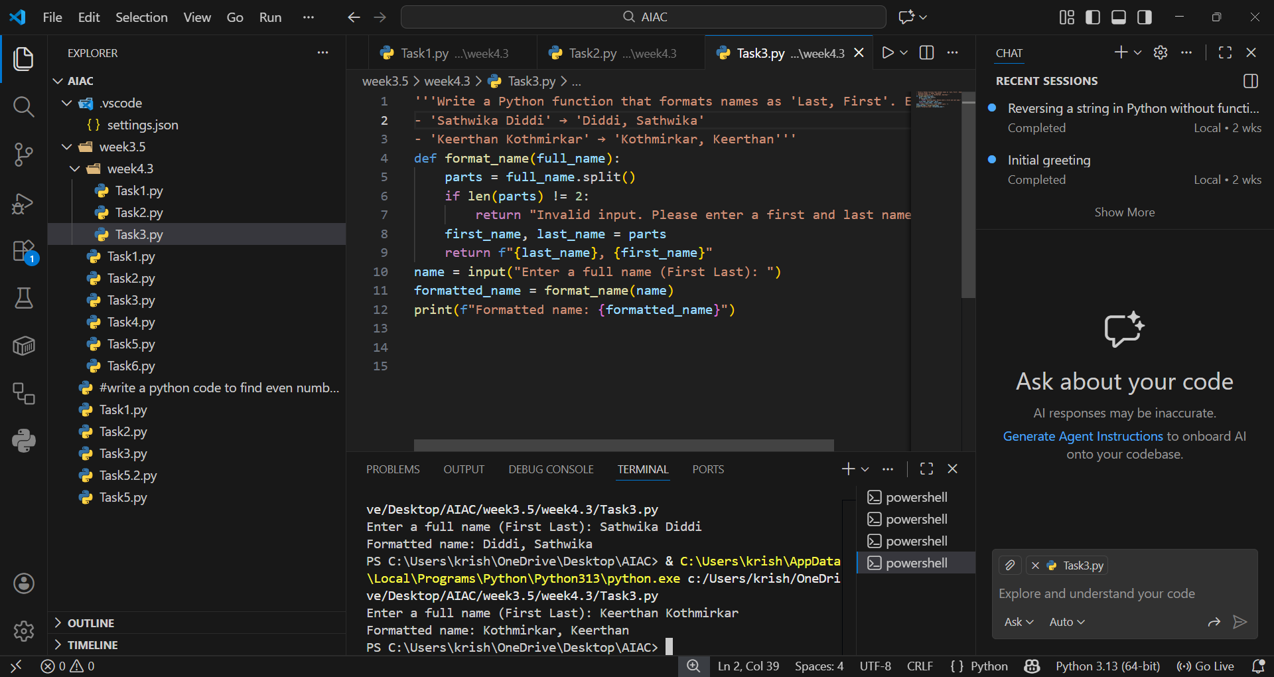

EXPLANTION:
Few-shot prompting uses multiple examples to reinforce the desired output pattern. By showing “Sathwika Diddi→ Diddi, Sathwika” and “Keerthan Kothmirkar → Kothmirkar, Keerthan”, the AI learns to split names and rearrange them as “Last, First.” The function applies string splitting and formatting to achieve this consistently. Multiple examples reduce ambiguity and ensure the AI follows the exact formatting style.

Task 4: Comparative Analysis – Zero-Shot vs Few-Shot
Scenario
Different prompt strategies may produce different code quality.
Task Description
- Use zero-shot prompting to generate a function that counts vowels in a string
- Use few-shot prompting for the same problem
- Compare both outputs based on:
  - Accuracy
  - Readability
  - Logical clarity
Expected Output
- Two vowel-counting functions
- Comparison table or short reflection paragraph
- Conclusion on prompt effectiveness
ZERO-SHOT PROMPT:
PROMPT:
“Write a Python function that counts vowels in a string.”
OUTPUT:
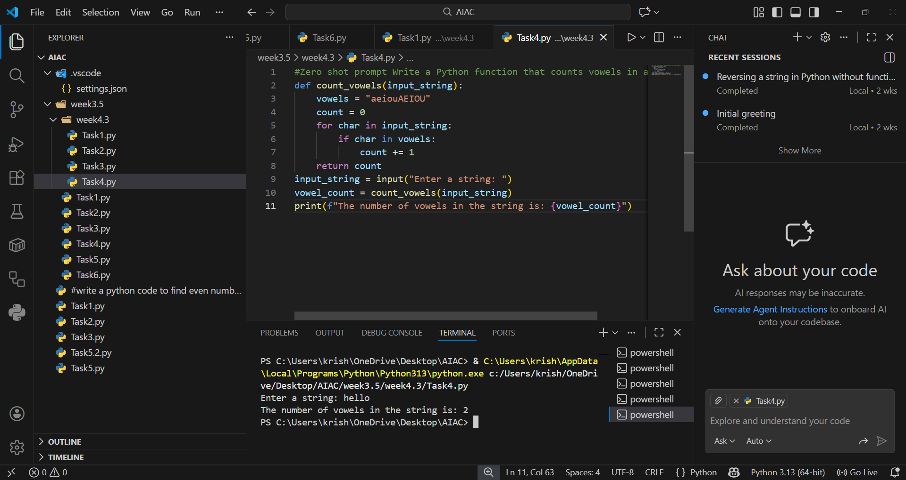
FEW SHOT PROMPT:
PROMPT:
“Write a Python function that counts vowels in a string. Examples:
- 'hello' → 2
- 'world' → 1
- 'AI' → 2”
OUTPUT:
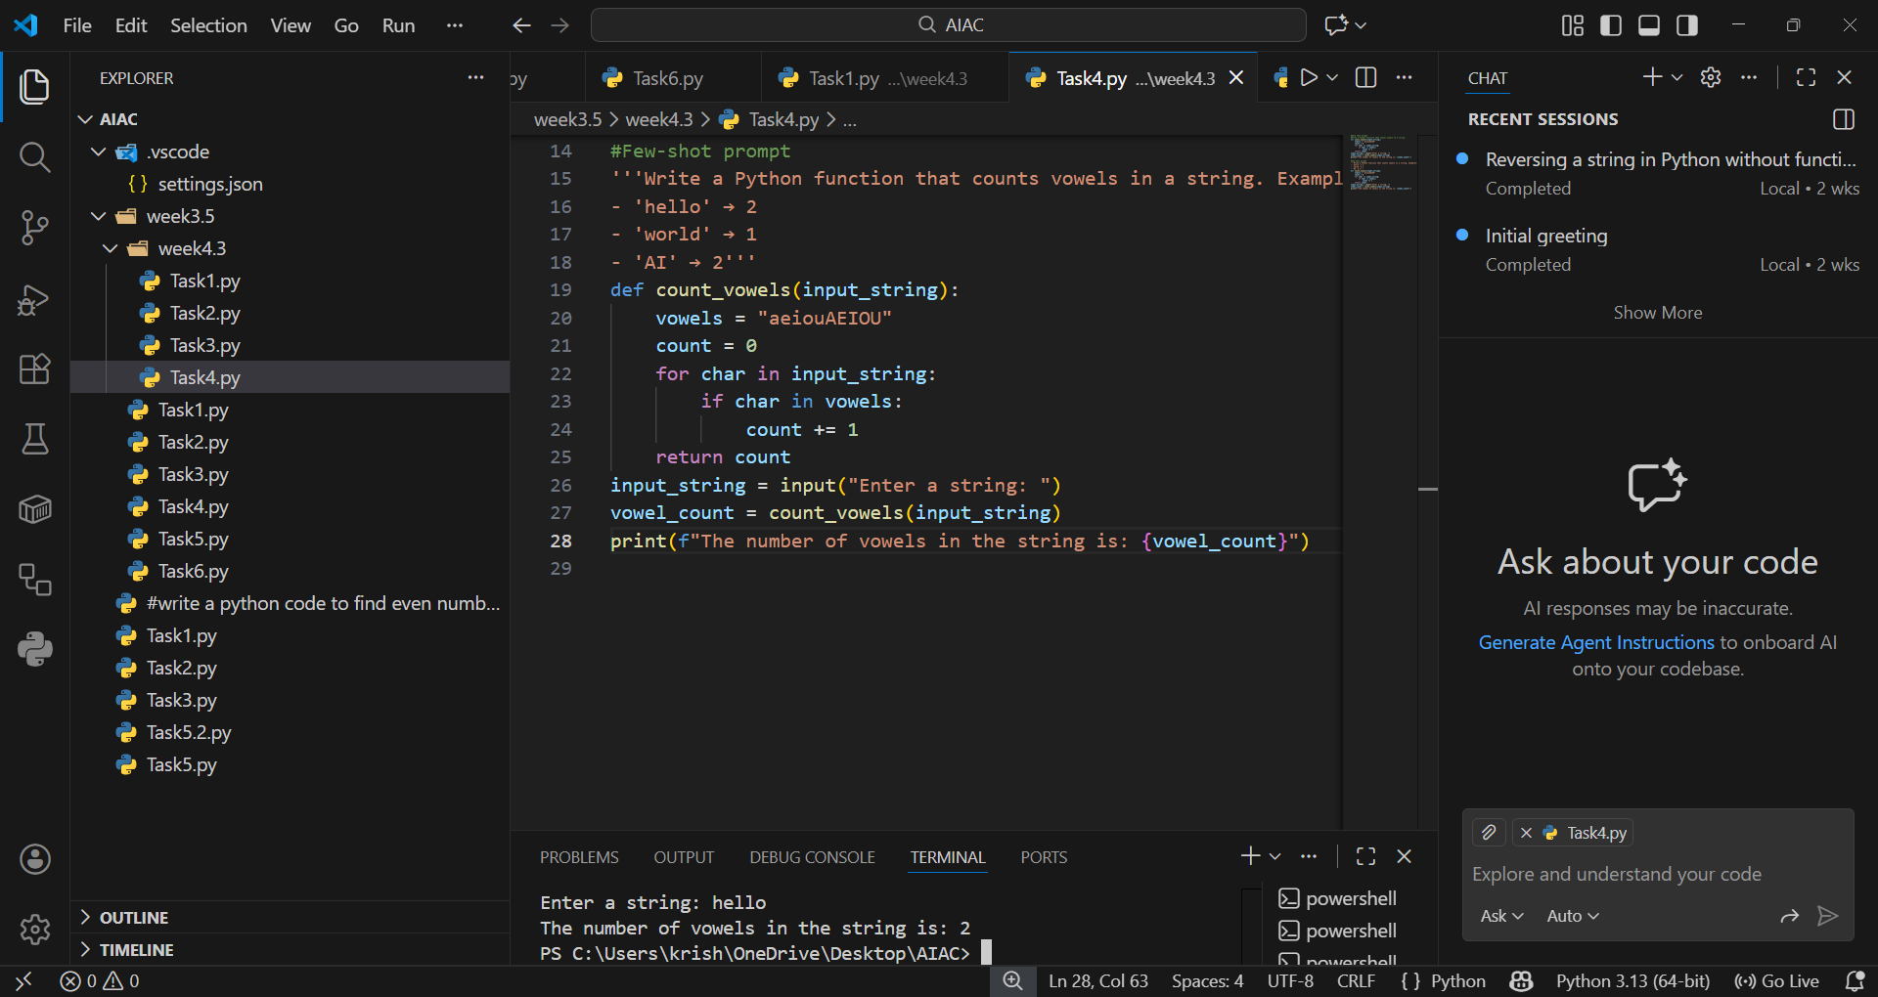

SHORT REFLECTION PARAGRAPH:
Through this lab, it became clear that the quality of AI-generated code depends heavily on the prompting strategy. Zero-shot prompting works well for simple, well-known problems but may produce varied styles. One-shot prompting improves accuracy by anchoring the logic with a single example, while few-shot prompting provides the strongest consistency by reinforcing patterns with multiple examples. Overall, few-shot prompting proves most effective, as it enhances confidence, readability, and reliability in the outputs.

Task 5: Few-Shot Prompting – File Handling
Scenario
File processing requires clear logical understanding.
Task Description
Use few-shot prompting to generate a Python function that:
- Reads a .txt file
- Counts the number of lines in the file
- Returns the line count
Expected Output
- Working Python file-processing function
- Correct line count
- Sample .txt input and output
- AI-assisted logic explanation
PROMPT:
“Write a Python function that reads a .txt file and counts the number of lines. Examples:
- File with 3 lines → Output: 3
- File with 5 lines → Output: 5”

OUTPUT:

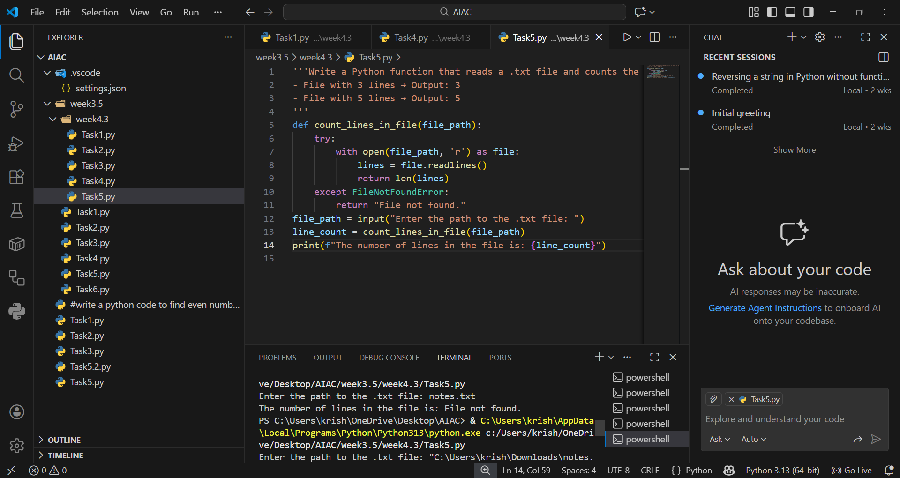
EXPLANATION:
File handling requires stepwise logic, and few-shot prompting helps the AI grasp the process clearly. By providing examples of files with known line counts, the AI generates a function that opens a file, reads its lines, and counts them correctly. Using Python’s with open() ensures safe file handling and automatic closure. Few-shot prompting reduces errors and ensures accurate line counting across different files

